Histopathological Examination
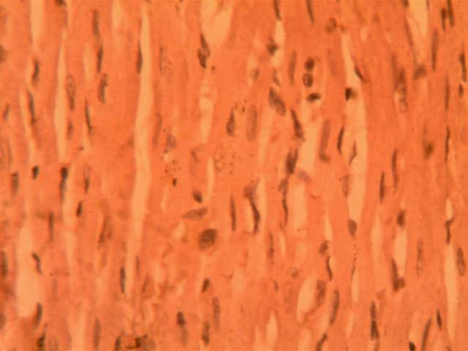
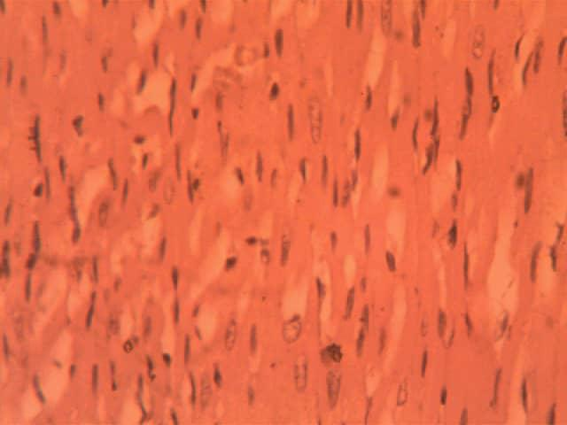
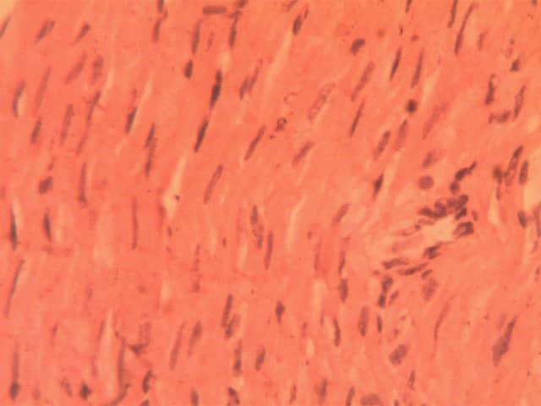
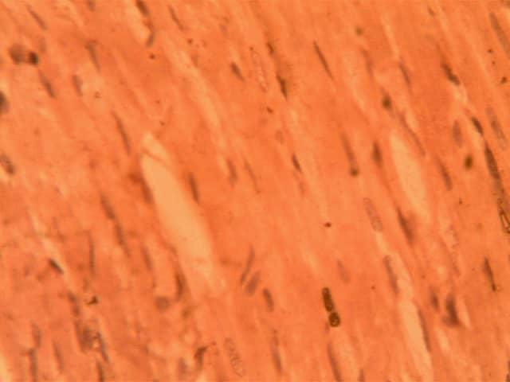
Figure 1: Heart Group 1 Figure 2: Heart Group 2
Figure 3: Heart Group 3 Figure 4: Heart Group 4

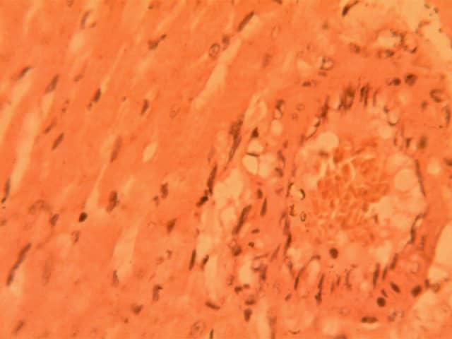
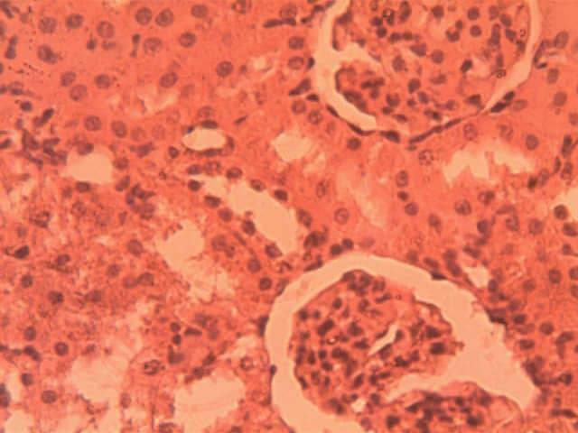
Figure 5: Heart Group 5 Figure 6: Kidney Group 1
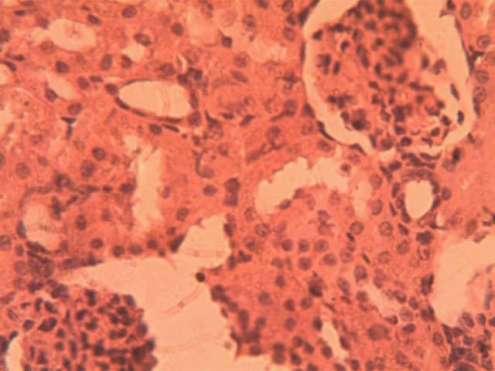
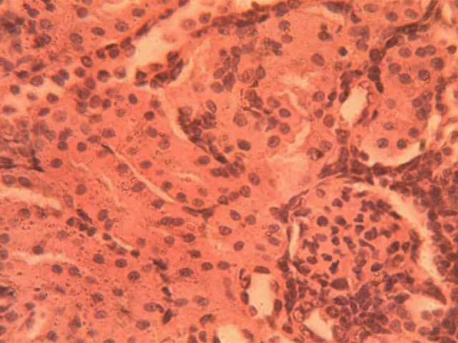
Figure 7:KidneyGroup 2 Figure 8: Kidney Group 3

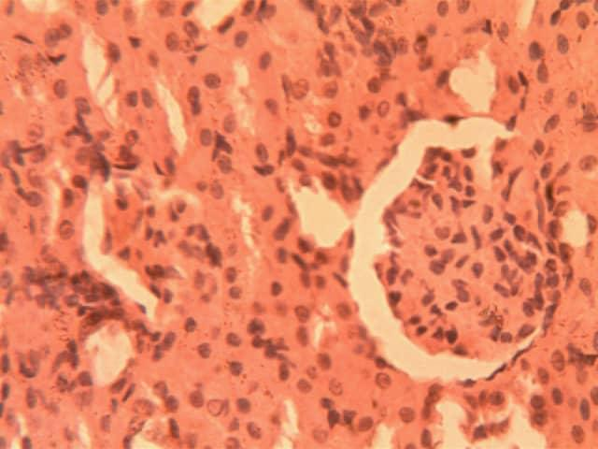
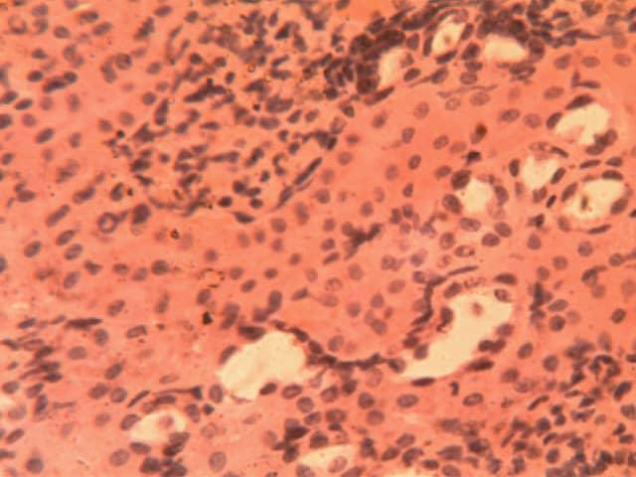
Figure 9: Kidney Group 4 Figure 10: Kidney Group 5
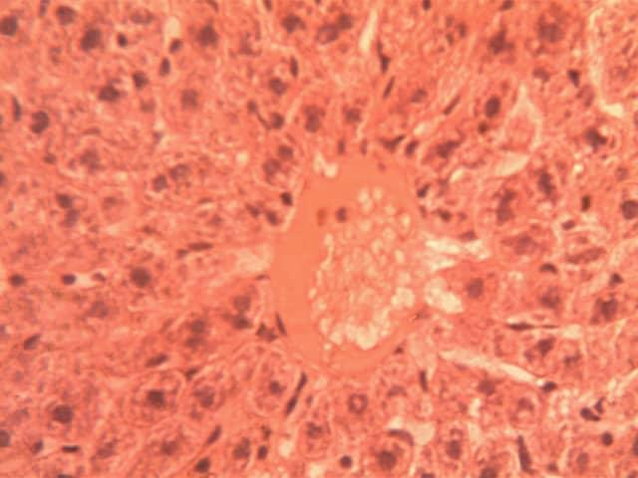
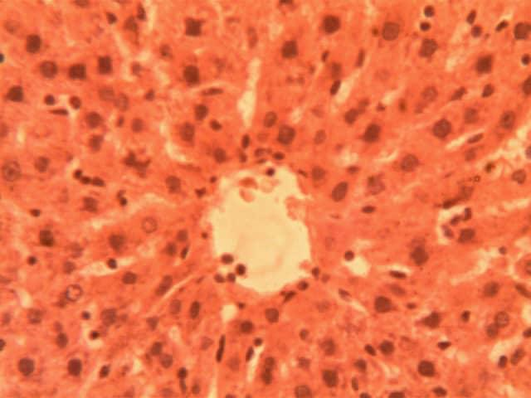
Figure 11: Liver Group 1 Figure 12: Liver Group 2

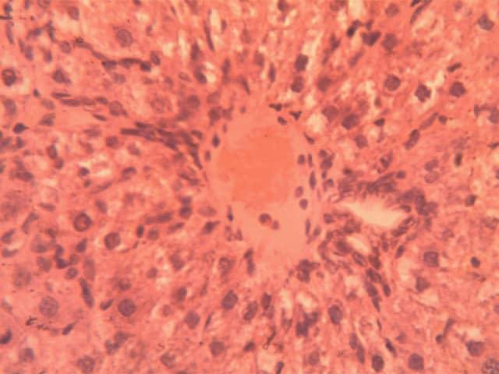
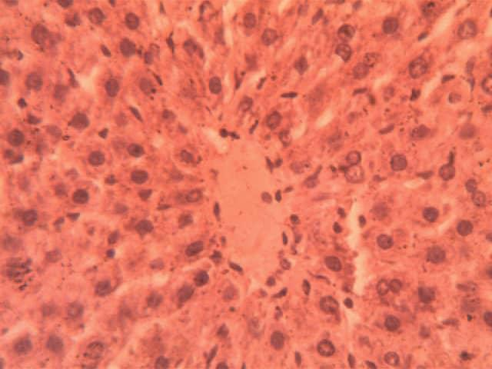
Figure 13: Liver Group 3 Figure 14: Liver Group 4
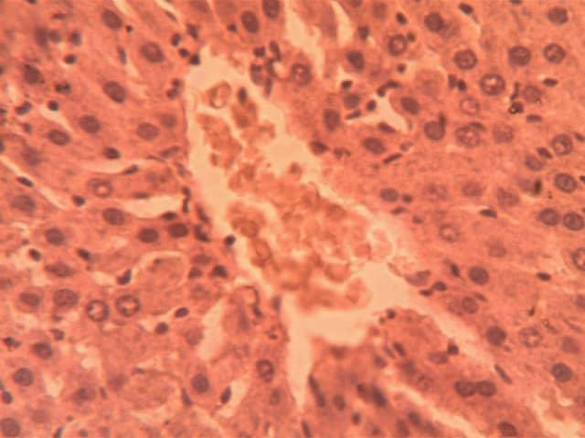
Figure 15: Liver Group 5

