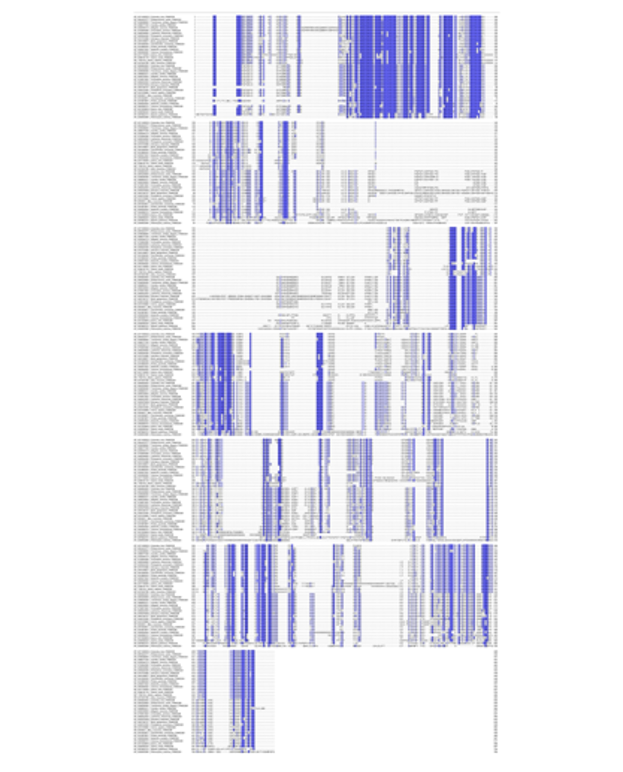Supplementary Figure 1. Multiple sequence alignment (MSA) of FAM222 proteins. The multiple sequence alignment (MSA) was generated using FASTA sequences from FAM222 proteins belonging to different vertebrate groups. The alignment is shaded according to sequence identity using Jalview.
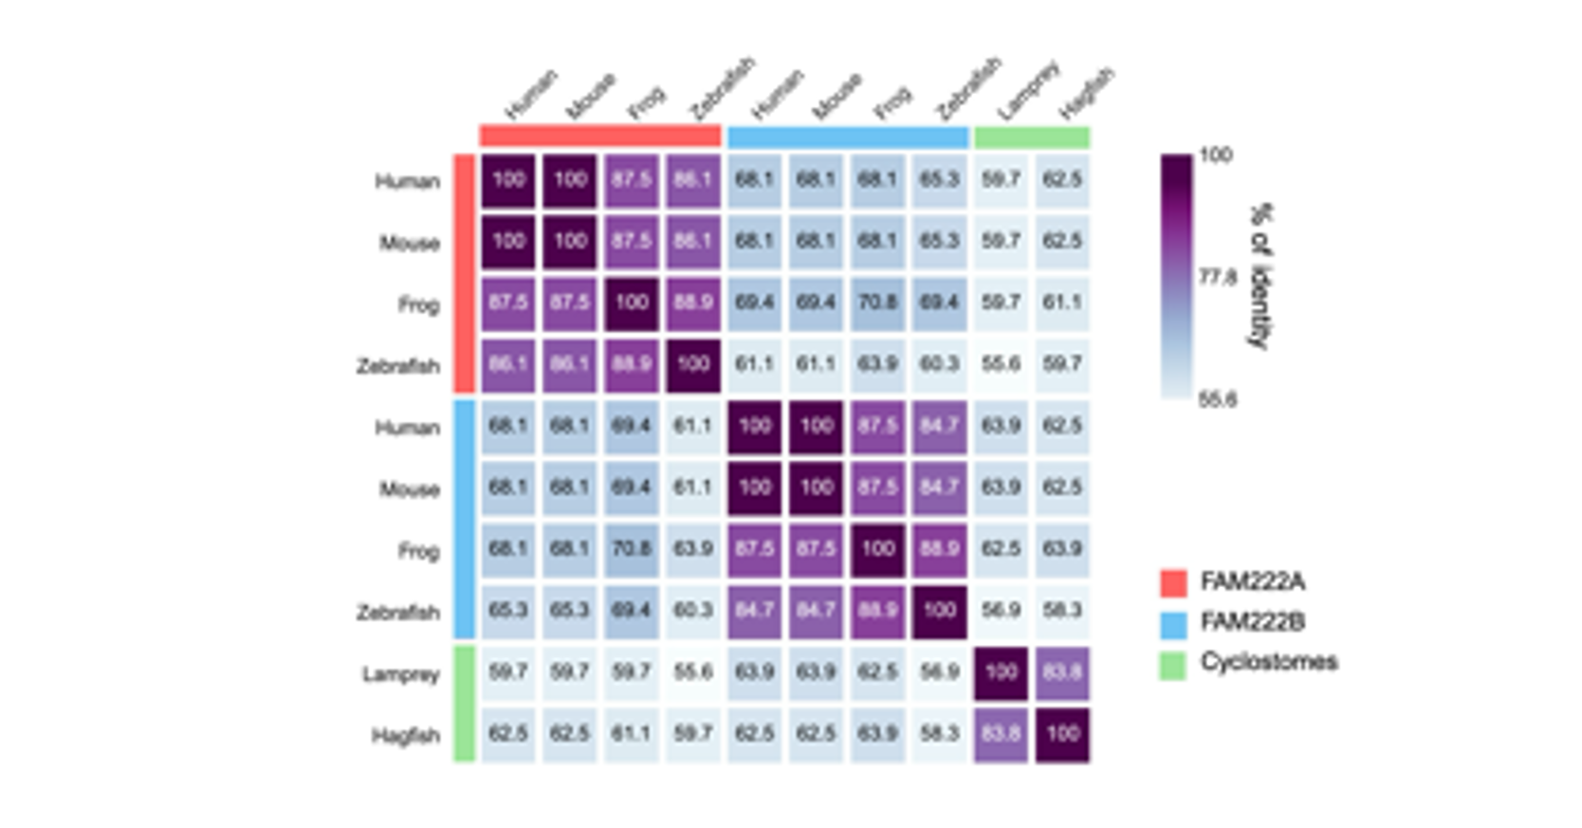
Supplementary Figure 2. Identity matrix of the DCD222 domain.
The identity matrix was derived from a MAFFT alignment of FAM222 protein sequences from human (Homo sapiens), mouse (Mus musculus), frog (Xenopus tropicalis), zebrafish (Danio rerio), lamprey (Petromyzon marinus), and hagfish (Myxine glutinosa).

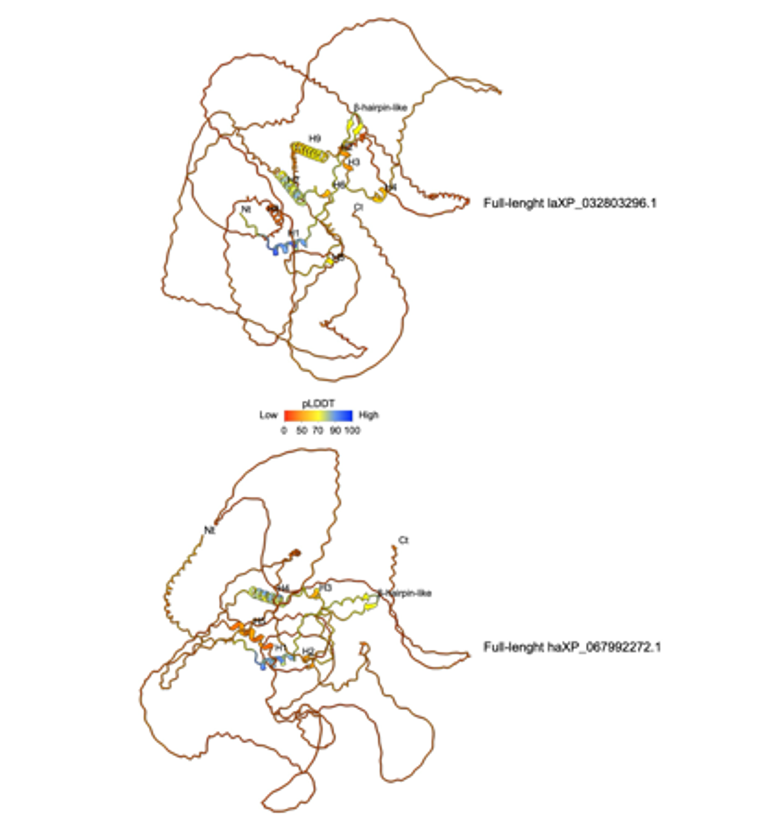

Supplementary Figure 3. Structural models of laXP and haXP proteins.
Structural models of laXP and haXP were generated using AlphaFold3 and visualized with ChimeraX. Each protein is colored based on its pLDDT confidence score.

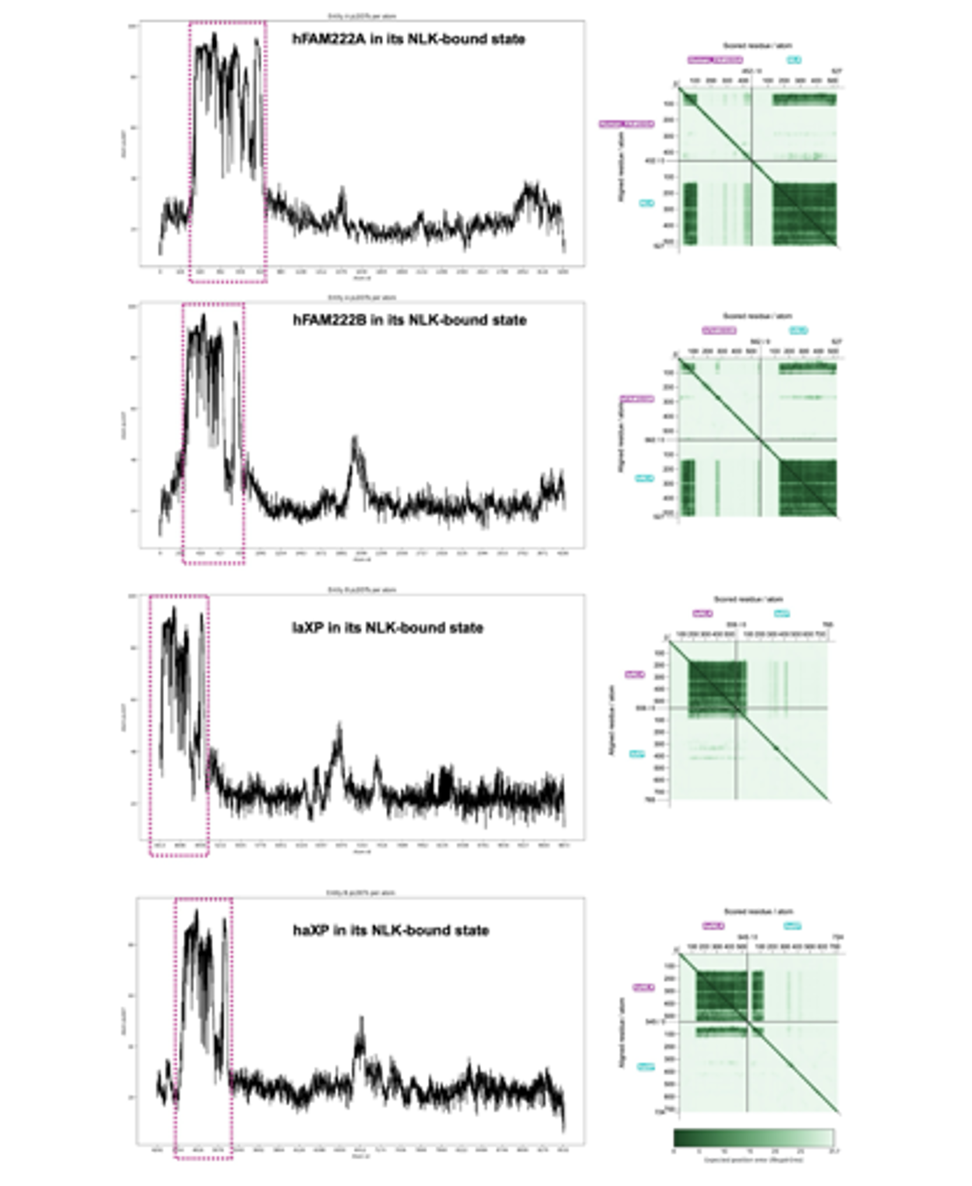
Supplementary Figure 4. pLDDT and PAE plots of FAM222 proteins bound to NLK
On the left, the pLDDT scores were extracted from mmCIF files of models predicted by AlphaFold3. The purple dashed boxes highlight the DCD222 domains of hFAM222A, hFAM222B, laXP, and haXP in bound state to NLK. On the right, the Predicted Aligned Error (PAE) matrices for the same complex are shown illustrating their interactions with NLK. Values near 0 Å indicate high confidence in the predicted spatial relationship between residues or domains.

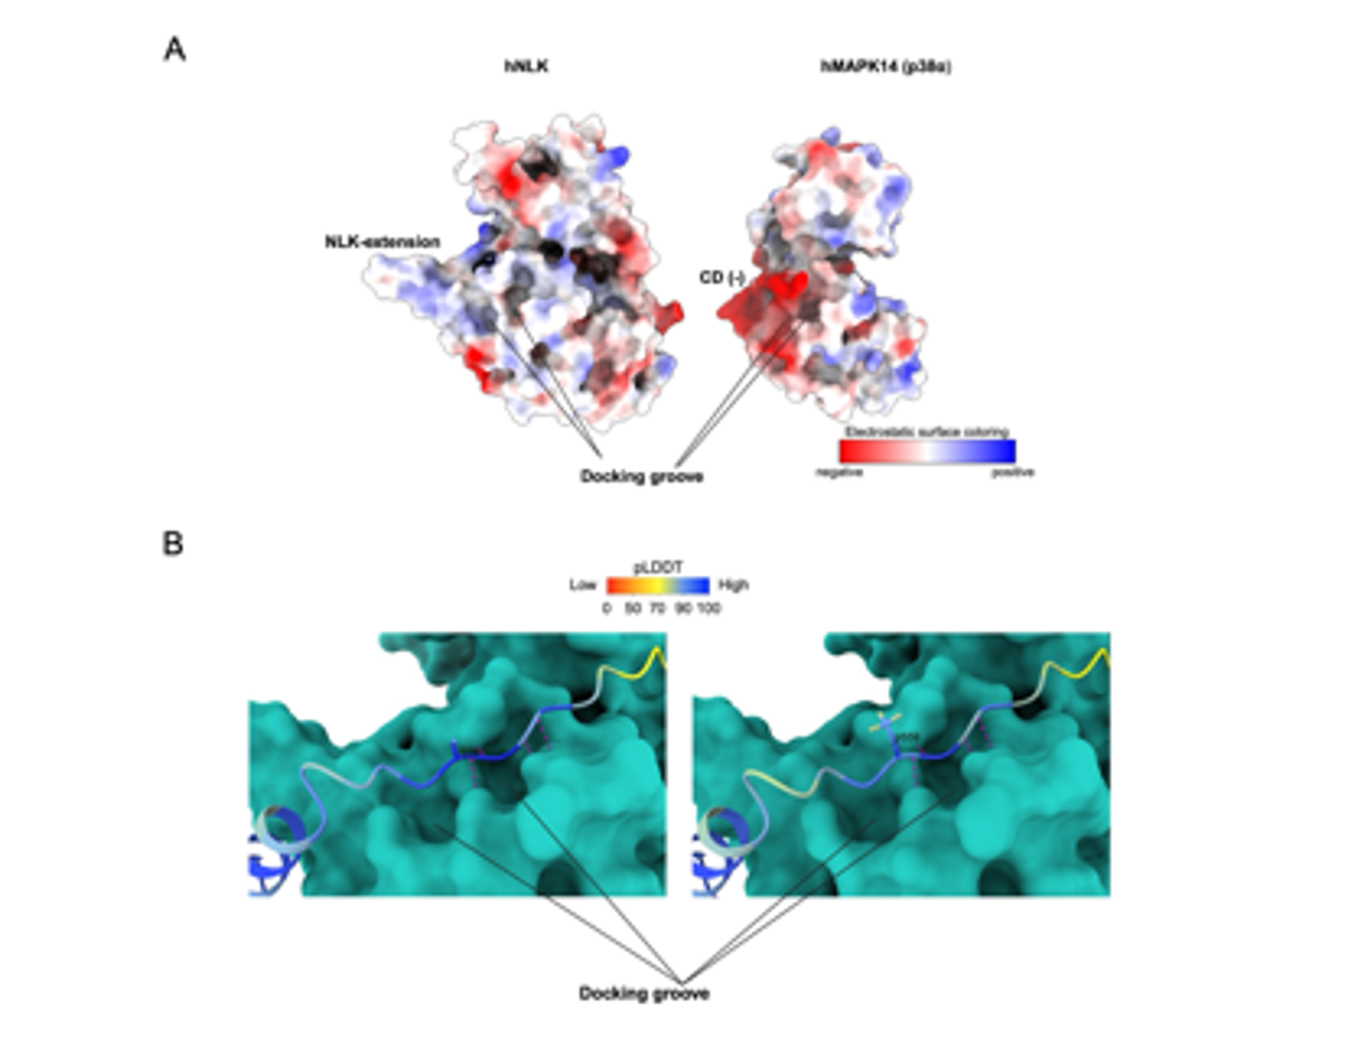
Supplementary Figure 5. Surface representation of hNLK.
A) The electrostatic surfaces of hNLK (Alphafold model from this study) and hMAPK14 (PDB:5ETA) are shown, highlighting negatively and positively charged regions. Although these two human MAPKs share significant structural similarities, NLK lacks the negatively charged common docking (CD) region adjacent to the docking groove, a feature unique to MAPKs. Instead, NLK possesses an alternative structural extension known as the “NLK extension.” B) The residue S59 within the revD-motif-like of DCD222, which does not interact with the docking groove of NLK through its side chain but rather through its peptide backbone, forming hydrogen bonds (depicted in pink). Upon phosphorylation of S59 (right panel), no significant changes are observed in the DCD222-NLK interaction.

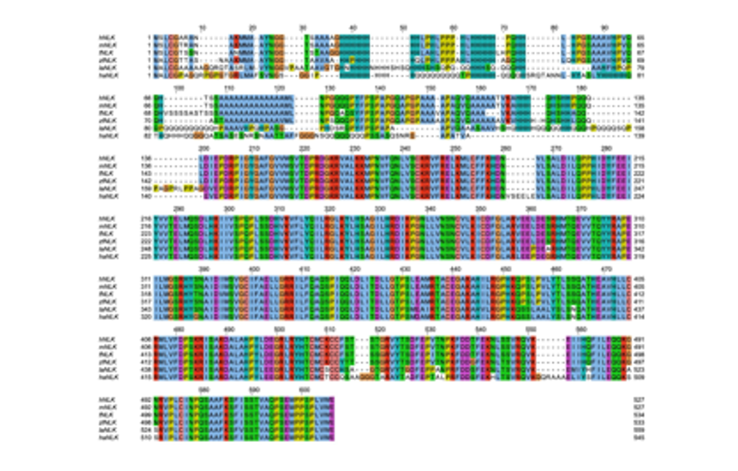
Supplementary Figure 6. Multiple sequence alignment (MSA) of Nemo-like kinase (NLK).
The MSA of full-length NLK protein sequences is presented, including human, mouse (Mus musculus), frog (Xenopus tropicalis), zebrafish (Danio rerio), lamprey (Petromyzon marinus), and hagfish (Myxine glutinosa). Sequence conservation across vertebrates is evident, particularly after position 200, which marks the beginning of the kinase domain. In this alignment, amino acids are shaded according to sequence conservation and chemical properties using Jalview: blue = hydrophobic residues, red = positively charged residues, magenta = negatively charged residues, green = polar residues, cyan = aromatic residues, pink = cysteines, orange = glycines, yellow = prolines, and white = non-conserved residues.

