Supplementary
Subset |  |  | Phenotype
NK cells |  |  | CD45+/CD3-/CD19-/CD16+CD56+
B cells |  |  | CD45+/CD3-/CD19+
 | Pre-germinal B cells |  | CD27-/IgM+/IgD++
 | Switched CD27- B cells |  | CD27-/IgM-/IgD-
 | Memory B cells |  | CD27+/CD38-
 |  | Switched MBC | IgM-/IgD-
 |  | Unswitched MBC | IgM+/IgD+
 |  | IgD MBC | IgM-/IgD+
 | Plasma cells |  | CD27+/CD38++
T cells |  |  | CD45+/CD3+/CD19-
 | CD4+ |  | CD4+/CD8-/TCRgd-
 |  | Naive CD4 | CD27+/CD45RA+
 |  | CM CD4 | CD27+/CD45RA-
 |  | EM CD4 | CD27-/CD45RA-
 |  | TD CD4 | CD27-/CD45RA+
 | CD8+ |  | CD4-/CD8+/TCRgd-
 |  | Naive CD8 | CD27+/CD45RA+
 |  | CM CD8 | CD27+/CD45RA-
 |  | EM CD8 | CD27-/CD45RA-
 |  | TD CD8 | CD27-/CD45RA+
 | Double negative T cells |  | CD4-/CD8-/TCRgd-
 | TCRgd |  | CD3+/TCRgd+
Supplementary Table 1. Immunophenotyping of lymphocyte subsets. Abbreviations: NK, natural killer; IgM, immunoglobulin M; IgD, immunoglobulin D; MBC, memory B cells; CM, central memory; EM, effector memory; TD, terminally differentiated; TCR, T cell receptor.

.

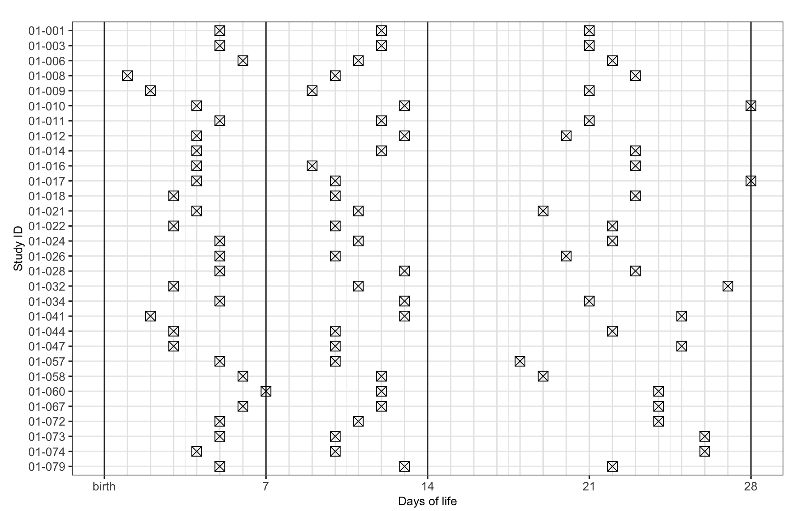
Supplementary figure 2. Samples.
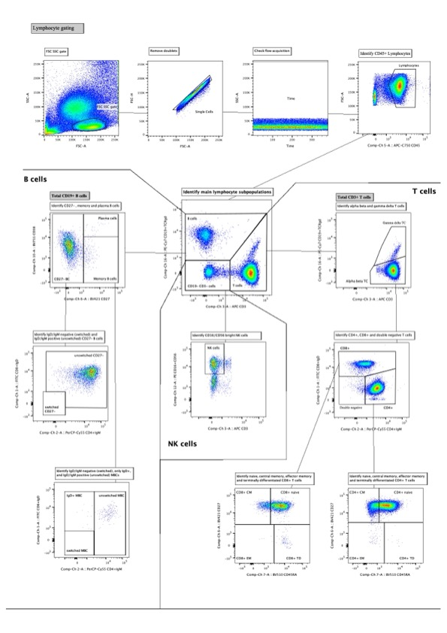
Supplementary figure 2. Lymphocyte gating. Abbreviations: FSC, forward scatter; SSC, side scatter; NK, natural killer.

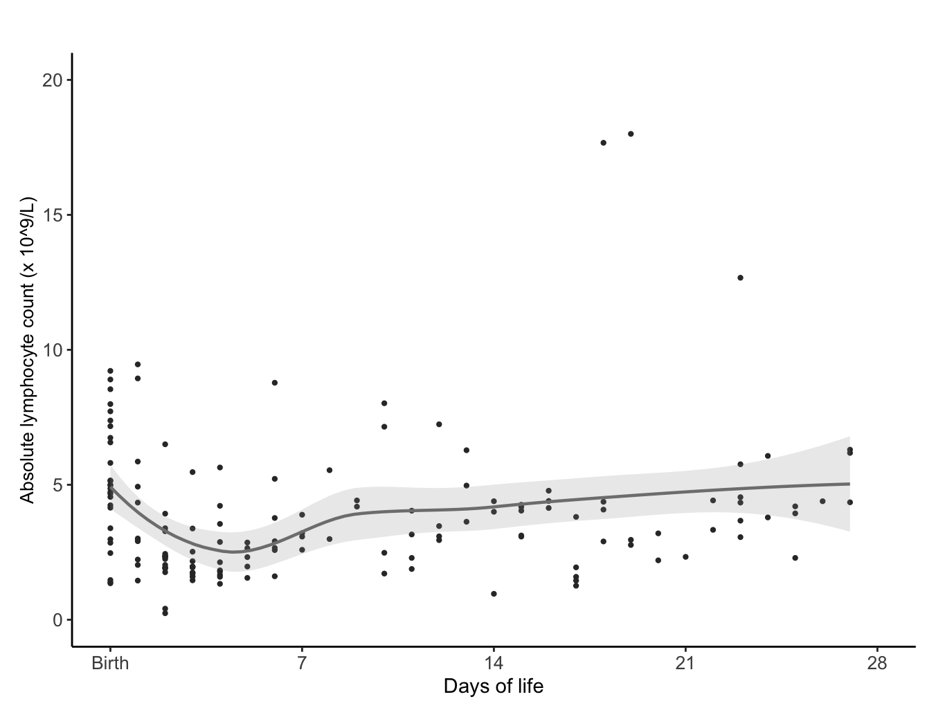Supplementary figure 3. Available data and trends in absolute lymp

