SUPPLEMENTARY

TABLE S1 Allele Frequencies of the SNPs in TUSEB and 1000 Genome Data Sets

SNP ID | Position | TÜSEB Frequency | 1000 Genome Frequency
rs10889664 | 67169792 | 0.35 | 0.323
rs11117433 | 85985910 | 0.108 | 0.104
rs12220700 | 62801746 | 0.412 | 0.261
rs12525170 | 31131984 | 0.11 | 0.093
rs1495965 | 67287825 | 0.485 | 0.534
rs1518110 | 206771516 | 0.711 | 0.426
rs1518111 | 206771300 | 0.712 | 0.427
rs1660760 | 52394860 | 0.389 | 0.608
rs17006292 | 121261187 | 0.011 | 0.048
rs17482078 | 96783162 | 0.107 | 0.101
rs17753641 | 159929885 | 0.053 | 0.028
rs17810546 | 159947262 | 0.073 | 0.040
rs1800871 | 206773289 | 0.706 | 0.435
rs1874886 | 160011868 | 0.328 | 0.321
rs2087726 | 46166818 | 0.661 | 0.652
rs2121033 | 43900916 | 0.296 | 0.315
rs2121034 | 43899730 | 0.294 | 0.314
rs2230801 | 89772751 | 0.09 | 0.064
rs224127 | 62701513 | 0.548 | 0.320
rs2442736 | 31378844 | 0.208 | 0.144
rs2617170 | 10408358 | 0.647 | 0.557
rs2848479 | 98216871 | 0.426 | 0.439
rs2848713 | 31416702 | 0.186 | 0.081
rs3024490 | 206771966 | 0.706 | 0.438
rs3783550 | 112775308 | 0.689 | 0.380
rs4896243 | 137193653 | 0.618 | 0.274
rs4947296 | 31090401 | 0.13 | 0.102
rs4959053 | 31131800 | 0.111 | 0.093
rs6660226 | 67278918 | 0.383 | 0.370
rs681343 | 48703205 | 0.492 | 0.322
rs7203487 | 85983088 | 0.859 | 0.102
rs7574070 | 191145762 | 0.575 | 0.506
rs7616215 | 46164194 | 0.661 | 0.652
rs76830965 | 159919889 | 0.053 | 0.028
rs7770216 | 31372834 | 0.29 | 0.315
rs79556279 | 31362069 | 0.16 | 0.05
rs897200 | 191153045 | 0.571 | 0.501
rs913678 | 50338887 | 0.381 | 0.395
rs924080 | 67294457 | 0.384 | 0.396
rs9260997 | 29995539 | 0.864 | 0.932
rs9266490 | 31372381 | 0.29 | 0.315
rs104895081 | 3254268 | 0.002 | 0.000199680511182109
rs104895085 | 3243529 | X | 0.000199680511182109
rs104895094 | 3243403 | 0.007 | 0.002
rs104895127 | 3254342 | X | 0.000199680511182109
rs61732874 | 3243257 | 0.004 | 0.002
rs4149584 | 6333477 | 0.012 | 0.006

FIGURES S1 Genealogy Trees
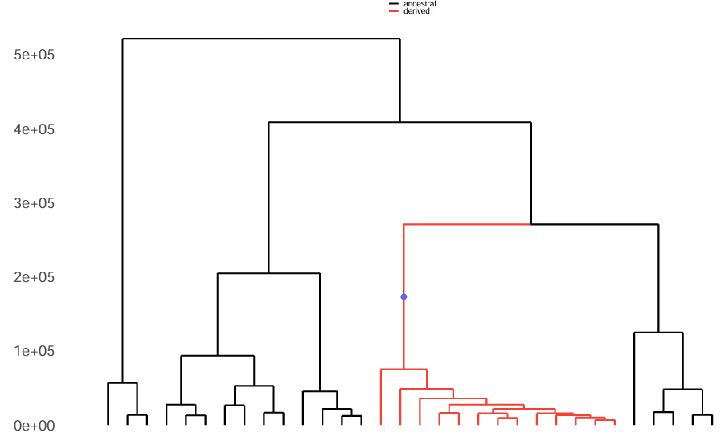
rs924080 – Modern Anatolia

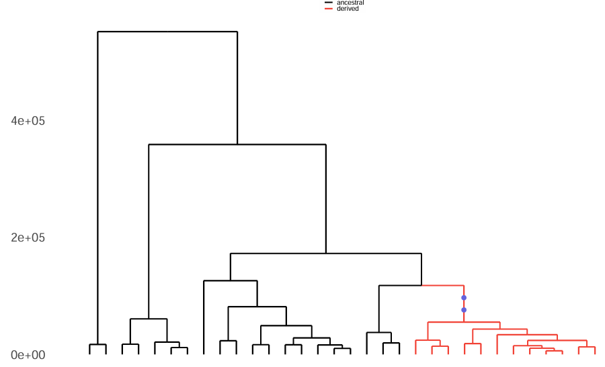
rs1495965 – Modern Anatolia
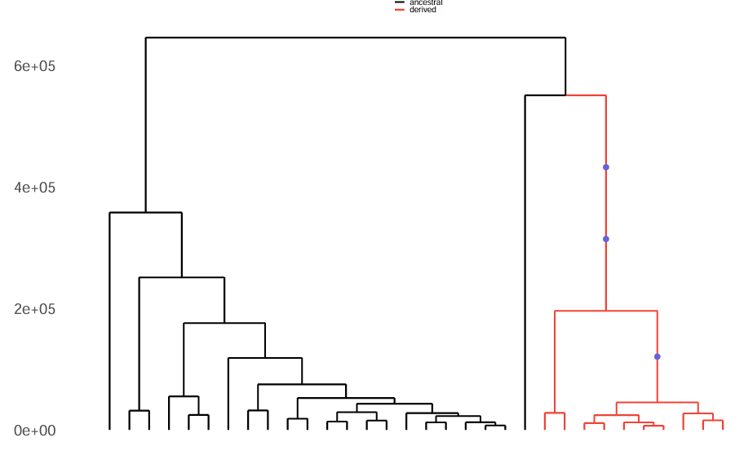
rs1518110 – Modern Anatolia

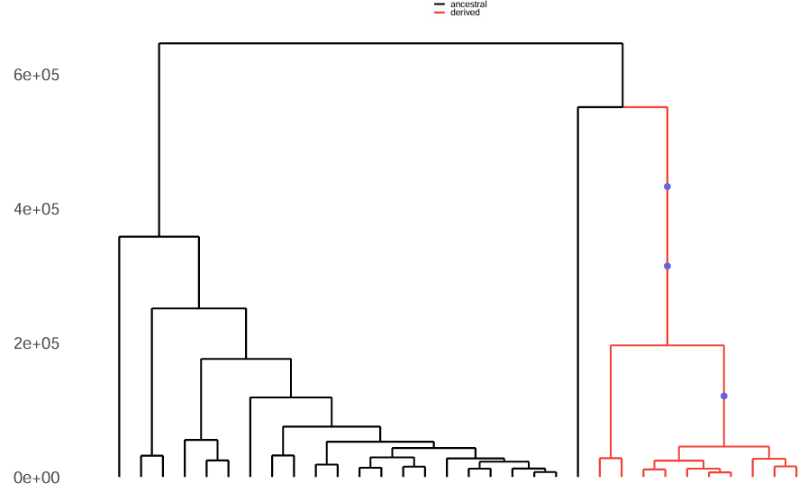
rs1518111 – Modern Anatolia

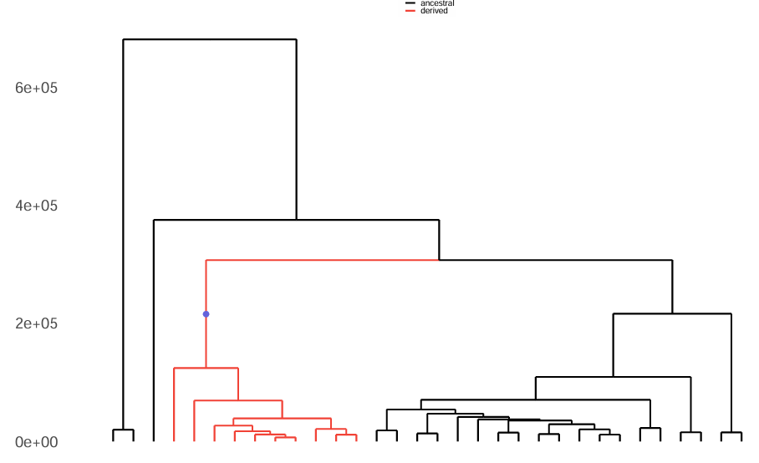
rs1800871 - Modern Anatolia

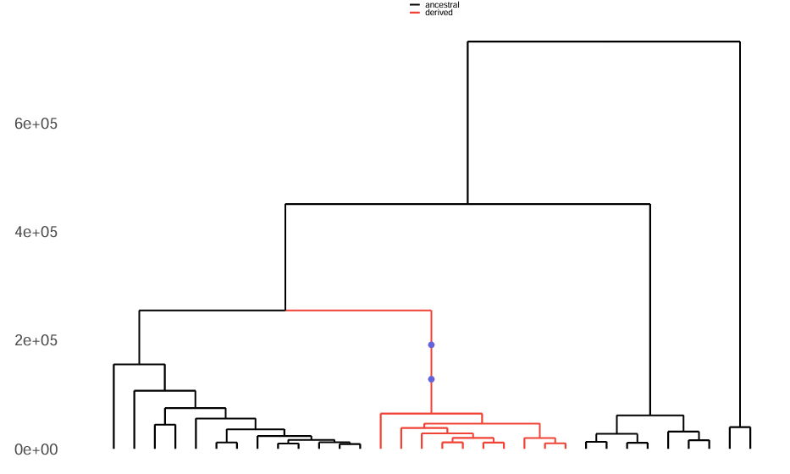
rs3024490 - Modern Anatolia
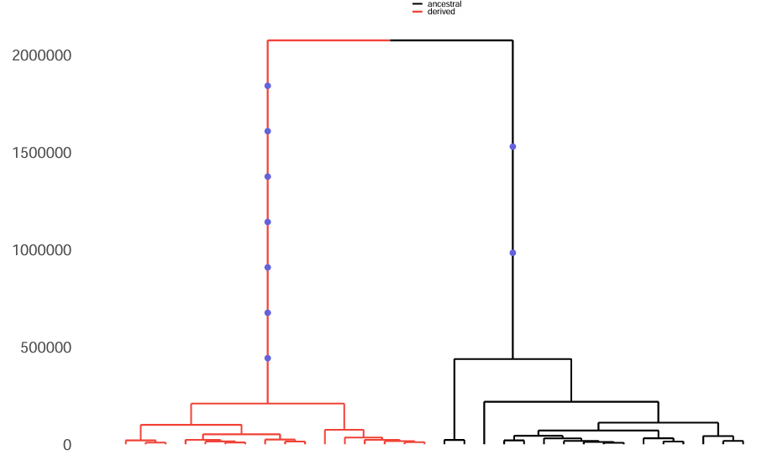
rs897200 - Modern Anatolia

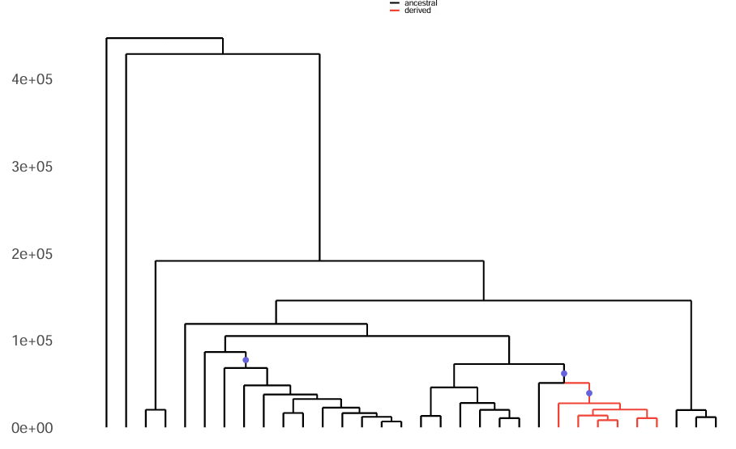
rs3783550 - Modern Anatolia

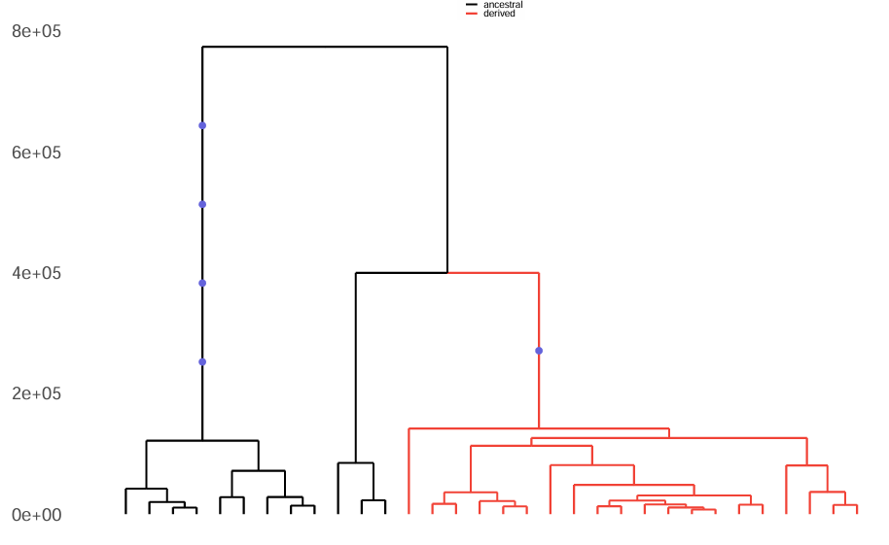
rs7574070 - Modern Anatolia

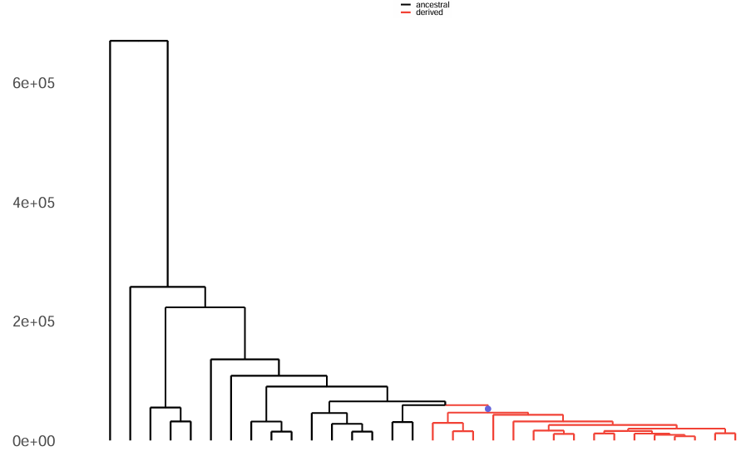
rs76830965 - Modern Anatolia

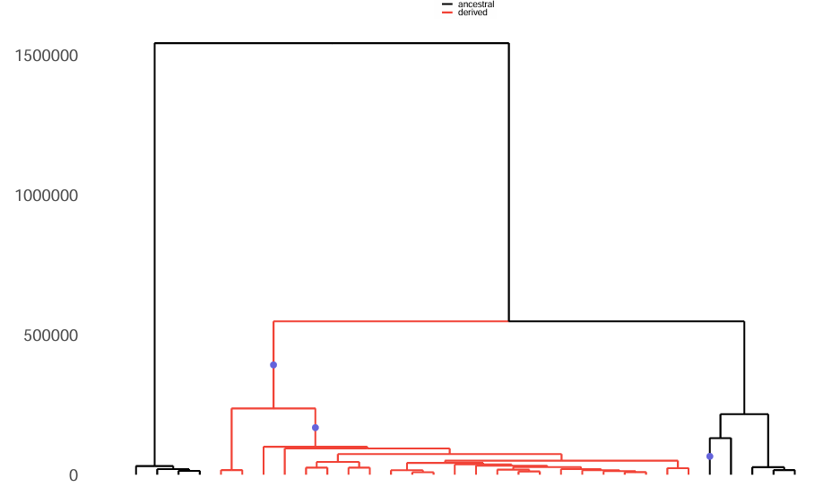
rs2442736 - Modern Anatolia

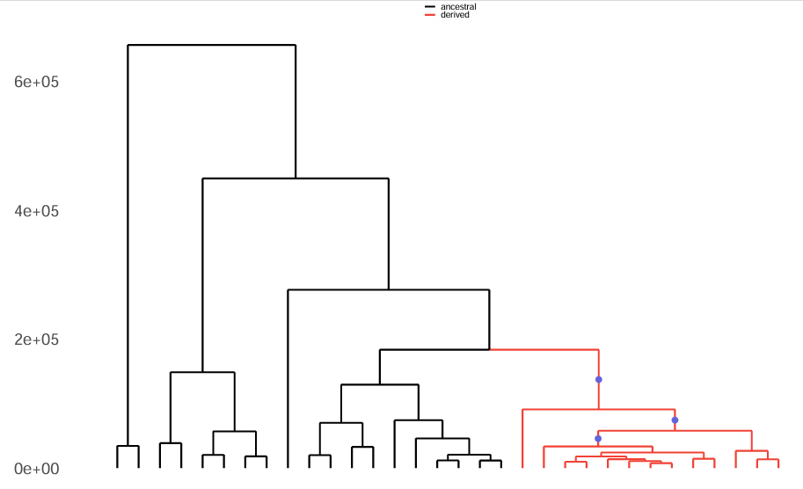
rs4896243 - Modern Anatolia

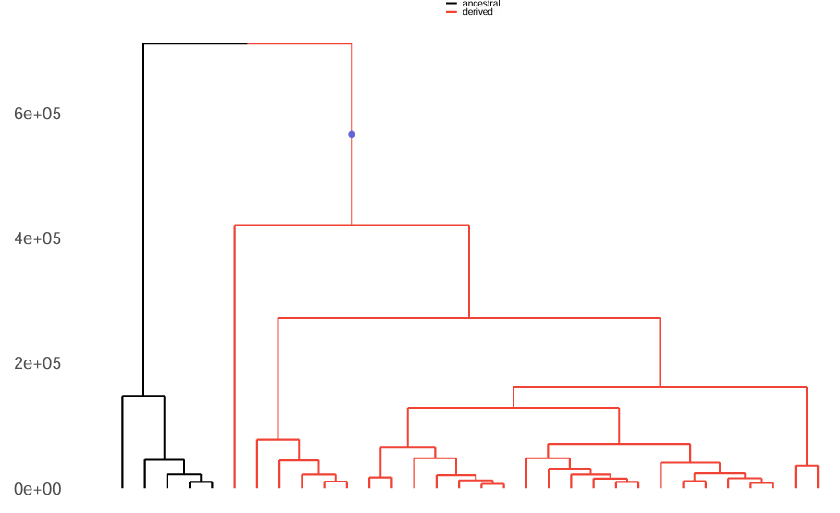
rs4959053 - Modern Anatolia

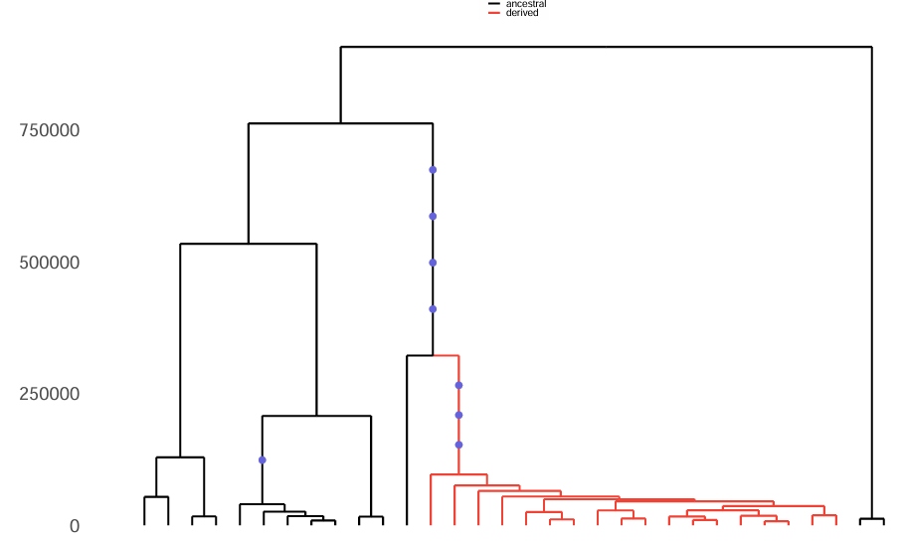
rs9266490 - Modern Anatolia

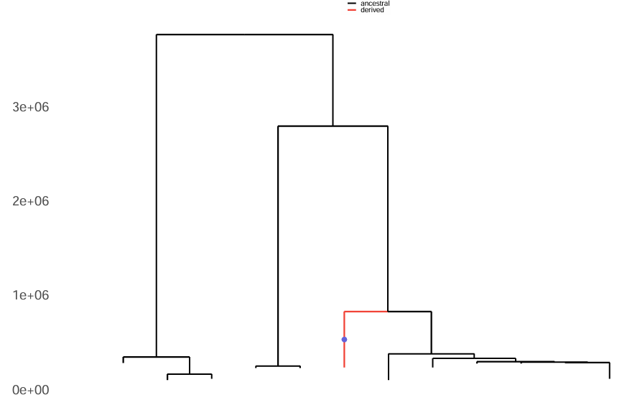
rs2230801 – Ancient Anatolia

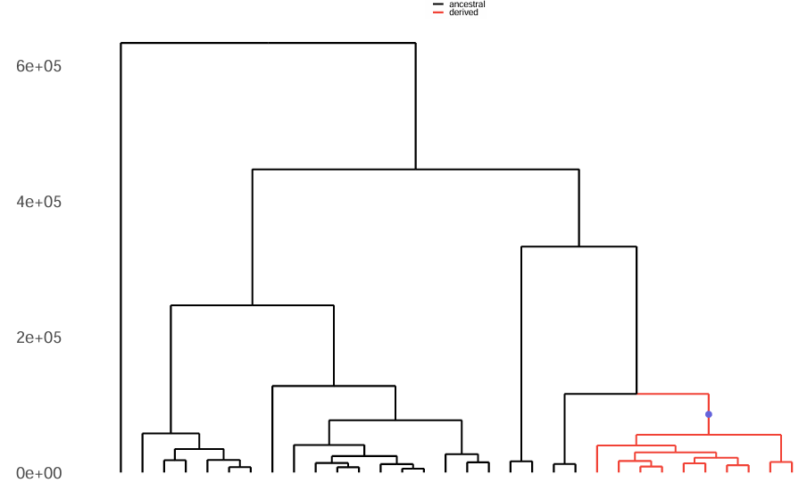
rs224127 - Modern Anatolia

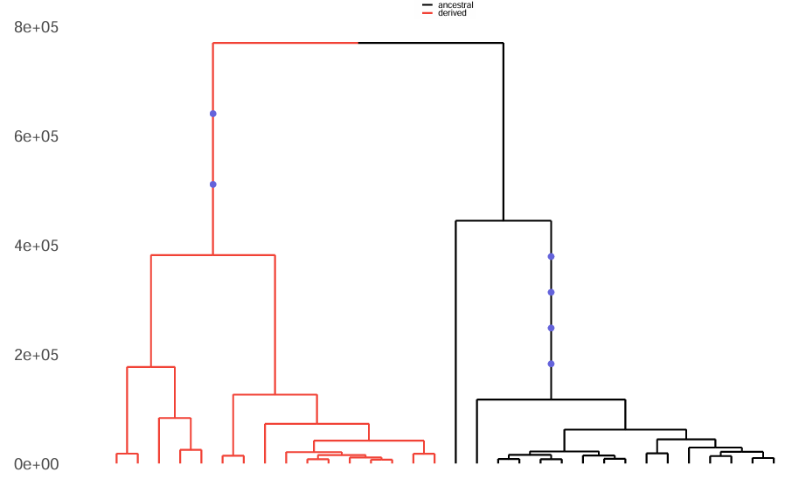
rs1660760 - Modern Anatolia

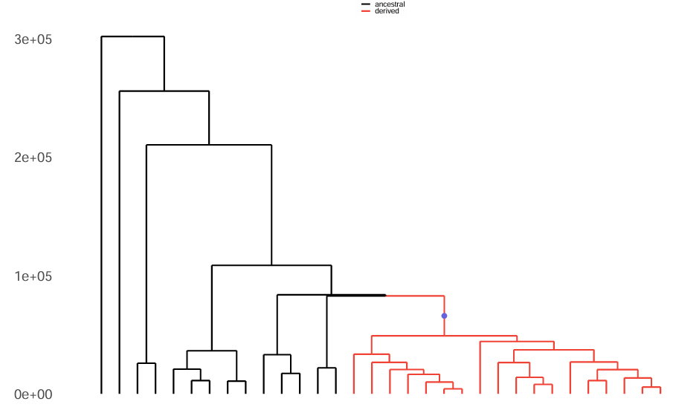
rs12220700 - Modern Anatolia

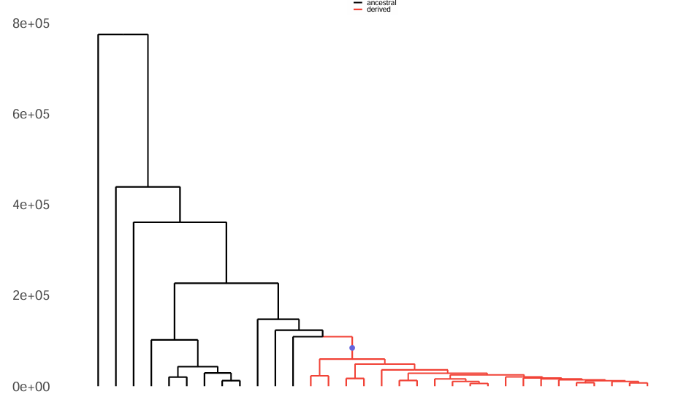
rs2848479 - Modern Anatolia

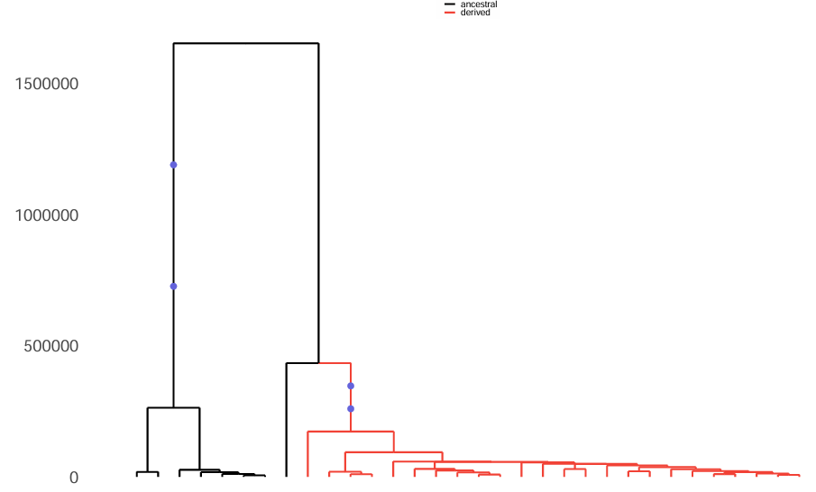
rs2617170 - Modern Anatolia

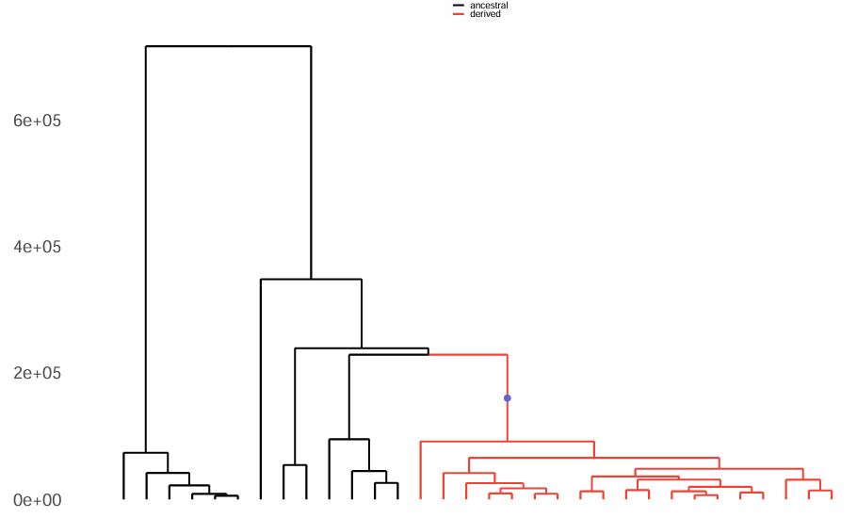
rs4149584 - Modern Anatolia

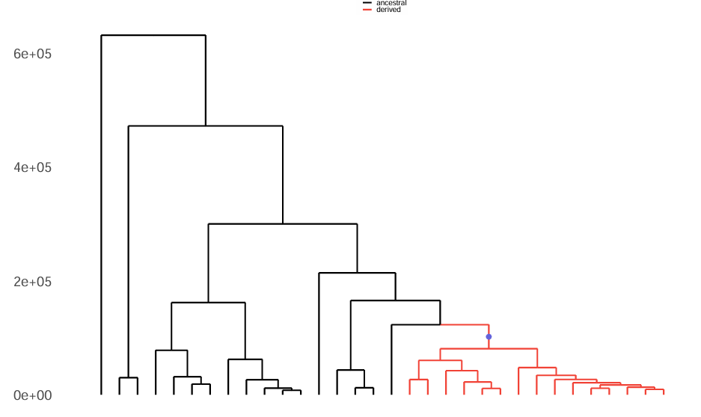
rs2121034 - Modern Anatolia

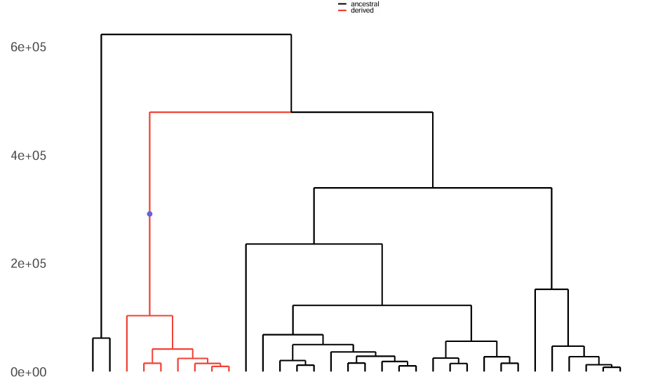
rs7203487 - Modern Anatolia

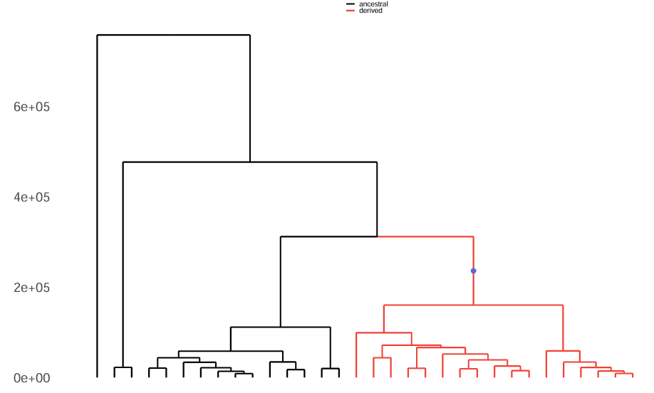
rs11117433 - Modern Anatolia

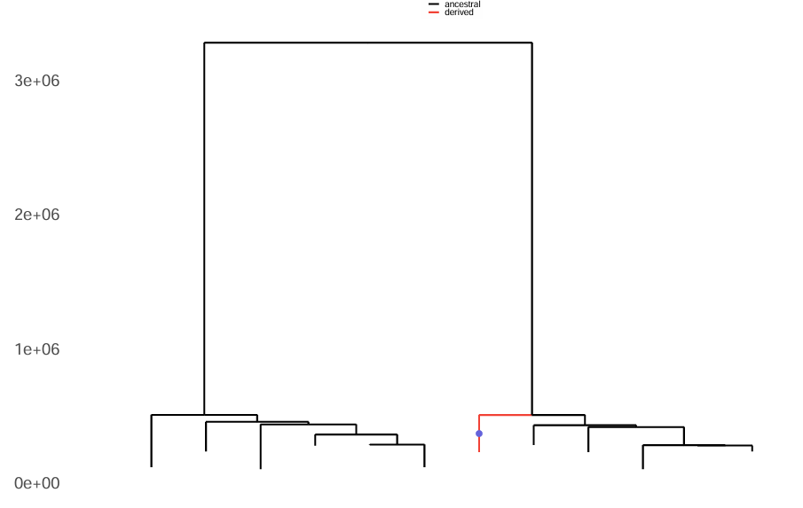
rs61732874 – Ancient Anatolia
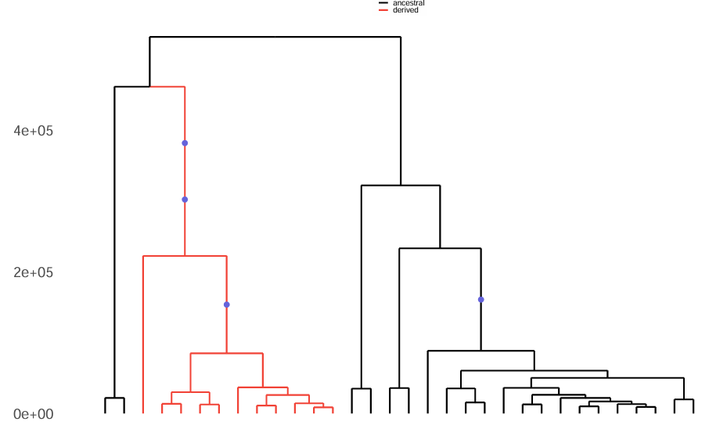
rs913678 – Modern Anatolia

