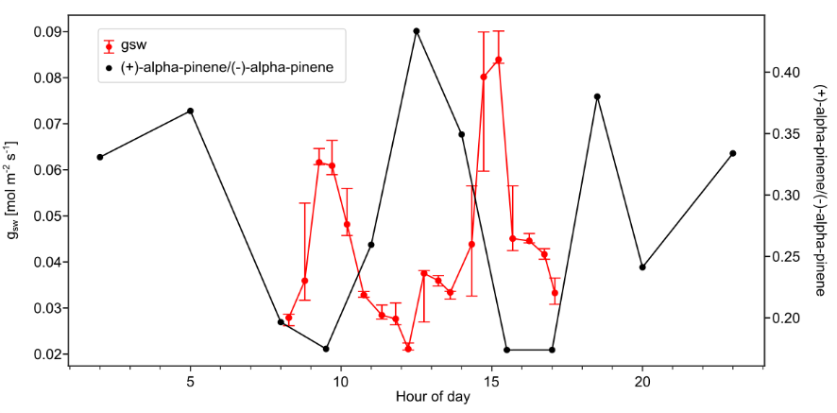
Extended Data Fig. 1 |Stomatal conductance generally peaked in the morning and afternoon during September 2023 reflecting the pattern seen for the ratio of (+)-alpha-pinene to (-)-alpha-pinene in October 2023. Combined stomatal conductance data for one leaf from 12 plant species around the 80 m walk-up tower measured at different times of day over 5 days from 15th September to 19th September 2023. The data was first smoothed with a moving median function and then averaged to every 30 minutes, the whiskers represent the 25th and 75th percentiles, see methods section for more detail. The (+)-alpha-pinene to (-)-alpha-pinene ratio data is the same as that showed in Fig. 2 and is the median of (+)-alpha-pinene to (-)-alpha-pinene mixing ratio for each measurement time.
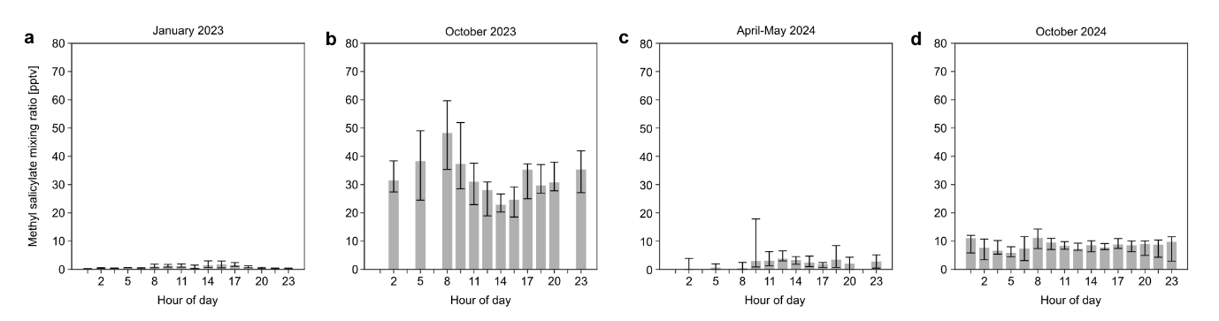
Extended Data Fig. 2 | Extreme abiotic stress during October 2023 causes increases in abundance of methyl salicylate. Diurnal cycles for each measurement period showing median mixing ratios for MeSA and the whiskers represent the 25th and 75th percentiles. e. January 2023. f. October 2023. g. April-May 2024. h. October 2024.
Extended Data Table 1. List of species from which stomatal conductance was measured and their leaf phenological types: BD = brevideciduous; EV = evergreen.
ID | Species | Leaf phenological type
27 | Manilkara bidentata | BD
37 | Cariniana decandra | BD
140 | Pouteria guianensis | BD
28 | Dinizia excelsa | EV
70 | Scleronema micranthum | EV
227 | Croton matourensis | EV
80 | Endopleura uchi | BD
96 | Peltogyne catingae | BD
189 | Brosimum parinarioides | BD
135 | Eschweilera cyathiformis | EV
160 | Protium spruceanum | EV
161 | Minquartia guianensis | EV

