Supplementary material

Table S1. Multiple linear regression models to estimate the climatic risk index of cocoa moniliasis occurrence (RICM) for the state of Bahia, Brazil, and their statistical performance, during the development and validation phases.
Month | Equation | F test | Development |  |  |  |  |  | Validation
Month | Equation | F test | R² | d | c | ME | MAE | CV | R² | d | c | ME | MAE | CV
January | RICM (%) = - 113.388 – 3.687 x Lat – 2.843 x Lon - 0.011 x Alt | 0.001 | 0.82 | 0.94 | 0.85 | -1.91 | 3.58 | 0.21 | 0.85 | 0.96 | 0.88 | -0.19 | 3.14 | 0.20
February | RICM (%) = - 84.012 – 2.214 x Lat – 2.605 x Lon – 0.016 x Alt | 0.001 | 0.74 | 0.88 | 0.76 | -1.87 | 3.39 | 0.15 | 0.63 | 0.88 | 0.69 | -0.06 | 4.56 | 0.16
March | RICM (%) = - 71.125 – 2.864 x Lat – 2.105 x Lon – 0.010 x Alt | 0.001 | 0.85 | 0.90 | 0.83 | -2.59 | 3.84 | 0.16 | 0.62 | 0.87 | 0.69 | -0.18 | 4.63 | 0.15
April | RICM (%) = 91.195 – 2.168 x Lat + 1.574 x Lon – 0.013 x Alt | 0.001 | 0.78 | 0.86 | 0.76 | -1.36 | 6.30 | 0.16 | 0.59 | 0.86 | 0.66 | -0.15 | 5.35 | 0.16
May | RICM (%) = 297.389 – 1.140 x Lat + 6.164 x Lon – 0.022 x Alt | 0.001 | 0.71 | 0.88 | 0.75 | 1.45 | 8.74 | 0.24 | 0.88 | 0.97 | 0.91 | -0.03 | 5.52 | 0.37
June | RICM (%) = 373.778 + 7.633 x Lon - 0.026 x Alt | 0.001 | 0.73 | 0.89 | 0.76 | 3.23 | 9.46 | 0.26 | 0.92 | 0.98 | 0.94 | -0.21 | 5.03 | 0.45
July | RICM (%) = 306.619 – 1.052 x Lat + 6.411 x Lon – 0.027 x Alt | 0.001 | 0.81 | 0.92 | 0.83 | 1.69 | 7.87 | 0.28 | 0.92 | 0.98 | 0.94 | 0.19 | 4.89 | 0.44
August | RICM (%) = 231.647 – 1.688 x Lat + 4.869 x Lon – 0.030 x Alt | 0.001 | 0.70 | 0.89 | 0.75 | 1.60 | 8.77 | 0.31 | 0.85 | 0.96 | 0.88 | 0.17 | 6.06 | 0.44
September | RICM (%) = 159.292 – 2.887 x Lat + 3.567 x Lon – 0.030 x Alt | 0.001 | 0.63 | 0.87 | 0.69 | 0.93 | 8.76 | 0.36 | 0.81 | 0.95 | 0.85 | -0.20 | 6.25 | 0.43
October | RICM (%) = 73.218 – 4.270 x Lat + 1.975 x Lon – 0.024 x Alt | 0.001 | 0.65 | 0.89 | 0.72 | -0.86 | 6.84 | 0.38 | 0.80 | 0.94 | 0.84 | -0.04 | 5.29 | 0.37
November | RICM (%) = - 18.438 – 5.414 x Lat – 0.013 x Alt | 0.001 | 0.83 | 0.95 | 0.87 | -0.50 | 4.00 | 0.32 | 0.82 | 0.95 | 0.86 | 0.04 | 4.51 | 0.26
December | RICM (%) = -118.358 – 5.414 x Lat – 2.464 x Lon – 0.009 x Alt | 0.001 | 0.89 | 0.97 | 0.91 | -1.49 | 3.13 | 0.29 | 0.91 | 0.98 | 0.93 | 0.15 | 2.92 | 0.23
Annual | RICM (%) = 92.018 – 2.774 Lat + 1.813 x Lon – 0.019 x Alt | 0.001 | 0.84 | 0.94 | 0.86 | -0.05 | 4.62 | 0.22 | 0.82 | 0.95 | 0.85 | 0.16 | 4.21 | 0.23
Lat = latitude, Lon = longitude and Alt = altitude.

Table S2. Nonparametric Pettitt's Test (p<0,05) for temperature (°C) and relative humidity, in 28 locations in the state of Bahia, Brazil.
Station | id | Temperature (1988-2018) |  |  | Relative Humidity (1988 - 2018)
Station | id | p-value | Alternative Hypothesis | Change Point Time | p-value | Alternative Hypothesis | Change Point Time
Itiruçu | 1 | <0.001 | two sided | 2002-10-15 | <0.001 | two sided | 1992-08-23
Itaberaba | 2 | <0.001 | two sided | 1997-09-06 | <0.001 | two sided | 1992-08-22
Irecê | 3 | <0.001 | two sided | 2007-10-10 | <0.001 | two sided | 2011-05-25
Guaratinga | 4 | <0.001 | two sided | 2007-10-17 | <0.001 | two sided | 2007-07-05
Feira de Santana | 5 | <0.001 | two sided | 2004-10-05 | <0.001 | two sided | 2005-09-19
Senhor do Bonfim | 6 | <0.001 | two sided | 2008-09-20 | <0.001 | two sided | 2011-08-01
Salvador | 7 | <0.001 | two sided | 1997-10-22 | <0.001 | two sided | 2005-07-30
Remanso | 8 | <0.001 | two sided | 2011-09-21 | <0.001 | two sided | 2011-06-03
Paulo Afonso | 9 | <0.001 | two sided | 1997-09-06 | <0.001 | two sided | 2011-09-28
Morro do Chapéu | 10 | <0.001 | two sided | 2007-10-10 | <0.001 | two sided | 2011-07-31
Monte Santo | 11 | <0.001 | two sided | 2008-09-21 | <0.001 | two sided | 2011-08-02
Lençóis | 12 | <0.001 | two sided | 1997-09-03 | <0.001 | two sided | 1992-07-29
Jacobina | 13 | <0.001 | two sided | 2007-10-10 | <0.001 | two sided | 2011-08-01
Ituaçu | 14 | <0.001 | two sided | 1997-09-03 | <0.001 | two sided | 1992-07-28
Cruz das Almas | 15 | <0.001 | two sided | 2002-10-21 | <0.001 | two sided | 2005-08-23
Correntina | 16 | <0.001 | two sided | 1997-09-03 | <0.001 | two sided | 1997-06-22
Cipó | 17 | <0.001 | two sided | 2004-10-03 | <0.001 | two sided | 1992-09-25
Cariranha | 18 | <0.001 | two sided | 2012-01-20 | <0.001 | two sided | 2011-05-25
Caravelas | 19 | <0.001 | two sided | 1997-10-20 | <0.001 | two sided | 1994-08-04
Canavieiras | 20 | <0.001 | two sided | 1997-10-29 | <0.001 | two sided | 2000-06-22
Caetité | 21 | <0.001 | two sided | 2009-08-18 | <0.001 | two sided | 2011-06-03
Bom Jesus da Lapa | 22 | <0.001 | two sided | 2012-01-05 | <0.001 | two sided | 2011-05-24
Barreiras | 23 | <0.001 | two sided | 1997-09-03 | <0.001 | two sided | 2011-04-25
Barra | 24 | <0.001 | two sided | 2011-09-21 | <0.001 | two sided | 2011-05-25
Alagoinhas | 25 | <0.001 | two sided | 2004-10-18 | <0.001 | two sided | 2005-09-19
Serrinha | 26 | <0.001 | two sided | 2004-10-03 | <0.001 | two sided | 2007-09-11
Santa Rita de Cássia | 27 | <0.001 | two sided | 2009-08-18 | <0.001 | two sided | 2011-05-20
Vitória da Conquista | 28 | <0.001 | two sided | 2002-10-02 | <0.001 | two sided | 2007-07-15

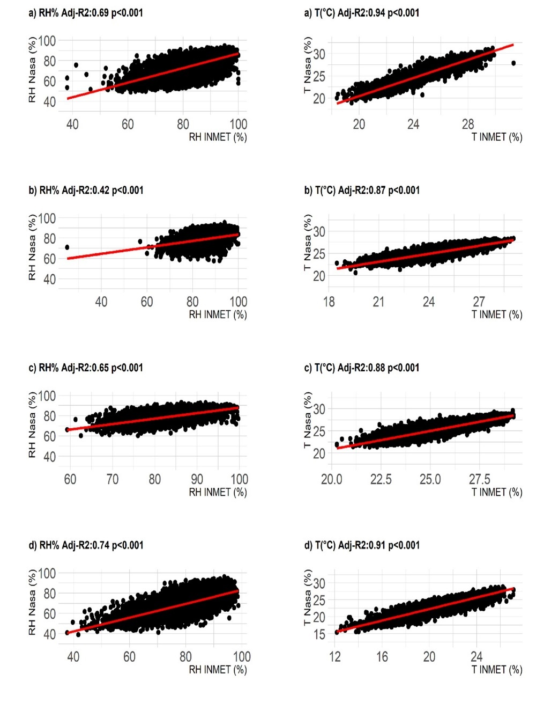

Fig. S1 Relationship between observed (INMET) and gridded (NASA POWER) data for temperature (T) and relative humidity (RH) in four sites in the state of Bahia, Brazil: a) Feira de Santana; b) Canavieiras; c) Salvador; and d) Vitória da Conquista.

Fig. S2 Monthly risk index of cocoa moniliasis occurrence (RICM) for 28 locations in the state of Bahia, Brazil.
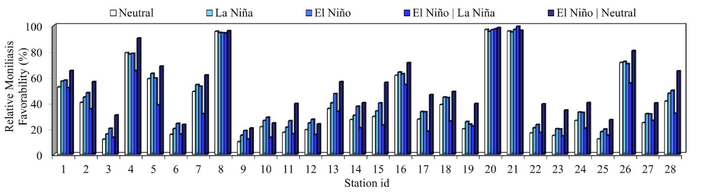
Fig. S3. Percentage of favorable days to the occurrence of cocoa moniliasis (FCMO %) for each phase of El Niño Southern Oscillation (ENSO) for 28 locations in the state of Bahia, Brazil

