Supplementary Information
The 21st Century Climate Responses to China's Clean Air Actions
Authors: Xiaodong Zhang^{1,&}, Xiaohu Jian^{1,5,&} Bo Fu¹, Jianmin Ma^{1,}, Thomas Gasser^{2,3,}, Xinrui Liu^{1,2}, Shu Tao¹, Junfeng Liu¹, Tao Huang⁴, Hong Gao⁴, Yuan Zhao⁴
Affiliations:
¹ Laboratory for Earth Surface Processes, College of Urban and Environmental Sciences, Peking University, Beijing 100871, PR China
² The International Institute for Applied Systems Analysis (IIASA), Laxenburg, Austria
³ Laboratoire des Sciences du Climat et de l’Environnement (LSCE), IPSL, CEA/CNRS/UVSQ, Université Paris-Saclay, Gif-sur-Yvette, France
⁴ Key Laboratory for Environmental Pollution Prediction and Control, Gansu Province, College of Earth and Environmental Sciences, Lanzhou University, Lanzhou 730000, PR China
⁵ PowerChina Zhongnan Engineering Corporation Limited, Changsha 410014, PR China

Corresponding author: Jianmin Ma (jmma@pku.edu.cn); Thomas Gasser (gasser@iiasa.ac.at)
& These authors contributed equally to this work

This file contains:
2 Supplementary Texts
2 Supplementary Tables
16 Supplementary Figures

Supplementary Texts
Supplementary Text 1. RF trends under DPEC pathways
In the case of CO₂ (Supplementary Fig. 6a), the RF_CO₂ under the Baseline and Clean air scenarios (black and red solid lines) do not differ significantly, showing a continuous upward trend from 2020-2060, growing from 0.242±0.034 W m⁻² in 2020 to 0.649±0.090 W m⁻² in 2060. Since CO₂ emission (Supplementary Fig. 9a) in the Early scenario will reach the peak in 2025 and close to zero in 2060, the RF_CO₂ under the Early scenario (blue solid line) is 0.292±0.040 W m⁻² in 2025, reaching the peak growth rate. From 2025-2050, the growth rate of RF_CO₂ slows down and modeled RF_CO₂ reaches 0.400±0.056 W m⁻² in 2050 and decline to 0.386±0.053 W m⁻² by 2060, consistent with projected CO₂ emission (Supplementary Fig. 9a). Under the Peak scenario (solid green line), after the carbon peak in 2030, the CO₂ emission remains relatively stable and falls after 2040 with its RF_CO₂ growing from 0.242±0.034 W m⁻² to 0.435±0.060 W m⁻² in 2040 and 0.572±0.079 W m⁻² in 2060, respectively, indicating that this scenario fails to achieve the carbon neutrality. Since CO₂ emission in the Zero scenario will reach the peak in 2030 and become zero in 2060 (Supplementary Fig. 9a), the RF_CO₂ will keep growing and reaching 0.343±0.047 W m⁻² in 2030. From 2030 to 2050, the growth rate of RF_CO₂ will slow down and reach 0.447±0.061 W m⁻² in 2050. After 2050, RF_CO₂ will drop to 0.428±0.059 W m⁻² by 2060, suggesting that carbon neutrality is achieved between 2050-2055 (Supplementary Fig. 6a).
RF_O_{3t} (Supplementary Fig. 6b) is associated with NO_{x} and VOC emissions (Supplementary Figs. 9c and 9d). In the Baseline scenario, the NO_{x} emissions will increase from 2020 to 2030 and reach a peak of 8.53 TgN yr⁻¹ in 2030 and decline to 7.42 TgN yr⁻¹ by 2060 (Supplementary Fig. 9c). As a result, the RF_O_{3t} under the Baseline scenario will rise to 0.106±0.012 W m⁻² from 2020 to 2030 and drop to 0.097±0.011 W m⁻² from 2030 to 2060, in line with the temporal trend of NO_{x} emissions. The RF_O_{3t} in the other four scenarios illustrate falling trends from 2020 to 2060. Of these trends, the clean scenario yields the slowest rate of decrease during this period, dropping by 0.064±0.008 W m⁻² by 2060, corresponding to NO_{x} emissions that will decline on an annual basis from 2020 onward, reaching 4.75 TgN yr⁻¹ by 2060 (Supplementary Fig. 9c). The most rapid decrease of RF_O_{3t} occurs in the Early and Zero scenarios, under which the RF_O_{3t} will decline on an annual basis throughout 2020 to 2060 and drop to 0.021±0.002 W m⁻² by 2060, in line the fastest decline of NO_{x} emission that will dive to 0.95 TgN yr⁻¹ by 2060 (Supplementary Fig. 9c). The annual fluctuations of RF_BC (Supplementary Fig. 6c) are similar to RF_O_{3t}. All five scenarios yield declining trends with the different falling rate, determined, to a significant extent, by projected BC emissions (Supplementary Fig. 9f). The slowest rate of decline occurs in the Baseline scenario, in which the RF_BC will drop to 0.053±0.009 W m⁻² by 2060, corresponding to the slowly declining BC emissions from 1.00 Tg yr⁻¹ in 2020 to 0.94 Tg yr⁻¹ by 2060. The fastest rate of decline can be identified in the Early and Zero scenarios, in which the RF_BC will decrease to 0.011±0.002 W m⁻² by 2060, corresponding to the falling BC emissions at 0.07 Tg yr⁻¹ by 2060 (Supplementary Fig. 9f). Differing from RF_O_{3t} and RF_BC, RF_N₂O exhibits a rising trend under all five model scenarios (Supplementary Fig 6d). The N₂O is associated with CO₂ and NO_{x} emissions and the RF_N₂O can be affected by many chemical and physical processes. Given its very small values compared to the other compounds, the effect of the RF_N₂O on summed RF is tiny and hence almost negligible.
Among the four negative aerosol forcers, the change in RF_SO₄ (Supplementary Fig. 6e) from 2020 to 2060 is also determined by projected SO₂ emissions (Supplementary Fig. 9b). In the Baseline scenario, SO₂ emissions will increase to 4.17 TgS yr⁻¹ in 2030, leading to a falling RF_SO₄ at -0.028±0.004 W m⁻² during 2020-2030. However, from 2030-2060, along with decreasing SO₂ emission by 3.67 TgS yr⁻¹ in 2060, the negative RF_SO₄ will increases to -0.025±0.004 W m⁻². The Clean scenario projects a rising negative RF_SO₄ at -0.020±0.003 W m⁻², corresponding to the SO₂ emission decline at 2.69 TgS yr⁻¹ by 2060. Like RF of other compounds, the Early and Zero scenarios predict the same lowest RF_SO₄ at -0.006±0.0001 W m⁻² by 2060, though with somewhat different rate of increase, in line with more rapidly decreasing SO₂ emission to 0.49 TgS yr⁻¹ by 2060 (Supplementary Fig. 9b). The RF of the other three aerosol species, RF_NO₃, RF_POA, and RF_SOA, exhibit the similar trends subject to the five scenarios from 2020 to 2060, driven largely by projected NH₃, OC, and VOC emissions (Supplementary Figs. 9h, 9g, and 9d), respectively. The future emission scenarios of these substances have been used to simulate the corresponding changes in the RF of NO₃, POA, and SOA.
Under the five scenarios, the same CH₄ emissions were adopted (Supplementary Fig. 7a). As shown, CH₄ emissions will decline slowly from 2020 to 2030 and reach 58.92 TgC yr⁻¹ in 2030 and decline rapidly thereafter to 31.79 TgC yr⁻¹ by 2060 (Supplementary Fig. 7a). Accordingly, RF_CH₄ will increase from 2020 to 2030 and reach a peak of 0.101±0.012W m⁻² in 2030 (Supplementary Fig. 7b). The slow decline in CH₄ emissions has reduced the growth rate of RF_CH₄ to zero. From 2030 to 2060, RF_CH₄ will drop to 0.080±0.009 W m⁻², in line with the temporal trend of CH₄ emissions (Supplementary Fig. 7a and 7b). The annual changes in the net RF summed over the nine climate components from 2020 to 2060 (Supplementary Fig. 8) is almost identical to the RF_CO₂ (Supplementary Fig. 6a), manifesting that RF_CO₂ still dominate the future trend of the RF induced by projected emissions of GHGs and aerosol species.

Supplementary Text 2. Summed RF_CO₂ and RF_SO₄ subject to CAA
The Clean scenario yields strongest RFs, followed by the Baseline and Early scenarios, respectively, and the RF_CAA values are greater than RF_noCAA values subject to all three scenarios, suggesting stronger warming (Supplementary Fig. 10). A comparison between RF_CAA and RF_noCAA under the Baseline scenario reveals that RF_CAA (solid gray line) increases from 0.216±0.011 W m⁻² in 2020 to 0.623±0.028 W m⁻² in 2060 and RF_noCAA increases from 0.053±0.015 W m⁻² in 2020 to 0.471±0.030 W m⁻² in 2060, 24.4% lower than the RF_CAA (Supplementary Fig. 10a).
In the Clean scenario, RF_CAA (red solid line) increases from 0.216±0.011 W m⁻² in 2020 to 0.629±0.028 W m⁻² in 2060. RF_noCAA (red dashed line) increases from 0.053±0.015 W m⁻² in 2020 to 0.472±0.030 W m⁻² in 2060, 25.03% lower than the RF_CAA (Supplementary Fig. 10b). The similarities of RF_CAA values between the Baseline and Clean scenarios are attributed to similar projected CO₂ emissions in the two scenarios (Supplementary Fig. 9a). The Early scenario projects the lowest RF values subject to the CAA and noCAA scenarios due to the lower SO₂ emissions (Supplementary Fig. 9b). Under this scenario, the RF_CAA (blue solid line) increases from 0.216±0.011 W m⁻² in 2020 to 0.380±0.017 W m⁻² in 2060 (Supplementary Fig. 10c). If we define the percentage change between RF_SO_{4_}CAA (or RF_SO_{4_}noCAA) and RF_CO₂ as the cooling effect, represents the magnitude of the radiative forcing due to sulfate aerosols relative to that due to carbon dioxide, estimated by RF_SO_{4_}k / RF_CO₂ × 100%, k=CAA, noCAA. The RF_SO_{4_}CAA imposes a cooling effect by 6.56% from 2020-2060 and the RF_SO_{4_}noCAA yields the cooling effect by 51.01% during the same period for the Baseline scenario. Likewise, the cooling effects induced by noCAA under the Clean and Early scenarios are 51.00% and 59.75%, considerably greater than the cooling effect of the RF_CAA at 5.65% and 4.16% from 2020-2060.
The changes in RF_SO₄ under the CAA and noCAA subject to the DPEC Peak and Zero emission scenarios are depicted in Supplementary Fig. 10d-10e. In the Peak scenario, RF_CAA (solid green line) increases from 0.216±0.011 W m⁻² in 2020 to 0.557±0.025 W m⁻² in 2060, yielding stronger RF than the RF_noCAA (dashed green line). The latter extends from 0.053±0.015 W m⁻² in 2020 to 0.395±0.027 W m⁻² in 2060. As a result, the cooling effect of the RF_SO_{4_}CAA at 5.01% is one order of magnitude smaller than the RF_SO_{4_}noCAA with 53.25% from 2020 to 2060 (Supplementary Fig. 10d). The Zero scenario also projects stronger RF in the CAA scenario with the RF_CAA (solid purple line) ranging from 0.216±0.011 W m⁻² in 2020 to 0.423±0.019 W m⁻² in 2060, as compared to the noCAA with the RF_noCAA (dashed pink line) extending from 0.053±0.015 W m⁻² in 2020 to 0.251±0.021 W m⁻² in 2060. Again, under these two pathways, the RF_SO_{4_}CAA exerts a weaker cooing effect at 4.42% than the RF_SO_{4_}noCAA with the cooling effect of 56.56% (Supplementary Fig. 10e). Compared to the Peak scenario, the growing trend of both RF_CAA and RF_noCAA slows down and even decreases from 2050, consistent with the RF_CO₂ trend (Supplementary Fig. 6a). Supplementary Fig. 10f highlights the RF_SO₄ under the noCAA pathway, which is a typical case of the cooling effect due to remarkable decline in the DPEC projected SO₂ emissions. With projected falling raw coal production and rising GDP and electricity generation due to social and economic development and technique progresses driven by China's "dual carbon" targets and the promotion of energy transition, SO₂ emissions will start to decline after 2030. The MRM predicted SO₂ emissions (Supplementary Fig. 10f) fitted by the MRM model (Methods) tends to rise from 33.28±3.87 TgS yr⁻¹ in 2020 to 40.19±4.37 TgS yr⁻¹ in 2030, and rapidly drops to 31.03±4.21 TgS yr⁻¹ in 2060. As a result, the RF_SO₄ subject to noCAA will decrease from -0.190±0.010 W m⁻² in 2020 to -0.229±0.012 W m⁻² in 2030, meaning the increasing cooling effect, and rapidly increase thereafter to -0.177±0.009 W m⁻² in 2060. Differing from CO₂ whose past emissions also contribute to present-day RF larger due to its much longer lifetime, the SO₄ RF has no accumulative effect. This can be also demonstrated by the statistically significant negative correlation between SO₂ emissions and RF_SO₄ (Supplementary Fig. 10f).

Supplementary Figures

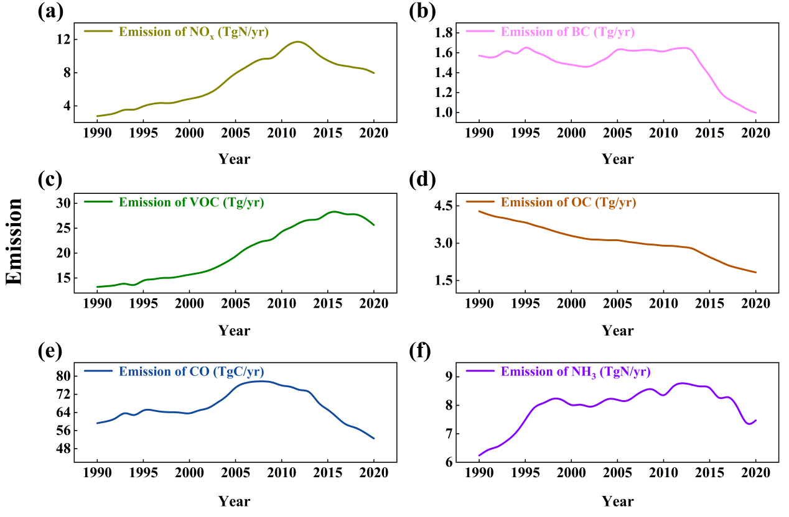

Supplementary Figure 1. Annual emissions of six climate forcers in China from 1990 to 2020 under the baseline (CAA) scenario. (a) NO_{x}, (b) BC, (c) NMVOC, (d) OC, (e) CO, (f) NH₃. Emission data is collected from the MEIC inventory (Multi-resolution Emission Inventory for China, http://meicmodel.org.cn/?page_id=560).

Supplementary Figure 2. Annual emissions of CH₄ in China from 1990 to 2020. Emission data is collected from the Community Emissions Data System (CEDS, https://zenodo.org/records/14145000).

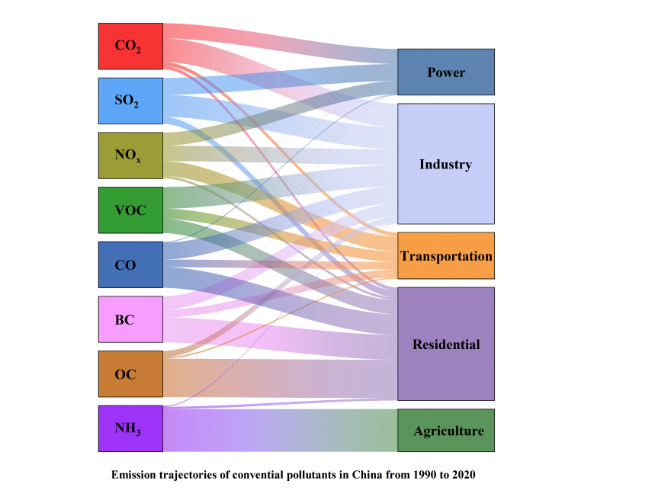

Supplementary Figure 3. Sector emissions from five major sources, including power, industry, transportation, residential, and agriculture, contributing to emission in each of the eight climate forcers. The wide of shaded belts indicates the magnitude of contribution from each sector to emission.

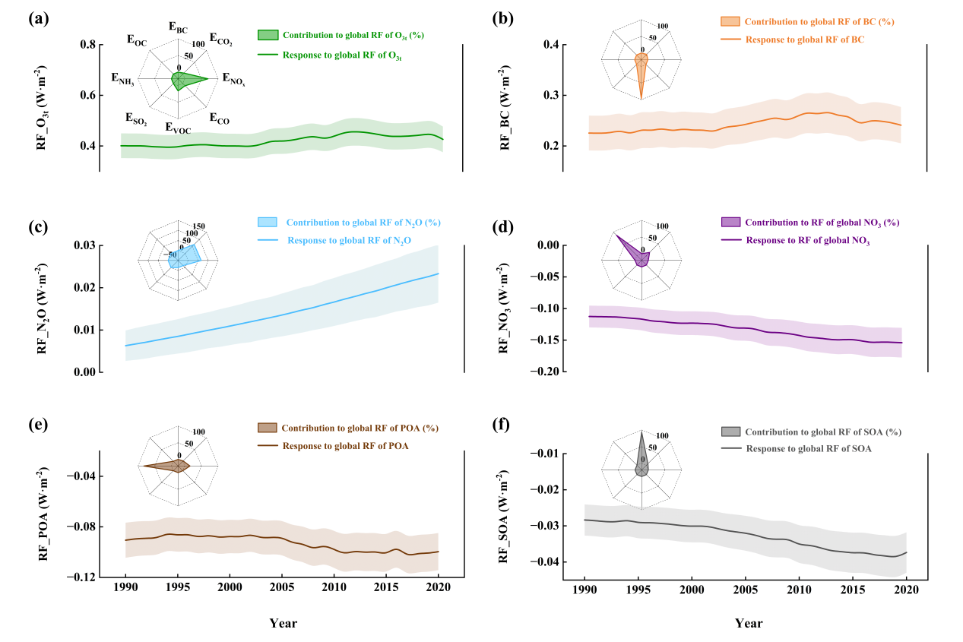

Supplementary Figure 4. Annual global radiative forcing (W m⁻²) from 1990 to 2020. (a) O_{3t}, (b) BC, (c) N₂O, (d) NO₃, (e) POA, (f) SOA. Radar plots represent the contribution of emission from each climate forcer to its RF from 1990 to 2020, and shading indicates the uncertainty interval estimated by Monte Carlo simulations.

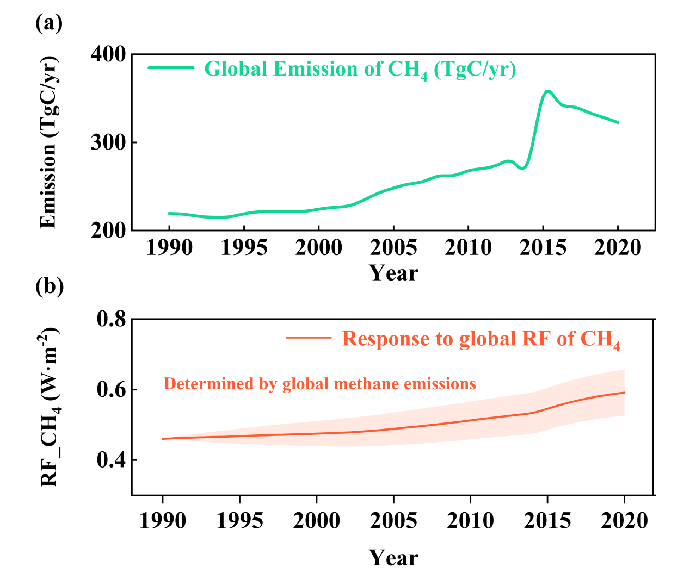

Supplementary Figure 5. Annual global emission and radiative forcing (W m⁻²) of CH₄ from 1990 to 2020. (a) emission, (b) RF. Shading represents the uncertainty interval estimated by Monte Carlo simulations.

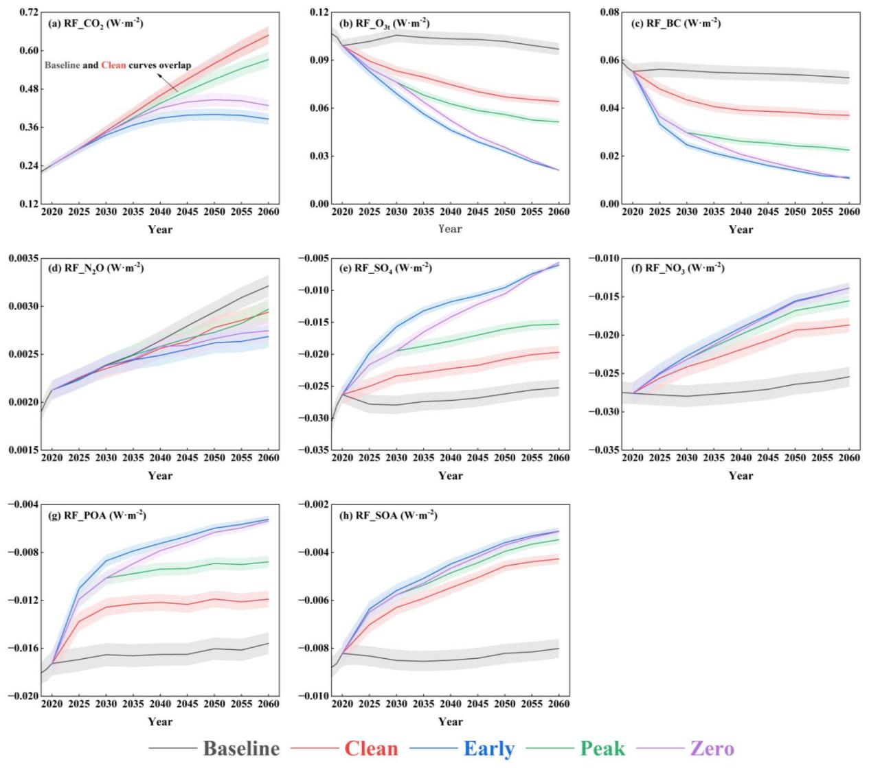

Supplementary Figure 6. Time evolution of RF (W m⁻²) of each eight GHG and aerosol species subject to five future DPEC scenarios. (a) RF_CO₂, (b) RF_O_{3t}, (c) RF_BC, (d) RF_N₂O, (e) RF_SO₄, (f) RF_NO₃, (g), RF_POA, (h) RF_SOA. The RF in Baseline scenario is denoted by solid black line, solid red line for Clean scenario, solid blue line for Early scenario, solid green line for Peak scenario, and solid purple line for Zero scenario, respectively. The shading indicates the uncertainty interval estimated by Monte Carlo simulations.

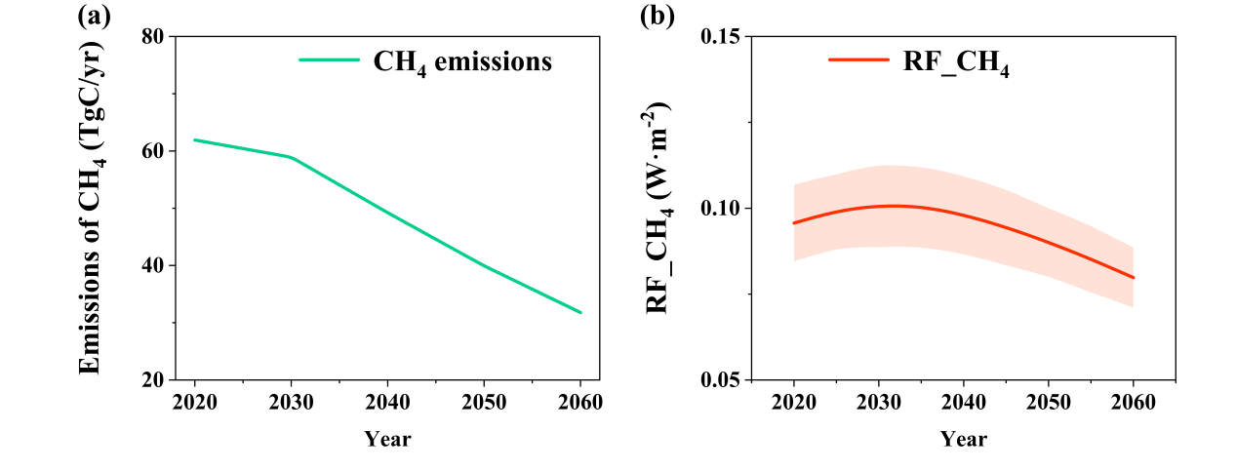

Supplementary Figure 7. Time evolution of CH₄ emission and RF (W m⁻²) from 2020 to 2060. (a) emission, (b) RF. The shading indicates the uncertainty interval estimated by Monte Carlo simulations.

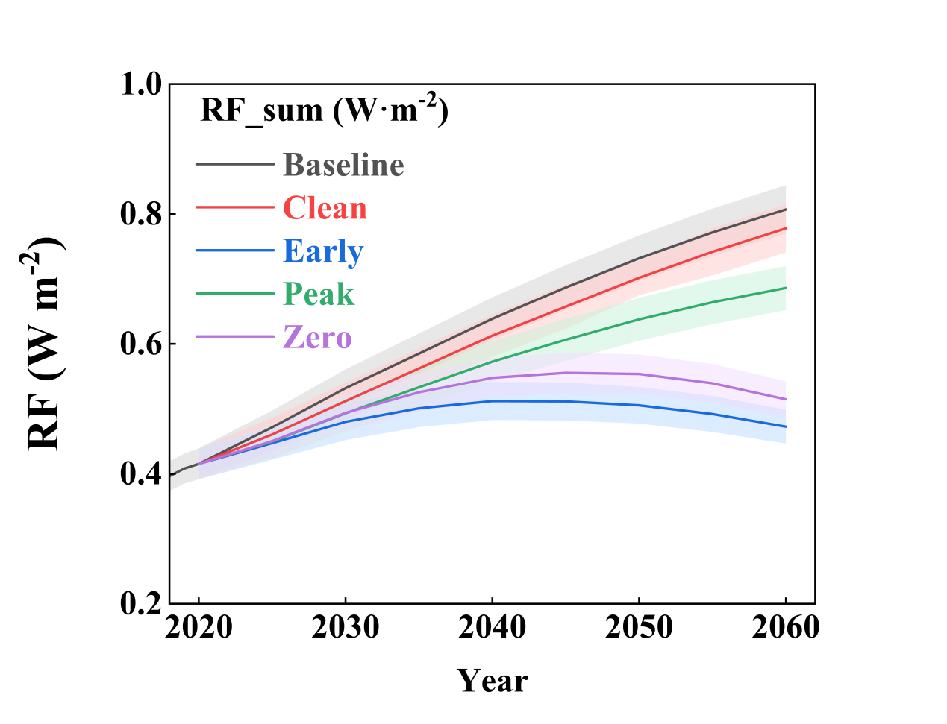

Supplementary Figure 8. Summed RF (W m⁻²) of nine species subject to five future DPEC scenarios from 2020 to 2060. The RF in Baseline scenario is denoted by solid black line, solid red line for Clean scenario, solid blue line for Early scenario, solid green line for Peak scenario, and solid purple line for Zero scenario, respectively. The shading indicates the uncertainty interval estimated by Monte Carlo simulations.

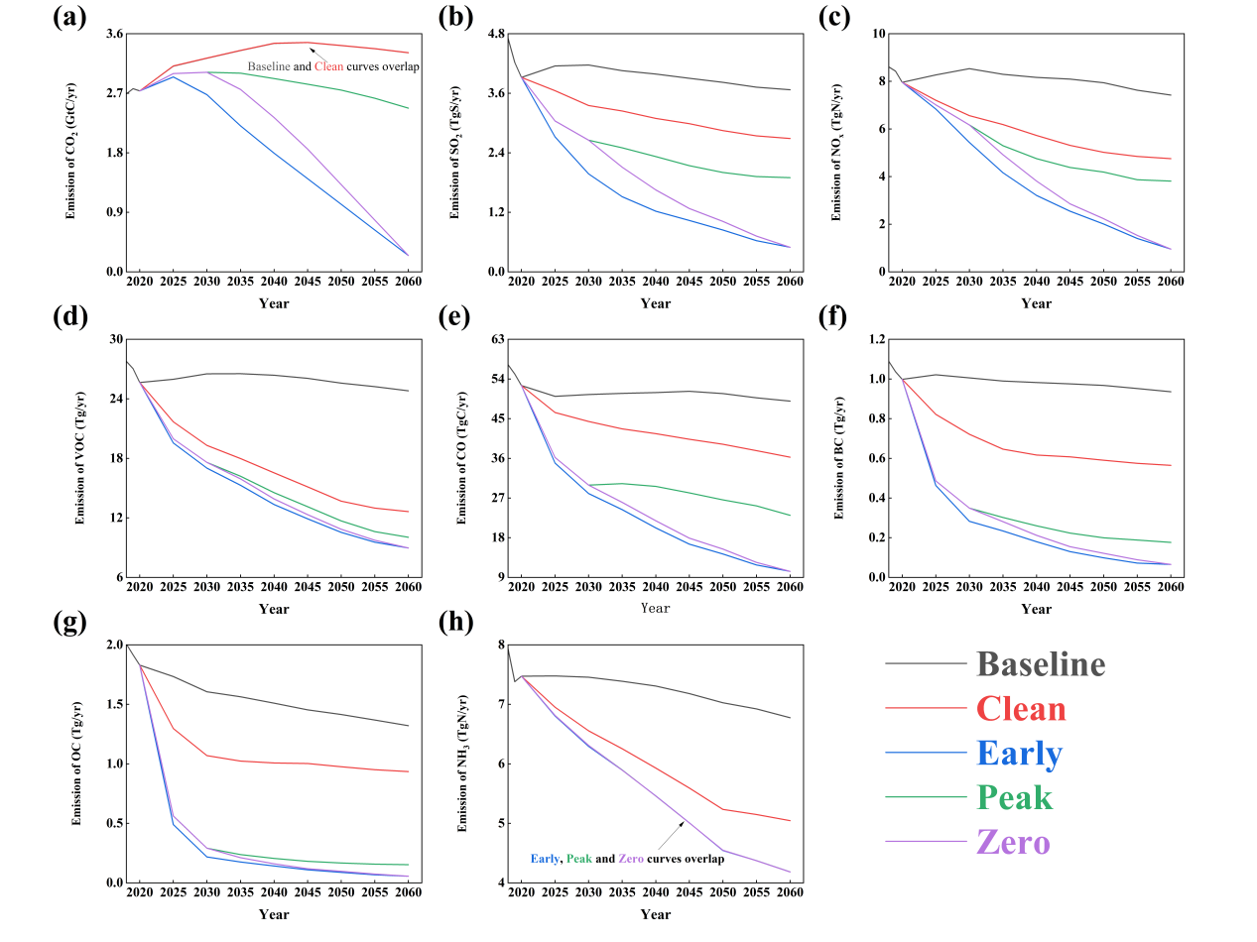

Supplementary Figure 9. Annual emissions of eight climate forcers under five DPEC pathways from 2020 to 2060 based on China’s carbon peak by 2030 and carbon neutrality by 2060. (a) CO₂, (b) SO₂, (c) NO_{x}, (d) NMVOC, (e) CO, (f) BC, (g) OC, (h) NH₃.

Supplementary Figure 10. Time evolution RF_CO₂ and RF_SO₄ (W m⁻²) under CAA and noCAA scenarios subject to five DPEC future pathways from 2020 to 2060. (a) summered RF_SO₄ and RF_CO₂ subject to CAA (solid black line) and noCAA (dashed black line) subject to Baseline scenario from 2020 to 2060; (b) the same as Supplementary Fig. 10a but for Clean scenario; (c) the same as Supplementary Fig. 10a but for Early scenario; (d) the same as Supplementary Fig. 10a but for Peak scenario; (e) the same as Supplementary Fig. 10a but for Zero scenario; (f) SO₂ emissions (Emission_SO_{2_}noCAA, dashed purple line) scaled on the right Y-axis, and RF_SO₄ (RF_SO_{4_}noCAA, solid red line) subject to noCAA, scaled on the left Y-axis. Shadings represent the uncertainty interval estimated by Monte Carlo simulations.

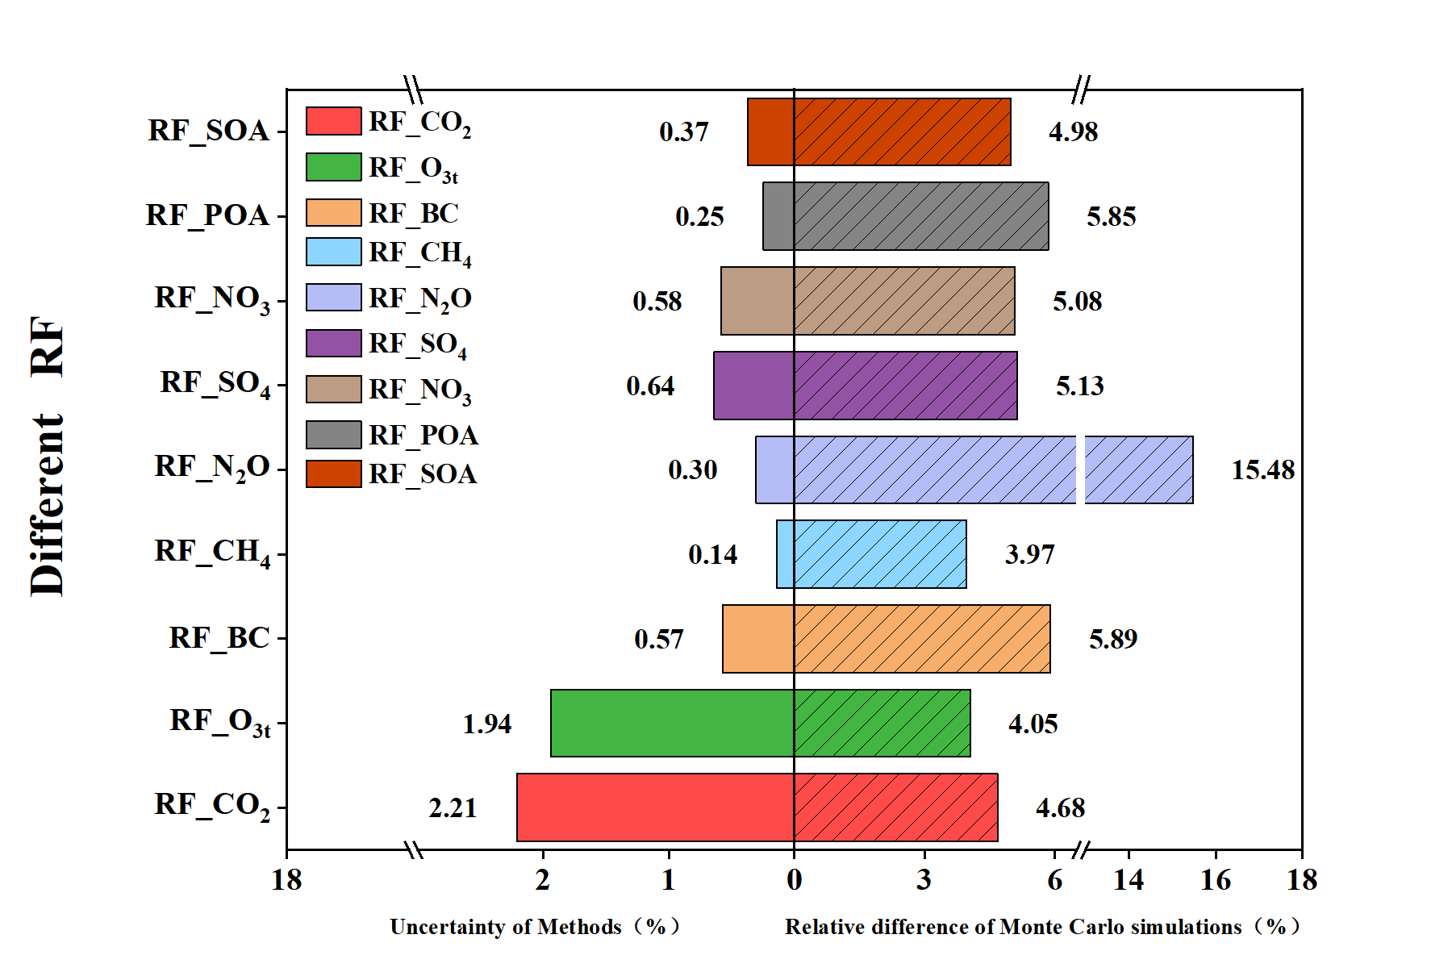
Supplementary Figure 11. Uncertainties in OSCAR modeled RF (left panel) and Monte Carlo uncertainty (right panel) estimated RF in nine climate forcers. OSCAR modeled CO₂ RF has the highest uncertainty due to its cumulative effect but it does not exceed 3%. Higher modeled RF uncertainty (<2%) is also seen in O₃ which can be attributed to its multiple precursor emissions. The other modeled RF uncertainties are all below 1%. The right panel highlights the Monte Carlo uncertainty in RF of nine climate forcers, of which N₂O has the largest uncertainty dur to its complex sources and precursors, thought its RF is small.

Supplementary Figure 12. Uncertainty in MRM predicted SO₂ emissions without CAA and unbalanced emissions. (a) Uncertainty from 10,000 times Monte Carlo simulations using the Crystal Ball model in constructed SO₂ emissions without CAA; (b) uncertainty in unbalanced emission under the Peak scenario; (c) same as Supplementary Fig. 12(b) but for Zero scenario; (d); distribution of uncertainties relative to SO₂ emission without CAA and unbalanced emissions subject to Peak and Zero pathways.

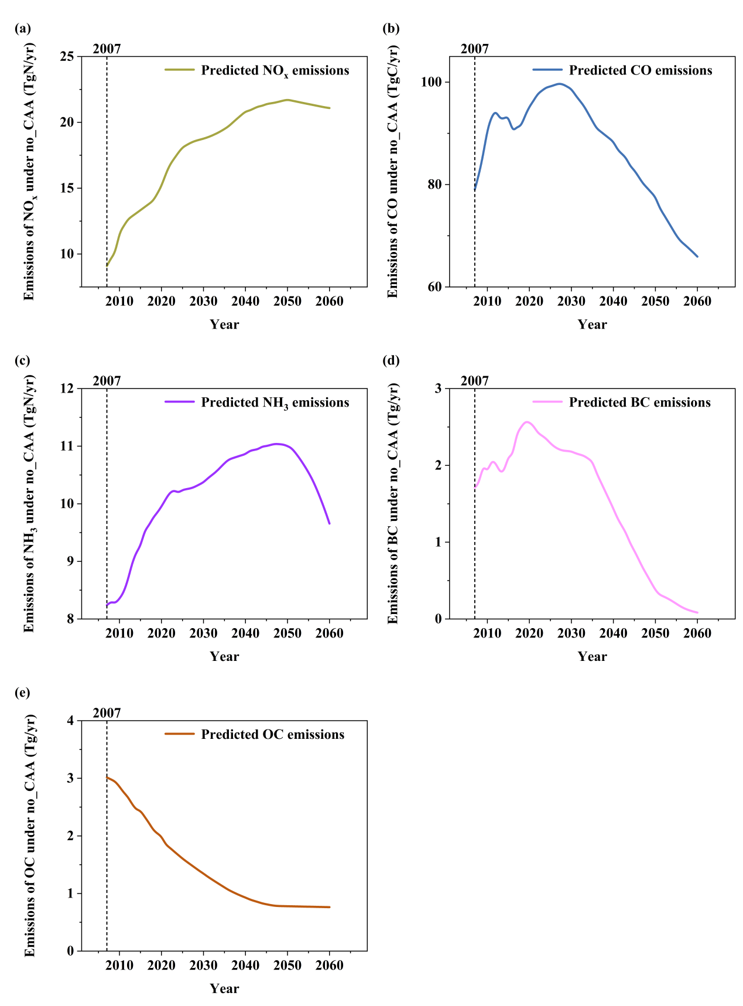
Supplementary Figure 13. MRM predicted annual emissions (Tg yr⁻¹) of major air pollutants from 2007 to 2060 (Eqs. 4-5 in main text and Supplementary Table 2). (a) NO_{x}, (b) CO, (c) NH₃, (d) BC, and (e) OC.

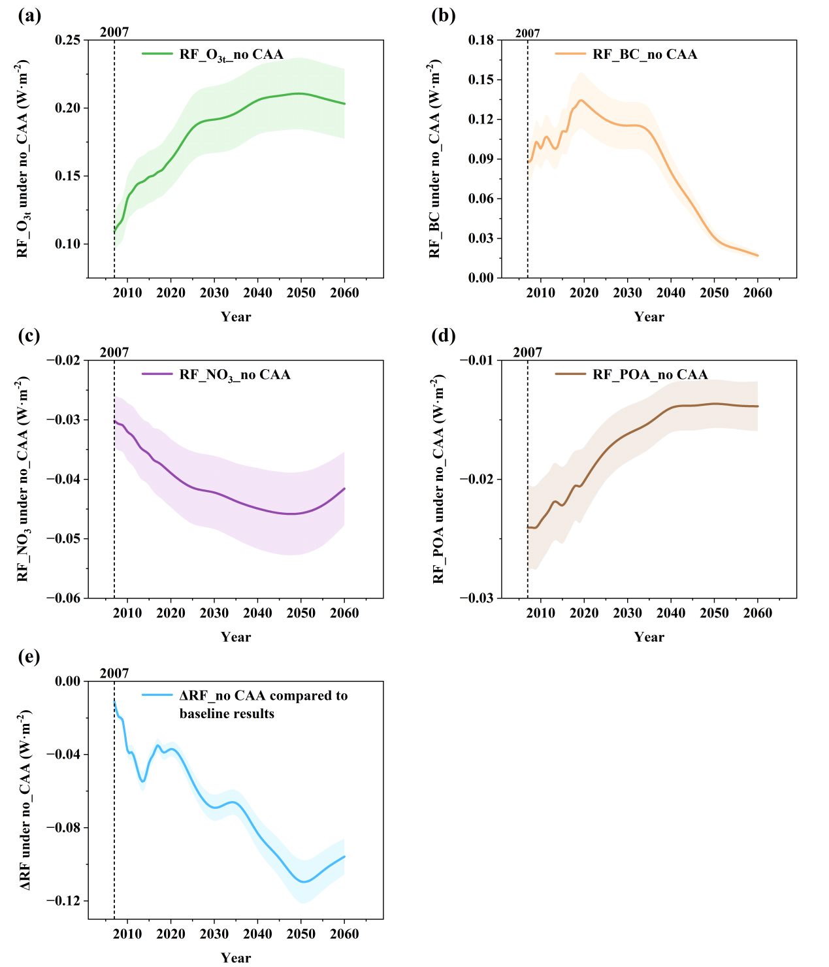
Supplementary Figure 14. Radiative forcing (W m⁻²) of four climate forcers rather than CO₂ and SO₄ from 2007 to 2060. (a) O₃, (b) BC, (c) NO_{3,} (d) POA, (e) ΔRF (RF difference) of summed major pollutants over Supplementary Figs. 14 (a)-(d) between CAA (baseline) and noCAA scenarios.

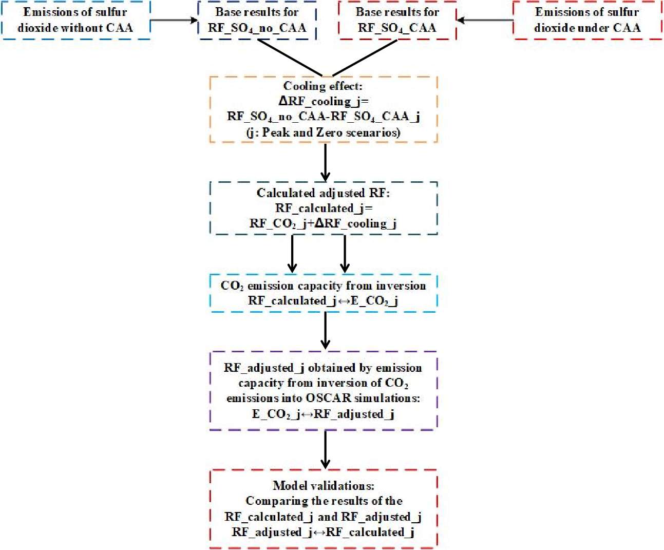
Supplementary Figure 15. Flowchart of procedures for estimating adjusted CO₂ emissions, emission capacity, and RF.

Supplementary Figure 16. Comparison of RF derived from adjusted emissions between OSCAR simulation and calculation. (a) Calculated RF (RF_calculate) and the OSCAR simulated RF (RF_adjusted) under the Peak scenario; (b) distribution of fractions between the OSCAR simulated and calculated RFs from adjusted emissions under the Peak scenario; (c) same as Supplementary Fig. 16(a) but for Zero scenario, and (d) same as Supplementary Fig. 16(b) but for Zero scenario. Violin diagram in Supplementary Figs. 16(b) and 16(d) indicate the fractions between mean RFs from OSCAR simulation and calculation, overall showing smaller fractions than the uncertainties in estimated RFs.

Supplementary Tables
Supplementary Table 1. Statistics of the MRM for predicting NO_{x}, CO, NH₃, BC, OC, and SO₂ emissions without CAA, where STD denotes standard deviation and VIF is the variance inflation factor. The VIF <10 indicates the weak multicollinearity in the MRM.
NO_{x} (TgN/yr) | Intercept | Coal | POW | Oil
Coefficients | -6.24*** | 0.00008* | 0.00005* | 0.0006***
STD | 1.48 | 0.00005 | 0.00003 | 0.0001
P-values | 0.00 | 0.10 | 0.10 | 0.00
VIF |  | 3.75 | 9.85 | 9.07
CO (TgC/yr) | Intercept | Coal | POP | Oil
Coefficients | 10.18*** | 0.001* | 0.0002*** | 0.0009***
STD | 3.37 | 0.0001 | 0.0001 | 0.0005
P-values | 0.01 | 0.10 | 0.01 | 0.00
VIF |  | 4.50 | 6.87 | 2.32
NH₃ (TgN/yr) | Intercept | Coal | POP | Agri
Coefficients | -9.14*** | -0.00005* | 0.0001*** | 0.0004
STD | 1.48 | 0.00003 | 0.00002 | 0.0004
P-values | 0.00 | 0.10 | 0.00 | 0.38
VIF |  | 2.81 | 9.70 | 5.23
BC (Tg/yr) | Intercept | Coal | POP | Oil
Coefficients | -0.54** | 0.00005*** | 0.00004*** | -0.0002***
STD | 0.20 | 0.000006 | 0.000005 | 0.00003
P-values | 0.01 | 0.00 | 0.00 | 0.00
VIF |  | 4.50 | 6.87 | 2.32
OC (Tg/yr) | Intercept | POP | POW | Coal
Coefficients | 7.01*** | -0.00003*** | -0.00002*** | 0.000008***
STD | 0.35 | 0.000003 | 0.0000003 | 0.000003
P-values | 0.00 | 0.01 | 0.00 | 0.01
VIF |  | 4.24 | 6.20 | 3.65
SO₂ (t/yr) | Intercept | POP | POW | Coal
Coefficients | -22886519.89*** | 252.04*** | 332.60*** | 841.89***
STD | 3429753.28 | 31.44 | 3.34 | 31.28
P-values | 0.00 | 0.00 | 0.00 | 0.00
VIF |  | 4.24 | 6.20 | 3.65
The asterisks indicate the statistical significance level based on P values: *P < 0.1, **P < 0.05, ***P < 0.01.

Supplementary Table 2. Statistics of the MRM for the contribution rates to quantify the impact of three regression parameters on emission prediction.
NO_{x} (TgN/yr) | Coal | POW | Oil
Contribution rates | 42.11% | 26.32% | 31.58%
CO (TgC/yr) | Coal | POP | Oil
Contribution rates | 47.62% | 9.52% | 42.86%
NH₃ (TgN/yr) | Coal | POP | Agri
Contribution rates | -11.11% | 22.22% | 88.89%
BC (Tg/yr) | Coal | POP | Oil
Contribution rates | -45.45% | -36.36% | 181.82%
OC (Tg/yr) | POP | POW | Coal
Contribution rates | 71.43% | 47.62% | -19.05%
SO₂ (t/yr) | POP | POW | Coal
Contribution rates | 17.67% | 23.32% | 59.02%

