Table 2 Optimization of the reaction conditions for the synthesis of 1,4-dihydropyridines under the catalysis of the UiO-66-NH₂-CC@Cu(II) nanocatalyst ª
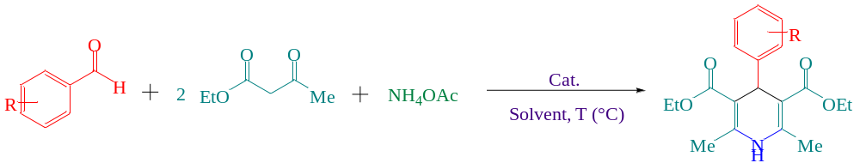
Entry | Catalyst (g) | Solvent | Temperature (°C) | Time (min) | Yield (%)^{b}
1 | UiO-66-NH₂-CC@Cu(II) (0.02) | Solvent free | 80 | 20 | 89
2 | UiO-66-NH₂-CC@Cu(II) (0.02) | H₂O | 80 | 30 | 49
3 | UiO-66-NH₂-CC@Cu(II) (0.02) | DMF | 80 | 20 | 75
4 | UiO-66-NH₂-CC@Cu(II) (0.02) | CH₃CN | 80 | 20 | 56
5 | UiO-66-NH₂-CC@Cu(II) (0.02) | THF | 66 | 20 | 35
6 | UiO-66-NH₂-CC@Cu(II) (0.02)) | Toluene | 80 | 60 | 30
7 | UiO-66-NH₂-CC@Cu(II) (0.02) | MeOH | 64.7 | 20 | 55
8 | UiO-66-NH₂-CC@Cu(II) (0.02) | EtOH | 80 | 20 | 96
9 | UiO-66-NH₂-CC@Cu(II) (0) | EtOH | 80 | 2880 | trace
10 | UiO-66-NH₂-CC@Cu(II) (0.007) | EtOH | 80 | 20 | 65
11 | UiO-66-NH₂-CC@Cu(II) (0.01) | EtOH | 80 | 20 | 73
12 | UiO-66-NH₂-CC@Cu(II) (0.015) | EtOH | 80 | 20 | 84
13 | UiO-66-NH₂-CC@Cu(II) (0.02) | EtOH | 25 | 20 | 35
14 | UiO-66-NH₂-CC@Cu(II) (0.02) | EtOH | 60 | 20 | 78
15 | UiO-66-NH₂ (0.02) | EtOH | 80 | 20 | 31
16 | Cu(II) pincer complex (0.02) | EtOH | 80 | 20 | 59
ªReaction condition: benzaldehyde (1 mmol), ethyl acetoacetate (2 mmol), ammonium acetate (1 mmol), 2 mL of solvent, and catalyst. ^{b}Isolated yield
Table 3 Synthesis of 1,4-dihydropyridine derivatives catalyzed by the UiO-66-NH₂-CC@Cu(II) nanocatalyst ª
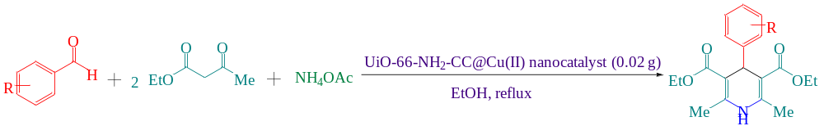
Entry | Aldehyde | Product | Time | Yield (%)^{b} | MP (°C)
 |  |  |  |  | Observed | Literature
1 | 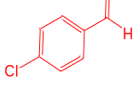 | 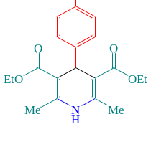 | 15 | 95 | 146-147 | 145–147 [49]
2 | 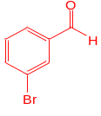 | 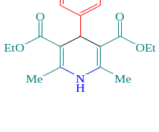 | 20 | 93 | 115-117 | 115-117 [50]
3 | 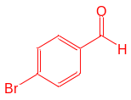 | 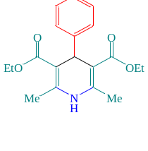 | 15 | 95 | 159-161 | 160-162 [51]
4 | 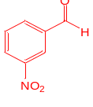 | 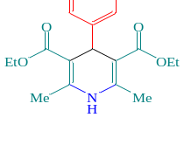 | 25 | 90 | 156-158 | 156–158 [51]
5 | 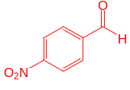 | 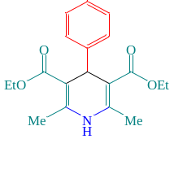 | 15 | 93 | 128-130 | 127‐129 [52]
6 | 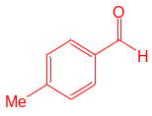 | 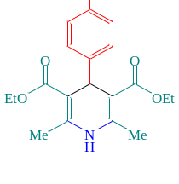 | 20 | 90 | 136-138 | 135–137 [53]
7 | 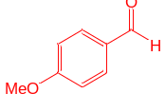 | 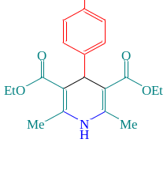 | 25 | 93 | 156-158 | 155–157 [51]
8 | 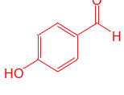 | 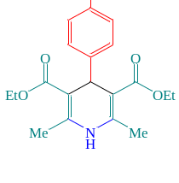 | 25 | 92 | 227-228 | 226-228 [51]
9 | 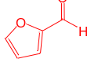 | 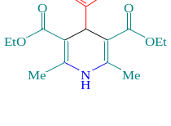 | 20 | 89 | 162-164 | 161–163 [54]
10 | 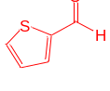 | 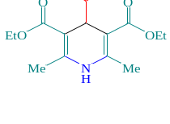 | 25 | 90 | 167-170 | 168–170 [49]
11 | 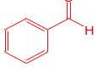 | 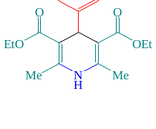 | 20 | 96 | 156-158 | 156–158 [53]
ª Reaction conditions: aldehyde (1 mmol), ethyl acetoacetate (2 mmol), ammonium acetate (1 mmol), UiO-66-NH₂-CC@Cu(II) nanocatalyst (0.02 g), EtOH (2 mL), and temperature (80 °C). ^{b} Isolated yield
Table 4 Optimization of the reaction conditions for the synthesis of 3,4-dihydropyrimidinones under the catalysis of the UiO-66-NH₂-CC@Cu(II) nanocatalyst ª
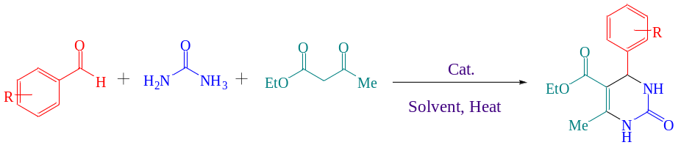
Entry | Catalyst (g) | Solvent | Temperature (°C) | Time (min) | Yield (%)^{b}
1 | UiO-66-NH₂-CC@Cu(II) (0.007) | EtOH | 70 | 90 | 65
2 | UiO-66-NH₂-CC@Cu(II) (0.01) | EtOH | 70 | 40 | 75
3 | UiO-66-NH₂-CC@Cu(II) (0.02) | EtOH | 70 | 35 | 86
4 | UiO-66-NH₂-CC@Cu(II) (0.025) | EtOH | 70 | 35 | 95
5 | UiO-66-NH₂-CC@Cu(II) (0.03) | EtOH | 70 | 35 | 95
6 | UiO-66-NH₂-CC@Cu(II) (0.025) | EtOH | 25 | 60 | 50
7 | UiO-66-NH₂-CC@Cu(II) (0.025) | EtOH | 60 | 35 | 80
8 | UiO-66-NH₂-CC@Cu(II) (0.025) | EtOH | reflux | 35 | 95
9 | UiO-66-NH₂-CC@Cu(II) (0.025) | EtOH | 70 | 20 | 75
10 | UiO-66-NH₂-CC@Cu(II) (0.025) | EtOH | 70 | 60 | 95
11 | UiO-66-NH₂-CC@Cu(II) (0.025) | H₂O | 90 | 35 | 40
12 | UiO-66-NH₂-CC@Cu(II) (0.025) | EtOH/H₂O | 70 | 35 | 75
13 | UiO-66-NH₂-CC@Cu(II) (0.025) | DMF | 70 | 35 | 88
14 | UiO-66-NH₂-CC@Cu(II) (0.025) | PEG | 70 | 35 | 65
15 | UiO-66-NH₂-CC@Cu(II) (0.025g) | MeOH | reflux | 35 | 55
16 | UiO-66-NH₂-CC@Cu(II) (0.025) | Toluene | 70 | 5h | 20
17 | UiO-66-NH₂-CC@Cu(II) (0.025) | Solvent free | 70 | 35 | 69
18 | UiO-66-NH₂ (0.025) | EtOH | 70 | 35 | 65
19 | UiO-66-NH₂-CC@Cu(II) (0.025) | EtOH | 70 | 35 | 33
ªReaction condition: 4-chlorobenzaldhyde (1mmol), urea (1mmol), ethlacetoacetate (1 mmol), 2 ml solvent, and catalyst. ^{b}Isolated yield.
Table 5 Synthesis of 3,4-dihydropyrimidinone derivatives catalyzed by the UiO-66-NH₂-CC@Cu(II) nanocatalyst ª
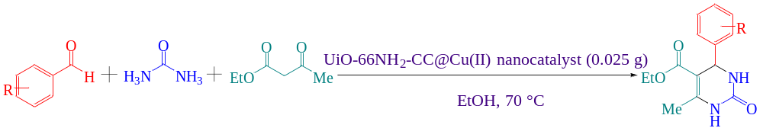
Entry | Aldehyde | Product | Time | Yield (%)^{b} | MP (°C)
 |  |  |  |  | Observed | Literature
1 | 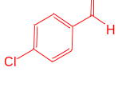 | 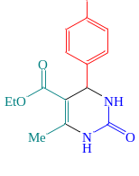 | 35 | 95 | 212-214 | 212-214 [56]
2 |  | 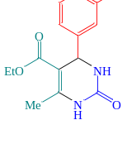 | 30 | 90 | 200-201 | 198‐200 [57]
3 |  | 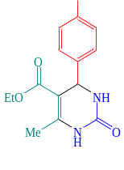 | 40 | 93 | 210-212 | 211-213 [56]
4 |  | 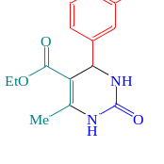 | 25 | 91 | 225-227 | 225–226 [58]
5 |  | 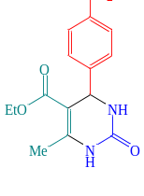 | 35 | 93 | 208-210 | 207‐209 [58]
6 |  | 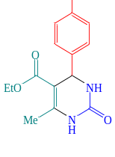 | 50 | 90 | 211-213 | 212–214 [56]
7 |  | 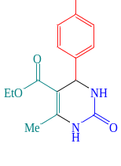 | 40 | 93 | 203-205 | 203-204 [54]
8 | 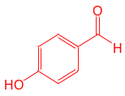 |  | 40 | 93 | 210-211 | 208-210 [56]
9 |  | 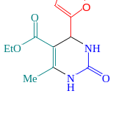 | 35 | 90 | 209-211 | 209-211 [59]
10 |  | 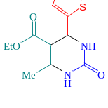 | 30 | 90 | 216-218 | 215-217 [60]
11 |  | 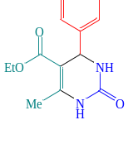 | 40 | 95 | 203-204 | 202–204 [56]
12 | 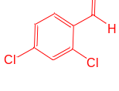 | 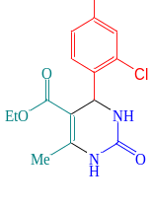 | 40 | 91 | 237-239 | 236-238 [56]
13 | 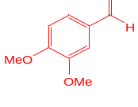 | 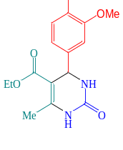 | 45 | 90 | 177-178 | 173-176 [61]
ª Reaction conditions: aldehyde (1 mmol), urea (1 mmol), ethylacetoacetate (1 mmol), the UiO-66-NH₂-CC@Cu(II) nanocatalyst (0.025 g), temperature (70 °C), EtOH (2 mL). ^{b}Isolated yield

