Variable | Dimension | References
Perceived Usefulness | Convenience | (Venkatesh and Davis, 2000), (King and He, 2006)
Perceived Usefulness | Accessibility | (Venkatesh and Davis, 2000), (King and He, 2006)
Perceived Ease of Use | Simplicity | (Lescevica, Ginters and Mazza, 2013)
Perceived Ease of Use | Benefits | (Lescevica, Ginters and Mazza, 2013)
Academic decision making | Curriculum development | (Mitra, 2022), (Osabutey, Senyo and Bempong, 2024)
Academic decision making | Student evaluation | (Mitra, 2022), (Osabutey, Senyo and Bempong, 2024)
Academic decision making | Instructional improvement | (Mitra, 2022), (Osabutey, Senyo and Bempong, 2024)
Table 1: Operationalization of the study

university positions in the sample
 |  | Frequency | Percent | Valid Percent | Cumulative Percent
Valid | Professor | 15 | 10.0 | 10.0 | 10.0
Valid | Associate Professor | 2 | 1.3 | 1.3 | 11.3
Valid | Senior Lecturer – Grade I | 21 | 14.0 | 14.0 | 25.3
Valid | Senior Lecturer – Grade II | 4 | 2.7 | 2.7 | 28.0
Valid | Lecturer | 10 | 6.7 | 6.7 | 34.7
Valid | Lecturer (Probationary) | 44 | 29.3 | 29.3 | 64.0
Valid | Temporary Assistant Lecturer | 54 | 36.0 | 36.0 | 100.0
Valid | Total | 150 | 100.0 | 100.0
Table 2: University Positions in the Sample

Variable | No of items | Cronbach alpha value
Independent Variable | 17
Convenience | 4 | .701
Accessibility | 4 | .718
Simplicity | 5 | .737
Benefits | 4 | .697
Dependent Variable | 12
Academic decision making | 12 | .801
Table 4: Reliability

Variable | KMO | BTS Sig | AVE
Convenience | .640 | .000 | 0.61
Accessibility | .682 | .000 | 0.60
Simplicity | .661 | .000 | 0.62
Benefits | .619 | .000 | 0.60
Academic decision making | .713 | .000 | 0.67
Table 5: Validity
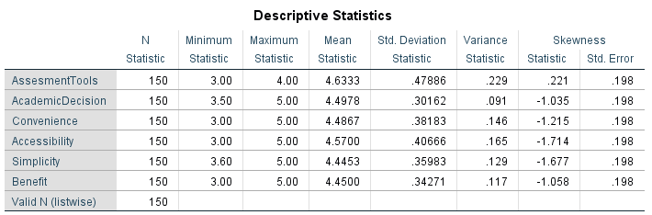
Table 6: Descriptive Statistics

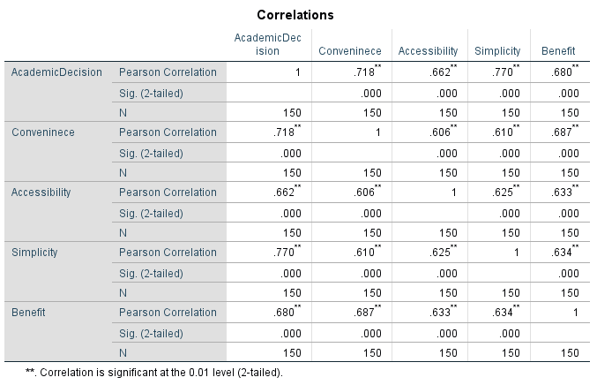

Table 7: Correlation analysis

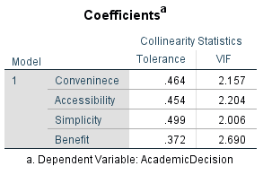

Table 8: Tolerance and VIF

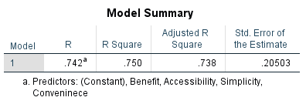

Table 9: Model Summary
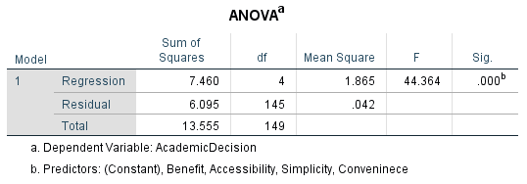

Table 10: ANOVA

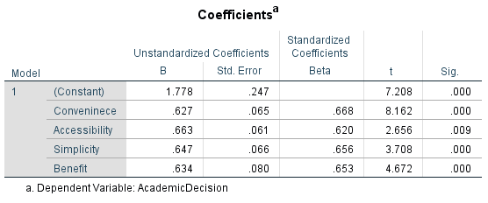

Table 11: Coefficient

Hypothesis | Correlation Analysis |  | Accept/ Reject | Regression Analysis |  | Accept/ Reject
Hypothesis | R | P | Accept/ Reject | β | P | Accept/ Reject
H1 - There is a significant relationship between convenience and academic decision-making. | .718 | .000 | Accept | .668 | .000 | Accept
H2 - There is a significant relationship between accessibility and academic decision-making. | .662 | .000 | Accept | .620 | .009 | Accept
H3 - There is a significant relationship between simplicity and academic decision-making. | .770 | .000 | Accept | .656 | .000 | Accept
H4 - There is a significant relationship between benefits and academic decision-making. | .680 | .000 | Accept | .653 | .000 | Accept
Table 12: Test Hypothesis

