Phenological plasticity alters community structures of alpine Lepidoptera

Werner Ulrich, Thomas Schmitt, Patrick Gros, Jan Christian Habel

Figure B1. Numbers of Lepidoptera records (1960–2022) from the Salzburg region in dependence on study year (a) and altitude (b). c) Numbers of species recorded in each study year. Total numbers from all study years: 189,939 records of imagines representing 2111 species.

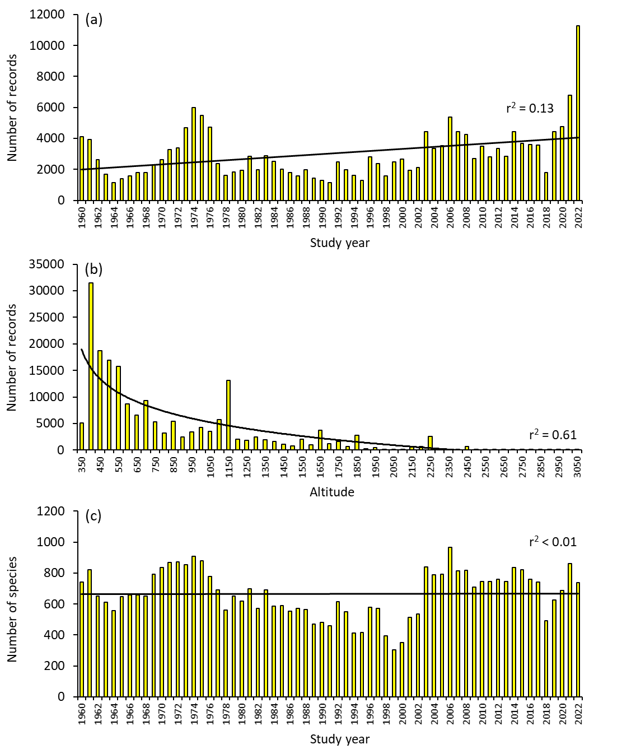

Figure B2. Average annual temperatures (a) and precipitation (b) based on monthly averages 1960–2024 for two weather stations in the Salzburg region: Salzburg Airport (green: 430 m a.s.l.) and Schmittendorf (orange: 1,965 m a.s.l). Given are also average values for three time periods (1960–1980, 1981–2010, 2011–2024).

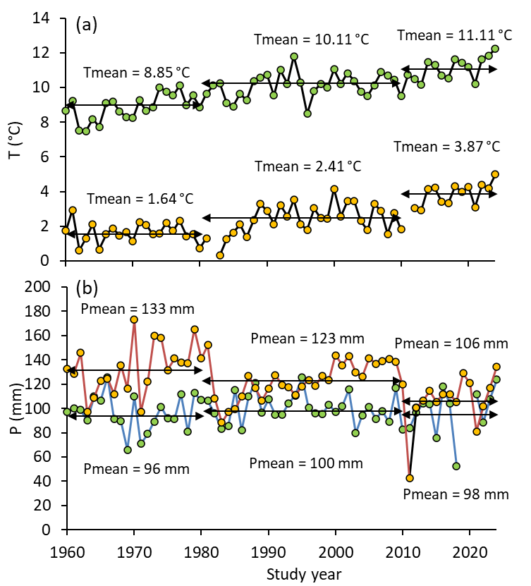

Figure B3. Species accumulation curve of Lepidoptera of the Salzburg region. The power function regression line (r² = 0.49, slope = 0.35) identifies a number of study years, in particular the years 2019–2022, with comparably small numbers of observed species.

