Table 1. Preliminary Life Cycle Inventory of Indonesian Aerospace (Achmad, et al., 2019)
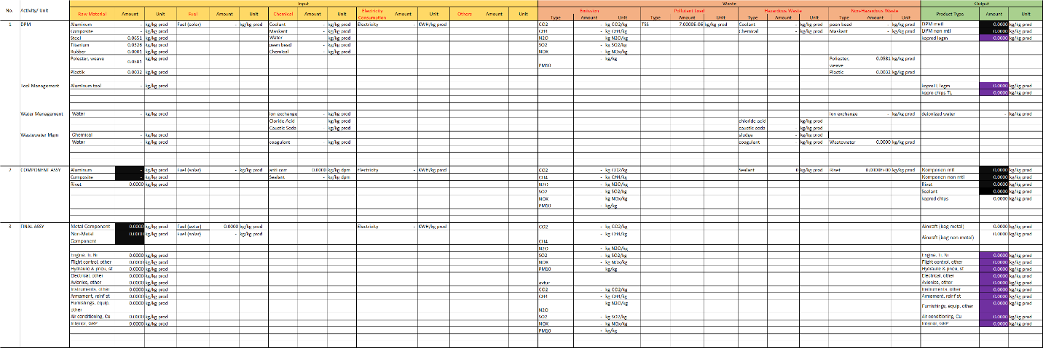
Table 2. Preliminary Impact Potential of Environmental Categories (Achmad, et al., 2019)
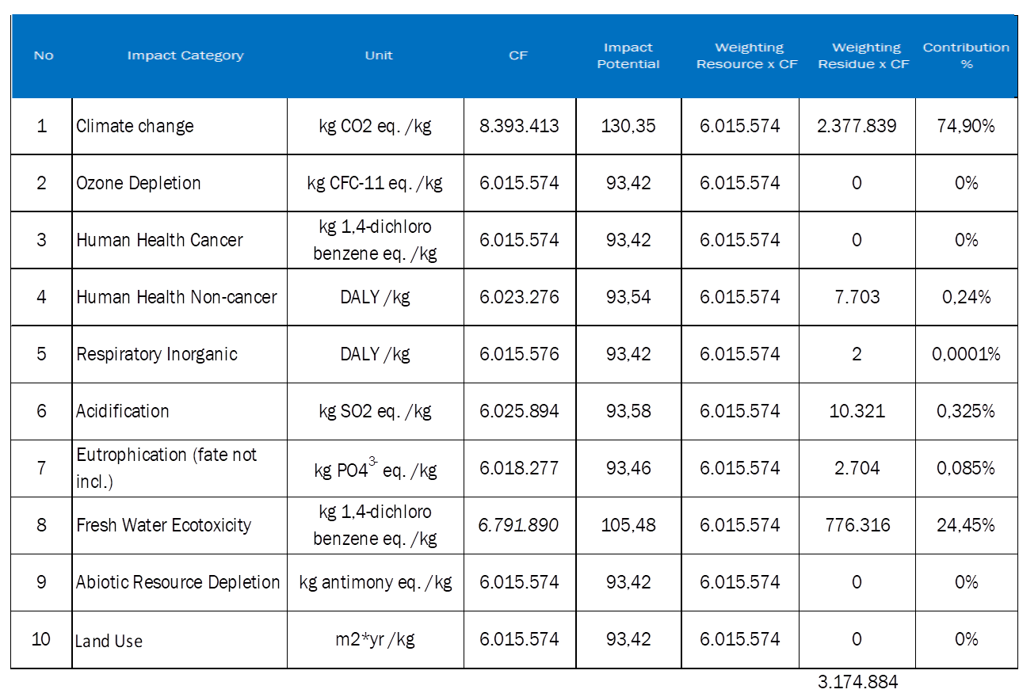
Table 3. Comparison of Climate Change Impact (Achmad, et al., 2019)
