Supplementary Note 1 The formulas of Evaluation Metrics.
Scenario 1: Consistency with scRNA-seq
Conservative Criteria:

$$Recall=\frac{{TP}_{conservative }}{{TP}_{conservative }+{FN}_{conservative }}$$ | (1)

$${Precision}_{conservative }=\frac{{TP}_{conservative }}{{TP}_{conservative }+{FP}_{conservative }}$$ | (2)

$${F1}_{conservative }=2×\frac{{Precision}_{conservative }×Recall}{{Precision}_{conservative }+Recall}$$ | (3)

Permissive Criteria (the calculation of recall in Permissive Criteria remains the same as in Conservative Criteria):

$${Precision}_{permissive }=\frac{{TP}_{permissive }}{{TP}_{permissive }+{FP}_{permissive }}$$ | (4)

$${F1}_{permissive }=2×\frac{{Precision}_{permissive }×Recall}{{Precision}_{permissive }+Recall}$$ | (5)

${TP}_{conservative }$: DP cell types identified in both scRNA-seq data and deconvolution results
${FP}_{conservative }$: DP cell type identified in deconvolution results but not in scRNA-seq data.
${FN}_{conservative }$: DP cell type identified in scRNA-seq data but not in deconvolution results.
${TP}_{permissive }$: DP cell types identified in deconvolution results that align with trends in scRNA-seq data.
${FP}_{permissive }$: DP cell types identified in deconvolution results that opposite with trends in scRNA-seq data.

Scenario 2: Reproducibility Across Cohorts
Conservative Criteria:

$${Jaccard}_{conservative }=\frac{A∩B}{A∪B}$$ | (6)
$$Recall=\frac{\left(A∩B\right)∩C}{C}$$ | (7)
$${Precision}_{conservative }=\frac{\left(A∩B\right)∩C}{A∩B}$$ | (8)
$${F1}_{conservative }=2×\frac{{Precision}_{conservative }×Recall}{{Precision}_{conservative }+Recall}$$ | (9)

Permissive Criteria (the calculation of recall in Permissive Criteria remains the same as in Conservative Criteria):

$${Jaccard}_{permissive }=\frac{(A_{trend}∩B)∪(A∩B_{trend})}{A∪B}$$ | (10)
$${Precision}_{permissive }=\frac{{(A}_{trend}∩B∩C)∪(A∩B_{trend}∩C)}{{(A}_{trend}∩B)∪(A∩B_{trend})}$$ | (11)
$${F1}_{permissive }=2×\frac{{Precision}_{permissive }×Recall}{{Precision}_{permissive }+Recall}$$ | (12)

$A$: DP cell types identified by deconvolution method in the first bulk cohort.
$B$: DP cell types identified by deconvolution method in the second bulk cohort.
$A_{trend}$: DP cell types identified by deconvolution method in the first bulk cohort and exhibit consistent trend with the second bulk cohort.
$B_{trend}:$ DP cell types identified by deconvolution method in the second bulk cohort and exhibit consistent trend with the first bulk cohort.
$C$: DP cell types identified in scRNA-seq data.

Scenario 3: Prognostic Relevance
Conservative Criteria:

$${Jaccard}_{conservative }=\frac{D∩E}{D∪E}$$ | (13)
Permissive Criteria:

$${Jaccard}_{permissive }=\frac{{(D}_{trend}∩E)∪(D∩E_{trend})}{D∪E}$$ | (14)

$D$: PR cell types identified by deconvolution method in the first bulk cohort.
$E$: PR cell types identified by deconvolution method in the second bulk cohort.
$D_{trend}:$ PR cell types identified by deconvolution method in the first bulk cohort and exhibit consistent trend with the second bulk cohort.
$E_{trend}:$ PR cell types identified by deconvolution method in the second bulk cohort and exhibit consistent trend with the first bulk cohort.

Figure Legends
Supplementary Figure 1: The proportion of dendritic cells in TCGA-COAD.

Supplementary Figure 2: The consistency between the DP cell types identified by the deconvolution methods and the scRNA-seq standard. For PRAD, both recall and conservative precision are 0 due to the absence of scRNA-seq DP cell type. (A) Recall. (B) Conservative precision. (C) Permissive precision.

Supplementary Figure 3: The number of shared DP cell types identified in two cohorts across six methods in eight cancers. (A) Conservative number. (B) Conservative number.

Supplementary Figure 4: The reproducibility of DP cell types identified in two cohorts across six methods in eight cancers. (A) Conservative recall. (B) Conservative precision. (C) Permissive recall. (D) Permissive precision.

Supplementary Figure 5: The association of mCAF and cDC_CLEC9A with prognosis across 12 cancer entities. (A) The association of mCAF with prognosis across 12 cancer entities. (B) The association of cDC_CLEC9A with prognosis across 12 cancer entities.

Supplementary Figure 6: Kaplan-Meier curves for ReCIDE (ASC% - mCAF%), BayesPrism (Mast_KIT% + cDC_CLEC9A%), and BayesPrism (Hypoxia% + cDC_CLEC9A%) prognostic indicator in GEO cohorts. (A) Kaplan-Meier curves for ReCIDE (ASC% - mCAF%) prognostic indicator in GEO cohorts. (B) Kaplan-Meier curves for BayesPrism (Mast_KIT% + cDC_CLEC9A%) prognostic indicator in GEO cohorts. (C) Kaplan-Meier curves for BayesPrism (Hypoxia% + cDC_CLEC9A%) prognostic indicator in GEO cohorts.

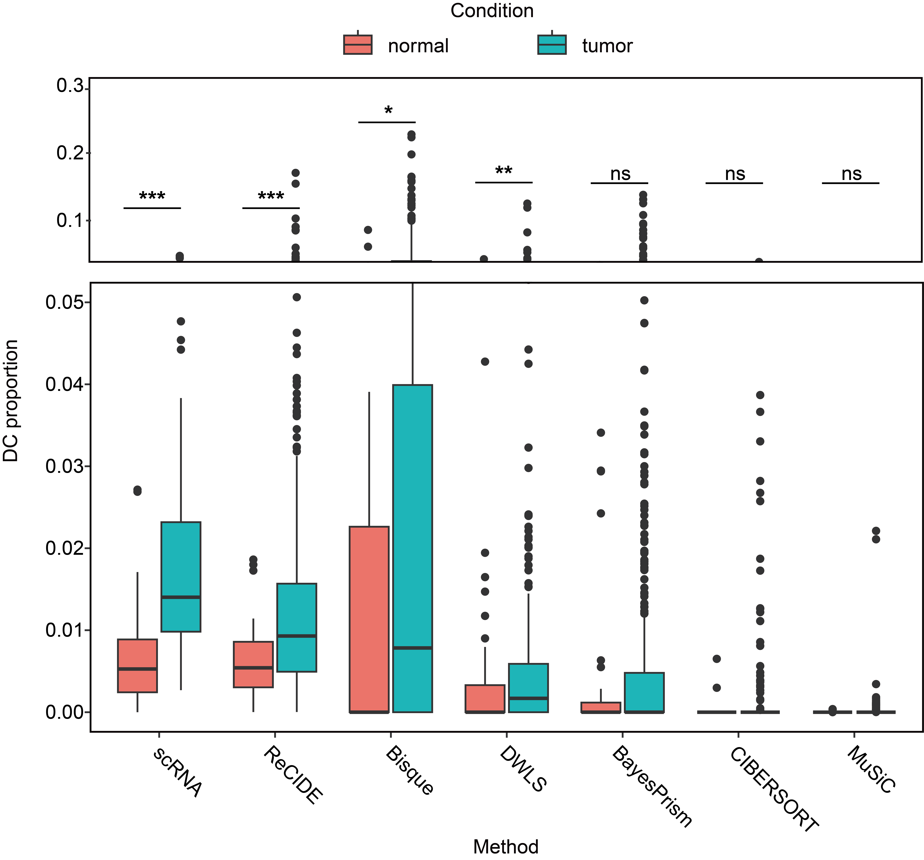
Supplementary Figure 1: The proportion of dendritic cells in TCGA-COAD.

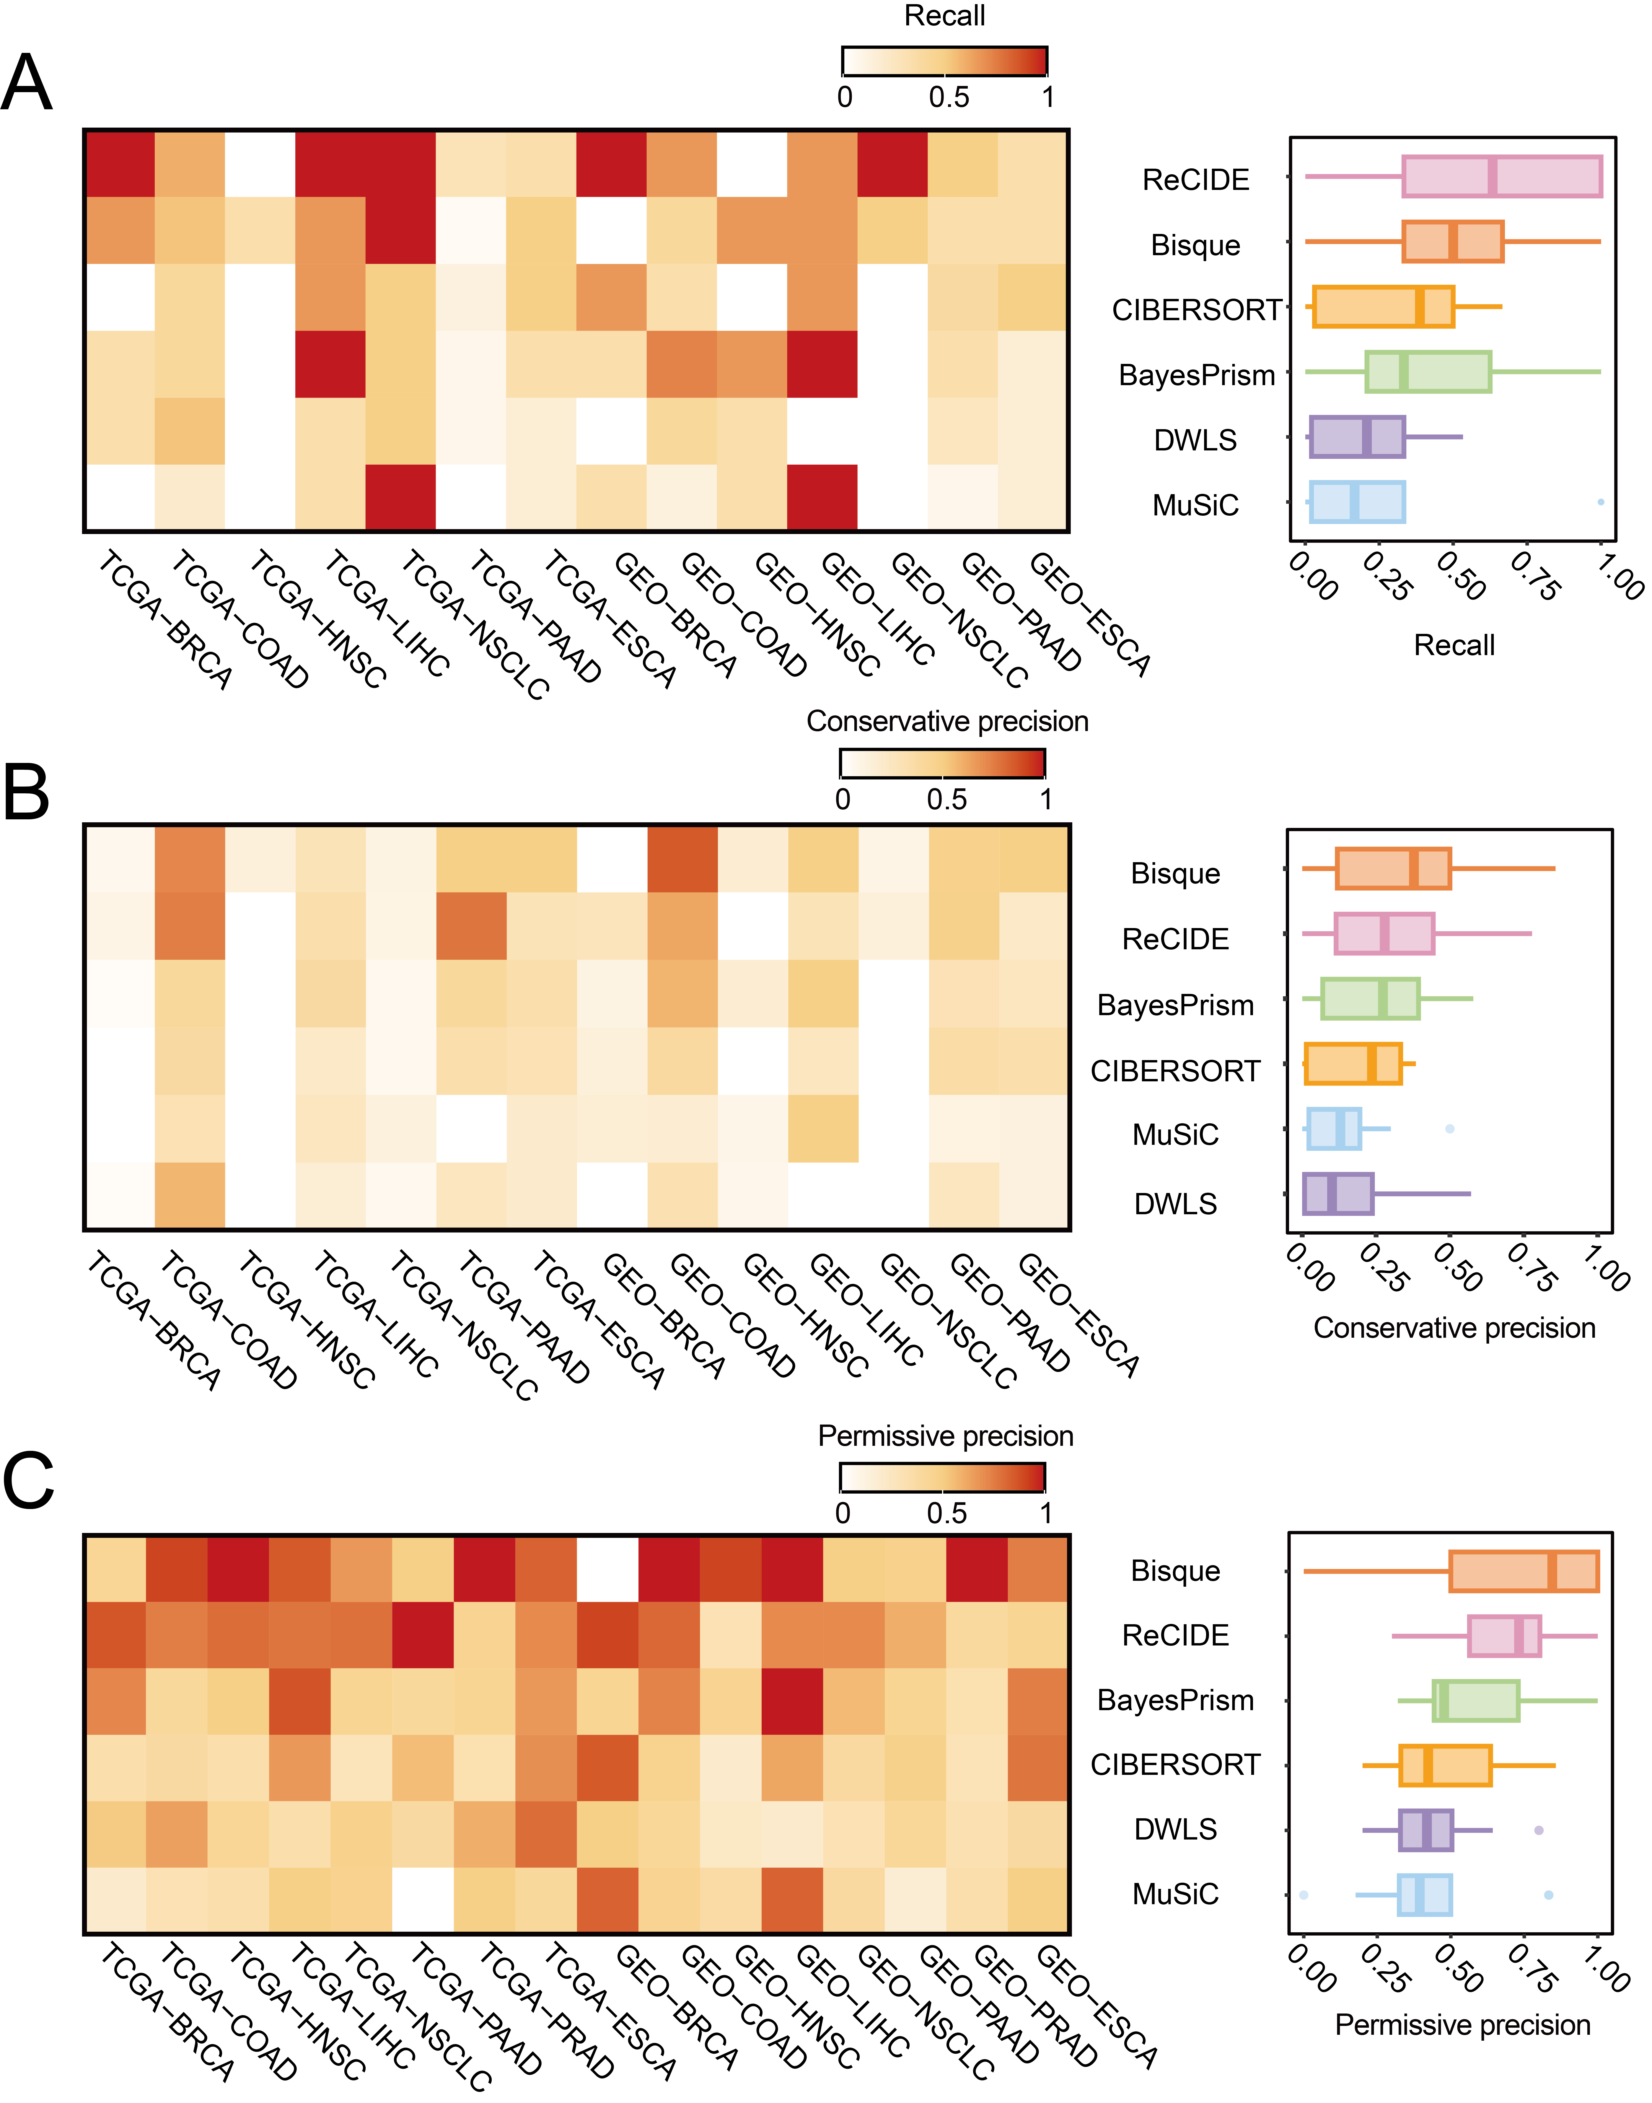
Supplementary Figure 2: The consistency between the DP cell types identified by the deconvolution methods and the scRNA-seq standard. For PRAD, both recall and conservative precision are 0 due to the absence of scRNA-seq DP cell type. (A) Recall. (B) Conservative precision. (C) Permissive precision.
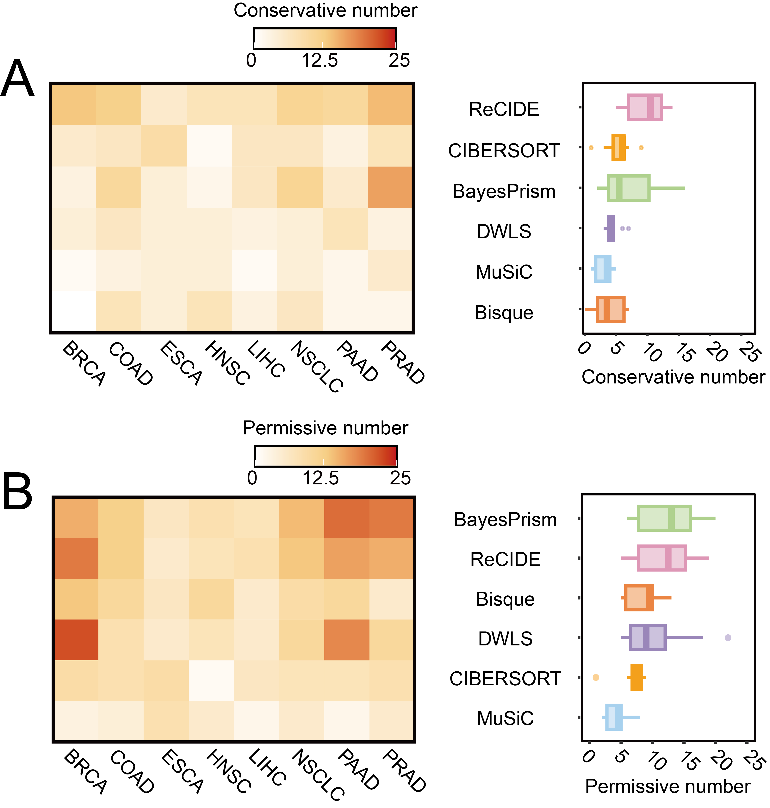
Supplementary Figure 3: The number of shared DP cell types identified in two cohorts across six methods in eight cancers. (A) Conservative number. (B) Conservative number.

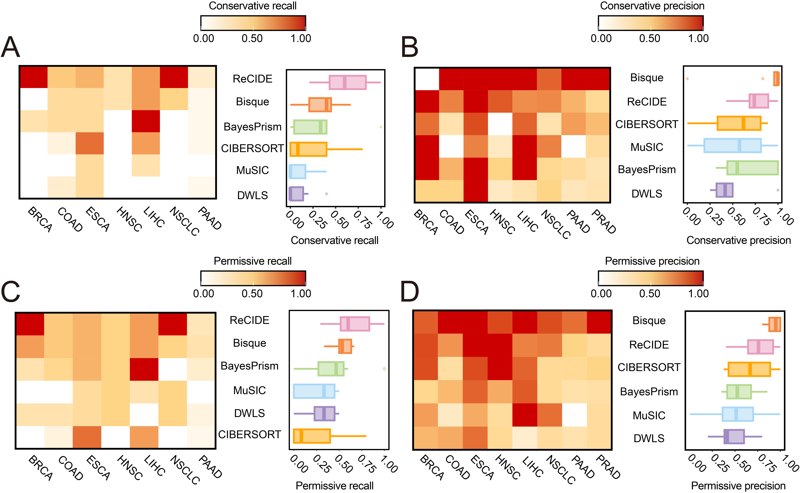
Supplementary Figure 4: The reproducibility of DP cell types identified in two cohorts across six methods in eight cancers. (A) Conservative recall. (B) Conservative precision. (C) Permissive recall. (D) Permissive precision.

Supplementary Figure 5: The association of mCAF and cDC_CLEC9A with prognosis across 12 cancer entities. (A) The association of mCAF with prognosis across 12 cancer entities. (B) The association of cDC_CLEC9A with prognosis across 12 cancer entities.
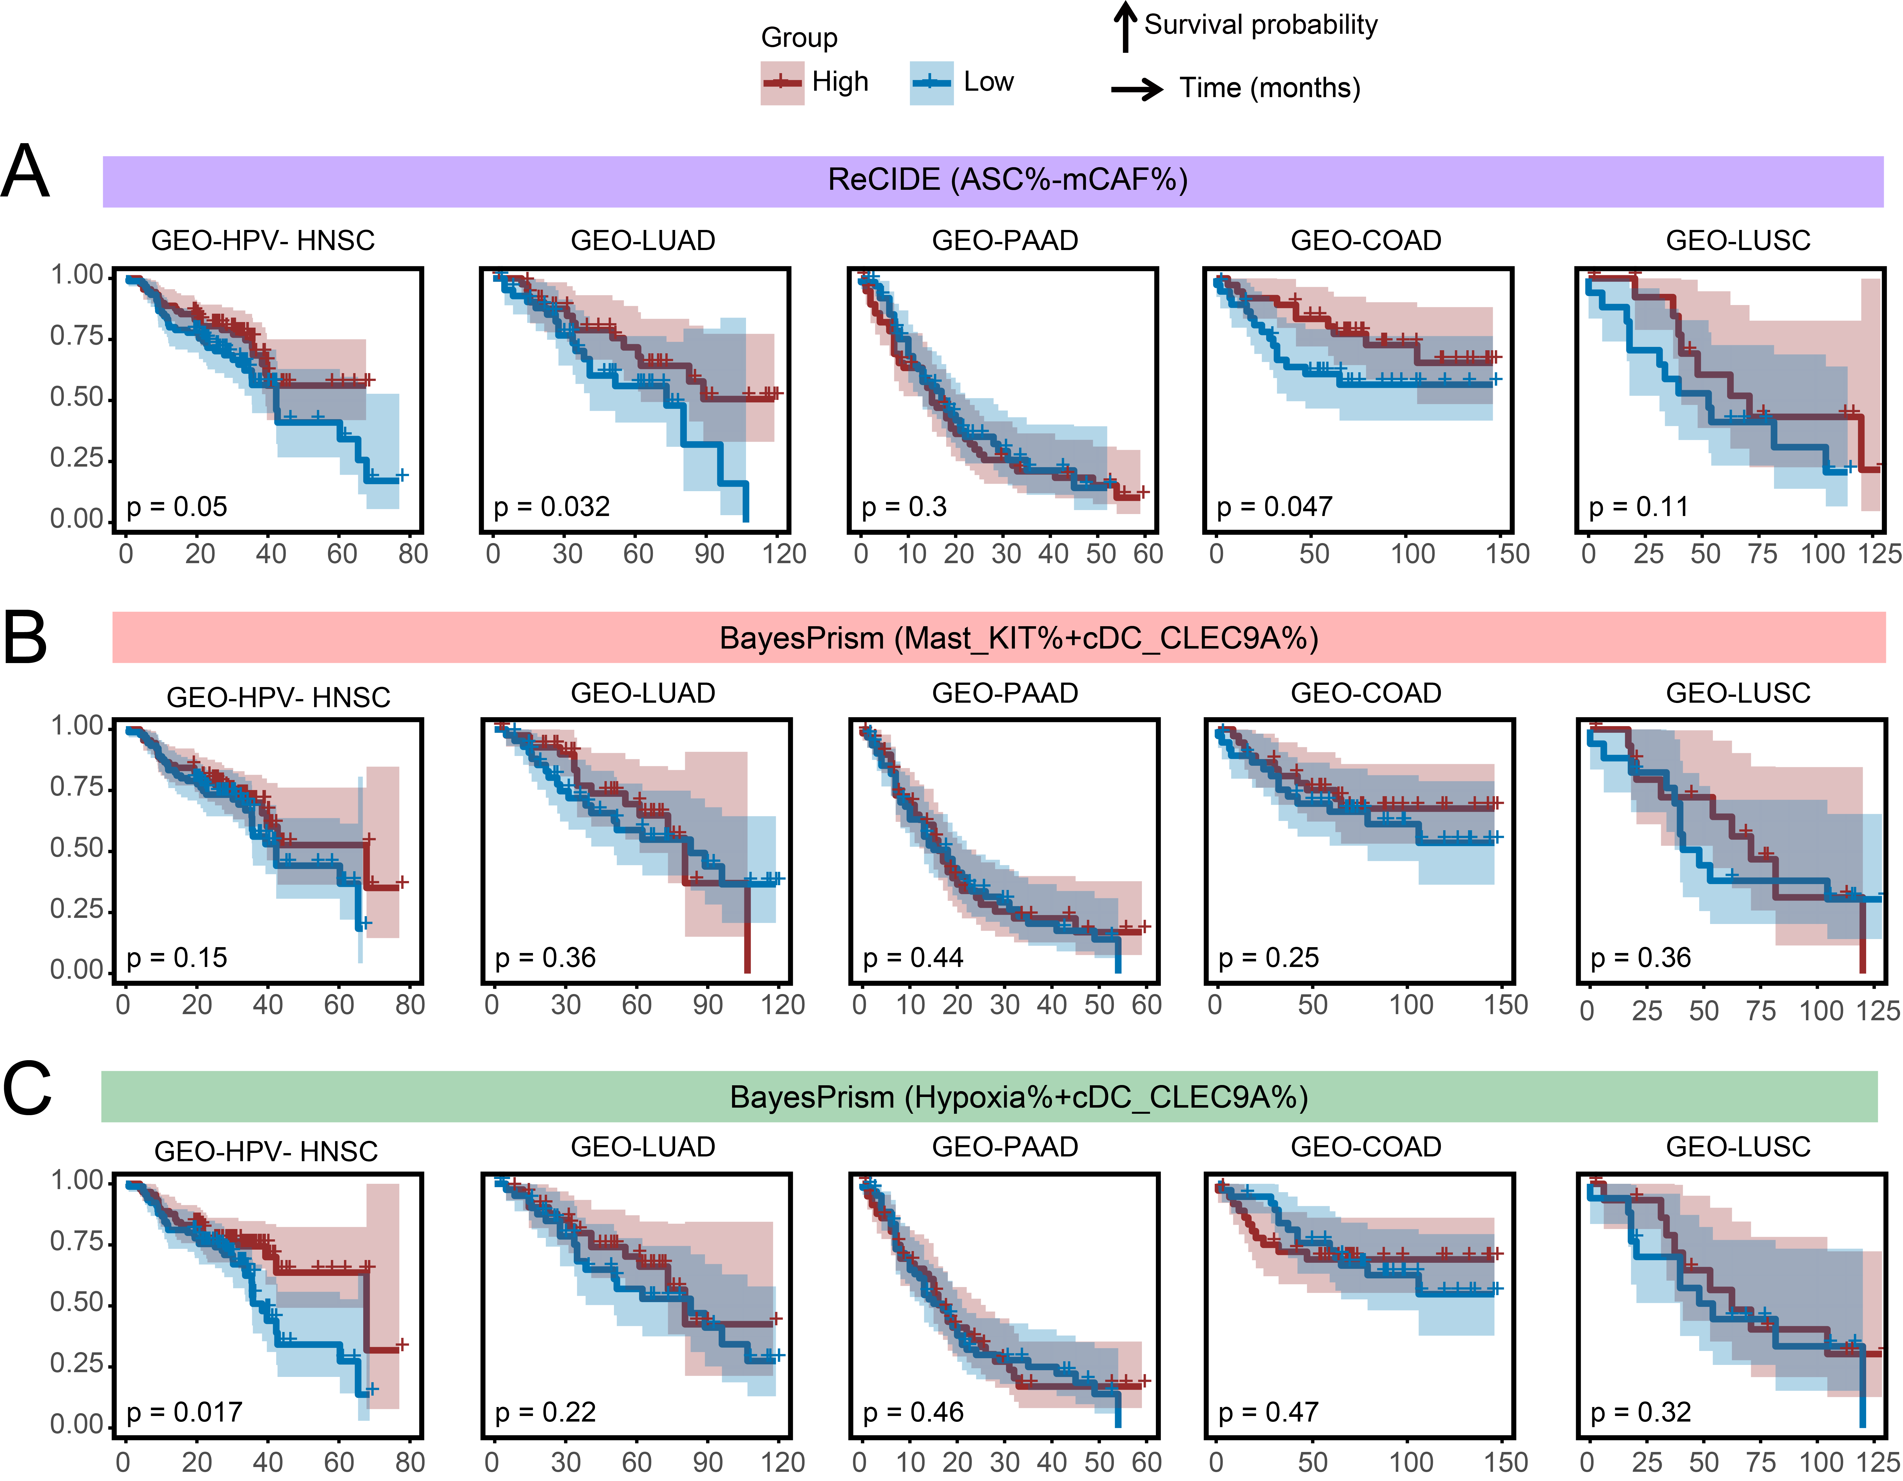
Supplementary Figure 6: Kaplan-Meier curves for ReCIDE (ASC% - mCAF%), BayesPrism (Mast_KIT% + cDC_CLEC9A%), and BayesPrism (Hypoxia% + cDC_CLEC9A%) prognostic indicator in GEO cohorts. (A) Kaplan-Meier curves for ReCIDE (ASC% - mCAF%) prognostic indicator in GEO cohorts. (B) Kaplan-Meier curves for BayesPrism (Mast_KIT% + cDC_CLEC9A%) prognostic indicator in GEO cohorts. (C) Kaplan-Meier curves for BayesPrism (Hypoxia% + cDC_CLEC9A%) prognostic indicator in GEO cohorts.

