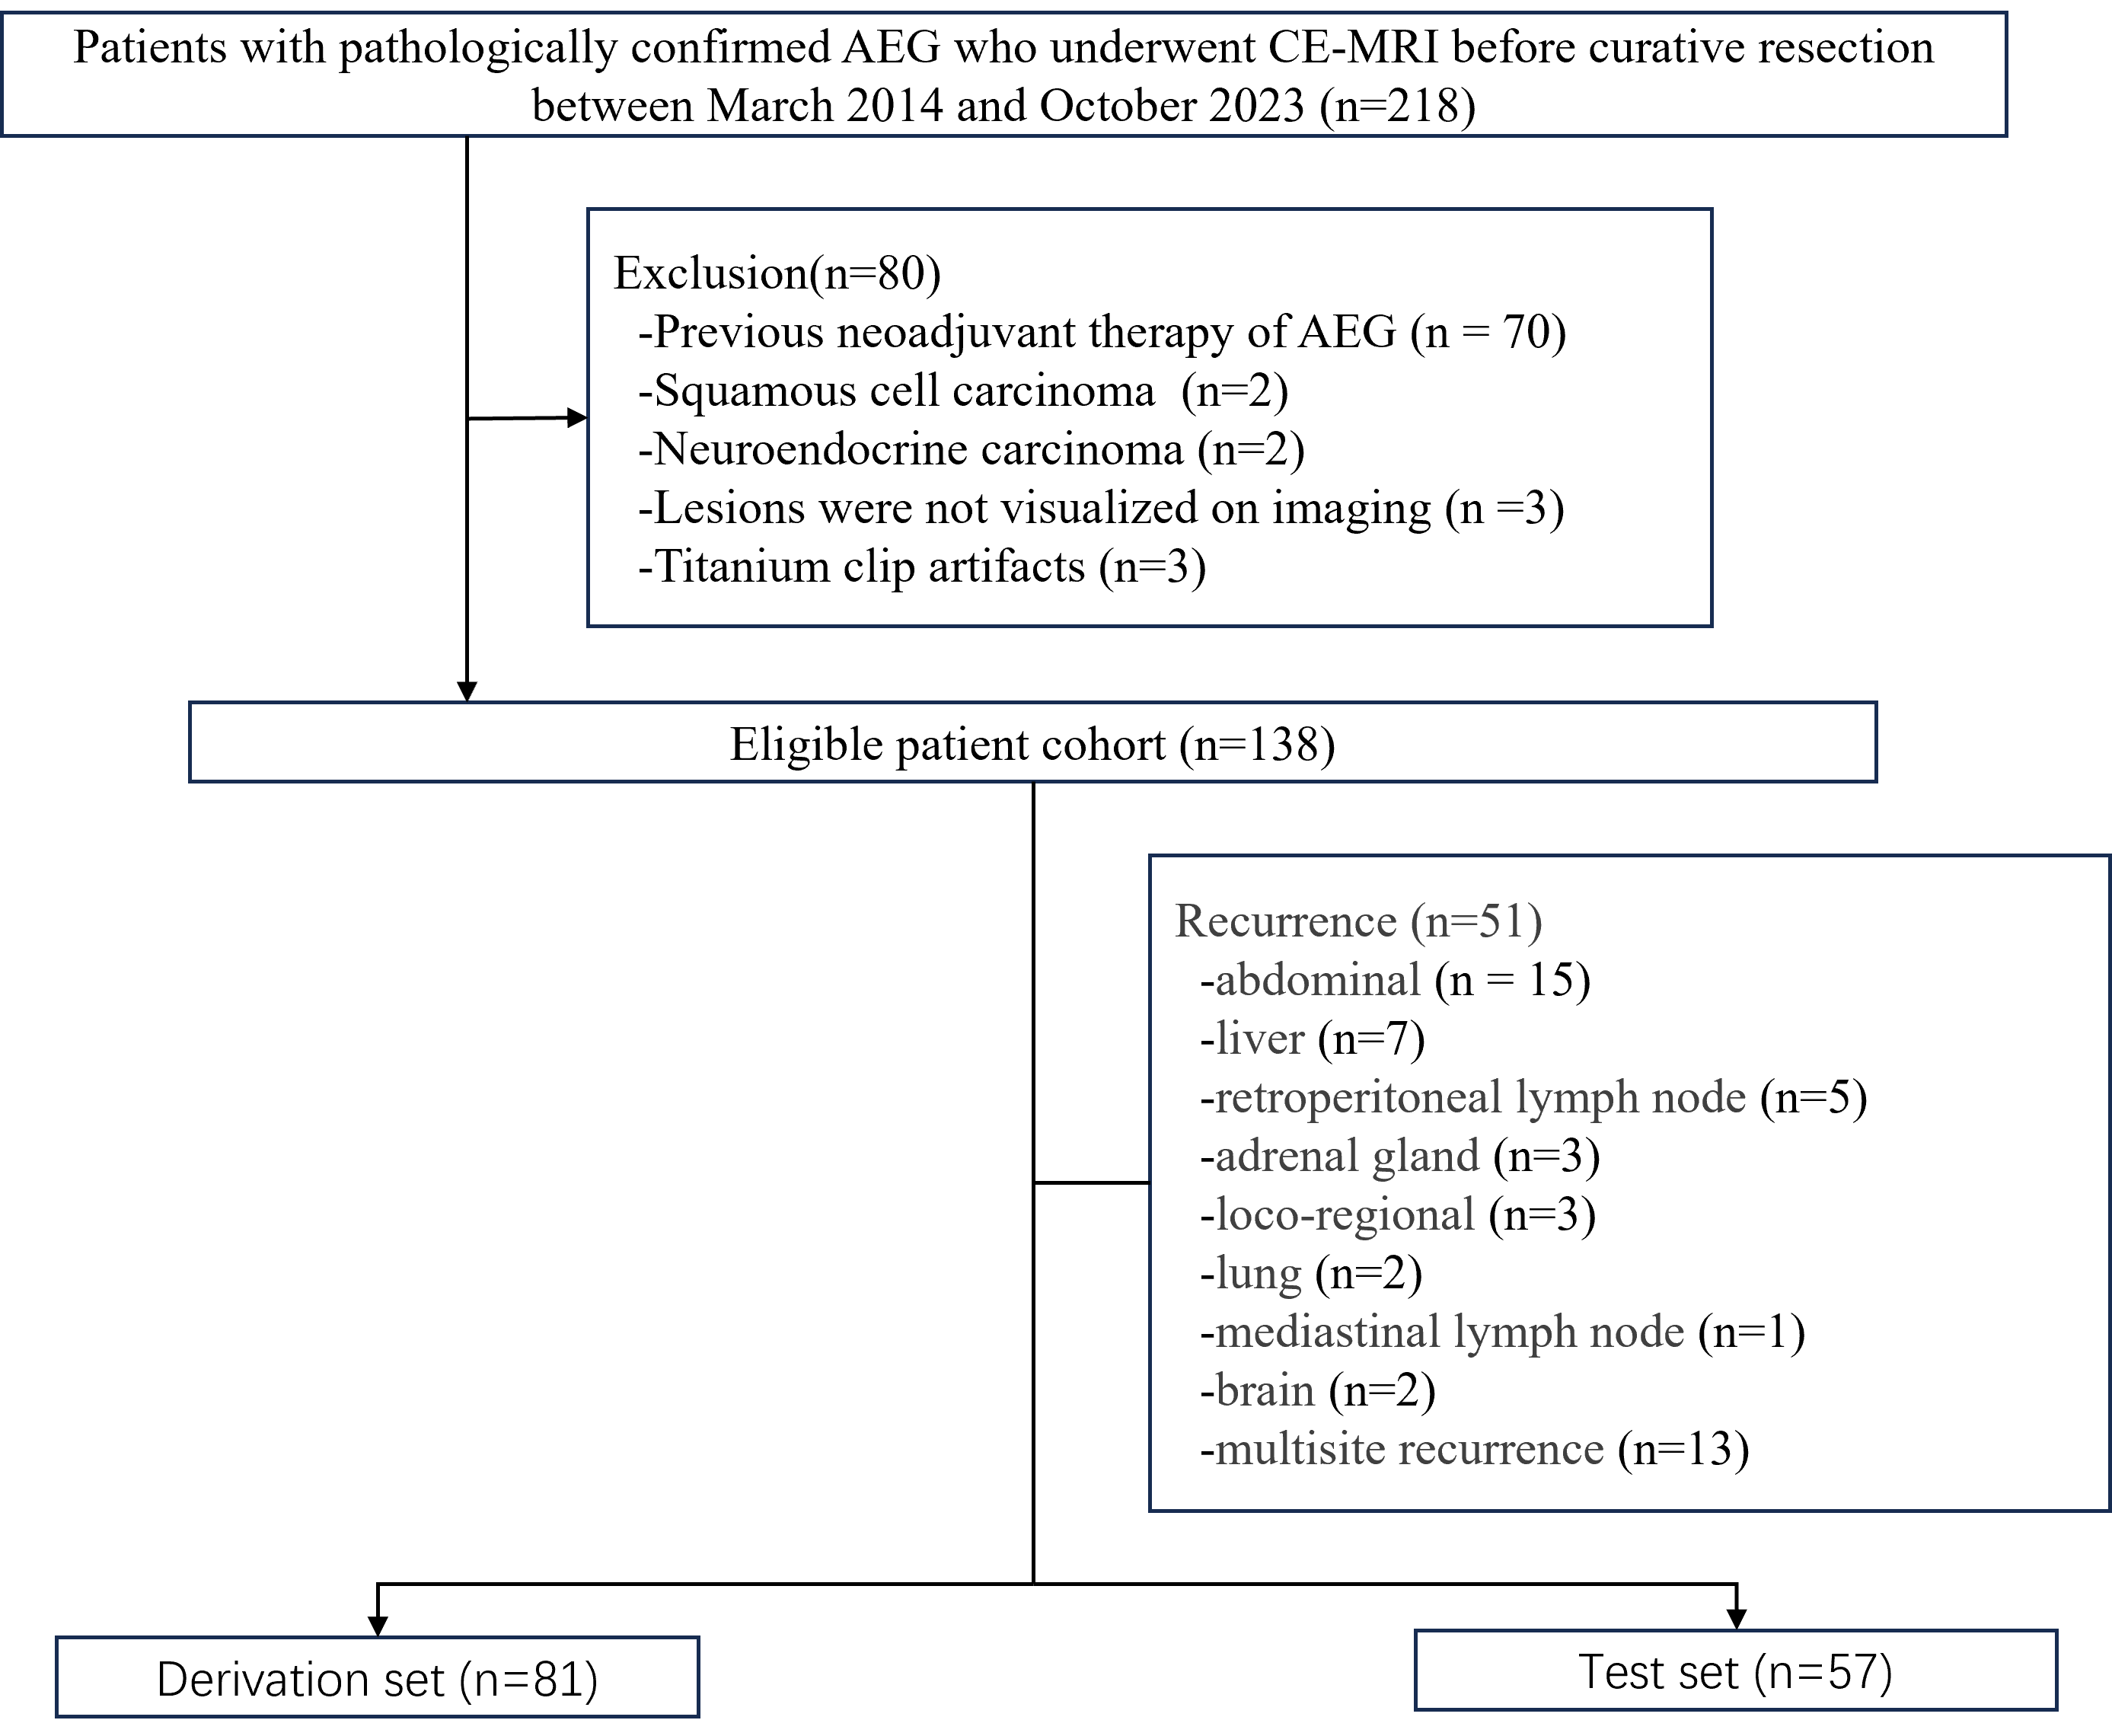

Fig. S1 Flowchart of patient selection and recurrence patterns.
CE-MRI=Contrast–enhanced Magnetic Resonance Imaging

