Figure S1. Food intake of each group.
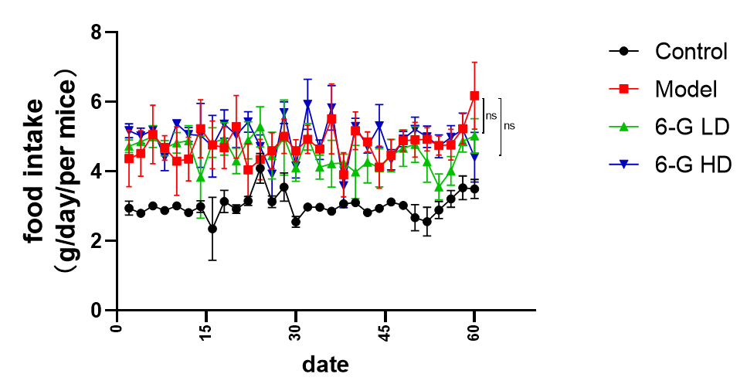
The data are presented as the means ± SEMs. ns p > 0.05 compare to model group.

