Supplemental Information

Figure S1 – Drone image of warming chambers and control plots at the Northern site of the Guana Tolomato Matanzas National Estuarine Research Reserve.
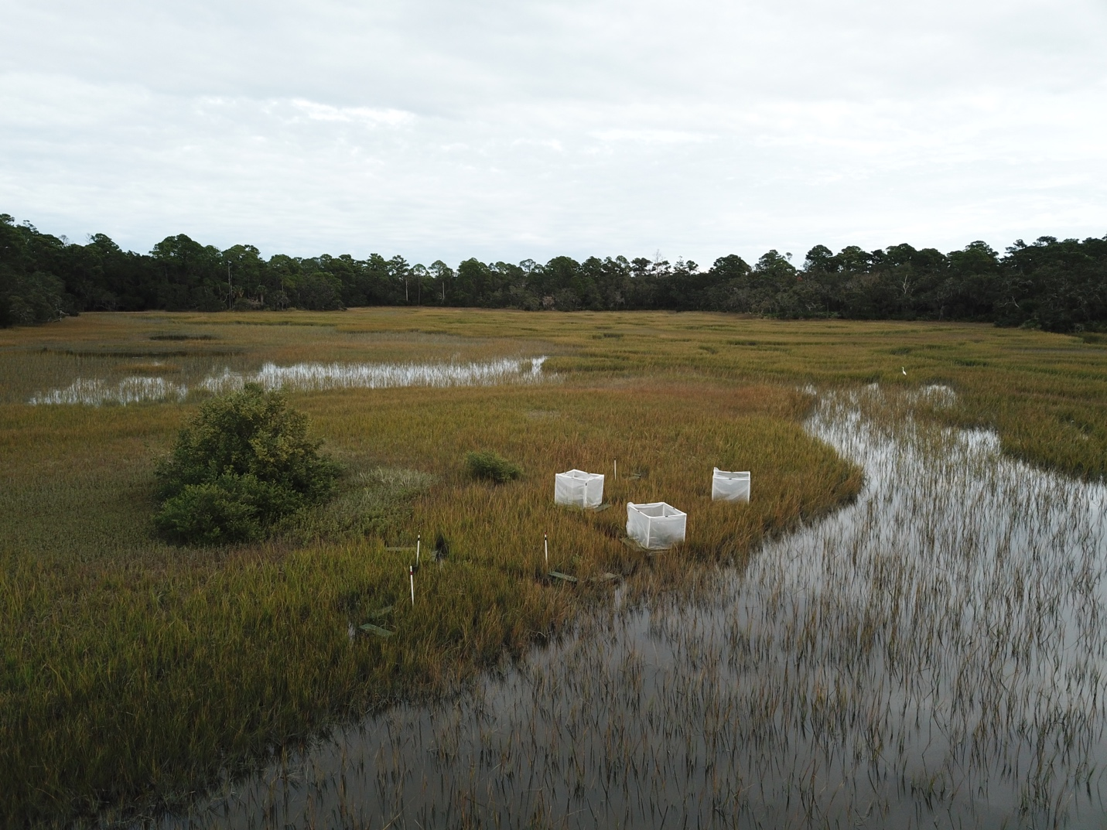

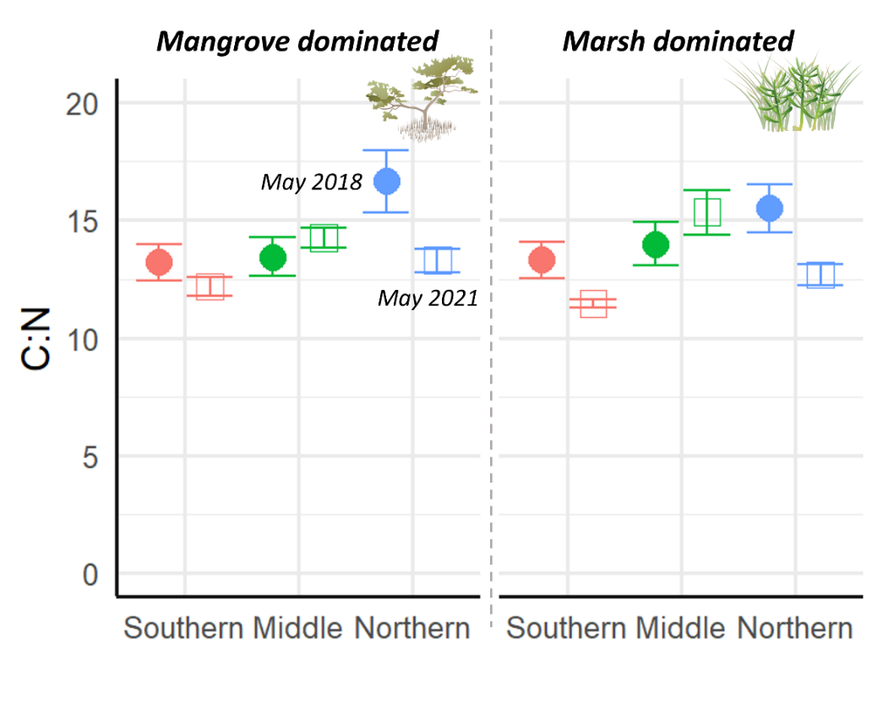
Figure S2. C:N ratio of soil at 5cm depth across sites, dominant vegetation, and year. Closed circles represent average 2018 values, and open squares represent average 2021 values. Error bars represent standard error (n = 6).

