Supplementary material for
“Real-time determination of earthquake focal mechanism via deep learning”

Prepared by Wenhuan Kuang^{1*}, Congcong Yuan², and Jie Zhang³

Summary
The supplement file contains description texts and figures to support the main manuscript.

Description texts
- Simulate the real data scenario.
In real practice, we may encounter situations where the data are contaminated and picked with uncertainties. In order to resemble real data and make the FMNet recognize these effects, we add realistic noise and random phase shifts within 10 seconds to the synthetics. One synthetic sample is displayed in Fig. S1a. It has been processed by filtering between 0.05 Hz to 0.1 Hz, aligning with the theoretical P-wave first arrivals, and normalizing to the maximum amplitude. We also add noise and random time shifts to this sample and show it in Fig. S1b. We perform this way for all synthetic samples and prepare them for training the FMNet.
- Evaluate the training performance
During the training, both training and validation losses are employed to evaluate the performance of the training process. Fig. S2 shows the distribution curves of the training (black) and validation (blue) losses with increasing iterations. The final training loss converges to a minimum of 0.001 and becomes stable. After 50 iterations, both the training and validation losses stabilize and hence we stop training there. Both converged loss functions demonstrate that the FMNet has been stably well-trained.
The goodness of fitting between true labels and predicted results of validation data is viewed as another metric to evaluate the performance of the training process. Fig. S3 shows an example of the fitting level between the true and predicted labels of the validation data after training. The very tiny differences between the true and predicted labels do not affect the results. We check over one thousand samples by random selections Therefore, we posit that the FMNet is already well-trained.
- Waveform comparison for quality control
We also compare the waveforms between real and synthetic data. We take the Mw 6.4 foreshock as an example. Fig. S4 shows the waveform comparison of the preprocessed real recordings (black) and the theoretical waveforms (red) using the predicted solution by the FMNet. Both waveforms have a good overlap with a large coefficient of 0.86.
- Waveform differences regarding different focal depths
The variations of earthquake depth cause very minor changes in waveforms. Fig. S5 shows the comparison of modeled waveforms at depths of 2 km (blue) and 18 km (green) with an identical source focal mechanism. The waveform differences are very minor. The current FMNet is challengingly difficult to recognize the tiny differences that represent different depths.
- Extracted features in feature domain by the encoder
The encoder can take any waveform as input and output the extracted data features with the size of 128$×1×1$. It is effective to transform the data domain to the feature domain. Fig. S6 shows several examples of the extracted features exported using the encoder. Each example corresponds to a training input with a different focal mechanism.
- FMNet labels
The training label is three Gaussian probability distributions, in which the maximum probability of each distribution corresponds to one component of the source focal mechanism (i.e. strike, dip, and rake). Fig. S7a shows an example of the output label for training data, with the strike, dip, and rake angles of 225˚, 35˚, and 40˚ (blue dashed lines), respectively. Fig. S7b shows an example of the predicted output label for testing the real data of the Mw 6.4 foreshock. The source focal mechanism can be easily derived by finding the peaks of the distributions.
- Testing the learning rate
The choice of learning rate may affect the convergence of the FMNet training and hence performance of the FMNet. We test different learning rates and keeping other factors the same. Fig S8 shows the final training losses for testing different learning rates. The performance of each learning rate is evaluated by the final training loss after the same training iterations. We pick the learning rate with the minimum training loss for this study.

Supplementary figures
(a)
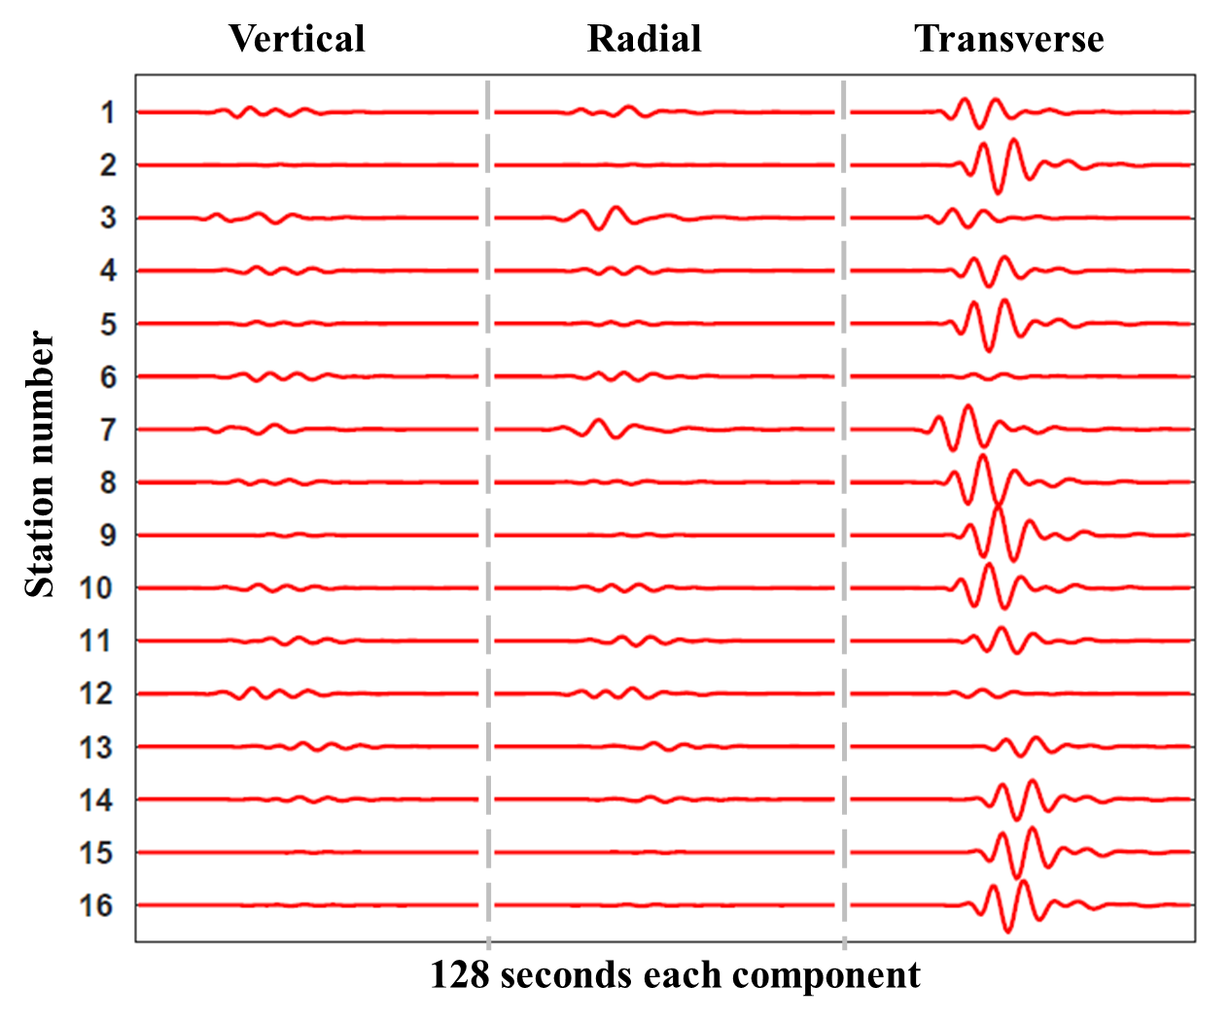
(b)
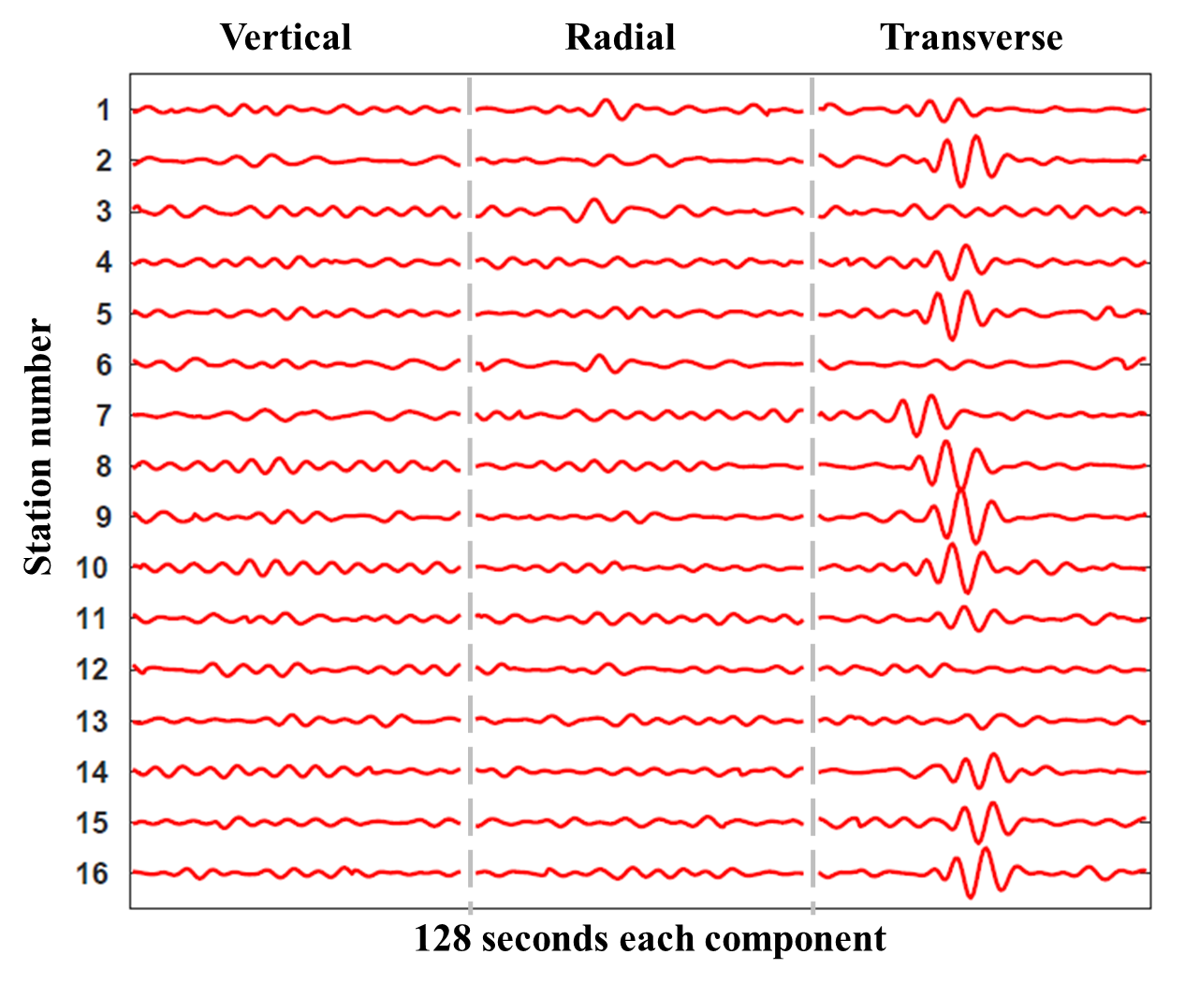
Fig. S1 Training data preparation. a The noise-free synthetic waveforms after filtering between 0.05 Hz to 0.1 Hz, alignment by P-wave first arrivals, and amplitude normalization. b The same synthetic example of a, but adding in noises from real recordings and random time shifts for each trace. The added random time shifts are to account for the picking errors.

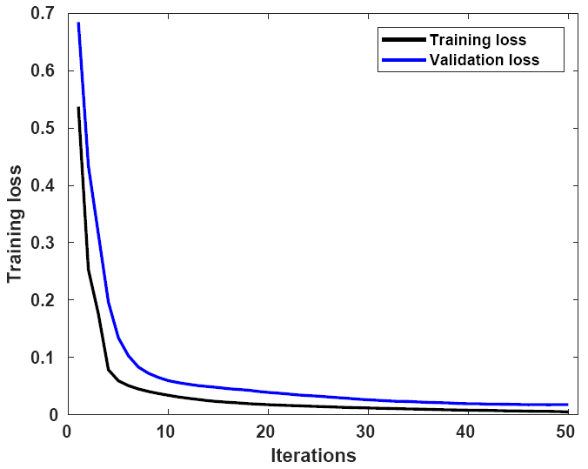
Fig. S2 Training and validation loss. The training loss (black) smoothly decreases from about 0.54 to a minimum of 0.001 and stabilizes. Meanwhile, the validation loss (blue) follows similar decreasing patterns but slightly larger than the training loss. After 50 iterations, both training and validation losses become stable, and hence more iterations are unnecessary.

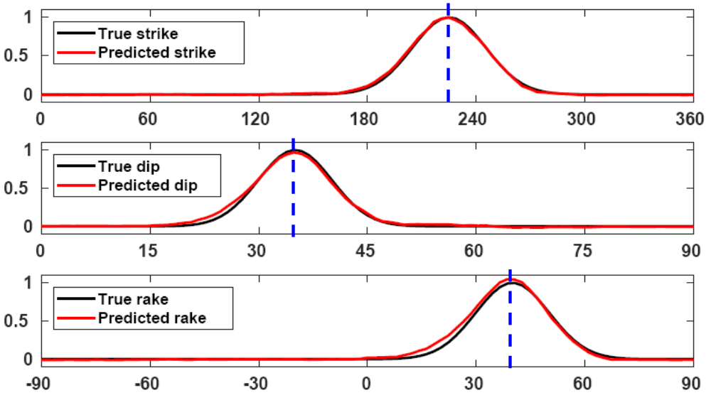
Fig. S3 FMNet training evaluation. An example showing the fitting level between the true (true) and the predicted (in red) labels for validation data. The labels are three Gaussian probability distributions, representing the strike, dip, and rake angles of a focal mechanism (see method section for details).

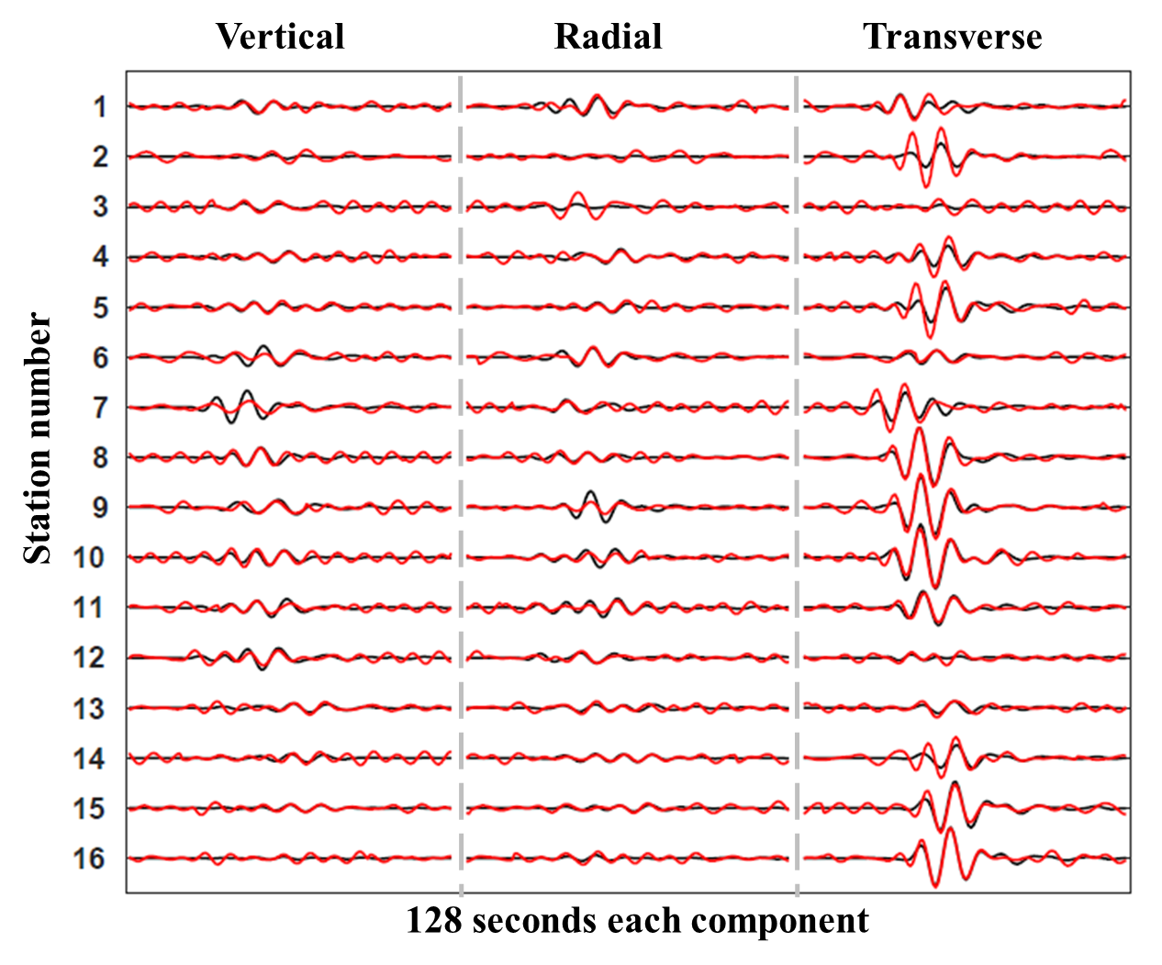
Fig. S4 Waveform comparison between real data and synthetic data. The real data (black) and the modeled synthetic data (red) using the predicted focal mechanism are shown for quality control purpose for the Mw 6.4 foreshock. The 3-C waveforms from 16 seismic stations are filtered between 0.05 Hz to 0.1 Hz, aligned with P-wave first arrivals, and normalized with the maximum amplitudes. Realistic noise is added to synthetic data to be consistent with the training data.

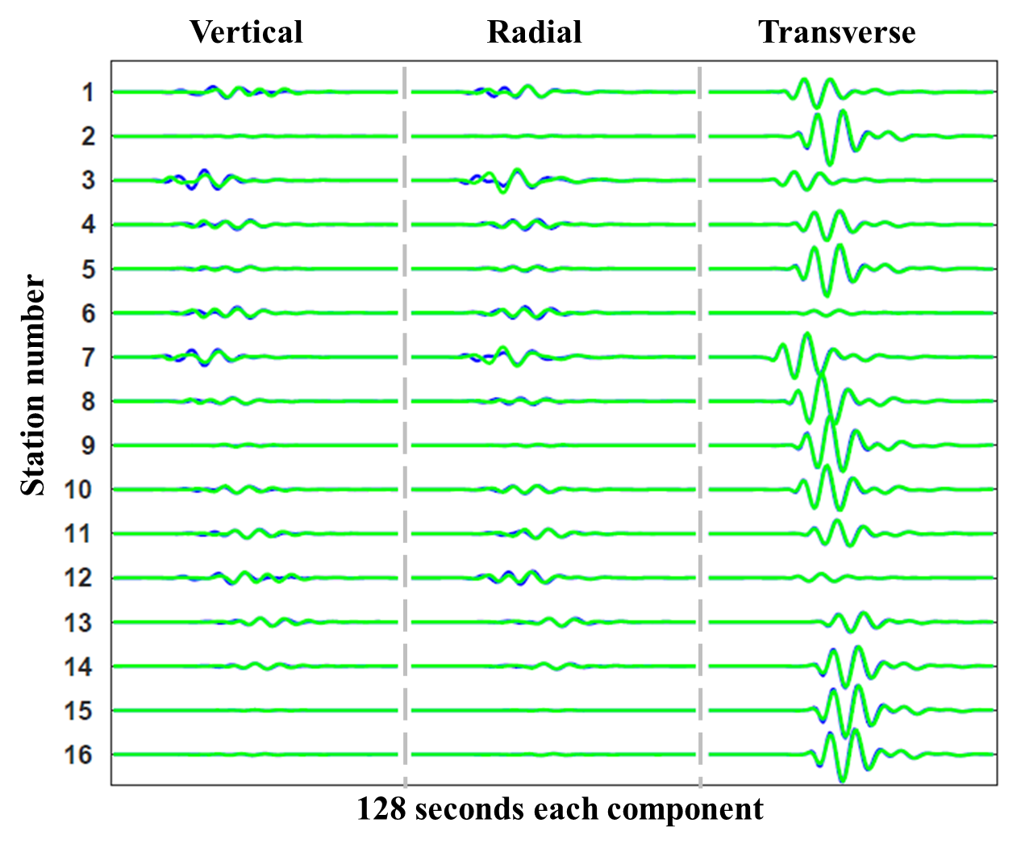
Fig. S5 Explaining the current limitation on focal depth. Using two focal depths of 2 km and 18 km while keeping other factors the same, we model the corresponding theoretical waveforms. The waveforms at different depths show minor differences and thus it is more challenging for the current FMNet to include focal depth.

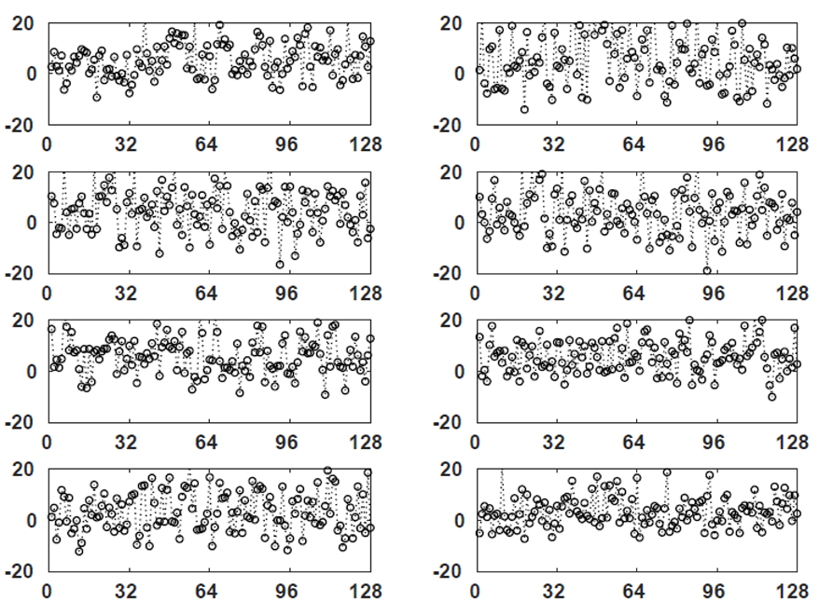
Fig. S6 Examples showing the extracted features of training data in feature domain using the encoder. The size of each example is 128$×$1$×$1. Each example corresponds to a training input with a different focal mechanism.

(a)
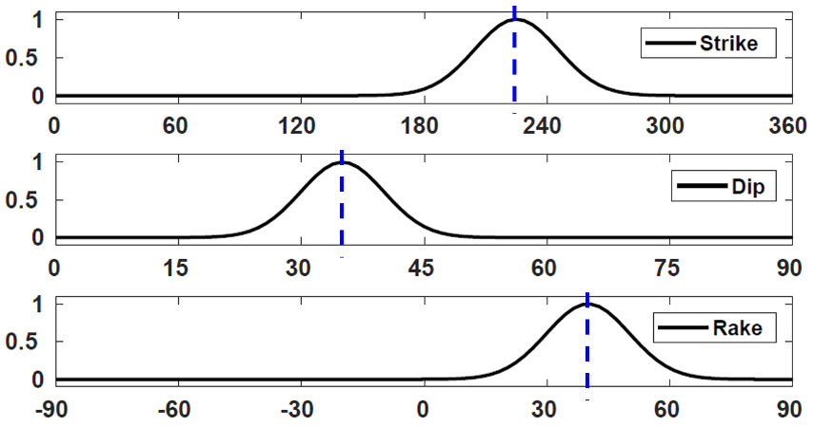

(b)
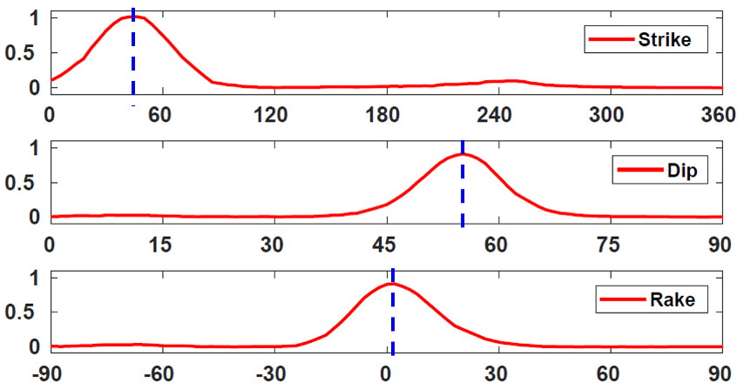

Fig. S7 FMNet labeling. a The true training labels of synthetic data. The labels are three Gaussian probability distributions, representing the strike, dip, and rake angles of a focal mechanism. The peaks of the Gaussian probability distributions correspond to the true values of the three angles (dashed blue lines). b The predicted output labels of the Mw 6.4 earthquake as an example. We can derive the predicted focal mechanism by finding the peaks of the predicted Gaussian probability distributions (dashed blue lines).

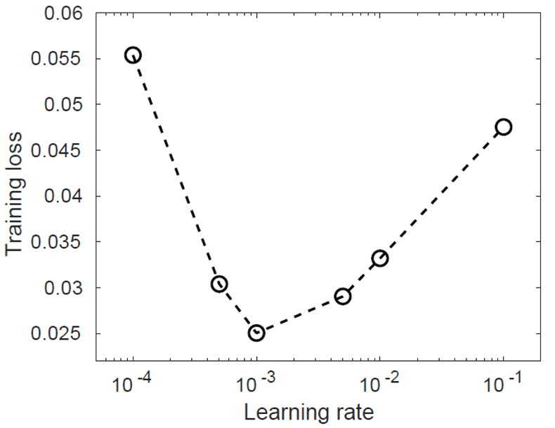
Fig. S8 Testing the learning rate. We test the learning rates on a logarithm parameterization while keeping other factors the same. 50 iterations are implemented. For each test, the final training loss at the last iteration is used to evaluate the convergence level. This test is done on a smaller training set to find the best training parameters.

