Supplementary Figures
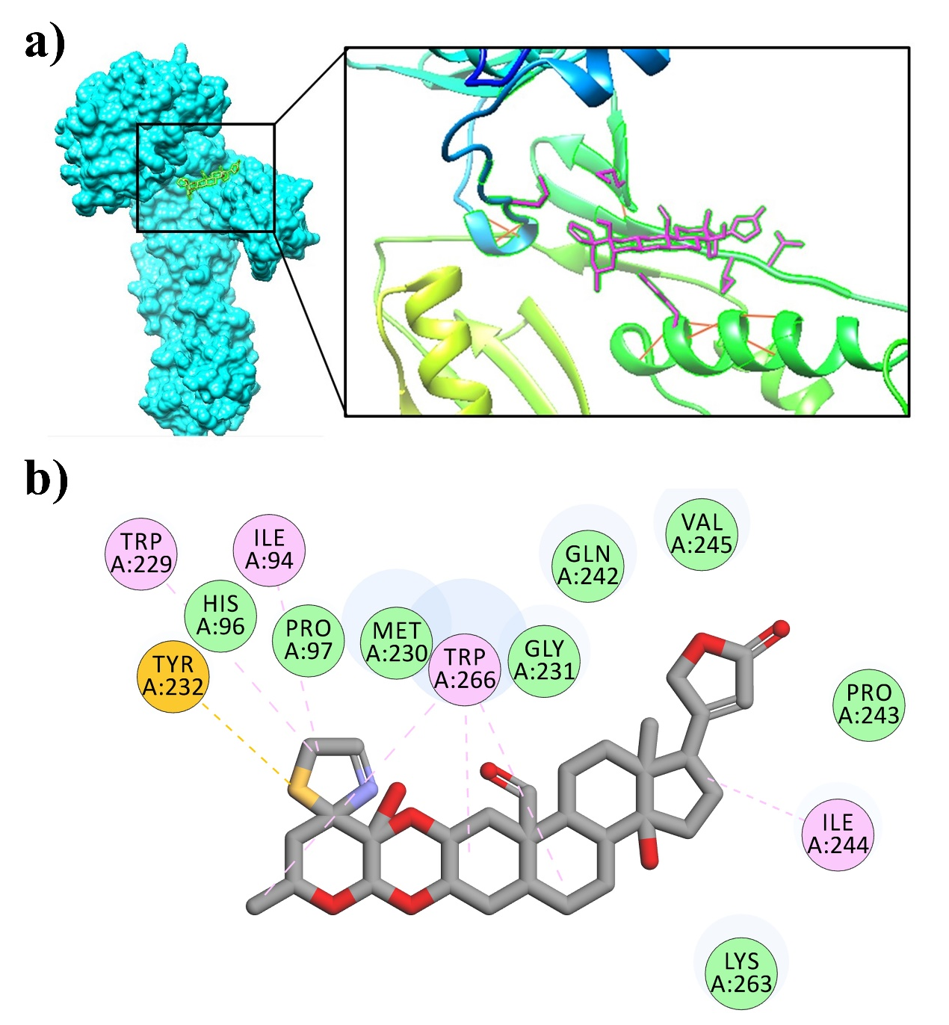

Supplementary Fig. 1 Binding mode for 2-oxovorucharin with HIV-1 RT
(PDB ID 1JLB)
a) Ligand is shown in "Stick" format and green color whereas the HIV-1 RT is shown in "Surface" format. b) 2D images generated using discovery studio 4.1 Visualizer showing amino acid residues involved in interactions between ligand and enzyme.

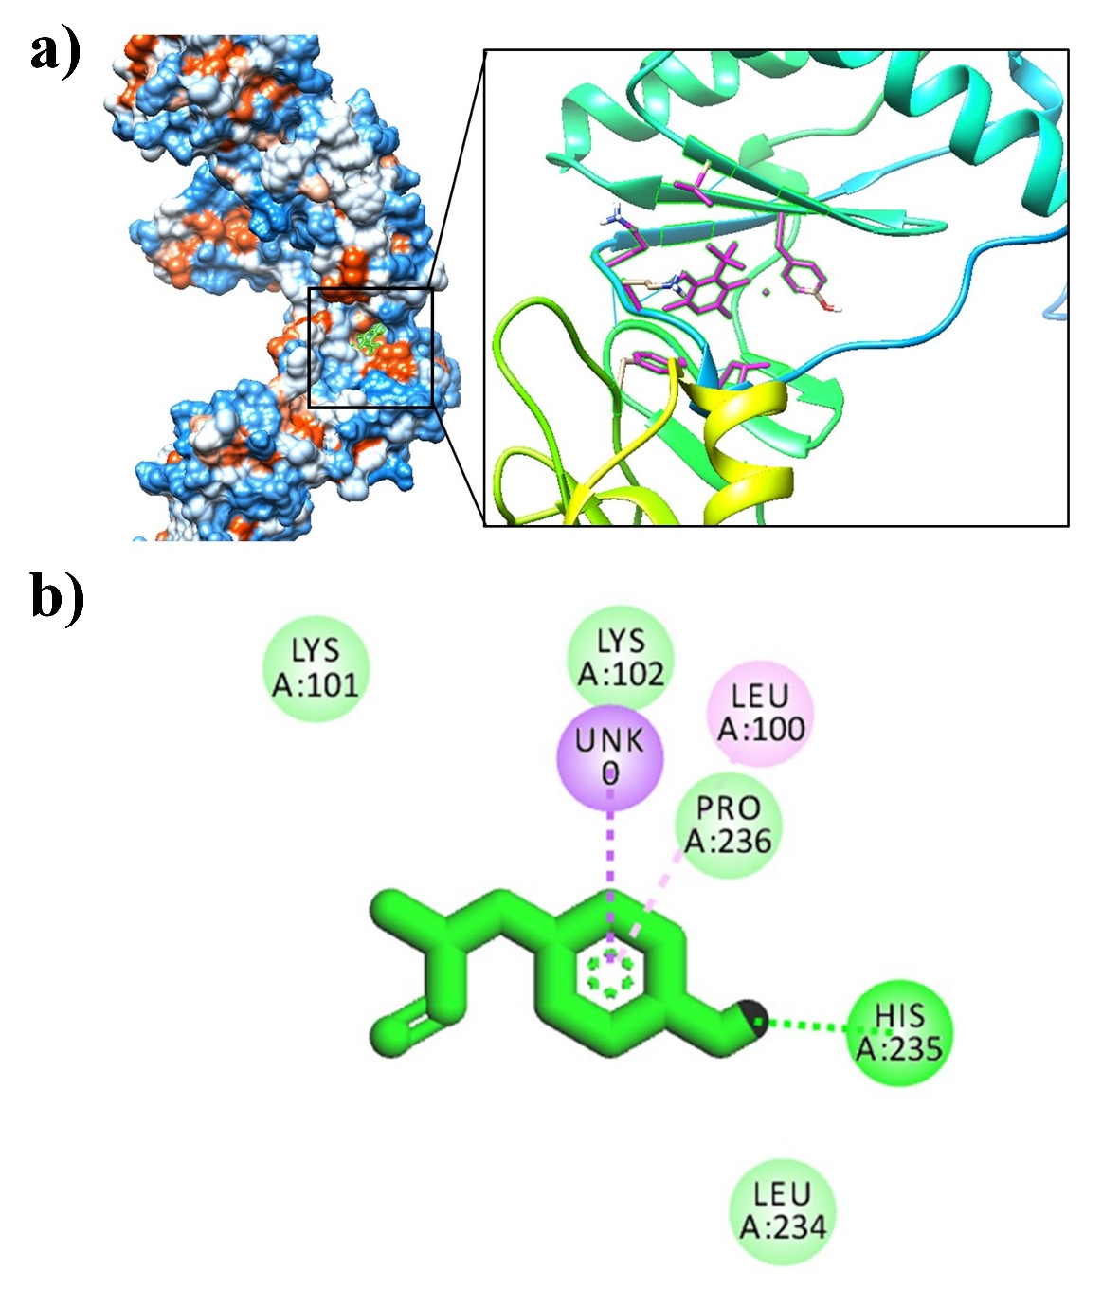

Supplementary Fig. 2 Binding mode for α-Amyrinacetate with HIV-1 RT (PDB ID 1JLB)
a) Ligand is shown in "Stick" format and green color whereas the HIV-1 RT is shown in "Surface" format. b) 2D images generated using discovery studio 4.1 Visualizer showing amino acid residues involved in interactions between ligand and enzyme.

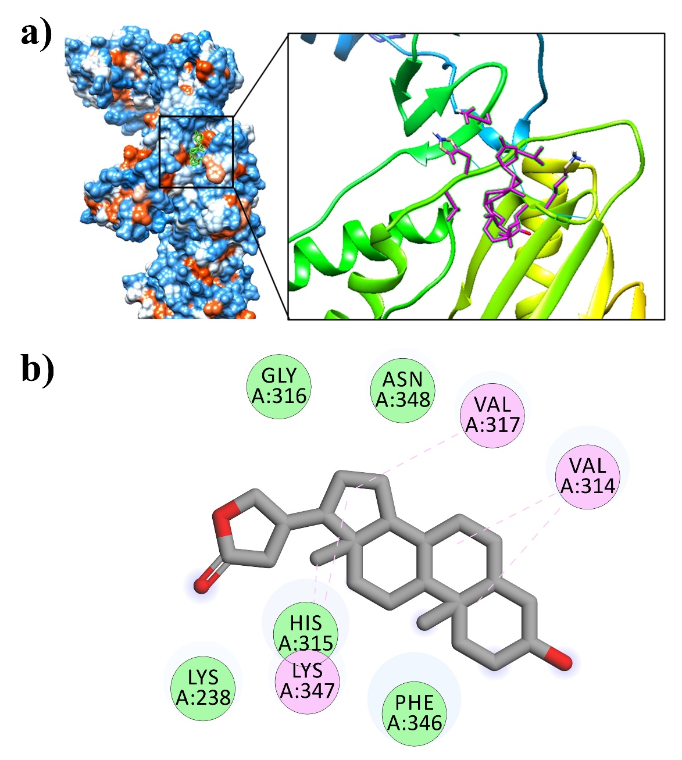

Supplementary Fig. 3 Binding mode for ß-Anhydroepidigitoxigenin with HIV-1 RT (PDB ID 1JLB)
a) Ligand is shown in "Stick" format and green color whereas the HIV-1 RT is shown in "Surface" format. b) 2D images generated using discovery studio 4.1 Visualizer showing amino acid residues involved in interactions between ligand and enzyme.

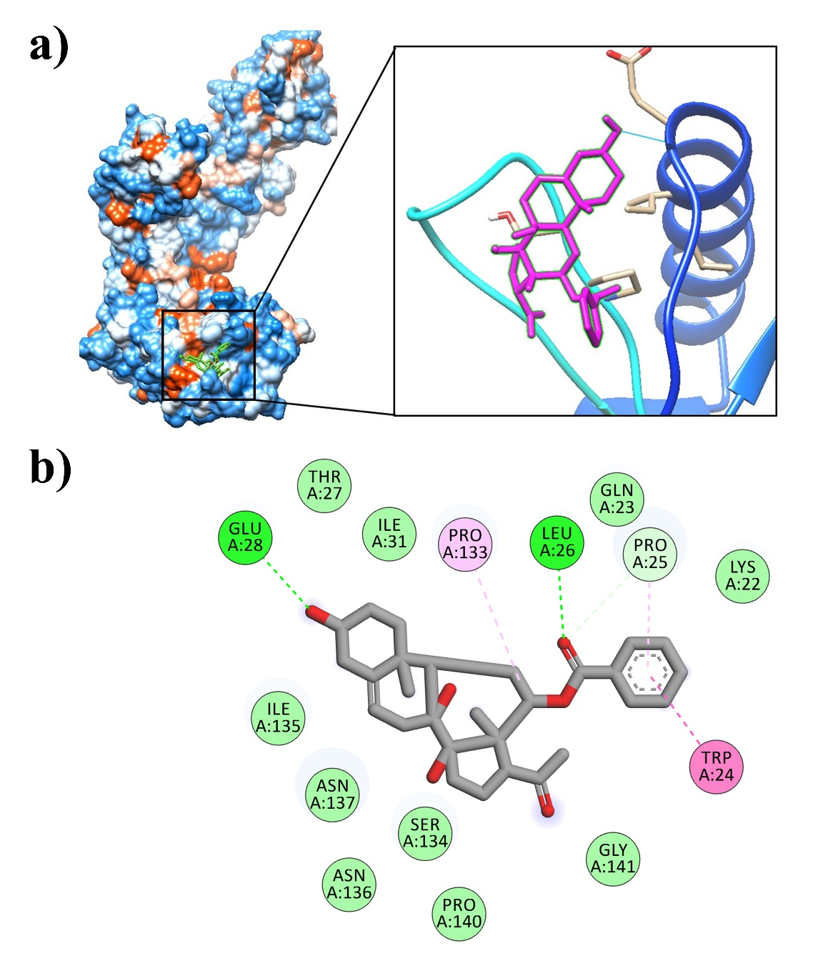

Supplementary Fig. 4 Binding mode for benzoyllineolone with HIV-1 RT (PDB ID 1JLB)
a) Ligand is shown in "Stick" format and green color whereas the HIV-1 RT is shown in "Surface" format. b) 2D images generated using discovery studio 4.1 Visualizer showing amino acid residues involved in interactions between ligand and enzyme.

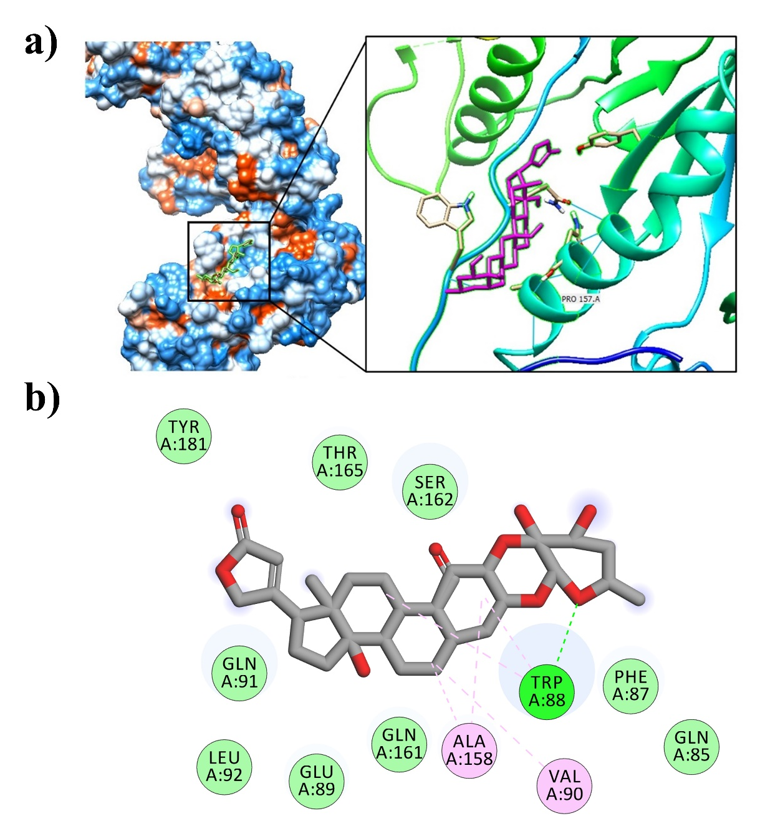

Supplementary Fig. 5 Binding mode for calotropin with HIV-1 RT (PDB ID 1JLB)
a) Ligand is shown in "Stick" format and green color whereas the HIV-1 RT is shown in "Surface" format. b) 2D images generated using discovery studio 4.1 Visualizer showing amino acid residues involved in interactions between ligand and enzyme.

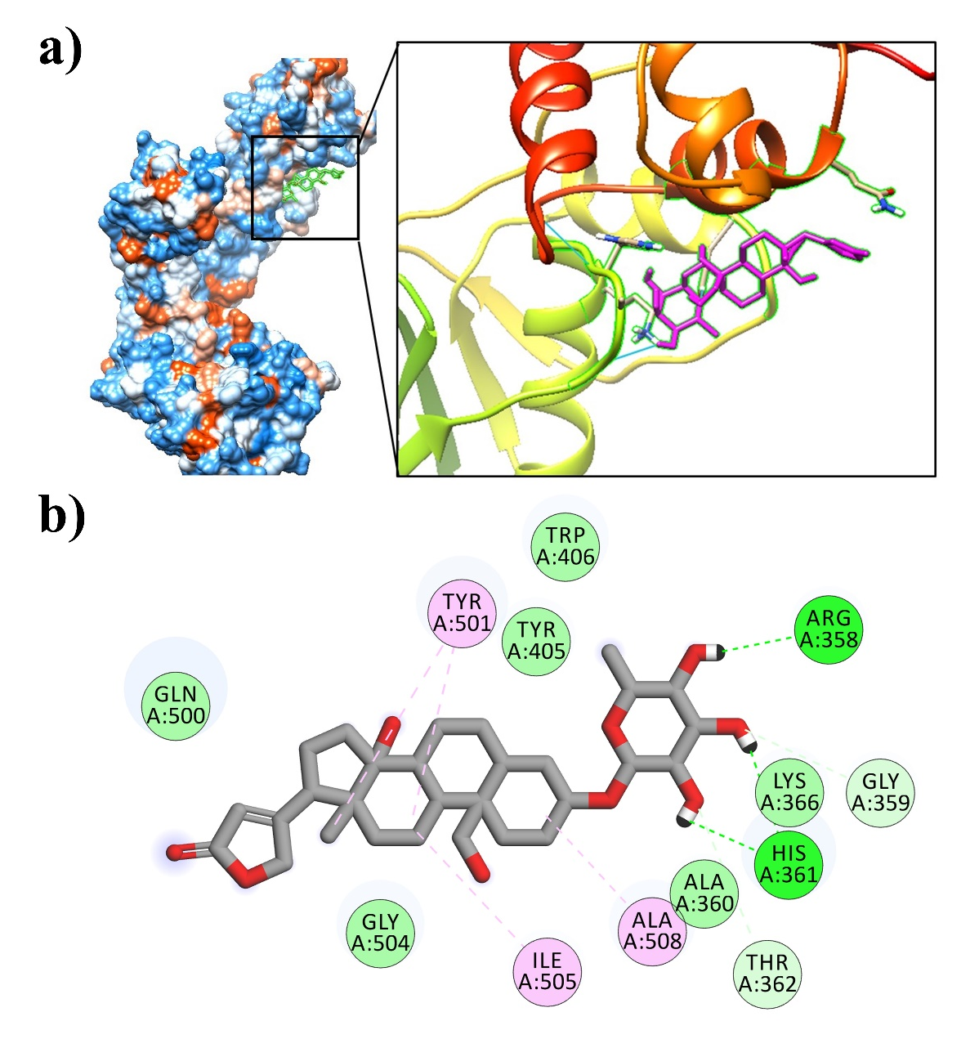

Supplementary Fig. 6 Binding mode for Frugoside with HIV-1 RT (PDB ID 1JLB)
- Ligand is shown in "Stick" format and green color whereas the HIV-1 RT is shown in "Surface" format. b) 2D images generated using discovery studio 4.1 Visualizer showing amino acid residues involved in interactions between ligand and enzyme.

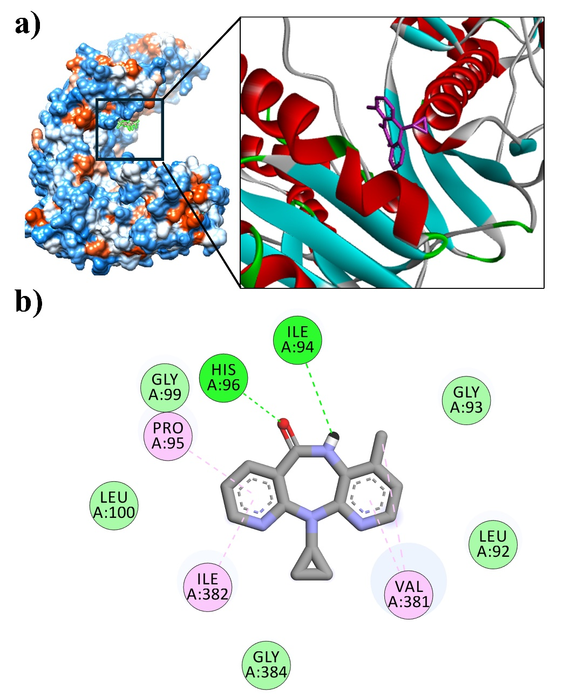

Supplementary Fig. 7 Binding mode for Nevirapine (reference drug) with HIV-1 RT (PDB ID 1JLB)
a) Ligand is shown in "Stick" format and green color whereas the HIV-1 RT is shown in "Surface" format. b) 2D images generated using discovery studio 4.1 Visualizer showing amino acid residues involved in interactions between ligand and enzyme.

