Table 1 The chemical compounds of C. procera considered in the present study

Sl.No | Phytochemical Compound Name  (PubChem ID) | Structure
1 | 2-oxovorucharin (CID:11261800) | 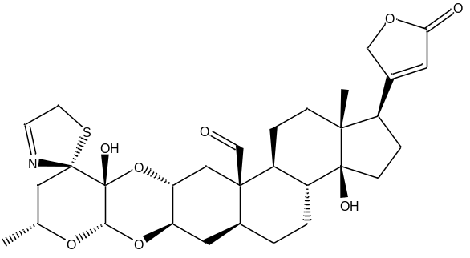
2 | α-amyrin (CID:73170) | 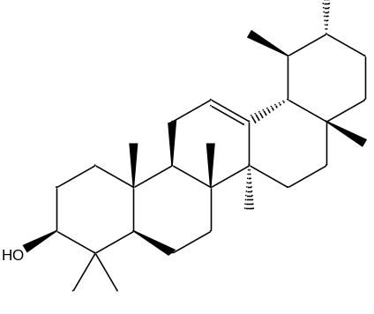
3 | α -Amyrinacetate (CID:19019008) | 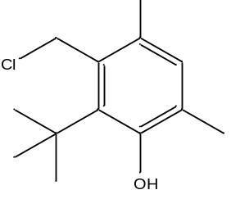
4 | ß-Anhydroepidigitoxigenin (CID:272842500) | 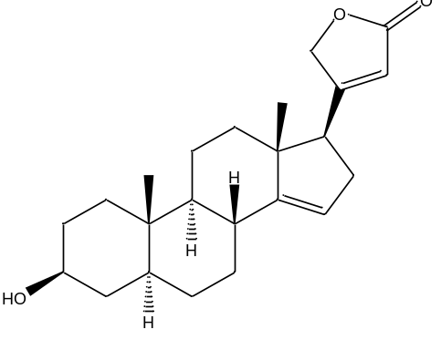
5 | Benzoyllineolone (CID:9982084) | 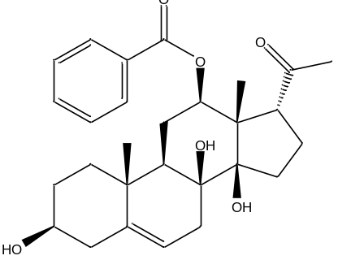
6 | Calotropin  (CID:16142) | 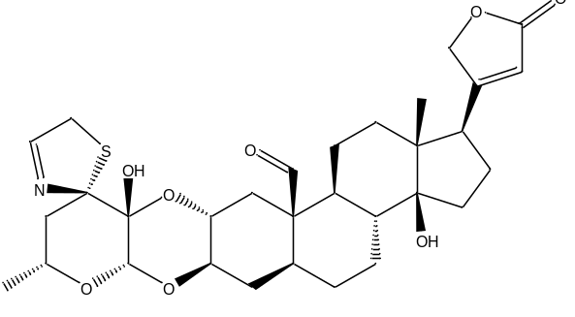
7 | Frugoside  (CID:120728) | 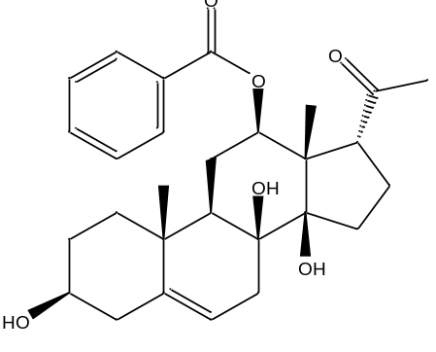
8 | Nevirapine  (CID:4463;  Reference drug) | 