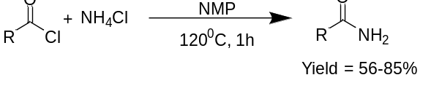
Scheme 1. Preparation of amide by reaction of acid halide with ammonium halide.

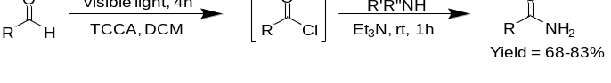
Scheme 2. Preparation of amide from aldehyde group.

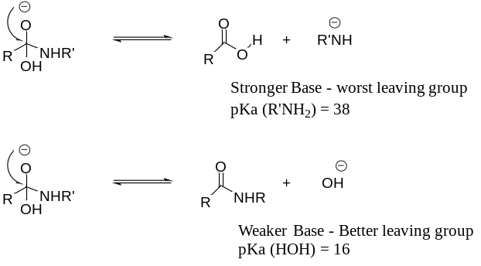
Scheme 3. Reaction showing the different leaving groups in the presence of strong and weak base.

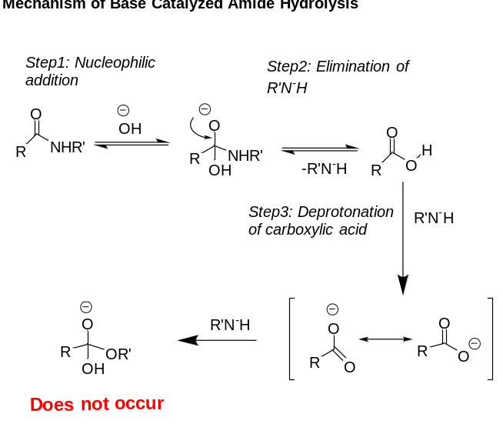
Scheme 4. Mechanism of base catalyzed amide hydrolysis.

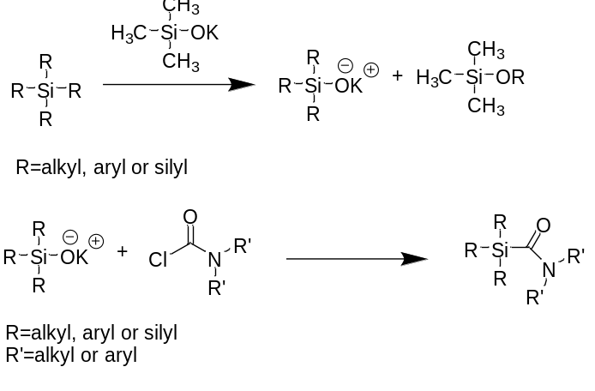
Scheme 5. synthesis of tris(trimethylsily)silylamides (TTSAs).

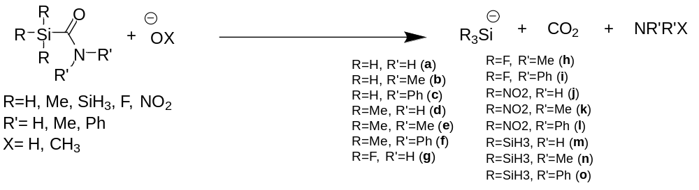
Scheme 6. Reaction of silyl amides with the bases.

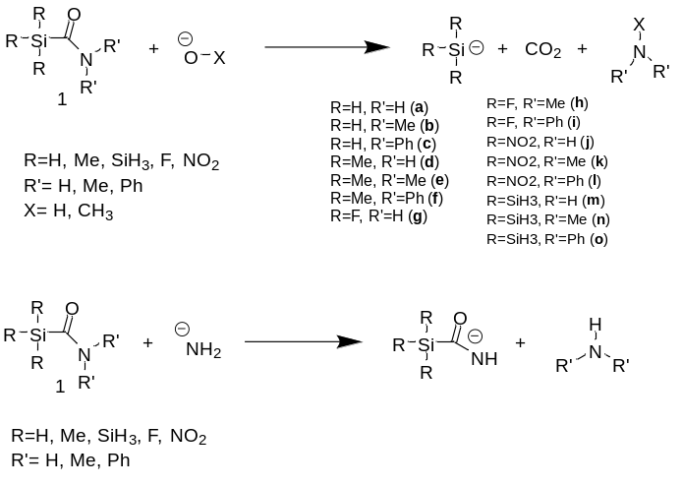
Scheme 7. Reaction of silyl amide containing different substituents with a general base (above), and an amide base (below).

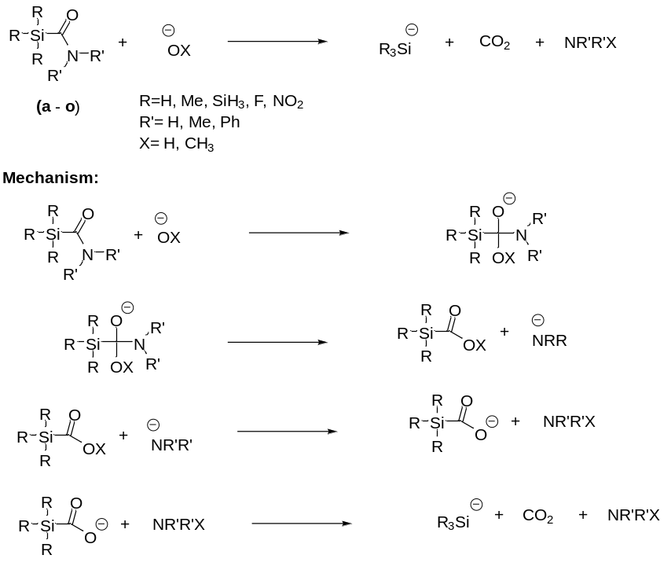

Scheme 7. General reaction and mechanism of silyl amide containing different substituents from a to b.

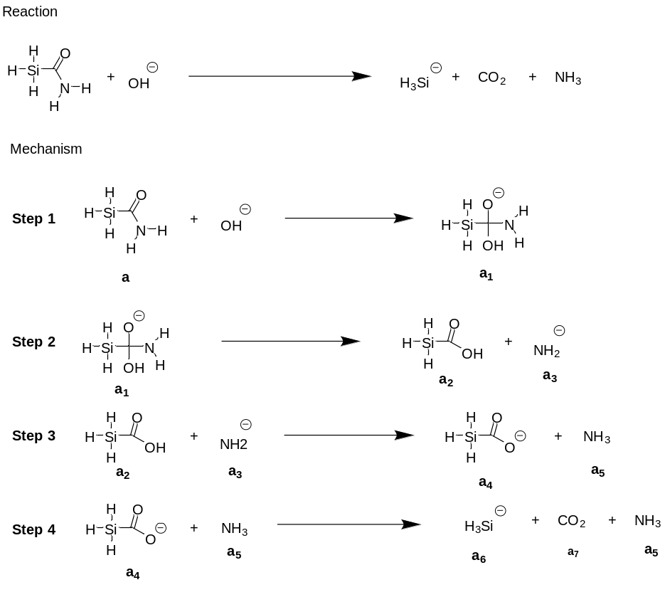
Scheme 8. Reaction of a with base ⁻OH and mechanism.

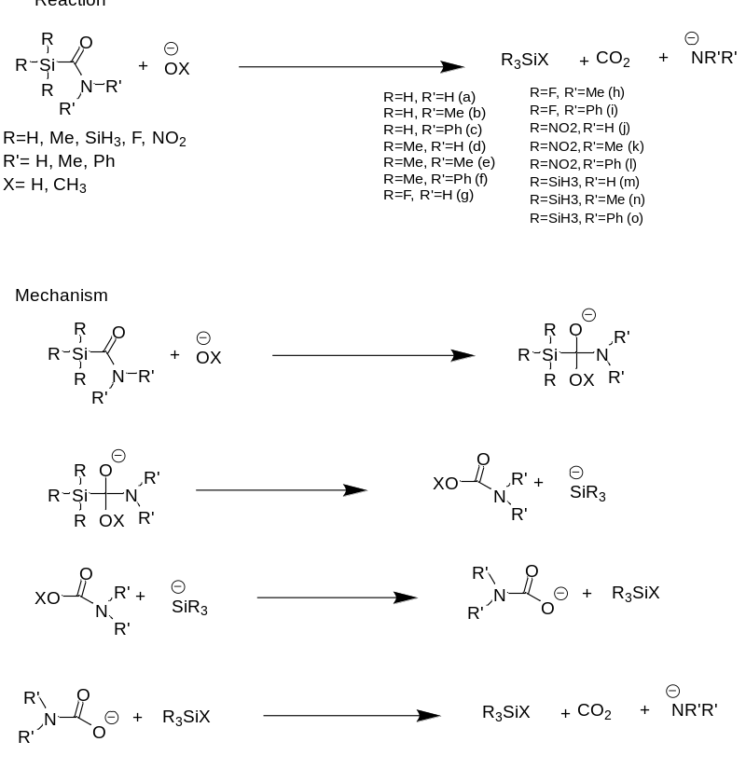

Scheme 9. Mechanism of silyl amide with base.

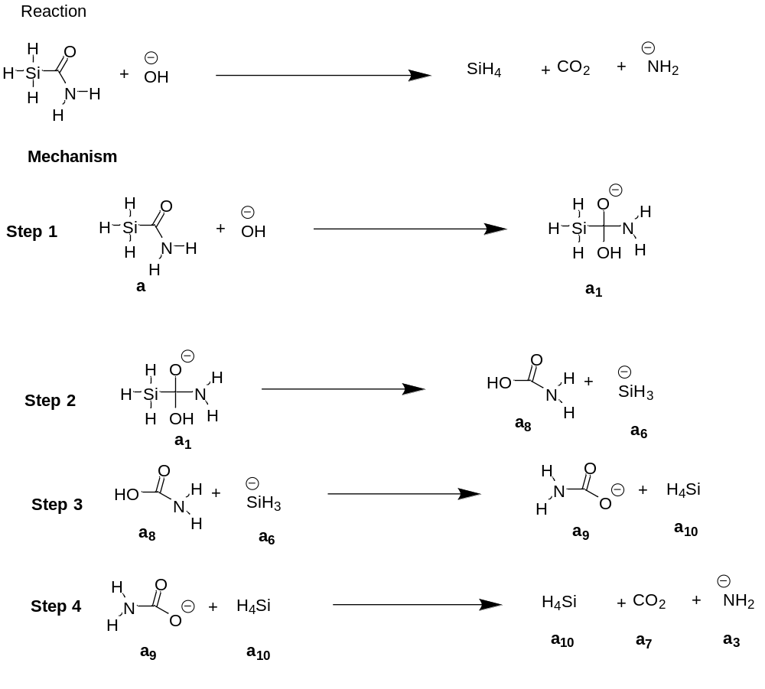

Scheme 10. Mechanism of reaction of silyl amide with R=R’=H with base ⁻OH.

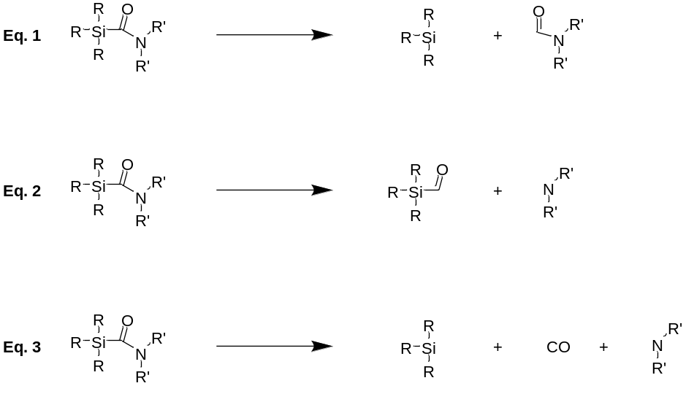
Scheme 11: Fragmentation of silyl amide for BDE analysis.

