Supplementary Information

Glymphatic System Assessment Using Diffusion Tensor Images: Introducing the New-ALPS Index Through Genetic Programming

Ahmadali Jamali^{1†}, Majid Abbasi Sisara^{2†}, Elahe Kazeminasab¹, Debby Van Dam^{3,4*}, Mahmood Amiri^{1,5 *}
†These authors contributed equally to this work.
1 Medical Technology Research Center, Institute of Health Technology, Kermanshah University of Medical Sciences, Kermanshah, Iran.

2 Division of Biokinesiology and Physical Therapy, University of Southern California, Alcazar Street, Los Angeles, 9006, CA, USA.

3 Laboratory of Neurochemistry and Behavior, Experimental Neurobiology Unit, Department of Biomedical Sciences, University of Antwerp, Antwerp, Belgium.
4 Department of Neurology and Alzheimer Research Center, University of Groningen and University Medical Center Groningen, Groningen, the Netherlands.
5 Department of Engineering Management, University of Antwerp, Antwerp, Belgium

* Corresponding authors
Mahmood Amiri
Medical Technology Research Center, Institute of Health Technology, Kermanshah University of Medical Sciences, Kermanshah, Iran
Department of Engineering Management, University of Antwerp, Antwerp, Belgium
Email: Ma_amiri_bme@yahoo.com
Email: Mahmood.amiri @uantwerpen.be

Fig. S1. Fiber diffusivities vs. MMSE scatter plot

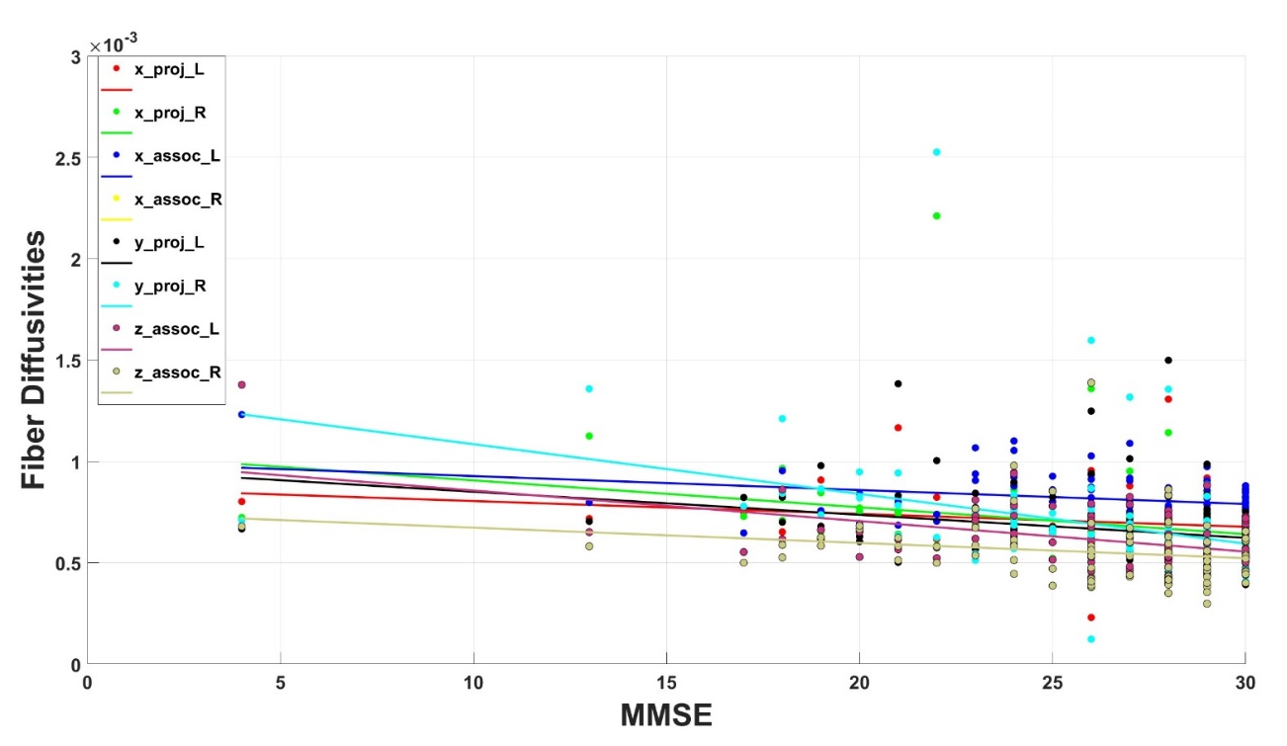

Fig. S2. Fiber diffusivities vs. CDR scatter plot.

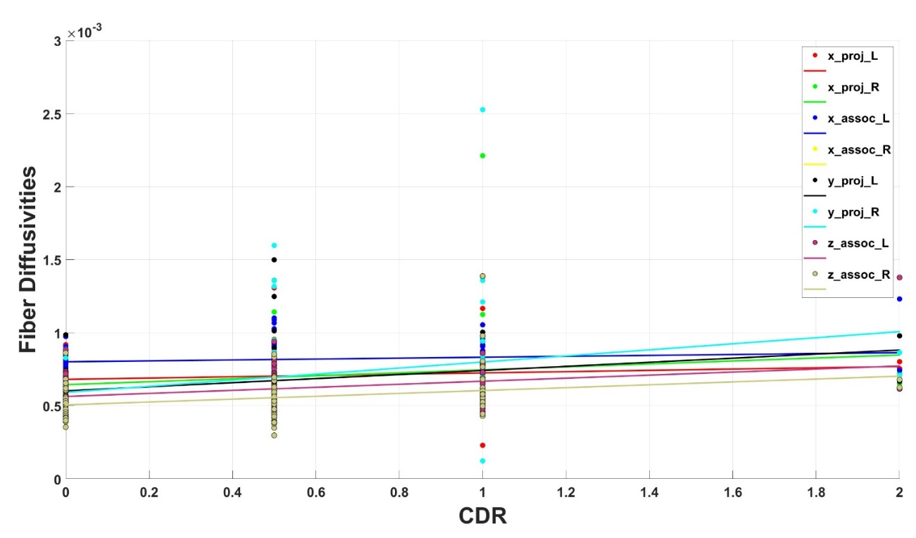

Fig. S3. Fiber diffusivities vs. FAQ scatter plot.

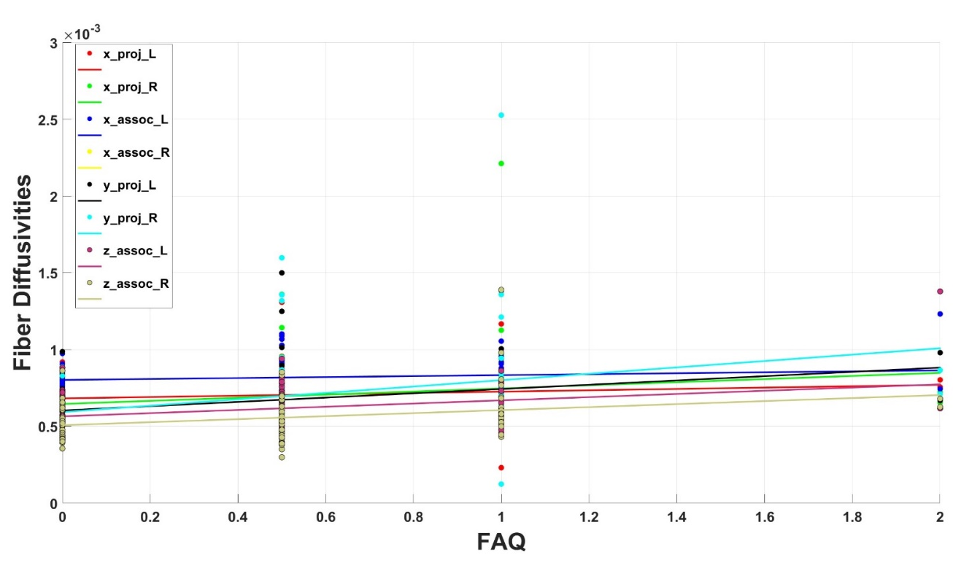

Fig. S4. Fiber diffusivities vs. PSQI scatter plot.

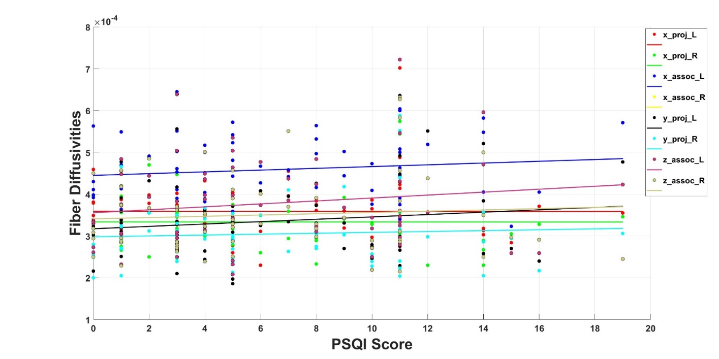

Table S1. Demographic information of ADNI dataset that was used for generating New-ALPS index.

Group | Images n.  Subject n. | Sex |  | Age |  | Test score (All group)
Group | Images n.  Subject n. | F | M | Range | Mean std | Type | Range | Mean  std | p-value  PCC
 |  |  |  |  |  |  |  |  | New (S) | New(m)
AD | 22  19 | 9  8 | 13  11 | Min= 64.3  Max=91.5 | Mean=75.61  Std=7.13 | MMSE | Min= 4  Max=30 | 21.5  4.970367 | p-value: 0.00007  PCC:  0.386815 | p-value: 0.000128  PCC:  0.3738
 |  |  |  |  |  |  |  | 26.41463  2.871012 | p-value: 0.00007  PCC:  0.386815 | p-value: 0.000128  PCC:  0.3738
MCI | 41  29 | 21  16 | 20  13 | Min= 61  Max=88.5 | Mean=76.5  Std=7.9 | MMSE | Min= 4  Max=30 | 29.05405  1.137706 | p-value: 0.00007  PCC:  0.386815 | p-value: 0.000128  PCC:  0.3738
 |  |  |  |  |  | CDR | Min= 0  Max=2 | 0.977273  0.383681 | p-value:  0.000008  PCC:  -0.42888 | p-value:  0.000014  PCC:  -0.41916
 |  |  |  |  |  |  |  | 0.54878  0.184948 | p-value:  0.000008  PCC:  -0.42888 | p-value:  0.000014  PCC:  -0.41916
NC | 37  19 | 28  12 | 9  7 | Min= 65.9  Max=90.1 | Mean=73.8  Std=5.55 | CDR | Min= 0  Max=2 | 0.013514  0.081081 | p-value:  0.000008  PCC:  -0.42888 | p-value:  0.000014  PCC:  -0.41916
 |  |  |  |  |  | FAQ | Min= 0  Max=30 | 18.36364  7.119407 | p-value:  0.00001  PCC:  -0.42563 | p-value:  0.000014  PCC:  -0.418743
All Group | 100  67 | 58  36 | 42  31 | Min= 61  Max=91.5 | Mean=75.3  std=7.04 | FAQ | Min= 0  Max=30 | 5.097561  7.104807 | p-value:  0.00001  PCC:  -0.42563 | p-value:  0.000014  PCC:  -0.418743
 |  |  |  |  |  |  |  | 0.135135  0.664227 | p-value:  0.00001  PCC:  -0.42563 | p-value:  0.000014  PCC:  -0.418743

Table S2. Demographic information of ADNI dataset that was used as test data.

Group | Images n.  Subject n. | Sex |  | Age |  | Test score (All group)
Group | Images n.  Subject n. | F | M | Range | Mean std | Type | Range | Mean  std | p-value  PCC
 |  |  |  |  |  |  |  |  | New (S) | New(m)
AD | 11  10 | 5  4 | 6  6 | Min= 66  Max=84.3 | Mean=75.95  Std =6.37 | MMSE | Min=15  Max=30 | 22.09091  3.47601 | p-value:  0.007471  PCC:  0.373941 | p-value:  0.007512  PCC:  0.3737
 |  |  |  |  |  |  |  | 25.95  2.43875 | p-value:  0.007471  PCC:  0.373941 | p-value:  0.007512  PCC:  0.3737
MCI | 20  13 | 10  6 | 10  7 | Min= 72.5  Max= 93.6 | Mean=80.88  Std=5.76 | MMSE | Min=15  Max=30 | 28.84211  1.22531 | p-value:  0.007471  PCC:  0.373941 | p-value:  0.007512  PCC:  0.3737
 |  |  |  |  |  | CDR | Min= 0  Max=2 | 1.045455  0.334021 | p-value:  0.003248  PCC:  -0.408256 | p-value:  0.004066  PCC:  -0.399351
NC | 19  13 | 10  7 | 9  6 | Min= 68.4  Max= 85.1 | Mean=74.98  Std= 4.24 | CDR | Min= 0  Max=2 | 0.55  0.15 | p-value:  0.003248  PCC:  -0.408256 | p-value:  0.004066  PCC:  -0.399351
 |  |  |  |  |  |  |  | 0.026316  0.111648 | p-value:  0.003248  PCC:  -0.408256 | p-value:  0.004066  PCC:  -0.399351
 |  |  |  |  |  | FAQ | Min= 0  Max=26 | 18.54545  5.821022 | p-value:  0.00144  PCC:  -0.43866 | p-value:  0.001656  PCC:  -0.433638
All Group | 50  36 | 25  17 | 25  19 | Min= 66  Max=93.6 | Mean=77.18  Std=6.22 | FAQ | Min= 0  Max=26 | 4.9  3.618011 | p-value:  0.00144  PCC:  -0.43866 | p-value:  0.001656  PCC:  -0.433638
 |  |  |  |  |  |  |  | 0.263158  1.116484 | p-value:  0.00144  PCC:  -0.43866 | p-value:  0.001656  PCC:  -0.433638

Table S3. Demographic information of HCP dataset that was used as test data.

Group | Images n.  Subject n. | Sex |  | Age |  |  |  | Test score (All group)
Group | Images n.  Subject n. | F | M | Range |  | Mean std |  | Type | Range | Mean  std |  | p-value  PCC
 |  |  |  |  |  |  |  |  |  |  |  | New  (S) | New  (m)
sleep disorder | 31  31 | 16  16 | 15  15 | Min=  22  Max=  31 | Min=  25  Max=  35 | Mean=  26.19355  Std=  3.701955 | Mean=  29.83871  Std=  4.112113 | MMMSE | Min= 27  Max=30 | SD | 28.93548  1.013951 | p-value:  0.539332  PCC:  0.076317 | p-value:  0.460125  PCC:  0.091776
 |  |  |  |  |  |  |  |  |  | NC | 29.02778  0.83287 | p-value:  0.539332  PCC:  0.076317 | p-value:  0.460125  PCC:  0.091776
 |  |  |  |  |  |  |  | PSQI | Min= 0  Max=19 | SD | 10.32258  3.449049 | p-value:  0.473460  PCC:  -0.089080 | p-value:  0.418382  PCC:  -0.100504
 |  |  |  |  |  |  |  |  |  | NC | 2.777778  1.717736 | p-value:  0.473460  PCC:  -0.089080 | p-value:  0.418382  PCC:  -0.100504
 |  |  |  |  |  |  |  | PSQI_Comp1 | Min= 0  Max=3 | SD | 1.709677  0.770151 | p-value:  0.159026  PCC:  -0.174017 | p-value:  0.138696  PCC:  -0.182804
 |  |  |  |  |  |  |  |  |  | NC | 0.5  0.552771 | p-value:  0.159026  PCC:  -0.174017 | p-value:  0.138696  PCC:  -0.182804
NC | 36  36 | 17  17 | 19  19 | Min=  22  Max=  31 | Min=  25  Max=  35 | Mean=  26.51429  Std=  3.245845 | Mean=  30.28571  Std=  3.574285 | PSQI_Comp2 | Min= 0  Max=3 | SD | 1.83871  0.953661 | p-value:  0.362945  PCC:  -0.112914 | p-value:  0.341732  PCC:  -0.117966
 |  |  |  |  |  |  |  |  |  | NC | 0.583333  0.595119 | p-value:  0.362945  PCC:  -0.112914 | p-value:  0.341732  PCC:  -0.117966
 |  |  |  |  |  |  |  | PSQI_Comp3 | Min= 0  Max=3 | SD | 1.741935  1.014976 | p-value:  0.531951  PCC:  0.077706 | p-value:  0.614339  PCC:  0.062679
 |  |  |  |  |  |  |  |  |  | NC | 0.305556  0.615514 | p-value:  0.531951  PCC:  0.077706 | p-value:  0.614339  PCC:  0.062679
 |  |  |  |  |  |  |  | PSQI_Comp4 | Min= 0  Max=3 | SD | 1.483871  1.073762 | p-value:  0.361112  PCC:  -0.113344 | p-value:  0.331896  PCC:  -0.120375
 |  |  |  |  |  |  |  |  |  | NC | 0.25  0.546453 | p-value:  0.361112  PCC:  -0.113344 | p-value:  0.331896  PCC:  -0.120375
All Group | 67  67 | 33  33 | 34  34 | Min=  22  Max=  31 | Min=  25  Max=  35 | Mean=  26.36364  std=  3.471251 | Mean=  30.07576  std=  3.842784 | PSQI_Comp5 | Min= 0  Max=2 | SD | 1.322581  0.589538 | p-value:  0.241948  PCC:  -0.144925 | p-value:  0.202182  PCC:  -0.157801
 |  |  |  |  |  |  |  |  |  | NC | 0.75  0.493007 | p-value:  0.241948  PCC:  -0.144925 | p-value:  0.202182  PCC:  -0.157801
 |  |  |  |  |  |  |  | PSQI_Comp6 | Min= 0  Max=3 | SD | 1.16129  1.246848 | p-value:  0.868568  PCC:  -0.020601 | p-value:  0.852409  PCC:  -0.023162
 |  |  |  |  |  |  |  |  |  | NC | 0.083333  0.363242 | p-value:  0.868568  PCC:  -0.020601 | p-value:  0.852409  PCC:  -0.023162
 |  |  |  |  |  |  |  | PSQI_Comp7 | Min= 0  Max=3 | SD | 1.064516  0.839949 | p-value:  0.993298  PCC:  0.001046 | p-value:  0.960569  PCC:  -0.006156
 |  |  |  |  |  |  |  |  |  | NC | 0.305556  0.460642 | p-value:  0.993298  PCC:  0.001046 | p-value:  0.960569  PCC:  -0.006156

Table S4. p-value of Pearson correlation coefficient analysis of ADNI dataset as source of GP data.

ALPS | Brain Part |  | p-value CDR | p-value MMSE | p-value class
New | left |  | 0.000056 | 0.001061 | 0.0013
Classic |  |  | 0.000029 | 0.000679 | 0.000605
New | right |  | 0.0000641 | 0.000136 | 0.000072
Classic |  |  | 0.0000164 | 0.0001680 | 0.00001593
New | Whole | avg | 0.000014 | 0.00012 | 0.000105
New | Whole | sum | 0.0000085 | 0.000070 | 0.000073
Classic | Whole |  | 0.0000051 | 0.00012 | 0.000034

Table S5. p-value of Pearson correlation coefficient analysis of ADNI dataset as test data.

ALPS | Brain Part |  | p-value CDR | p-value MMSE | p-value class
New | left |  | 0.0363 | 0.0493 | 0.00921
Classic |  |  | 0.05850 | 0.06428 | 0.02106
New | right |  | 0.00063 | 0.0015 | 0.00021
Classic |  |  | 0.00037 | 0.00177 | 0.000169
New | Whole | avg | 0.0040 | 0.0075 | 0.0009
New | Whole | sum | 0.0032 | 0.00747 | 0.00082
Classic | Whole |  | 0.0052398 | 0.01031 | 0.001755

Table S6. p-value of Pearson correlation coefficient analysis of HCP dataset.

ALPS | Brain Part |  | p-value MMSE | p-value PSQI | p-value  PSQI-1 | p-value  PSQI-2 | p-value  PSQI-3 | p-value  PSQI-4 | p-value  PSQI-5 | p-value  PSQI-6 | p-value  PSQI-7 | p-value  Class
New | left |  | 0.8486 | 0.28253 | 0.09806 | 0.26399 | 0.73488 | 0.30991 | 0.33289 | 0.46734 | 0.66464 | 0.24177
Classic |  |  | 0.9099 | 0.31172 | 0.10424 | 0.31888 | 0.66423 | 0.37997 | 0.31370 | 0.44885 | 0.61984 | 0.26369
New | right |  | 0.24023 | 0.82955 | 0.43821 | 0.66642 | 0.58840 | 0.55363 | 0.21913 | 0.58727 | 0.65877 | 0.34715
Classic |  |  | 0.30021 | 0.78557 | 0.33216 | 0.64558 | 0.53548 | 0.56389 | 0.16678 | 0.58738 | 0.72537 | 0.34546
New | Whole | avg | 0.46013 | 0.41838 | 0.13870 | 0.34173 | 0.61434 | 0.33190 | 0.20218 | 0.85241 | 0.96057 | 0.20948
New | Whole | sum | 0.53933 | 0.47346 | 0.15903 | 0.36295 | 0.53195 | 0.36111 | 0.24195 | 0.86857 | 0.99330 | 0.28382
Classic | Whole |  | 0.54272 | 0.43005 | 0.12194 | 0.38010 | 0.54851 | 0.38826 | 0.17214 | 0.83888 | 0.89213 | 0.22712

Table S7. Mean slope and mean R-Square of aging analysis in AD.

ALPS | Mean Slop (std) | Mean R-Square  (std)
New (avg) | -0.09543  (0.025287) | 0.872857  (0.096992)
New (sum) | -0.09757 (0.026614) | 0.88  (0.0864)
Classic | -0.01426 (0.008622) | 0.877143  (0.090)

Table S8. Mean slope and mean R-Square of aging analysis in MCI.

ALPS | Mean Slop (std) | Mean R-Square  (std)
New (avg) | -0.04833 (0.006731) | 0.765222  (0.121694)
New (sum) | -0.04677 (0.006881) | 0.765889  (0.133463)
Classic | 0.0239 (0.024085) | 0.719444  (0.169428)

Table S9. Mean slope and mean R-Square of aging analysis in NC.

ALPS | Mean Slop (std) | Mean R-Square (std)
New (avg) | 0.093783 (0.05817) | 0.454917  (0.151564)
New (sum) | 0.013717 (0.002019) | 0.454  (0.154307)
Classic | 0.0071 (0.000776) | 0.448917  (0.143874)

