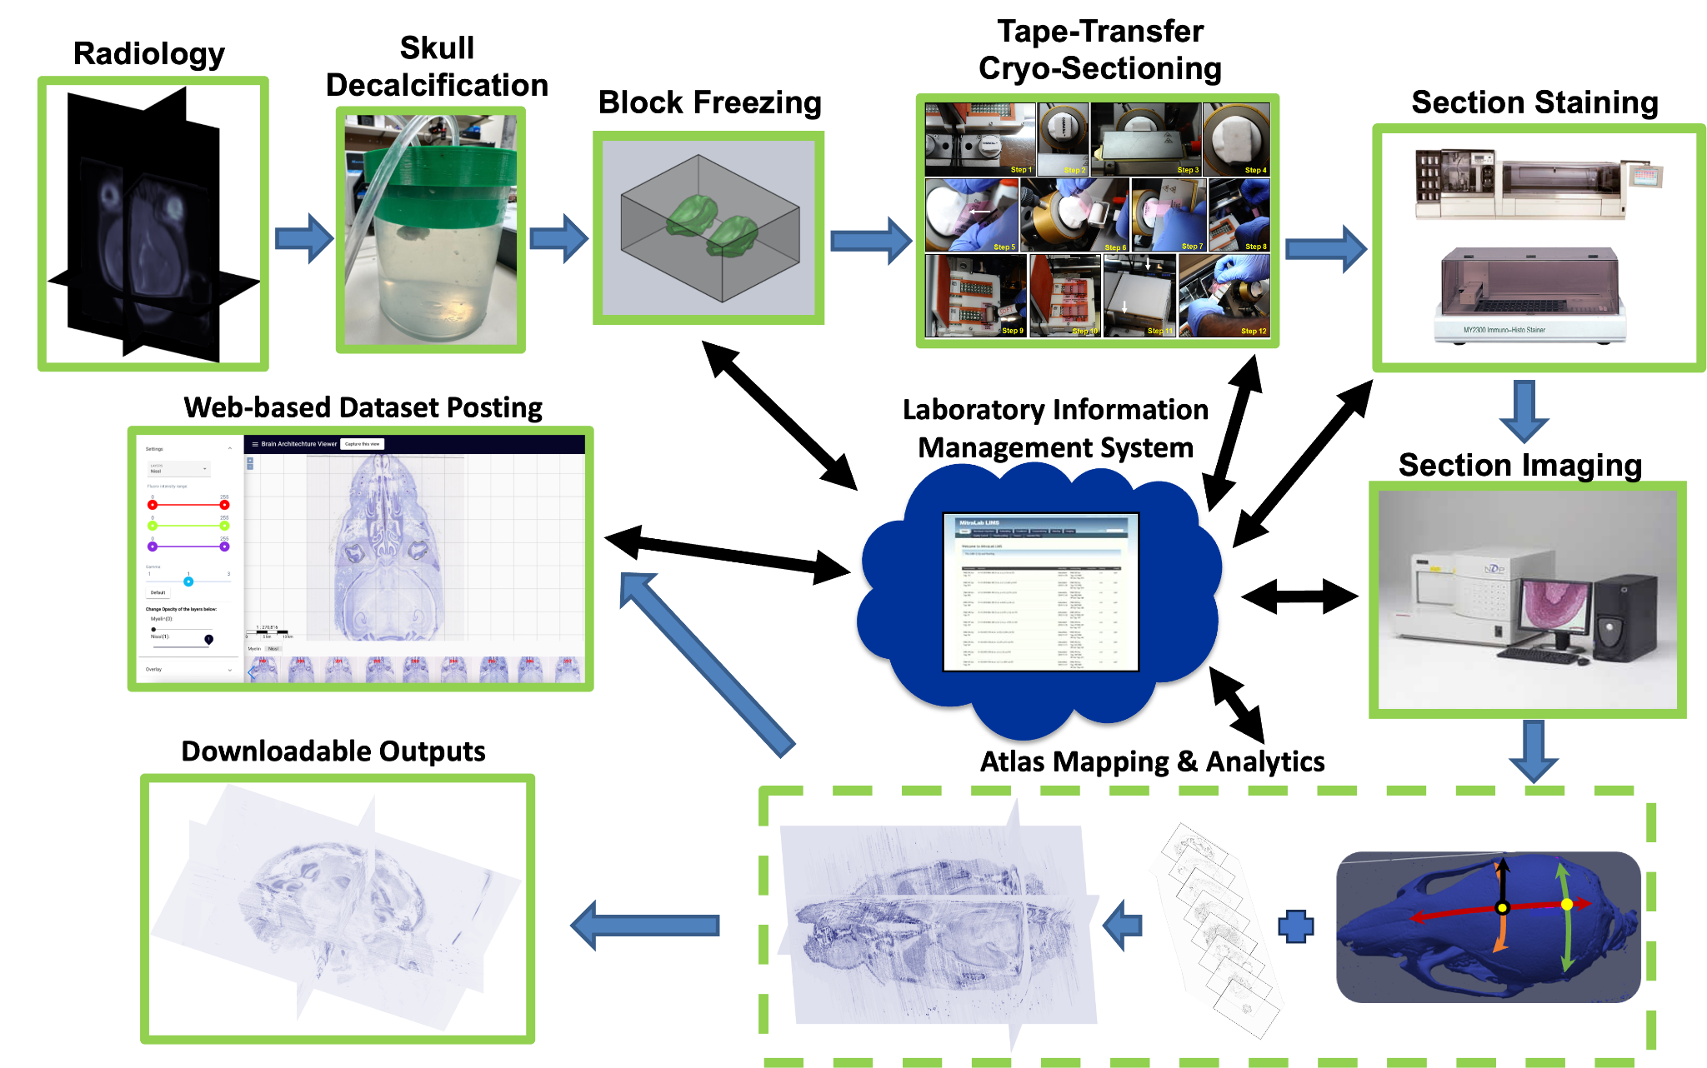
Extended Data Figure 1. The mouse head/brain processing pipeline is summarized below. (1) Radiological images are acquired, both MRI & CT, in vivo and ex vivo. (2) Mouse heads are received at CSHL and undergo skull decalcification. (3) Mouse heads are frozen into blocks. (4) Blocks are tape-transfer cryosectioned. (5) Sections are stained on slide using an automated stainer for both Nissl and Myelin histology. (6) Sections are imaged with a Hamamatsu Nanozoomer. (7) Following section image QC, section images are aligned and mapped into the in vivo stereotactic reference coordinate space. (8) Following additional analytics and atlas mapping, per subject outputs are released in both web viewable and downloadable formats. Black arrows indicate steps with key integration with the LIMS (an in-house built Laboratory Information Management System).

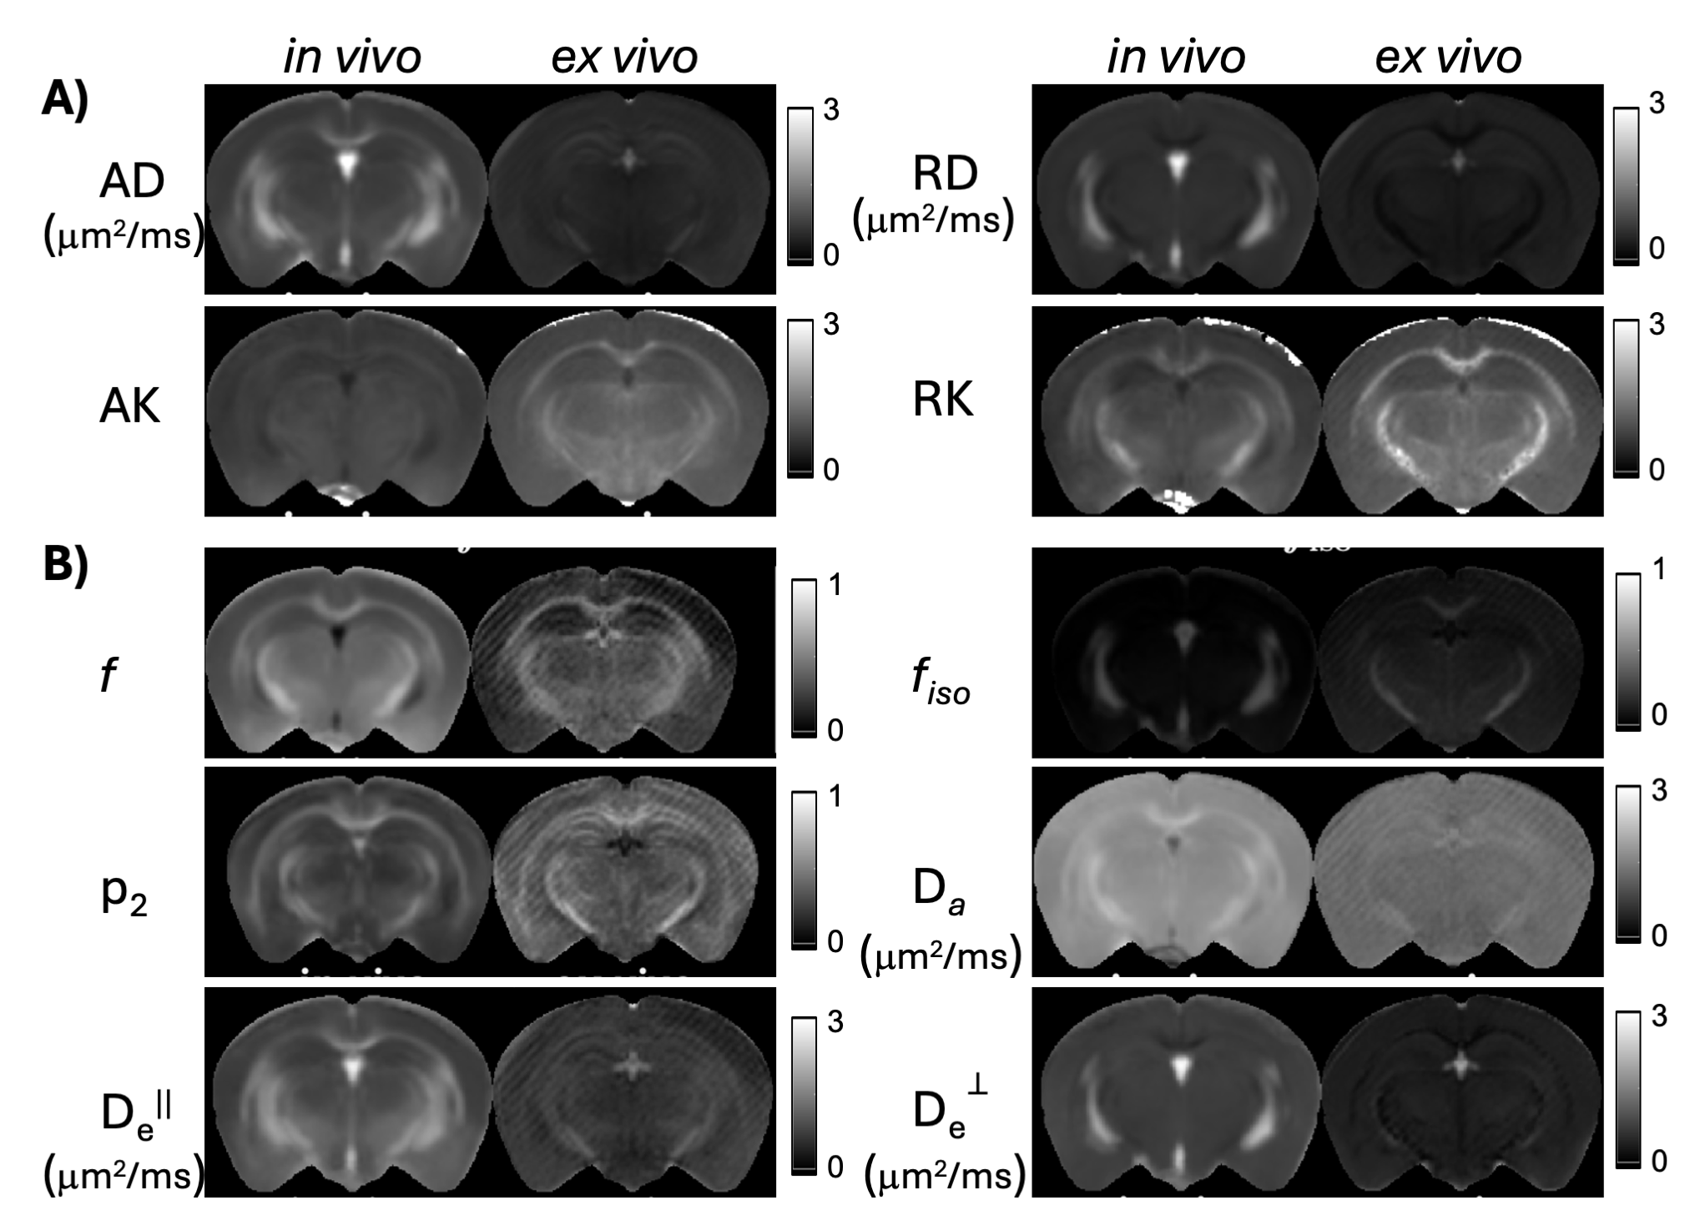
Extended data Figure 2: Additional in vivo and ex vivo population-averaged diffusion MRI parameter maps of the female mouse brain. A: In vivo and ex vivo axial diffusivity (AD), radial diffusivity (RD), axial kurtosis (AK), and radial kurtosis (RK) derived from the empirical diffusion tensor and kurtosis model. B: In vivo and ex vivo tissue microstructure parameters derived from a biophysical model, in which axons are approximated by long impermeable cylinders and cell bodies by spheres. Abbreviations: f : axonal fraction; f_{iso}: fraction of isotropic diffusion compartment; p₂: fiber dispersion; Da: intra-axonal axial diffusivity; D_{e}||: extracellular axial diffusivity; D_{e}⊥: extracellular radial diffusivity.

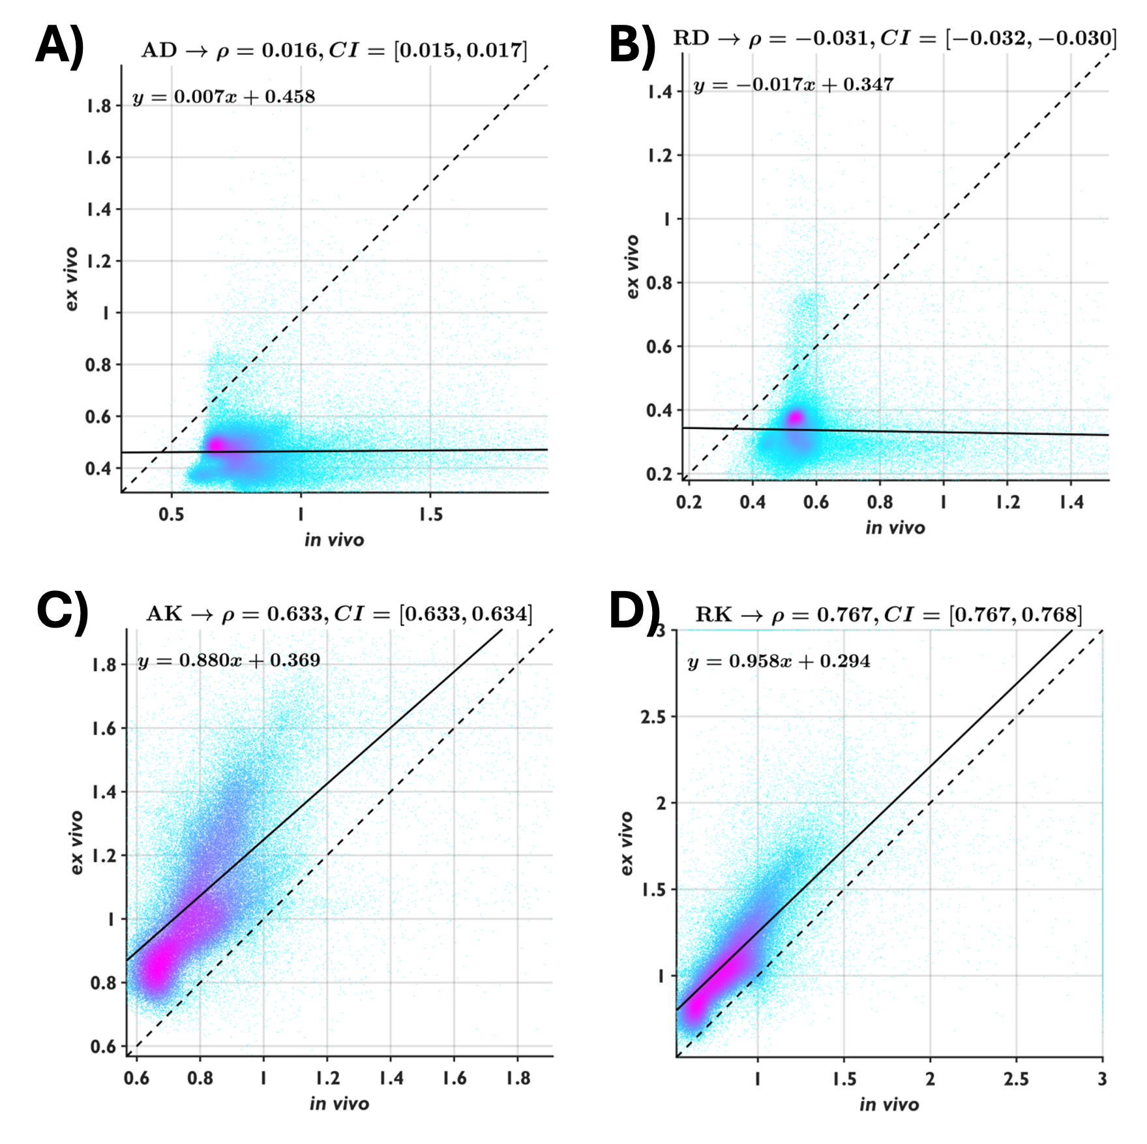
Extended Data Figure 3: Voxel-wise comparisons between in vivo and ex vivo values of axial diffusivity (AD), radial diffusivity (RD), axial kurtosis (AK), and radial kurtosis (RK), derived from the empirical diffusion tensor and kurtosis model and shown in scatter plots with Pearson correlation coefficient ($ρ$) and 95% confidence interval (CI). The solid lines represent the results of linear regression, and the dashed diagonal lines indicate the reference line for no change. The color indicates the density of voxels. Both ex vivo AD and RD are reduced compared to in vivo AD and RD, whereas ex vivo AK and RK show slight increases compared to in vivo AK and RK.

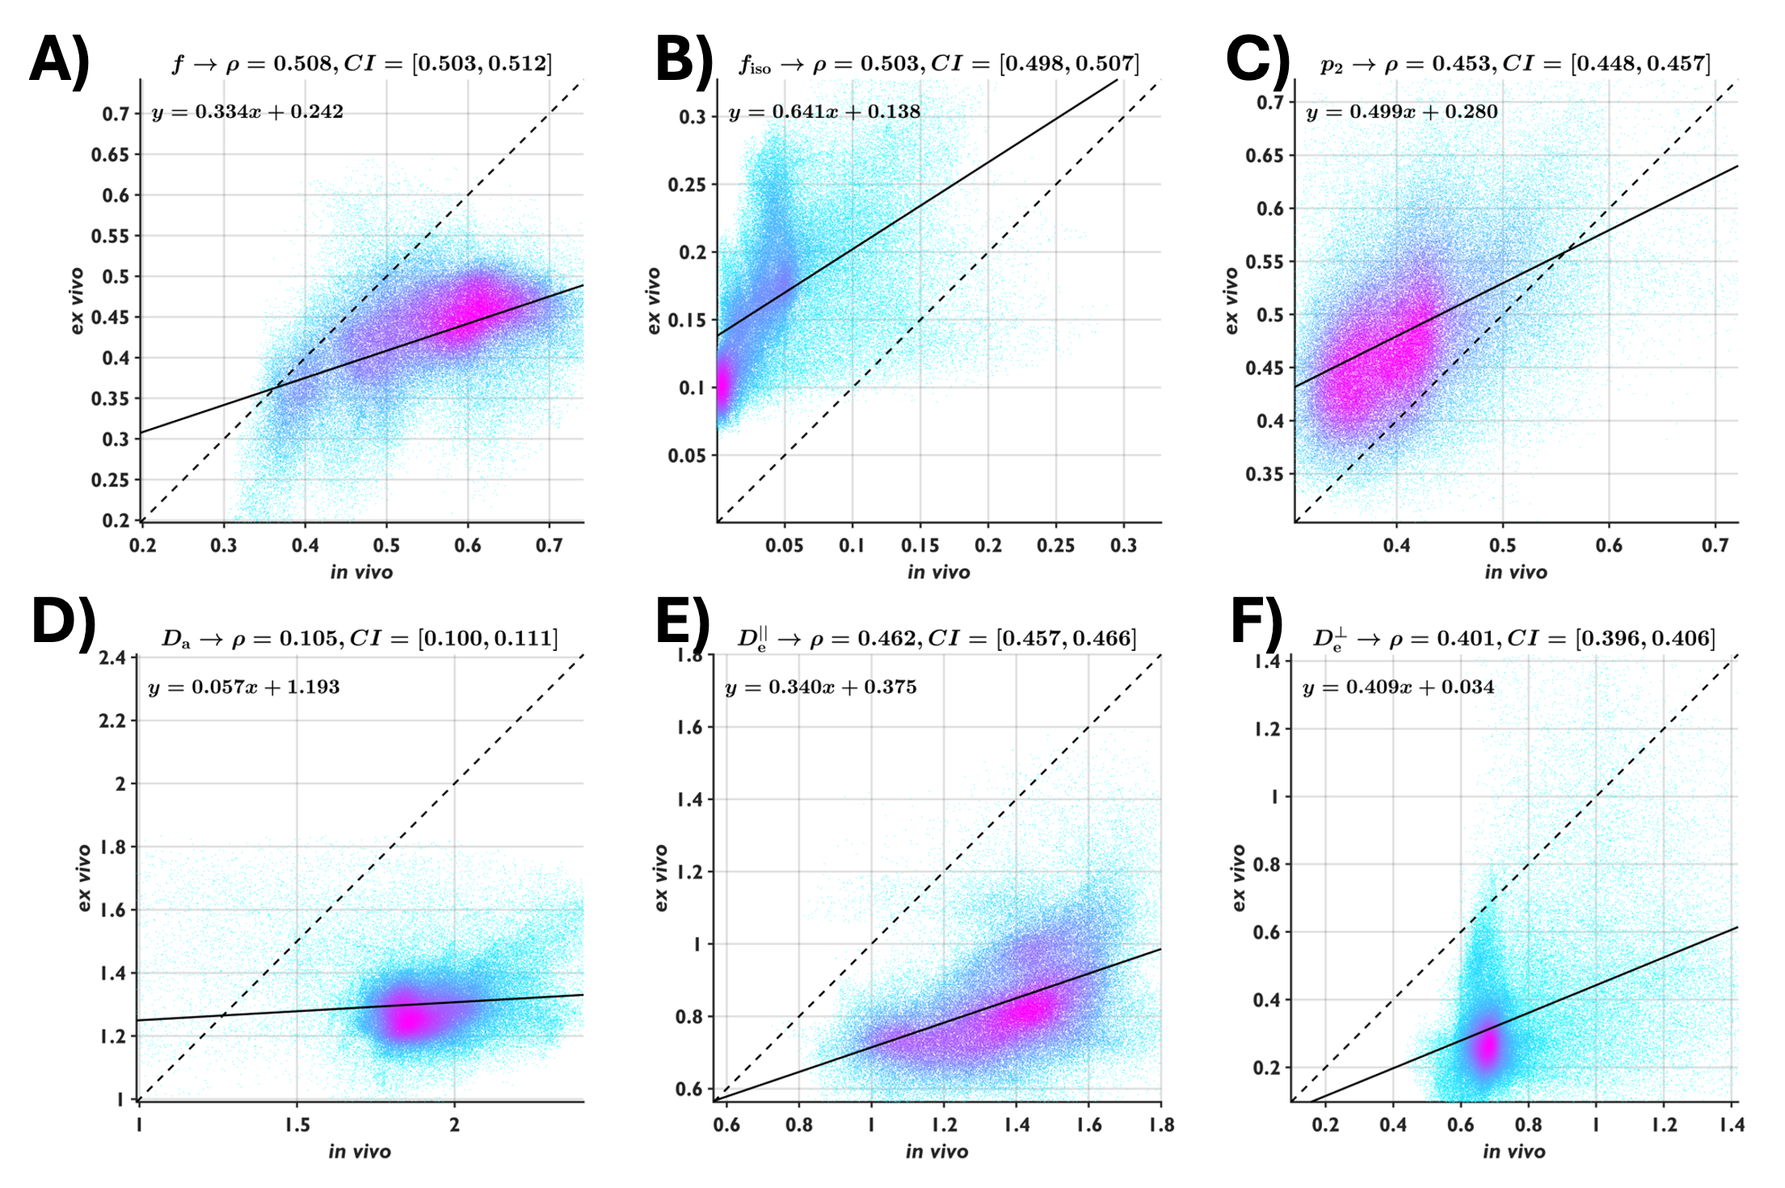
Extended Data Figure 4: Voxel-wise comparisons between in vivo and ex vivo values of axonal fraction (f), fraction of isotropic diffusion compartment (f_{iso}), fiber dispersion (p₂), intra-axonal axial diffusivity (D_{a}), extracellular axial diffusivity (D_{e}||), and extracellular radial diffusivity (D_{e}⊥), computed from the biophysical model and shown in scatter plots with Pearson correlation coefficient ($ρ$) and 95% confidence interval (CI). The solid lines represent the results of linear regression, and the dashed diagonal lines indicate the reference line for no change. Ex vivo f, D_{a}, D_{e}||, and D_{e}⊥ are lower than the in vivo results, and ex vivo f_{iso} and p₂ are higher than the in vivo results.

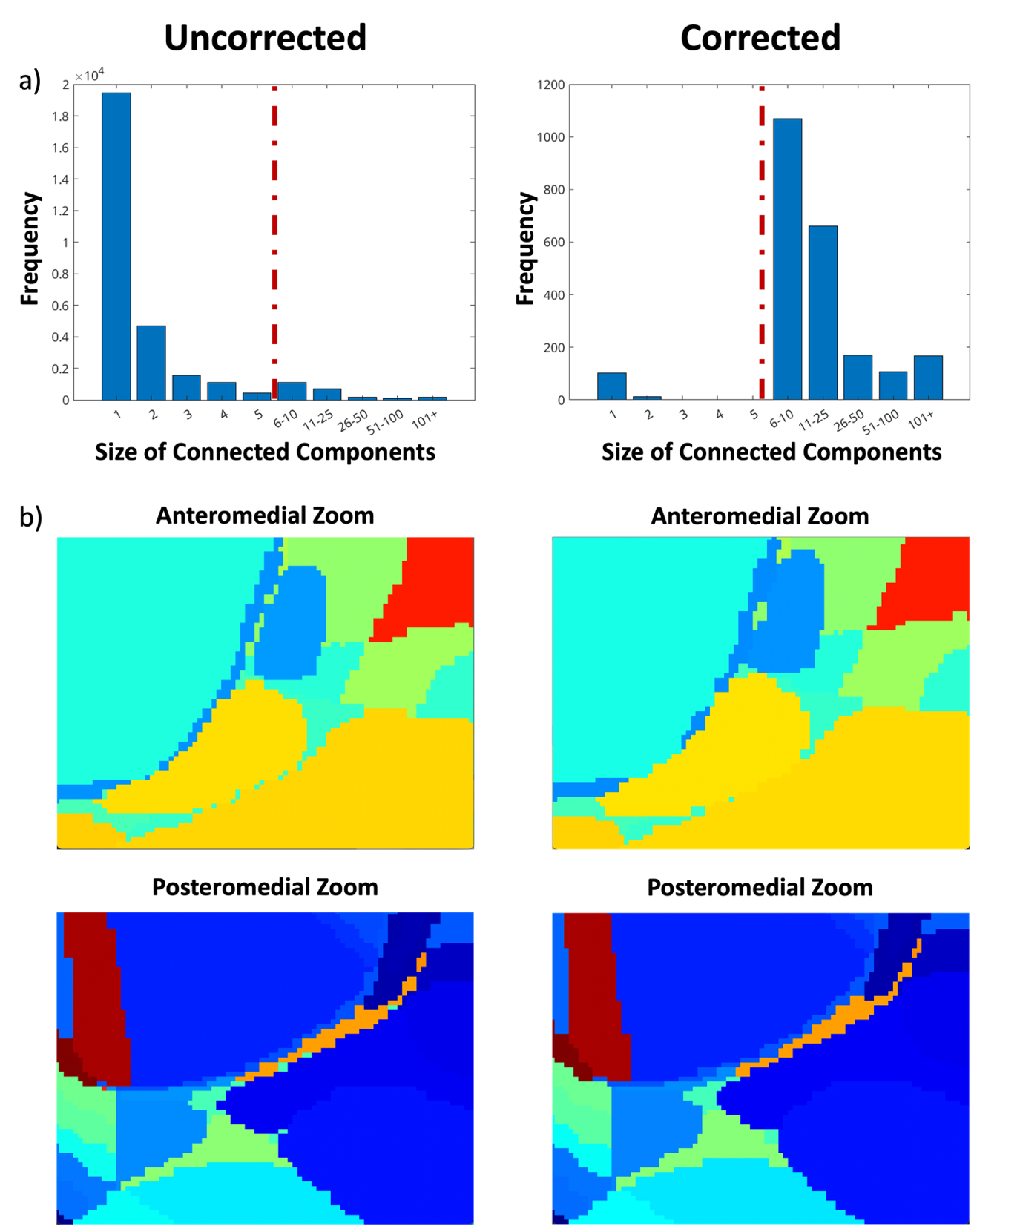
Extended Data Figure 5. Demonstration of output of bubble correction in action. (a) Histograms of the size of connected components for both the uncorrected and corrected volumes. Note the dashed red line after a voxel size of 5, defining all components whose size was less than 5 voxels as a bubble. (b) Anteromedial and posteriomedial zoom in panels showing the segmentations at a per-voxel resolution both before and after bubble correction. Note the reduction in isolated voxels in the right, corrected anteromedial and posteromedial panels relative to the left uncorrected anteromedial and posteromedial panels.
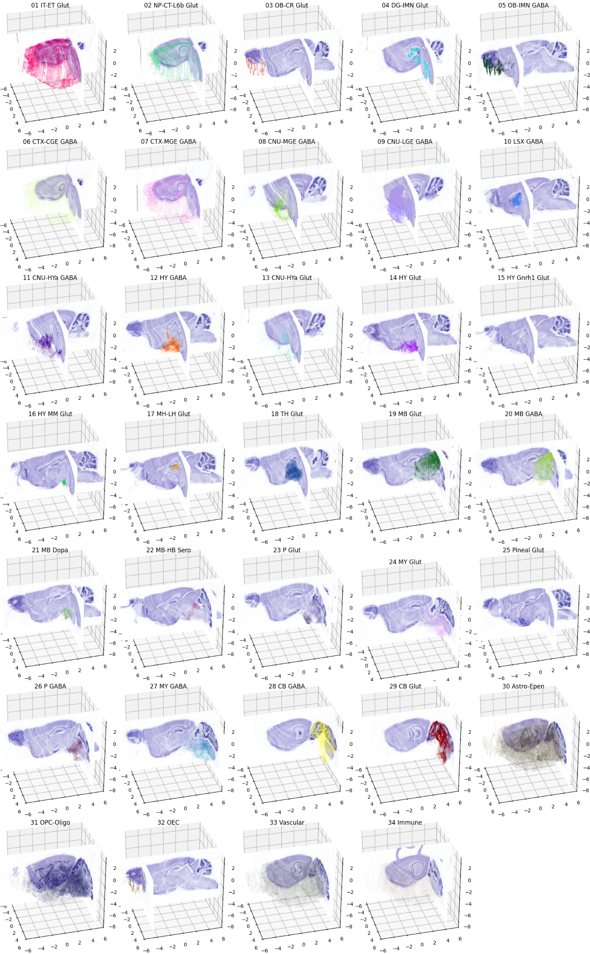

Extended Data Figure 6: Distribution of 35 cell types from the ABC atlas in our reference atlas coordinate system. Here we show the distribution of 35 different cell types loaded using the Allen Brain Cell (ABC) Atlas python API as described at the url https://alleninstitute.github.io/abc_atlas_access/notebooks/merfish_ccf_registration_tutorial.html, with coordinates mapped from the Allen CCF into our reference atlas framework. Sagittal and coronal sections from one of our Nissl volumes are shown such that 90% of cells are rendered in front of the section. Coordinates are in mm, with the bregma point at (0,0,0). Cells are rendered as a 3D scatter plot, with colors using the conventions from the API.

