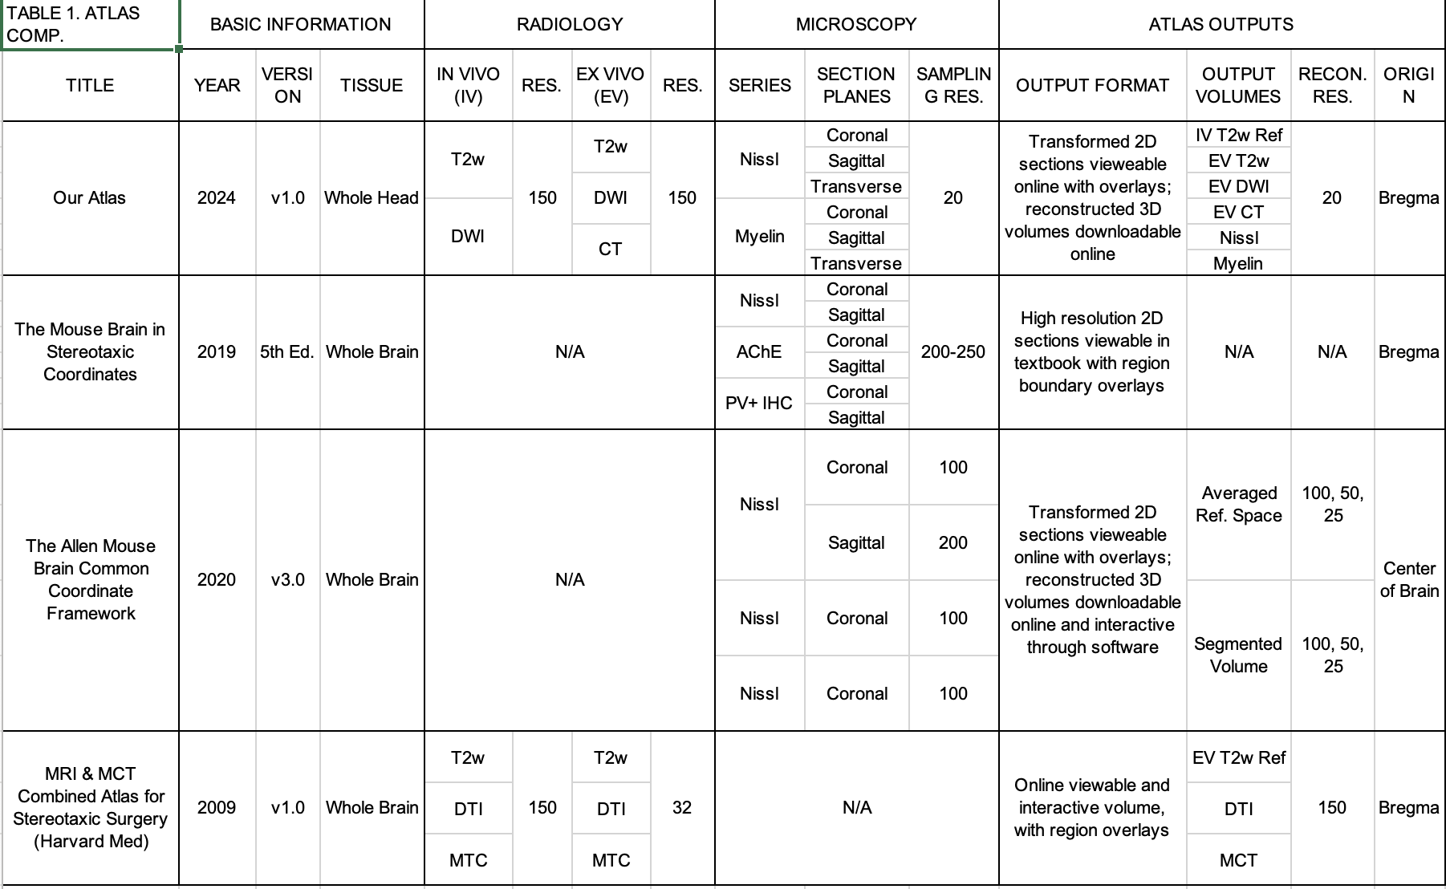
Table 1. Comparison of the new and current field-standard mouse brain atlas resources. This table compares radiological and microscopy series sampling, resolution, atlas outputs and reference coordinate spaces. “N/A” indicates that a particular resource did not utilize a specific imaging modality.

Table 2. Atlas Outpus | Web Viewable | Downloadable
MRI series: (in vivo, ex vivo) x (T2W, Axial/Radial/Mean Diffusivity and Kurtosis, Fractional Anisotropy, | N/A | 20μm isotropic voxels Reference Space volumes
Nissl Series: Head (Coronal, Sagittal, Transverse) | High resolution Section Images (0.46μm in plane resolution, 10μm thickness) | 20μm isotropic voxels Reference Space volumes
Myelin Series: Head (Coronal, Sagittal, Transverse) | High resolution Section Images (0.46μm in plane resolution, 10μm thickness) | 20μm isotropic voxels Reference Space volumes
Nissl Series: Brain (Coronal, Sagittal, Transverse) | High resolution Section Images (0.46μm in plane resolution, 20μm thickness) | 20μm isotropic voxels Reference Space volumes
Brain Region Segmentations | Overlay on high resolution Nissl and myelin Images | Annotated volume
Curvilinear Atlas Coordinate Grid | Overlay on high resolution Nissl and myelin Images | N/A
Reference Atlas Coordinates | Retrievable on hover from high resolution Nissl and myelin images | N/A

Table 2. Atlas outputs are listed with columns noting whether and how they appear as both “Web Viewable” (https://www.brainarchitecture.org/bap-mouse-atlas/) and “Downloadable” outputs (https://data.brainarchitectureproject.org/pages/mouse). Usage of the atlas to register mouse brain data is demonstrated using data examples together with the associated code (https://data.brainarchitectureproject.org/pages/mouse)

