Combined therapy with dendritic cell loaded-exosomes supplemented with PD-1 inhibition have superior antitumor effect in hepatocellular carcinoma
Shengbin Shi , Cuijuan Wang, Chuangnian Zhang, Wenyu Zhang, Yibo Qin,Zuoxing Niu
Methods
- Immune function reconstruction in the BALB/C nude mice
The thymi of 4-week-old BALB/C male mice were excised under aseptic conditions and added to RPMI 1460 medium. Fat tissue and fascia were removed and cleaned. The piston of a glass syringe was then ground on 70-µm nylon mesh, and lymphocytes were separated with 40% Percoll. The cell concentration was adjusted to 1×10⁷ cells/ml and the isolated lymphocytes were injected into BALB/C nude mice via caudal vein injection.
- Preparation of dendritic cells derived from bone marrow
BALB/C mice aged 4 weeks were killed by cervical dislocation and sterilized with 75% alcohol for 3 min. The tibia and fibula were removed under sterile conditions on a super clean bench, and the marrow cavity was repeatedly rinsed with a 1-ml glass syringe. Then the plunger of the syringe was gently milled on 70-µm nylon mesh. Next, 2 ml of red blood cells were added, and the mixture was mixed well and allowed to stand at room temperature for 2 min. Finally, the cells were resuspended in complete medium, followed by the addition of 10 ng/ml IL-4 and 30 ng/ml GM-CSF, and then the cells were cultured at a constant temperature of 37°C in 5% CO₂. The medium was replaced on day 3, and then half of the medium was replaced every 2 days. The Dendritic cells (DCs) were cultured until day 7.

- Western blotting
Protein concentrations were quantified using a bicinchoninic acid protein concentration assay reagent and western blotting was conducted as previously described [12]. The primary antibodies were as follows: TSG101, CD63, cytochrome C, AFP, GPC-3, and PD-1 (all purchased from Abcam), all of which were used at 1:1000 dilution. The secondary antibody was goat anti-rabbit IgG (Sigma, USA).
- CD8+T cell separation by magnetic beads
The spleens of 4-week-old C57 mice were removed under aseptic conditions and then added to RPMI medium. The piston of a glass syringe was then ground on 70-µm nylon mesh, and lymphocytes were separated with 40% Percoll. The obtained cells were suspended in 90 µl PBS containing 5% fetal bovine serum, and then 10 µl CD8+ antibody-conjugated magnetic beads were added at 4°C for 20 min before centrifugation at 500 ×g for 10 min and elution with 500 µl buffer. Finally, cell separation purity was determined by flow cytometer (BD Biosciences, CA, USA).
- qRT–PCR primers.
PDCD1 forward 5′-GCAATCAGGGTGGCTTCT-3′, reverse 5′-TTGGCTCAAACCATTACAGA-3'; CD274 forward 5′-GGTGCCGACTAC AAGCGAAT-3′, reverse 5′-AGCCCTCAGCCTGACATGTC-3′; GAPDH forward 5′-CTCAAGATCATCAGCAATG-3', reverse-5′-GTCATGAGTCCTTCCACG-3'.

Results
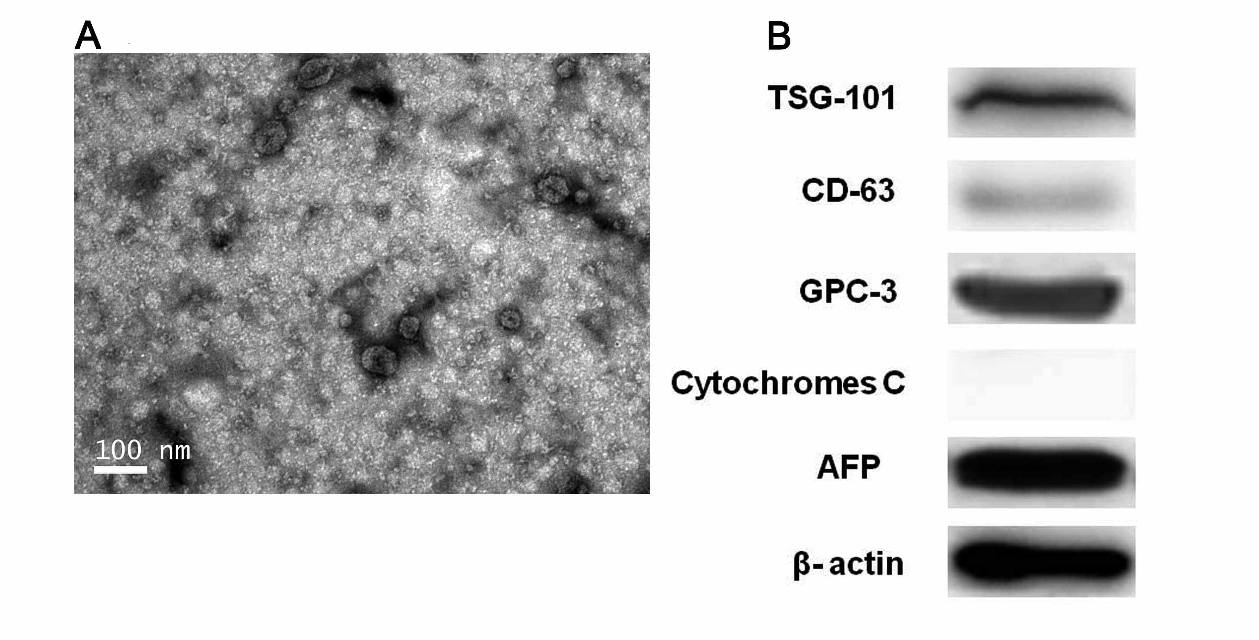
Figure S1. The characteristic of exosome. A. Transmission electron microscopy image of an exosome. B. Exosome biomarkers examined by western blotting.
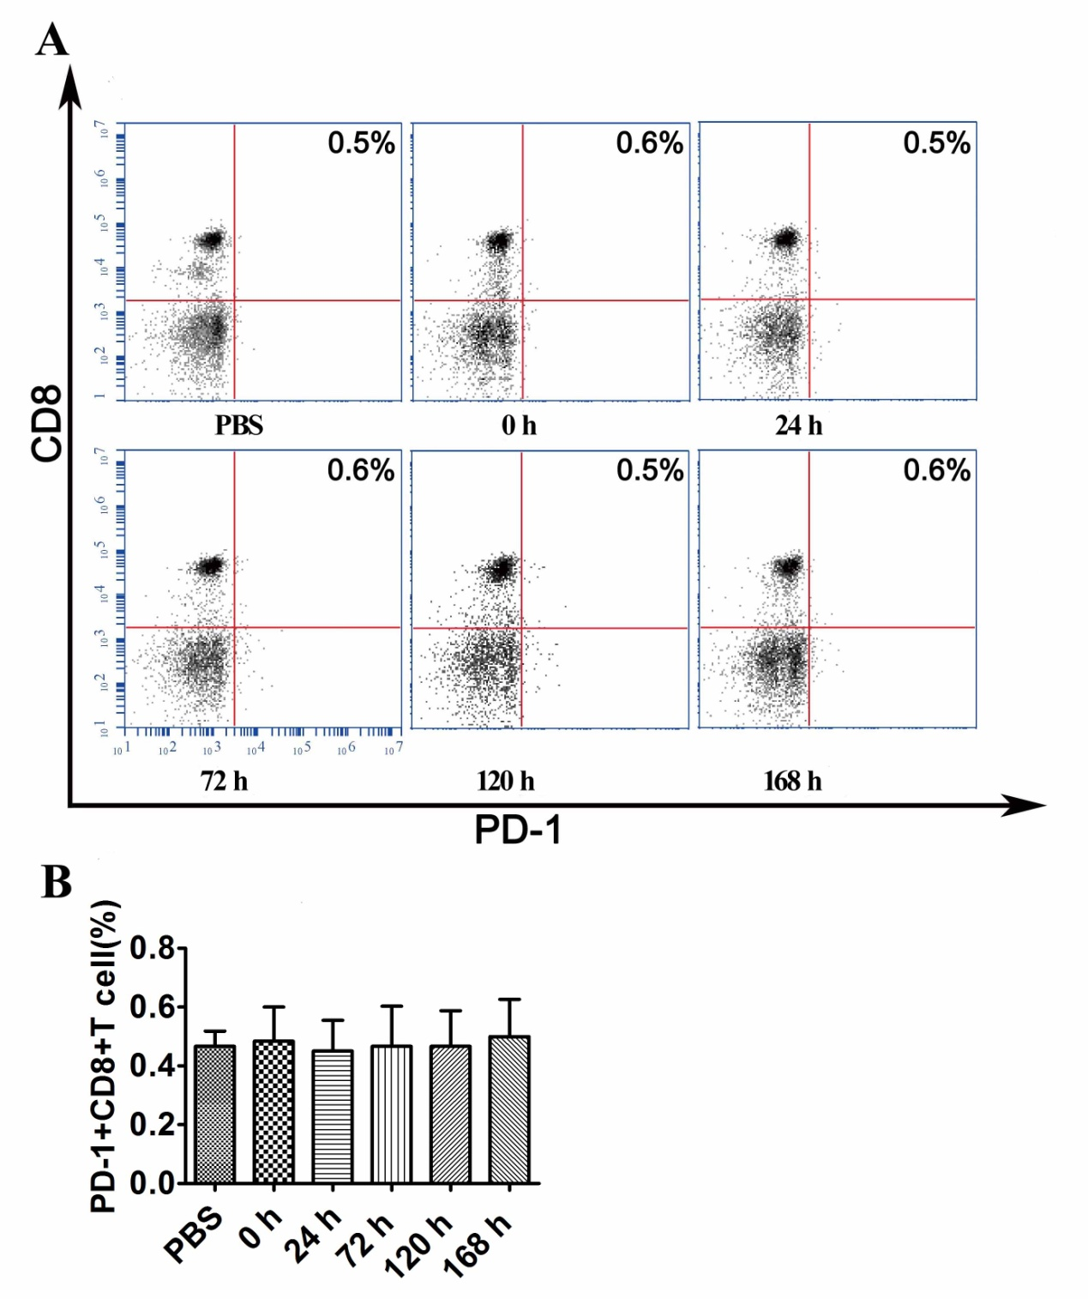
Figure S2. Homotypic negative control of PD-1. A, B. The number of PD-1+CD8+ T cells in tumor tissue at different time points was analyzed by flow cytometry. No significance difference was observed among different time points.
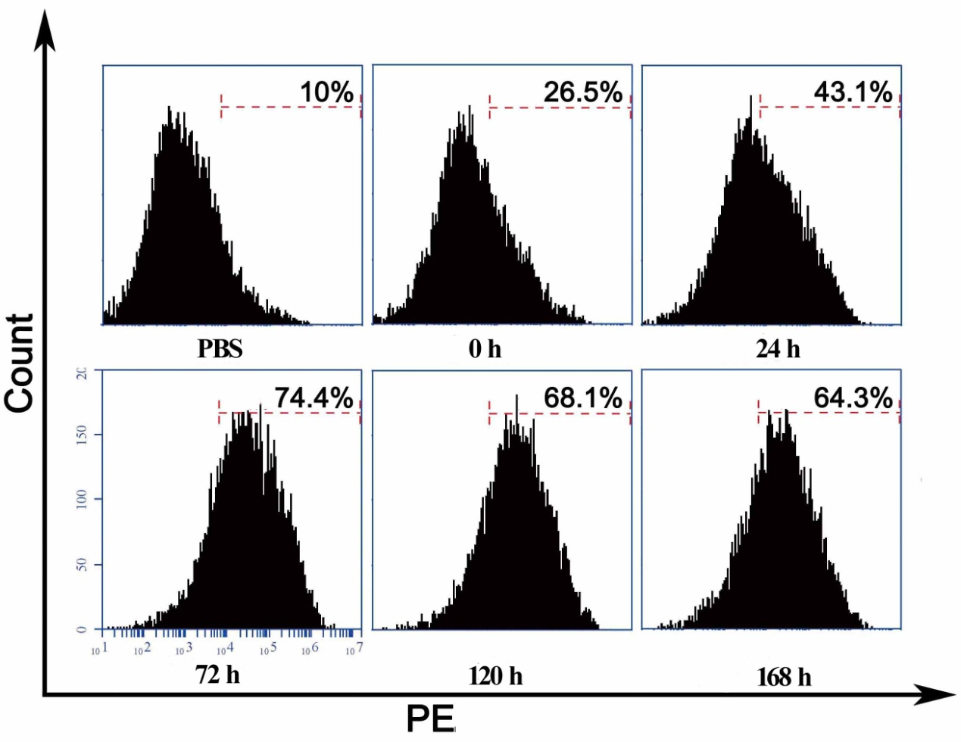
Figure S3. PD-1 expression during T cell culture in vitro. DC-TEX was cocultured with naïve T lymphocytes derived from the spleens of C57BL/6 mice at a ratio of 1:10 for 7 days, and then the variation of PD-1 expression was observed by flow cytometry (***P<0.001).
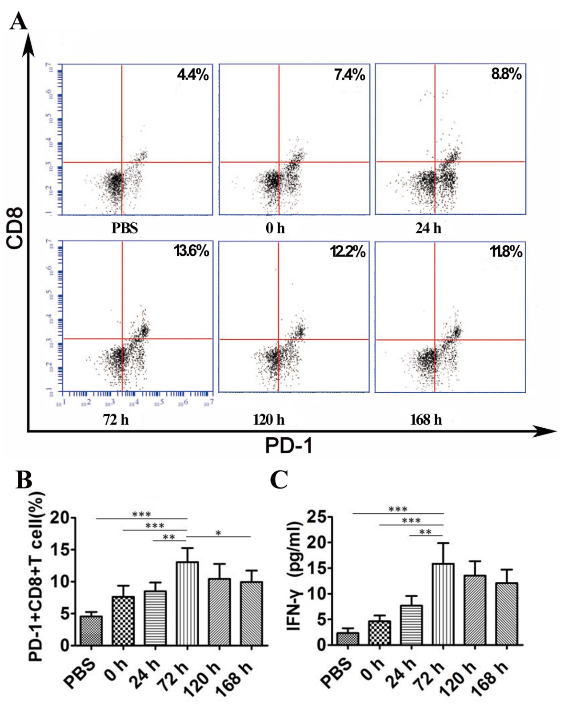
Figure S4. PD-1 expression after immune reconstruction. A-B. We constructed an orthotopic HCC model in BALB/C nude mice and then restored the T cell population by injecting T cells derived from the thymi of BALB/C mice. We then administered DC-TEX (dendritic cells derived from the bone marrow of BALB/C mice) to these mice and found that the number of PD-1+CD8+ T cells in tumor tissue demonstrated a significant difference at different time points. C. Serum IFN-γ level was analyzed by ELISA. (*P<0.05,**P<0.01, ***P<0.001).
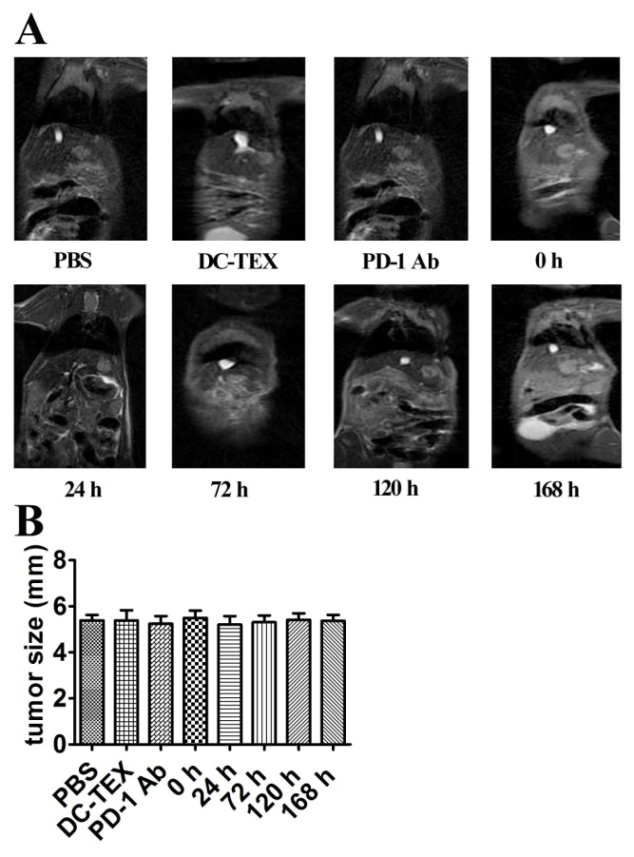
Figure S5. MRI showing the longest diameter of tumors before treatment. The longest diameter was not significantly different among the PBS, DC-TEX, PD-1 Ab, 0 h, 24 h, 72 h, 120 h and 168 h groups (P>0.05).
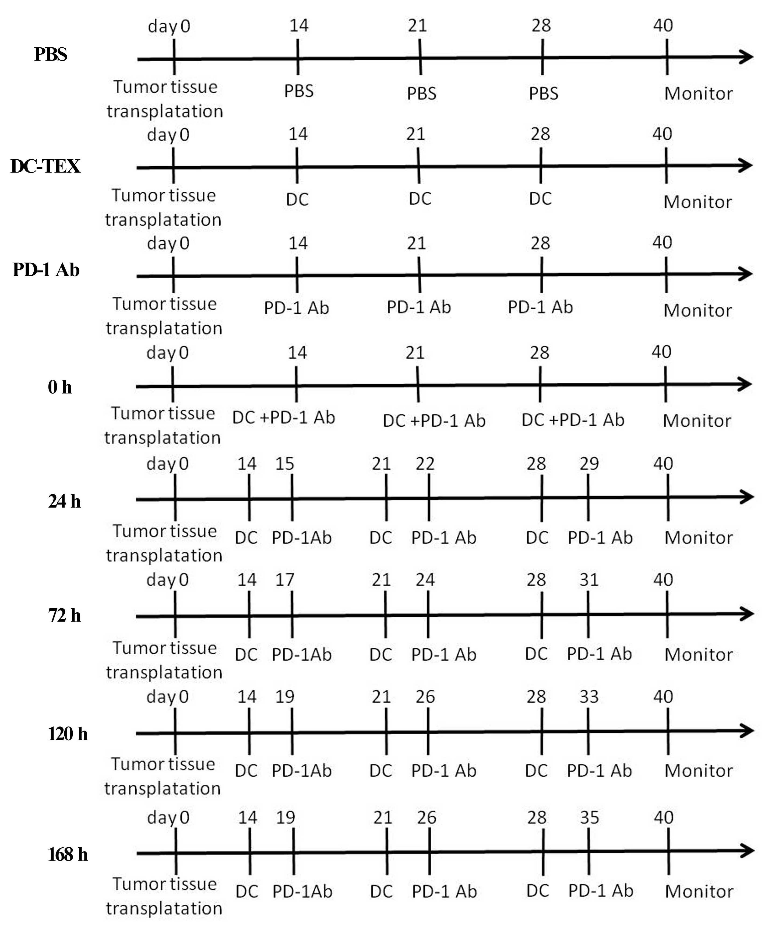
Figure S6. Treatment schedule. DC-TEX and PD-1 antibody were administered three times in total at an interval of 7 days. The treatment started on day 14 following the transplantation of subcutaneous tumors.
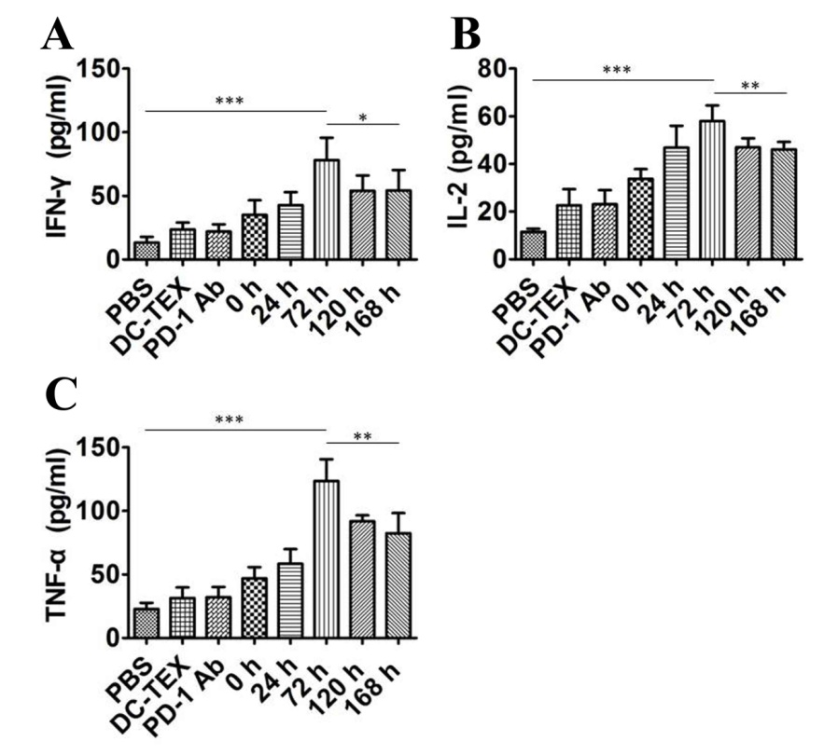
Figure S7. Serum IFN-γ, IL-2 and TNF-α levels were analyzed by ELISA in orthotopic HCC model. IFN-γ, IL-2 and TNF-α levels were significantly higher in the 72 h group compared to the other groups (*P<0.05,**P<0.01, ***P<0.001).
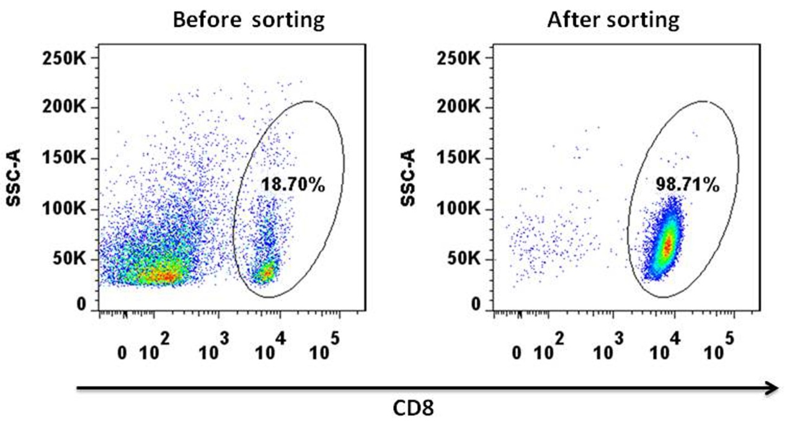
Figure S8. The CD8+T cells were separated from the spleens of C57 mice. We separated CD8+T cells by magnetic activated cell sorting.

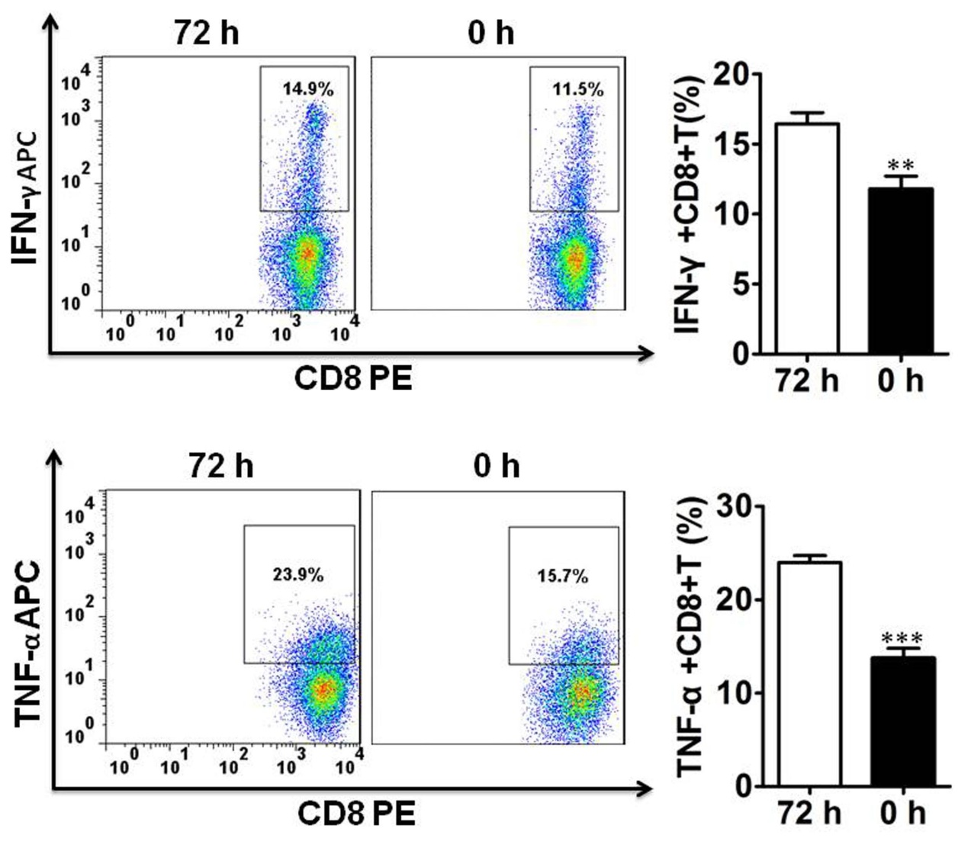
Figure S9. IFN-γ+CD8+T cells and TNF-α+CD8+T cells were analyzed by flow cytometry. CD8+T cells derived from spleen were cocultured with DC-TEX and then PD-1 Ab was added at different time points. The IFN-γ+CD8+T cell and TNF-α+CD8+T cell numbers were shown significanly different at 72 h and 0 h (**P<0.01, ***P<0.001).
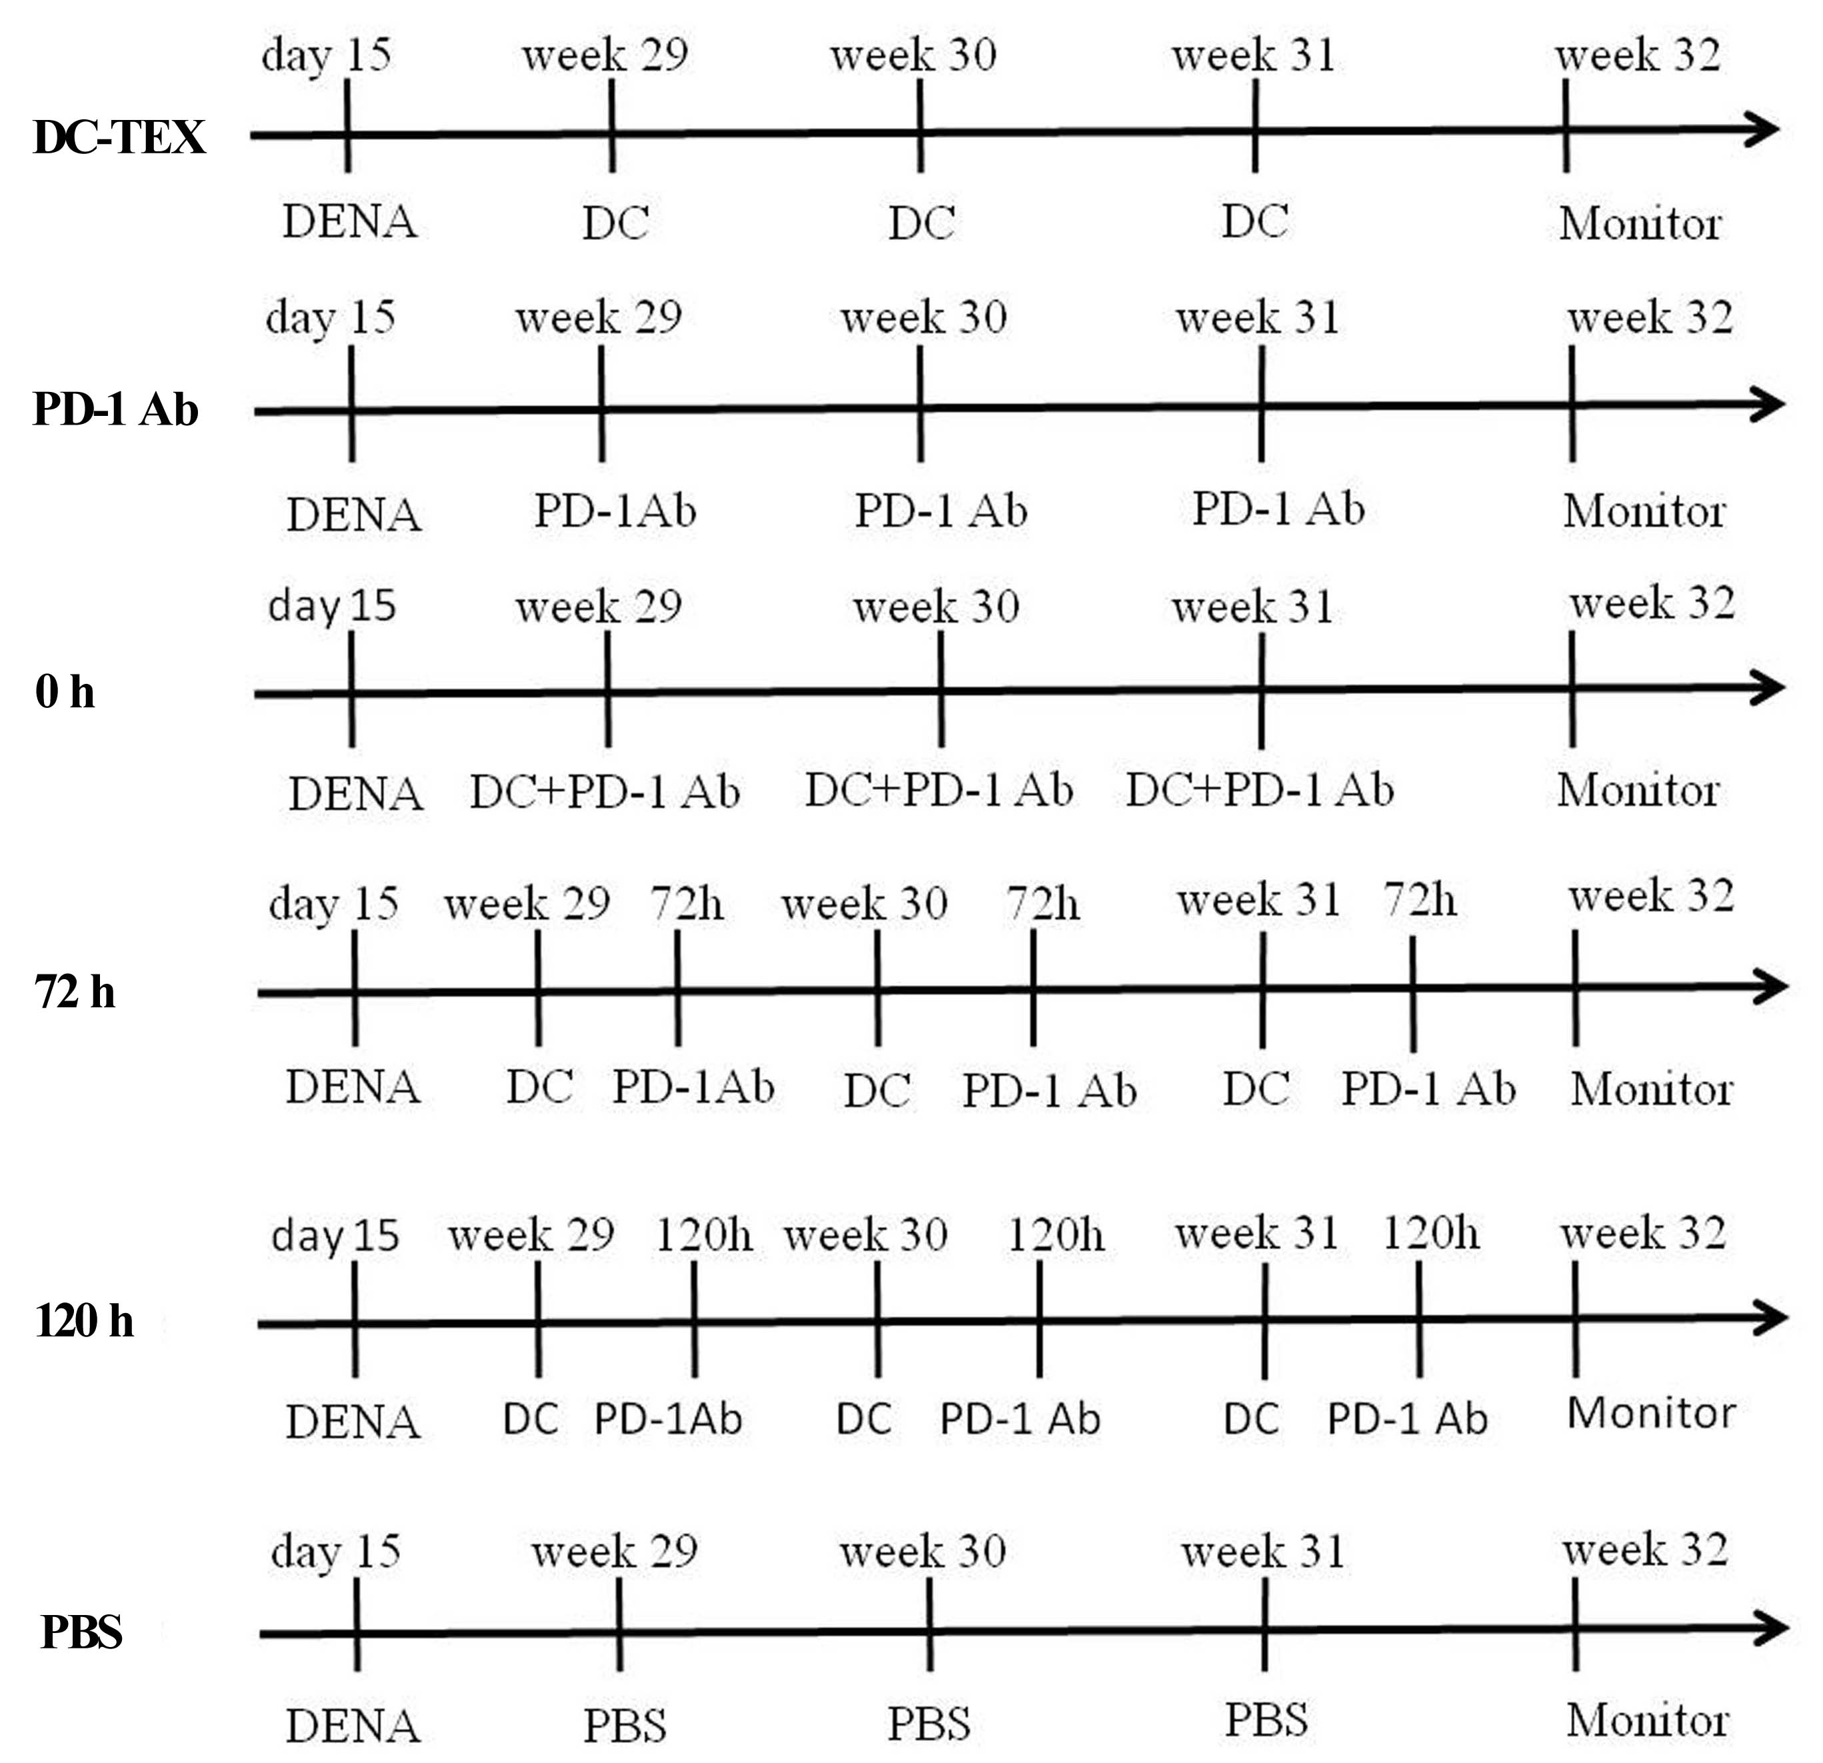
Figure S10. Treatment schedule for the chemically induced HCC murine model. DC-TEX and PD-1 antibody were administered three times in total at an interval of 7 days. A chemically induced model was established using 15-day-old C57 mice.

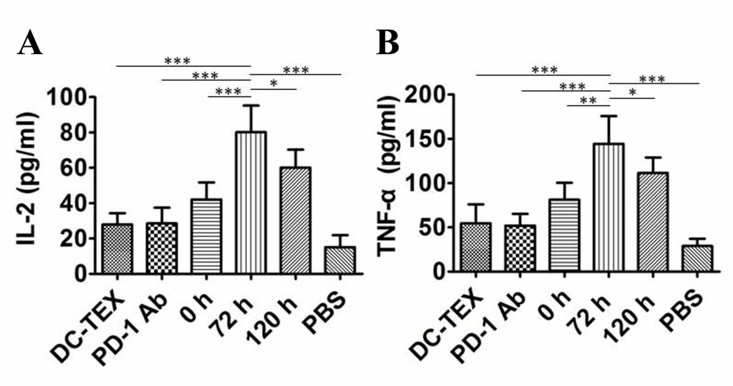
Figure S11. Serum IL-2 and TNF-α levels were analyzed by ELISA in a chemically HCC model. IL-2 and TNF-α levels were significantly higher in the 72 h group compared with the other groups (*P<0.05,**P<0.01, ***P<0.001).

