Supplementary Material
Patients admitted to the Gastroenterology Department of Hospital de Braga (January 2016 to January 2022) with acute GI bleeding and diagnosed with hepatic cirrhosis. (n = 176)
Previous surgical shunts or TIPS. (n = 1)

Hepatocellular carcinoma (n = 10)

Anemia without clinical evidence of an acute GI bleeding event. (n = 3)

Severe hemorrhage resulting in death prior to endoscopy. (n = 1)

Patients with incomplete medical records (n = 4)

Occlusive portal vein thrombosis (n = 2)
Non-cirrhotic portal hypertension (n = 1)

Eligible patients for the study, according to inclusion and exclusion criteria. (n = 154)
Figure 1. Patient flow chart. GI gastrointestinal; TIPS, transjugular intrahepatic portosystemic shunt.

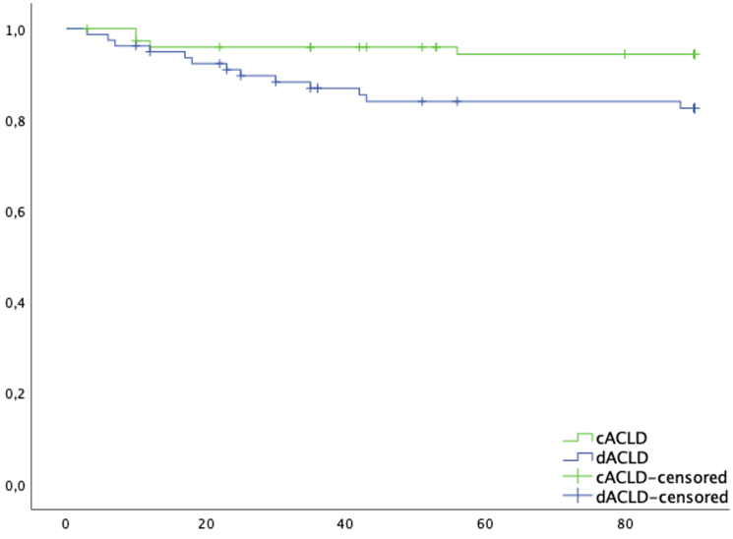

Cumulative 90-day survival

Log rank p = 0.028
Follow-up (days)
Survival (%)
cACLD | 100 | 95.9 | 95.9 | 94.4 |  | 94.4
dACLD | 100 | 92.3 | 86.9 | 84.0 |  | 84.0

Figure 2. 90-day liver-related death in cACLD and dACLD patients. Note. Survival rates of 90-day liver-related death in cACLD and dACLD patients were obtained from Kaplan-Meier estimates and compared using the log-rank test (p-value <0.05). The survival rate at day 90 was 94.4% in the cACLD and 82.5% in the dACLD.
cACLD, compensated advanced chronic liver disease; dACLD, decompensated advanced chronic liver disease.

A
Patients at risk
cACLD | 50 | 49 | 48 | 46 | 45 | 44 | 44
dACLD | 43 | 43 | 42 | 39 | 39 | 37 | 35
Patients at risk
cACLD | 49 | 49 | 49 | 49 | 49 | 48
dACLD | 46 | 44 | 43 | 43 | 43 | 43
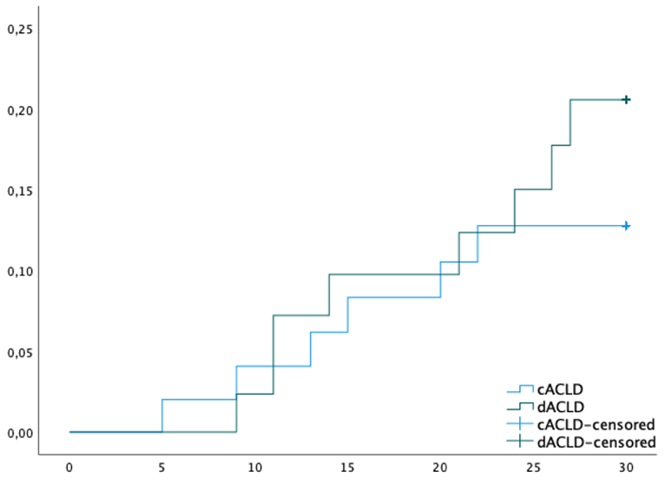
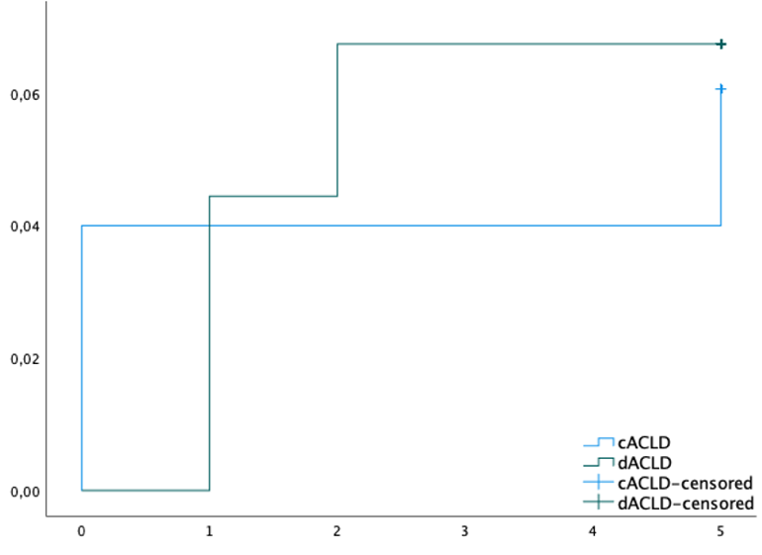
Log rank p = 0.405
Cumulative probability of decompensation

Cumulative probability of rebleeding
Log rank p = 0.907
Follow-up (days)
Follow-up (days)
B

C
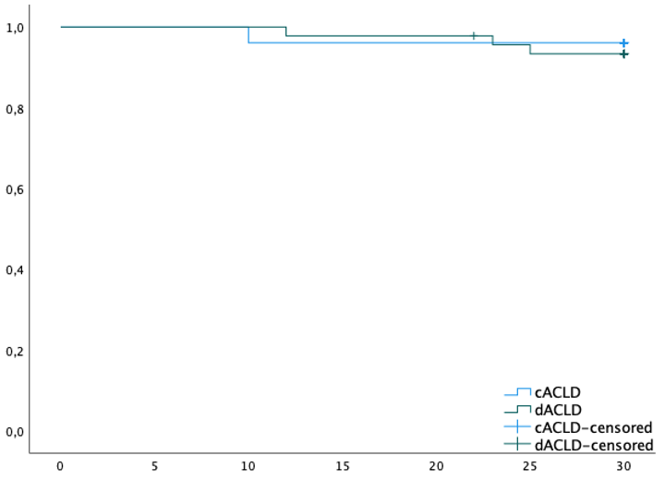

Cumulative 30-day survival

Log rank p = 0.574
Follow-up (days)

Survival (%)
cACLD | 100 | 100 | 96.1 | 96.1 | 96.1 | 96.1 | 96.1
dACLD | 100 | 100 | 100 | 97.8 | 97.8 | 93.4 | 93.4

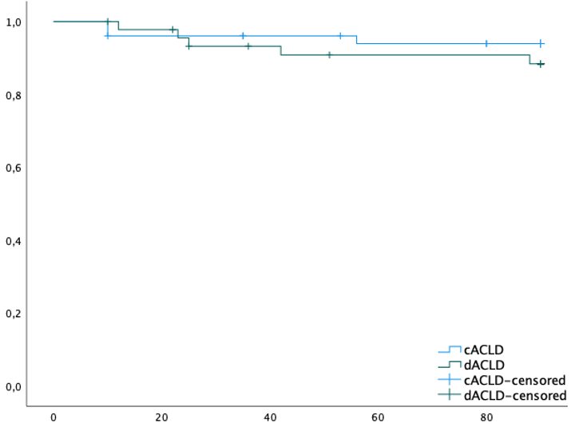
D

Cumulative 90-day survival

Log rank p = 0.375
Follow-up (days)
Survival (%)
cACLD | 100 | 96.1 | 96.1 | 93.9 |  | 93.9
dACLD | 100 | 97.8 | 93.2 | 90.8 |  | 90.8

Figure 3. Outcomes incidences (cACLD and dACLD). Hazard rates of rebleeding (A) and decompensation (B) and survival rates of 30-day (C) and 90-day (D) liver-related death in both groups were obtained from Kaplan-Meier estimates and compared using the log-rank test (p-value <0.05). In Figure 3D, the survival rate at day 90 was 93.9% in the cACLD and 88.4 % in the dACLD.
cACLD, compensated advanced chronic liver disease; dACLD, decompensated advanced chronic liver disease.

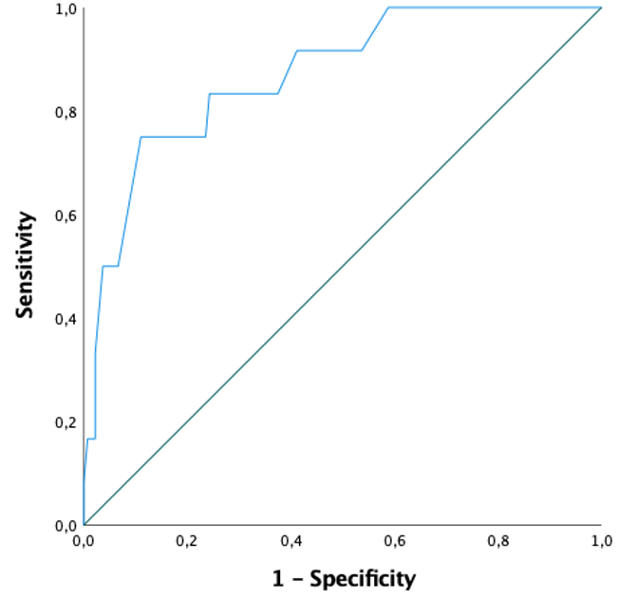
A

AUC = 0.869; p-value <0.001

B

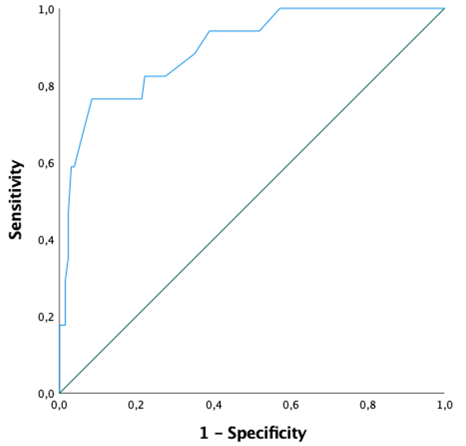

AUC = 0.895; p-value <0.001

Figure 4. ROC curves for MELDNa score for 30-day (A) and 90-day (B) liver-related mortality. Maximum Youden index in Figure 4A was 0.64, while in Figure 4B was 0.68.
AUC, area under the curve; ROC, Receiver Operating Characteristic.

