Online Resource 1: Codes that identified covariates in the current study.
Term | SNOMED Code or ICD-10 code (for diagnoses) or Concept ID (for medications)
Hydroquinone and hydroquinone-containing combination products | 976778ª
Azelaic acid | 986790
Topical retinoids | 981774 (Adapalene), 903643 (Tretinoin), 37497383 (Trifarotene), 947416 (Tazarotene)
Niacinamide | 19018419
Tranexamic acid | 1303425
Combined oral contraceptives | 21602566
Depression | 370143000
Pregnancy | 248982007
Radiation | 24803000, 85983004, 200861004, 108290001
Mood disorder | 13746004 (Bipolar disorder), 78667006 (Dysthymia), 370143000 (Major depressive disorder)
Anxiety disorder | F41.9 (Unspecified anxiety disorder), F41.1 (generalized anxiety disorder), F40.0 (agoraphobia)
Substance use disorder | F10.2 (Alcohol dependence), F11 (opioid related disorders), F12.1-2 (cannabis abuse/dependence), F13 (Sedative, hypnotic, or anxiolytic related disorders), F14 (cocaine related disorders), F15 (stimulant related disorders), F16 (hallucinogen related disorders), F17 (nicotine dependence), F18 (inhalant related disorders), F19 (other psychoactive substance related disorders)
Stress disorder | F43 (acute stress disorder, post-traumatic stress disorder, and adjustment disorders)
Sleep disorder | F51 (Sleep disorders not due to a substance or known physiological condition)
ª Natural language processing was used to identify hydroquinone-containing combination preparations within codes for topical retinoids

Online Resource 2: Melasma patients with psychiatric diagnoses that occurred before the first diagnosis of melasma (“pre-existing”) or after the first diagnosis of melasma (“subsequent”).
Category | Frequency (%) | Combined Frequency (%)
Pre-existing mood disorder | 230 (30.8%) | 316 (42.4%)
Subsequent mood disorder | 86 (11.5%) | 316 (42.4%)
No mood disorder | 430 (57.6%) | --
Pre-existing anxiety disorder | 206 (27.6%) | 335 (44.9%)
Subsequent anxiety disorder | 129 (17.3%) | 335 (44.9%)
No anxiety disorder | 411 (55.1%) | --
Pre-existing substance use disorder | 65 (8.7%) | 79 (10.6%)
Subsequent substance use disorder | 14 (1.9%) | 79 (10.6%)
No substance use disorder | 667 (89.4%) | --
Pre-existing stress disorder | 130 (17.4%) | 181 (24.3%)
Subsequent stress disorder | 51 (6.8%) | 181 (24.3%)
No stress disorder | 565 (75.7%) | --
Pre-existing sleep disorder | 39 (5.2%) | 57 (7.6%)
Subsequent sleep disorder | 18 (2.4%) | 57 (7.6%)
No sleep disorder | 689 (92.4%) | --

Online Resource 3: Characteristics of participants with Melasma (N=746)
Group | Mean (95% CI) or Frequency (Percent)
Age, years | 53.8 (52.8, 54.7)
Duration of melasma, years | 5.26 (5.05, 5.47)
Global Horizontal Irradiance, W/m² | 4.43 (4.39, 4.48)
Female | 694 (93.0%)
Male | 34 (4.56%)
Other sex | 18 (2.41%)
Asian | 52 (6.97%)
Black | 95 (12.7%)
White | 289 (38.7%)
Other raceª | 62 (8.31%)
Hispanic or Latino | 248 (33.2%)
Household income under $25k^{b} | 135 (18.1%)
Household income $25k-50k | 121 (16.2%)
Household income $50k-100k | 263 (35.3%)
Household income $100k-200k | 145 (19.4%)
Household income over $200k | 82 (11.0%)
ª Race and ethnicity were obtained from self-report and were included in this analysis as a goal of All of Us to collect and report data from a diverse group of participants. “Other” races included American Indian or Alaskan Native, Middle Eastern or North African, Native Hawaiian or Other Pacific Islander, race not specified, and more than one population.
^{b} Obtained via self-report for N=589 (78.9%) participants. Participants who declined to provide their income (N=157, 21.1%) were assigned the median household income of their postal code for analysis.

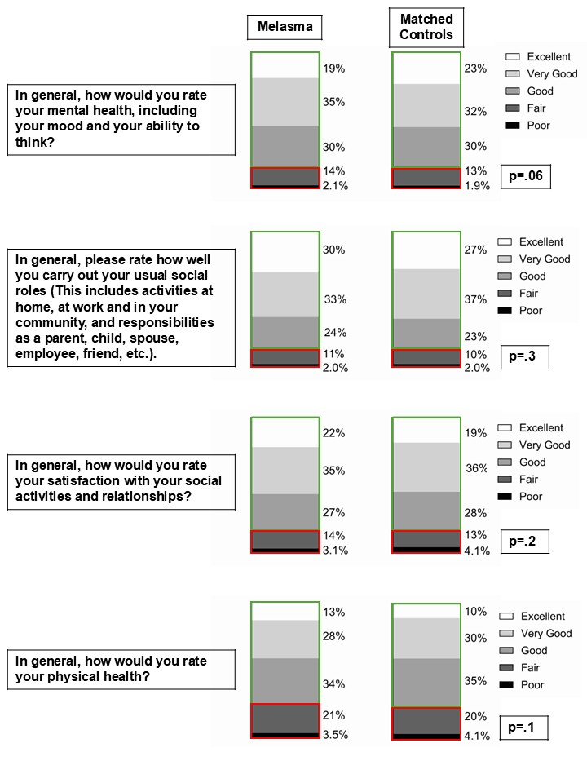
Online Resource 4: Distribution of survey responses for participants with melasma (n=746) and age, sex, race, ethnicity, and income-matched controls. Green boxes represent survey responses that were assigned to “High” and red boxes represent survey responses that were assigned to “Low”. P-values were obtained from Chi-square tests.
Online Resource 5: Association of race and income with low mental and social health in participants with melasma, adjusting for pre-existing psychiatric conditions. P-values are displayed to one significant figure.
Comparisonª | Low Mental Health | Low Social Roles | Low Social Satisfaction | Low Physical Health
Age (continuous) | 1.0 (1.0, 1.0), p=.1 | 1.0 (1.0, 1.0), p=.3 | 1.0 (1.0, 1.0), p=.1 | 1.0 (1.0, 1.0), p=.5
Female vs Male | 2.7 (0.6, 12.8), p=.2 | 2.3 (0.5, 10.9), p=.3 | 0.9 (0.3, 2.4), p=.8 | 2.9 (0.9, 9.3), p=.07
Other sex vs Male | 3.7 (0.5, 28.2), p=.2 | 1.8 (0.2, 15.3), p=.6 | 1.5 (0.3, 6.8), p=.6 | 13.6 (2.6, 70.4), p=.002
Asian^{b} vs White | 4.9 (1.9, 12.9), p=.001 | 3.5 (1.4, 9.2), p=.009 | 4.7 (2.0, 11.4), p=.0005 | 1.2 (0.4, 3.2), p=.8
Black vs White | 1.2 (0.5, 2.8), p=.7 | 1.2 (0.5, 2.8), p=.7 | 1.5 (0.7, 3.2), p=.3 | 0.7 (0.4, 1.5), p=.4
Other race vs White | 1.5 (0.6, 3.9), p=.4 | 1.1 (0.4, 3.1), p=.8 | 1.5 (0.6, 3.6), p=.4 | 0.7 (0.3, 1.6), p=.4
Hispanic vs White Non-Hispanic | 1.9 (1.1, 3.6), p=.03 | 1.5 (0.8, 2.9), p=.2 | 1.4 (0.8, 2.4), p=.3 | 2.1 (1.3, 3.5), p=.004
Pre-existing^{c} mood disorder | 2.8 (1.6, 5.0), p=.0006 | 2.3 (1.3, 4.3), p=.006 | 3.0 (1.7, 5.2), p=<.0001 | 2.7 (1.6, 4.3), p=<.0001
Subsequent mood disorder | 2.0 (0.9, 4.3), p=.1 | 1.9 (0.9, 4.1), p=.1 | 2.5 (1.2, 5.2), p=.01 | 1.1 (0.6, 2.2), p=.7
Pre-existing anxiety disorder | 2.2 (1.2, 3.9), p=.01 | 1.2 (0.7, 2.2), p=.5 | 1.5 (0.9, 2.5), p=.2 | 1.1 (0.7, 1.9), p=.7
Subsequent anxiety disorder | 2.1 (1.1, 4.1), p=.03 | 1.5 (0.7, 2.9), p=.3 | 1.4 (0.7, 2.7), p=.3 | 1.0 (0.6, 1.9), p=.9
Pre-existing substance use disorder | 1.3 (0.7, 2.7), p=.4 | 1.3 (0.6, 2.6), p=.5 | 1.5 (0.8, 2.9), p=.3 | 2.4 (1.3, 4.6), p=.01
Subsequent substance use disorder | 2.1 (0.4, 11.8), p=.4 | 1.9 (0.3, 10.6), p=.5 | 0.5 (0.1, 4.3), p=.5 | 2.6 (0.6, 12.3), p=.2
Pre-existing stress disorder | 1.1 (0.6, 2.0), p=.7 | 1.6 (0.9, 2.9), p=.1 | 1.3 (0.7, 2.3), p=.4 | 1.6 (1.0, 2.7), p=.05
Subsequent stress disorder | 2.7 (1.2, 5.7), p=.01 | 2.7 (1.2, 5.8), p=.01 | 2.1 (1.0, 4.5), p=.05 | 1.6 (0.7, 3.4), p=.3
Pre-existing sleep disorder | 1.2 (0.7, 2.2), p=.4 | 1.6 (0.9, 2.8), p=.1 | 1.1 (0.6, 1.8), p=.8 | 1.7 (1.0, 2.7), p=.03
Subsequent sleep disorder | 0.9 (0.4, 1.8), p=.7 | 1.6 (0.8, 3.3), p=.2 | 1.3 (0.7, 2.4), p=.5 | 1.6 (0.9, 2.9), p=.1
<$25k vs Over 200k | 3.6 (1.2, 11.0), p=.02 | 3.8 (1.1, 12.5), p=.03 | 3.7 (1.3, 10.2), p=.01 | 2.6 (1.1, 6.3), p=.04
$25k–50k vs Over 200k | 2.2 (0.7, 6.8), p=.2 | 1.8 (0.5, 6.1), p=.4 | 2.0 (0.7, 5.6), p=.2 | 2.5 (1.0, 5.9), p=.04
$50k–100k vs Over 200k | 1.7 (0.6, 4.9), p=.3 | 2.2 (0.7, 6.7), p=.2 | 1.8 (0.7, 4.6), p=.3 | 1.2 (0.5, 2.7), p=.7
$100k–200k vs Over 200k | 1.1 (0.4, 3.7), p=.8 | 1.3 (0.4, 4.6), p=.6 | 1.2 (0.4, 3.4), p=.8 | 0.5 (0.2, 1.4), p=.2
Hydroquinone used | 1.0 (0.6, 1.7), p=.9 | 0.8 (0.5, 1.3), p=.3 | 1.0 (0.6, 1.5), p=.9 | 0.9 (0.6, 1.5), p=.8
Other topicals used | 1.1 (0.7, 1.8), p=.7 | 1.2 (0.7, 2.0), p=.5 | 0.9 (0.6, 1.5), p=.8 | 0.7 (0.4, 1.1), p=.1
Past pregnancy | 1.2 (0.7, 2.0), p=.6 | 0.7 (0.4, 1.2), p=.2 | 0.6 (0.3, 1.0), p=.04 | 0.7 (0.4, 1.1), p=.1
Past combined oral contraceptives | 0.8 (0.5, 1.3), p=.3 | 0.9 (0.5, 1.5), p=.7 | 0.9 (0.5, 1.4), p=.5 | 0.8 (0.5, 1.3), p=.4
Past radiation | 1.3 (0.7, 2.6), p=.4 | 1.1 (0.6, 2.1), p=.2 | 1.1 (0.6, 2.1), p=.8 | 0.8 (0.4, 1.5), p=.5
Global Horizontal Irradiance (continuous) | 0.8 (0.5, 1.2), p=.3 | 1.0 (0.6, 1.5), p=.8 | 1.0 (0.6, 1.4), p=.8 | 0.8 (0.5, 1.1), p=.2
Duration (continuous) | 1.0 (0.9, 1.1), p=.9 | 1.0 (0.9, 1.1), p=.7 | 1.0 (0.9, 1.1), p=.4 | 1.0 (0.9, 1.1), p=.5
ªAdjusted odds ratios and 95% confidence intervals are shown.
^{b} Race and ethnicity were obtained from self-report and were included in this analysis as a goal of All of Us to collect and report data from a diverse group of participants. “Other” races included American Indian or Alaskan Native, Middle Eastern or North African, Native Hawaiian or Other Pacific Islander, race not specified, and more than one population.
^{c} “Pre-existing” and “Subsequent” refer to the date of first melasma diagnosis.

