SUPPLEMENTARY INFORMATION

Effect of thioredoxin tag, oxidizing environment, and temperature on the global metabolome of E. coli strains
Snehal D Ganjave^{1#}, Meghna Srivastava^{1#}, Prajval Nakrani², Vivek Mishra², Pramod P Wangikar^{1,2*}
¹Department of Chemical Engineering, Indian Institute of Technology Bombay, Powai, Mumbai, India; ²Clarity Bio Systems India Pvt. Ltd., Pune, India
# These authors contributed equally
*Corresponding author. Email: wangikar@iitb.ac.in

LC-MS/MS instrumentation and analysis:
To achieve chromatographic separation, a 5 μL sample was injected into an HSS T3 column (Waters) and BEH-HILIC column (Waters). Two mobile phases were used: 0.1% formic acid (FA) in water (A) and 0.1% FA and acetonitrile (B). Gradient conditions for HSS T3 column were: 0.01 min = 1% B; 1 min = 15% B; 4 min = 35% B; 7 to 13 min = 95% B; 14 to 18 min = 1% B. The MS data was collected in negative and positive ion mode with an iron spray voltage of 4500 V and interface heater temperature of 450 ºC. The ion source gas 1 and gas 2 (GS1 and GS2) and curtain gas were set at 40, 40, and 35, respectively. Calibration was performed before injecting each biological replicate. The consistency of quantification between calibration curves was checked by running a Quality Control sample that was composed of all biological replicates. Solvent blanks were injected in every fifth sample to check for carryover.

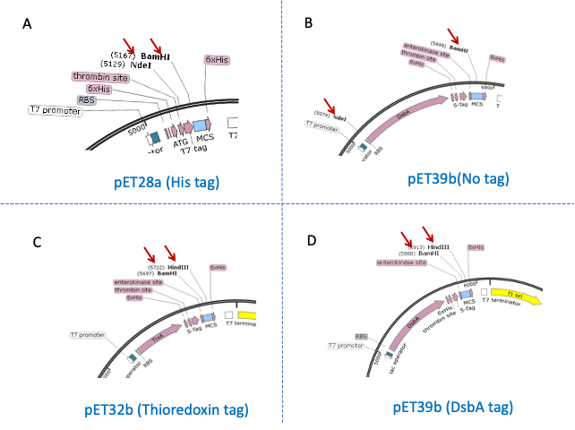
Figure S1. Cloning strategy adapted for designing PDGF expression constructs with different fusion tags. The figures represent focused sections of different pET vectors derived from Snapgene software used for clone development. The restriction enzyme sites utilized for cloning PDGF are highlighted with red arrows.
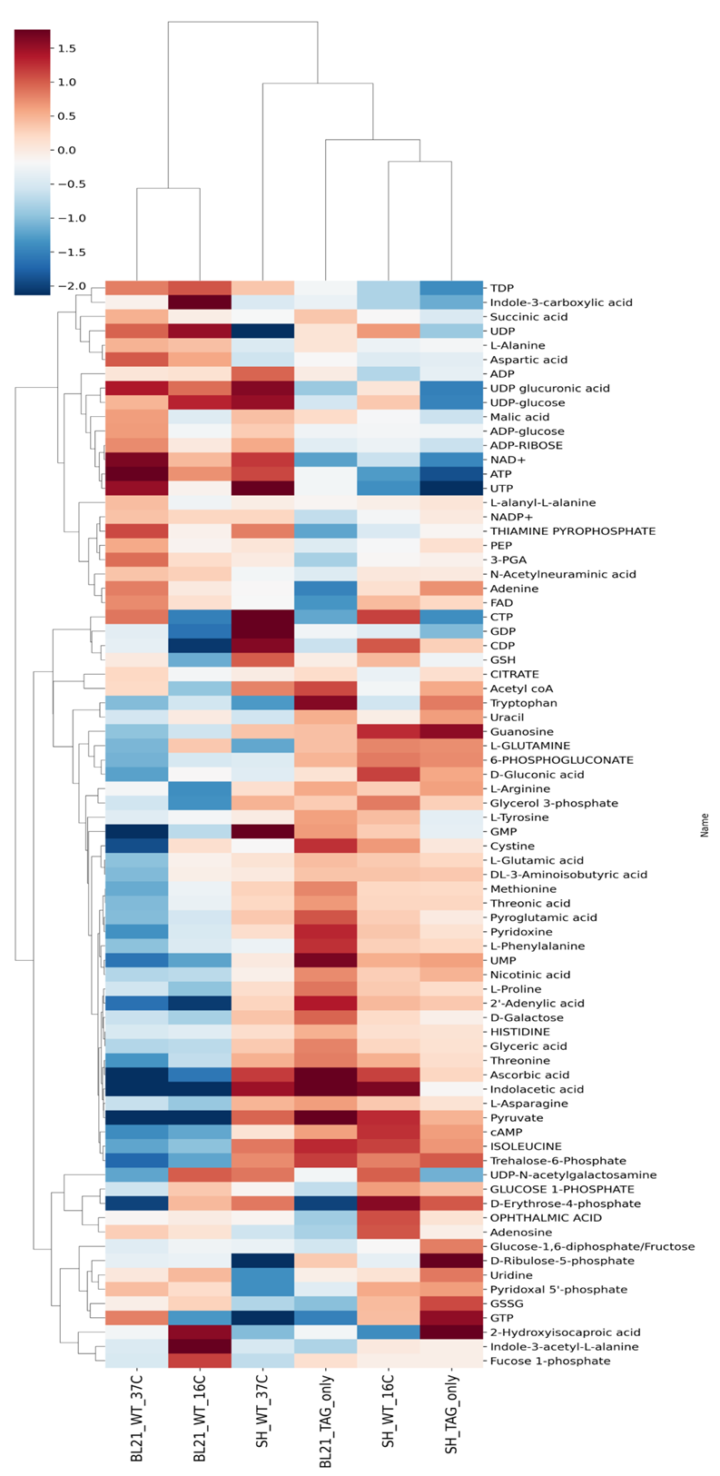
Figure S2. Overview of the effect of thioredoxin tag on cellular metabolism of host strains. pET32b vector containing thioredoxin tag was expressed in BL21 (DE3) and SHuffle host strains at 16 °C, and the intracellular metabolites were extracted and injected on LC-MS/MS. Intracellular metabolic profiles of Trx-expressing BL21 (DE3) and SHuffle T7 strains to were compared to those of the corresponding host strains. (Data also shown in Figure 2 in the main manuscript). The heatmap is generated using the Metastat tool (available at msone.claritybiosystems.com).

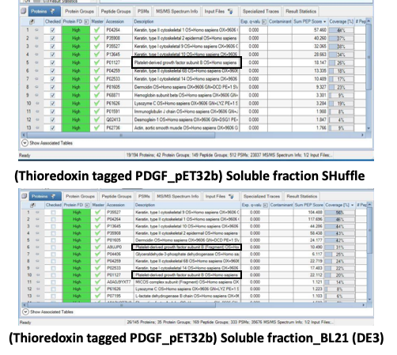
Figure S3: HR-MS data showing the presence of soluble PDGF. The supernatant obtained after cell lysis (sonication) was loaded onto 12% SDS-PAGE gel. The Coomassie brilliant blue-stained band of the soluble fraction containing PDGF was excised. The standard in-gel trypsin digestion protocol was followed for preparing the sample for proteomic analysis. Samples were run for MS analysis on Orbitrap Fusion in the Mass Spectrometry Facility at IIT Bombay (MASSFIITB).

