9. APPENDEX (1)
Mean separation table for the effect of districts on motility
District | Mean
Sankura | 50.92ª
Lanfro | 42.27^{b}
Dalocha | 36.96^{c}
CV | 28.45
LSD | 2.004
Mean separation table for the effect of breed on motility
Breed | Mean
Friesian | 50.92ª
F*F*Bo | 42.27^{b}
Jersey | 36.96^{c}
CV | 28.45
LSD | 2.004

10. APPENDEX (2)
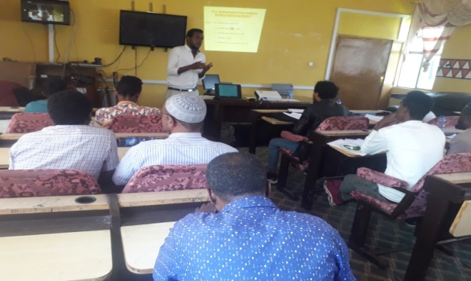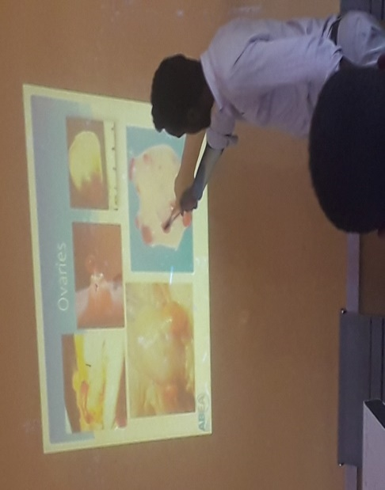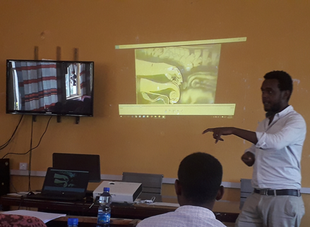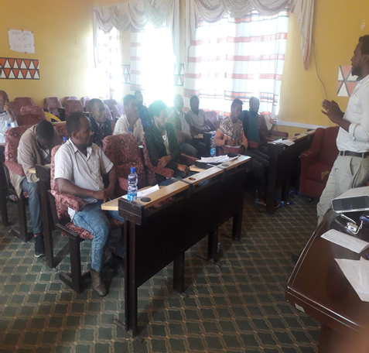
Figure 1. Training for AIT& woreda experts about insemination, estrus detection and PD check
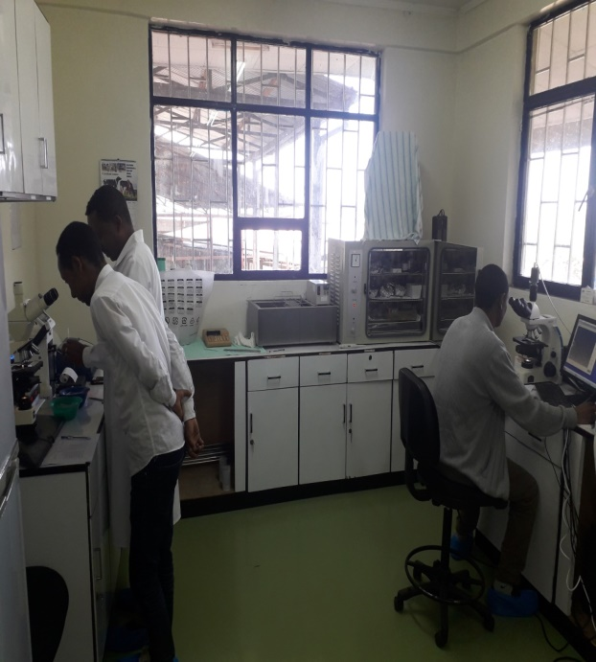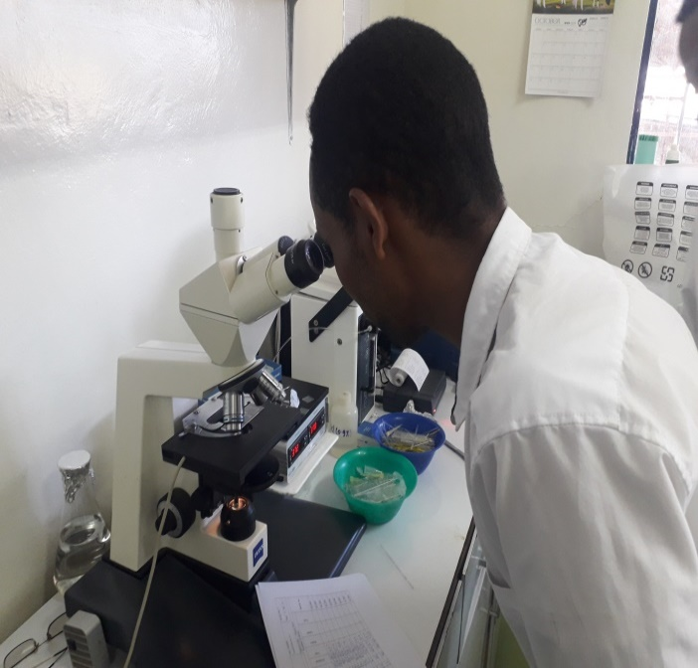
Figure 2. Evaluation of semen quality in national animal genetic improvement institute laboratory.

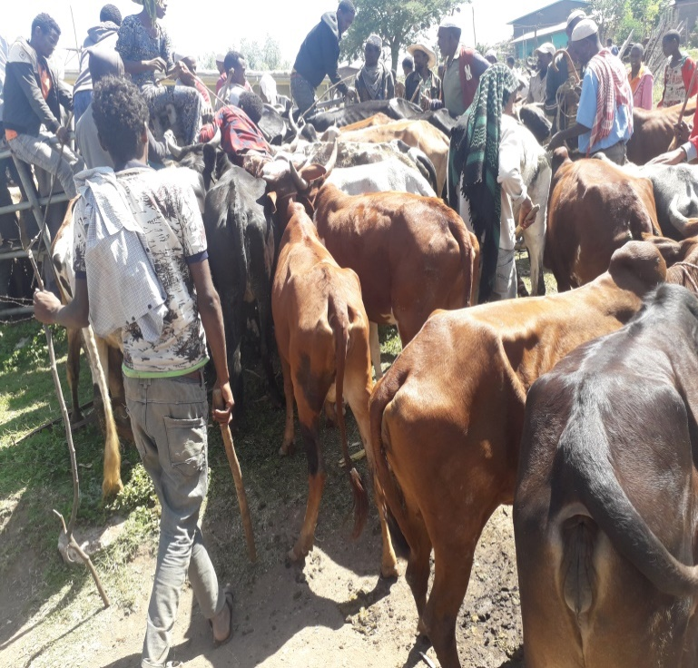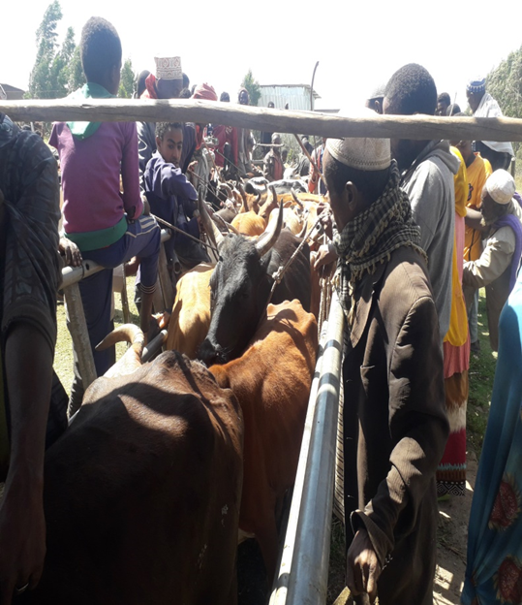
Figure 3.Mass number of cow provide during OSMI program in the study districts during the program

