Supplementary Information

Supplementary Fig. 1: Flowchart of study.
Supplementary Fig. 2: Distribution of original and ln-transformed lung function measures.
Supplementary Fig. 3: Distribution of original and ln-transformed liver MRI biomarkers.
Supplementary Fig. 4: Directed acyclic graphic for the causal relationship among key variables in the current study.
Supplementary Fig. 5: Dose-response associations of lung function measurements with the risk of incident MASLD and hepatic MRI indexes.
Supplementary Fig. 6: Correlations between lung function measures and the proteomic signatures.
Supplementary Fig. 7: The top 10 enrichment pathways (FDR<0.05) of the protein biomarkers for FEV1, FVC and PEF.

Supplementary Fig. 1: Flowchart of study.
Supplementary Fig. 2: Distribution of original and ln-transformed lung function measures.
Supplementary Fig. 3: Distribution of original and ln-transformed liver MRI biomarkers.

Supplementary Fig. 4: Directed acyclic graphic for the causal relationship among key variables in the current study.
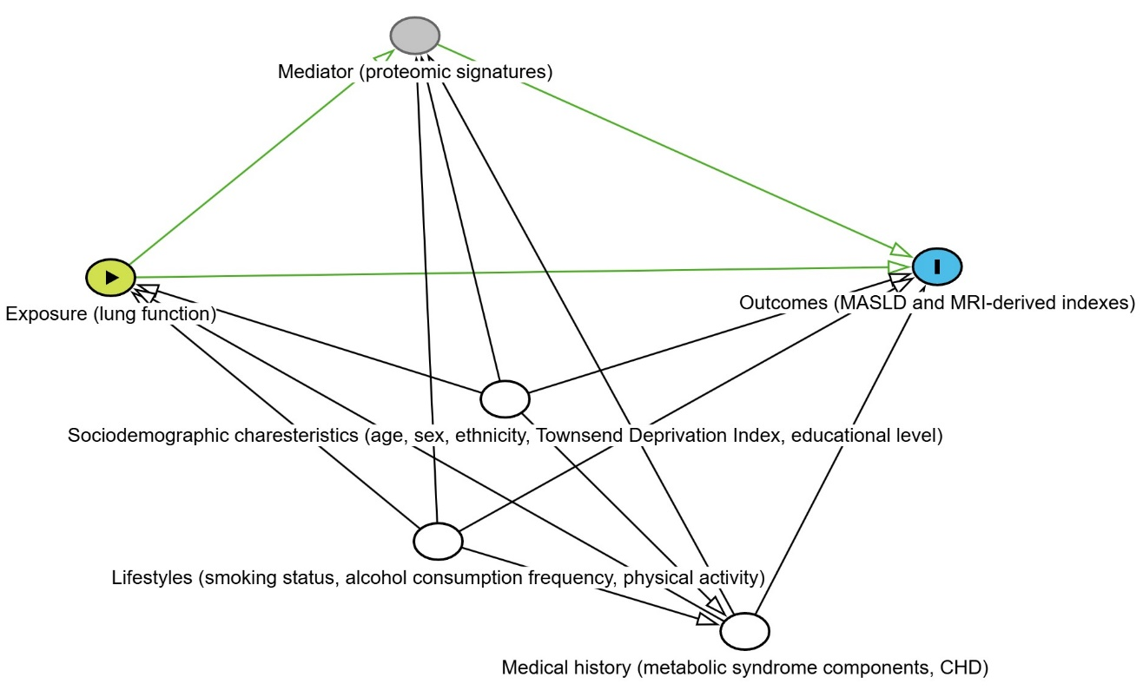
Directed acyclic graph was generated via http://dagitty.net/. Here, “sociodemographic characteristics” represents a set of variables, including age, sex, race/ethnicity, and education, “Lifestyle” includes smoking status, alcohol consumption frequency, and regular physical activity, "Medical history" represents metabolic syndrome components, and coronary heart disease. In this figure, there is an arrow from “Exposure” to “Mediator”, assuming proteomic signatures were intermediate variables. White circles indicate these variables are required to be adjusted to derive the causal relationship between lung function and outcomes. The light green circle refers to the measured exposure (lung function), the grey circle refers to measured mediators, and the blue circle refers to measured outcomes. Accordingly, the green line indicates the causal path. Black lines indicate adjusted biased paths.

Supplementary Fig. 5: Dose-response associations of lung function measurements with the risk of incident MASLD and hepatic MRI indexes.
Data were fitted by using the restricted cubic spline with four knots (reference is the minimum values). Models were adjusted for age, sex, ethnicity, Townsend Deprivation Index, educational level, smoking status, alcohol consumption frequency, physical activity, metabolic syndrome components, and coronary heart disease.
HR, hazard ratio; CI, confidence interval; MASLD, metabolic dysfunction-associated steatotic liver disease; PDFF, proton density fat fraction; cT1, liver iron corrected T1; FEV1, forced expiratory volume in 1s; FVC, forced vital capacity; PEF, peak expiratory flow.

Supplementary Fig. 6: Correlations between lung function measures and the proteomic signatures.

Supplementary Fig. 7: The top 10 enrichment pathways (FDR<0.05) of the protein biomarkers for FEV1, FVC and PEF.
(A) Downregulated proteins and (B) upregulated proteins.

