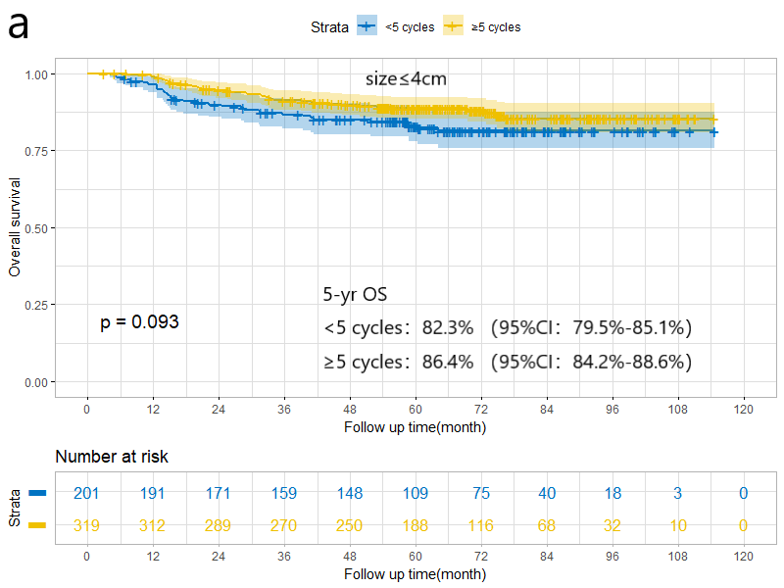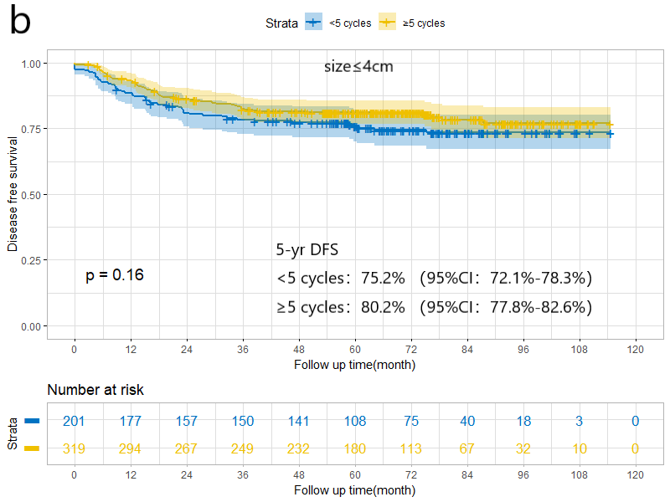

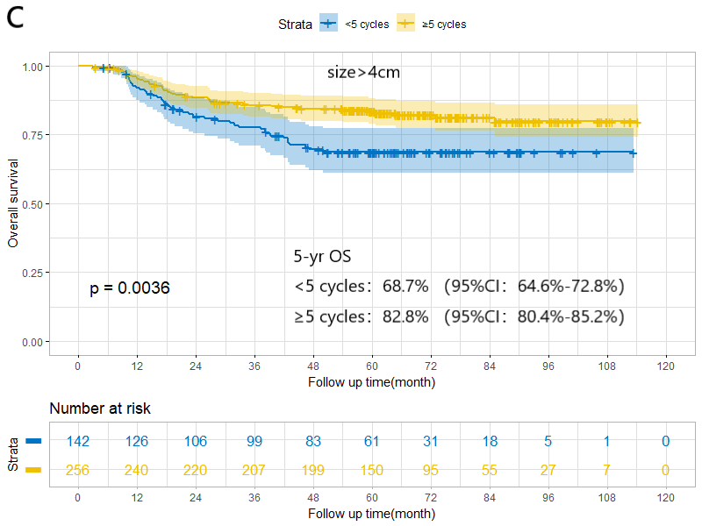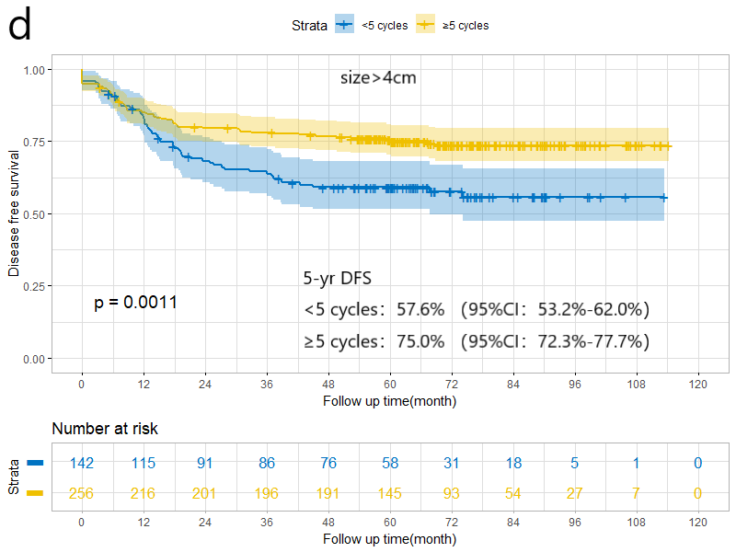

Figure S1. The comparison of OS between < 5 cycles and ≥ 5 cycles group in tumor size ≤ 4cm (a) and tumor size > 4cm (c); The comparison of DFS between < 5 cycles and ≥ 5 cycles group in tumor size ≤ 4cm(b) and tumor size > 4cm (d). OS, Overall survival; DFS, Disease free survival; HR: Hazard ratio; CI: Confidential interval.

