Supplementary Materials
for
AI (Artificial Intelligence)-Coupled Self-Calibrating SERS Spectroscopy for Robust Clinical Diagnosis of Diabetes and Associated Complications
Kaitao Lai^{1, #}, Shoubin Long^{2, #}, Xiacong Wang^{1, #}, Shah Faisal¹, Shiqing Zhang¹, Fucheng Zhong¹, Soham Samanta^{1,6}, Gengwen Chen⁵, Jiarong Lian¹, Dixian Luo^{3,} * Zhigang Yang^{1,} * and Xiaojun Peng⁴
¹ Key Laboratory of Optoelectronic Devices and Systems of Ministry of Education and Guangdong Province, College of Physics and Optoelectronic Engineering, Shenzhen University, Shenzhen, 518060, China
² Laboratory Medicine Center, The sixth Affiliated Hospital of Shenzhen University (Nanshan District People’s Hospital), Shenzhen 518052, China
3 Medical Laboratory Center, the Third Affiliated Hospital (The Affiliated Luohu Hospital) of Shenzhen University, Shenzhen, 518060, China
⁴State Key Laboratory of Fine Chemicals, College of Material Science and Engineering, Shenzhen University, Shenzhen, 518060, China
⁵Hematology Reagent R&D department, Mindray Bio-medical Electronics Co. LTD, Shenzhen, 518107, China
⁶Department of Basic Science and Humanities, Institute of Engineering and Management (IEM), Kolkata -700091, India
# These authors contributed equally to this work.
*Corresponding Email: luo_dixian@email.szu.edu.cn; zhgyang@szu.edu.cn

Content Outline
- Materials preparations S3
- The identification of Gold nanoparticles and surface functionalization S3
- SERS measurements of AuNPs on small molecules S4
- SERS spectral tests of blood serum samples from different Diabetes patients and dataset split. S7
- Training and validation loss, accuracy, and ROC plots S8
- t-Distributed Stochastic Neighbor Embedding (t-SNE) plots S12
- Confusion matrix S15
- Training and validating processes and ROC, t-SNE, and confusion matrix S18
- Confusion matrix using traditional machine learning methods S21
- Reference S30

Materials preparations.
Gold nanoparticle solution was synthesized using the sodium citrate reduction method [1]. Initially, 50 mL of chloroauric acid solution (50 mM) was heated to boiling. Then, 0.3 mL of sodium citrate solution with a mass fraction of 1 wt% was rapidly added. The solution’s color changed from light yellow to black and subsequently to reddish-brown within 2 minutes. The solution was kept boiling with continuous stirring for 30 minutes to ensure a complete reaction. Then, it was naturally cooled down to room temperature to obtain gold nanoparticles with a particle size of approximately 45 nm. To adjust the pH value to a weak alkaline state, 0.5 mL of 0.5 M KOH solution was added to the prepared gold nanoparticle solution and stirred through a magnetic stirrer. In the next step, 4-mercaptophenylboronic acid (1 mM, 4) was added to the solution and stirred at room temperature for 12 hours to obtain the AuNPs@4MPBA solution. The newly synthesized AuNPs@4MPBA solution was centrifuged at 7500 rpm for 10 minutes to remove the supernatant and obtain a concentrated AuNPs@4MPBA solution for further use (Figure S1). The clinical serum samples were collected from the Union Hospital of Huazhong University of Science and Technology and Shenzhen Hospital, and were tested using standard procedures in the clinics.
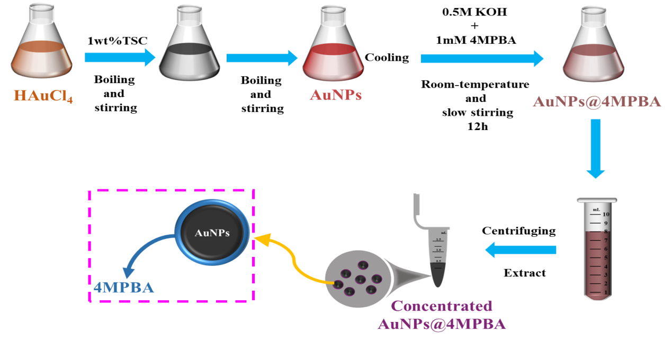
Figure S1 Schematic diagram of the preparation process of AuNPs@4MPBA

The identification of Gold nanoparticles and surface functionalization.
Figure S2a shows the zeta potential plots of AuNPs and AuNPs@4MPBA. Zeta potential tests were performed on AuNPs both before and after the modification of 4MPBA. Each sample was subjected to five experimental tests under the same conditions to prevent accidental errors. The average zeta potential value, along with its standard error, for AuNPs and AuNPs@4MPBA is shown in the figure. The average change in Zeta potential, from -22.44 mV to -27.75 mV, indicates a change in the charge state on the surface of the nanoparticles due to the chemical bonding of Au-S between 4MPBA and the surface of AuNPs. This also suggests that the nanoparticles possess a higher surface charge density. This higher electrostatic repulsion between the particles effectively mitigates aggregation and precipitation.
To further verify whether 4MPBA is truly modified to the surface of AuNPs, FTIR spectroscopy was conducted. The results shown in Figure S2b contain a schematic representation of the chemical structure of AuNPs@4MPBA. The comparison shows that the AuNPs@4MPBA, represented by the blue curve at 550 cm⁻¹ and 1394 cm⁻¹, exhibits two obvious peaks. The peak at 550 cm⁻¹ corresponds to the out-of-plane bending of B-CH. In contrast, the peak at 1394 cm⁻¹ is attributed to the out-of-plane bending of C-H within the benzene ring, along with the bending vibration of C-H and B-OH [2], indicating that 4MPBA was successfully modified onto the surface of AuNPs.
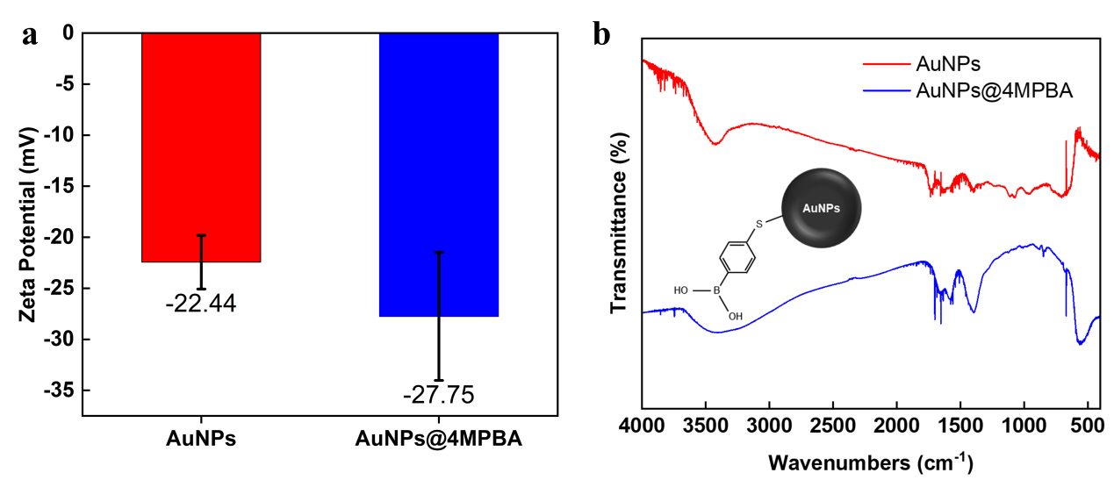
Figure S2 a. Zeta potential maps of AuNPs and AuNPs@4MPBA; b. FTIR spectra of AuNPs and AuNPs@4MPBA.

SERS measurements of AuNPs on small molecules.
To verify that AuNPs@4MPBA exhibits a specific signal while maintaining the non-specific enhancement of AuNPs, Surface-enhanced Raman scattering (SERS) was conducted, and the SERS results for different probe molecules are shown in Figure S3. The spectra of the 10 μM R6G solution (black solid line) and the AuNPs (red solid line) show almost no Raman signal. In contrast, gold nanoparticles modified with 4-mercaptophenylboronic acid (blue solid line) show two distinct characteristic peaks. The surface-enhanced Raman scattering (SERS) signal (green solid line) obtained by proportionally mixing AuNPs@4MPBA with 10 μM R6G solution retains the distinctive peaks of 4MPBA and shows a weak R6G signal. On the other hand, the SERS signal (purple solid line) obtained after proportionally mixing AuNPs with 10 μM R6G solution shows a stronger R6G signal. This is because the phenylboronic acid covering the surface of the gold nanoparticles increases the distance between the R6G molecules and the AuNPs, reducing the enhancement effect.
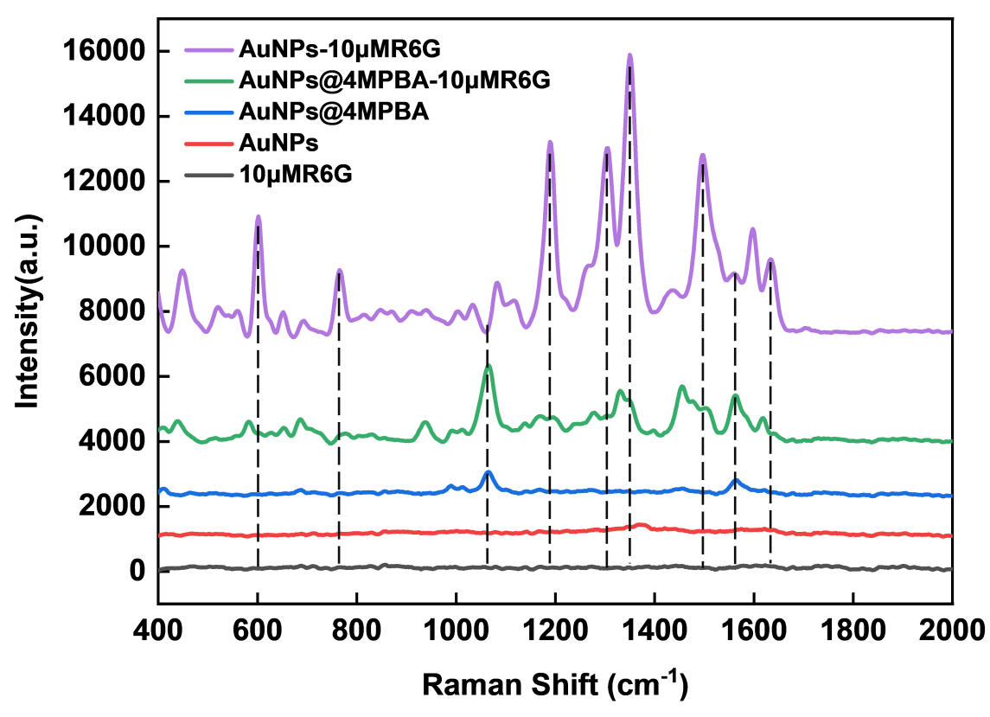
Figure S3 Plot of SERS results for different probe molecules
As shown in Figure S4, the average SERS spectra and standard deviations for different types of diabetes and their early complications are presented. The relatively large standard deviation for each disease category is due to significant individual variations even within the same disease category. Consequently, relying on visual inspection only complicates the direct identification of the spectrum. This research achieved precise classification using deep learning. Table 1 shows some Raman peaks along with their corresponding attributions.
Table S1 Attributions corresponding to some Raman peaks ^{[3-4]}
Raman Shift(cm⁻¹) | Assignments
627 | ν(CS)，Glutamic acid
686 | Guanine ring breathing vibration
728 | Adenosine ring breathing vibration
814 | ν(CC)，RNA
993 | δ(CC)
1014 | δ(CH)
1067 | δ(CC) and ν(CS)，Proline
1171 | Tyrosine
1261 | β(CH)，Lipids
1461 | β(CH)，Lipids、DNA
1479 | Amide II belt
1560 | Non-complete symmetric ring stretching, Tryptophan
Symbols：ν—stretching; β—bending; δ—in-plane deformation
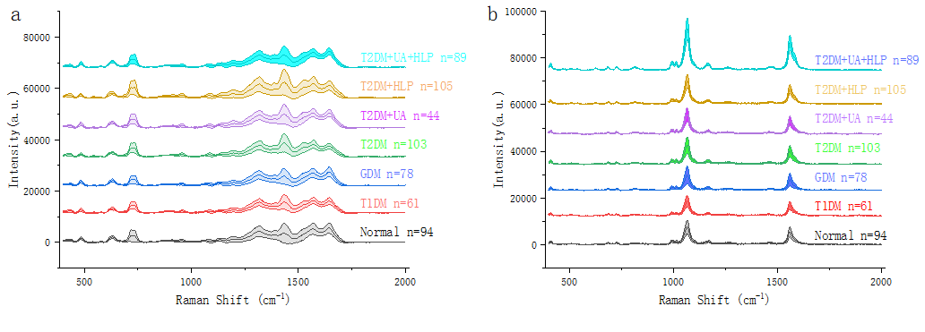
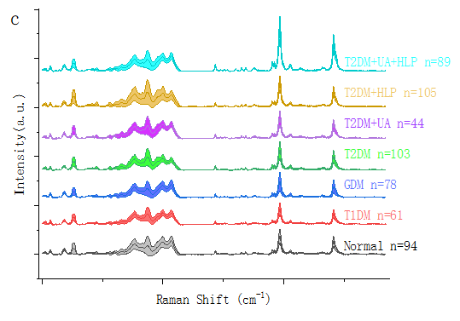
Figure S4 The non-specific and specific SERS spectra of different serum and the concatenated SERS spectra of a and b. (a) and (b) show the average SERS spectra and standard deviations of different types of diabetes and their early complications measured on AuNPs and AuNPs@4MPBA substrates, respectively; (c) displays the combined SERS spectra of AuNPs and AuNPs@4MPBA.

SERS spectral tests of blood serum samples from different Diabetes patients and dataset split.
Each serum sample was examined in 10 different locations to test 10 specific SERS spectra. After preprocessing, the collected spectra were fed into the ResNet-attention network using the Air-PLS algorithm for classification. This research employs a progressive classification technique for two, four, and seven class classification. The primary classification process consists of two classes to determine the presence of diabetes, followed by four classes to differentiate among specific types of diabetes, and finally, seven classes that allow for more detailed identification of diabetes and its early complications. The serum samples were divided into training and testing datasets at the ratio 3:7 for all classification tasks. All spectral numbers in the training set are divided into training and validation subsets in a 7:3 ratio, as shown in Table 2. A total of 190 samples and 1,900 spectral data points were used for the two-classification task, comprising 94 samples from the normal group. First, the training set is used to divide each class of samples: The test set is a 3:7 ratio, which combines 280 spectra from 28 samples taken from the diabetes group and 280 spectra from 28 samples taken from the normal group to form a training set. This results in 56 samples with a total of 560 spectra used for the training set, while all remaining sample spectra were used as the test set. Then, the spectra in the training set are divided into a training subset and a validation subset. The training subset consists of 392 spectra, while the validation subset consists of 168 spectra. The test set consists of 134 samples, totaling 1,340 spectra. This includes 66 samples of normal and 68 samples of diabetes. Four-classification and seven-classification used similar dataset-splitting techniques. In terms of four-classification, the dataset contains 336 serum samples. The training set comprises normal samples (28 cases), T1DM (18 cases), GDM (23 cases), and T2DM (30 cases), totaling 99 samples (990 spectral data points). This subset is further divided into a training subset with 693 spectra and a validation subset with 297 spectra. The generalization ability test was conducted on 237 samples with 2370 spectra. In terms of seven-classification, the dataset contained 574 serum samples, and the training set was composed of normal samples (28 cases), T1DM (18 cases), GDM (23 cases), T2DM (30 cases), T2DM+UA (13 cases), T2DM+HLP (31 cases), and T2DM+UA+HLP (26 cases). This resulted in a total of 169 samples, corresponding to 1690 spectral data points. The dataset was further divided into a training subset of 1183 spectra and a validation subset of 507 spectra. The test set consisted of 405 samples, totaling 4050 spectra. The dataset's samples or spectra were randomly selected.
Table S2 Division of the dataset for different classification tasks
Classification | Type | Train | Test | Sum
Two | Normal | 28 | 66 | 94
Two | Diabetes | 28 | 68 | 96
Two | Sum | 56 | 134 | 190
Four | Normal | 28 | 66 | 94
Four | T1DM | 18 | 43 | 61
Four | GDM | 23 | 55 | 78
Four | T2DM | 30 | 73 | 103
Four | Sum | 99 | 237 | 336
Seven | Normal | 28 | 66 | 94
Seven | T1DM | 18 | 43 | 61
Seven | GDM | 23 | 55 | 78
Seven | T2DM | 30 | 73 | 103
Seven | T2DM+UA | 13 | 31 | 44
Seven | T2DM+HLP | 31 | 74 | 105
Seven | T2DM+UA+HLP | 26 | 63 | 89
Seven | Sum | 169 | 405 | 574

Training and validation loss, accuracy, and ROC plots
Figure S5 shows the training, validation, and testing results for the two, four, and seven-class classification tasks using the ResNet-Attention network on the specified spectra. Figure S5a illustrates the loss and accuracy curves for both the training and validation sets of a two-class classification task, achieving a training accuracy of 1.000 after 30 epochs, with stable convergence attained by the 10th epoch. Figure S5b presents model validation using the test set, indicating that the corresponding ROC curves cover the upper-left quadrant and all AUC values equal 1.000, suggesting that the network can perform rapid and precise classification for both classes, with or without diabetes. The network can achieve fast, efficient, and precise classification for binary classification of diabetes presence or absence. In the four-classification task, the loss function and accuracy curves for both the training and validation sets are illustrated in Figure S5c. The training set accuracy achieves 1.000, as does the validation accuracy. The classification model, which showed high accuracy, was evaluated using the test set data. The results in Figure S5d show the ROC curves for the four classification tasks, indicating effective classification of the four spectral types with excellent AUC values. The AUC value is consistently over 0.98. In the seven-class classification task, Figure S5e illustrates the loss function curve and accuracy curve for both the training and validation sets, where the training and validation accuracies reach a value of 1.000. A high-precision classification model is retained and then evaluated on the test set data. Figure 5f illustrates the ROC curve for the test set of the seven-class classification problem. The classification of the seven spectra is effective, with all the corresponding AUC values over 0.994. The network shows excellent classification performance for diabetes-specific SERS spectra, indicating significant practical application prospects.
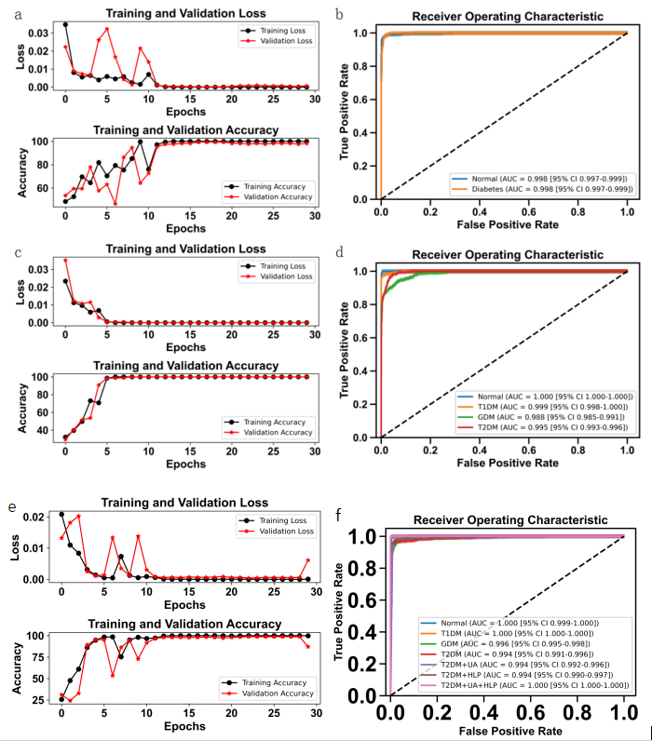
Figure S5 a. Loss function curves and accuracy curves for the training and validation sets of the two-classification task, b. ROC curves and AUC for the test set corresponding to a, with 95% CI denoting 95% confidence intervals, c. Loss function curves and accuracy curves for the training and validation sets of the four classification tasks, and d. ROC curves and AUC for the test set corresponding to c, with 95% CI denoting 95% confidence intervals. Loss function curves and accuracy curves for the training and validation sets of the seven classification tasks, and f. ROC curves and AUC for the test set corresponding to c, with 95% CI denoting 95% confidence intervals.

Figure S6 illustrates the performance of the ResNet-Attention network in two, four, and seven class classification tasks using non-specific spectra. Figure S6a displays the training and validation loss and accuracy curves for the two-class classification task. The training accuracy reaches 1.000, indicating stable convergence by epoch 10, while the validation accuracy is 0.989. Figure S6b presents the ROC curves for the test set, with the AUC values consistently measuring 0.94, demonstrating the model’s efficiency and accuracy in classification. Figure S6c shows the training and validation loss and accuracy curves for the four-class classification task. The training accuracy achieves 1.000, whereas the validation accuracy is 0.874. The model with the highest validation accuracy was evaluated on the test dataset. Panel S6d illustrates the ROC curves for the test set in the four-class task, with AUC values consistently above 0.96, indicating strong classification performance. For the seven-class classification task, Figure S6e displays the training and validation loss curves along with the corresponding accuracy curves. The training accuracy reaches 1.000, and the validation accuracy is 0.765. The model with the highest precision was evaluated on the test dataset. Panel S6f shows the ROC curve for the test set in the seven-class task, with all AUC values exceeding 0.901, indicating effective classification. These results underscore the network's high classification efficacy for diabetes-specific SERS spectra, highlighting its significant potential for practical application in clinical settings.
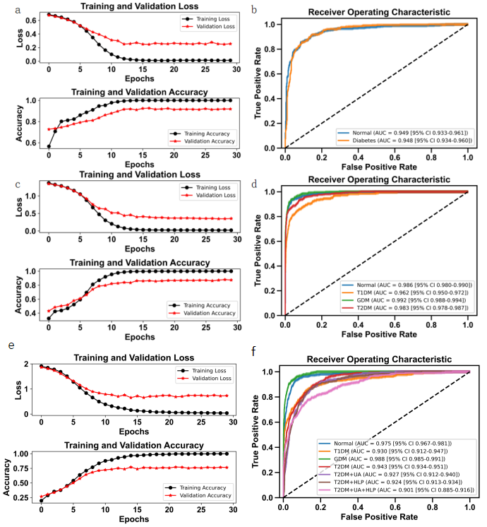
Figure S6 a. Loss function curves and accuracy curves for the training and validation sets of the two-classification task, b. ROC curves and AUC for the test set corresponding to a, with 95% CI denoting 95% confidence intervals, c. Loss function curves and accuracy curves for the training and validation sets of the four classification tasks, and d. ROC curves and AUC for the test set corresponding to c, with 95% CI denoting 95% confidence intervals. Loss function curves and accuracy curves for the training and validation sets of the four-classification task, and f. ROC curves and AUC for the test set corresponding to c, with 95% CI denoting 95% confidence intervals.

t-Distributed Stochastic Neighbor Embedding (t-SNE) plots
Figure S7 displays the t-SNE results before and after the network for two, four, and seven class classification tasks using the specific spectra. Figures S7a and S7b illustrate the t-SNE results for the two-class classification task, illustrating a clear distinction between diabetic and non-diabetic spectra post-classification by the network. Similarly, the t-SNE results and confusion matrix results for the test set in the four-class classification task are shown in Figures S7c and S7d, respectively. Figures S7e and S7f illustrate the t-SNE results for the seven-class classification task. Overall, the two-class, four-class, and seven-class classifications effectively consolidate similar disease spectra using the ResNet-attention network. In contrast, the spectra of different disease types are dispersed for better differentiation.
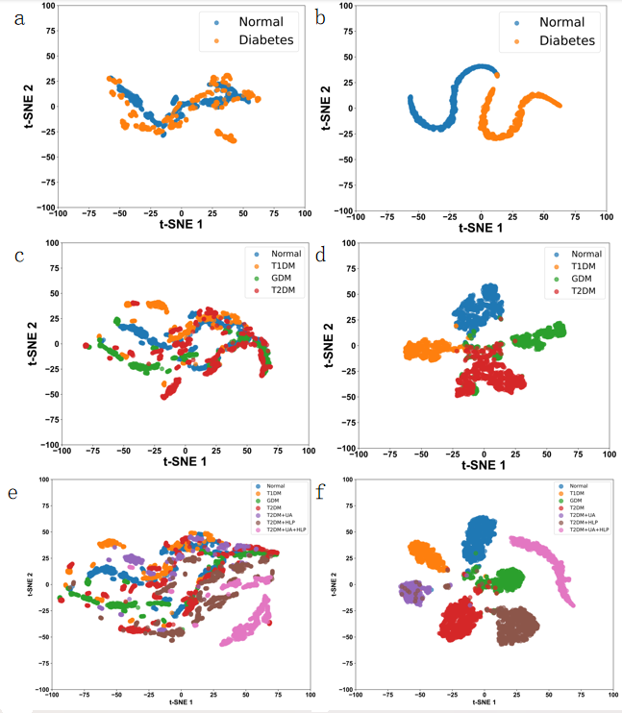
Figure S7 a. and b. t-SNE plots before and after the test set in the dichotomous task are classified by the ResNet-attention network, respectively, c. and d. t-SNE plots before and after the test set in the four-classification task are classified by the ResNet-attention network, respectively; and f. t-SNE plots before and after the test set in the seven-classification task are classified by the ResNet-attention network, respectively.
Figure S8 illustrates the t-SNE results before and after the network for two, four, and seven class classification tasks of the non-specific spectra. Specifically, Figures S8a and S8b present the t-SNE results for two class classification tasks, showing a clear distinction between diabetic and non-diabetic spectra after network classification. Similarly, the t-SNE results and confusion matrix results for the test set in the four-class classification task are shown in Figures S8c and S8d, respectively. Figures S8e and S8f illustrate the t-SNE results for the seven-class classification task. Overall, both the two-class, four-class, and seven-class classifications effectively combine similar disease spectra using the ResNet-attention network. In contrast, the spectra of different disease types are dispersed for enhanced differentiation.
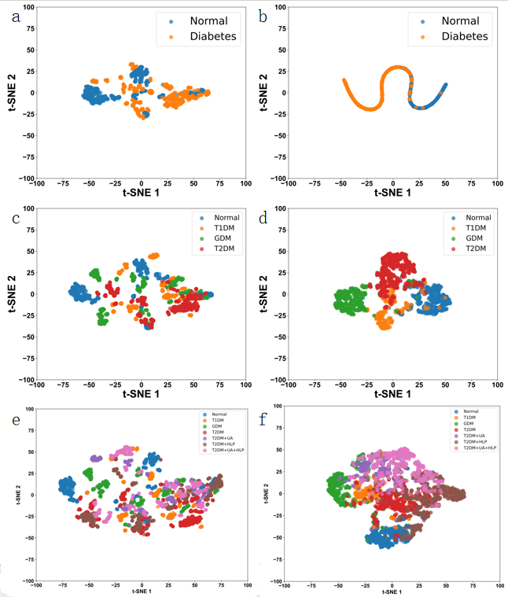
Figure S8 a. and b. t-SNE plots before and after the test set in the dichotomous task are classified by the ResNet-attention network, respectively, c. and d. t-SNE plots before and after the test set in the four-classification task are classified by the ResNet-attention network, respectively; e. and f. t-SNE plots before and after the test set in the seven-classification task are classified by the ResNet-attention network, respectively.

Confusion matrix
Figure S9 represents the results of the respective confusion matrices for the test sets. Figures a, b, and c represent the confusion matrices of the non-specific spectra. Figure S9a presents the confusion matrix for the two-class classification test set, illustrating the number of spectra precisely classified in each category, with an overall accuracy rate of 0.867 for the whole test set. The accuracy rate for the four-class classification is 0.879, as shown in the confusion matrix in Figure S9b. The confusion matrix for the seven-class test set, illustrated in Figure S9.c, shows an overall accuracy of 0.729. Figures S9d, S9e, and f represent the confusion matrices of the particular spectra. Figure S9d presents the confusion matrix for the binary classification test set, showing the number of spectra accurately classified in each category and an overall accuracy rate of 0.958 for the whole test set. The accuracy rate of the test set for the four-class classification is 0.921, shown in the confusion matrix in Figure S9e. Figure 9f shows the confusion matrix for the seven-class test set, which achieved an overall accuracy of 0.957. Results are shown in Figure S9. The ResNet-attention network has high generalization capabilities for diabetes-specific SERS spectra, achieving excellent classification accuracy.
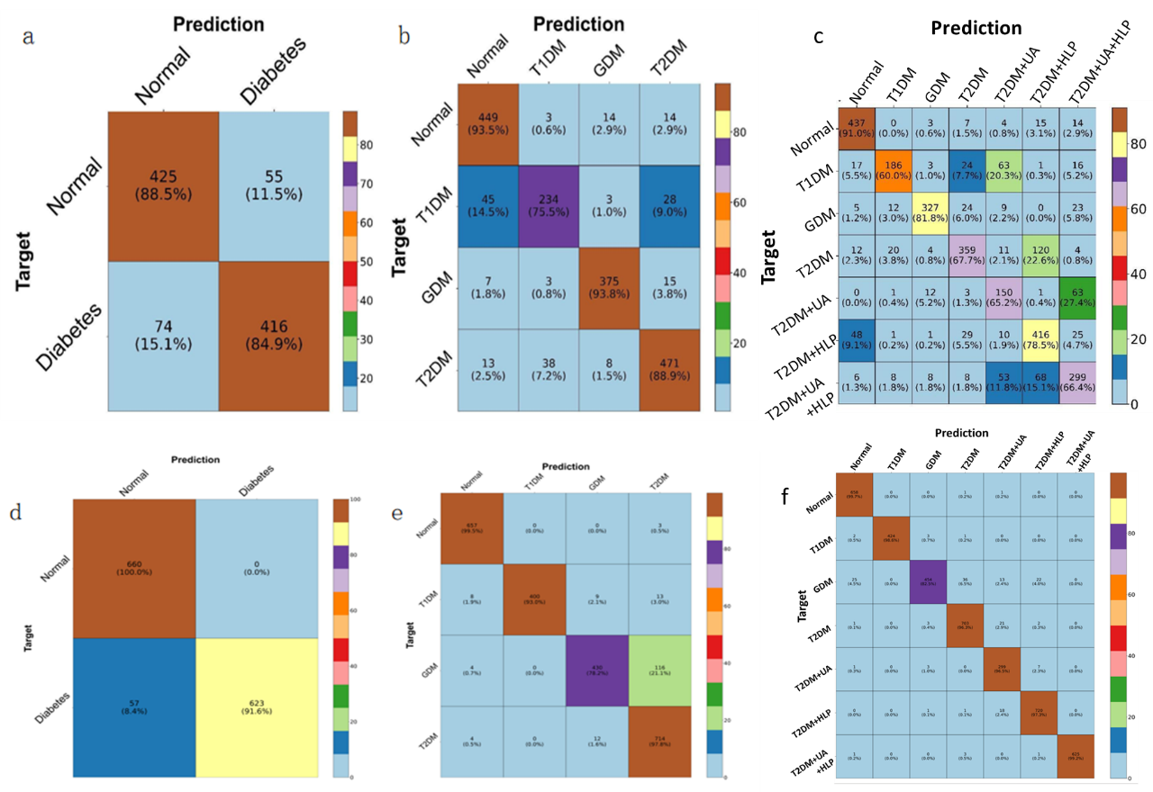
Figure S9 a. Confusion matrix of the test set in the binary classification task for the non-specific spectra, b. Confusion matrix of the test set in the four-classification task for the non-specific spectra; c. Confusion matrix of the test set in the seven-classification task for the non-specific spectra; d. Confusion matrix of the test set in the binary classification task for the specific spectra; e. Confusion matrix of the test set in the four-classification task for the specific spectra; f. Confusion matrix of the test set in the seven-classification task for the specific spectra.
The performance metrics and visualization from Figures S10 and S11 demonstrate the strengths of the ResNet-LSTM multihead self-attention neural network. While the model performs exceptionally well, especially for certain classes, there are still challenges in fully optimizing the network for all classes. The slight differences in accuracy compared to the main text suggest that further refinements and optimizations to the model could lead to even better classification performance. Figure 5 in the main text demonstrates an example of perfect classification by the neural network. In contrast, Figures S10 and S11 here are examples with slightly lower accuracy than those in the main text. These figures illustrate how deep learning models can be applied to complex, multi-class classification tasks in the context of medical diagnostics, offering valuable insights into the identification and differentiation of various diabetes mellitus-related conditions. And similarly, the designed neural network model also exhibited accurate classifications of four- and two-classes of diabetes, seen in Figure S12 and S13.

Training and validating processes and ROC, t-SNE and confusion matrix
Figure S10 The training and test performance of the 7-class of diabetes mellitus and its complications. (a, b) training and validating loss function curves and accuracy curves; (c) ROC curves and AUC for the test set, with 95% CI denoting the 95% confidence interval; (d, e) the t-SNE mapping plots of the test set before and after classified by the ResNet-LSTM multihead-self-attention neural network, respectively; (f) Confusion matrix for the test set.
Figure S11 The training and test performance of the 7-class of diabetes mellitus and its complications. (a, b) training and validating loss function curves and accuracy curves; (c) ROC curves and AUC for the test set, with 95% CI denoting the 95% confidence interval; (d, e) the t-SNE mapping plots of the test set before and after classified by the ResNet-LSTM multihead-self-attention neural network, respectively; (f) Confusion matrix for the test set.

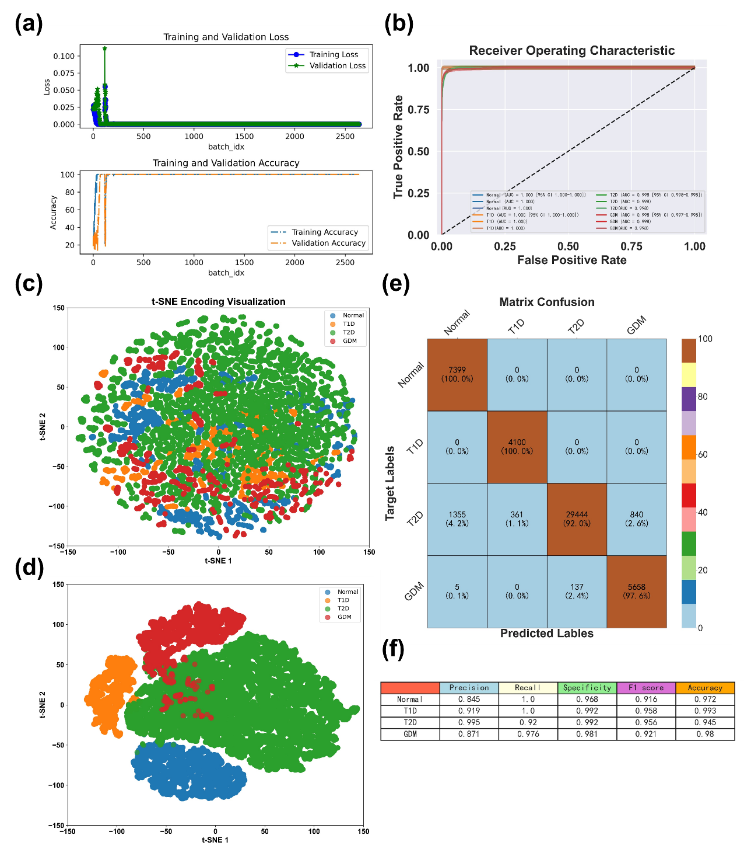
Figure S12 The training and test performance of the 4-class of diabetes mellitus and its complications. (a) training and validating loss function curves and accuracy curves; (b) ROC curves and AUC for the test set, with 95% CI denoting the 95% confidence interval; (c, d) the t-SNE mapping plots of the test set before and after classified by the ResNet-LSTM multihead-self-attention neural network, respectively; (e) Confusion matrix for the test set. (f) Precision, recall, specificity, F1 score and accuracy of 4-classifications.
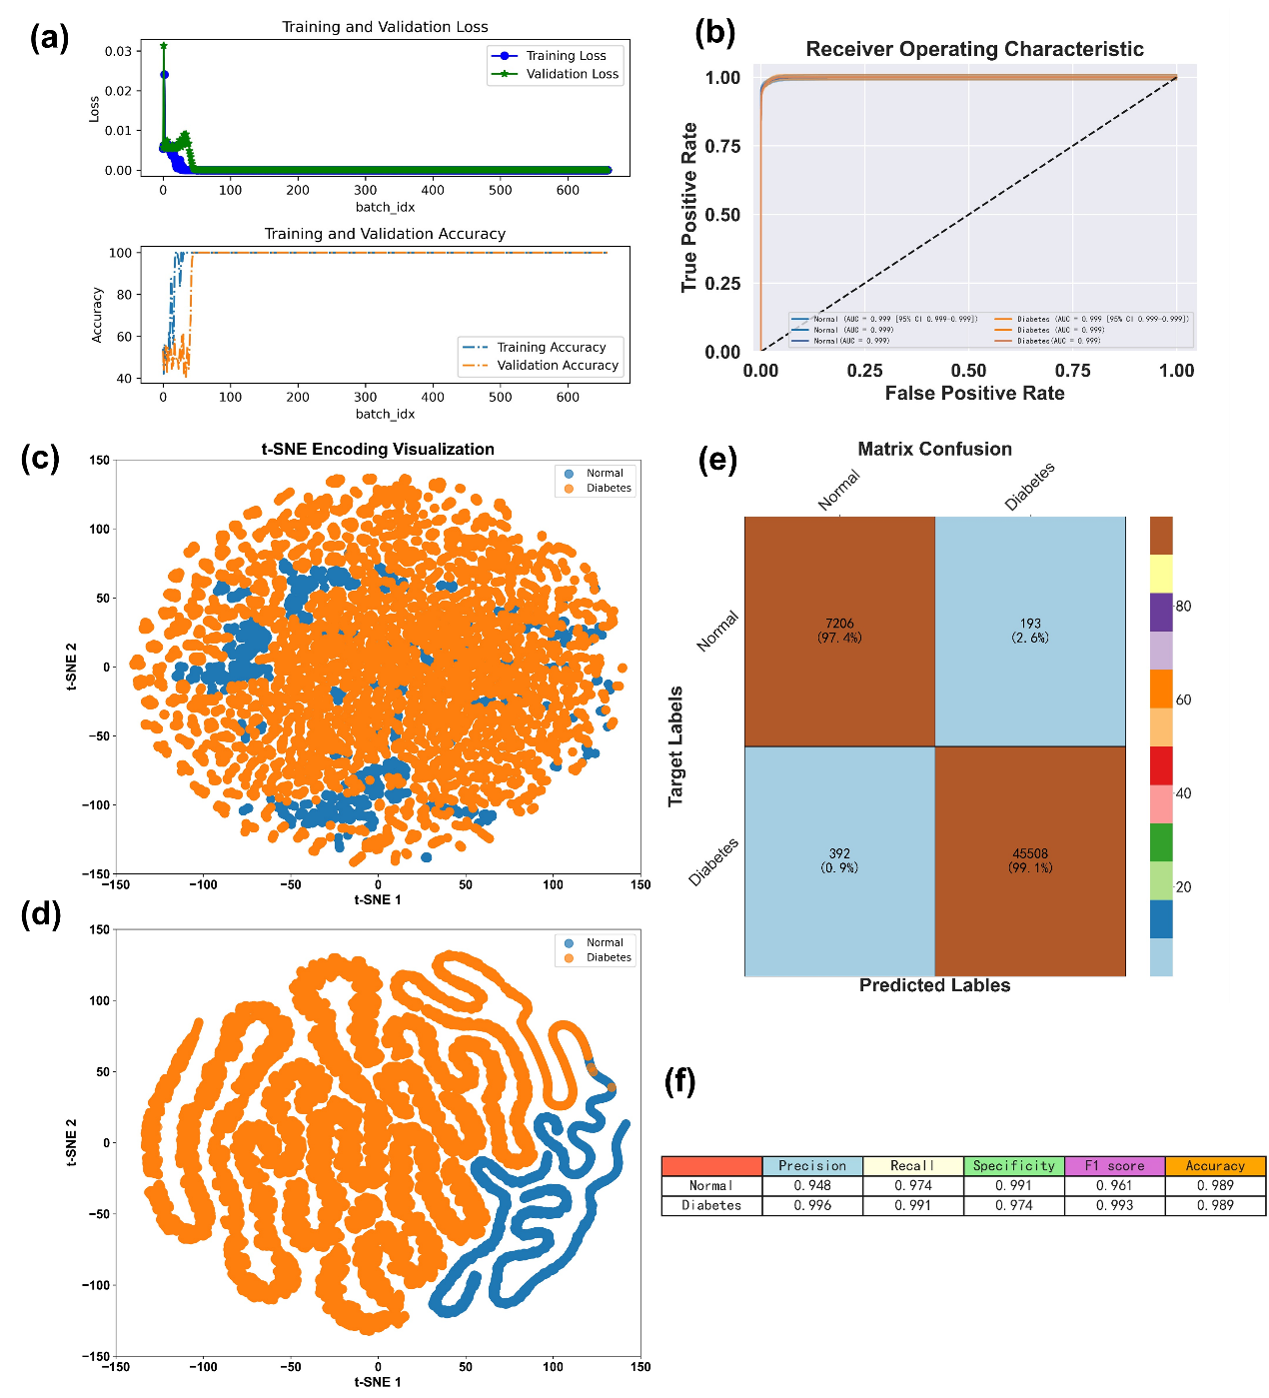
Figure S13 The training and test performance of the 2-class of diabetes mellitus and its complications. (a) training and validating loss function curves and accuracy curves; (b) ROC curves and AUC for the test set, with 95% CI denoting the 95% confidence interval; (c, d) the t-SNE mapping plots of the test set before and after classified by the ResNet-LSTM multihead-self-attention neural network, respectively; (e) Confusion matrix for the test set. (f) Precision, recall, specificity, F1 score and accuracy of 2-classifications.

Confusion matrix using traditional machine learning methods
The results of the confusion matrices for the two class classifications using PCA (Principal Component Analysis) on the test set are illustrated in Figure S14. Figure S14a presents the confusion matrix for the non-specific spectra test set, showing the number of accurately classified spectra in each category and the corresponding accuracy, with an overall accuracy of 0.919 for the entire test set. Figure S14b illustrates the confusion matrix for the particular spectra dataset, with an overall test set accuracy of 1.000. The accuracy of the combined test set of non-specific and specific spectra also achieves 1.000, as shown in the confusion matrix in Figure S14c. The calculated results are given in Figure S14, illustrating that for simple two-class classification, both the pre-combined and combined datasets perform well using PCA.
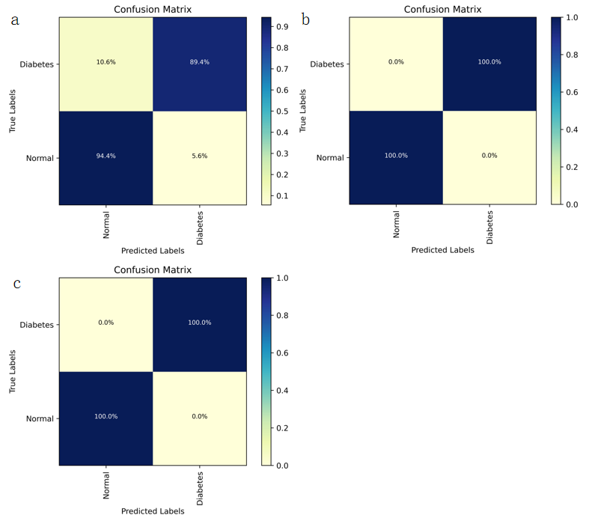
Figure S14 The confusion matrices for the two class classification on the test set using PCA (Principal Component Analysis) are as follows: a, the confusion matrix for the non-specific spectra; b, the confusion matrix for the specific spectra; and c, the confusion matrix for the combined non-specific and specific spectra.
Figure S15 illustrates the results of the confusion matrices for the four-class classification problem using Principal Component Analysis (PCA) on the test set. Figure S15a presents the confusion matrix for the non-specific spectra test set, indicating the number of correctly classified spectra in each category and the respective accuracy, achieving an overall accuracy of 0.885 for the entire test set. Figure S15b illustrates the confusion matrix for the specific spectra dataset, with an overall test set accuracy of 0.928. The accuracy of the combined test set, comprising non-specific and specific spectra, achieves 0.958, as shown in the confusion matrix in Figure S15c. The calculation results are shown in Figure S15. The combined dataset indicates high performance using PCA for the more complex four-classification test.
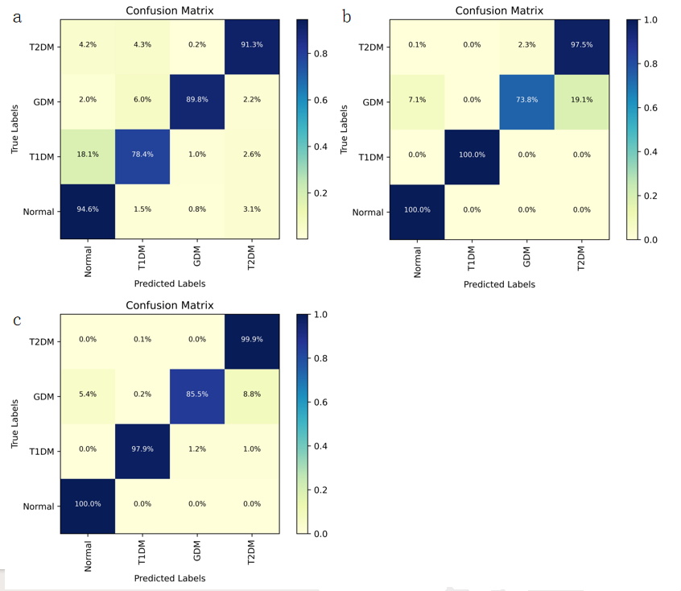Figure S15 The confusion matrices for the four-classification task on the test set using PCA (Principal Component Analysis) are as follows: a，the confusion matrix for the non-specific spectra; b，the confusion matrix for the specific spectra, and c, the confusion matrix for the combined non-specific and specific spectra.
Figure S16 presents the result of the confusion matrices for the seven-class classification problem using Principal Component Analysis (PCA) on the test set. Figure S16a illustrates the confusion matrix for the non-specific spectra test set, showing the number of accurately classified spectra in each category and the associated accuracy, which achieves an overall accuracy of 0.725 for the entire test set. Figure S16b illustrates the confusion matrix for the specific spectra dataset, with an overall test set accuracy of 0.922. The accuracy of the combined test set, comprising non-specific and specific spectra, is 0.957, as shown in the confusion matrix in Figure S16c. The results in Figure S17-S22 show that the combined dataset performs more effectively using Principal Component Analysis (PCA)/ Support Vector Machine (SVM)/Decision Tree (DT) for the more complicated four-class/two-class classification task, respectively.
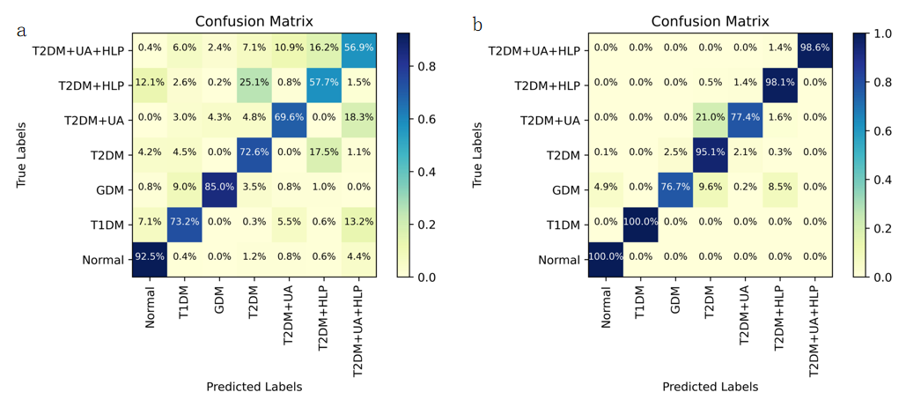
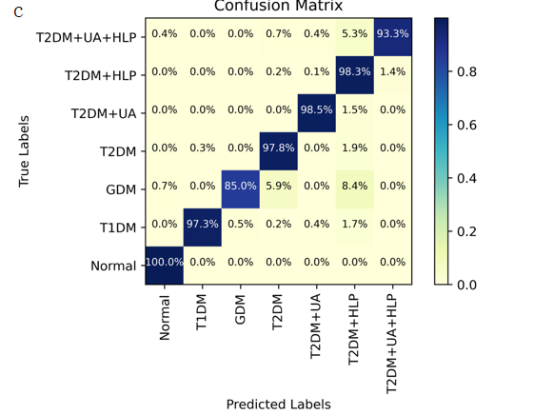
Figure S16 The confusion matrices for the seven-classification task on the test set using Principal Component Analysis (PCA) are as follows: a, the confusion matrix for the non-specific spectra, b, the confusion matrix for the specific spectra, and c, the confusion matrix for the combined non-specific and specific spectra.
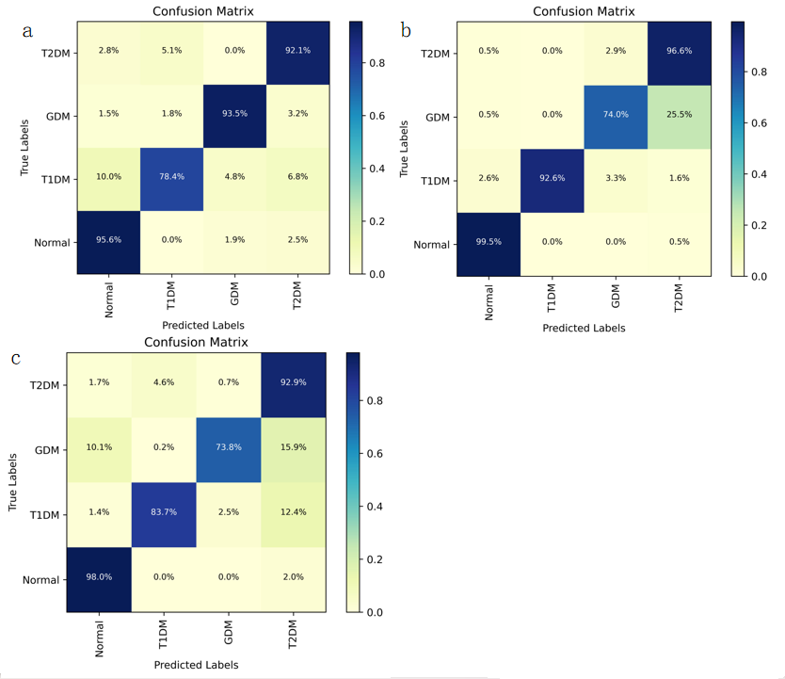Figure S17 The confusion matrices for the four class classifications on the test set using SVM (Support Vector Machine) are as follows: a, the confusion matrix for the non-specific spectra; b, the confusion matrix for the specific spectra; and c, the confusion matrix for the combined non-specific and specific spectra.
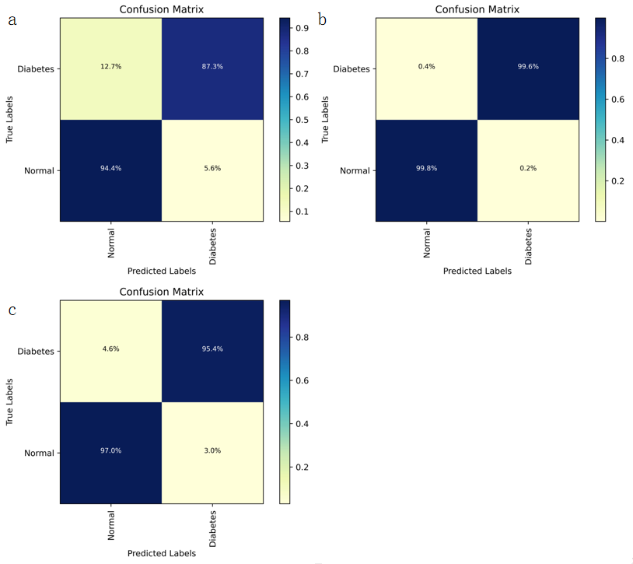
Figure S18 The confusion matrices for the two-class classifications on the test set using Support Vector Machine (SVM) are as follows: a, the confusion matrix for the non-specific spectra; b. the confusion matrix for the specific spectra, and c, the confusion matrix for the combined non-specific and specific spectra.
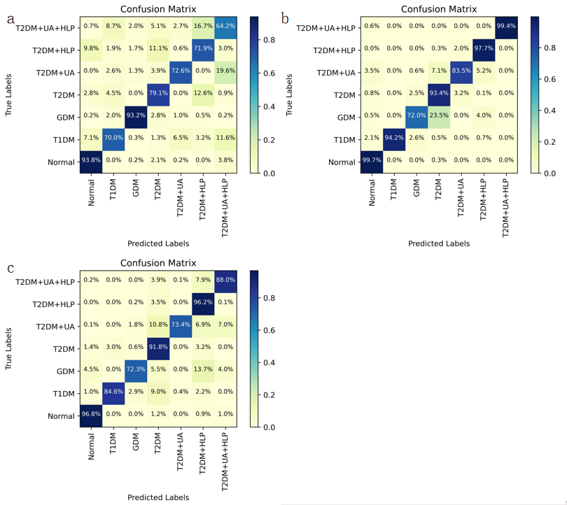
Figure S19 The confusion matrices for the seven-class classifications on the test set using SVM (Support Vector Machine) are as follows: (a) the confusion matrix for the non-specific spectra, (b) the confusion matrix for the specific spectra, and (c) the confusion matrix for the combined non-specific and specific spectra.
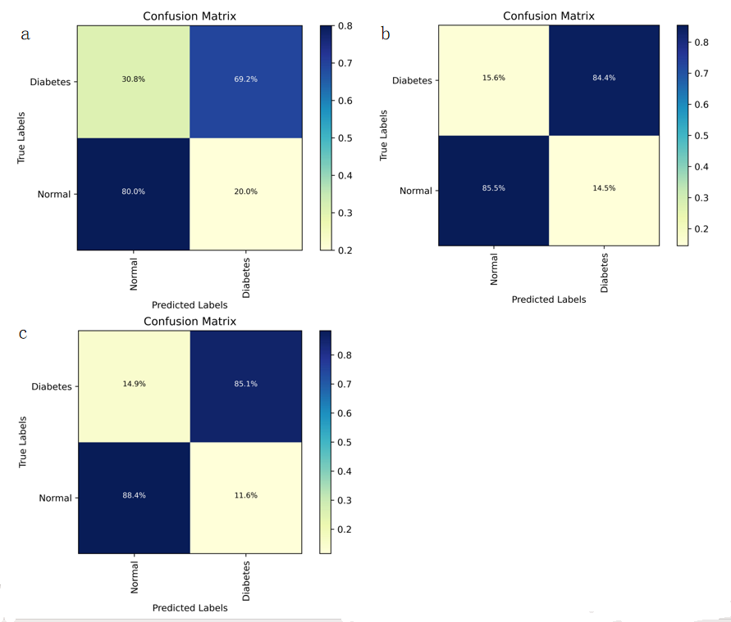Figure S20: The confusion matrices for the two-class classifications on the test set using Decision Tree (DT) are as follows: (a) the confusion matrix for the non-specific spectra, (b) the confusion matrix for the specific spectra, and (c) the confusion matrix for the combined non-specific and specific spectra.
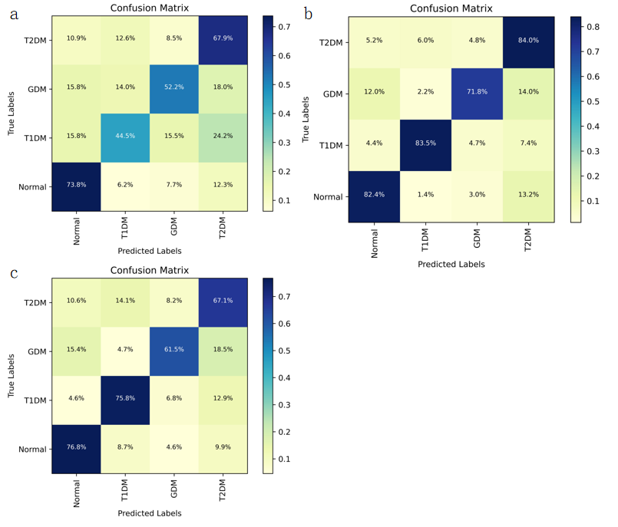Figure S21 The confusion matrices for the four-classification task on the test set using Decision Tree (DT) are as follows: (a) the confusion matrix for non-specific spectra, (b) the confusion matrix for specific spectra, and (c) the confusion matrix for the combined non-specific and specific spectra.
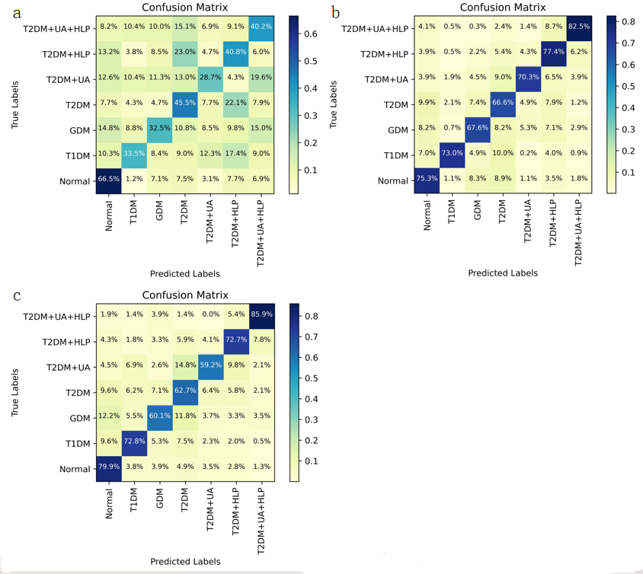
Figure S22 The confusion matrices for the seven-classification task on the test set using DT (Decision Tree) are as follows: a, the confusion matrix for the non-specific spectra; b, the confusion matrix for the specific spectra; and c, the confusion matrix for the combined non-specific and specific spectra.

References:
[1] FRENS G. Controlled Nucleation for the Regulation of the Particle Size in Monodisperse Gold Suspensions [J]. Nature Physical Science, 1973, 241(105): 20-2.
[2] SUNDARI S, MUTHURAJA A, CHANDRA S, et al. Spectroscopic analysis (FT-IR/FT-Raman), electronic (UV–visible), NMR and docking on 4-methoxyphenylboronic acid (4MPBA) by DFT calculation [J]. Molecular Crystals and Liquid Crystals, 2022, 755(1): 23-40.
[3] MOVASAGHI Z, REHMAN S, REHMAN I U. Raman Spectroscopy of Biological Tissues [J]. Applied Spectroscopy Reviews, 2007, 42(5): 493-541.
[4] STONE N, KENDALL C, SMITH J, et al. Raman spectroscopy for identification of epithelial cancers [J]. Faraday Discuss, 2004, 126: 141-57; discussion 69-83.

