Geometric Relationships | Functional Analysis
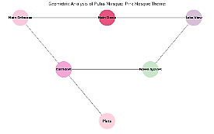 | 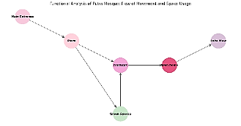
Visual Analysis ️ | Integrative Analysis
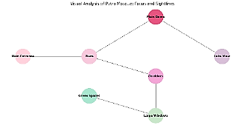 | 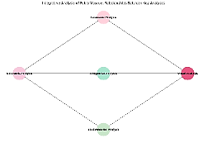
Table 3: Engineering, Functional and Visual Analysis of Putra Mosque (researcher)

Google Earth Virtual Exploration |  | Geometric Relationships | Functional Analysis | Visual Analysis ️ | Integrative Analysis
Main Entrance of the Mosque | 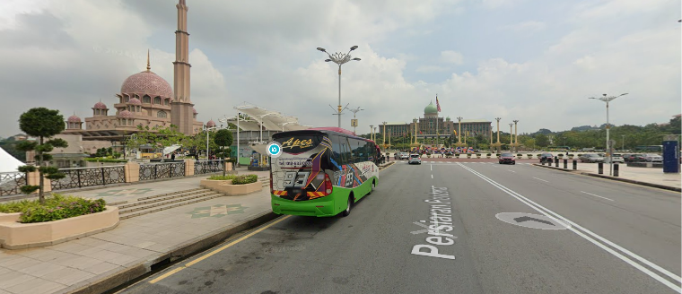 | 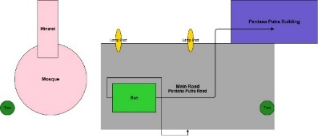 | A pivotal geometric design that directs movement towards the main entrance. | Smooth movement flows from the outdoor arena to the inside. | A clear visual line that draws attention to the main dome.
View Towards the Lake | 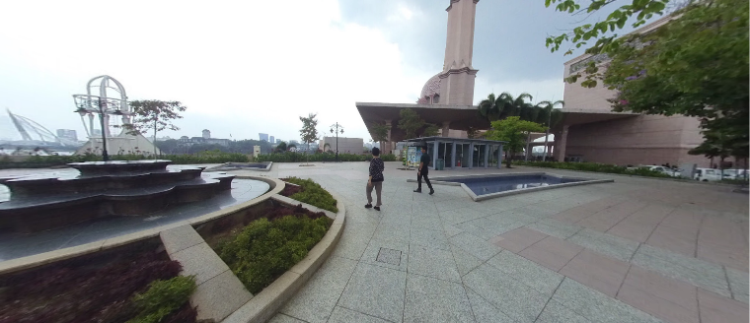 | 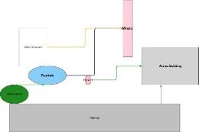 | Direct visual connection between tracks and lake through open design. | Easy access to waterfront. | Water reflections add visual dimensions.
External Plaza | 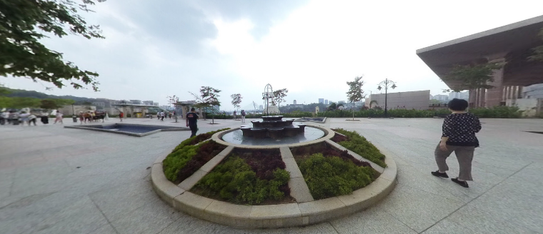 | 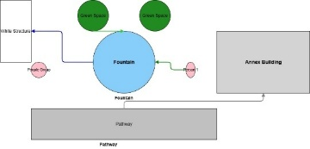 | Geometric balance between major blocks and external spaces. | Accurate regulation of movement paths between squares. | Visual orientation towards key points.
Interior Corridors | 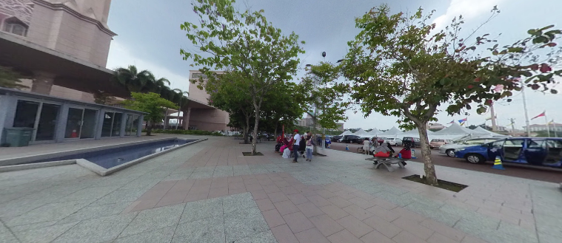 | 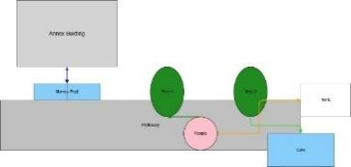 | Corridors link the internal and external spaces seamlessly. | Regulate the flow of users across spaces. | Promote natural light through open passages.
Large Windows Overlooking the Lake | 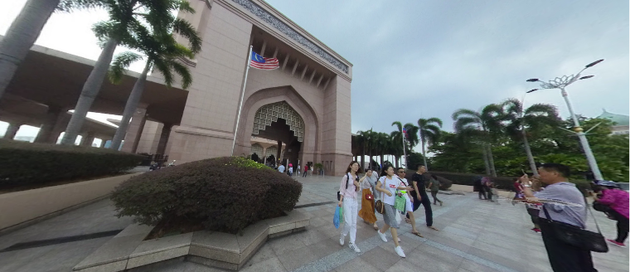 | 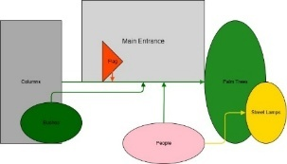 | Direct large windows towards the lake to achieve visual integration. | Provide effective natural ventilation. | A direct view of the lake inside.
Transitional Pathways | 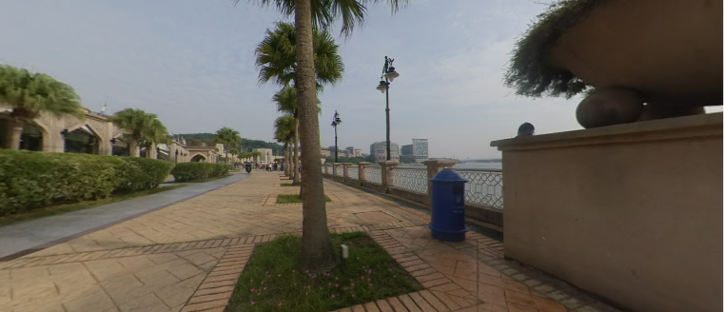 | 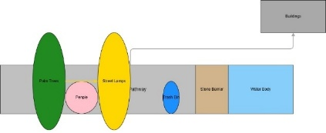 | A pivotal distribution identifying key points of transmission between spaces. | Central crossing points facilitate movement. | Optical focus on axial elements.
Green Spaces Integration | 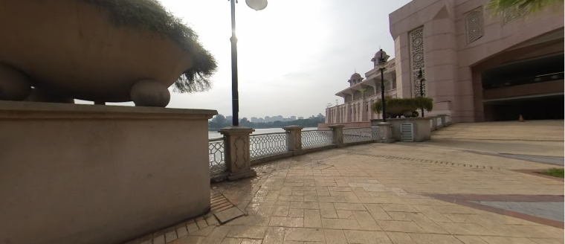 | 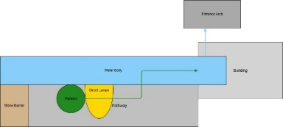 | Harmonious geometric distribution between green squares and corridors. | Hierarchy of movement towards the main arenas. | A clear view of the green spaces.
Corridors and Natural Ventilation | 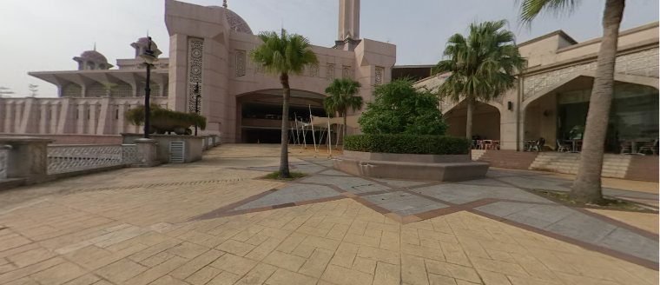 | 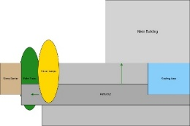 | Openings strike a balance between inside and outside and air flow. | Improve internal ventilation and thermal comfort. | Visual association with surrounding natural elements.
Panoramic Viewpoint | 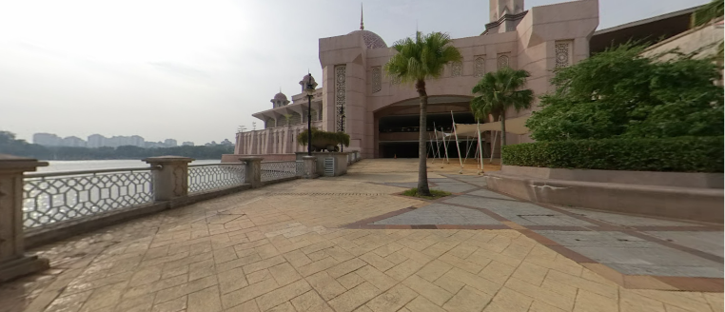 | 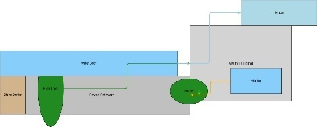 | A pivotal relationship between internal spaces and external views. | Smooth flows between squares and inside. | Promote natural lighting and visual transparency.
Open Pathways to the Horizon | 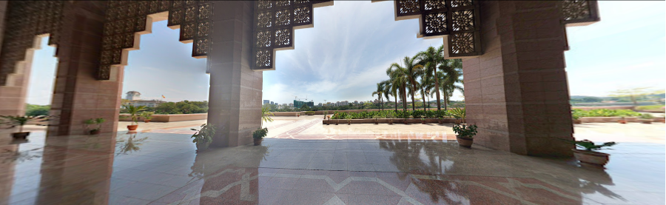 | 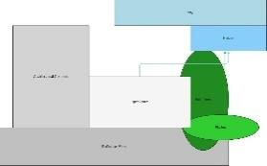 | Geometric epetition of columns achieves visual and logical continuity. | The corridor acts as a flexible transition zone linking indoor and outdoor spaces. | Direct views of the lake offer a quiet visual experience.
Table 4: Engineering and Visual Analysis using Satellite Images from Google Earth (researcher)

Analytical component |  | Design and Engineering Description | Results | Suggestions
Engineering Scale | 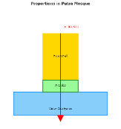 | Ensure vertical and horizontal symmetry. | Make space clear and balanced. | Improve volume-spatial balance.
Visual Orientation | 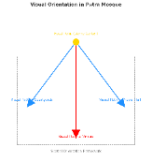 | Use of dome and minarets as key guiding elements. | Visibility towards key spaces. | Enhance optical signals at transit points.
Functional Sequencing | 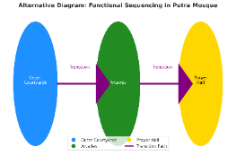 | Logical arrangement of spaces from outdoor squares towards the prayer hall. | Smooth and tidy transmission without congestion. | Add break points in the main tracks.
Visual Integration | 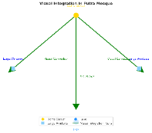 | Use large windows and brackets to achieve visual continuity. | Natural visual connection between inside and outside. | Increase optical binding openings.
Sensory Overlap | 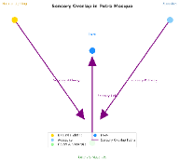 | Use natural lighting, quiet colors and water bodies. | Promote psychological and visual comfort. | Integrate additional natural elements.
Circulation Distribution | 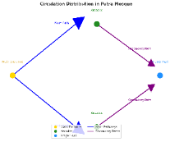 | Clear main and sub-tracks that facilitate mobility. | Clarity of movement flows without hindrance. | Improve indicative marks.
Interaction between Masses and Spaces | 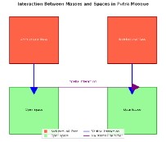 | A balanced relationship between open and closed spaces. | Successful blending between hard blocks and open spaces. | Improved use of outdoor squares.
Axial Symmetry | 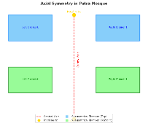 | Relying on a main axis connecting indoor and outdoor spaces. | The clarity of the belligerent orientation. | Support axes with additional visual elements.
Visual Transparency | 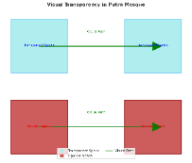 | Use glass and large windows to achieve visual transparency. | Clarity of communication between spaces. | Enhancing transparency in transition points.
Interior-Exterior Connection | 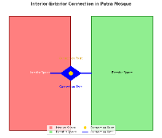 | Clear transmission points between spaces across arcades and corridors. | Functional and visual continuity. | Enhance the design of transitional splicing points.
Decorative Harmony | 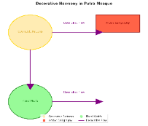 | Use harmonious recurrent decorative patterns. | Unifying the mosque's architectural identity. | Preserve traditional elements.
Functional Distribution | 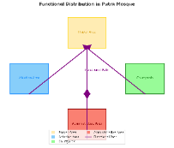 | Define clear functions for each space (prayer, meditation, transit). | High efficiency in the use of blanks. | Improve the distribution of break points.
Lighting | 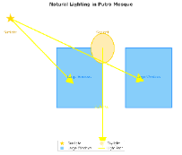 | Relying on overhead openings and large windows. | Balanced lighting inside the prayer hall. | Increase overhead openings to improve lighting.
Environmental Integration | 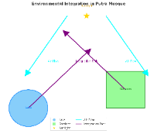 | Using the lake as a natural element promotes visual comfort. | Reduce heat and achieve environmental balance. | Increase green spaces.
Material Continuity | 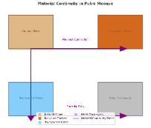 | Use uniform building materials at home and abroad. | Achieve visual and physical continuity. | Maintain the consistency of materials across spaces.
Table 5: Results of the statistical questionnaire (researcher)

