Supplementary Information (SI)
Cell Death and Differentiation
IL-1β priming triggers an adaptive stress response that enhances pancreatic β-cell resilience to subsequent cytotoxic inflammatory insult

Carolina Sétula^{1,2}, Andrea Scelza-Figueredo^{1,2}, Ingrid Pensado-Evans*^{1,2}, Miranda Sol Orellano*^{1,2}, Ignacio Rodríguez-Valero^{1,2}, Eduardo Spinedi³, Raghavendra G. Mirmira^{4,}, Luz Andreone^{1,2} and Marcelo Javier Perone^{1,2‡}

¹ Immuno-Endocrinology, Diabetes & Metabolism Laboratory, Instituto de Investigaciones en Medicina Traslacional (IIMT), CONICET-Universidad Austral, Pilar, Argentina.
² Facultad de Ciencias Biomédicas, Universidad Austral, Pilar, Argentina.
³ Centre of Experimental and Applied Endocrinology (CENEXA, UNLP-CONICET), La Plata Medical School, Universidad Nacional de La Plata, Argentina.
⁴ Department of Medicine and the Kovler Diabetes Center, The University of Chicago, Chicago, Illinois, USA.

Supplementary Table 1. Primer sequences for qPCR
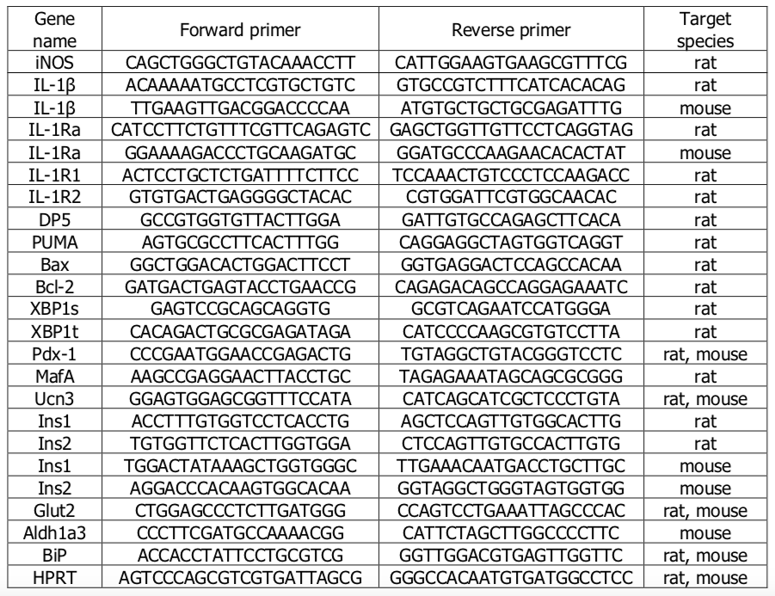

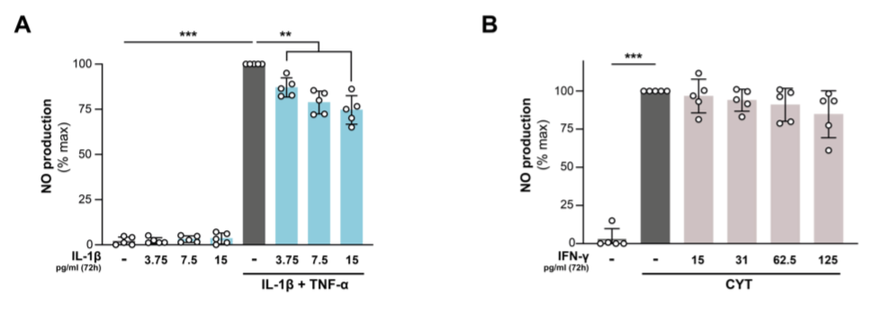

Supplementary Figure 1: A. INS-1E cells were treated for 72 h with IL-1β (3.75, 7.5 or 15 pg/ml as indicated) and subsequently challenged or not with IL-1β 100 pg/ml + TNF-α 8 ng/ml for 16 h, n=5.
B. INS-1E cells were treated for 72 h with IFN-γ (15, 31, 62.5 or 125 pg/ml as indicated) and subsequently challenged or not with or IL-1β 100 pg/ml + IFN-γ 5 ng/ml (CYT) for 16 h, n=5. NO levels in the conditioned media were assessed by Griess reaction and normalized to total cell protein content. Data are shown as mean ± SD. (**) p < 0.01, (***) p < 0.001

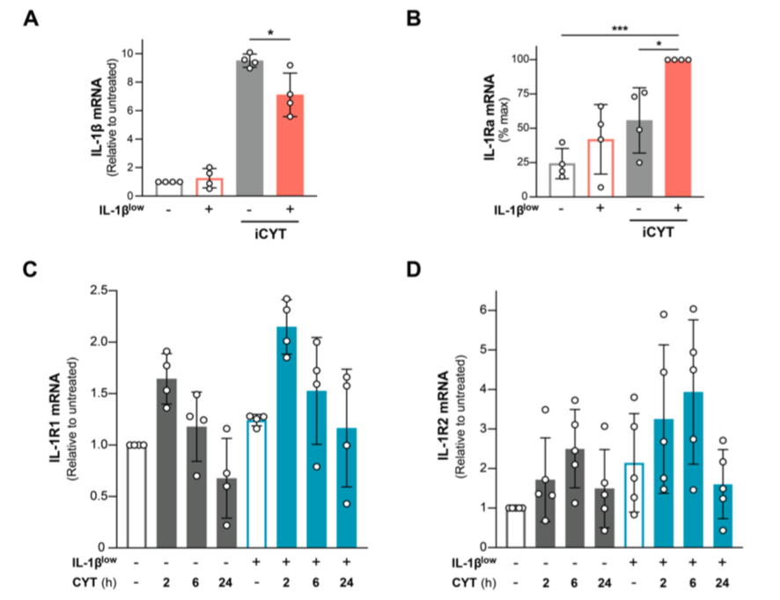

Supplementary Figure 2: A-B. Murine islets (50 IEQ/well) were conditioned for 72 h with IL-1β 10 pg/ml (IL-1β^{low}) and subsequently challenged or not with IL-1β 100 pg/ml + IFN-γ 5 ng/ml + TNF-α 8 ng/mL (iCYT) for 16h. A. IL-1β mRNA and B. IL-1Ra mRNA expression were analyzed by RT-qPCR. Relative mRNA levels normalized to HPRT, n=4. C-D. INS-1E cells were conditioned for 72 h with IL-1β 10 pg/ml (IL-1β^{low}) and subsequently challenged or not with IL-1β 100 pg/ml + IFN-γ 5 ng/ml (CYT) for the indicated times. C. IL-1R1 mRNA and D. IL-1R2 mRNA expression were analyzed by RT-qPCR. Relative mRNA levels normalized to HPRT, n=4-5. Data are shown as mean ± SD. Experiments were performed independently at least 4 times. (*) p < 0.05, (***) p < 0.001.

