Supplementary Material: A new dietary rat model fully recapitulates metabolic dysfunction-associated steatotic liver disease pathophysiology and mimics human disease with advanced liver fibrosis and portal hypertension
- Expanded methods
- Experimental unit and Sample size
- Randomization and Blinding
- Inclusion and Exclusion criteria
- Tables
ST1. The scoring system for steatosis, lobular inflammation, and fibrosis was based on the NASH-Clinical Research Network (CRN) system.
ST2. The results of the blood biochemistry parameters at the model endpoint were tested during the three studies.
ST3. Fibrosis stage according to the NASH-Clinical Research Network (CRN) system at the end of the model for Studies 2 and 3.

- Figures.
SF1. Body weight according to study groups.
SF2. Assessment of systemic insulin resistance.
SF3. Hematoxylin & eosin-stained liver sections for histological evaluation.
SF4. Comparison between study-2 models at 16 and 24 weeks
SF5. Western blot analysis of intrahepatic endothelial dysfunction markers.
SF6. Immunohistochemistry analysis of ductular reaction with CK-7.
SF7. Diet Effect: differences with respect to controls and between diets.
SF8. Analysis of the biological significance of changes in pathway activation induced by MASLD diets.
SF9. Analysis of the biological significance of common changes in human samples from patients with SLD and MASLD diets in rats.

- ARRIVE checklist

- Expanded Methods
  - Hemodynamics
Hemodynamic measurements were performed in fasted rats from all studies at the time of sacrifice under constant anesthesia with inhaled isoflurane (5% induction and 2% maintenance; Baxter International Inc., Deerfield, IL, USA). Body temperature was maintained at 37°C for continuous recording of hemodynamic parameters. Mean arterial pressure (MAP, mmHg) and portal pressure (PP, mmHg) were measured by catheterization (polyethylene PE-catheter, PE50) of the femoral artery and ileocolic vein, respectively, using highly sensitive pressure transducers (Harvard Apparatus, Holliston, MA, USA). Superior mesenteric artery blood flow (SMABF, mL/[min×100 g]) and portal blood flow (PBF, mL/[min×100 g]) were measured using a perivascular ultrasonic transit-time flow probe (1 mm diameter, Transonic Systems Inc., Ithaca, NY, USA). The superior mesenteric artery resistance (SMAR, mmHg/mL×min×100 g) and intrahepatic vascular resistance (IHVR, mmHg/mL×min×100 g) were calculated as [(MAP-PP)/SMABF] and (PP/PBF), respectively.
  - Biochemistry
Fasted rat blood samples were collected from the caval vein immediately after the registration of hemodynamic parameters. Glucose, bilirubin, aspartate aminotransferase (AST), alanine aminotransferase (ALT), alkaline phosphatase (AP), total cholesterol, triglycerides (TG), and albumin levels were measured using standard methods at the Hospital Vall d’Hebron CORE lab.
  - Insulin resistance
Insulin levels were quantified using an ELISA commercial kit (Merck, Darmstadt, Germany) in duplicate for each sample. The 96-well plate readings were performed at 450 nm and 590 nm using a Synergy MX spectrophotometer (Biotek, Winooski, VT, USA) and Gen 5 v2.9 software. Insulin resistance was estimated using the homeostasis model of insulin resistance index (HOMA-IR), which was calculated using the following formula:
$$\text{HOMA}\text{-}\text{IR }\text{=} \frac{\text{Fasting} \text{serum} \text{insulin}\text{ (}{\text{ng}}/{\text{mL}\text{)}}\text{∙ }\text{Fasting} \text{serum} \text{glucose}\text{ (}{\text{mg}}/{\text{dL}\text{)}}}{\text{405}}$$
  - Histology
Liver samples were fixed in 4% formaldehyde for 24 h, embedded in paraffin, and sectioned into 4 μm-thick slides. Hematoxylin-eosin (H&E) staining was used to assess the liver parenchyma. To detect collagen fibers (fibrosis), liver sections from all studies were hydrated and stained with 0.1% Sirius Red (Merck, Darmstadt, Germany). All stained liver sections were examined by an expert liver pathologist who was blinded to animal interventions.
All histological parameters were evaluated using the NASH-CRN system [14] (Suppl. Table 1). Steatosis was scored on a scale of 0 to 3, corresponding to <5%, 5-33%, 33-66% and >66%, respectively. Lobular inflammation was scored from 0 to 3, corresponding to none, <2, 2-4 and >4 foci, respectively. Fibrosis was assessed from F0 (no fibrosis) to F4 (cirrhosis) stages.
Liver fibrosis was assessed quantitatively by image analysis. Ten fields from each Sirius red-stained liver section were randomly captured at 10× magnification using an optical microscope (Olympus BX61; Olympus, Hamburg, Germany). The proportion of Sirius red-stained area per total area was measured using a Java-based image processing software (Image J; National Institute of Health, Bethesda, MD, USA) and expressed as the fibrotic area (%).
  - Immunohistochemistry
Cytokeratin-7 (CK-7) immunohistochemistry was performed in 4 µm sections of formalin-fixed, paraffin-embedded liver tissue from STUDY-2 and STUDY-3 rats. sections were blocked with 5% goat serum (Merck, Darmstadt, Germany) and subsequently incubated with the primary antibody anti-CK-7 (ab181498, 1/8000, Abcam, MA, USA) overnight at 4 °C. The secondary antibody was applied for 30 min (EnVisionTM Dual Link System-HRP; Dako, Glostrup, Denmark). A peroxidase solution (Vector® Vip SK-4600, Vector Laboratories, Inc., Burlingame, CA, USA) was used for detection and mounted with DPX rapid mounting medium (PanReac AppliChem). Quantitative analysis of CK-7 positive-stained areas was performed using Image J software on ten random vision fields per sample at 10× magnification with an optical microscope (Olympus BX61). The results are reported as the median of all quantified areas for each sample and group.
  - Western blot analysis
Rat liver samples from STUDY-2 and STUDY-3 containing 60 μg of protein were run on a NuPAGE Bis-Tris 4–12% SDS-PAGE (Invitrogen, Thermo Fisher Scientific, Waltham, MA, USA) under denaturing conditions, blotted onto a polyvinylidene difluoride (PVDF) blotting membrane, and incubated with the appropriate dilution of the primary antibodies for eNOS (1:500 in 5% BSA; BD, USA), p-eNOS (1:250 in 5% BSA; Cell Signaling, Danvers, MA, USA), AKT (1:500 in 5% BSA; Cell Signaling), P-AKT (1:500 in 5% Phosphoblocker; Cell Signaling), and KLF2 (1:200 in 5% BSA; Santa Cruz Biotechnology, Santa Cruz, CA, USA). GAPDH antibody (1:5000 in TTBS 1X, Ambion, Austin, TX, USA) was used as the loading control. The electrophoretic bands of western blots were detected through digital chemiluminescence using an Odyssey Fc Imaging System (LI-COR Biosciences, Lincoln, NE, USA). Protein quantification was performed using the Image Studio Lite software version 5.2 (LI-COR Biosciences).
  - RNA extraction and gene expression
Rat liver samples from STUDY-2 and STUDY-3 were maintained for at least 24 h in RNAlater Stabilization Solution (Thermo Fisher Scientific) and then stored at -80 °C until further use. Total RNA was extracted using the RNeasy Mini Kit (QIAGEN, Venlo, Netherlands) and reverse-transcribed to cDNA. Each cDNA sample was amplified using Taqman probes for adiponectin receptor 2 (AdipoR2; Rn01463173_m1), insulin receptor substrates 1 and 2 (IRS-1, IRS-2; Rn02132493_s1, and Rn01482270_s1), and leptin receptor (LepR; Rn01433210_m1). The relative gene expression was normalized to that of β-actin (Actb; Rn00667869_m1). Each sample was analyzed in triplicate.
- Experimental unit and Sample size
A total of 100 rats were initially included across the three studies (the number of animals per group/study is detailed in Materials and Methods). However, due to various procedural incidences, the number of animals in some groups was reduced. Specifically, in Study 1, the D1-MASLD group was reduced to 13 animals. In Study 3, the D4-MASLD group was comprised of 11 animals, and the D5-MASLD group had 10 animals.
Upon arrival at the animal facility, rats were housed in pairs per cage. Individual animals were used as the experimental unit. The number of animals required for each study was calculated using an analysis of variance with a bilateral contrast, an alpha risk of 0.05, and a beta of 0.20. The primary outcome parameter was portal pressure, with a minimum detectable difference set at 1.50. Based on this, the required sample size per group was determined using the GRANMO software, assuming a standard deviation of 0.85 (derived from the control group in previous studies) and an alpha risk of 0.05, with a beta risk of 0.20, to detect a minimum difference of 1.5 between groups.
In line with previous experience, it was estimated that approximately 15% of animals would lose blood or die during the cannulation procedure, which would render their data invalid for analysis. Consequently, to account for potential losses, an additional 15% of animals were included in the study design. This adjustment was made by applying an incidence formula to recalculate the total number of animals required.

- Randomization and Blinding
Rats were assigned to their respective groups upon arrival at the facility, without prior knowledge of how they would behave in each group throughout the study. This allocation occurred before the commencement of the diet, and rats were assigned indiscriminately as they were received from the distributor on a weekly basis. Each cage housed two rats from the same group, with rats receiving the same diet, but individual data were collected for each animal regarding food consumption, caloric intake, and weight, treating each animal as the experimental unit.
To minimize potential time effects, rats arriving in the same week (usually 8 animals) were allocated to different dietary groups. This procedure ensured a balanced distribution of animals across the various groups. Additionally, the cages were equipped with individual ventilation systems to guarantee uniform airflow and avoid any potential bias related to environmental conditions.
While the experimental procedure was carried out, MMG, AB, and IR were aware of the group allocations. They were also informed of the animal groups during the measurement of hemodynamic parameters; however, these measurements were objective and could not be manipulated. All other analyses were performed in a blinded manner to avoid any bias.
- Inclusion and Exclusion criteria
The first a priori exclusion criterion involved the rejection of animals exhibiting any abnormal behavior or physical appearance, as assessed through a weekly supervision protocol throughout the duration of the study. The second exclusion criterion was based on hemodynamic measurements taken at the endpoint, specifically Mean Arterial Pressure (MAP) and Beats Per Minute (BPM). Animals with MAP values below 80 mmHg were excluded from the analysis, and only those with BPM values between 280 and 350 were considered for inclusion.
It should be noted that the final n reported in the Materials and Methods section 1, animals and diets, reflects the number of animals actually included in the analyses after excluding those that did not meet the inclusion criteria.

ST1. Scoring system for steatosis, lobular inflammation and fibrosis based on the NASH-Clinical Research Network (CRN) system*.

Histological feature | Definition | Score
Steatosis | <5% | 0
 | 5%-33% | 1
 | 34%-66% | 2
 | >66% | 3
Lobular inflammation | None | 0
 | <2 foci | 1
 | 2-4 foci | 2
 | >4 foci | 3
Fibrosis | None | 0
 | Perisinusoidal or periportal | 1
 | Mild, zone 3, perisinusoidal | 1A
 | Moderate, zone 3, perisinusoidal | 1B
 | Portal/periportal | 1C
 | Portal/periportal and perisinusoidal | 2
 | Bridging fibrosis | 3
 | Cirrhosis | 4

* Kleiner, D. E. et al. Design and validation of a histological scoring system for nonalcoholic fatty liver disease. Hepatology 41, 1313-1321 (2005)
ST2. Results of blood biochemistry parameters at model endpoint tested at during the three studies.

 | Group |  | Glucose  (mg/dL) |  | AST  (IU/dL) |  | ALT  (IU/dL) |  | Cholesterol  (mg/dL) |  | TG  (mg/dL) |  | Albumin  (g/dL)
STUDY I | D1-MASLD |  | 342.56±27.64 |  | 140.60±22.50 |  | 59.81±9.93 |  | 89.37±5.90 |  | 59.25±9.40 |  | 3.06±0.04
STUDY I | D1-MASLD+LPS |  | 410.25±19.79 |  | 82.17±13.78 |  | 38.75±7.92 |  | 81.25±3.99 |  | 85.00±13.95 |  | 3.06±0.16
STUDY II | Control |  | 187.67±31.35 |  | 95.50±26.50 |  | 39.20±3.61 |  | 62.33±5.09 |  | 35.33±3.60 |  | 3.58±0.08
STUDY II | D2-MASLD |  | 190.17±12.22 |  | 371.00±33.15** |  | 157.42±19.68** |  | 129.17±5.74*** |  | 24.17±2.53* |  | 4.08±0.06***
STUDY III | Control |  | 188.14±20.47 |  | 126.20±23.77 |  | 41.38±1.65 |  | 62.20±6.48 |  | 39.25±3.55 |  | 3.41±0.07
STUDY III | D3-MASLD |  | 225.67±10.66 |  | 301.80±14.63** |  | 107.40±11.09*** |  | 220.40±47.22*** |  | 32.83±2.96 |  | 4.11±0.07***
STUDY III | D4-MASLD |  | 282.45±25.43* |  | 306.30±45.86* |  | 139.10±16.37*** |  | 139.30±14.97*** |  | 41.45±4.48 |  | 3.86±0.08**
STUDY III | D5-MASLD |  | 308.40±28.68** |  | 213.00±31.40 |  | 95.60±17.01* |  | 116.40±10.02*** |  | 29.80±4.12 |  | 3.83±0.11**

ST3. Fibrosis stage according to the NASH-Clinical Research Network (CRN) system at the end of the model for Studies 2 and 3.

 | Fibrosis Stage
 | Group | 0 |  |  | 1a |  |  | 1b |  |  | 2 |  | 3 |  |  | 4
STUDY-2 | CD | 5 |  |  | 0 |  |  | 0 |  |  | 0 |  | 0 |  |  | 0
STUDY-2 | D2-MASLD | 0 |  |  | 2 |  |  | 0 |  |  | 3 |  | 3 |  |  | 1
 | Group | 0 |  |  | 1a |  |  | 1b |  |  | 2 |  | 3 |  |  | 4
STUDY-3 | CD | 8 |  | 0 |  |  | 0 |  |  | 0 |  |  |  | 0 |  |  | 0
STUDY-3 | D3-MASLD | 4 |  | 5 |  |  | 1 |  |  | 1 |  |  |  | 1 |  |  | 0
STUDY-3 | D4-MASLD | 6 |  | 1 |  |  | 0 |  |  | 0 |  |  |  | 4 |  |  | 0
STUDY-3 | D5-MASLD | 4 |  | 1 |  |  | 0 |  |  | 2 |  |  |  | 3 |  |  | 0

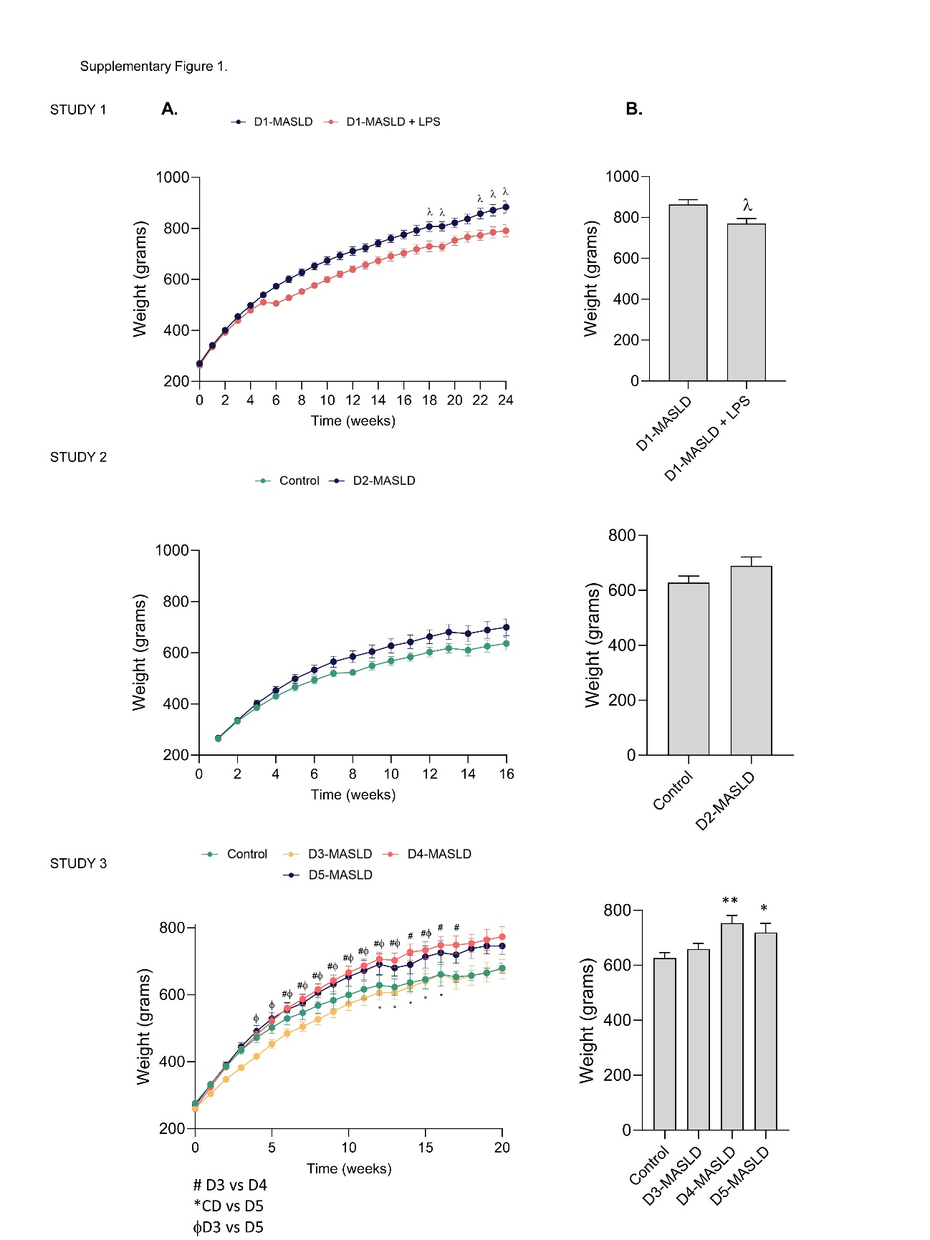
Supplementary Figure 1. Body weight according to study groups. (A) Evolution of body weight per week of the dietary groups. (B) Bar diagrams representing the mean weight at the end of each study after 8h fasting before hemodynamic measurements. Values are expressed as mean ± SEM. λP ≤ 0.05 versus D1-MASLD; #P ≤ 0.05 D3-MASLD versus D4-MASLD; φP ≤ 0.05 D3-MASLD versus D5-MASLD. CD: Control; HFGFD: High Fat Glucose Fructose Diet; LPS: Lipopolysaccharide; Chol: Cholesterol; CA: Colic acid; D1-MASLD: HFGFD; D1-MASLD + LPS: HFGFD + LPS; D2-MASLD: HFGFD + 2% Chol + 0.5% CA; D3-MASLD: HFGFD + 0.5% Chol + 0.5% CA; D4-MASLD: HFGFD + 2% Chol; D5-MASLD: HFGFD + 2% Chol + 0.1% CA.

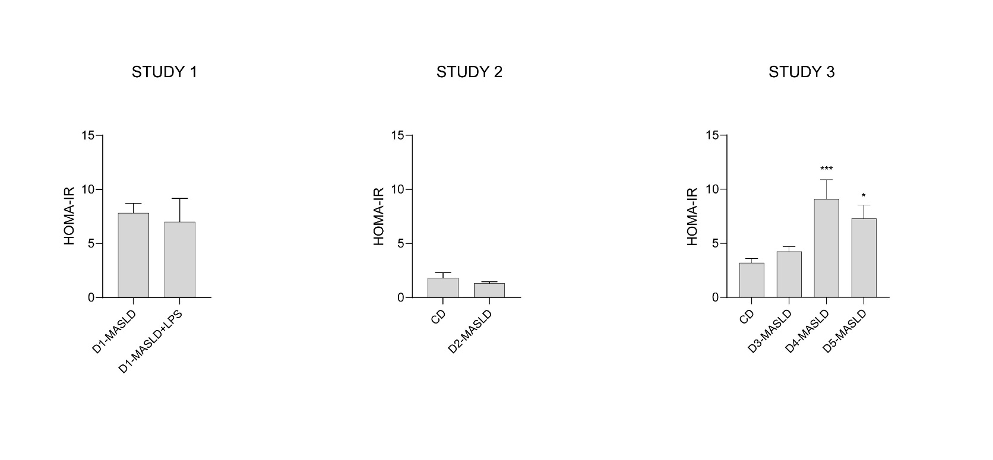
Supplementary Figure 2. Assessment of systemic insulin resistance. Bar diagrams of the HOMA-IR (homeostasis assessment model of insulin resistance). Values are expressed as mean ± SEM. P ≤ 0.05; **P ≤ 0.01; ***P ≤ 0.001 versus CD. CD: Control; HFGFD: High Fat Glucose Fructose Diet; LPS: Lipopolysaccharide; Chol: Cholesterol; CA: Colic acid; D1-MASLD: HFGFD; D1-MASLD + LPS: HFGFD + LPS; D2-MASLD: HFGFD + 2% Chol + 0.5% CA; D3-MASLD: HFGFD + 0.5% Chol + 0.5% CA; D4-MASLD: HFGFD + 2% Chol; D5-MASLD: HFGFD + 2% Chol + 0.1% CA.

.

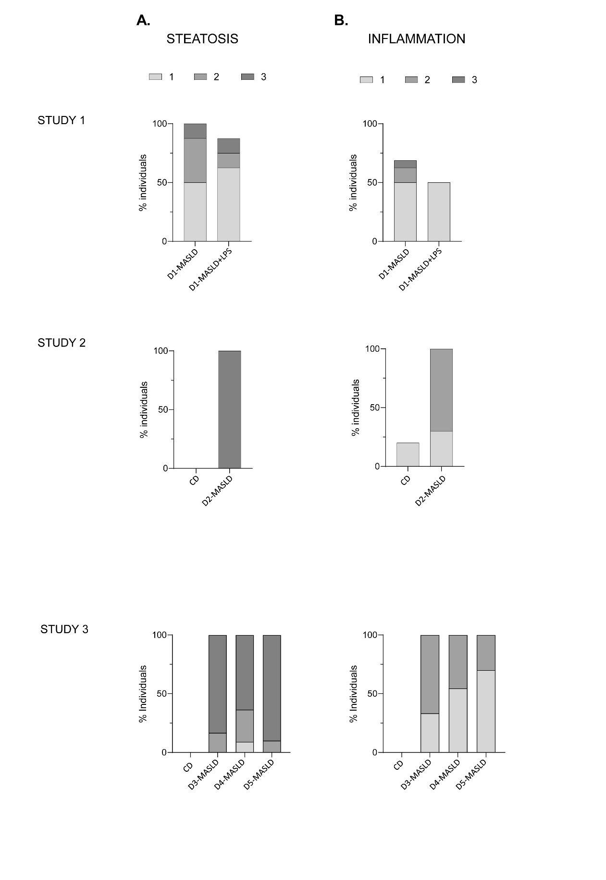
Supplementary Figure 3. Haematoxylin & eosin-stained liver sections for histological evaluation. Evaluation followed the NASH-Clinical Research Network system. The scored bar diagrams represent the percentage of individuals presenting (A) steatosis and (B) inflammation in the different studies. CD: Control; HFGFD: High Fat Glucose Fructose Diet; LPS: Lipopolysaccharide; Chol: Cholesterol; CA: Colic acid; D1-MASLD: HFGFD; D1-MASLD + LPS: HFGFD + LPS; D2-MASLD: HFGFD + 2% Chol + 0.5% CA; D3-MASLD: HFGFD + 0.5% Chol + 0.5% CA; D4-MASLD: HFGFD + 2% Chol; D5-MASLD: HFGFD + 2% Chol + 0.1% CA.
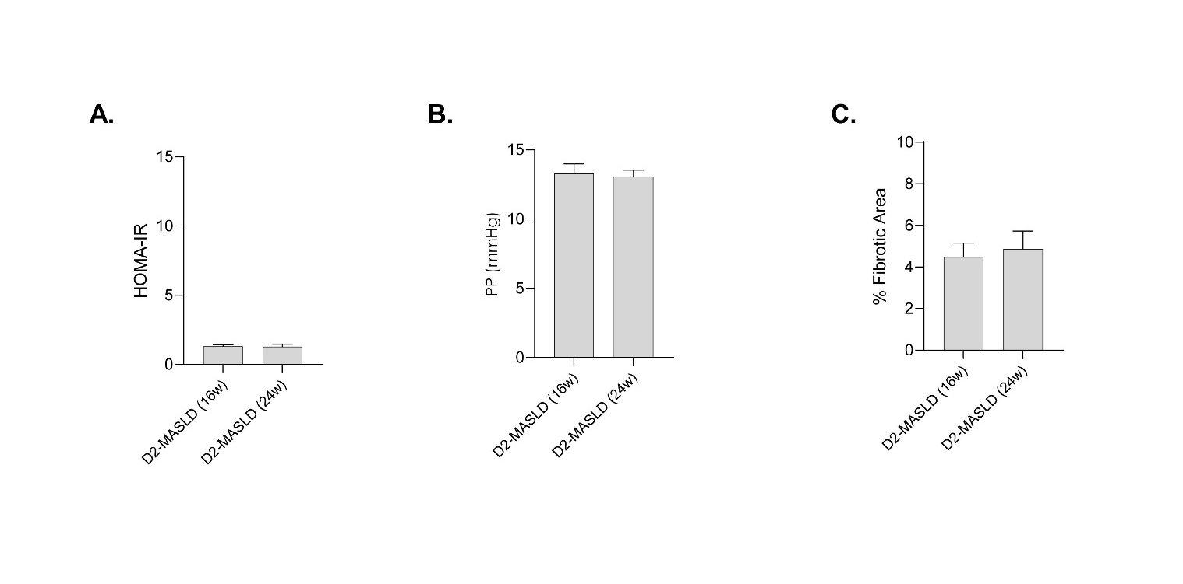

Supplementary Figure 4. Comparison between study-2 models at 16 and 24 weeks. (A) Bar diagrams of HOMA-IR (homeostasis assessment model of insulin resistance); (B) portal pressure and (C) quantification of the hepatic fibrotic area (%) at 16 and 24 weeks. Values are expressed as mean ± SEM. HFGFD: High Fat Glucose Fructose Diet; D2-MASLD: HFGFD + 2% Chol + 0.5% CA; 16w:16 weeks; 24w:24 weeks.

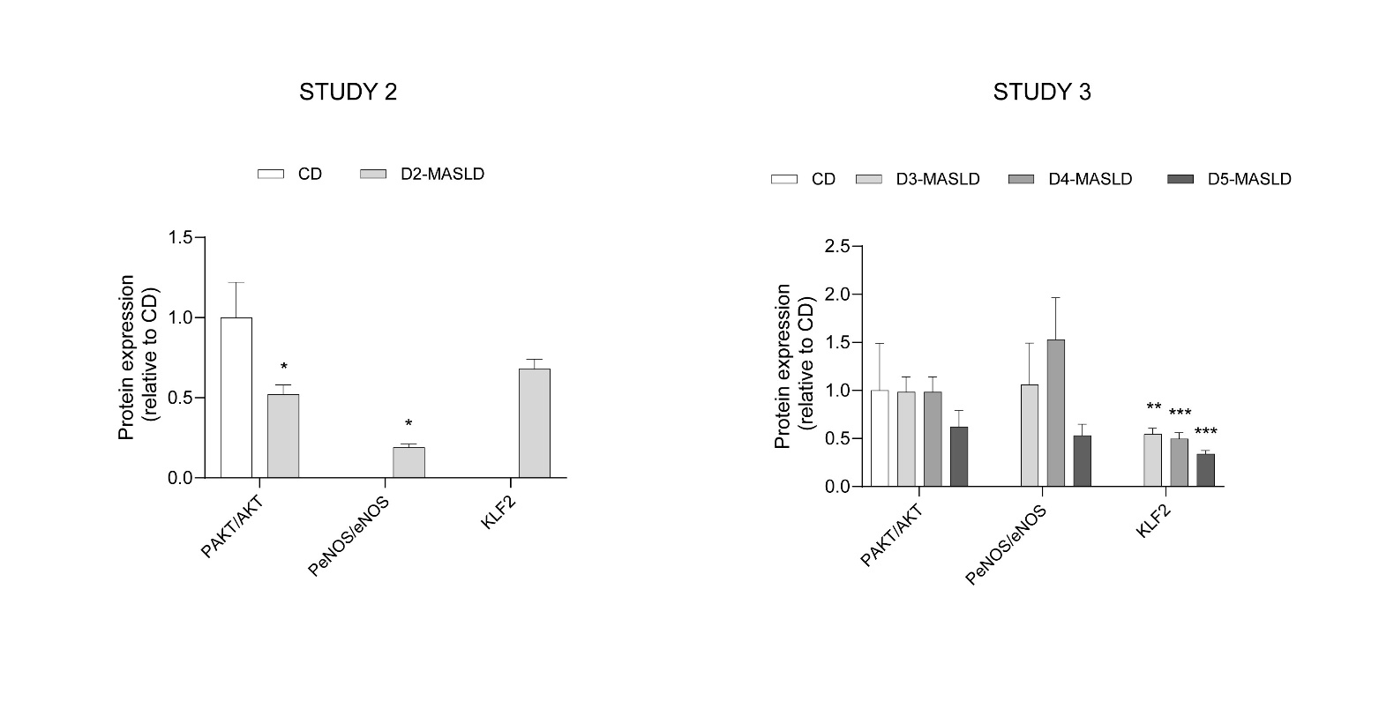
Supplementary Figure 5. Western blot analysis of intrahepatic endothelial dysfunction markers. The bar graphs show the quantification of the KLF2 protein and the ratios of p-Akt/Akt and p-eNOS/eNOS in each group of the different studies. GAPDH was used as loading control and all proteins were normalized to the control group. Protein levels are expressed as mean ± SEM. P ≤ 0.05; **P ≤ 0.01; ***P ≤ 0.001 versus CD. CD: Control; HFGFD: High Fat Glucose Fructose Diet; Chol: Cholesterol; CA: Colic acid; D2-MASLD: HFGFD + 2% Chol + 0.5% CA; D3-MASLD: HFGFD + 0.5% Chol + 0.5% CA; D4-MASLD: HFGFD + 2% Chol; D5-MASLD: HFGFD + 2% Chol + 0.1% CA.

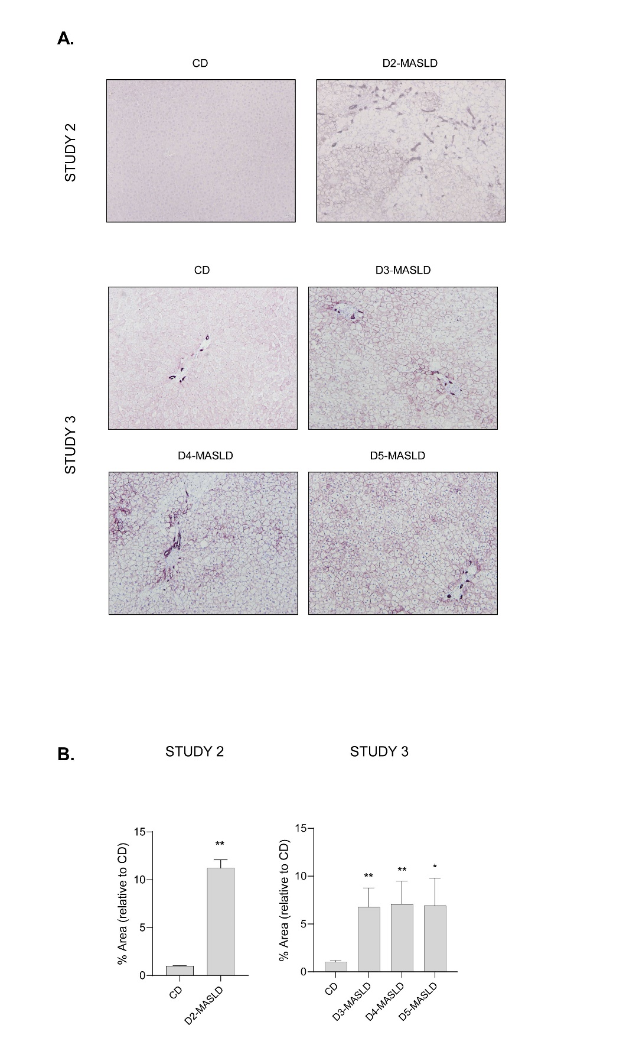
Supplementary Figure 6. Immunohistochemistry analysis of ductular reaction with CK-7. (A) Representative images of liver section stained with CK-7 (10X magnification) and (B) Bar diagrams showing the quantification of CK-7 positive area (%). Values are expressed as mean ± SEM. CD: Control; HFGFD: High Fat Glucose Fructose Diet; Chol: Cholesterol; CA: Colic acid; D2-MASLD: HFGFD + 2% Chol + 0.5% CA; D3-MASLD: HFGFD + 0.5% Chol + 0.5% CA; D4-MASLD: HFGFD + 2% Chol; D5-MASLD: HFGFD + 2% Chol + 0.1% CA.
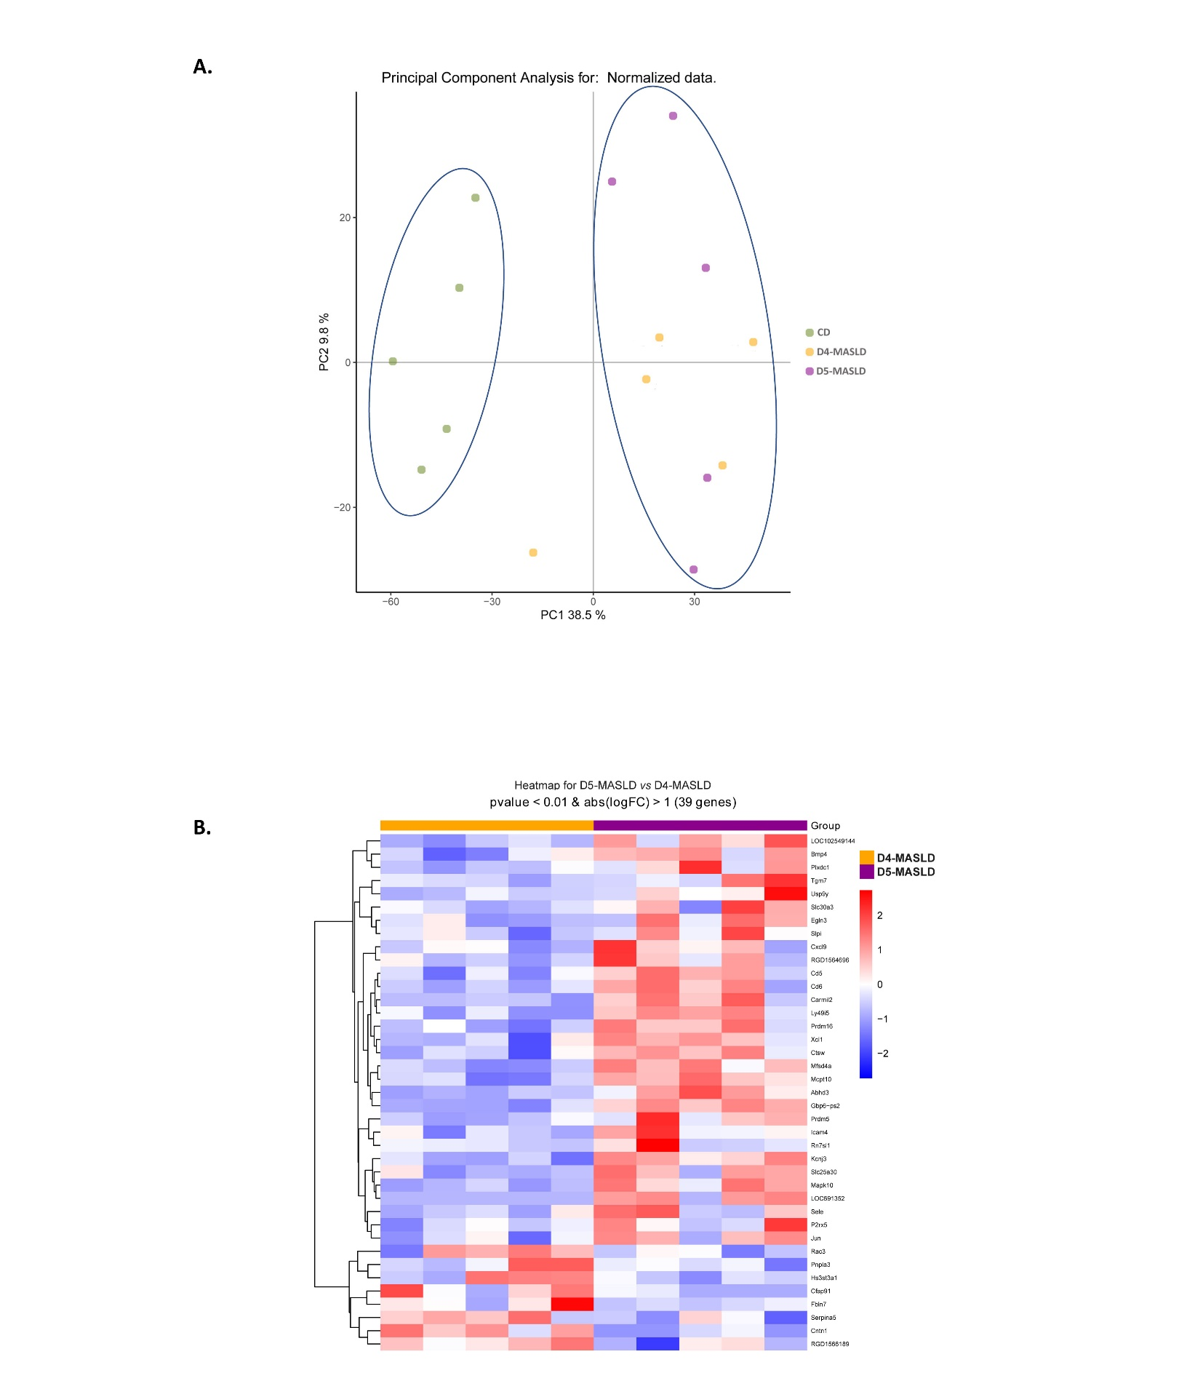
Supplementary Figure 7. Diet Effect: differences with respect to controls and between diets. (A) Principal component analysis (PCA) displays a scatter plot of the samples along the first two principal components, calculated using all the analyzed genes. The first component accounts for 38.5% of the total variance, while the second component accounts for 9.8%. Samples from the CD group are mainly located on the left side of the plot, whereas samples from D4-MASLD and D5-MASLD appear on the right, with no clear separation between the two groups. (B) Heatmap of the expression profiles showing 39 differentially expressed genes from the comparison between D5-MASLD and D4-MASLD, using a p-value < 0.01 and a log2 fold change ≥ 1. HFGFD: high-fat glucose-fructose diet; Chol: cholesterol; CA: cholic acid; D4-MASLD: HFGFD + 2% Chol; D5-MASLD: HFGFD + 2% Chol + 0.5% CA.

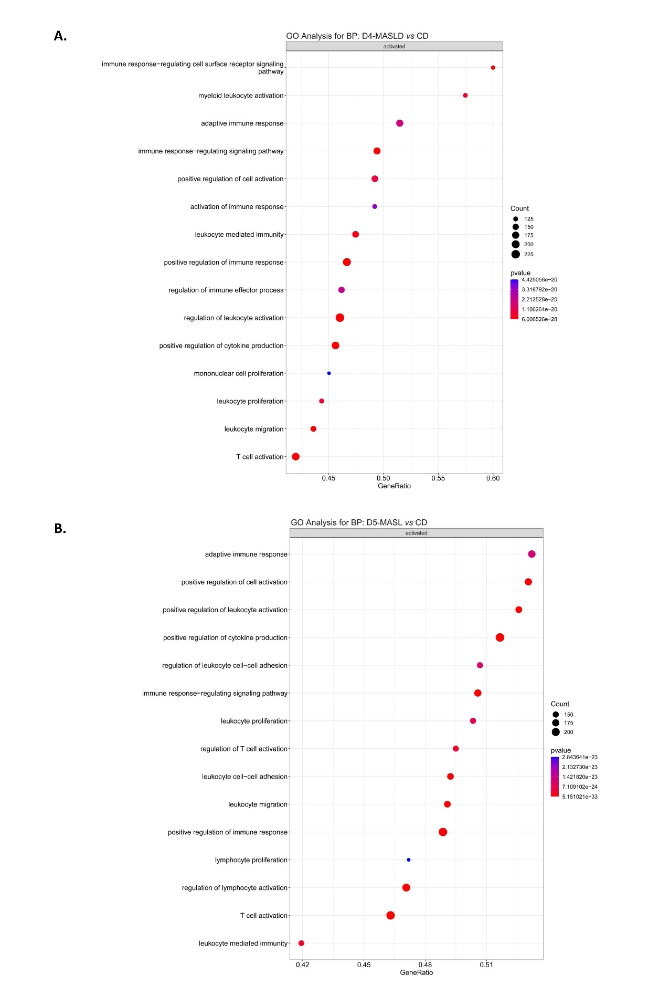

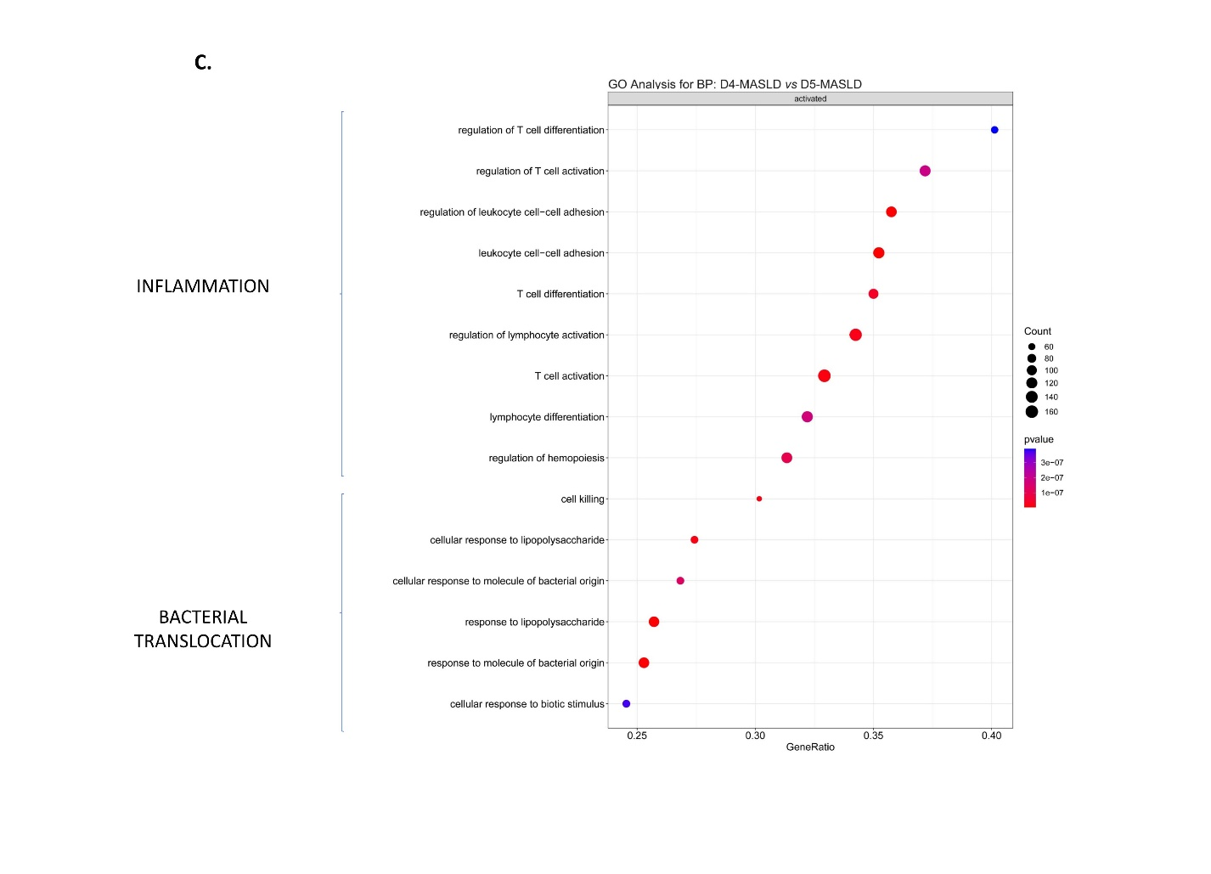
Supplementary Figure 8. Analysis of the biological significance of pathway activation changes induced by MASLD Diets. Enrichment analysis produced dot plots of the top 15 GO-BP terms of activated and suppressed pathways based on significantly differentially expressed genes in: D4-MASLD (A), D5-MASLD (B), and D5-MASLD compared with D4-MASLD (C). The size of the dots represents the number of genes associated with each pathway, while the color indicates the significance level. The gene ratio refers to the proportion of genes in the dataset that belong to a given pathway compared to the total number of genes in that pathway. GO-BP: Gene Ontology-Biological Process; CD: control diet; HFGFD: high-fat glucose-fructose diet; Chol: cholesterol; CA: cholic acid; D4-MASLD: HFGFD + 2% Chol; D5-MASLD: HFGFD + 2% Chol + 0.5% CA.

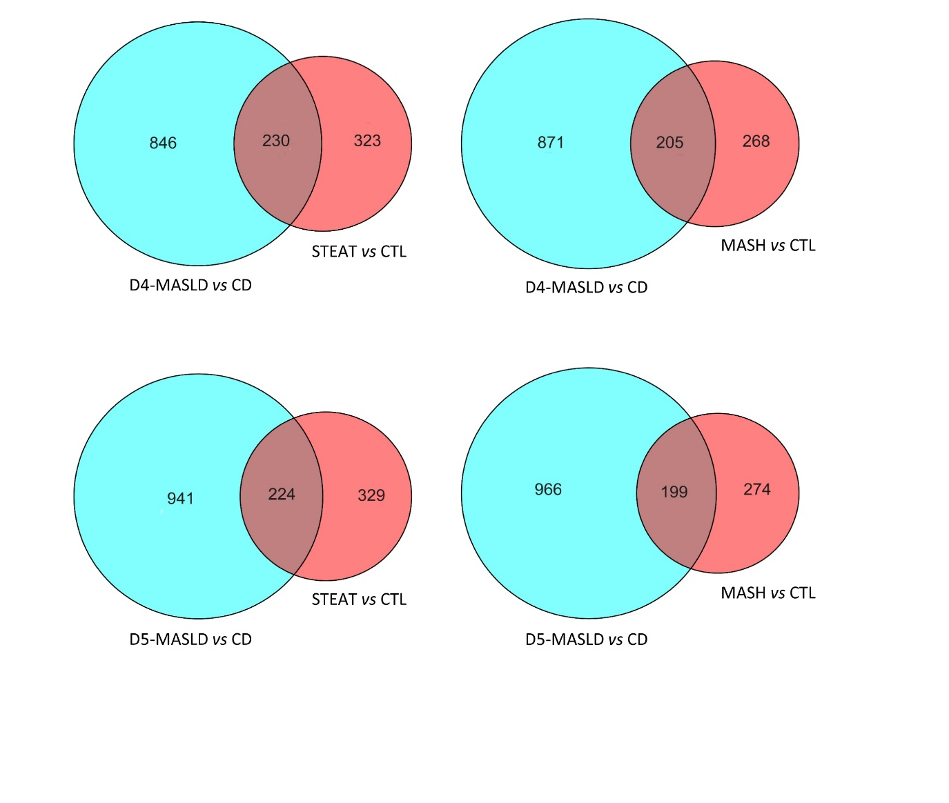
Supplementary Figure 9. Analysis of the biological significance of common changes in human samples from SLD Patients and MASLD diets in rats. Venn diagrams illustrate the comparison of significantly associated pathways in both human and rat samples, based on differentially expressed genes relative to their respective controls. Shared elements between humans and rats represent commonly altered GO-BP pathways, related to different disease stages (STEAT and MASH) and the effects of MASLD diets (D4-MASLD and D5-MASLD). GO-BP: Gene Ontology-Biological Process; CTL: healthy human controls; STEAT: human steatosis; MASH: human metabolic-associated steatohepatitis; CD: control diet; HFGFD: high-fat glucose-fructose diet; Chol: cholesterol; CA: cholic acid; D4-MASLD: HFGFD + 2% Chol; D5-MASLD: HFGFD + 2% Chol + 0.5% CA.

