Supplementary Information

Supplementary Figures

Figure S1. Distribution of 11 recipient wheat genotypes in four of the five wheat growing agro-climatic zones of India.

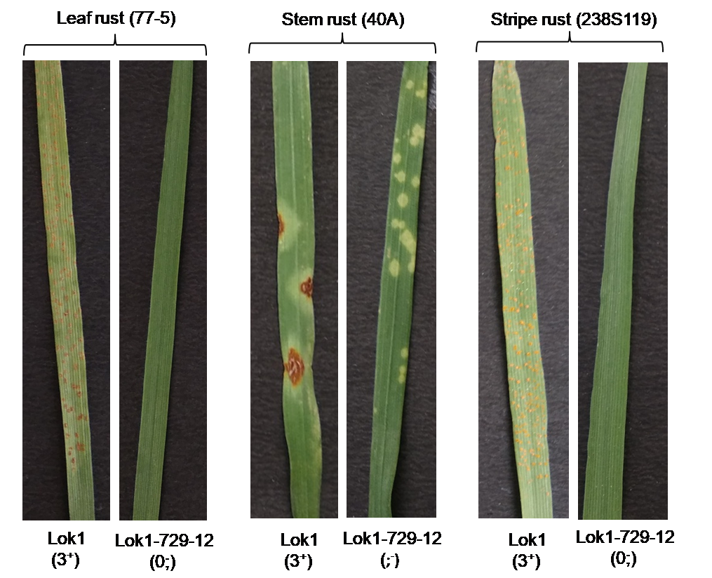

Figure S2. Disease symptom for three rusts on seedling leaves of recurrent parent (Lok1) and MAS-derived line (Lok1-7929-12) in glasshouse conditions. Rust pathotypes used are indicated in parenthesis at the top whereas the disease reactions are given in parenthesis at the bottom.

Supplementary Tables.

Table S1. A summary of the field experiments conducted for the evaluation of MABB derived progenies.

Recipient cultivar | MSBB derived progenies and parental genotypes/checks | Plot size | Experimental details | Institution
Lok1 and HD2967 | BC₁F₇/ BC₂F₆ + parental genotypes | 12 rows x 6m; row-to-row distance of 20 cm | RBD (3 Reps)  (one year); two locations | CCS University, Meerut
MACS 2496 and NI 5439 | BC₂F_{4,5} + checks | 5 rows x 2.5m row-to-row distance 23cm | RBD (3 Reps)  (two years); RBD | ARI, Pune
PBW550 (Yr15), DBW17 and PBW621 | BC₁F_{6/7} + checks (PBW761,PBW723, HD3086, HD3059, PBW621 & DBW17) | 6 rows x 4.5m; row-to-row distance of 20 cm | RBD (3 Reps)  (3 year) | PAU, Ludhiana
UP 2338 and UP 2382 | BC₃F₄ + parental genotypes | 4 rows x 3 m; row to row distance of 23 | RBD (3 Reps); | GBPUA&T, Pantnagar
HUW234 and HUW468 | BC₂F₆ + parental genotypes | 6 rows x 5m;  row-to-row distance of 20 cm | RBD (3 Reps)  (two years); five locations | BHU, Varanasi
Reps, replications

Table S2. Analysis of variance for 1000-grain yield, grain yield GPC (%), Fe and Zn of parental lines (Lok-1 and HD2329) and MAS-derived progenies based on data recorded for two consecutive years at Meerut.

Source of variation | df | Mean square
Source of variation | df | TGW (g) | GY (t/ha) | GPC (%) | Fe (ppm) | Zn (ppm)
Replication | 2 | 179.6 | 2.2 | 1.5 | 9.3 | 3.0
Year | 1 | 4384.2** | 13.3** | 21.8** | 179.3** | 29.9**
Genotype | 8 | 84.4 | 1.3** | 2.0** | 31.2** | 10.2**
Genotype x Year | 8 | 65.2 | 0.2 | 0.1 | 12.6* | 7.5*
Error | 34 | 70.3 | 0.2 | 0.3 | 4.7 | 3.0
TGW=thousand grain weight, GY= grain yield, GPC=grain protein content, Fe=iron, Zn: zinc, df=degree of freedom,
* Significant at 5% level, ** Significant at 1% level

Table S3. Analysis of variance for 1000-grain yield, grain yield, GPC (%) and MSDSSV of parental line (MACS249) and MAS-derived progenies based on data recorded for two consecutive years at Pune.

Source of variation | df | Mean square
Source of variation | df | TGW (g) | GY (q/ha) | GPC (%) | MSDS-SV (mm)
Replication | 2 | 1.594 | 4 | 0.2438 | 0.4988
Year | 1 | 55.51*** | 11984.5*** | 6.7734*** | 3.2084**
Genotype | 15 | 100.448*** | 364.8*** | 3.6686*** | 2.2344***
Genotype x year | 15 | 0.01 | 139.2 | 0.8266** | 0.1659
Error | 63 | 1.685 | 16.5 | 0.287 | 0.2735
TGW=thousand grain weight, GY= grain yield, GPC=grain protein content, MSDSSV=micro SDS sedimentation volume, df=degree of freedom,
** Significant at 1% level, ** *Significant at 0.1% level

Table S4. Analysis of variance for 1000-grain yield, grain yield, GPC (%) and MSDSSV of parental line (NI5439) and MAS-derived progenies based on data recorded for two consecutive years at Pune.

Source of variation | df | Mean square
Source of variation | df | TGW (g) | GY (q/ha) | GPC (%) | MSDS-SV (mm)
Replication | 2 | 3.38 | 0.304 | 0.2709 | 3.565
Genotype | 23 | 351.88*** | 43.227*** | 4.1275*** | 6.588***
Year | 1 | 231.29*** | 204.014*** | 9.7136*** | 37.72***
Genotype x year | 23 | 130.24*** | 59.842*** | 1.2927*** | 0.241
Error | 95 | 14.43 | 1.227 | 0.4556 | 0.344
TGW=thousand grain weight, GY= grain yield, GPC=grain protein content, MSDS-SV=micro SDS sedimentation volume, df=degree of freedom,
** Significant at 1% level, ** *Significant at 0.1% level

Table S5. Analysis of variance for 1000-grain yield, grain yield, GPC (%), Fe and Zn concentration of parental line (PBW550, PBW621, and DBW17) and MAS-derived progenies based on data of three consecutive years at Ludhiana.

Source of Variation | df | Mean square
Source of Variation | df | TGW (g) | GY (t/ha) | GPC(%) | Fe (ppm) | Zn (ppm)
Replication | 1 | 1.80 | 0.60** | 0.58 | 12.80 | 0.02
Genotypes | 29 | 161.24** | 0.10 | 8.58** | 252.25** | 182.48**
Year | 2 | 23.02 | 2.78** | 18.60** | 24.15 | 58.38
Genotypes x year | 58 | 17.46 | 0.07 | 1.50 | 13.27 | 17.70
Error | 89 | 28.32 | 0.08 | 2.63 | 18.28 | 36.88
TGW=thousand grain weight, GY= grain yield, GPC=grain protein content Fe=iron concentration, Zn= zink concentration, df=degree of freedom,
**Significant at 0.1% level

Table S6. Analysis of variance for 1000-grain yield, grain yield and GPC (%) of parental line (UP2338) and MAS-derived progenies evaluated at Pantnagar.

Source of variation | df | Mean square
Source of variation | df | TGW (g) | GY(t/ha) | GPC (%)
Genotype | 7 | 32.166** | 0.306** | 1.538*
Error | 14 | 2.199 | 0.052 | 0.381
TGW=thousand grain weight, GY= grain yield, GPC=grain protein content, df=degree of freedom, *Significant at 5% level,**Significant at 1%
level

Table S7. Analysis of variance for 1000-grain yield, grain yield and GPC (%) of parental line (UP2382) and MAS-derived progenies evaluated at Pantnagar.

Source of variation | df | Mean square
Source of variation | df | TGW (g) | GY(t/ha) | GPC (%)
Genotype | 7 | 35.389** | 0.152** | 0.828**
Error | 14 | 0.964 | 0.019 | 0.138
TGW=thousand grain weight, GY= grain yield, GPC=grain protein content, df=degree of freedom, **Significant at 1% level

Table S8. Analysis of variance for 1000-grain yield, grain yield and GPC (%) of parental line (HUW234 & HUW468) and MAS-derived progenies of the crosses developed by BHU, Varanasi at five centres of NEPZ.

Source of Variation | df | Mean square
Source of Variation | df | TGW (g) | GY (q/ha) | GPC (%)
Genotype | 6 | 82.34** | 177.9** | 23.69**
Location | 4 | 184.41** | 207.25** | 4.05**
Replications | 2 | 4.42* | 9.64 | 0.05
Genotype x location | 24 | 13.76** | 20.57** | 0.91**
Error | 68 | 1.07 | 4.65 | 0.11

NEPZ=north eastern plane zone, TGW=thousand grain weight, GY= grain yield, GPC=grain protein content, df=degree of freedom,
*Significant at 5% level,**Significant at 1% level

Table S9. Mean values for 1000-grain weight, grain yield, grain protein content, Zn and Fe concentrations in the recipient parents and the respective MAS-derived progenies with significantly higher grain protein content.

Recurrent parents/progenies | 1000-GW | GY (q/ha) | GPC (%) | Zn (ppm) | Fe (ppm)
Lok 1 (RP) | 51.9 | 40.2 | 12.0 | 19.8 | 29.1
CCSU-Lok1-4 | 55.1 | 39.4 | 12.9* | 21.9* | 29.6
CCSU-Lok1-11 | 44.0 | 38.5 | 13.0* | 22.2* | 30.5*
CCSU-Lok1-12 | 49.7 | 39.6 | 13.1* | 20.7 | 30.9*
CCSU-Lok1-13 | 47.5 | 42.6 | 13.2* | 20.7 | 30.8*
CCSU-Lok1-14 | 47.4 | 42.8 | 13.3* | 22.0* | 32.5*
HD2967 (RP) | 42.9 | 50.6 | 12.9 | 21.5 | 30.8
CCSU-HD-765 | 47.5 | 48.7 | 14.0* | 22.4 | 32.5*
LSD | 4.6 | 2.7 | 0.3 | 1.0 | 1.2
MACS 2496 (RP) | 40.2 | 32.6 | 14.9 | - | -
MACS2496-9 | 36.3 | 36.0 | 16.0* | - | -
MACS2496-18 | 38.6 | 25.7 | 16.6* | - | -
MACS2496-22 | 42.7* | 26.0 | 16.8* | - | -
MACS2496-23 | 36.7 | 28.2 | 16.7* | - | -
MACS2496-24 | 37.6 | 24.7 | 16.7* | - | -
MACS2496-26 | 35.3 | 29.6 | 16.3* | - | -
MACS2496-34 | 37.7 | 23.0 | 16.5* | - | -
MACS2496-35 | 35.1 | 38.3 | 16.5* | - | -
MACS2496-36 | 40.9 | 29.3 | 16.4* | - | -
MACS2496-38 | 40.5 | 30.9 | 15.9* | - | -
MACS2496-42 | 36.7 | 27.3 | 16.7* | - | -
MACS2496-45 (+Lr24) | 43.4* | 28.1 | 16.5* | - | -
LSD | 2.1 | 6.7 | 0.8 | - | -
NI5439 (RP) | 36.9 | 46.1 | 13.9 | - | -
NI5439-1 | 36.3 | 27.7 | 16.9* | - | -
NI5439-2 (+Lr 24) | 41.2* | 44.3 | 15.0* | - | -
NI5439-3 | 42.6* | 32.3 | 17.1* | - | -
NI5439-4 | 38.9* | 32.4 | 15.7* | - | -
NI5439-5 (+Lr 24) | 38.9* | 24.0 | 16.9* | - | -
NI5439-6 (+Lr 24) | 39.6* | 53.8 | 16.0* | - | -
NI5439-7 | 37.4 | 48.3 | 15.5* | - | -
NI5439-8 (+Lr24) | 44.4* | 30.8 | 16.0* | - | -
NI5439-9 | 42.2* | 50.1 | 14.9* | - | -
NI5439-10 | 39.5* | 35.9 | 16.1* | - | -
NI5439-11 | 36.2 | 29.5 | 14.8* | - | -
NI5439-15 | 32.4 | 28.4 | 16.4* | - | -
NI5439-16 | 37.3 | 37.1 | 17.2* | - | -
NI5439-17 | 37.9 | 42.3 | 15.6* | - | -
NI5439-19 | 46.9* | 34.3# | 16.2* | - | -
NI5439-20 | 40.1* | 38.2# | 15.9* | - | -
LSD | 1.5 | 5.2 | 0.9 | - | -
PBW 550 (RP) | 43.3 | 56.3 | 11.1 | 35.6 | 29.4
PBW 550-1 | 42.1 | 53.1 | 14.2* | 40.1* | 33.1*
PBW 550-2 | 40.4 | 50.6 | 13.4* | 43.4* | 34.7*
PBW 550-3 | 40.1 | 50.4 | 13.2* | 43.9* | 33.5*
PBW621 (RP) | 39.6 | 50.1 | 10.3 | 36.4 | 28.7
PBW621-1 | 35.4 | 47.3 | 13.7* | 40.7* | 32.1*
DBW17 (RP) | 41.3 | 52.7 | 11.2 | 36.2 | 32.8
DBW17-1 | 36.3 | 47.4 | 13.8* | 41.5* | 34.7*
LSD | 0.77 | 1.02 | 0.43 | 1.32 | 1.21
HUW234 (RP) | 36.5 | 45.3 | 11.7 | - | -
HUW234-145 | 36.6 | 45.1 | 13.8* | - | -
HUW234-286 | 36.2 | 46.0 | 13.6* | - | -
LSD | 0.75 | 1.57 | 0.24 | - | -
HUW468 (RP) | 32.6 | 40.5 | 11.1 | - | -
HUW468-358 | 35.5* | 42.8* | 13.7* | - | -
HUW468-375 | 36.2* | 42.2* | 13.8* | - | -
LSD | 0.75 | 1.57 | 0.24 | - | -
UP 2338 (RP) | 31.4 | 44.5 | 11.2 | - | -
UP 2338-14-1 | 34.7* | 52.5* | 13.0* | - | -
UP 2338-14-2 | 34.9* | 52.1* | 12.7* | - | -
UP 2338-14-3 | 35.4* | 51.6* | 13.3* | - | -
UP 2338-14-4 | 35.9* | 53.1* | 13.1* | - | -
UP 2338-14-5 | 40.6* | 47.7 | 13.1* | - | -
UP 2338-14-6 | 40.4* | 48.2 | 13.1* | - | -
LSD | 2.7 | 4.1 | 1.1 | - | -
UP 2382 (RP) | 31.8 | 46.6 | 11.6 | - | -
UP 2382-14-1 | 40.4* | 49.9* | 13.2* | - | -
UP 2382-14-2 | 40.2* | 52.1* | 13.1* | - | -
UP 2382-14-3 | 40.8* | 50.7* | 12.4* | - | -
UP 2382-14-4 | 41.9* | 52.4* | 12.4* | - | -
UP 2382-14-5 | 40.8* | 48.4 | 12.6* | - | -
UP 2382-14-6 | 40.5* | 52.0* | 13.0* | - | -
UP 2382-14-7 | 43.1* | 53.1* | 12.1 | - | -
LSD | 1.7 | 2.4 | 0.7 | - | -
RP, Recurrent parent, 1000-GW, 1000-grain weight, GY, grain yield, GPC, grain protein content, Zn, Zink, Fe, iron, *, Significantly higher at 5%
level

