Lag phase | Exponential phase | Stationary phase
Biomass (g/L)

Biomass (g/L)
Biomass (g/L)

Biomass (g/L)

Biomass (g/L)

Biomass (g/L)

Biomass (g/L)

Biomass (g/L)

Biomass (g/L)

Biomass (g/L)

Biomass (g/L)

Biomass (g/L)

Biomass (g/L)

Biomass (g/L)

Biomass (g/L)

Biomass (g/L)

Biomass (g/L)

Biomass (g/L)

Biomass (g/L)

Biomass (g/L)

Incubation times (h)

Incubation times (h)
Fig. S1 Treatments effect on peanut suspension growth curve (fresh weight g/L) during 3 different phases separately at different concentrations of sodium malonate dibasic (M1: 0.5 mM; M2: 2.5 mM; M3: 12.5 mM); Phenylalanine feeding (P1: 0.2 mM; P2: 1 mM; P3: 5 mM); Cerulenin (Cr1: 0.2 µM; Cr2: 1 µM; Cr3: 5 µM) and control (No addition) for different incubation times (T1: 2 h; T2: 4 h; T3: 8 h; T4: 18h; T5: 32h; T6: 72h; T7: 96h; T8: 144 h). Values within a row above the line followed by the same letter indicate no significant differences among treatments at the same incubation time (p > 0.05)

Lag phase | Exponential phase | Stationary phase
Biomass (g/L)

Biomass (g/L)

Biomass (g/L)

Biomass (g/L)

Biomass (g/L)  Biomass (g/L) |  | f
Biomass (g/L)

Biomass (g/L)
Biomass (g/L)

Biomass (g/L)
Biomass (g/L)

Biomass (g/L)
Biomass (g/L)

Biomass (g/L)
Biomass (g/L)

Biomass (g/L)
Biomass (g/L)

Biomass (g/L)
Biomass (g/L)

Biomass (g/L)
Incubation times (h)

Incubation times (h)
Fig. S2 Treatments effect on peanut suspension growth curve (dry weight g/L) during 3 different phases separately at different concentrations of sodium malonate dibasic (M1: 0.5 mM; M2: 2.5 mM; M3: 12.5 mM); Phenylalanine feeding (P1: 0.2 mM; P2: 1 mM; P3: 5 mM); Cerulenin (Cr1: 0.2 µM; Cr2: 1 µM; Cr3: 5 µM) and control (No addition) for different incubation times (T1: 2 h; T2: 4 h; T3: 8 h; T4: 18h; T5: 32h; T6: 72h; T7: 96h; T8: 144 h). Values within a row above the line followed by the same letter indicate no significant differences among treatments at the same incubation time (p > 0.05)
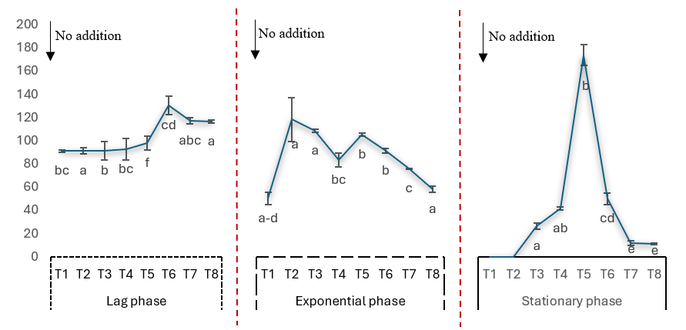
Resveratrol content (µg/L)

Resveratrol content (µg/L)
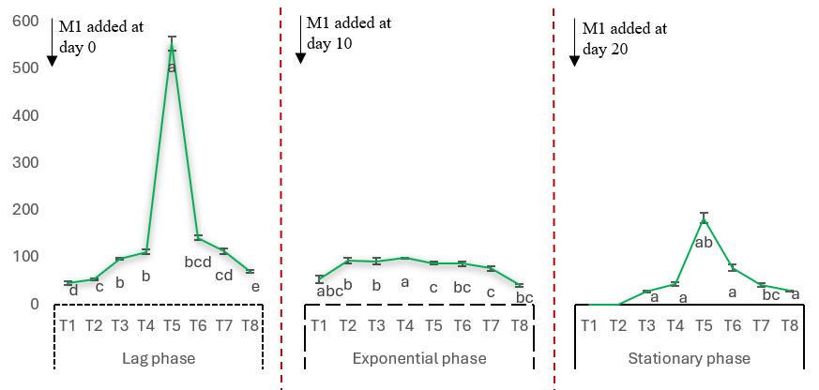
Resveratrol content (µg/L)

Resveratrol content (µg/L)
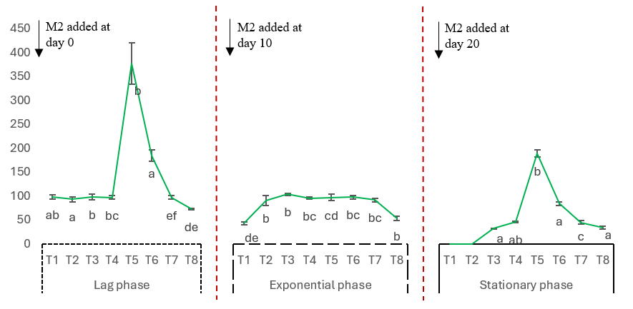
Resveratrol content (µg/L)

Resveratrol content (µg/L)
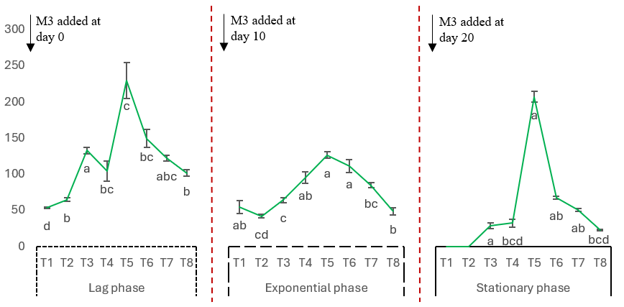
Resveratrol content (µg/L)

Resveratrol content (µg/L)
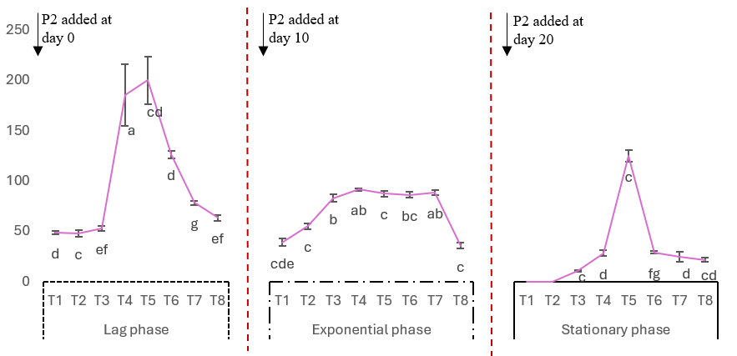
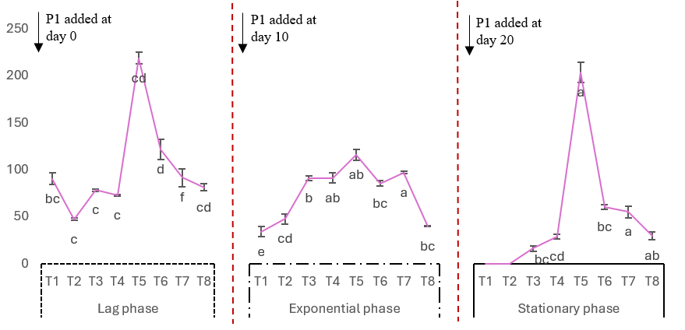
Resveratrol content (µg/L)

Resveratrol content (µg/L)
Resveratrol content (µg/L)

Resveratrol content (µg/L)
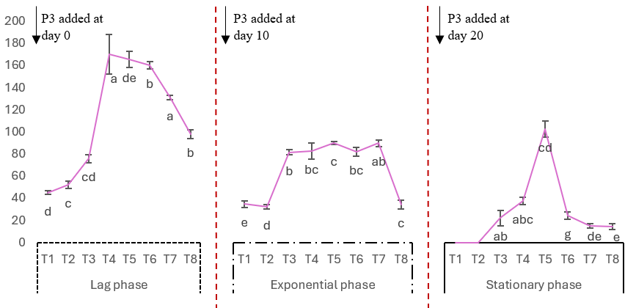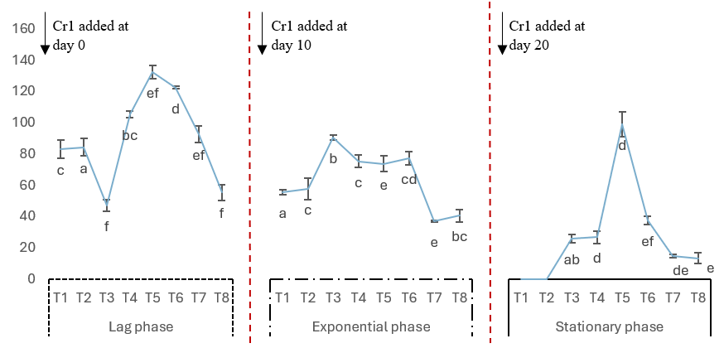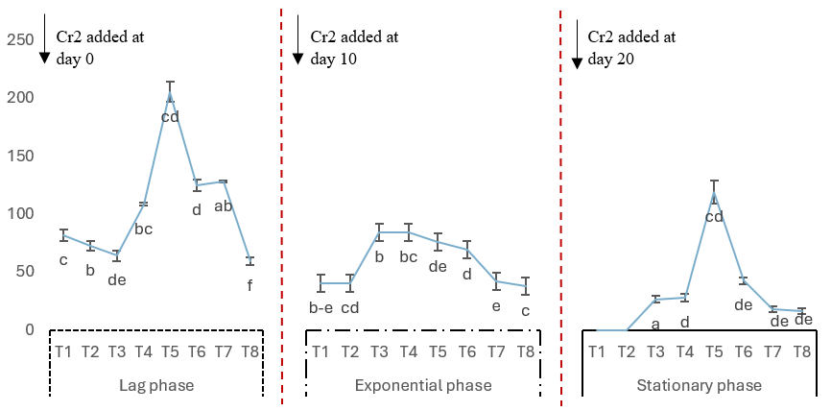
Resveratrol content (µg/L)

Resveratrol content (µg/L)
Resveratrol content (µg/L)

Resveratrol content (µg/L)
Resveratrol content (µg/L)

Resveratrol content (µg/L)
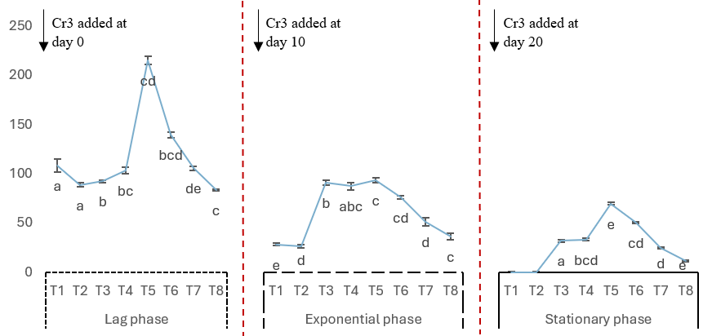
Resveratrol content (µg/L)

Resveratrol content (µg/L)
Fig. S3 Trans-resveratrol content in response to modulators treatments in peanut cell suspension during different growth phases (Phase 1 (Lag phase); Phase 2 (Exponential phase); Phase 3 (Stationary phase)) for various incubation times (T1: 2 h; T2: 4 h; T3: 8 h; T4: 18 h; T5: 32 h; T6: 72 h; T7: 96 h; T8: 144 h). No addition: control; Sodium malonate dibasic treatment (M1: 0.5mM; M2: 2.5 mM ; M3: 12.5 mM); L-phenylalanine treatment (P1: 0.2 mM ; P2: 1mM; P3: 5mM ); Cerulenin treatment (Cr1: 0.2 µM ; Cr2: 1µM ; Cr3: 5µM)
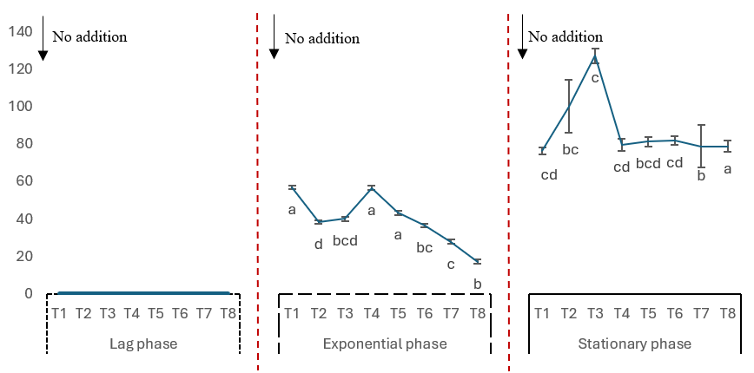
Piceid content (µg/L)

Piceid content (µg/L)
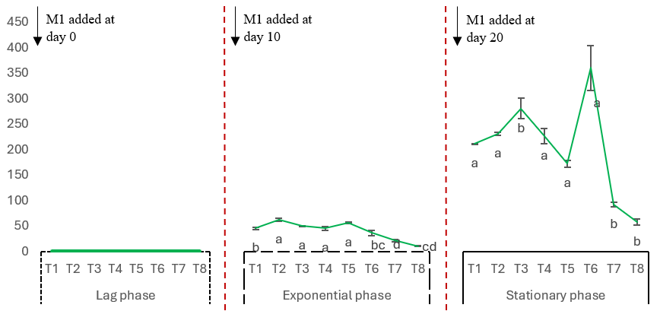
Piceid content (µg/L)

Piceid content (µg/L)
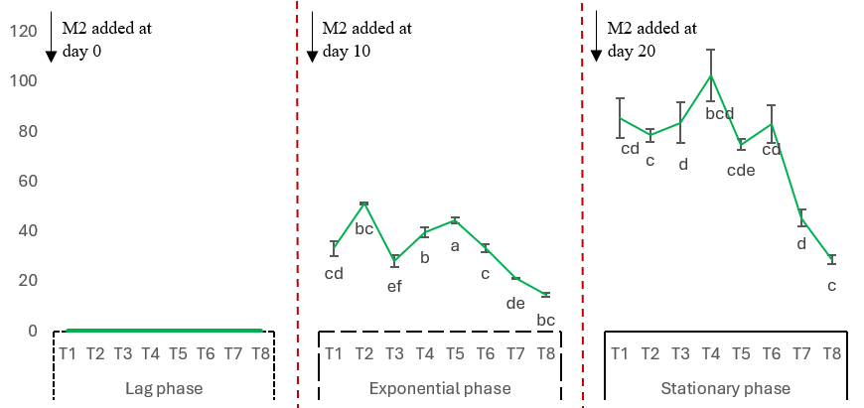

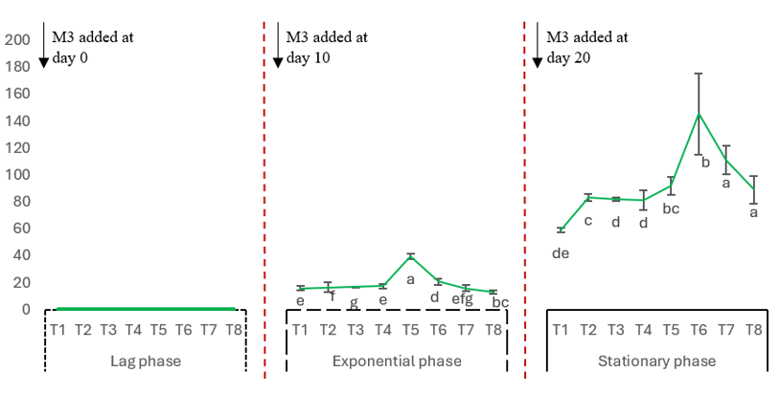
Piceid content (µg/L)

Piceid content (µg/L)
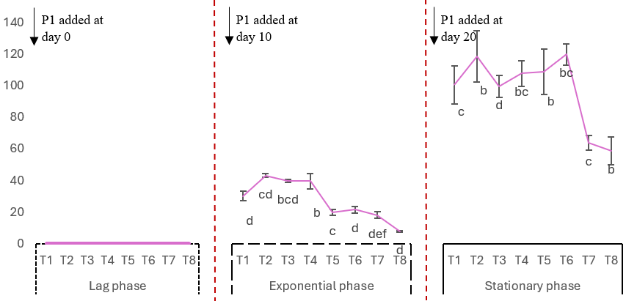
Piceid content (µg/L)

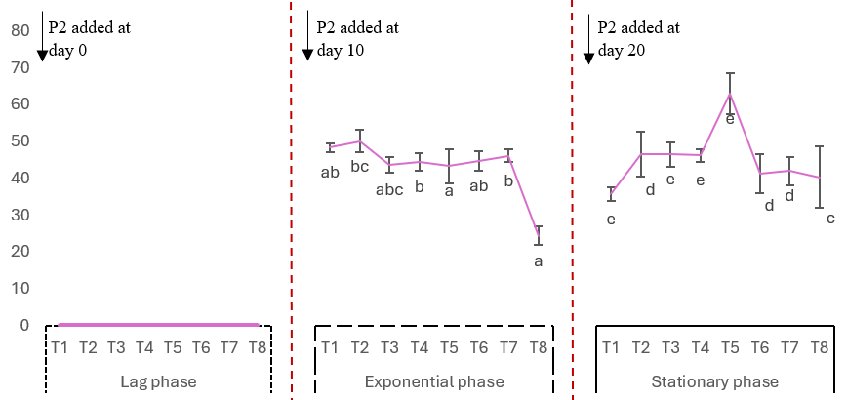
Piceid content (µg/L)

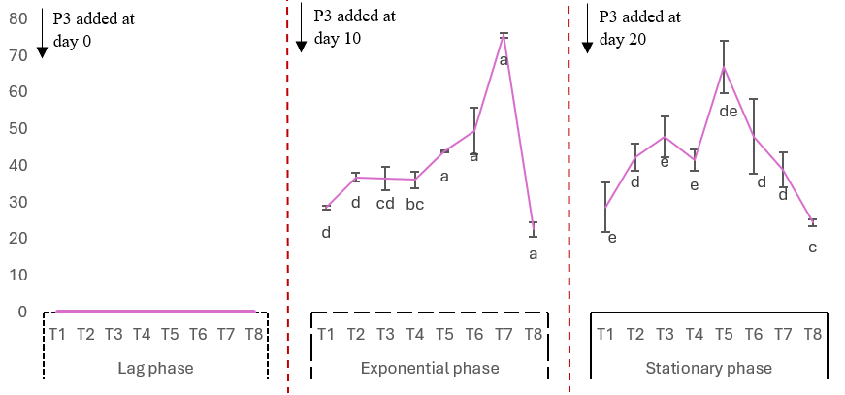
Piceid content (µg/L)

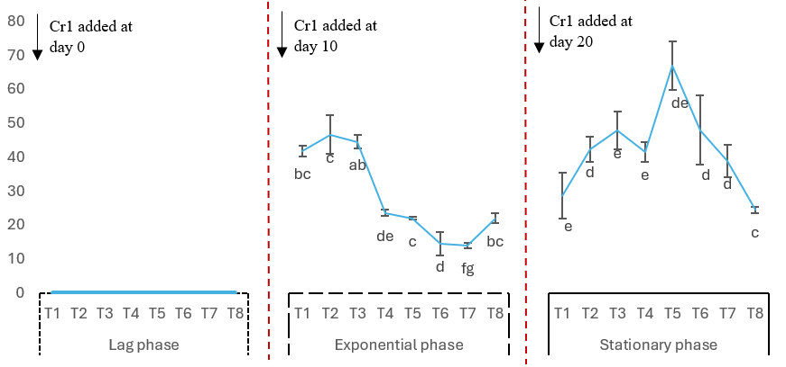
Piceid content (µg/L)

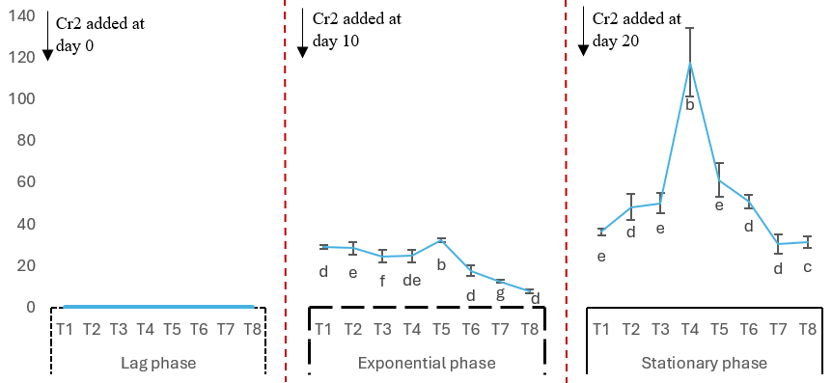
Piceid content (µg/L)

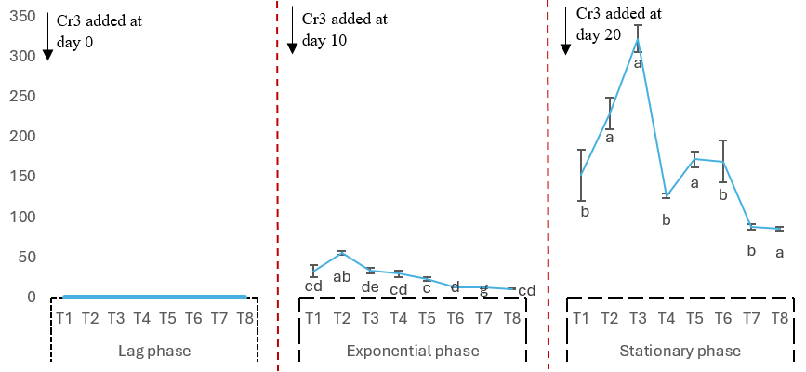
Piceid content (µg/L)

Fig. S4 Piceid content in response to modulators treatments in peanut cell suspension during different growth phases (Phase 1 (Lag phase); Phase 2 (Exponential phase); Phase 3 (Stationary phase)) for various incubation times (T1: 2 h; T2: 4 h; T3: 8 h; T4: 18 h; T5: 32 h; T6: 72 h; T7: 96 h; T8: 144 h). No addition: control; Sodium malonate dibasic treatment (M1: 0.5mM; M2: 2.5 mM ; M3: 12.5 mM); L-phenylalanine treatment (P1: 0.2 mM ; P2: 1mM; P3: 5mM ); Cerulenin treatment (Cr1: 0.2 µM ; Cr2: 1µM ; Cr3: 5µM)
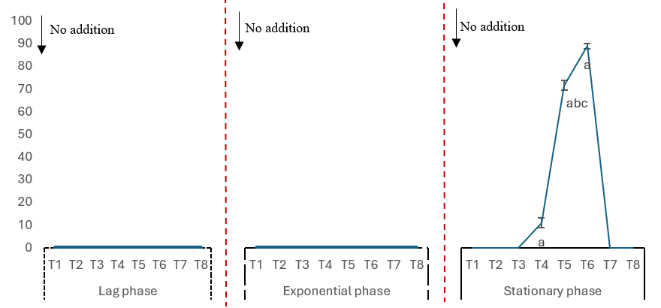
Piceatannol content (µg/L)

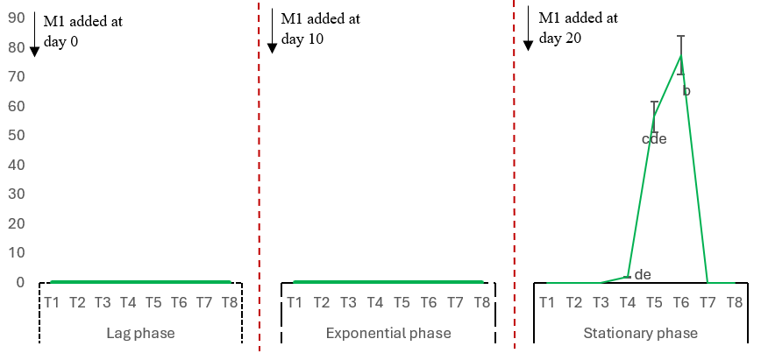
Piceatannol content (µg/L)

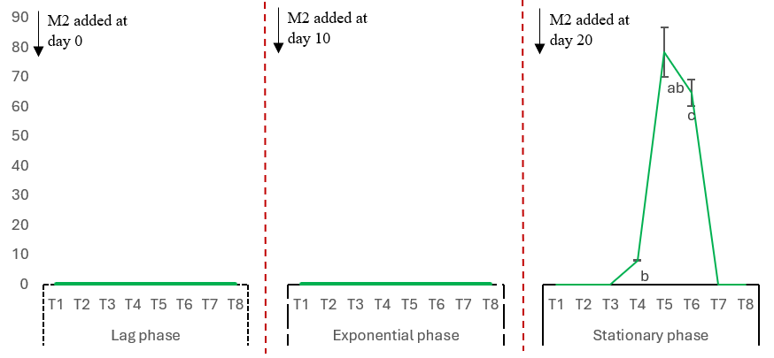
Piceatannol content (µg/L)

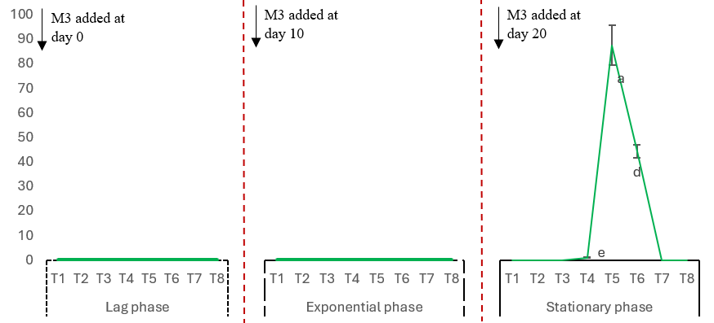
Piceatannol content (µg/L)

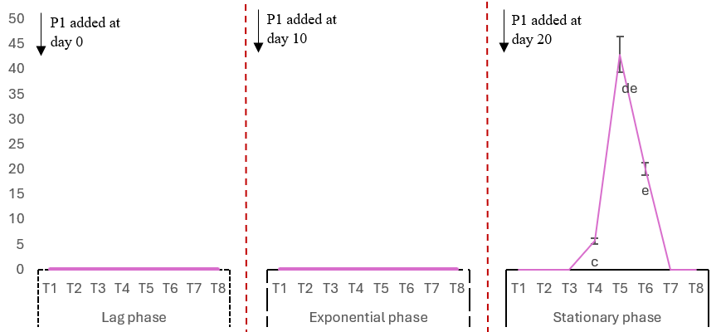
Piceatannol content (µg/L)

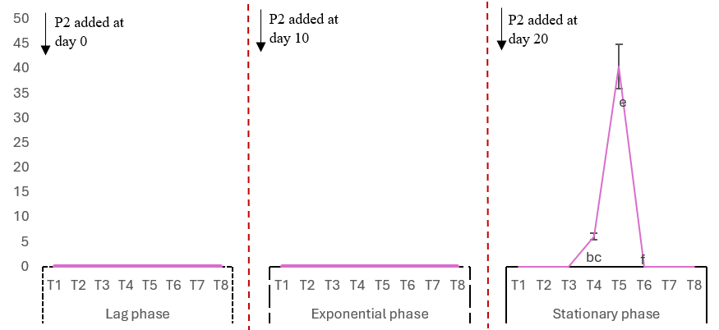
Piceatannol content (µg/L)

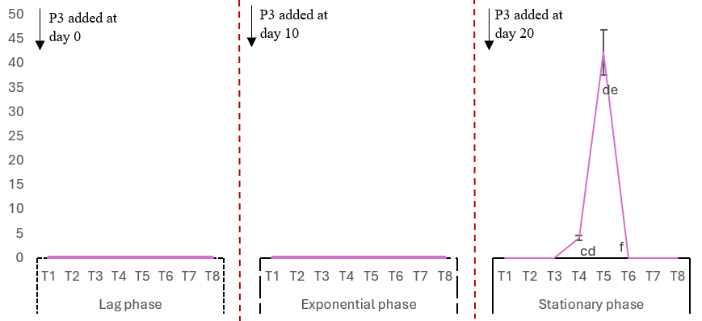
Piceatannol content (µg/L)

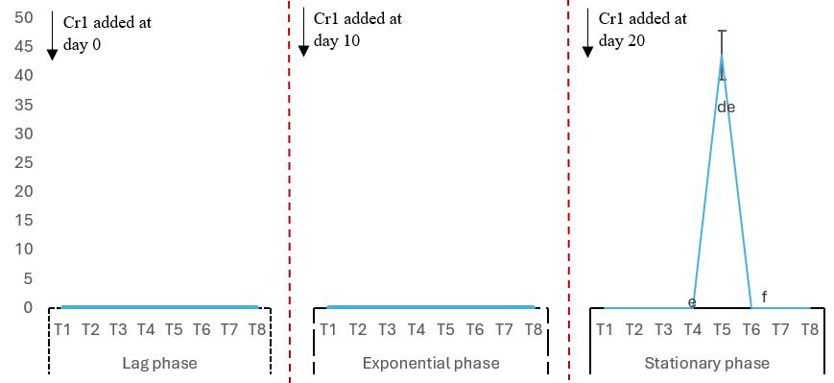
Piceatannol content (µg/L)

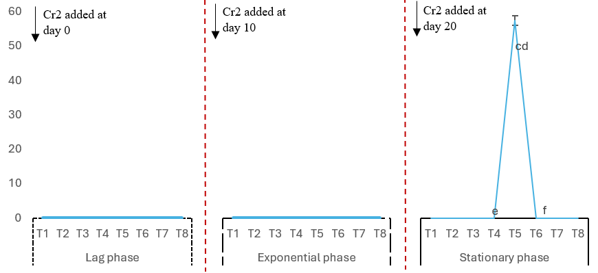
Piceatannol content (µg/L)

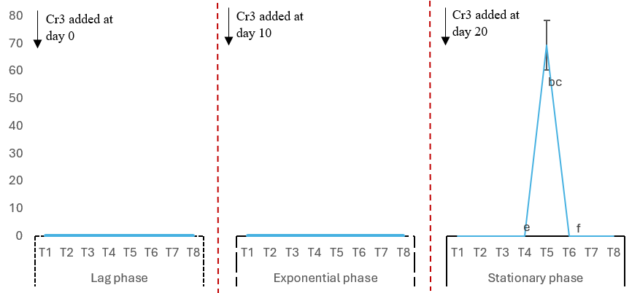
Piceatannol content (µg/L)

Fig. S5 Piceatannol content in response to modulators treatments in peanut cell suspension during different growth phases (Phase 1 (Lag phase); Phase 2 (Exponential phase); Phase 3 (Stationary phase)) for various incubation times (T1: 2 h ; T2: 4 h ; T3: 8 h; T4: 18 h; T5: 32 h; T6: 72 h; T7: 96 h; T8: 144 h). No addition: control; Sodium malonate dibasic treatment (M1: 0.5mM; M2: 2.5 mM ; M3: 12.5 mM); L-phenylalanine treatment (P1: 0.2 mM ; P2: 1mM; P3: 5mM ); Cerulenin treatment (Cr1: 0.2 µM ; Cr2: 1µM ; Cr3: 5µM)

