Appendix A

Figure A1. Correlations between the four environmental variables measured in this study (i.e. imperviousness, tree cover, distance to the closest road, distance to the city centre). Scatterplots of each pair of numeric variables are drawn on the left part of the figure. Pearson correlations are displayed on the right. Variable distribution is available on the diagonal.
***P$≤$0.001 **P$≤$0.01 *P$≤$0.05 ∙P$≤$0.10
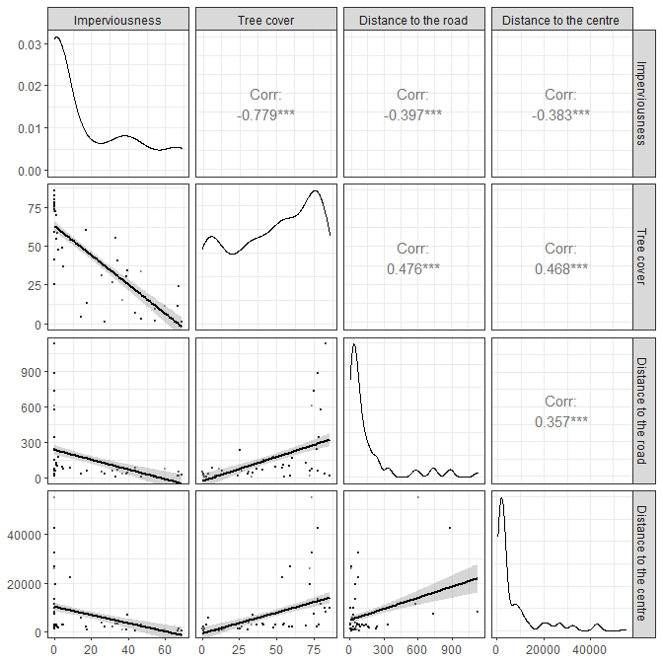

Appendix B
Figure B1. Relationship between MTE concentrations (i.e. Cu, Zn, Pb, Cd, As or Hg after log-transformation; in ppm) and the urbanization level (here tree cover) in blue tits (in blue) and in great tits (in black). For the x axis to positively correlates with the urbanization level, we highlight the percent of non-tree cover (100 – percent of tree cover). We highlight the concentration for each single individual (grey dots), the mean ± se concentration per percent of non-tree cover (in black) and the regression line (in blue) and its confidence interval (in grey).

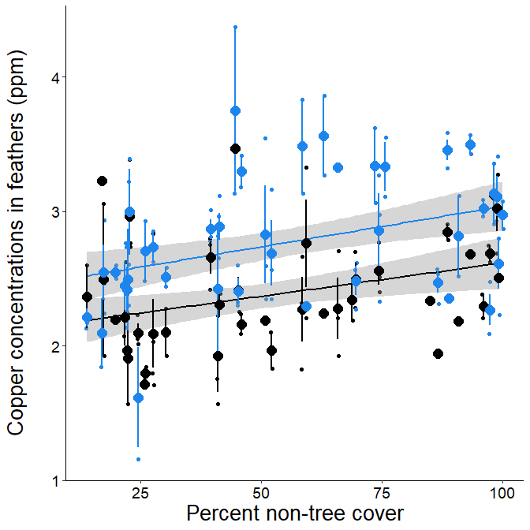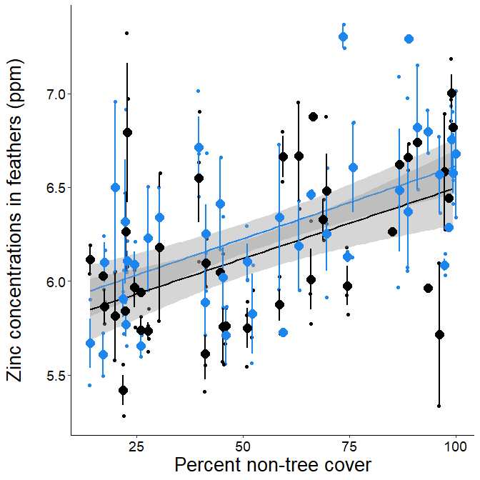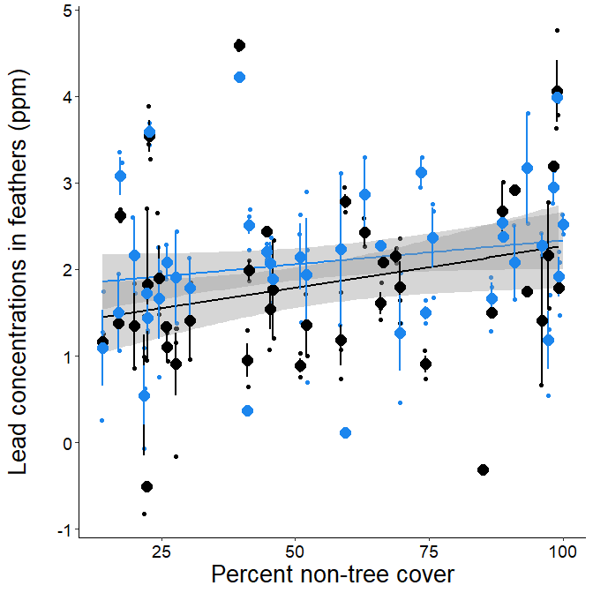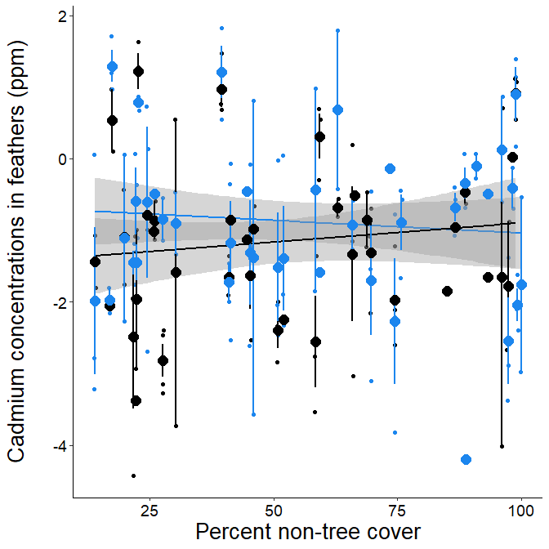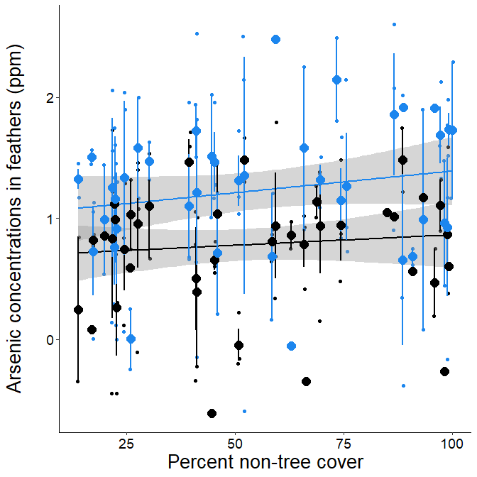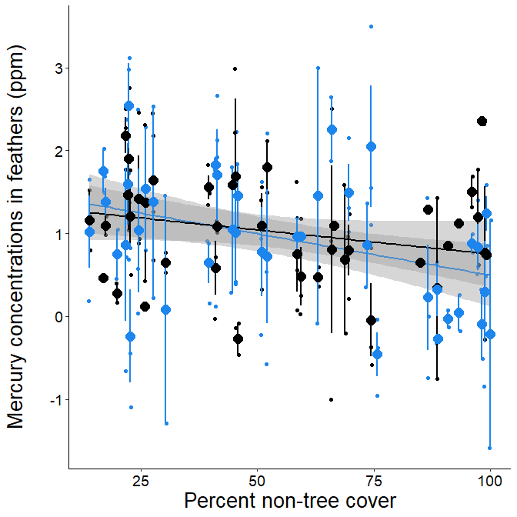

Appendix C

Table C1. Results of the best fitting statistical models testing the link between MTE concentrations (Cu, Zn, Pb, Cd, As and Hg) and urbanization score (a) or impervious surface cover (b) while taking into account the species and the age. The proportion of the variance in MTE concentrations that is explained by urbanization score or impervious surface cover – r² – is comprised between two values computed from the metrics “first” and “last” [31]. For Hg, the random effect “city” had a zero variance, preventing to calculate the coefficient of determination – R² – of the model; for this reason, we report for Hg the adjusted coefficient of determination from the linear model.

(a) | Cu | Zn | Pb | Cd | As | Hg
Urban. score | Χ² = 33.49, P < 0.001,  0.096 < r² < 0.163 | Χ² = 75.14, P < 0.001,  0.259 < r² < 0.295 | Χ² = 41.13, P < 0.001,  0.112 < r² < 0.122 |  |  | Χ² = 17.47, P < 0.001,  0.081 < r² < 0.084
Species | Χ² = 29.07, P < 0.001 | Χ² = 2.73, P = 0.098 | Χ² = 7.56, P = 0.006 | Χ² = 3.26, P = 0.071 | Χ² = 20.15, P < 0.001 | Χ² = 0.15, P = 0.697
Age | Χ² = 0.74, P = 0.39 | Χ² = 3.65, P = 0.056 | Χ² = 13.45, P < 0.001 | Χ² = 1.50, P = 0.220 | Χ² = 2.34, P = 0.126 | Χ² = 2.29, P = 0.130
R² | 0.352 | 0.409 | 0.576 | 0.345 | 0.128 | 0.081

(b) | Cu | Zn | Pb | Cd | As | Hg
Impervious surface cover | Χ² = 27.60, P < 0.001, 0.069 < r² < 0.129 | Χ² = 70.84, P < 0.001, 0.201 < r² < 0.274 | Χ² = 35.97, P < 0.001, 0.070 < r² < 0.098 |  |  | Χ² = 15.64, P < 0.001, 0.073 < r² < 0.077
Species | Χ² = 28.58, P < 0.001 | Χ² = 2.47, P = 0.116 | Χ² = 7.54, P = 0.007 | Χ² = 3.26, P = 0.071 | Χ² = 20.15, P < 0.001 | Χ² = 0.14, P = 0.712
Age | Χ² = 0.50, P = 0.48 | Χ² = 2.55, P = 0.111 | Χ² = 11.27, P < 0.001 | Χ² = 1.50, P = 0.220 | Χ² = 2.34, P = 0.126 | Χ² = 1.94, P = 0.164
R² | 0.325 | 0.351 | 0.534 | 0.337 | 0.129 | 0.073

Table C2. The proportion of the variance in MTE concentrations that is explained by distance to the closest road and distance to the city centre – r² – is comprised between two values computed from the metrics “first” and “last” [31].
 | Cu | Zn | Pb | Cd | As | Hg
R²  Distance to road | 0.011 < r² < 0.045 | 0.071 > r² > 0.062 | 0.034 > r² > 0.025 |  |  | 0.019 < r² < 0.026
R²  Distance to centre | 0.061 < r² < 0.121 | 0.070 < r² < 0.144 | 0.055 < r² < 0.083 |  |  | 0.041 < r² < 0.050

Appendix D

Table D1. Sample size (N) and mean ± se MTE concentrations in the feathers (Cu, Zn, Pb, As, Cd, As and Hg; in ppm) per species (blue tit i.e. BT, or great tit i.e. GT) and habitat category (protected forest, suburban forest, urban park, residential area or city centre).

 |  | Protected forest | Suburban forest | Urban park | Residential area | City centre
N | BT | 7 | 20 | 28 | 19 | 23
N | GT | 8 | 17 | 26 | 17 | 14
Cu | BT | 14.0 ± 2.6 | 12.7 ± 1.5 | 19.1 ± 2.0 | 19.6 ± 3.4 | 23.1 ± 1.9
Cu | GT | 6.7 ± 0.9 | 10.5 ± 1.4 | 11.2 ± 0.9 | 14.3 ± 1.7 | 15.2 ± 1.5
Zn | BT | 324.6 ± 20.7 | 455.4 ± 50.0 | 470.2 ± 25.7 | 748.7 ± 81.2 | 783.4 ± 64.1
Zn | GT | 364.5 ± 46.4 | 360.3 ± 16.0 | 468.5 ± 59.9 | 666.3 ± 60.0 | 718.1 ± 78.0
Pb | BT | 5.1 ± 1.2 | 8.6 ± 1.6 | 12.1 ± 2.0 | 11.9 ± 3.8 | 16.9 ± 3.3
Pb | GT | 4.4± 1.5 | 5.6 ± 1.1 | 8.0 ± 2.2 | 20.3 ± 7.8 | 22.3 ± 8.0
Cd | BT | 0.3 ± 0.1 | 1.1 ± 0.3 | 0.9 ± 0.2 | 1.0 ± 0.4 | 0.8 ± 0.2
Cd | GT | 0.3 ± 0.1 | 0.5 ± 0.2 | 0.7 ± 0.2 | 1.1 ± 0.3 | 1.0 ± 0.3
As | BT | 3.6 ± 1.0 | 3.5 ± 0.4 | 4.2 ± 0.6 | 6.5 ± 0.8 | 4.1 ± 0.6
As | GT | 2.4 ± 0.3 | 2.5 ± 0.3 | 2.4 ± 0.4 | 2.8 ± 0.4 | 2.8 ± 0.4
Hg | BT | 10.2 ± 3.0 | 4.7 ± 0.8 | 5.5 ± 1.4 | 2.6 ± 0.3 | 2.5 ± 0.7
Hg | GT | 4.5 ± 1.9 | 3.8 ± 0.8 | 4.5 ± 0.9 | 3.4 ± 0.4 | 3.9 ± 1.1

