Haplotype-resolved genome assembly of seed hemp (Cannabis sativa) revealed molecular divergence of Y chromosome evolution
Huawei Wei, Zuqing Yang, Lingling Zhuang, Xueqing Pan, Haifeng Jia, Shaolian Jiang, Qin Li, Jiantang Xu, Aifen Tao, Pingping Fang, Jianmin Qi, Ray Ming, Liwu Zhang

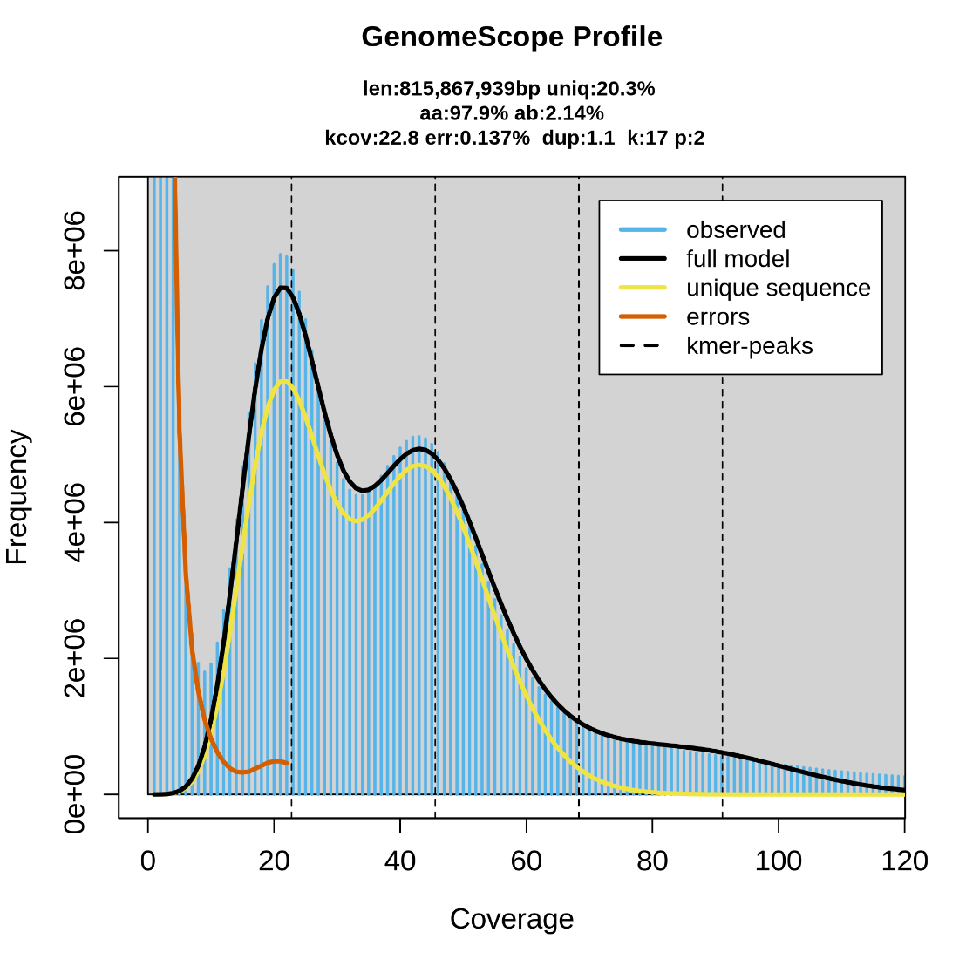
Fig. S1. Genome size, heterozygous and duplications of seed hemp predicted by K-mer (k=17) analysis. GenomeScope is used to draw the K-mer distribution. The genome size was estimated 816 Mb, genome heterozygosity was 2.14% and genome duplication was 1.1%.

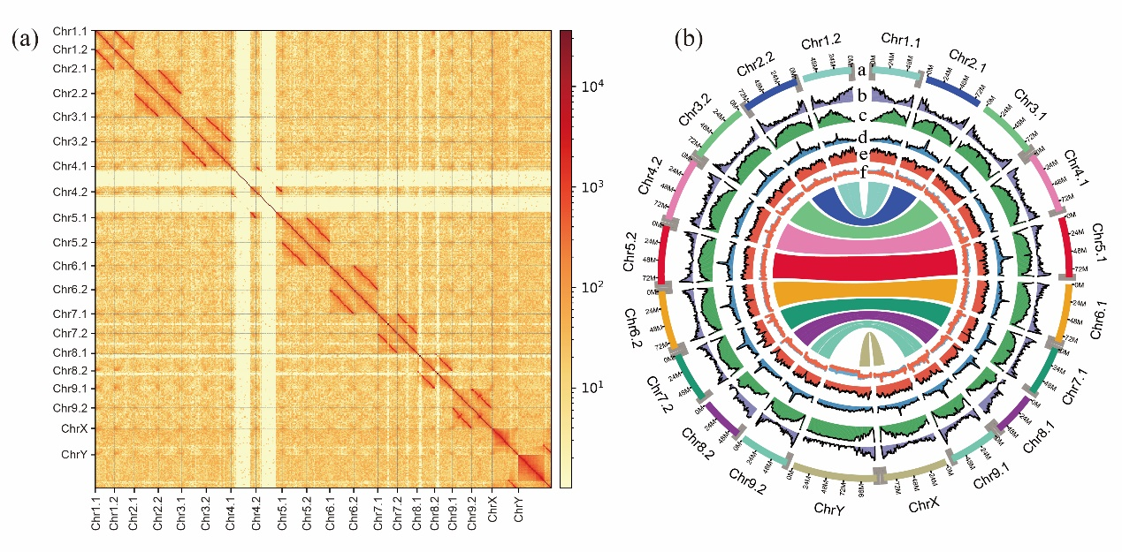
Fig. S2. Hi-C map and overview of the haplotype-resolved genomic features of dioecious seed hemp with YSM1 and YSM2. (a) Map of Hi-C links among 10 pseudochromosomes. (b) Haplotype-resolved genomic features. a, Length (Mb) of chromosomes; b, gene density; c, TE density; d, GC content, e, LAI distribution; f, BSA reads cover depth, with males in blue and females in red.

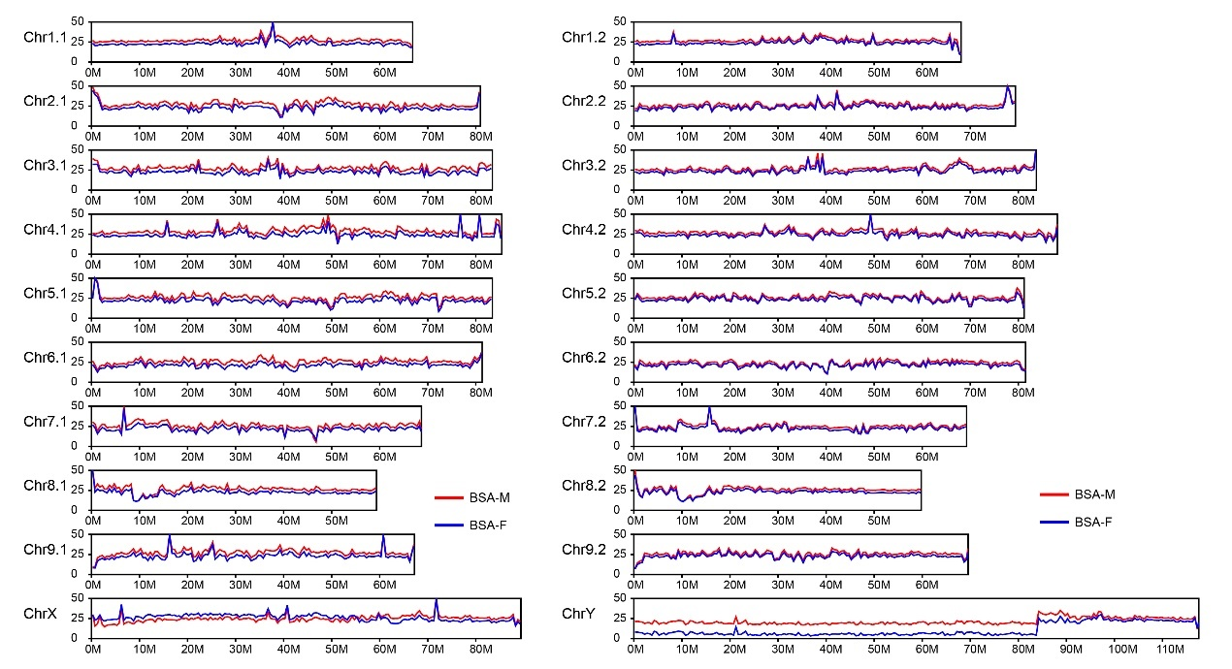
Fig. S3. Mapping results of BSA data to the YSM1 and YSM2 of seed hemp.

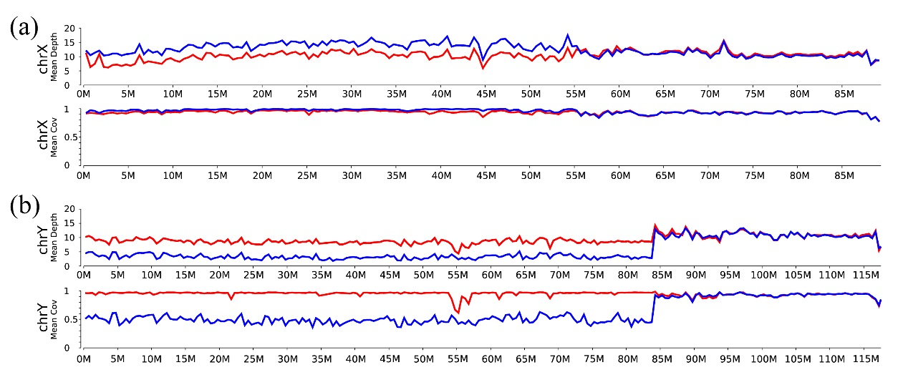
Fig. S4. Mapping results of resequencing data from leaves in male and female of 11 seed hemp varieties to the X and Y chromosomes. (a) depth of resequencing data coverage on the X chromosome. (b) depth of resequencing data coverage on the Y chromosome. The red line represents the male sample and the blue represents the female sample.

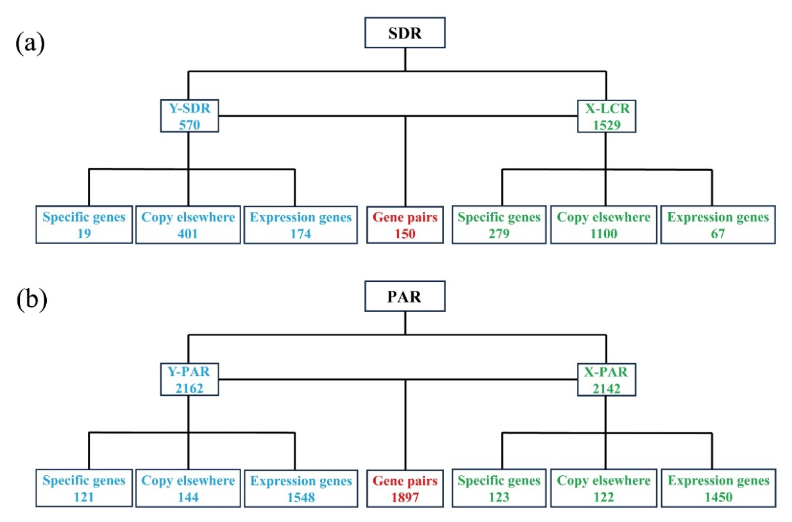
Fig. S5. Distribution of encoding genes in the Y and corresponding X.
(a) The genes distribution of SDR and its corresponding region on the X chromosome. SDR: Sex-determined region, Y-SDR: SDR on the Y chromosome, X-LCR: X-linked colinear region. (b) The genes distribution in the PAR on the X and Y chromosomes. PAR: Pseudo-autosomal region, Y-PAR: Pseudo-autosomal region on the Y chromosome, X-PAR: Pseudo-autosomal region on the X chromosome.

