  - Difference in environmental development and its geographical, social, economic drivers between Global North and Global South
Environmental indicators of the urban centers present big differences between Global North and Global South, illustrated in Fig. 1. The global map of carbon emissions shows lower emissions in Global South (especially in Africa, India and South-East Asia) while much higher in North America, Europe and East Asia. On average, carbon emissions per capita are 1.73 tons in Global North, significantly higher than the 0.55 tons in the Global South. The global greenness map reveals that Europe, India, Southeast Asia, Eastern North America and Central Africa are greener. Global North has a relatively higher mean greenness score (0.45) than Global South (0.40). Conversely, the air quality indicator shows higher PM_{2.5} levels in Asia and Africa. Global North has a lower mean PM_{2.5} concentration of 14.50 than Global South (38.77). In a word, Global North has twice higher mean CO₂, slightly higher greenness and twice lower mean PM_{2.5} than Global South while some urban centers in Global South present the case opposite to the mean values.
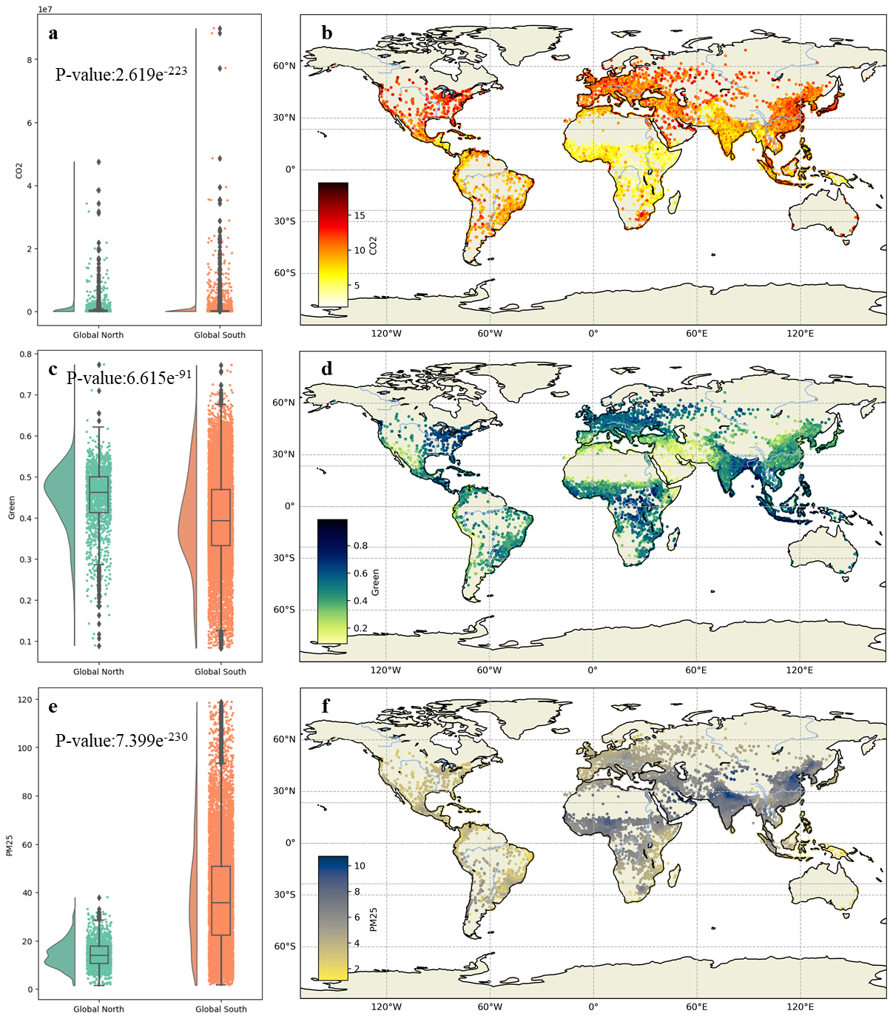
Fig. 1 Differences in environmental dimensions of the world's urban centers between Global North and Global South (a. CO₂. b. Distribution of global CO₂. c. Greenness. d. Distribution of global greenness. e. PM_{2.5}. f. Distribution of global PM_{2.5}.)
As one of the key geographic attributes, the elevations in Asia, Europe, Africa, North America, South America, and Oceania are less than 1,000 meters while exceeding 1,000 meters in high plateaus and mountain ranges of central North America, western South America, southern Africa, and the Tibetan Plateau region of Asia. On average, the elevation is 177.81 m in Global North and 439.06 m in Global South (Fig. 2). The mean annual temperature is 11.34°C in Global North and 22.00°C in Global South. Similarly, the mean annual precipitation is 818.23mm in Global North and 1144.80mm in Global South. Overall, Global North exhibits significantly lower mean values for elevation, temperature and precipitation than Global South.
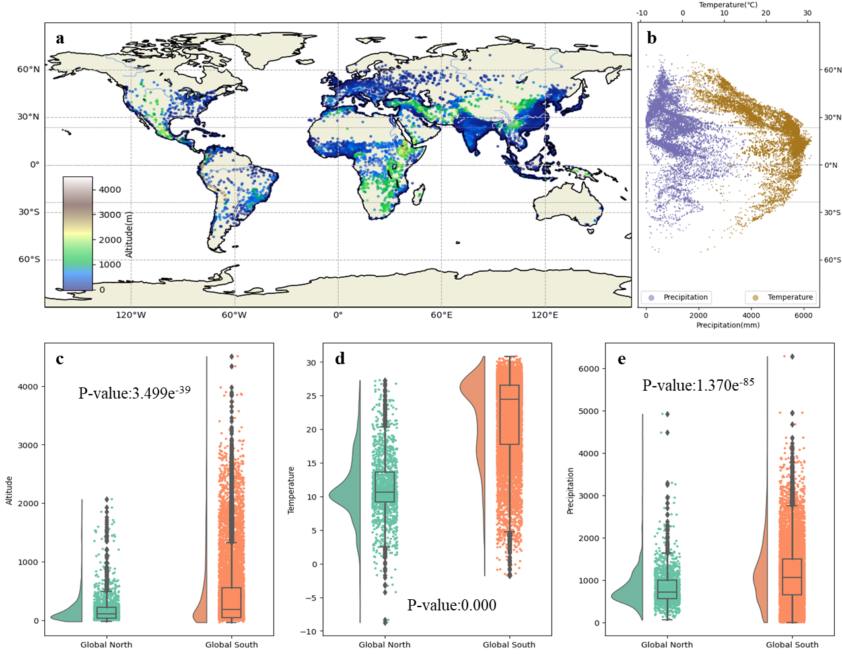
Fig. 2 Geographical attributes of the world's urban centers and the differences between Global North and Global South (a. Distribution of global elevation. b. Latitudinal distribution of global temperature and precipitation. c. Difference of elevation. d. Difference in temperature. e. Difference of precipitation)
Urban socio-economic characteristics also reveal disparities, as shown in Fig. 3. Global North has a higher average area per capita (2.58×10⁻⁴m²) than Global South (5.34×10⁻⁵m²). Furthermore, the average urban prosperity index in Global North is 28.77, more than double the value of 10.46 in the Global South. The GDP distribution reveals significant regional disparities, as shown in Fig. 3e. North America, Europe and Japan exhibit higher GDP values, while Africa displays lower value (Fig. 3f). The average GDP per capita in Global North is $18,377.47, significantly surpassing the Global South's $5,468.23. Global North has a higher mean and peak GDP distribution than Global South. However, a few urban centers in Global South, such as Greater Santa Cruz Area, Abu Dhabi, and Muhayil, exceed the GDP per capita of some urban centers in Global North. Global South’s GDP distribution forms a long tail, reflecting widespread income inequality. Meanwhile, high-income regions (depicted in green in Fig. 3h) are mainly located in North America, Western Europe, East Asia (such as Japan and South Korea), as well as Australia and New Zealand. In contrast, middle- and low-income regions (orange, blue and red in Fig. 3h) are concentrated in Latin America, South Asia, Southeast Asia, and sub-Saharan Africa. Although Global North has fewer urban centers, it contains the highest proportion of high-income-class (HIC) urban centers. In addition, Global South has a larger number of lower-middle-income-class urban centers, followed by upper-middle-income-class urban centers, reflecting the region's economic diversity. Overall, Global North exhibits significantly higher socio-economic values while Global South presents larger diversion in these indicators.
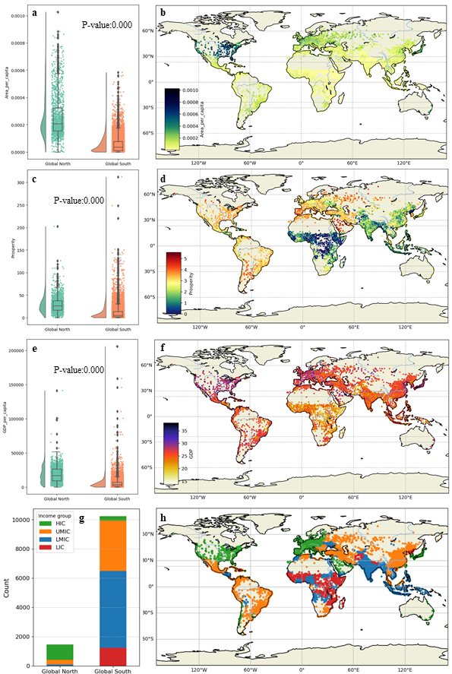
Fig. 3 Differences in socio-economic development of the urban centers between Global North and Global South (a. Per capita area. b. Per capita area. c. Prosperity. d. Distribution of global prosperity. e. GDP per Capita. f. Distribution of global GDP per capita. g. Difference of income group. h. Distribution of global income group.)
  - Difference in environmetal development from 2000 to 2015 between Global North and Global South
Three-dimensional figure of difference in environmetal development from 2000 to 2015 between Global North and Global South:
https://github.com/weii20230124/Mutiple-environmental-inequalities

