Supplementary Information
Stress modulates BNST connectivity during food cue and taste processing: a 7T dynamic causal modelling study
Eva Guerrero-Hreins, Matthew D. Greaves, Po-Han Kung, Bradford A. Moffat, Rebecca K. Glarin, Stuart B. Murray, Ben J. Harrison, Priya Sumithran, Robyn M Brown, Trevor Steward.

Supplementary Methods 2
Gustometer mouthpiece 3D printing documentation 2
Supplementary Results 3
Hunger and beverage pleasantness ratings 3
Supplementary Tables 4
Supplementary Table 1. Participant characteristics 4
Supplementary Table 2. Chocolate milk ingredients and nutritional information 5
Supplementary Table 3. Group-level GLM activation to CUE 6
Supplementary Table 4. Group-level GLM activation to TASTE 8
Supplementary Figures 10
Supplementary Figure 1. Spontaneous skin conductance fluctuations. 10
Supplementary References 11

Supplementary Methods

Gustometer mouthpiece 3D printing documentation

3D models: Mouthpieces, face shields, and tube guides were printed using STLs provided fromhttps://github.com/munoztd0/Mouthpiecegusto/tree/main/mouth_piecehttps://github.com/munoztd0/Mouthpiecegusto/tree/main/mouth_piece https://github.com/munoztd0/Mouthpiecegusto/tree/main/mouth_piecehttps://github.com/munoztd0/Mouthpiecegusto/tree/main/mouth_piecehttps://github.com/munoztd0/Mouthpiecegusto/tree/main/mouth_piecehttps://github.com/munoztd0/Mouthpiecegusto/tree/main/mouth_piece.
Of the multiple sizes provided, those that fitted closest to the tubes provided by Burghart Messtechnik GmbH, were those described as m01 in their filename.
3D printing: Mouth pieces, face shields, and tube guides were printed on a Prusa MK3S using PLA. Models were sliced with PrusaSlicer 2.5.0. To increase security of fit of tubes in tube guide, a ‘Fuzzy skin’ modifier was applied to the tube channels, with skin depth = 0.1mm, during slicing.

Supplementary Results

Hunger and beverage pleasantness ratings
Hunger levels slightly decreased from the low-stress run (mean 3.27 [SD 1.81]) to the high-stress run (mean 2.79 [SD 1.76], t₄₇ = 2.11, p = .04, n = 48; Figure 2a). Beverages were rated as less pleasant after high-stress versus low-stress induction (p = .02 for water, p = .002 for chocolate milk; Figure 2b-c).

Supplementary Tables

Supplementary Table 1. Participant characteristics
 | n = 48
Sex, female | 50.0%
Age, years | 26.2 (5.3)
BMI, kg/m² | 22.4 (3.8)
Ethnicity
Australian | 16.7% (8)
British or European | 18.8% (9)
Asian | 68.8% (33)
Middle Eastern | 2.1% (1)
African | 2.1% (1)
North American | 2.1% (1)
Central or Southern American | 6.3% (3)
Education level
Year 12 or equivalent | 20.8% (10)
Bachelor’s degree | 29.2% (14)
Postgraduate degree | 50.0% (24)
Handedness, right | 93.8% (45)
Days since last period | 16.4 (9.9)
BMI, body mass index. Data presented as % (n) or mean (SD). Days since last period are reported only for participants who menstruate (40%, n = 19 of the total sample).

Supplementary Table 2. Chocolate milk ingredients and nutritional information

Ingredients
Reduced Fat Milk, Sugar, Cocoa (0.5% Minimum), Flavour, Vegetable Gum (407).
Nutritional information per 100ml
Energy | 267 kj
Protein | 3.0g
– Gluten | Not detected
Fat, total | 1.7g
– Saturated | 1.2g
Carbohydrate | 9.0g
– Sugars | 7.9g
Sodium | 42.0mg
Potassium | 130.0mg
Calcium | 100.0mg
Kj, kilojoule; g, gram; mg, milligram; ml, millilitre. Obtained from https://nippys.com.au/product/iced-chocolate/

Supplementary Table 3. Group-level GLM activation to CUE
 | MNI coordinates
Label | x | y | z | Cluster size | Peak (T)
Lingual_R | 14 | -45 | -3 | 44801 | 13.28
Angular_L | -50 | -54 | 29 | 3346 | 7.3
Frontal_Mid_2_R | 35 | 21 | 54 | 1063 | 6.2
Cingulate_Mid_L | 0 | -30 | 42 | 443 | 6.11
Temporal_Mid_L | -67 | -43 | -5 | 828 | 5.45
Frontal_Mid_2_L | -43 | 19 | 42 | 441 | 5.2
Insula_R | 38 | -18 | 13 | 256 | 5.06
Frontal_Sup_2_R | 18 | 48 | 42 | 780 | 5
Frontal_Sup_Medial_L | -5 | 50 | 24 | 339 | 4.96
Temporal_Pole_Mid_L | -40 | 8 | -43 | 107 | 4.86
OFClat_L | -40 | 34 | -14 | 448 | 4.83
SN_pr_R | 8 | -19 | -24 | 186 | 4.6
Frontal_Inf_Tri_L | -53 | 29 | 11 | 214 | 4.54
Temporal_Sup_L | -67 | -26 | 8 | 39 | 4.51
Frontal_Inf_Orb_2_L | -27 | 24 | -11 | 43 | 4.39
Cerebellum_10_R | 3 | -8 | 32 | 49 | 4.28
Cingulate_Mid_R | 18 | -37 | -43 | 67 | 4.28
ACC_pre_L | -2 | 40 | 18 | 25 | 4.22
Rolandic_Oper_L | -51 | -5 | 2 | 21 | 4.11
Temporal_Sup_R | 70 | -27 | 11 | 13 | 4.1
Rectus_L | -30 | 3 | -37 | 25 | 3.94
Cerebelum_6_R | 34 | -54 | -29 | 20 | 3.83
Olfactory_R | 3 | 21 | -11 | 56 | 3.83
Insula_L | -34 | 13 | -3 | 31 | 3.81
Frontal_Inf_Tri_R | 53 | 18 | 21 | 11 | 3.79
Temporal_Inf_L | -56 | -10 | -26 | 19 | 3.76
Temporal_Pole_Sup_L | -53 | 19 | -22 | 32 | 3.76
Caudate_L | -16 | -6 | 18 | 43 | 3.75
ParaHippocampal_L | -22 | 3 | -26 | 52 | 3.75
ACC_sup_L | -3 | 32 | 19 | 22 | 3.68
Frontal_Sup_2_L | -18 | 51 | 24 | 47 | 3.63
Hippocampus_L | -18 | -11 | -8 | 19 | 3.61
Thal_MDm_L | -5 | -19 | 11 | 38 | 3.55
OFCant_R | 29 | 43 | -11 | 16 | 3.52
ACC_pre_R | -2 | -18 | -6 | 10 | 3.49
Red_N_L | 10 | 42 | 8 | 32 | 3.49
Fusiform_R | 24 | 14 | -46 | 25 | 3.45
Hippocampus_R | 21 | -16 | -11 | 20 | 3.44
Postcentral_R | 67 | -11 | 30 | 18 | 3.39
Thal_PuM_L | 22 | -11 | -19 | 13 | 3.39
Putamen_L | -26 | 16 | 3 | 13 | 3.34
Cerebelum_4_5_L | -14 | -50 | -27 | 10 | 3.31
Precentral_R | 58 | -10 | 51 | 11 | 3.27
Thal_VL_R | 8 | -13 | 11 | 23 | 3.25
Cerebelum_9_L | -16 | -42 | -54 | 14 | 3.24
Olfactory_L | -3 | 18 | -5 | 13 | 3.18
Parietal_Sup_L | -26 | -74 | 45 | 19 | 3.13
ParaHippocampal_R | 3 | -10 | -34 | 14 | 3.08
Anatomic regions are defined with Automated Anatomical Labelling Atlas 3 (AAL3¹, local maxima labelling, 1mm voxel edge). Significant clusters are thresholded at P_{FDR} < 0.05, K_{E} ≥ 10 voxels. T values represent peak activation for the cluster. MNI Montreal Neurological Institute, L left, R right.

Supplementary Table 4. Group-level GLM activation to TASTE
 | MNI coordinates
Label | x | y | z | Cluster size | Peak (T)
Rolandic_Oper_L | -62 | -8 | 11 | 16635 | 12.16
Insula_L | -34 | -11 | 16 | 16635 | 12.08
Postcentral_L | -53 | -10 | 32 | 16635 | 11.69
Postcentral_R | 61 | -13 | 24 | 18309 | 10.79
SupraMarginal_R | 54 | -19 | 24 | 18309 | 10.51
Precentral_R | 53 | -5 | 42 | 18309 | 10.41
Fusiform_R | 24 | -61 | -16 | 11149 | 9.62
Cerebelum_6_L | -14 | -61 | -13 | 11149 | 7.6
Supp_Motor_Area_R | 3 | 0 | 61 | 4686 | 9.55
Supp_Motor_Area_L | 0 | -5 | 69 | 4686 | 7.18
Frontal_Mid_2_R | 45 | 48 | 11 | 1020 | 7.35
Frontal_Inf_Orb_2_R | 50 | 50 | -6 | 1020 | 4.71
Thal_PuA_L | -8 | -21 | 10 | 313 | 7.04
Thal_MDm_L | -5 | -14 | -2 | 313 | 4.46
Thal_VL_L | -13 | -18 | -2 | 313 | 3.26
Cerebelum_8_L | -16 | -59 | -46 | 641 | 6.86
Frontal_Mid_2_L | -43 | 37 | 18 | 451 | 5.81
Frontal_Inf_Tri_L | -38 | 32 | 22 | 451 | 4.23
Cerebelum_9_R | 13 | -59 | -51 | 847 | 5.47
Cerebelum_8_R | 29 | -46 | -48 | 847 | 5.04
Rectus_L | -8 | 34 | -21 | 26 | 4.6
Cerebelum_6_R | 38 | -48 | -29 | 138 | 4.57
Red_N_L | -6 | -18 | -8 | 37 | 4.11
Temporal_Inf_R | 58 | -64 | -5 | 35 | 4.06
Temporal_Mid_R | 58 | -56 | 2 | 35 | 3.54
OFCmed_L | -13 | 43 | -24 | 27 | 4.05
OFCmed_R | 16 | 38 | -18 | 28 | 4.05
Cerebelum_7b_L | -34 | -64 | -48 | 20 | 3.99
OFCant_R | 34 | 40 | -19 | 26 | 3.88
Parietal_Inf_R | 54 | -54 | 43 | 45 | 3.82
Cerebelum_4_5_R | 21 | -45 | -32 | 65 | 2.89
Angular_R | 45 | -61 | 53 | 37 | 3.52
Heschl_R | 40 | -22 | 8 | 15 | 3.47
Parietal_Inf_L | -48 | -50 | 43 | 16 | 3.43
Olfactory_L | -6 | 11 | -16 | 25 | 3.4
Cingulate_Mid_R | 19 | -26 | 42 | 20 | 3.33
Frontal_Sup_2_L | -24 | 0 | 58 | 14 | 3.32
Occipital_Inf_R | 37 | -82 | -14 | 16 | 3.29
Parietal_Sup_R | 21 | -54 | 75 | 10 | 3.13
Temporal_Pole_Sup_R | 29 | 14 | -30 | 12 | 3.07
Precuneus_R | 8 | -74 | 35 | 11 | 3.06
SupraMarginal_L | -62 | -43 | 34 | 12 | 2.82
Anatomic regions are defined with Automated Anatomical Labelling Atlas 3 (AAL3¹, local maxima labelling, 1mm voxel edge). Significant clusters are thresholded at P_{FDR} < 0.05, K_{E} ≥ 10 voxels. T values represent peak activation for the cluster. MNI Montreal Neurological Institute, L left, R right.

Supplementary Figures
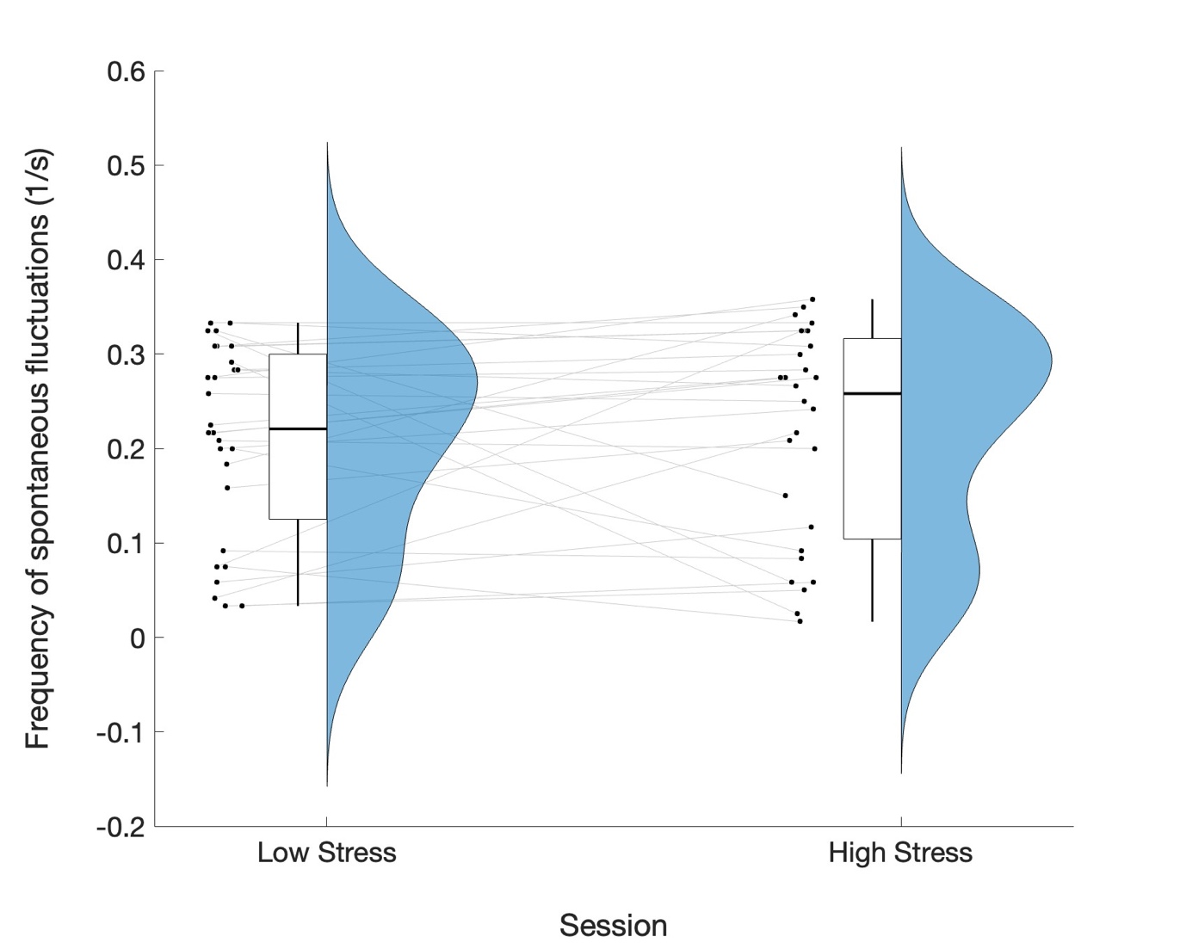
Supplementary Figure 1. Spontaneous skin conductance fluctuations. Raincloud plot showing the distribution of above-threshold spontaneous fluctuation frequency (1/s) for the 120-s low- and high-stress induction tasks. Boxplots show the median and interquartile range of the data, and black dots represent subject values. Gray lines indicate within-subject changes between conditions. The smoothed density plots (blue) show the estimated distribution of values in each condition. These data suggest a shift in spontaneous fluctuation frequency under high-stress conditions; however, this difference did not reach statistical significance (t₂₇ = -0.31, p = .76, n = 28, mean difference = -0.006 [-0.05, 0.04]).

Supplementary References

1. Rolls, E. T., Huang, C.-C., Lin, C.-P., Feng, J. & Joliot, M. Automated anatomical labelling atlas 3. NeuroImage 206, 116189 (2020).

