Supplementary information for
Enzyme mimics of bimetallic nanoclusters for detection of trypsin

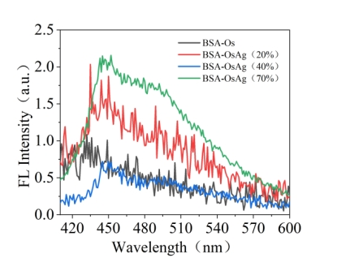
Fig. S1. Fluorescence spectra of BSA-OsAg nanoclusters with different silver contents.
Table. S1 The highest absorption value of different samples at 652 nm.
Catalyst | A_{652nm}（a.u.）
BSA-Os | 2.289
BSA-OsAg（20% Ag） | 2.351
BSA-OsAg（40% Ag） | 2.276
BSA-OsAg（70% Ag） | 0.349

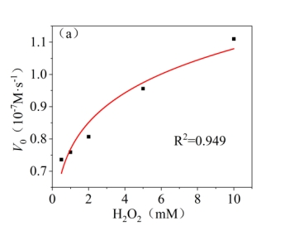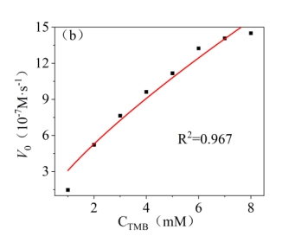
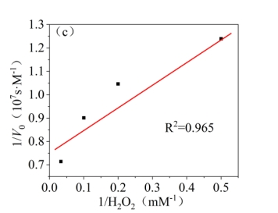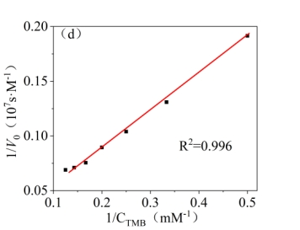
Fig. S2. Steady-state kinetic analysis with BSA-Os NCs, Michaelis-Menten trend of (a) H₂O₂ and (b) TMB, Lineweaver-Burk plot of (c) H₂O₂ and (d) TMB.
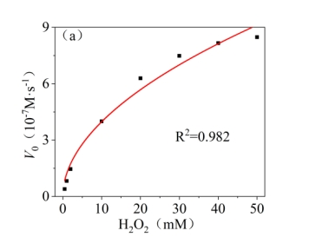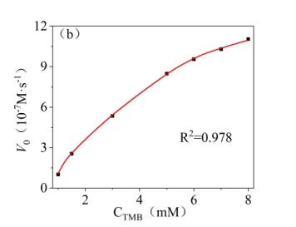
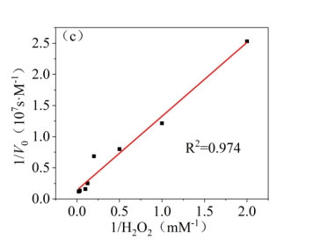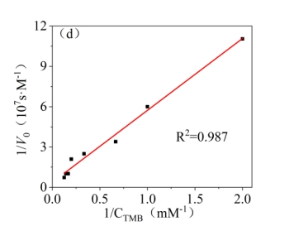
Fig. S3. Steady-state kinetic analysis with BSA-Os NCs with 40% silver content, Michaelis-Menten trend of (a) H₂O₂ and (b) TMB, Lineweaver-Burk plot of (c) H₂O₂ and (d) TMB.

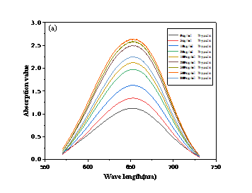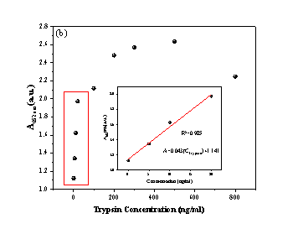
Fig. S4. (a)UV-Vis spectrum of trypsin at different concentrations , (b) absorption values and fitting plots of trypsin at 652nm at different concentrations

