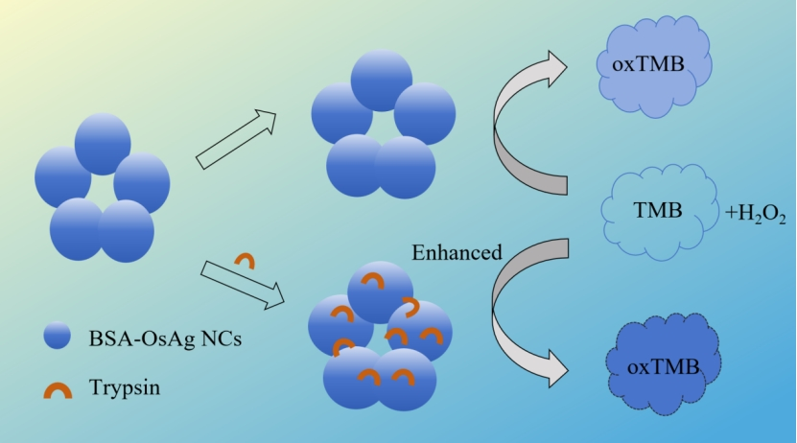
Scheme illustration for the detection of trypsin by using BSA-OsAg NCs.

