Supplementary Text
Diversity gap correlates
We found that the significant patterns and directions of fixed effects in our model were mostly robust to changes in the models; however, changing the transformations altered the results. Importantly, without log-transforming the number of clean records and the proportion of occurrence-based species the significance values were identical but both fixed effects variables were negatively associated with the response variables
We also sampled curves derived from the global- and country-level species occurrence data (Fig. S10). Except for GDPc, and — for the global dataset — the interaction term between the number of clean records and the proportion of occurrence-based species, the significance and sign of the remaining fixed effects were consistent (Table S3).

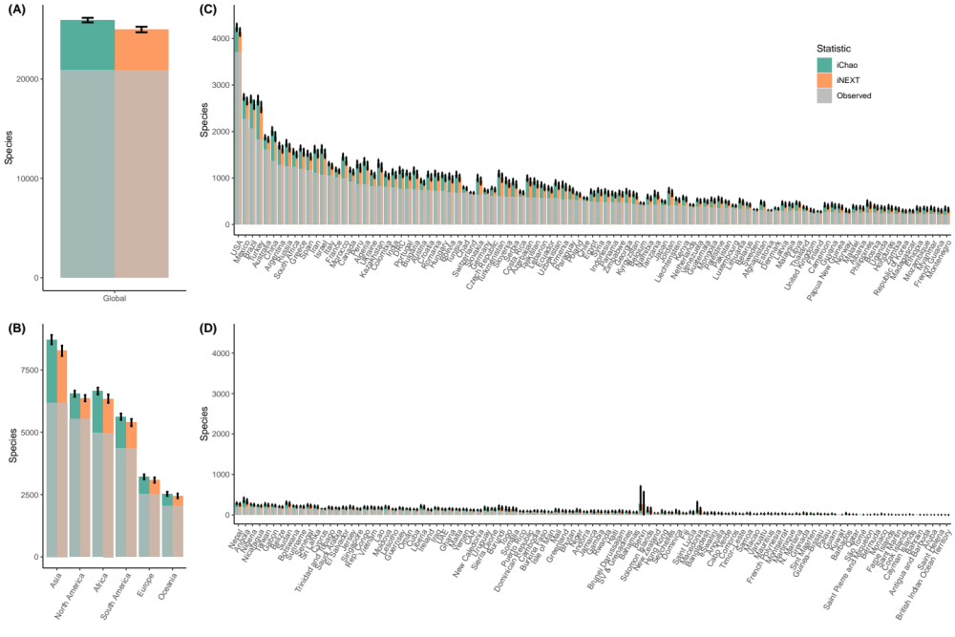

Fig. S1.
The (A) global, (B) continental, and (C and D) country plots showing the number of observed species (grey) and the number of estimated species using the statistics iChao (green) and iNEXT (orange). Estimates are from a single sample of the literature curve combined with the empirical data. Bars indicate 95% confidence intervals.

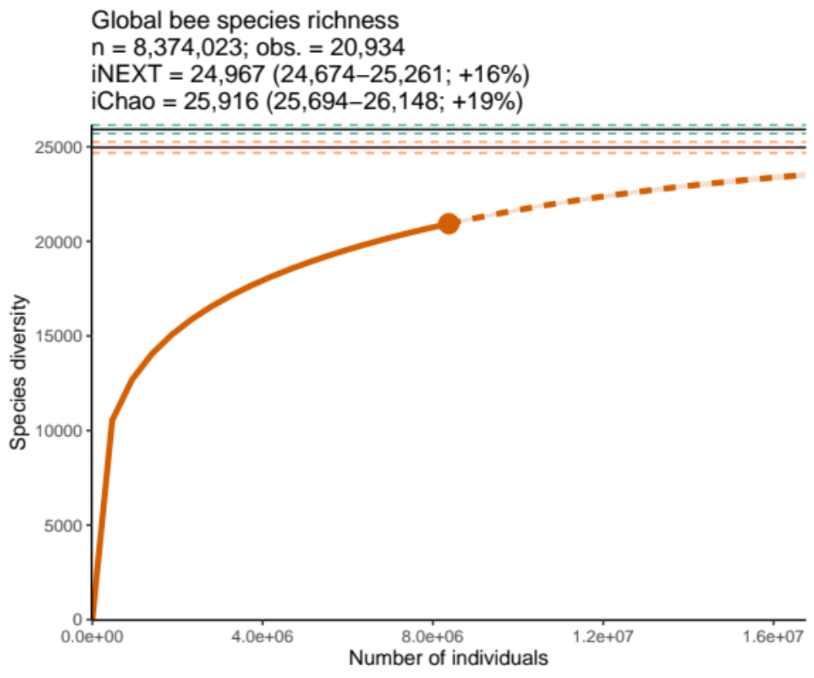

Fig. S2.
The global plot showing the estimated species accumulation curves from iNEXT (orange curve), the estimated value and 95% confidence intervals from iNEXT (orange) and iChao (green) over the number of individuals. The dashed curve indicates the iNEXT extrapolation past 100% of the empirical sample size. Estimates are from a single sample of the literature curve combined with the empirical data.

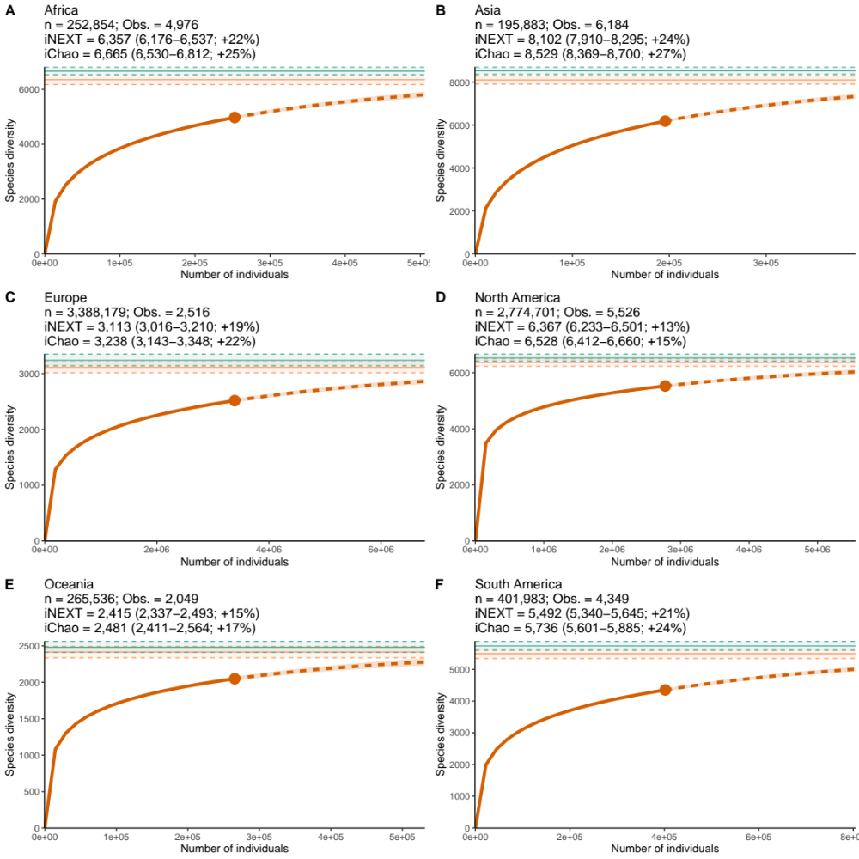

Fig. S3.
The continental plots showing the estimated species accumulation curves from iNEXT (orange curve), the estimated value and 95% confidence intervals from iNEXT (orange) and iChao (green) over the number of individuals. The dashed curve indicates the iNEXT extrapolation past 100% of the empirical sample size. Estimates are from a single sample of the literature curve combined with the empirical data. Estimates are from a single sample of the literature curve combined with the empirical data.

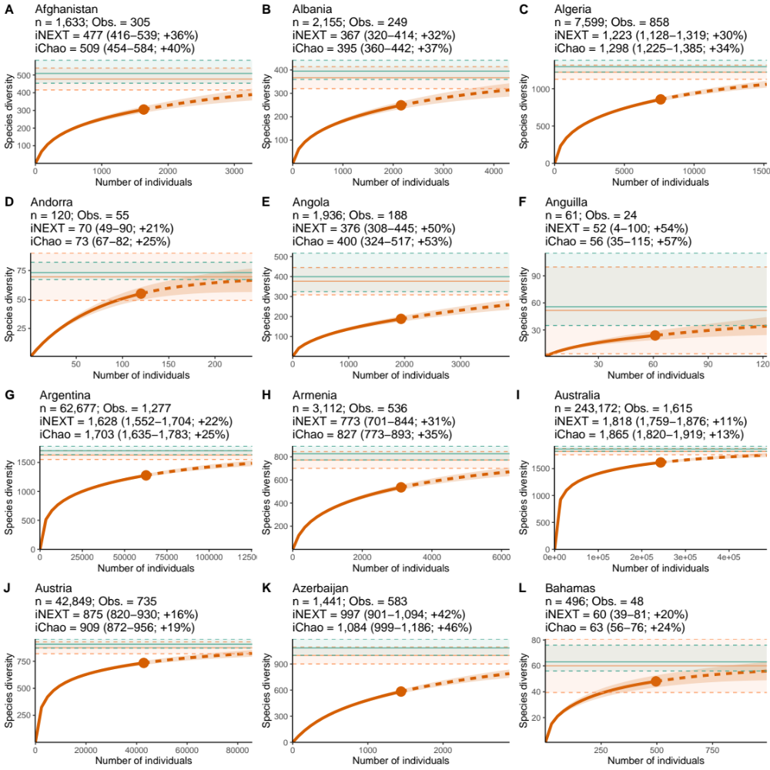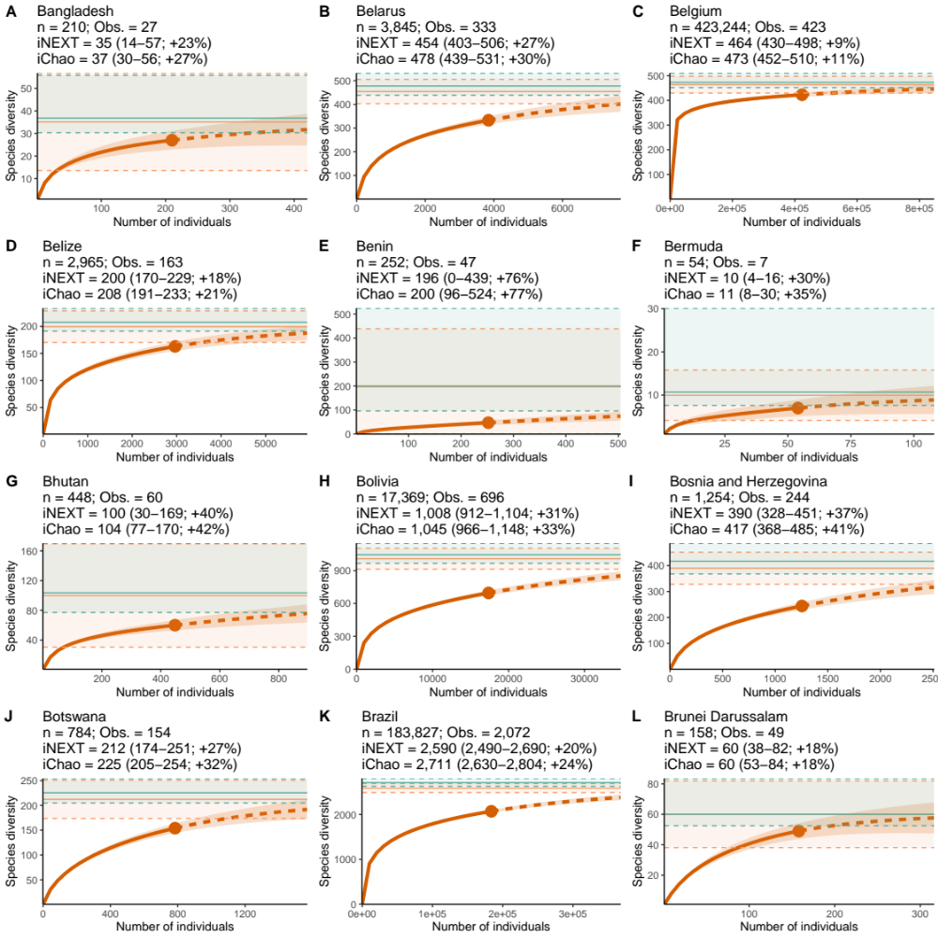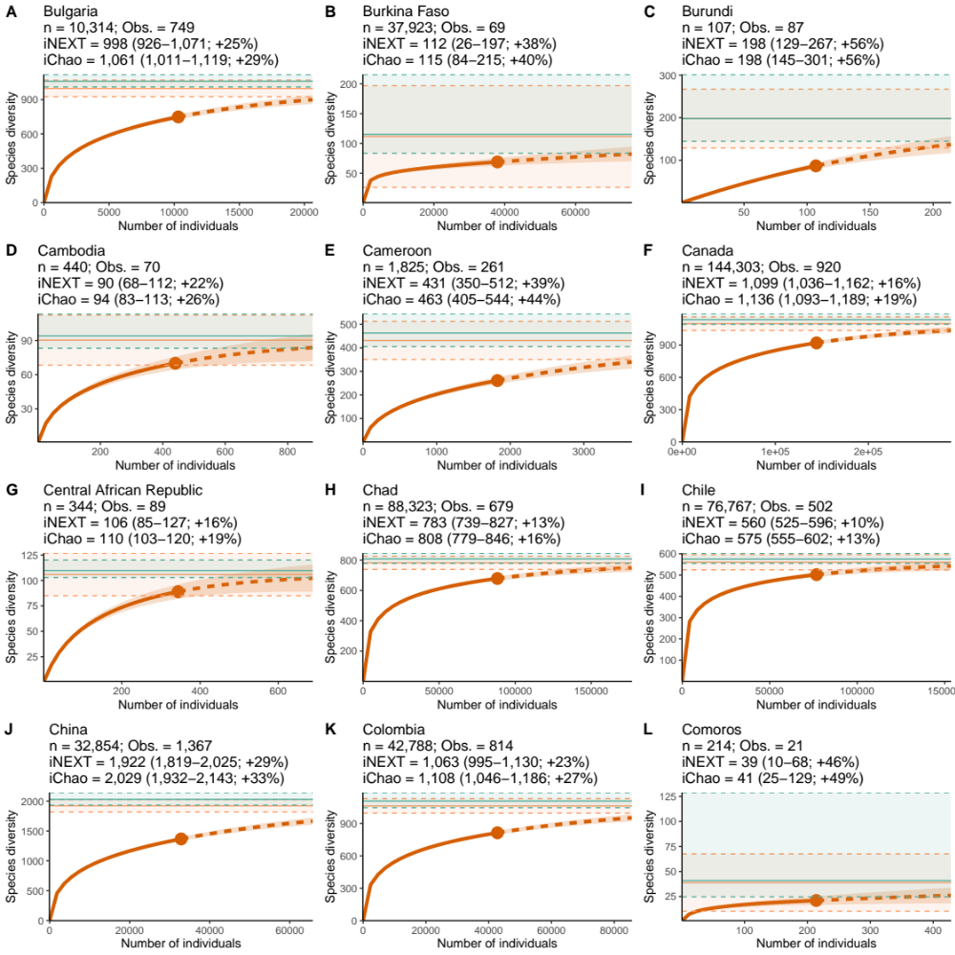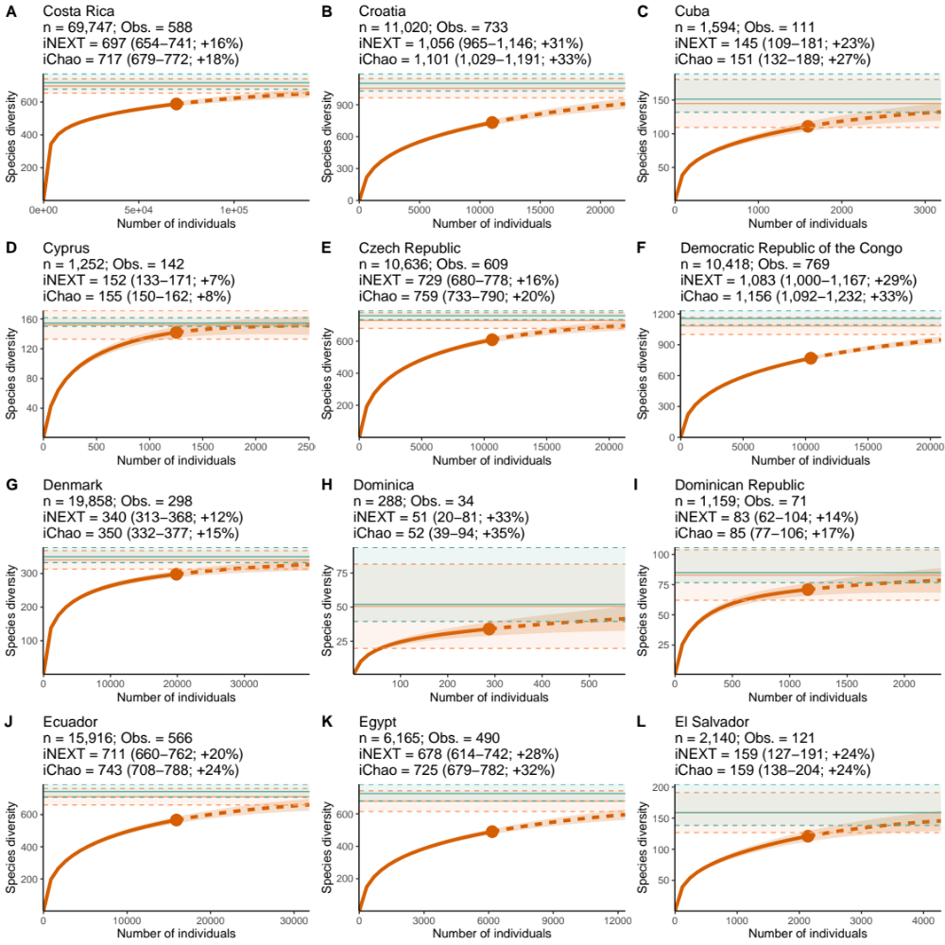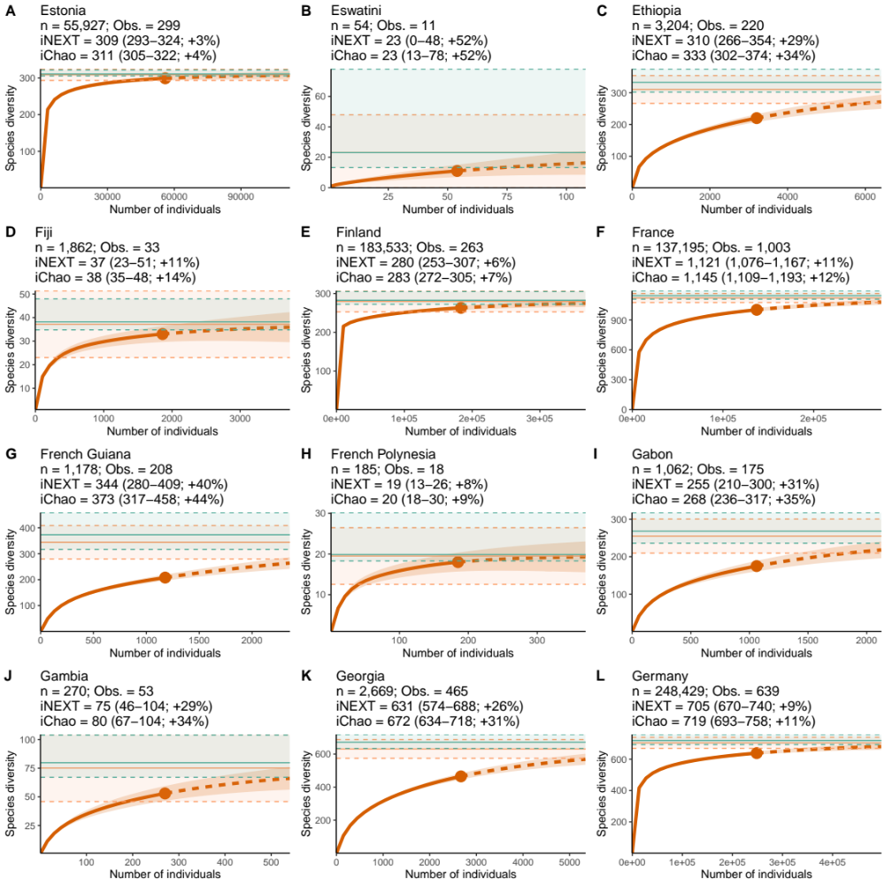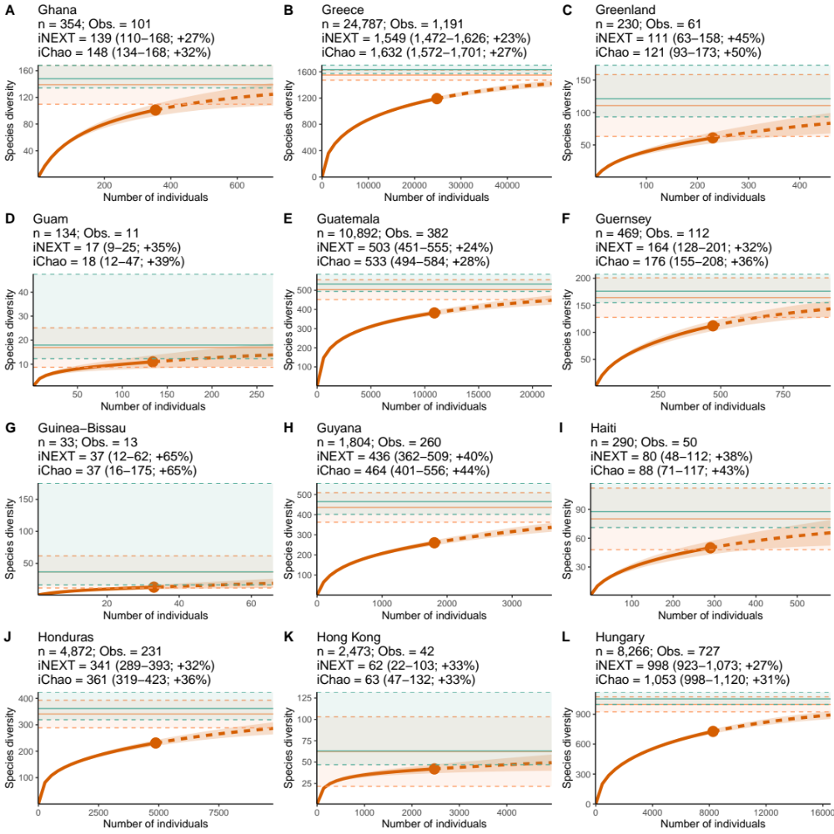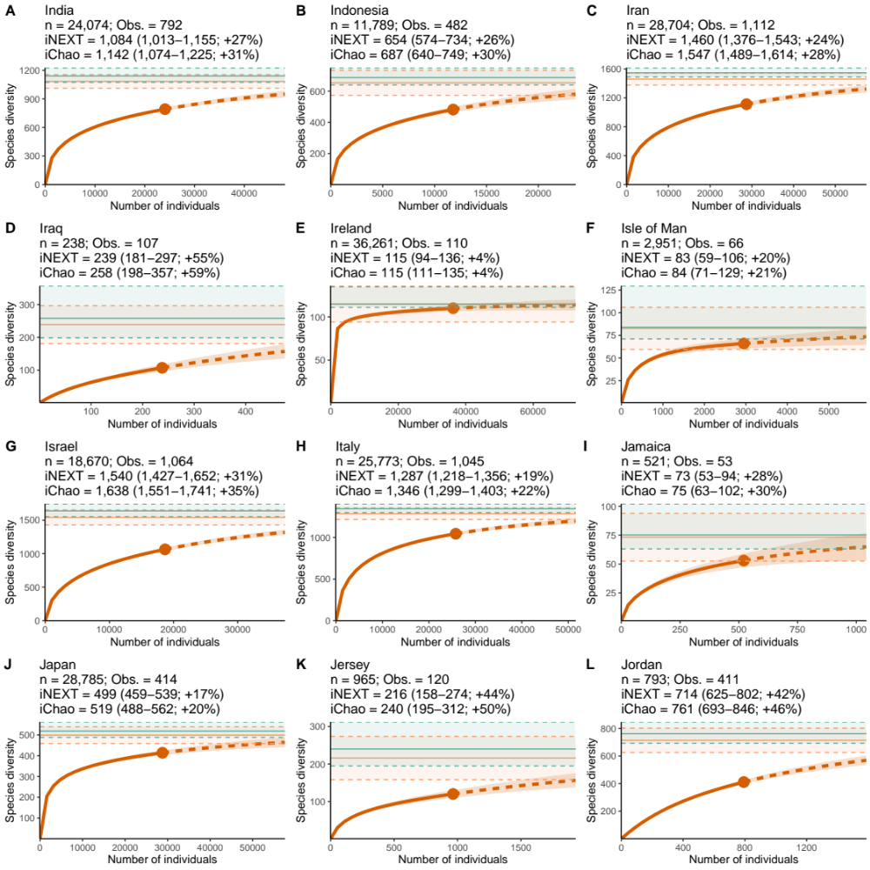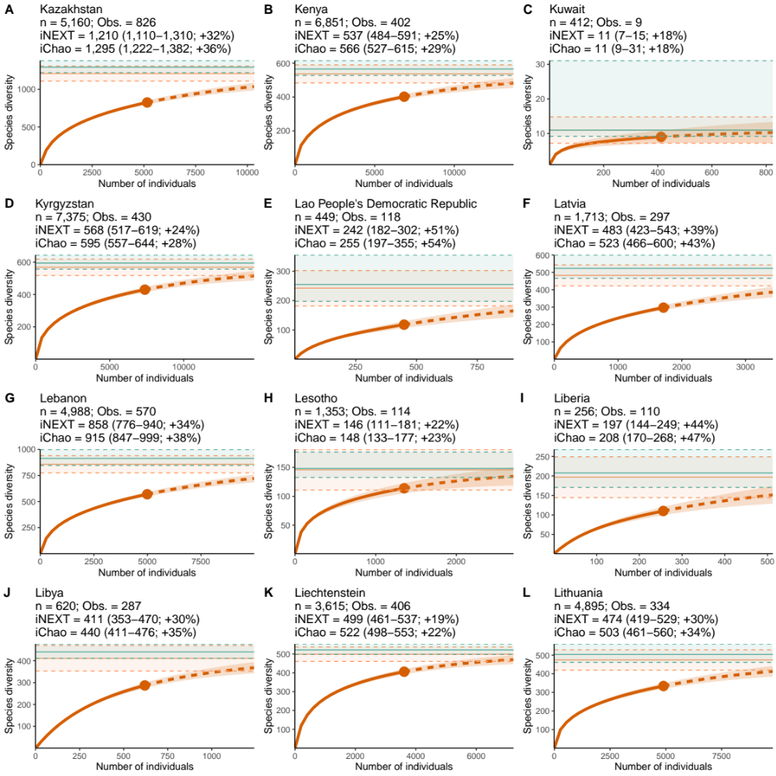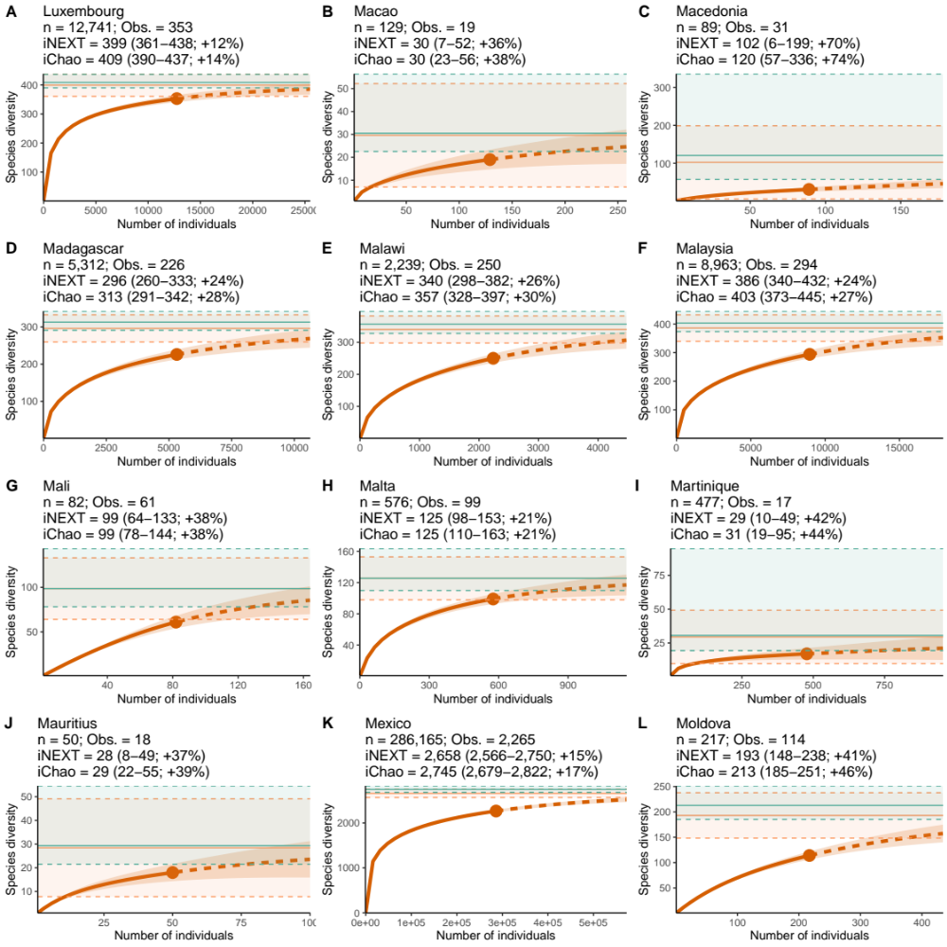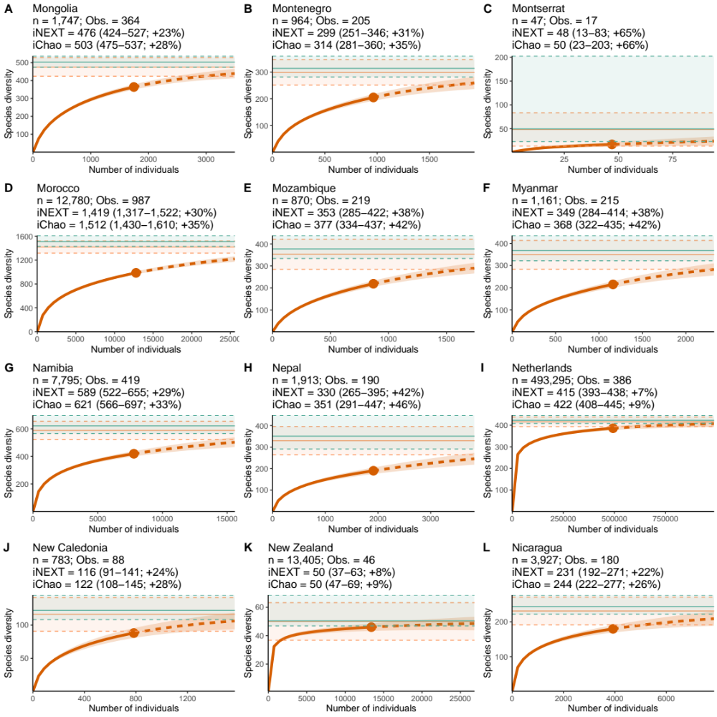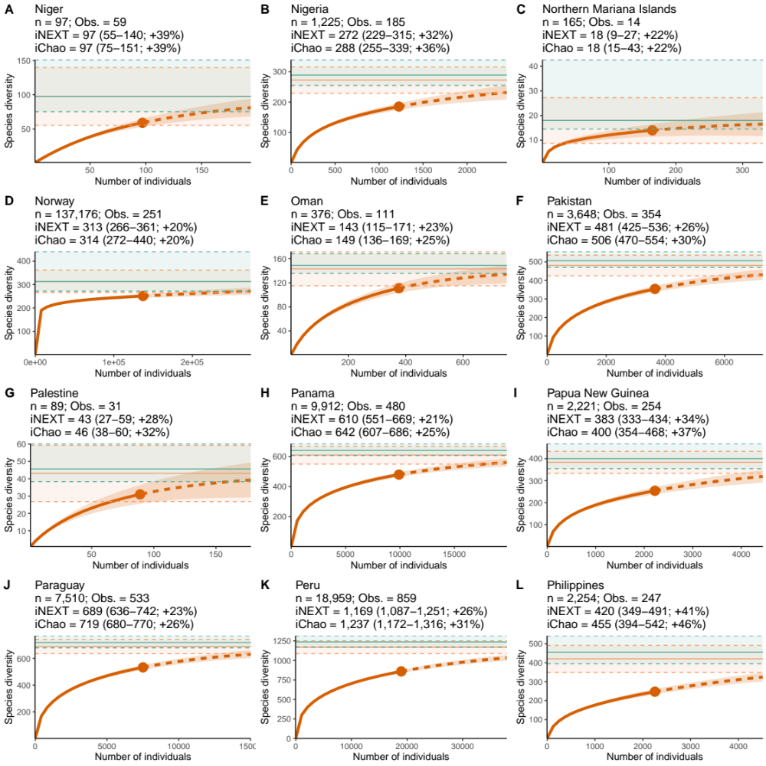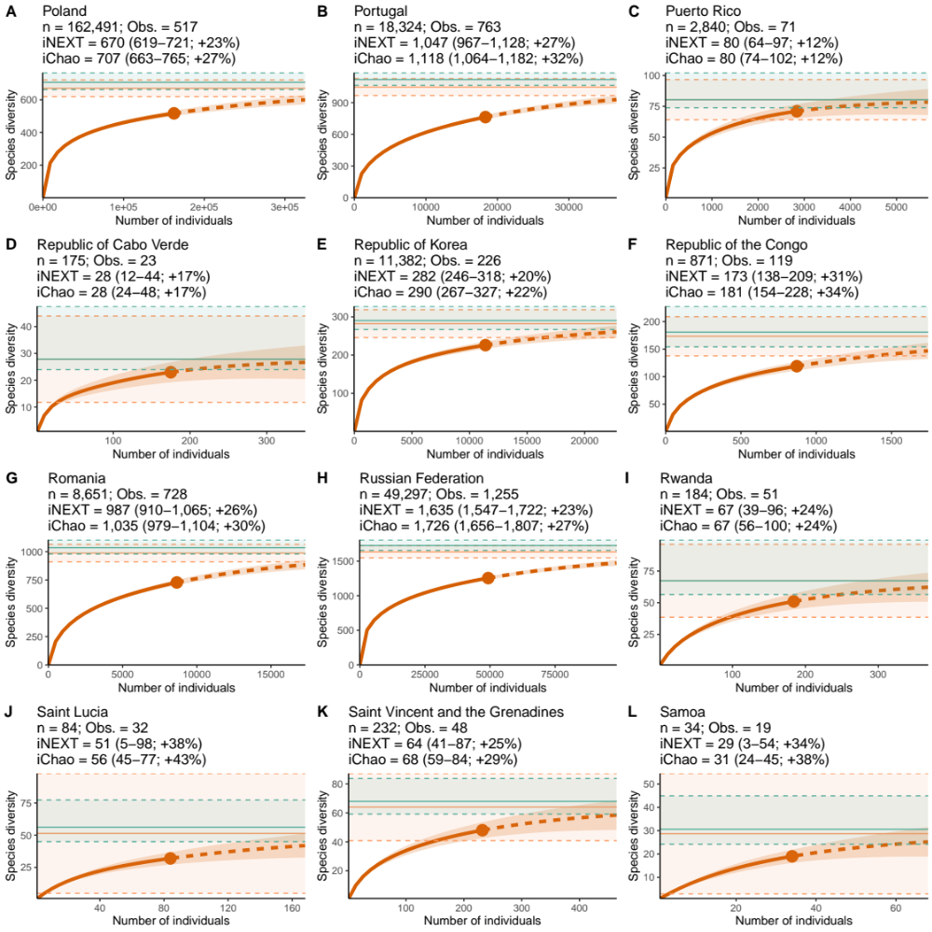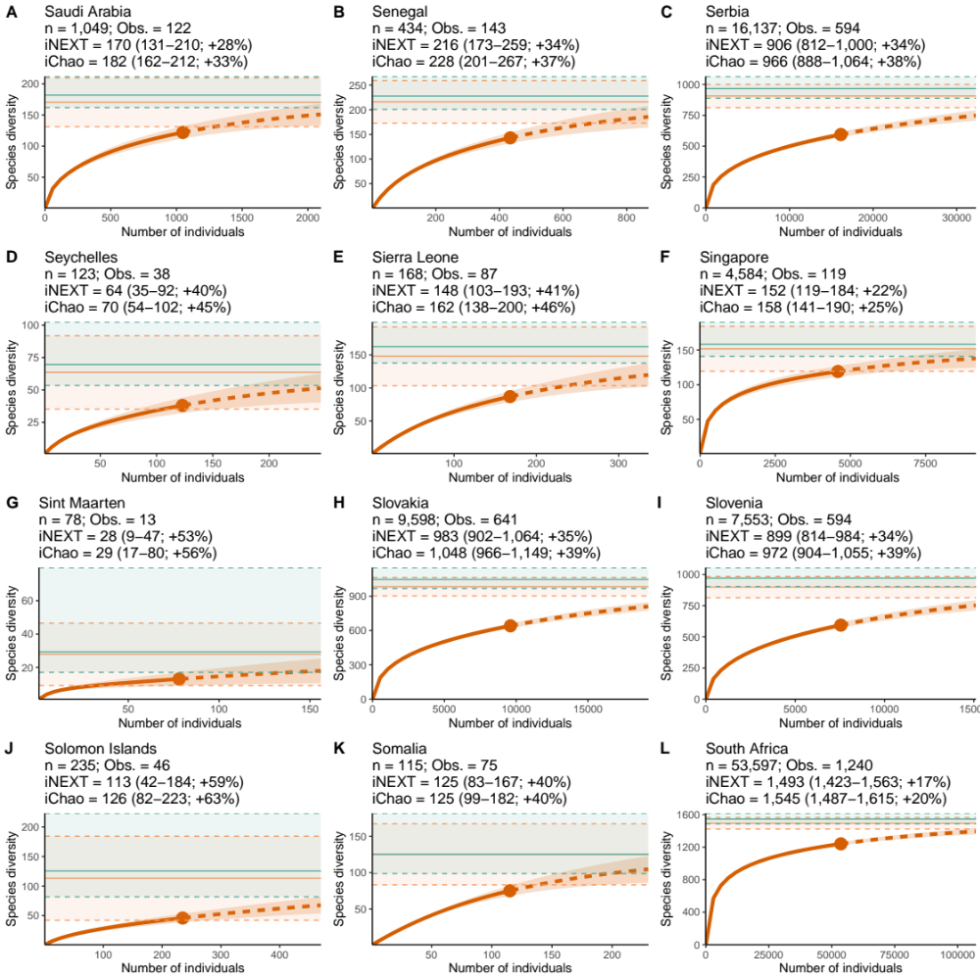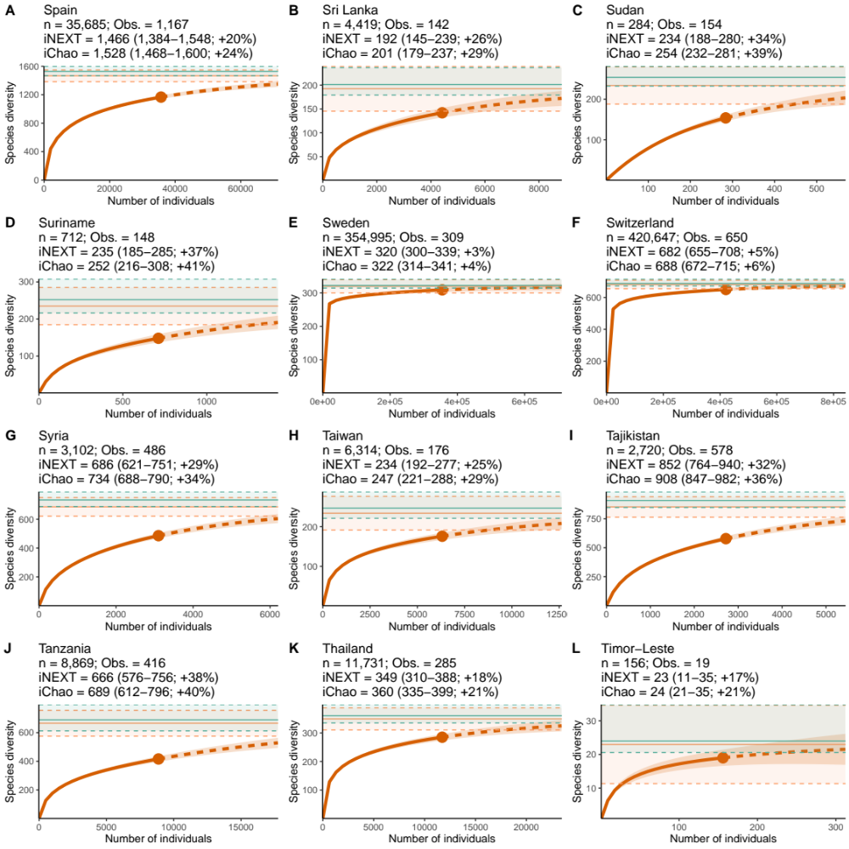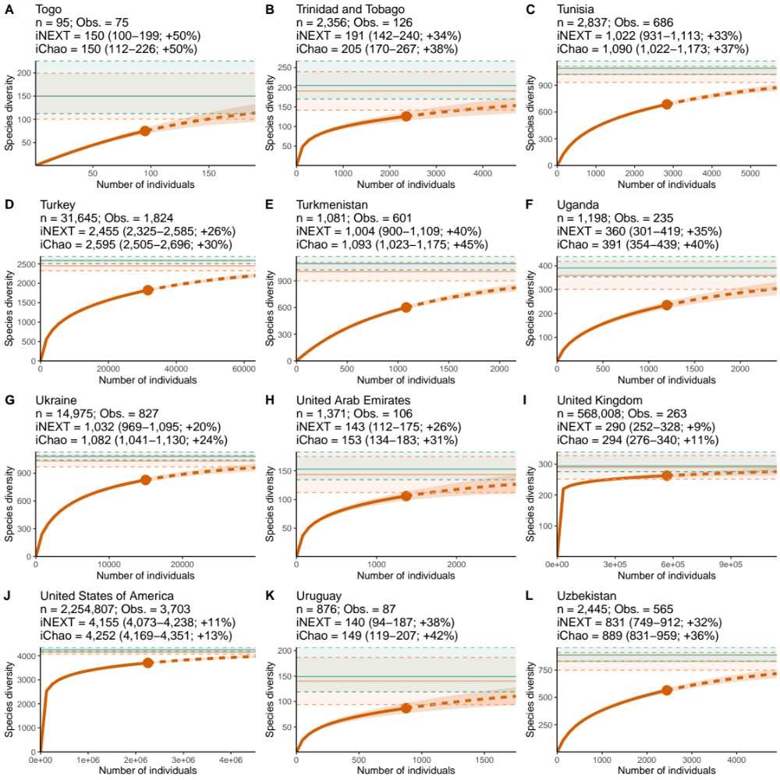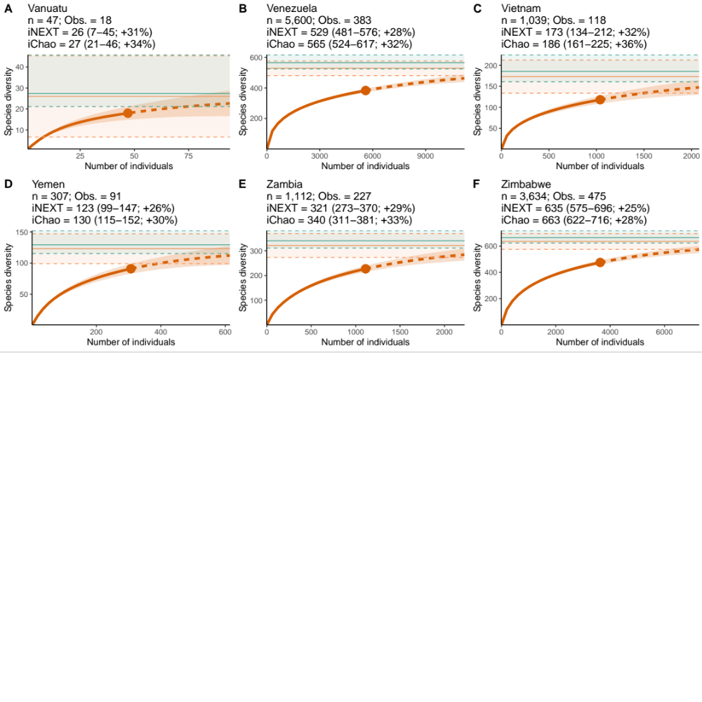

Fig. S4.
The country plots showing the estimated species accumulation curves from iNEXT (orange curve), the estimated value and 95% confidence intervals from iNEXT (orange) and iChao (green) over the number of individuals. The dashed curve indicates the iNEXT extrapolation past 100% of the empirical sample size. Estimates are from a single sample of the literature curve combined with the empirical data. Estimates are from a single sample of the literature curve combined with the empirical data.

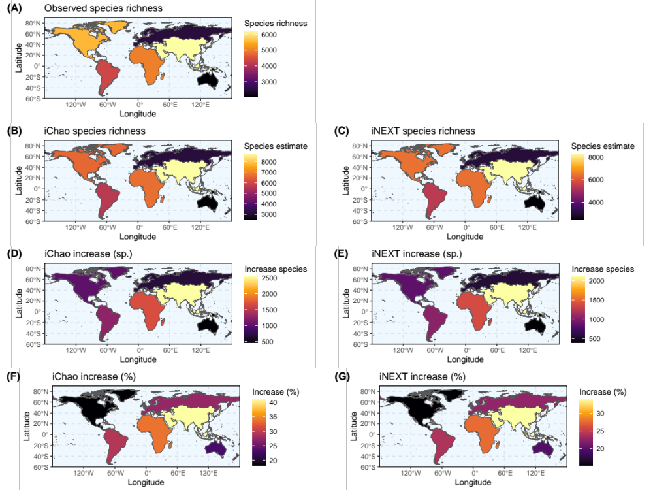

Fig. S5.
Continent-scale maps showing (A) observed species richness; species richness estimated using (B) iChao and (C) iNEXT; the estimated increase in species richness estimated using (D) iChao and (E) iNEXT; and the estimated percentage increase estimated using (F) iChao and (G) iNEXT. Estimates are from the median values of 100 iterations sampling the literature curve combined with the empirical data.

Fig. S6.
Country-scale maps showing (A) observed species richness; species richness estimated using (B) iChao and (C) iNEXT; the estimated increase in species richness estimated using (D) iChao and (E) iNEXT; and the estimated percentage increase estimated using (F) iChao and (G) iNEXT. Estimates are from the median values of 100 iterations sampling the literature curve combined with the empirical data.

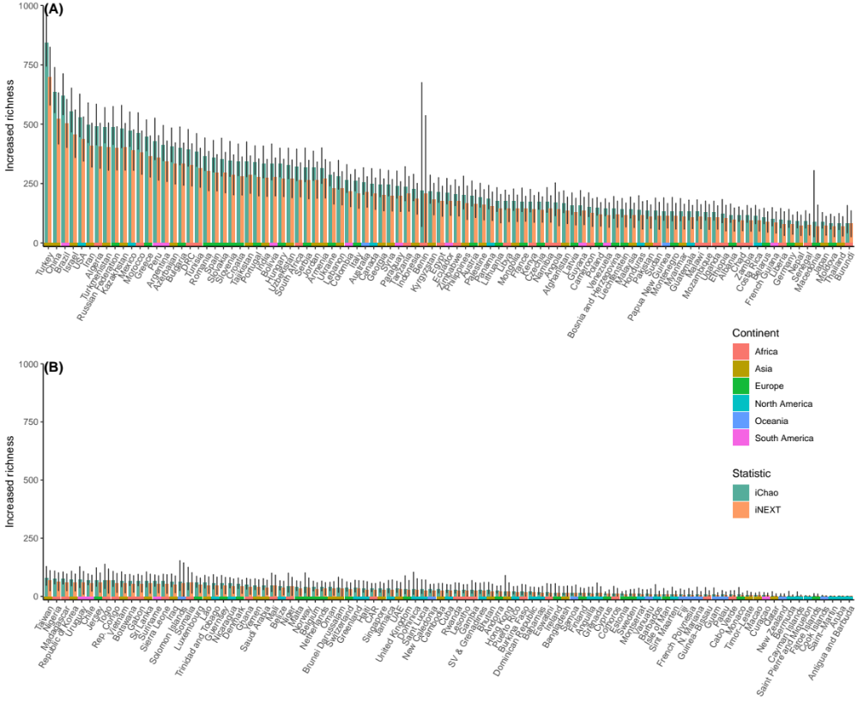

Fig. S7.
Bar plots showing the top (A) and bottom (B) half countries for increased species. Bars show numbers estimated using the statistics iChao (green) and iNEXT (orange). Lower bars indicate continent. Estimates are the median values from 100 samples of the literature curve and bars indicate 95% confidence intervals.

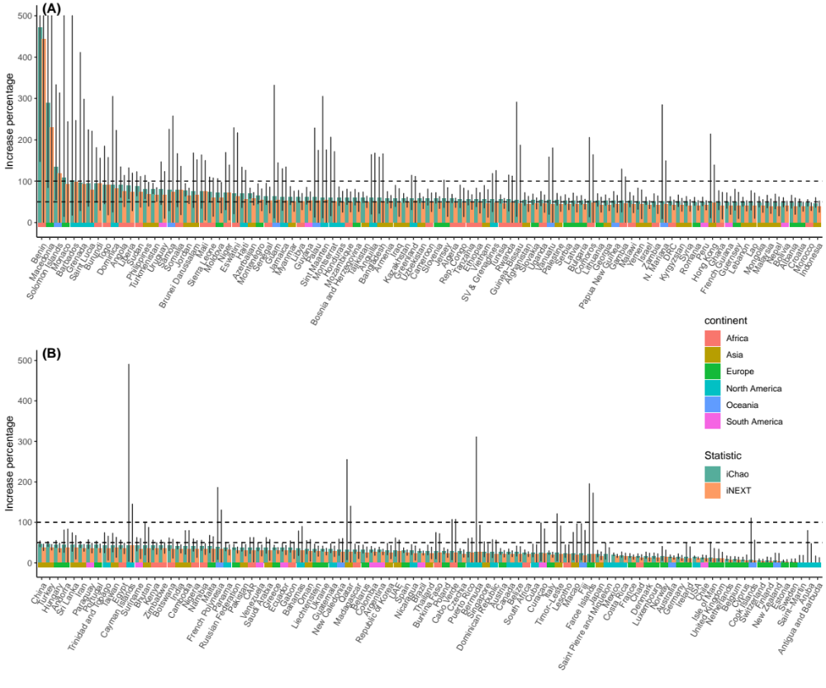

Fig. S8.
Bar plots showing the top (A) and bottom (B) half countries for increased species percentage. Note that the Y-axis is cut at 500% and that the horizontal dashed bars show 100% and 50% increases. Bars show numbers estimated using the statistics iChao (green) and iNEXT (orange). Lower bars indicate continent. Estimates are the median values from 100 samples of the literature curve and bars indicate 95% confidence intervals.

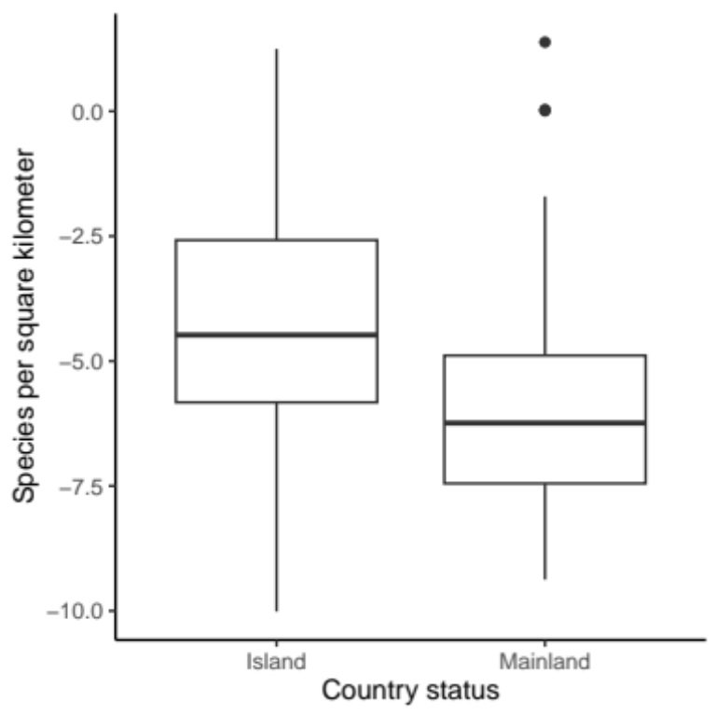

Fig. S9.
Box plot showing the species per square kilometer for countries that are islands or mainland. A two-sided Wilcoxon rank sum test found a significant difference between the groups (p = 5.0x10-8).

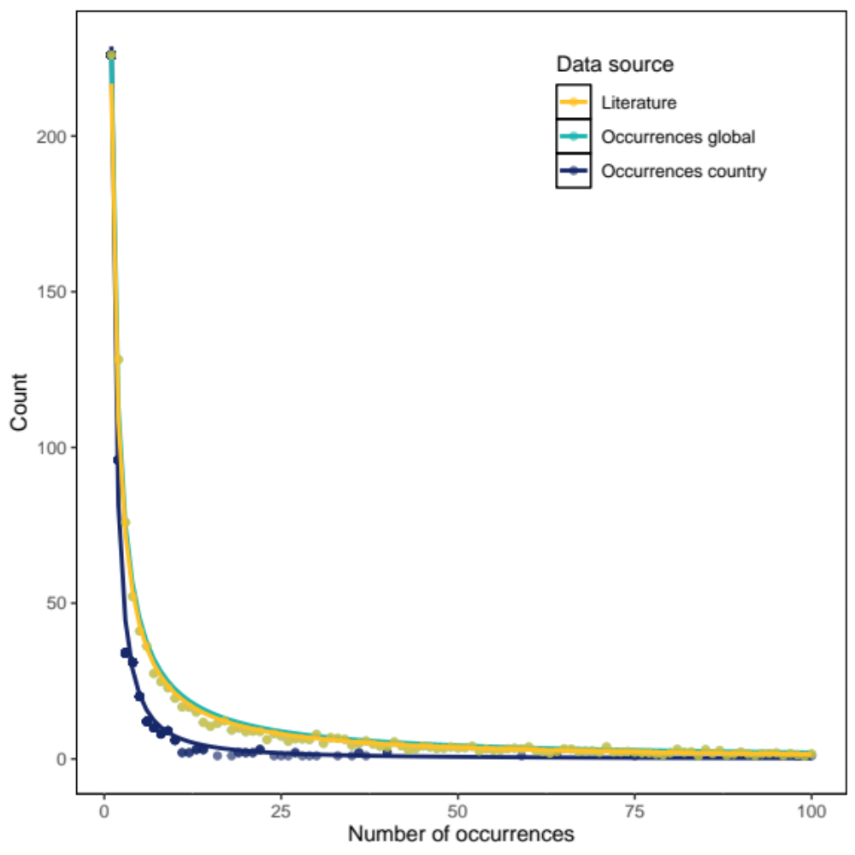

Fig. S10.
The curves (lines) generated from empirical data (points) on the number of specimens per species from three source. The yellow shows data from the most-recent taxonomic works for 497 species with a formula of $y=\left(226.6∙x\right)∙x^{-\log\left(10.7\right)}$. The light blue shows data derived from species counts at the global dataset level with a formula of $y=-0.1891+{226.4555}/x$. The dark purple shows data derived from species counts at the country dataset level with a formula of $=-0.68833+217.51375/x$.

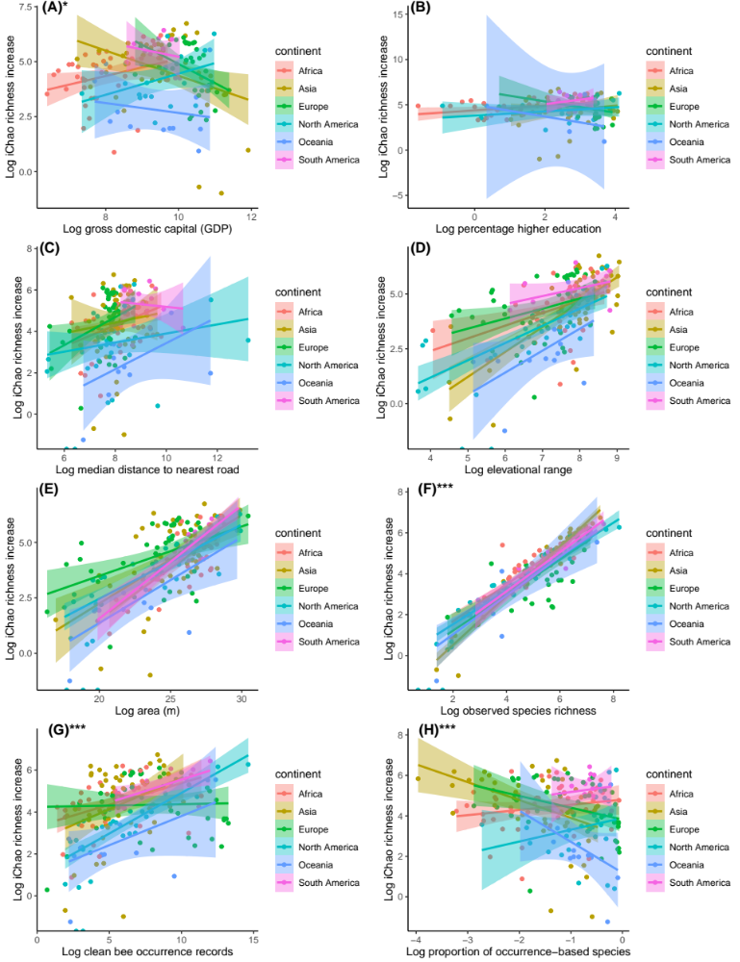Fig. S11.
The linear relationships between the log of iChao species richness increase (Y-axis) and the log of (A) gross domestic product (GDP) per capita ³⁹, (B) tertiary education ⁴⁰, (C) country-wide median distance from roads ⁴³, (D) elevational range ⁴¹, (E) the area of each country in meters, (F) the observed species richness, (G) the number of clean BeeBDC records, and (H) the proportion of species derived from the literature curve. Asterisks indicate statistical significance in the overall model (* 0.5–0.1; ** >0.1–0.001; *** >0.001).

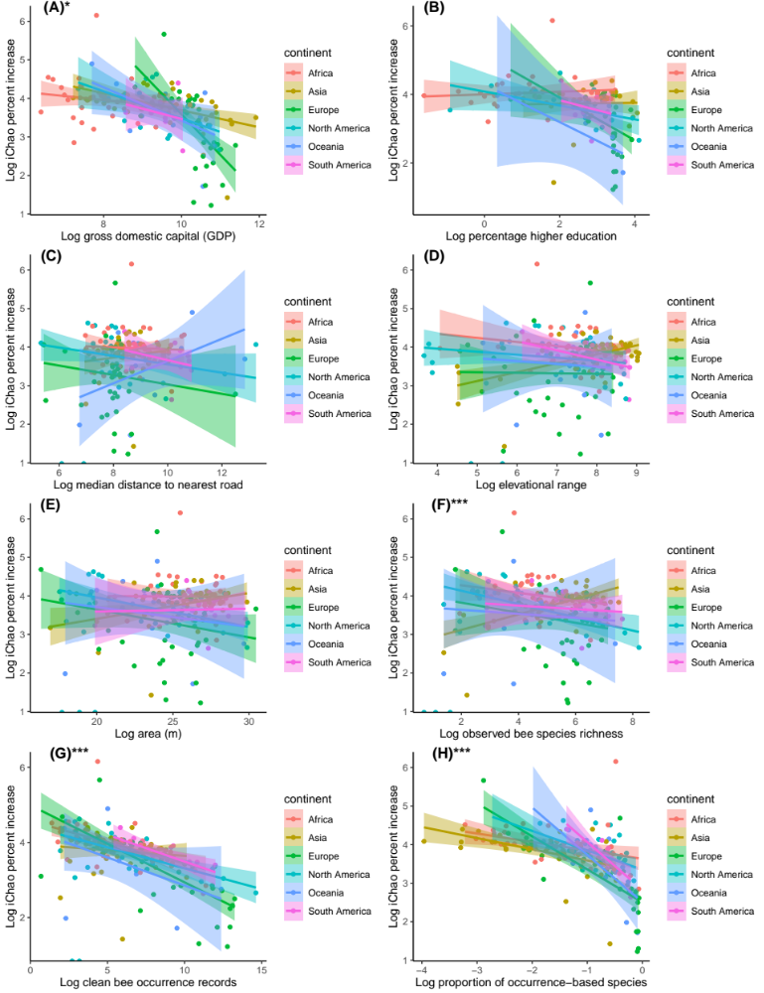

Fig. S12.
The linear relationships between the log of iChao percentage species richness increase (Y-axis) and the log of (A) gross domestic product (GDP) per capita ³⁹, (B) tertiary education ⁴⁰, (C) country-wide median distance from roads ⁴³, (D) elevational range ⁴¹, (E) the area of each country in meters, (F) the observed species richness, (G) the number of clean BeeBDC records, and (H) the proportion of species derived from the literature curve. Asterisks indicate statistical significance in the overall model (* 0.5–0.1; ** >0.1–0.001; *** >0.001).

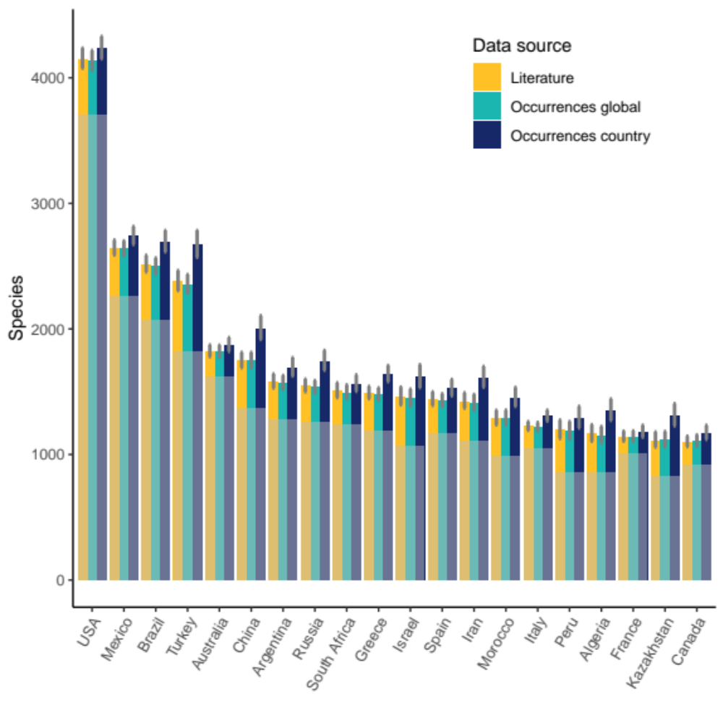

Fig. S13.
Bar plots of the top 20 countries predicted to have the highest species richness (according to the literature curve). For each country the number of observed species (grey) and the number of estimated species using the iChao statistic. A different value is shown depending on if the no-occurrence records were estimated from the literature (yellow), global occurrence (light blue), or country occurrence (dark purple) curves (Fig. S10). Bars indicate 95% confidence intervals.

Table S1.
Australian taxonomy papers since the year 2000 that described new species or synonyms. Papers that did include phylogenetic analyses are marked as “TRUE” for that column.
Taxon | New species | New synonyms | Title | doi | Year | Journal | Authors | Phylogeny used
Callalictus | 0 | 4 | Taxonomic revision of the Australian native bee subgenus Callalictus (Hymenoptera: Halictidae: Halictini: genus Lasioglossum) | https://orcid.org/0000-0001-8750-2035 | 2022 | Australian Journal of Taxonomy | Kenneth L. Walker | FALSE
Amegilla (Notomegilla), Amegilla (Zonamegilla) | 0 | 31 | The genus Amegilla (Hymenoptera, Apidae, Anthophorini) in Australia: A revision of the subgenera Notomegilla and Zonamegilla | https://doi.org/10.3897/zookeys.653.11177 | 2017 | ZooKeys | Remko Leijs, Michael Batley, Katja Hogendoorn | TRUE
Austroplebeia | 0 | 5 | Australian and New Guinean Stingless Bees of the Genus Austroplebeia Moure (Hymenoptera: Apidae)—a revision | https://doi.org/10.11646/zootaxa.4047.1.1 | 2016 | Zootaxa | Anne E. Dollin, Leslie J. Dollin & Claus Rasmussen | FALSE
Leioproctus (Exleycolletes) | 2 | 0 | New species in the bee subgenus Leioproctus (Exleycolletes) Maynard (Hymenoptera: Colletidae) | https://doi.org/10.54102/ajt | 2023 | Australian Journal of Taxonomy | Michael Batley | FALSE
Euhesma | 3 | 0 | A New Group of Euryglossine Bees from Australia (Hymenoptera: Apoidea: Colletidae) | http://www.jstor.org/stable/25086259 . | 2004 | Journal of the Kansas Entomological Society | Elizabeth M. Exley | FALSE
Euhesma | 7 | 0 | Bees of the Euhesma crabronica species-group (Hymenoptera: Colletidae: Euryglossinae) | https://museum.wa.gov.au/sites/default/files/BEES%20OF%20THE%20EUSHESMA%20CRABRONICA%20SPECIES-GROUPD%20(HYMENOPTERA%20COLLETIFDAE%20EURYGLOSSINAE).pdf | 2002 | Records of the Western Australian Museum | Elizabeth M. Exley | FALSE
Euhesma | 9 | 0 | The walkeriana species-group of Euhesma Michener (Hymenoptera: Colletidae: Euryglossinae) | https://doi.org/10.1046/j.1440-6055.2001.00214.x | 2001 | Australian Journal of Entomology | Elizabeth M. Exley | FALSE
Exoneurella | 1 | 0 | Taxonomy of the Australian Allodapine Bee Genus Exoneurella (Apidae: Xylocopinae: Allodapini) and Description of a New Exoneurella Species | https://doi.org/10.1093/isd/ixx013 | 2018 | Insect Systematics and Diversity | Rebecca M. Dew, Mark I. Stevens, And Michael P. Schwarz | TRUE
Goniocolletes | 2 | 0 | New species of Goniocolletes and Trichocolletes (Hymenoptera, Colletidae) from southern Australia | https://doi.org/10.3897/zookeys.598.9229 | 2016 | ZooKeys | Remko Leijs, Katja Hogendoorn | FALSE
Leioproctus | 33 | 59 | Revision of Goniocolletes and seven Australian subgenera of Leioproctus (Hymenoptera: Apoidea: Colletidae), and description of new taxa | http://dx.doi.org/10.11646/zootaxa.3715.1.1 | 2014 | Zootaxa | Glynn Vivian Maynard | FALSE
Austrothurgus | 1 | 0 | The lithurgine bees of Australia (Hymenoptera: Megachilidae), with a note on Megachile rotundipennis | http://dx.doi.org/10.17161/jom.v0i11.4520 | 2013 | Journal of Melittology | Victor H. Gonzalez, Michael S. Engel, & Terry L. Griswold | FALSE
Euhesma | 3 | 0 | DNA barcoding of euryglossine bees and the description of new species of Euhesma Michener (Hymenoptera, Colletidae, Euryglossinae) | http://dx.doi.org/10.3897/zookeys.520.6185 | 2015 | ZooKeys | Katja Hogendoorn, Mark Stevens, Remko Leijs | TRUE
Inquilina | 5 | 0 | New species and unexpected diversity of socially parasitic bees in the genus Inquilina Michener (Hymenoptera: Apoidea: Apidae) | https://doi.org/10.1111/j.1744-7917.2009.01266.x | 2009 | Insect Science | Jaclyn A. Smith And Michael P. Schwarz | TRUE
Leioproctus (Colletellus) | 26 | 0 | Twenty-six new species of Leioproctus (Colletellus): Australian Neopasiphaeinae, all but one with two submarginal cells (Hymenoptera, Colletidae, Leioproctus) | https://doi.org/10.3897/zookeys.811.28924 | 2018 | ZooKeys | Remko Leijs, James Dorey, Katja Hogendoorn | FALSE
Leioproctus (Protomorpha) | 5 | 0 | Five new species of Leioproctus (Protomorpha) Rayment (Hymenoptera: Colletidae) | http://dx.doi.org/10.3853/j.2201-4349.65.2013.1597 | 2013 | Australian Museum Scientific Publications | Batley, Michael, And Tony J. Popic | FALSE
Paracolletinae | 1 | 0 | A new Leioproctus with unique wing venation in males (Hymenoptera: Colletidae: Paracolletinae) with comments on unusual wing modifications in bees | https://doi.org/10.11646/zootaxa.1104.1.4 | 2006 | Zootaxa | Laurence Packer | FALSE
Coelioxys | 2 | 3 | A revision of the cleptoparasitic bee genus Coelioxys (Hymenoptera: Megachilidae) from Australia | http://dx.doi.org/10.14411/eje.2016.002 | 2016 | European Journal of Entomology | Léo Correia Da Rocha-Filho | FALSE
Trichocolletes | 23 | 4 | Revision of the Australian bee genus Trichocolletes Cockerell (Hymenoptera: Colletidae: Paracolletini) | http://dx.doi.org/10.3853/j.0067-1975.64.2012.1589 | 2012 | Australian Museum Scientific Publications | Batley, Michael, And Terry F. Houston | FALSE
Parasphecodes | 18 | 69 | Taxonomic revision of the native bee subgenus Parasphecodes Smith 1853 in Australia (Hymenoptera: Halictidae: Halictini: Lasioglossum Curtis 1833) | https://doi.org/10.11646/zootaxa.5408.1.1 | 2024 | Zootaxa | Kenneth L. Walker & Kathryn S. Sparks | FALSE
Australictus | 0 | 6 | Taxonomic revision of the Australian native bee subgenus Australictus (Hymenoptera: Halictidae: Halictini: genus Lasioglossum) – “Wood-Splitting Axe Bees” | https://doi.org/10.24199/j.mmv.2022.81.06 | 2022 | Memoirs of Museum Victoria | Kenneth L. Walker | FALSE
Koptortosoma | 2 | 3 | A revision of the Australian carpenter bees, genus Xylocopa Latreille, subgenera Koptortosoma Gribodo and Lestis Lepeletier & Serville (Hymenoptera : Apidae) | https://doi.org/10.1071/IT98014 | 2000 | Invertebrate Taxonomy | Remko Leijs | FALSE
Amegilla (Asaropoda) | 10 | 16 | The genus Amegilla (Hymenoptera, Apidae, Anthophorini) in Australia: a revision of the subgenus Asaropoda | https://doi.org/10.3897/zookeys.908.47375 | 2020 | Zookeys | Remko Leijs, James Dorey, Katja Hogendoorn | TRUE

Table S2.
The outputs from our linear mixed-effects models of the increased number of undescribed species (iChao) per country with the random effect of continent and several variables. We included one interaction term between the log of clean records and the log proportion of species derived from the literature curve. Bolded values indicate statistical significance.

Variable | Estimate | SE | df | t-value | Pr(>|t|)
(Intercept) | 0.84 | 0.76 | 114.21 | 1.10 | 0.27
log(GPD_per_cap) | -0.14 | 0.06 | 111.00 | -2.52 | 0.01
log(percent_ed) | 0.07 | 0.05 | 115.99 | 1.56 | 0.12
log(median_roadDist) | -0.02 | 0.06 | 115.00 | -0.38 | 0.71
log(elevationalRange) | 0.02 | 0.05 | 88.67 | 0.46 | 0.65
log(area_m) | 0.00 | 0.03 | 108.83 | -0.09 | 0.93
log(observedRichness) | 1.30 | 0.07 | 98.31 | 19.38 | < 2e-16
log(cleanRecords) | -0.29 | 0.04 | 115.83 | -7.88 | 2.00E-12
log(propOccurrences) | 0.43 | 0.10 | 115.38 | 4.21 | 5.04E-05
log(cleanRecords):log(propOccurrences) | -0.05 | 0.02 | 111.84 | -2.55 | 0.01

Table S3.
The outputs from our linear mixed-effects models of the percentage increase in the undescribed species (iChao) per country with the random effect of continent and several variables. We included one interaction term between the log of clean records and the log proportion of species derived from the literature curve. Bolded values indicate statistical significance.

Variable | Estimate | SE | df | t-value | Pr(>|t|)
(Intercept) | 5.44 | 0.76 | 114.21 | 7.12 | 1.04E-10
log(GPD_per_cap) | -0.14 | 0.06 | 111.00 | -2.52 | 0.01
log(percent_ed) | 0.07 | 0.05 | 115.99 | 1.56 | 0.12
log(median_roadDist) | -0.02 | 0.06 | 115.00 | -0.38 | 0.71
log(elevationalRange) | 0.02 | 0.05 | 88.67 | 0.46 | 0.65
log(area_m) | 0.00 | 0.03 | 108.83 | -0.09 | 0.93
log(observedRichness) | 0.30 | 0.07 | 98.31 | 4.51 | 1.78E-05
log(cleanRecords) | -0.29 | 0.04 | 115.83 | -7.88 | 2.00E-12
log(propOccurrences) | 0.43 | 0.10 | 115.38 | 4.21 | 5.04E-05
log(cleanRecords):log(propOccurrences) | -0.05 | 0.02 | 111.84 | -2.55 | 0.01

Table S4.
The outputs from our linear mixed-effects models of the number and percentage increase in the undescribed species (iChao) per country with the random effect of continent and several variables. The table contains four analyses alternating between the number increase and percentage increase. The analyses fill in the no-record species with data drawn from the (a) global species occurrence dataset or (b) country-level occurrence dataset. We included one interaction term between the log of clean records and the log proportion of species derived from the literature curve. Bolded values indicate statistical significance.

Variable | Estimate | SE | df | t-value | Pr(>|t|)
Global iChao increase
(Intercept) | 0.56 | 0.86 | 113.47 | 0.65 | 0.52
log(GPD_per_cap) | -0.11 | 0.06 | 110.86 | -1.71 | 0.09
log(percent_ed) | 0.05 | 0.05 | 114.99 | 0.93 | 0.36
log(median_roadDist) | -0.03 | 0.07 | 113.97 | -0.39 | 0.70
log(elevationalRange) | 0.02 | 0.06 | 88.02 | 0.41 | 0.68
log(area_m) | 0.00 | 0.03 | 108.62 | 0.12 | 0.91
log(observedRichness) | 1.27 | 0.08 | 101.25 | 16.46 | < 2e-16
log(cleanRecords) | -0.31 | 0.04 | 114.70 | -7.41 | 2.33E-11
log(propOccurrences) | 0.56 | 0.11 | 114.53 | 4.86 | 3.72E-06
log(cleanRecords):log(propOccurrences) | -0.04 | 0.02 | 111.35 | -1.92 | 0.06
Global iChao percentage
(Intercept) | 5.17 | 0.86 | 113.47 | 6.03 | 2.14E-08
log(GPD_per_cap) | -0.11 | 0.06 | 110.86 | -1.71 | 0.09
log(percent_ed) | 0.05 | 0.05 | 114.99 | 0.93 | 0.36
log(median_roadDist) | -0.03 | 0.07 | 113.97 | -0.39 | 0.70
log(elevationalRange) | 0.02 | 0.06 | 88.02 | 0.41 | 0.68
log(area_m) | 0.00 | 0.03 | 108.62 | 0.12 | 0.91
log(observedRichness) | 0.27 | 0.08 | 101.25 | 3.53 | 6.24E-04
log(cleanRecords) | -0.31 | 0.04 | 114.70 | -7.41 | 2.33E-11
log(propOccurrences) | 0.56 | 0.11 | 114.53 | 4.86 | 3.72E-06
log(cleanRecords):log(propOccurrences) | -0.04 | 0.02 | 111.35 | -1.92 | 0.06
Country iChao increase
(Intercept) | 0.51 | 0.83 | 114.62 | 0.61 | 0.54
log(GPD_per_cap) | -0.10 | 0.06 | 113.38 | -1.55 | 0.12
log(percent_ed) | 0.04 | 0.05 | 114.77 | 0.87 | 0.39
log(median_roadDist) | -0.04 | 0.06 | 114.71 | -0.69 | 0.49
log(elevationalRange) | 0.03 | 0.06 | 100.90 | 0.47 | 0.64
log(area_m) | 0.01 | 0.03 | 112.17 | 0.26 | 0.80
log(observedRichness) | 1.26 | 0.08 | 107.88 | 16.74 | < 2e-16
log(cleanRecords) | -0.30 | 0.04 | 114.98 | -7.54 | 1.19E-11
log(propOccurrences) | 0.56 | 0.11 | 113.96 | 5.03 | 1.86E-06
log(cleanRecords):log(propOccurrences) | -0.05 | 0.02 | 114.00 | -2.11 | 0.04
Country iChao percentage
(Intercept) | 5.11 | 0.83 | 114.62 | 6.15 | 1.14E-08
log(GPD_per_cap) | -0.10 | 0.06 | 113.38 | -1.55 | 0.12
log(percent_ed) | 0.04 | 0.05 | 114.77 | 0.87 | 0.39
log(median_roadDist) | -0.04 | 0.06 | 114.71 | -0.69 | 0.49
log(elevationalRange) | 0.03 | 0.06 | 100.90 | 0.47 | 0.64
log(area_m) | 0.01 | 0.03 | 112.17 | 0.26 | 0.80
log(observedRichness) | 0.26 | 0.08 | 107.88 | 3.45 | 7.98E-04
log(cleanRecords) | -0.30 | 0.04 | 114.98 | -7.54 | 1.19E-11
log(propOccurrences) | 0.56 | 0.11 | 113.96 | 5.03 | 1.86E-06
log(cleanRecords):log(propOccurrences) | -0.05 | 0.02 | 114.00 | -2.11 | 0.04

Data S1. (separate file)
Extra data and script can be found on the GitHub — https://github.com/jbdorey/BDE_R_wofklow. And bespoke functions and vignettes can be accessed from the BeeBDC R package ≥v1.3.0 — https://jbdorey.github.io/BeeBDC/.

