Supplementary Materials

Underestimated Risk of Glacial Lake Outburst Floods in the Himalayas
Weigui Guan^{2,3}, Fang Chen^{1,2,3,*}, Meimei Zhang^{1,2,3,*},
¹ International Research Center of Big Data for Sustainable Development Goals. Beijing 100094, China
² Key Laboratory of Digital Earth Science, Aerospace Information Research Institute, Chinese Academy of Sciences, Beijing 100094, China
³ University of Chinese Academy of Sciences, Beijing 100049, China

✉e-mail: chenfang@radi.ac.cn, zhangmm@radi.ac.cn

This file includes:
Supplementary Figures 1 to 13
Supplementary Tables 1 to 6
Supplementary References

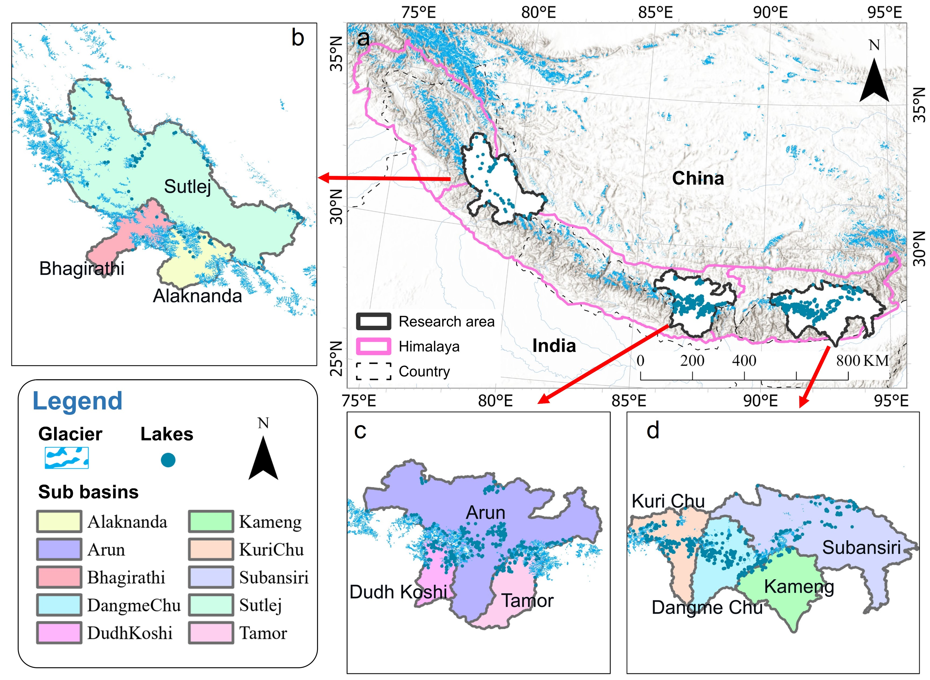
Supplementary Figure 1 | Location and distribution of glacial lakes in the ten sub-basins of Himalaya. a Overview map, including the boundaries of the study area and surrounding countries. b Sutlej, Bhagirathi, Alaknanda. c Arun, Dudh Koshi, Tamor. d Kuri Chu, Dangme Chu, Kameng and Subansiri.

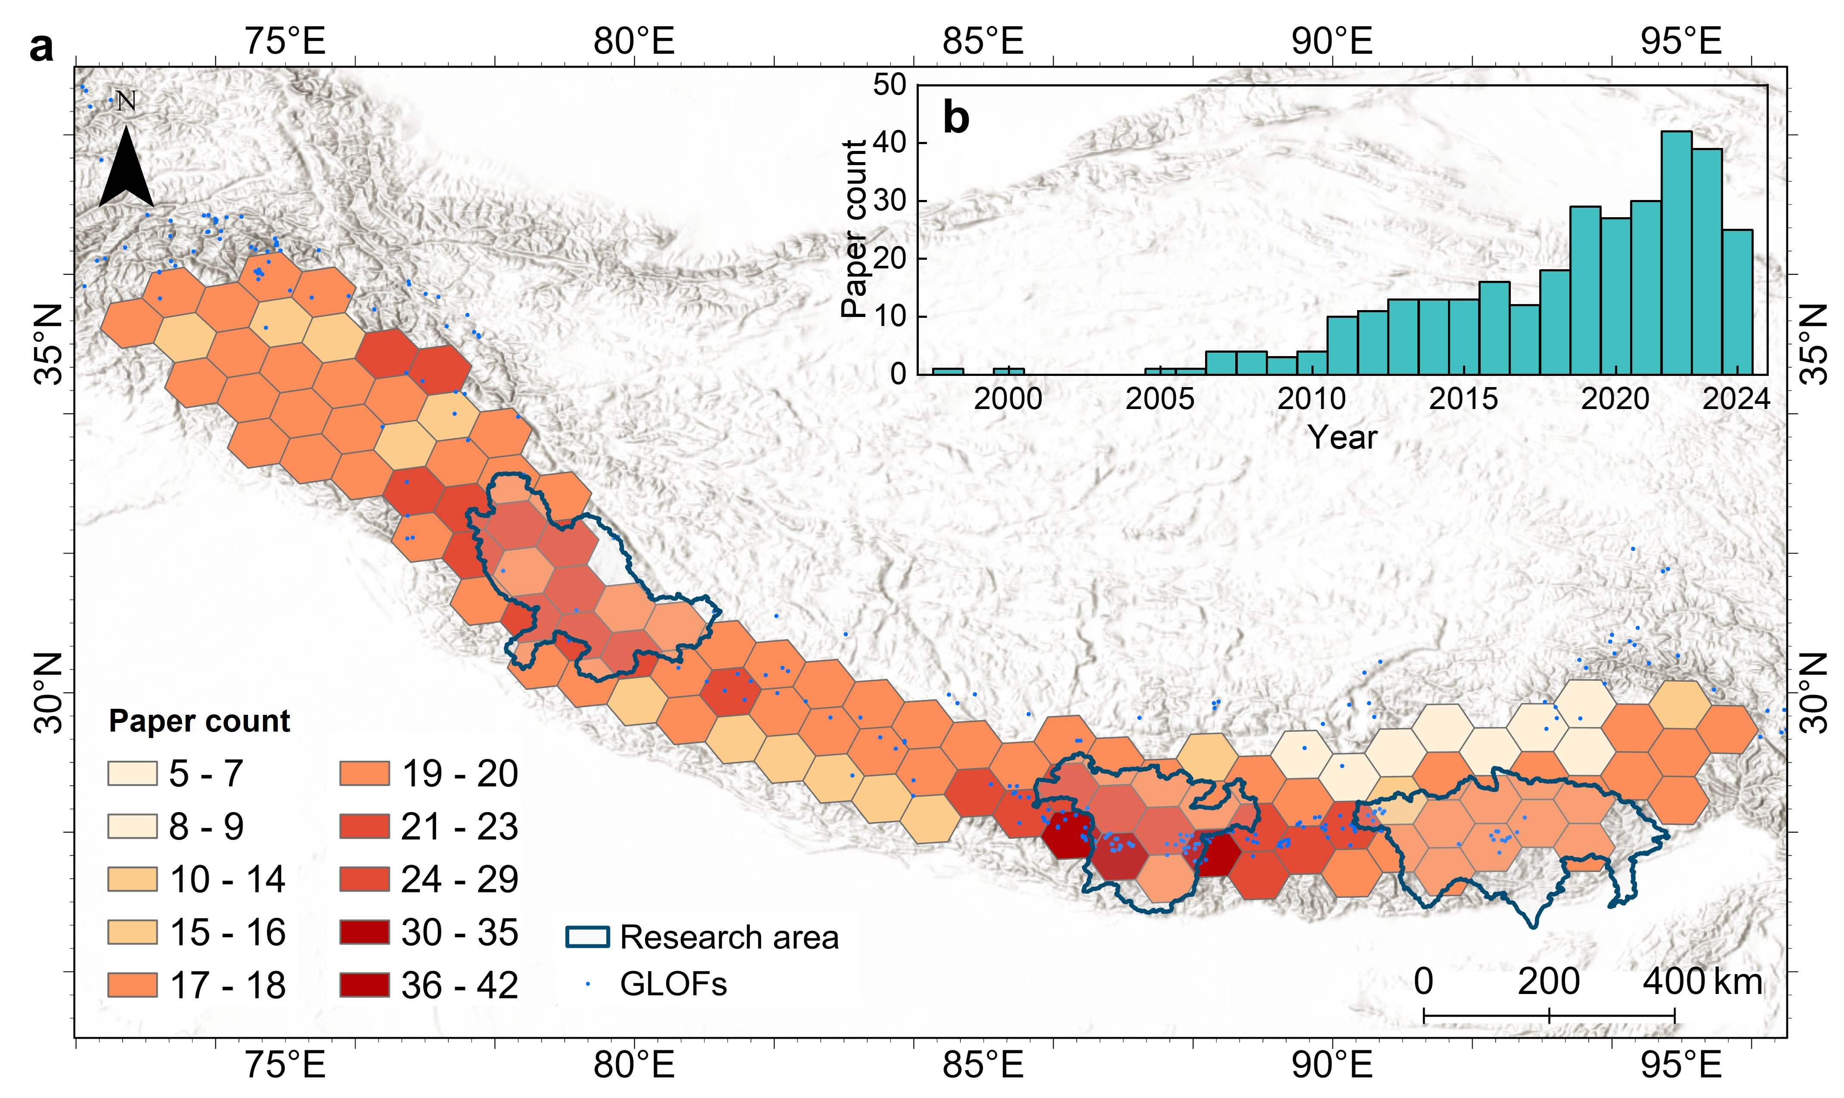
Supplementary Figure 2 | a The distribution and count of research papers related to GLOFs in the Himalayas, the literature statistics data is sourced from Web of Science (https://webofscience.clarivate.cn/). The hexagonal grid map shows the geographical concentration of GLOF studies, with each hexagon representing the number of research papers. b The inset bar graph provides a temporal trend of GLOF-related publications from 1995 to 2024.
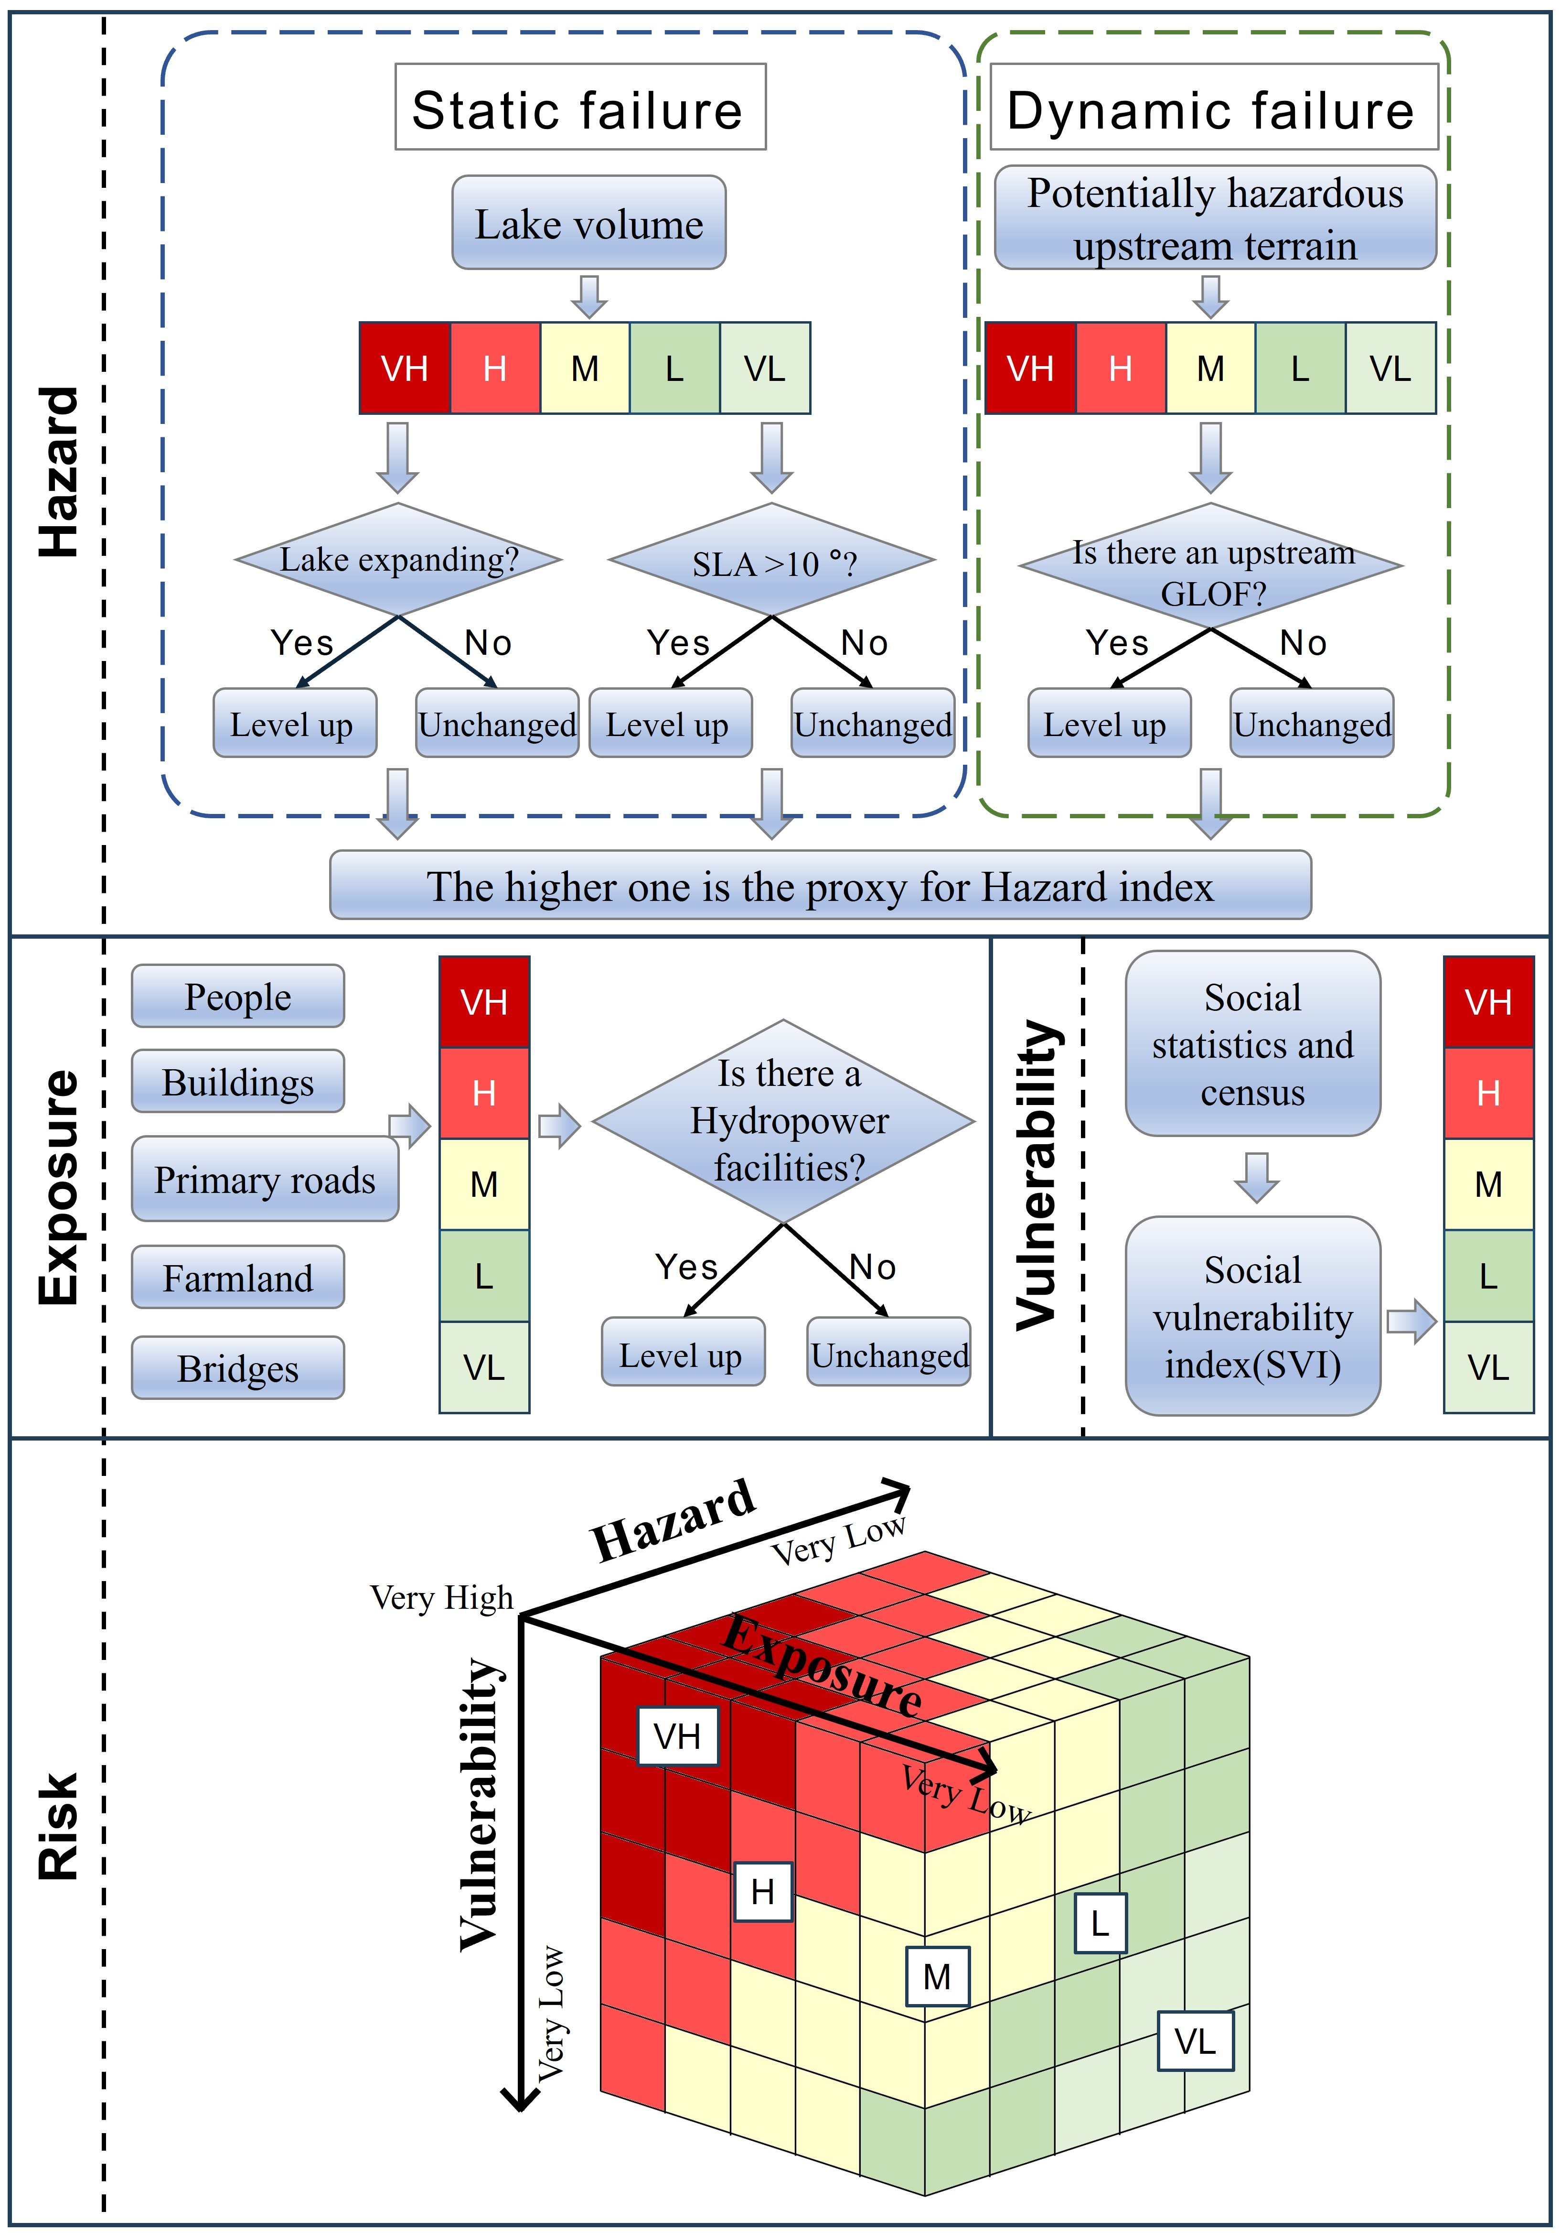
Supplementary Figure 3 | Workflow for calculating the Hazard, Exposure, and Vulnerability index of each glacial lake. 'VH' for 'Very High', 'H' for 'High', 'M' for 'Medium', 'L' for 'Low', and 'VL' for 'Very Low'.
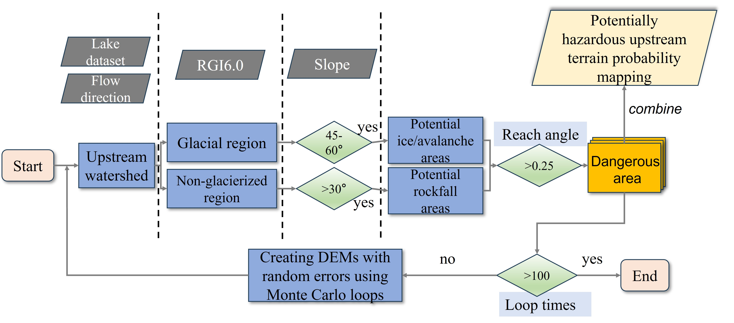
Supplementary Figure 4 | Workflow for the extraction of PHUT with DEM uncertainty using Monte Carlo loop. The process involves 100 iterations with a RMSE of 5 m.
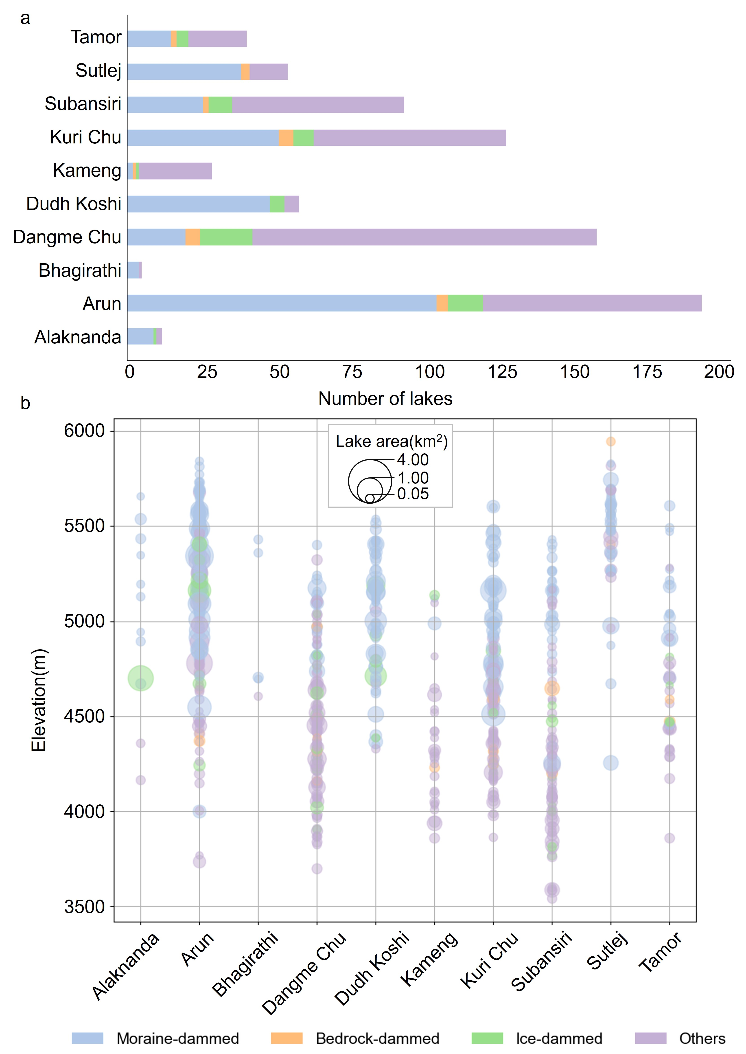
Supplementary Figure 5 | Types and altitude distribution of glacial lakes in the study area. a The bar chart displays the number and type of glacial lakes in each sub basin. b The bubble chart displays the elevation information of glacial lakes in each sub basin, and the size of the bubbles represents the area of glacial lakes

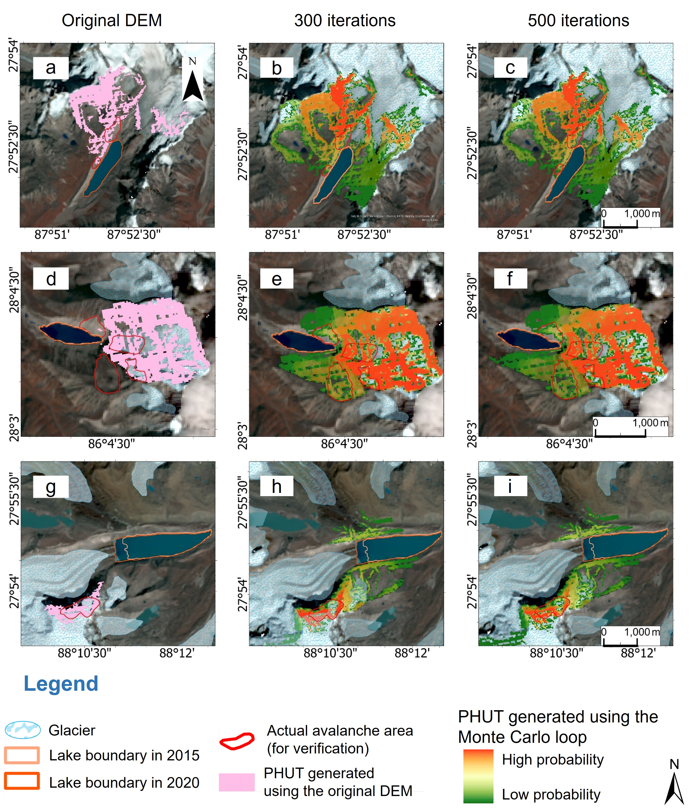
Supplementary Figure 6 | Three glacial lakes that have experienced GLOF (triggered by ice/avalanche or rockfall) were used to calculate the PHUT area using two methods. a-c Nagama Pokhari lake. d-f Cirenmaco lake. g-i South Lhonak lake. The pink areas mean the PHUT extracted using the original DEM, the gradient areas mean considering DEM uncertainty, and the red boundaries mean the actual area where avalanches occur.

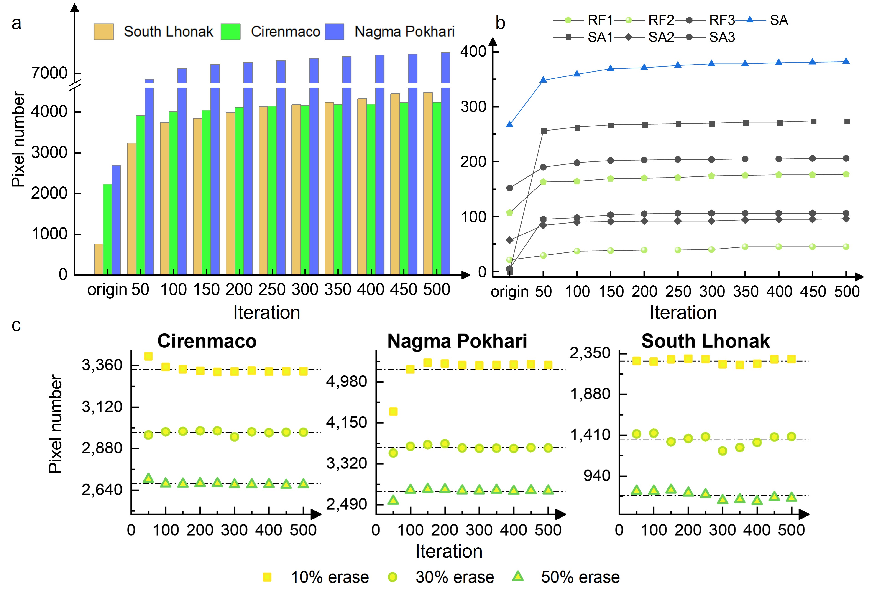
Supplementary Figure 7 | The relationship between the number of pixels and iterations in PHUT. a Relationship between iteration count and coverage of PHUT pixels. b Coverage of PHUT pixels in seven collapse areas, RF: rockfall, SA: snow/ice avalanche. c Coverage after removing 10%, 20%, 50% of PHUT pixels below the maximum pixel value.

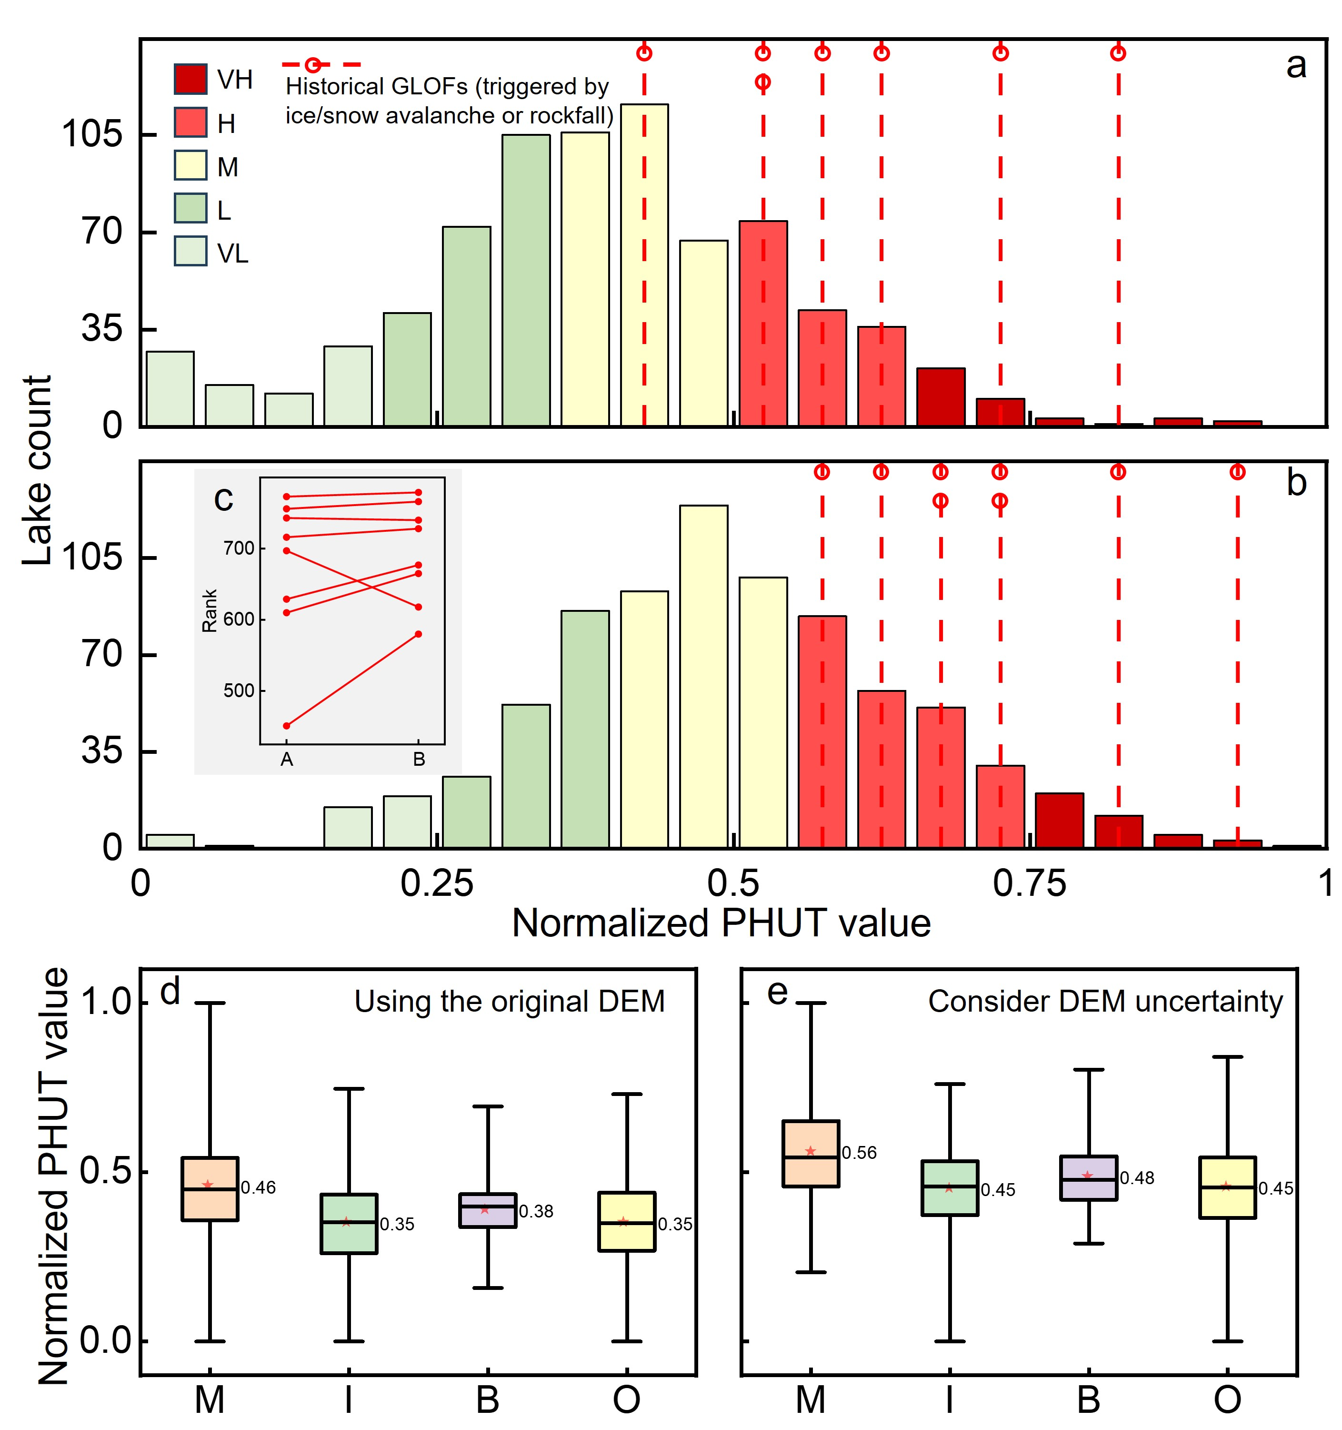
Supplementary Figure 8 | Normalize the PHUT index ranking of 8 historical GLOFs (triggered by ice/snow avalanche or rock avalanche) in the assessment of all glacial lakes. a Using the original DEM. b Calculated with DEM uncertainty. c Ranking changes of 8 historical GLOFs, A: using original DEM; B: calculated with DEM uncertainty. d-e PHUT distribution of four types of lakes, M: moraine-dammed,
I: ice-dammed, B: bed-dammed; O: others.

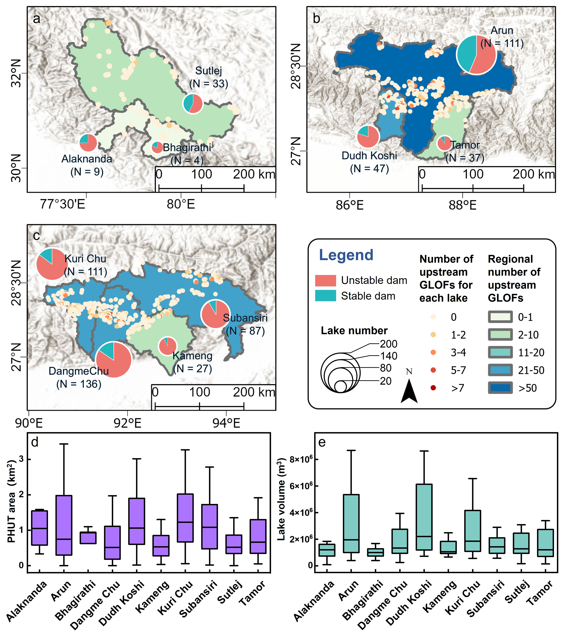
Supplementary Figure 9 | Statistics and distribution of factors controlling GLOF hazard levels. a-c Stability of lake dams and number of upstream GLOFs in ten sub-basins. d The distribution of PHUT area. e The volume distribution of glacial lakes is calculated using the area-volume empirical formula (see Methods).
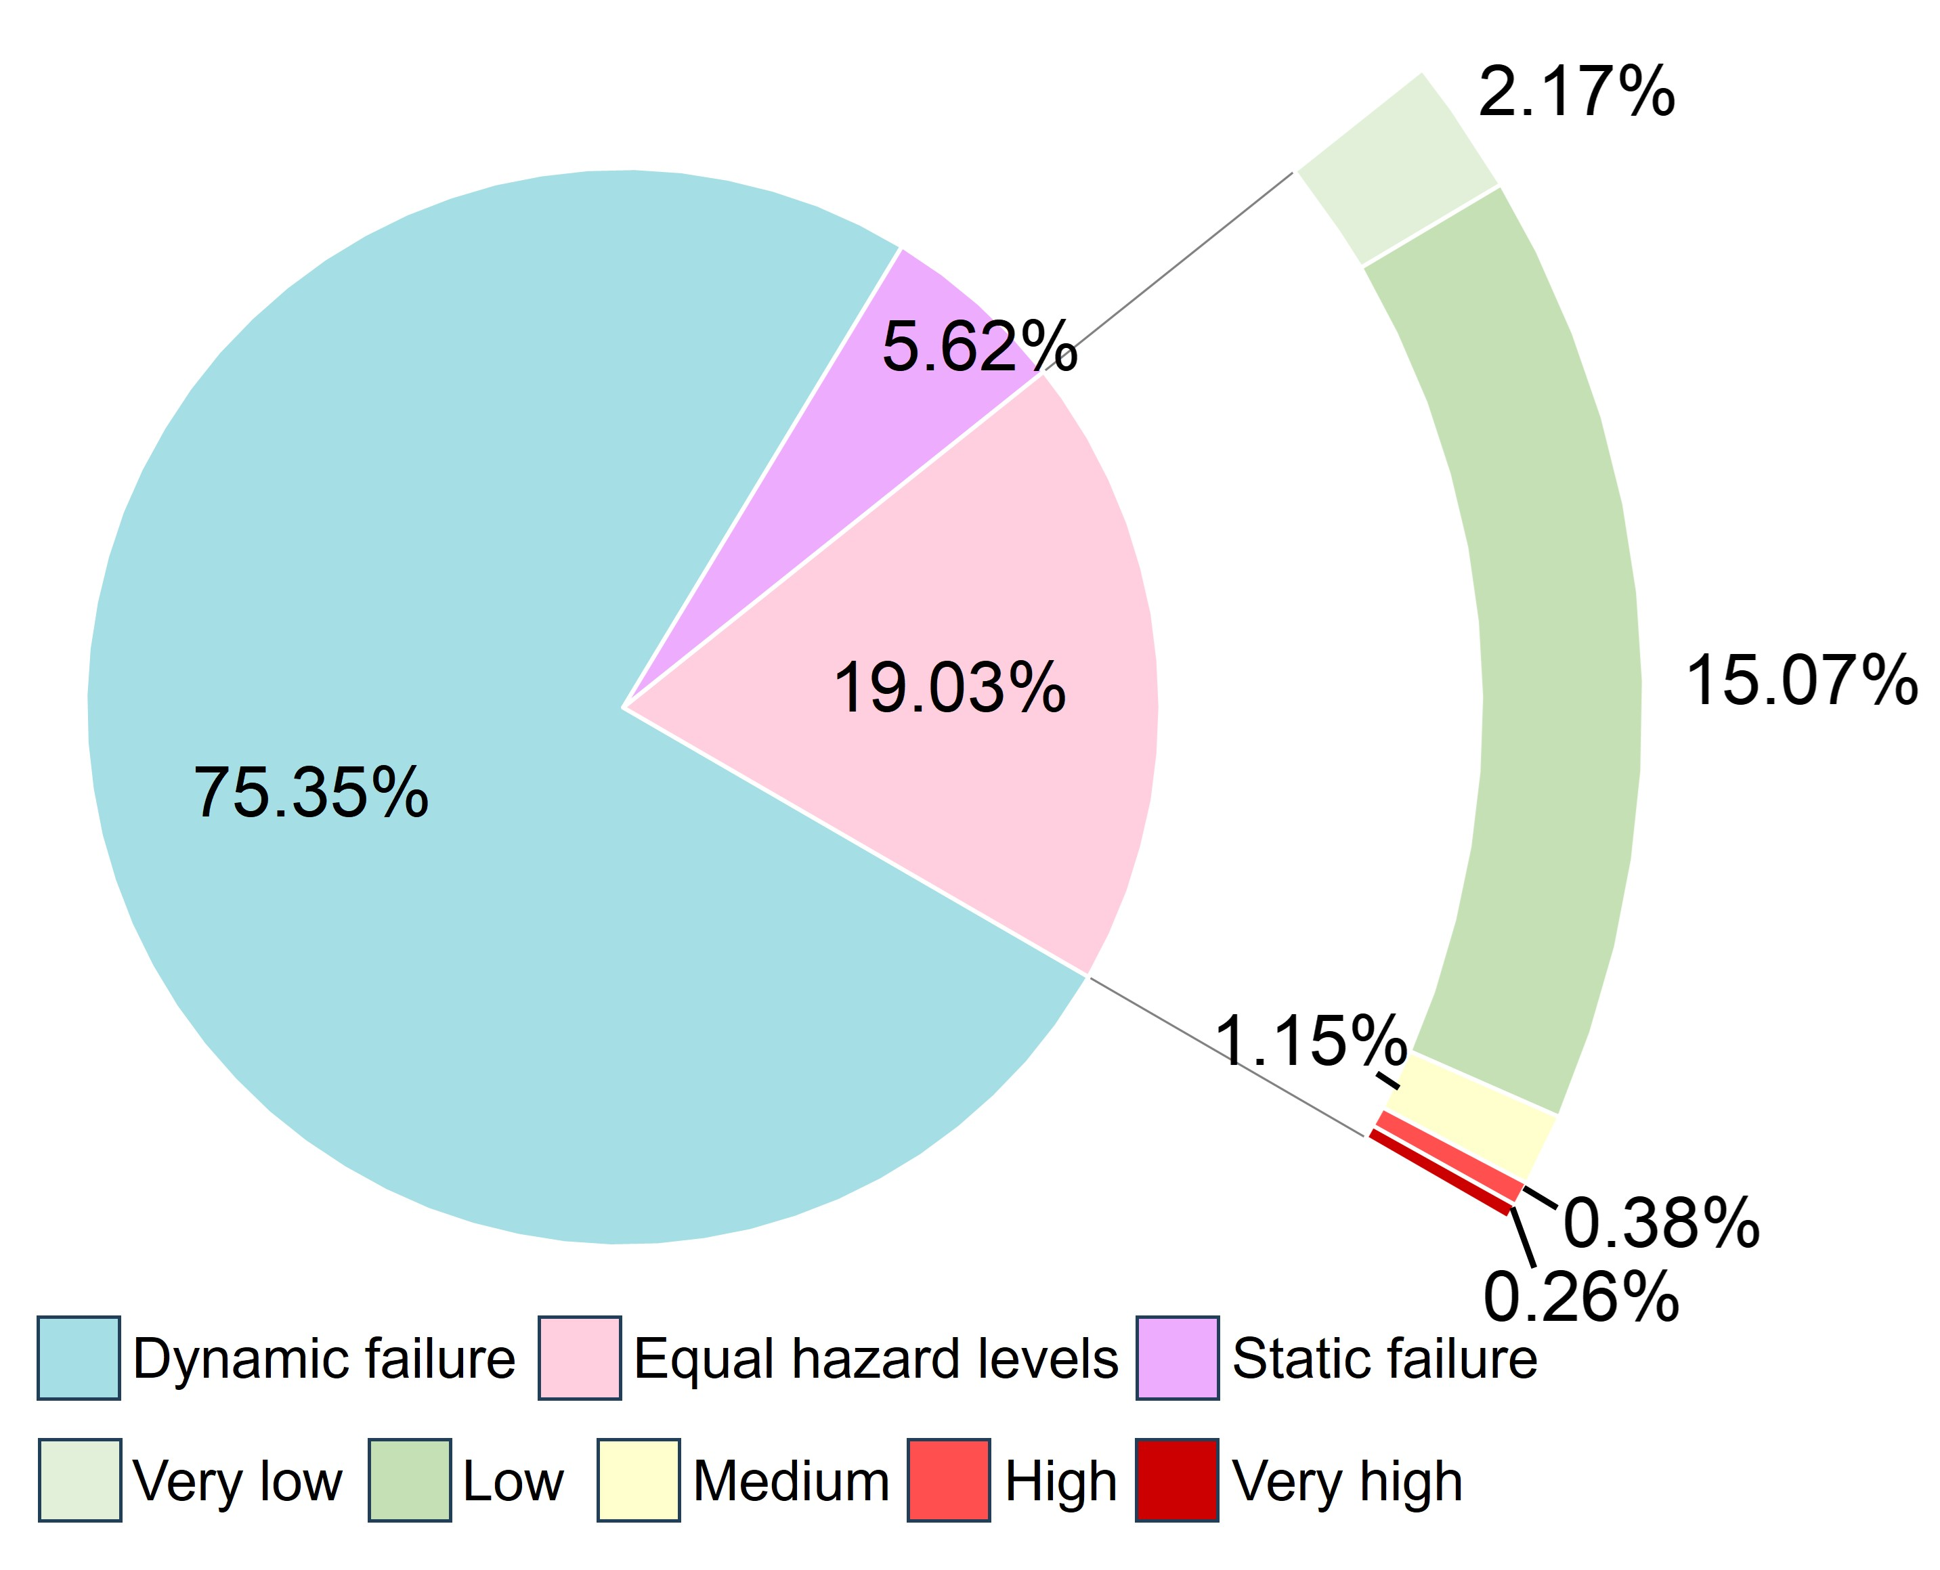
Supplementary Figure 10 | Distribution of glacial lakes hazard levels based on dynamic and static failure modes. The pie chart illustrates the proportion of hazard levels for all glacial lakes, determined by either dynamic failure or static failure modes. If the hazard level for dynamic failure is higher, it is assigned as the hazard level for the glacial lake, and vice versa.
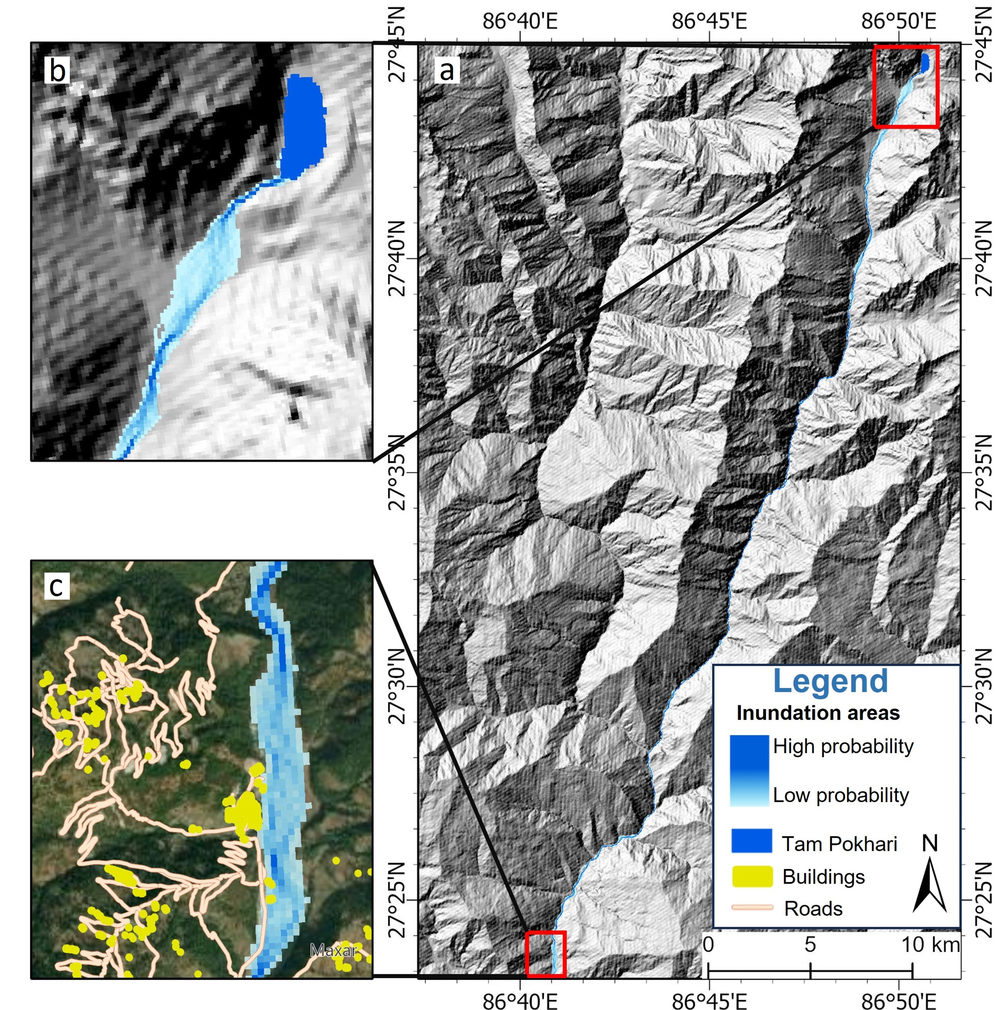
Supplementary Figure 11 | The simulation results of the inundation area for Tam Pokhari Lake located in Dudh Koshi using the MC-LCP model. a GLOF trajectory of Pokhari Lake under 50 km threshold. b-c Details of flood inundation, including downstream buildings and roads.
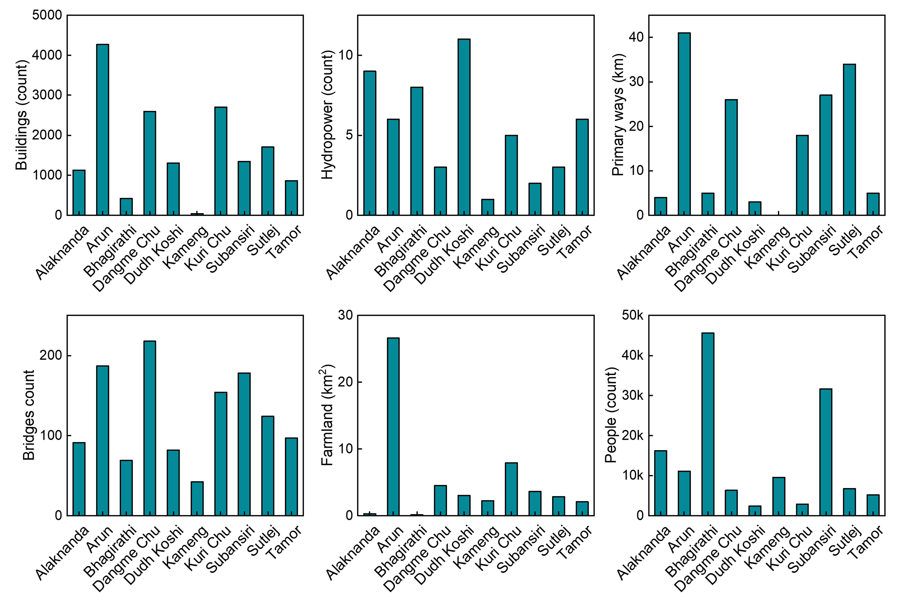
Supplementary Figure 12 | Exposure statistics of downstream population and facilities in each sub-basin.

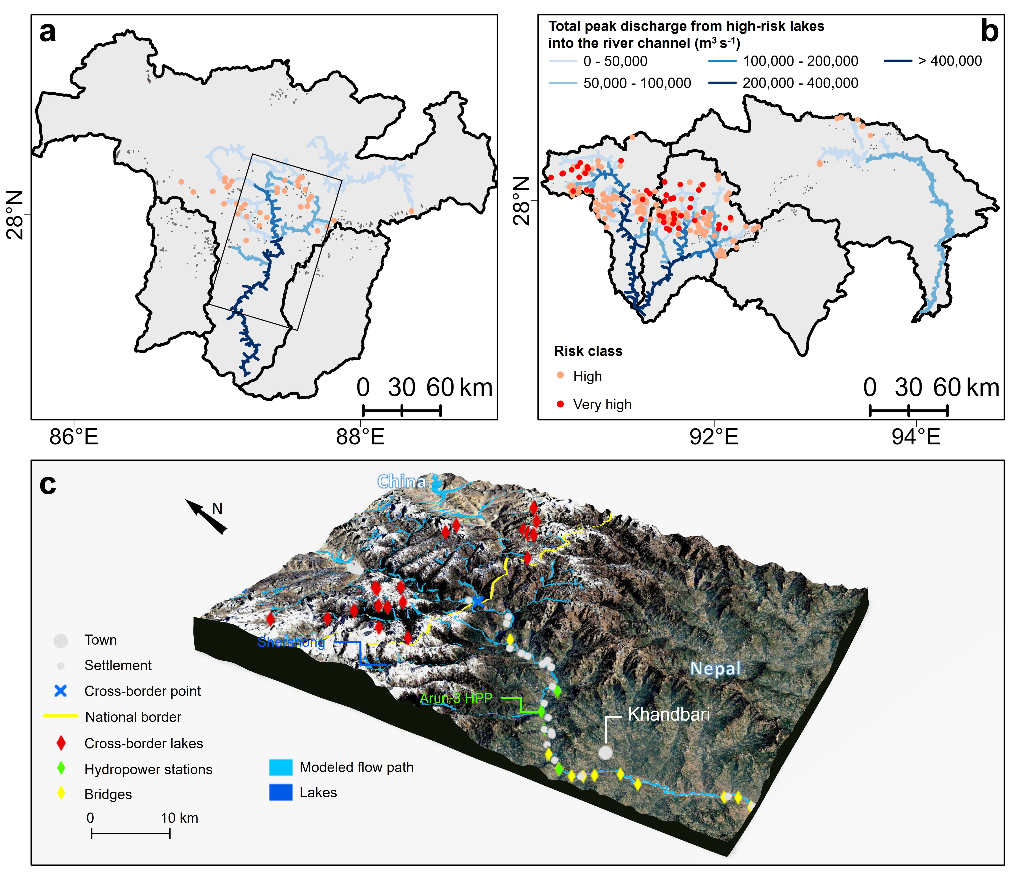
Supplementary Figure 13 | Potential GLOF peek discharge from high-risk level into the river channel and 3D map depicting an example of the potential transboundary GLOF threats in Arun river. a-b Potential GLOF peak discharge of each river channel within the sub-basin. c The cross-border area of Arun River. The base map uses Google imagery and annotates the villages, bridges, and hydropower stations around the river. Black box in a is the location of Arun river.

Supplementary Table 1 | Summary of all data used for lake outburst flood susceptibility assessment, downstream hazard, exposure, vulnerability, and risk assessment.
ID | Data set | Source | Period | Spatial resolution (m) | Purpose
1 | Sub-basin boundary | ICIMOD | April 2021 | - | Used to represent the boundary of the research area
2 | Satellite imagery | Landsat 8 OLI | 2015-2020 | 30 | Used to depict the boundaries of glacial lakes
3 | Elevation data | AW3D30 | April 2023 | 30 | Detecting terrain potential surrounding glacier lakes and simulate GLOF paths
4 | Building data | Open Street Map | October 2023 | - | Quantify structures exposed to the simulated GLOFs
4 | Population data | World Pop | 2020 | 100 | Statistics on downstream population exposure
5 | Hydroelectric facilities | Global Energy Monitor | May 2023 | - | Statistical exposure of downstream hydropower facilities
5 | Hydroelectric facilities | Google Maps |  | - | Statistical exposure of downstream hydropower facilities
6 | Social census data | Global Data Lab | 2010-2023 | - | Calculating SVI as a proxy for glacial lake vulnerability
6 | Social census data | Humanitarian Data Exchange | 2010-2023 | - | Calculating SVI as a proxy for glacial lake vulnerability
7 | GLOFs inventory | Shrestha, F. et al¹ | 1950-2022 | - | Extracting GLOFs from the study area for model validation.

Supplementary Table 2 | 90 Glacier Lakes with significant expansion from 2015 to 2020. Type refers to the type of glacier lake. Moraine-dammed lake (M), ice-dammed lake (I), bedrock-dammed lake (B), and others (O).
GL_id | Longitude  (°E) | Latitude  (°N) | Elevation | Type | Sub basin | lake area of 2015(km²) | lake area of 2020(km²) | lake area changes(km²) | change rate
3 | 78.1669 | 31.6605 | 4257 | M | Sutlej | 0.212±0.03 | 0.3±0.04 | 0.088±0.05 | 0.415±0.2
7 | 78.4456 | 33.0600 | 5690 | O | Sutlej | 0.07±0.01 | 0.095±0.02 | 0.025±0.02 | 0.358±0.27
8 | 78.4506 | 32.8875 | 5946 | B | Sutlej | 0.072±0.01 | 0.092±0.01 | 0.02±0.02 | 0.278±0.23
9 | 78.4546 | 33.0777 | 5820 | O | Sutlej | 0.057±0.02 | 0.088±0.02 | 0.03±0.02 | 0.529±0.34
11 | 78.4613 | 31.9720 | 5259 | M | Sutlej | 0.067±0.01 | 0.091±0.01 | 0.024±0.02 | 0.359±0.22
21 | 78.8402 | 31.9142 | 5583 | M | Sutlej | 0.181±0.02 | 0.218±0.02 | 0.037±0.03 | 0.201±0.15
26 | 78.9105 | 32.0180 | 5572 | B | Sutlej | 0.053±0.01 | 0.07±0.01 | 0.018±0.01 | 0.334±0.22
33 | 78.9775 | 32.1608 | 5575 | O | Sutlej | 0.079±0.01 | 0.105±0.01 | 0.027±0.02 | 0.339±0.17
35 | 78.9850 | 32.3004 | 5698 | M | Sutlej | 0.085±0.01 | 0.111±0.01 | 0.026±0.02 | 0.312±0.18
46 | 79.6187 | 30.6986 | 4164 | O | Alaknanda | 0.093±0.01 | 0.121±0.02 | 0.027±0.02 | 0.293±0.2
48 | 79.6828 | 32.2542 | 5609 | O | Sutlej | 0.052±0.01 | 0.082±0.01 | 0.03±0.01 | 0.572±0.22
49 | 79.7298 | 31.0284 | 5332 | M | Sutlej | 0.051±0.01 | 0.076±0.01 | 0.025±0.02 | 0.495±0.25
57 | 79.8942 | 30.8301 | 5196 | M | Alaknanda | 0.057±0.01 | 0.089±0.01 | 0.032±0.02 | 0.554±0.24
62 | 80.5980 | 30.5448 | 5501 | M | Sutlej | 0.064±0.01 | 0.084±0.01 | 0.019±0.02 | 0.302±0.21
66 | 81.1368 | 31.2339 | 5561 | M | Sutlej | 0.092±0.02 | 0.114±0.02 | 0.023±0.02 | 0.249±0.22
70 | 81.1595 | 31.2173 | 5598 | M | Sutlej | 0.066±0.01 | 0.091±0.01 | 0.025±0.02 | 0.382±0.25
203 | 87.3036 | 27.9381 | 4588 | O | Arun | 0.083±0.01 | 0.109±0.01 | 0.026±0.02 | 0.311±0.21
206 | 87.3417 | 27.8364 | 4243 | I | Arun | 0.174±0.02 | 0.228±0.02 | 0.053±0.03 | 0.307±0.16
231 | 87.4778 | 27.9967 | 4480 | O | Arun | 0.077±0.01 | 0.093±0.01 | 0.017±0.02 | 0.219±0.19
239 | 87.4920 | 28.8382 | 5453 | O | Arun | 0.053±0.01 | 0.085±0.01 | 0.031±0.02 | 0.581±0.25
250 | 87.5342 | 28.6942 | 5159 | O | Arun | 0.527±0.03 | 0.586±0.03 | 0.06±0.05 | 0.113±0.08
253 | 87.5536 | 28.7733 | 5316 | O | Arun | 0.225±0.02 | 0.265±0.02 | 0.04±0.03 | 0.177±0.12
267 | 87.5827 | 28.0488 | 4715 | M | Arun | 0.063±0.01 | 0.09±0.01 | 0.026±0.02 | 0.417±0.28
284 | 87.6211 | 28.2504 | 5842 | M | Arun | 0.07±0.01 | 0.089±0.01 | 0.019±0.02 | 0.275±0.21
298 | 87.6363 | 28.0929 | 5177 | M | Arun | 0.769±0.05 | 0.868±0.05 | 0.099±0.08 | 0.128±0.09
305 | 87.7020 | 27.8864 | 5193 | I | Arun | 0.074±0.01 | 0.144±0.02 | 0.071±0.02 | 0.963±0.19
340 | 87.9627 | 27.8462 | 5216 | M | Tamor | 0.077±0.01 | 0.11±0.01 | 0.033±0.02 | 0.423±0.2
347 | 88.0418 | 27.9426 | 5815 | M | Arun | 0.104±0.01 | 0.13±0.01 | 0.025±0.02 | 0.241±0.17
352 | 88.0658 | 27.9318 | 5562 | M | Arun | 0.959±0.06 | 1.095±0.06 | 0.136±0.08 | 0.142±0.08
353 | 88.0767 | 27.9446 | 5488 | M | Arun | 1.461±0.07 | 1.707±0.07 | 0.246±0.1 | 0.168±0.06
358 | 88.2420 | 28.0033 | 5269 | M | Arun | 0.42±0.04 | 0.485±0.04 | 0.064±0.05 | 0.153±0.12
369 | 90.3845 | 28.2044 | 5424 | M | Kuri Chu | 0.359±0.03 | 0.418±0.03 | 0.059±0.05 | 0.164±0.12
370 | 90.4085 | 28.1514 | 4847 | I | Kuri Chu | 0.084±0.04 | 0.137±0.03 | 0.054±0.05 | 0.639±0.49
388 | 90.6630 | 28.2075 | 5071 | M | Kuri Chu | 0.057±0.01 | 0.081±0.01 | 0.023±0.01 | 0.405±0.21
398 | 90.7434 | 28.0787 | 5166 | M | Kuri Chu | 0.165±0.02 | 0.211±0.02 | 0.046±0.03 | 0.281±0.14
403 | 90.8171 | 27.9885 | 4911 | O | Kuri Chu | 0.091±0.02 | 0.16±0.02 | 0.069±0.03 | 0.754±0.3
405 | 90.8277 | 27.9222 | 4616 | I | Kuri Chu | 0.053±0.01 | 0.08±0.01 | 0.027±0.02 | 0.501±0.24
406 | 90.8402 | 28.0223 | 4984 | M | Kuri Chu | 0.125±0.02 | 0.22±0.02 | 0.095±0.03 | 0.761±0.21
409 | 90.8503 | 27.8656 | 4594 | O | Kuri Chu | 0.095±0.02 | 0.126±0.02 | 0.031±0.02 | 0.324±0.2
417 | 90.8977 | 28.0533 | 4770 | M | Kuri Chu | 0.071±0.01 | 0.101±0.01 | 0.03±0.02 | 0.416±0.23
433 | 90.9659 | 27.9221 | 4520 | I | Kuri Chu | 0.063±0.01 | 0.088±0.01 | 0.025±0.02 | 0.405±0.26
435 | 90.9696 | 27.9075 | 4411 | O | Kuri Chu | 0.058±0.01 | 0.077±0.01 | 0.019±0.02 | 0.334±0.27
437 | 90.9785 | 28.0071 | 4401 | O | Kuri Chu | 0.093±0.01 | 0.11±0.01 | 0.018±0.02 | 0.194±0.18
443 | 90.9991 | 27.8744 | 4197 | O | Kuri Chu | 0.106±0.01 | 0.134±0.01 | 0.028±0.02 | 0.262±0.17
444 | 91.0041 | 28.0343 | 4206 | O | Kuri Chu | 0.755±0.06 | 0.935±0.07 | 0.179±0.09 | 0.237±0.1
445 | 91.0030 | 28.0445 | 4078 | O | Kuri Chu | 0.09±0.02 | 0.12±0.02 | 0.031±0.03 | 0.341±0.28
446 | 91.0132 | 27.8770 | 4173 | O | Kuri Chu | 0.114±0.02 | 0.138±0.01 | 0.024±0.02 | 0.208±0.17
448 | 91.0321 | 28.0312 | 4318 | O | Kuri Chu | 0.054±0.01 | 0.076±0.01 | 0.023±0.02 | 0.42±0.24
461 | 91.2088 | 28.0819 | 4267 | O | Kuri Chu | 0.06±0.01 | 0.082±0.01 | 0.023±0.02 | 0.377±0.26
463 | 91.2333 | 27.9677 | 4564 | O | Kuri Chu | 0.051±0.01 | 0.079±0.01 | 0.028±0.02 | 0.555±0.26
466 | 91.2426 | 27.9096 | 4385 | O | Kuri Chu | 0.16±0.02 | 0.297±0.03 | 0.137±0.03 | 0.858±0.14
479 | 91.2761 | 27.8920 | 4721 | O | Kuri Chu | 0.09±0.01 | 0.109±0.01 | 0.019±0.02 | 0.208±0.18
480 | 91.2776 | 27.9784 | 4421 | O | Kuri Chu | 0.068±0.01 | 0.093±0.01 | 0.025±0.02 | 0.371±0.23
490 | 91.3171 | 27.9904 | 4765 | M | Kuri Chu | 0.056±0.01 | 0.071±0.01 | 0.014±0.01 | 0.254±0.22
493 | 91.3338 | 28.0879 | 5145 | M | Kuri Chu | 0.05±0.01 | 0.066±0.01 | 0.016±0.01 | 0.323±0.25
499 | 91.4299 | 27.9673 | 4821 | O | Kuri Chu | 0.062±0.01 | 0.078±0.01 | 0.016±0.01 | 0.266±0.21
500 | 91.4486 | 27.8791 | 4242 | O | Dangme Chu | 0.096±0.01 | 0.127±0.01 | 0.031±0.02 | 0.327±0.18
505 | 91.4800 | 27.8892 | 4259 | O | Dangme Chu | 0.065±0.01 | 0.084±0.01 | 0.018±0.02 | 0.283±0.22
528 | 91.5894 | 27.8058 | 4413 | O | Dangme Chu | 0.121±0.01 | 0.144±0.01 | 0.022±0.02 | 0.185±0.16
529 | 91.5921 | 27.7968 | 4080 | O | Dangme Chu | 0.158±0.02 | 0.239±0.03 | 0.081±0.03 | 0.515±0.16
531 | 91.5960 | 27.8876 | 4640 | O | Dangme Chu | 0.166±0.02 | 0.206±0.02 | 0.04±0.03 | 0.242±0.15
537 | 91.6106 | 27.9179 | 4636 | O | Dangme Chu | 0.081±0.01 | 0.101±0.01 | 0.02±0.02 | 0.245±0.2
540 | 91.6283 | 27.8610 | 4640 | O | Dangme Chu | 0.081±0.01 | 0.106±0.01 | 0.025±0.02 | 0.308±0.21
544 | 91.6417 | 27.9015 | 4986 | O | Dangme Chu | 0.052±0.01 | 0.075±0.01 | 0.023±0.01 | 0.444±0.23
552 | 91.6759 | 28.0136 | 4425 | O | Dangme Chu | 0.128±0.01 | 0.151±0.02 | 0.023±0.02 | 0.181±0.16
562 | 91.7840 | 27.6207 | 3967 | O | Dangme Chu | 0.065±0.01 | 0.091±0.01 | 0.026±0.02 | 0.409±0.27
563 | 91.8033 | 27.6246 | 4328 | O | Dangme Chu | 0.087±0.01 | 0.112±0.01 | 0.025±0.02 | 0.286±0.17
571 | 91.8472 | 28.0943 | 5161 | M | Dangme Chu | 0.059±0.01 | 0.081±0.01 | 0.022±0.02 | 0.365±0.24
576 | 91.8642 | 28.1321 | 5404 | M | Dangme Chu | 0.071±0.01 | 0.095±0.01 | 0.024±0.02 | 0.336±0.26
608 | 92.0156 | 27.5081 | 4160 | O | Dangme Chu | 0.069±0.01 | 0.1±0.01 | 0.03±0.02 | 0.438±0.21
614 | 92.0394 | 28.1929 | 5034 | O | Dangme Chu | 0.222±0.02 | 0.308±0.02 | 0.086±0.03 | 0.385±0.11
616 | 92.0419 | 28.2301 | 5105 | O | Dangme Chu | 0.159±0.02 | 0.227±0.02 | 0.068±0.03 | 0.425±0.18
621 | 92.0628 | 28.2699 | 5037 | M | Subansiri | 0.056±0.01 | 0.077±0.01 | 0.02±0.02 | 0.359±0.25
626 | 92.1094 | 27.6054 | 4426 | O | Dangme Chu | 0.058±0.01 | 0.085±0.01 | 0.027±0.01 | 0.459±0.2
632 | 92.1353 | 27.5503 | 4609 | O | Dangme Chu | 0.056±0.01 | 0.077±0.01 | 0.021±0.02 | 0.377±0.23
658 | 92.3411 | 27.7293 | 4972 | O | Dangme Chu | 0.06±0.01 | 0.085±0.01 | 0.025±0.02 | 0.423±0.26
660 | 92.3449 | 27.7094 | 4908 | O | Dangme Chu | 0.065±0.01 | 0.082±0.01 | 0.018±0.02 | 0.273±0.24
672 | 92.4357 | 27.7702 | 5176 | M | Dangme Chu | 0.583±0.05 | 0.667±0.04 | 0.085±0.07 | 0.146±0.11
685 | 92.6410 | 28.0010 | 5267 | M | Subansiri | 0.095±0.02 | 0.119±0.01 | 0.024±0.02 | 0.255±0.21
690 | 92.6579 | 27.8235 | 4278 | O | Kameng | 0.071±0.01 | 0.194±0.02 | 0.123±0.02 | 1.738±0.19
710 | 92.8536 | 27.9440 | 4041 | O | Kameng | 0.052±0.01 | 0.07±0.01 | 0.018±0.01 | 0.356±0.25
715 | 92.9003 | 28.0698 | 4292 | O | Subansiri | 0.084±0.02 | 0.121±0.02 | 0.037±0.02 | 0.444±0.23
718 | 92.9265 | 28.7430 | 5083 | O | Subansiri | 0.068±0.01 | 0.085±0.01 | 0.017±0.01 | 0.252±0.2
725 | 93.0086 | 28.1547 | 4299 | O | Subansiri | 0.063±0.01 | 0.095±0.01 | 0.032±0.02 | 0.509±0.21
748 | 93.4381 | 28.3021 | 3956 | O | Subansiri | 0.33±0.03 | 0.494±0.04 | 0.164±0.05 | 0.497±0.13
755 | 93.5452 | 28.5652 | 4490 | I | Subansiri | 0.06±0.01 | 0.082±0.01 | 0.022±0.02 | 0.359±0.23
770 | 93.7568 | 28.6763 | 4181 | I | Subansiri | 0.06±0.01 | 0.08±0.01 | 0.02±0.02 | 0.331±0.24
772 | 93.8024 | 28.6472 | 3999 | I | Subansiri | 0.054±0.01 | 0.07±0.01 | 0.017±0.01 | 0.312±0.24
777 | 93.8256 | 28.5803 | 4216 | O | Subansiri | 0.083±0.01 | 0.107±0.02 | 0.025±0.02 | 0.297±0.23
781 | 93.8456 | 28.5855 | 4230 | O | Subansiri | 0.067±0.01 | 0.088±0.01 | 0.02±0.02 | 0.304±0.23
Tatoal | - | - | - | - | - | 13.162±0.19 | 16.923±0.20 | 3.760±0.78 | 0.335±0.02

Supplementary Table 3 | 25 Glacier Lakes with significant reduction from 2015 to 2020.
GL_id | Longitude  (°E) | Latitude  (°N) | Elevation | Type | Sub basin | lake area of 2015(km²) | lake area of 2020(km²) | lake area changes(km²) | change rate
1 | 32.7317 | 77.9812 | 4964 | O | Sutlej | 0.102 ± 0.01 | 0.022 ± 0.0 | -0.08 ± 0.01 | -0.786 ± 0.22
34 | 32.3197 | 78.9791 | 5498 | M | Sutlej | 0.108 ± 0.01 | 0.078 ± 0.01 | -0.03 ± 0.02 | -0.278 ± 0.21
52 | 32.0295 | 79.8126 | 5609 | M | Sutlej | 0.053 ± 0.02 | 0.027 ± 0.01 | -0.026 ± 0.02 | -0.486 ± 0.41
16 | 31.5535 | 78.7510 | 5268 | M | Sutlej | 0.113 ± 0.01 | 0.053 ± 0.01 | -0.06 ± 0.02 | -0.53 ± 0.22
44 | 30.9803 | 79.4871 | 5656 | M | Alaknanda | 0.054 ± 0.01 | 0.014 ± 0.0 | -0.04 ± 0.01 | -0.747 ± 0.27
767 | 28.5944 | 93.7257 | 4201 | B | Subansiri | 0.24 ± 0.02 | 0.206 ± 0.02 | -0.034 ± 0.03 | -0.141 ± 0.12
760 | 28.5755 | 93.5782 | 3844 | O | Subansiri | 0.375 ± 0.03 | 0.326 ± 0.03 | -0.049 ± 0.04 | -0.131 ± 0.12
727 | 28.3199 | 93.0467 | 4255 | M | Subansiri | 0.697 ± 0.05 | 0.631 ± 0.04 | -0.066 ± 0.06 | -0.095 ± 0.1
742 | 28.3131 | 93.3914 | 4072 | O | Subansiri | 0.189 ± 0.02 | 0.157 ± 0.01 | -0.031 ± 0.02 | -0.166 ± 0.13
747 | 28.2977 | 93.4190 | 3820 | O | Subansiri | 0.186 ± 0.03 | 0.104 ± 0.02 | -0.082 ± 0.03 | -0.442 ± 0.21
394 | 28.2737 | 90.7362 | 4510 | M | Kuri Chu | 1.733 ± 0.09 | 1.582 ± 0.09 | -0.151 ± 0.13 | -0.087 ± 0.08
395 | 28.0967 | 90.7383 | 5006 | M | Kuri Chu | 0.728 ± 0.05 | 0.619 ± 0.05 | -0.109 ± 0.07 | -0.15 ± 0.11
367 | 28.0568 | 88.5172 | 5570 | M | Arun | 0.123 ± 0.02 | 0.072 ± 0.01 | -0.051 ± 0.02 | -0.414 ± 0.23
356 | 27.9946 | 88.2118 | 5231 | M | Arun | 0.055 ± 0.01 | 0.041 ± 0.01 | -0.014 ± 0.01 | -0.26 ± 0.25
256 | 27.9799 | 87.5570 | 4773 | O | Arun | 0.097 ± 0.01 | 0.078 ± 0.01 | -0.02 ± 0.02 | -0.203 ± 0.18
334 | 27.9431 | 87.8969 | 5493 | M | Arun | 0.137 ± 0.02 | 0.055 ± 0.01 | -0.081 ± 0.02 | -0.595 ± 0.2
558 | 27.9398 | 91.7600 | 4507 | O | Dangme Chu | 0.074 ± 0.01 | 0.059 ± 0.01 | -0.015 ± 0.01 | -0.206 ± 0.22
487 | 27.9207 | 91.3012 | 4554 | O | Kuri Chu | 0.078 ± 0.01 | 0.06 ± 0.01 | -0.018 ± 0.01 | -0.227 ± 0.2
488 | 27.8928 | 91.3052 | 4050 | O | Kuri Chu | 0.271 ± 0.03 | 0.193 ± 0.02 | -0.078 ± 0.04 | -0.287 ± 0.16
535 | 27.8784 | 91.6043 | 4444 | O | Dangme Chu | 0.058 ± 0.01 | 0.029 ± 0.01 | -0.029 ± 0.01 | -0.495 ± 0.31
530 | 27.8151 | 91.5943 | 4681 | O | Dangme Chu | 0.151 ± 0.02 | 0.069 ± 0.01 | -0.083 ± 0.03 | -0.548 ± 0.22
351 | 27.7839 | 88.0655 | 4813 | I | Tamor | 0.071 ± 0.01 | 0.019 ± 0.0 | -0.051 ± 0.01 | -0.727 ± 0.26
577 | 27.7456 | 91.8703 | 4339 | O | Dangme Chu | 0.44 ± 0.03 | 0.398 ± 0.03 | -0.043 ± 0.04 | -0.097 ± 0.09
243 | 27.6811 | 87.5177 | 4471 | O | Arun | 0.115 ± 0.02 | 0.092 ± 0.01 | -0.024 ± 0.02 | -0.206 ± 0.2
248 | 27.5815 | 87.5322 | 4289 | O | Tamor | 0.095 ± 0.02 | 0.053 ± 0.01 | -0.042 ± 0.02 | -0.444 ± 0.23
Total | - | - | - | - | - | 6.341 ± 0.15 | 5.035 ± 0.12 | -1.306 ± 0.19 | -8.747 ± 1.06

Supplementary Table 4 | Hazard levels of 23 historical GLOFs events within the study under the same evaluation method.
Lake ID | Lake name | GLOF date | GLOF driver | Latitude (°N) | Longitude (°E) | Sub  basin | Volume normalization index | PHUT normalization index | Hazard
324 | Gelhaip Co | September 21, 1964 | Ice avalanche | 27.964 | 87.816 | Arun | 0.834 | 0.868 | Very High
78 | Aya Co | August 15th, 1968  August 17th, 1968  August 18th, 1968 | Ice avalanche | 28.346 | 86.49 | Arun | 0.791 | 0.547 | Middle
327 | Nagma Pokhari | June 23, 1980 | Unknown | 27.869 | 87.867 | Tamor | 0.869 | 0.933 | Very High
382 | Zari Co | June 24, 1981 | Ice avalanche | 28.2995 | 90.6072 | Kuri Chu | 0.801 | 0.547 | High
335 | Jin Co/Yindapu Co | August 27, 1982 | Ice avalanche | 27.951 | 87.908 | Arun | 0.862 | 0.881 | Very High
123 | Sabai Tsho/ Tam Pokhari | September 3rd, 1998 | Ice avalanche | 27.742 | 86.845 | Dudh Koshi | 0.766 | 0.978 | Very High
564 | Lang Co | August 10th, 2007 | Unknown | 27.828 | 91.807 | Dangme Chu | 0.568 | 0.724 | Very High
343 | Geiqu | 2010 | Intense rainfall | 27.951215 | 87.98544 | Arun | 0.569 | 0.761 | Very High
335 | Jin Co/Yindapu Co | 2015 | Unknown | 27.951 | 87.908 | Arun | 0.862 | 0.881 | Very High
174 | Langmale | April 20, 2017 | Rockfall | 27.814 | 87.141 | Arun | 0.520 | 0.733 | Very High
151 | Unnamed | - | Unknown | 27.799 | 86.966 | Dudh Koshi | 0.765 | 0.595 | Very High
166 | Barun | - | Unknown | 27.843 | 87.081 | Arun | 0.815 | 0.998 | Very High
169 | Barun | - | Unknown | 27.829 | 87.094807 | Arun | 0.679 | 0.619 | High
354 | Unnamed | - | Unknown | 27.8349 | 88.0787 | Tamor | 0.698 | 0.199 | Low
372 | Unnamed | - | Unknown | 28.2419 | 90.5062 | Kuri Chu | 0.766 | 0.744 | Very High
377 | Lure Co | - | Unknown | 28.27 | 90.59 | Kuri Chu | 0.851 | 0.935 | High
379 | Unnamed | - | Ice avalanche | 28.06 | 90.605 | Kuri Chu | 0.839 | 0.460 | High
390 | Dega Co | - | Unknown | 28.33357 | 90.673572 | Kuri Chu | 0.685 | 0.866 | Very High
396 | Upper Shegong Co | - | Ice avalanche | 28.304 | 90.741 | Kuri Chu | 0.664 | 0.7503 | High
651 | Unnamed | - | Unknown | 27.8922 | 92.3032 | Subansiri | 0.815 | 0.672 | High
679 | Unnamed | - | Unknown | 27.9292 | 92.5352 | Subansiri | 0.599 | 0.686 | High
685 | Unnamed | - | Unknown | 28.0013 | 92.6407 | Subansiri | 0.676 | 0.550 | High
698 | Unnamed | - | Unknown | 28.2112 | 92.7491 | Subansiri | 0.626 | 0.633 | High

Supplementary Table 5 | Five social census indicators for downstream administrative regions, unit (%).
Regin | County | Poor population | Illiterate | Population | Population | Rural population | SVI
Regin | County | Poor population | Population | <15 yrs | >65 yrs | Rural population | SVI
Ngari Prefecture | China | 17.3 | 30.71 | 26.2 | 4.54 | 59.6 | 27.67
Nyingchi | China | 16.42 | 22.21 | 20.6 | 5.05 | 57.7 | 24.396
Shigatse | China | 10.7 | 32.75 | 26.3 | 5.61 | 75 | 30.072
Shannan | China | - | 26.28 | 19.22 | 7.51 | 68.1 | 30.2775
Koshi | Nepal | 26.6 | 14.35 | 28.7 | 8.26 | 35.5 | 22.682
Madhesh | Nepal | 41.8 | 38.85 | 35.6 | 6.85 | 25.9 | 29.8
Lhuentse | Bhutan | 65.5 | 34.6 | 29.5 | 15.8 | 84.2 | 45.92
Monggar | Bhutan | 63.5 | 36.9 | 30.6 | 7.1 | 72.3 | 42.08
Trashigang | Bhutan | 65.1 | 35.5 | 27.6 | 7.31 | 77.7 | 42.642
Trashi Yangtse | Bhutan | 60.6 | 34.1 | 32.2 | 7.12 | 80.1 | 42.824
Ladakh | India | 21.3 | 16.35 | 20 | 7 | 77.4 | 28.41
Assam | India | 47.7 | 35.6 | 26.2 | 5.23 | 84.9 | 39.926
Uttaranchal | India | 2.25 | 15.45 | 23.8 | 8.76 | 71.3 | 24.312
Himachal Pradesh | India | 4.89 | 8.25 | 19.8 | 10.1 | 83.8 | 25.368

Supplementary Table 6 | 58 glacial lakes defined as ‘high’ or ‘very high’ risk levels and their comparison with previous studies. Purple data from Zheng et al.² and orange data from Zhang et al.³
G_id | LAT | LON | ELEV | Sub_basin | Hazard | Exposure | Vulnerability | Risk | Risk | Risk
113 | 28.20 | 86.75 | 5734 | Arun | High | Very high | Low | High | Medium
152 | 28.15 | 86.97 | 5731 | Arun | High | Very high | Low | High | Medium
157 | 28.07 | 87.05 | 5588 | Arun | High | Very high | Low | High | Medium | High
161 | 28.17 | 87.07 | 5553 | Arun | High | Very high | Low | High | Low | Very low
173 | 28.07 | 87.13 | 4878 | Arun | High | Very high | Low | High | High | Very low
184 | 27.84 | 87.20 | 4002 | Arun | Very high | High | Low | High | Medium
228 | 28.15 | 87.47 | 5105 | Arun | High | Very high | Low | High | Medium | Low
229 | 28.21 | 87.47 | 4781 | Arun | Very high | Very high | Low | High |  | Very high
259 | 28.18 | 87.56 | 5010 | Arun | Very high | Very high | Low | High | High | Low
265 | 28.23 | 87.58 | 5247 | Arun | Very high | Very high | Low | High | Medium
274 | 28.23 | 87.59 | 5410 | Arun | Very high | Very high | Low | High | High | Low
291 | 28.05 | 87.63 | 5066 | Arun | Very high | High | Low | High | High | Medium
298 | 28.09 | 87.64 | 5177 | Arun | Very high | High | Low | High | High | High
304 | 27.90 | 87.70 | 5230 | Arun | Very high | High | Low | High | Very high | Low
318 | 27.93 | 87.77 | 4914 | Arun | Very high | High | Low | High | High | High
324 | 27.96 | 87.82 | 5247 | Arun | Very high | High | Low | High | Medium | Very high
371 | 28.24 | 90.50 | 5606 | Kuri Chu | High | Very high | High | Very high | High | Very high
372 | 28.24 | 90.51 | 5478 | Kuri Chu | Very high | Very high | High | Very high | High | High
377 | 28.27 | 90.59 | 5414 | Kuri Chu | High | Very high | High | Very high | Very high | Very high
382 | 28.30 | 90.61 | 5348 | Kuri Chu | High | High | High | High | Very high | High
383 | 28.30 | 90.65 | 5466 | Kuri Chu | High | Very high | High | Very high | Very high | High
388 | 28.21 | 90.66 | 5071 | Kuri Chu | Very high | High | High | Very high | Medium | Medium
389 | 28.11 | 90.67 | 5161 | Kuri Chu | High | High | High | High | Low
390 | 28.33 | 90.67 | 4648 | Kuri Chu | Very high | Very high | High | Very high | High | High
392 | 28.27 | 90.72 | 4619 | Kuri Chu | Medium | High | High | High | High
394 | 28.27 | 90.74 | 4510 | Kuri Chu | Medium | High | High | High | High
395 | 28.10 | 90.74 | 5006 | Kuri Chu | Very high | High | High | Very high | Very high | High
396 | 28.30 | 90.74 | 4778 | Kuri Chu | High | High | High | High | High | Very low
398 | 28.08 | 90.74 | 5166 | Kuri Chu | Medium | High | High | High | High | Medium
399 | 28.30 | 90.75 | 4731 | Kuri Chu | Very high | High | High | Very high | Medium
400 | 28.28 | 90.75 | 4722 | Kuri Chu | Very high | High | High | Very high | Very high
401 | 28.09 | 90.79 | 5165 | Kuri Chu | Very high | High | High | Very high | High | High
419 | 28.00 | 90.91 | 4753 | Kuri Chu | High | Medium | High | High | Medium
452 | 28.31 | 91.07 | 4729 | Kuri Chu | High | High | High | High | Very high | Low
454 | 28.35 | 91.08 | 4790 | Kuri Chu | Very high | High | High | Very high | High | High
485 | 28.04 | 91.29 | 4780 | Kuri Chu | High | Medium | High | High | High | Very low
489 | 28.02 | 91.31 | 4973 | Kuri Chu | Medium | Medium | Very high | High | High
490 | 27.99 | 91.32 | 4765 | Kuri Chu | Medium | Medium | Very high | High | Medium
491 | 28.00 | 91.32 | 4801 | Kuri Chu | Medium | Medium | Very high | High | Medium
493 | 28.09 | 91.33 | 5145 | Kuri Chu | High | Very high | High | Very high | Medium | Medium
494 | 28.06 | 91.36 | 4620 | Kuri Chu | Very high | Very high | High | Very high | Medium
497 | 28.08 | 91.42 | 5385 | Kuri Chu | Medium | Very high | High | High | Medium
498 | 27.96 | 91.43 | 4857 | Kuri Chu | Medium | Medium | Very high | High | Medium
512 | 28.00 | 91.51 | 5326 | Dangme Chu | Very high | Very high | High | Very high |  | Medium
515 | 28.05 | 91.52 | 5087 | Dangme Chu | High | Very high | High | Very high | High | Low
524 | 28.02 | 91.57 | 4664 | Dangme Chu | Very high | Very high | High | Very high | Medium | Medium
532 | 28.02 | 91.60 | 4806 | Dangme Chu | Very high | Very high | High | Very high | Very high | Very high
550 | 28.14 | 91.66 | 5139 | Dangme Chu | Very high | Very high | High | Very high | High | Low
565 | 27.82 | 91.82 | 4746 | Dangme Chu | Medium | High | High | High | High
571 | 28.09 | 91.85 | 5161 | Dangme Chu | High | Very high | High | Very high | High | Very low
576 | 28.13 | 91.86 | 5404 | Dangme Chu | Medium | Very high | High | High | High
587 | 28.14 | 91.89 | 5240 | Dangme Chu | High | Very high | High | Very high | Medium
619 | 27.79 | 92.05 | 4948 | Dangme Chu | High | Very high | High | Very high | High | Medium
655 | 27.77 | 92.31 | 4878 | Dangme Chu | High | High | High | High | High
668 | 27.76 | 92.40 | 4970 | Dangme Chu | Medium | High | High | High | Low
672 | 27.77 | 92.44 | 5176 | Dangme Chu | Medium | High | High | High | Medium | High
727 | 28.32 | 93.05 | 4255 | Subansiri | Very high | Medium | Medium | High | Very high
752 | 28.65 | 93.47 | 4122 | Subansiri | Very high | Medium | Medium | High | Medium

1 Shrestha, F. et al. A comprehensive and version-controlled database of glacial lake outburst floods in High Mountain Asia. Earth System Science Data 15, 3941-3961 (2023).
2 Zheng, G. et al. Increasing risk of glacial lake outburst floods from future Third Pole deglaciation. Nature Climate Change 11, 411-417 (2021).
3 Zhang, T., Wang, W., An, B. & Wei, L. Enhanced glacial lake activity threatens numerous communities and infrastructure in the Third Pole. Nature Communications 14, 8250 (2023).

