Supporting Information

Cold-Induced Pyroelectric Stimulation Enhances Implant Osteointegration via TRPM8 Activation

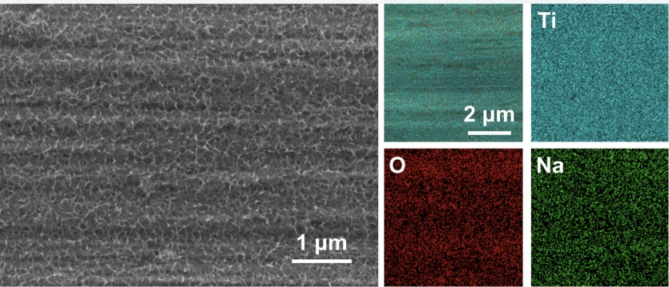
Figure S1 FESEM image of the NTO-Ti surface.

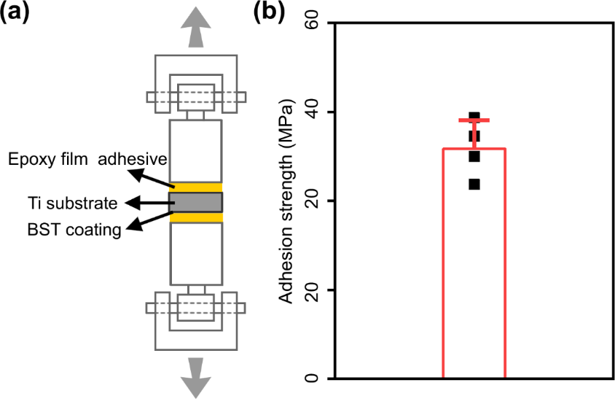
Figure S2 Adhesion-tension test. (a)Schematic illustration of adhesion-tension test. (b) Adhesion strength between coating and substrate of pyroTi. Data are presented as mean values ± SD (n = 4 for each group).

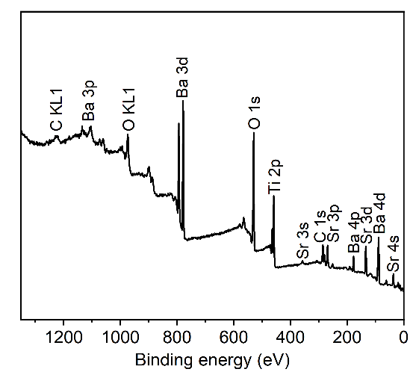
Figure S3 XPS survey of the pyroTi surface.

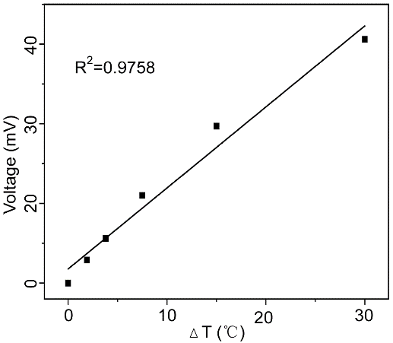
Figure S4 Linear relationship between the pyroelectric potential (Φpyro) and temperature change (ΔT).

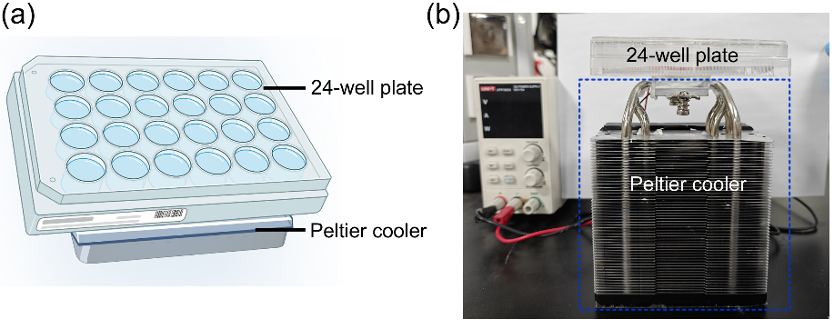
Figure S5 (a) Schematic illustration and (b) profile display of the cold treatment process utilizing a Peltier cooler.

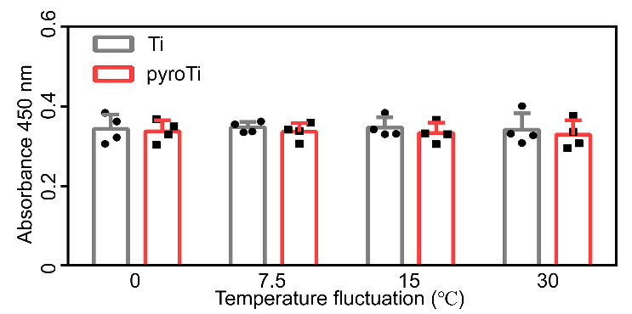
Figure S6 MC-3T3 cell viability on Ti and pyroTi surfaces with different temperature fluctions (0 to 30 ℃). Data are presented as mean values ± SD (n = 4 for each group).

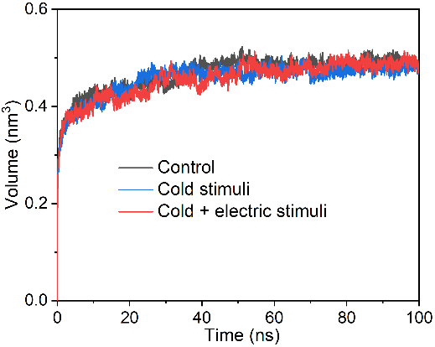
Figure S7 Time series of RMSD values for the interaction of electric and cold stimuli with MmTRPM8.

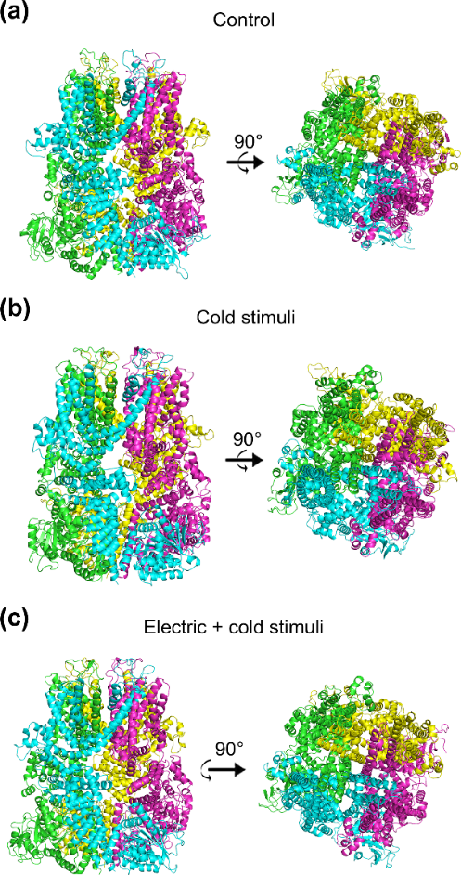
Figure S8 Cartoon representation of MmTRPM8 with cold-induced pyroelectric stimulation.

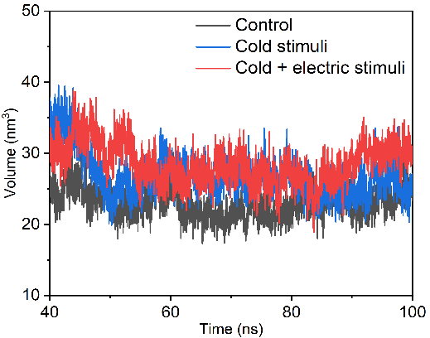
Figure S9 Time series of volume of channel values for the interaction of electric stimulation and cold treatment with MmTRPM8.

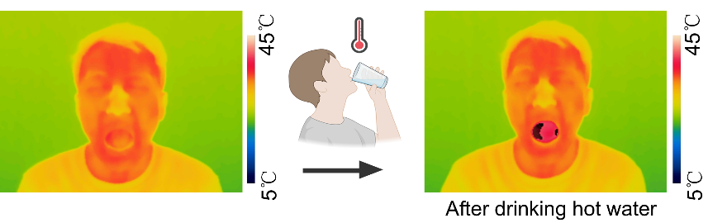
Figure S10 The mouth temperature recorded by the infrared camera after drinking hot water.

Table S1 Lattice parameters (a and c) of Barium titanate in pyroTi.
Samples | Lattice parameter (±0.001 Å) |  | c/a
Samples | a | c | c/a
pyroTi | 3.968 | 3.999 | 1.008

Table S2 Rat species primers used for qRT-PCR and the corresponding annealing temperatures
Gene | Forward primer sequence (5’–3’) | Forward primer sequence (5’–3’) | Annealing temperature(°C) |  | Product size(bp)
ALP | ACAACACCAACGCTCAGGTC | GTGACCTCGTTCCCCTGAGT |  | 60 | 142
OPN | GGTGATAGCTTGGCTTACGGA | TGGCATCGGGATACTGTTCA |  | 60 | 76
Runx-2 | ACGAATGCACTATCCAGCCA | GCAGGTACGTGTGGTAGTGA |  | 60 | 98
OCN | TGACAAAGCCTTCATGTCCAAG | GAAGCCAATGTGGTCCGCTA |  | 60 | 172
GAPDH | CTGGAGAAACCTGCCAAGTATG | GGTGGAAGAATGGGAGTTGCT |  | 60 | 138

