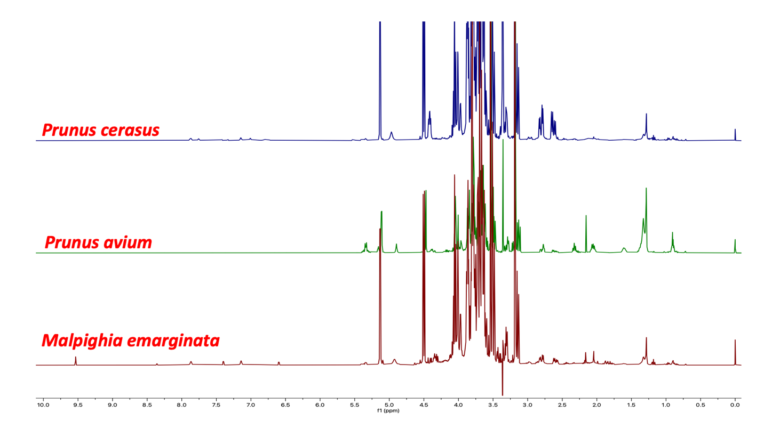
Figure S1: NMR Spectra for Malphigia and Prunus.

Table S1: Genbank Accession and project sample numbers.
Voucher Specimen | Genbank accession | Tissue
BRM1518_M. emarginata_ITSFL | Pending | Leaf
BRM1519_M. emarginata_ITSFL | Pending | Leaf
BRM1520_ M. emarginata_ITSFL | Pending | Leaf
BRM1521_ M. emarginata_ITSFL | Pending | Leaf
BRM1525_ M. emarginata_ITSFL | Pending | Leaf
BRM1526_ M. emarginata_ITSFL | Pending | Leaf
BRM1527_ M. emarginata_ITSFL | Pending | Leaf
BRM1528_ M. emarginata_ITSFL | Pending | Leaf
BRM1517_ _ M. glabra _ITSFL | Pending | Leaf
BRM1522_ _ M. glabra _ITSFL | Pending | Leaf
BRM1523_ _ M. glabra _ITSFL | Pending | Leaf
BRM1099_ M. emarginata _ITSFL | Pending | Dry fruit
BRM1524_ M. glabra_ITSFL | Pending | Leaf
BRM1529_M. glabra_ITSFL | Pending | Leaf
NHPRA190903_ M. glabra_ITSFL | Pending | Dry fruit
NHPRA221212_ M. glabra_ITSFL | Pending | Dry fruit

Table S2: NMR metabolomic sample numbers and tissue type.
NMR_ID | Species | Tissue
NHPRA190903-Malp_glab | Malpighia glabra | Fruit
NHPRA221212-Malp_glab | Malpighia glabra | Fruit
NHPRA230510-Malp_glab (BRM1522-DNA leaf) | Malpighia glabra | Fruit
NHPRA190826-Malp_glab | Malpighia glabra | Organic fruit
NHPRA201019-Malp_glab | Malpighia glabra | Processed
NHPRA230722-Malp_emar  (BRM1520_DNA leaf) | Malpighia emarginata | Fruit
NHPRA230922-Malp_emar  (BRM1099_DNA leaf) | Malpighia emarginata | Fruit
NHPRA221213-Malp_emar | Malpighia emarginata | Processed
NHPRA221018-Malp_emar | Malpighia emarginata | Processed
NHPRA210316-Malp_emar | Malpighia emarginata | Processed
NHPRA1610-Prun_cera | Prunus cerasus | Fruit
NHPRA1654-Prun_aviu | Prunus avium | Fruit
NHPRA346-Prun_cera | Prunus cerasus | Processed
NHPRA132-Prun_cera | Prunus cerasus | Processed
NHPRA115-Prun_aviu | Prunus avium | Fruit
NHPRA183-Prun_cera | Prunus cerasus | Processed

