Supplementary Table S2.1: Psychometric Properties of Study Variables
Standards / Dimensions | Number of Items (N) | Cronbach’s Alpha | CR | AVE
JCI Patient-Centered Standards
IPSG | 9 | 0.925 | 0.917 | 0.553
ACC | 7 | 0.923 | 0.920 | 0.622
PCC | 7 | 0.929 | 0.930 | 0.657
AOP | 5 | 0.911 | 0.919 | 0.694
COP | 8 | 0.932 | 0.932 | 0.631
MMU | 6 | 0.930 | 0.927 | 0.681
Total (JCI Standards) | 42 | 0.980 | — | —
Nursing Performance
Performance Efficiency | 5 | 0.897 | 0.885 | 0.606
Performance Effectiveness | 4 | 0.922 | 0.922 | 0.749
Performance Indicators | 15 | 0.944 | 0.940 | 0.513
Total (Nursing Performance) | 24 | 0.956 | — | —
Overall Total (Scored Items) | 66 | 0.982 | — | —
Notes: Cronbach’s alpha values were ≥0.7 indicate acceptable reliability. Composite Reliability (CR) values ≥0.7 and Average Variance Extracted (AVE) values ≥0.5 confirm convergent validity. The questionnaire included 91 items in total, with 66 scored items (42 for JCI standards and 24 for nursing performance) and 25 demographic items (e.g., hospital name and department), which were not included in the reliability analysis. The questionnaire was pre-tested with 40 nurses to ensure clarity and feasibility, and all subscales demonstrated high reliability and validity. CR and AVE were not calculated for the totals, as they are aggregate measures of the subscales.
Abbreviations: JCI = Joint Commission International; IPSG = International Patient Safety Goals; ACC = Access to Care and Continuity; PCC = Patient-Centered Care; AOP = Assessment of Patients; COP = Care of Patients; MMU = Medication Management and Use; CR = Composite Reliability; AVE = Average Variance Extracted.

Supplementary Figure. S2. 1: Confirmatory Factor Analysis (CFA) path diagram for JCI patient-centered standards.
This figure illustrates the CFA model for the six-factor JCI standards structure, including 42 item across International Patient Safety Goals (IPSG, 9 items, M1–M9), Access to Care and Continuity (ACC, 7 items, M10–M16), Patient-Centered Care (PCC, 7 items, M17–M23), Assessment of Patients (AOP, 5 items, M24–M28), Care of Patients (COP, 8 items, M29–M36), and Medication Management and Use (MMU, 6 items, M37–M42). The diagram shows standardized factor loadings (ranging from 0.41 to 0.88), covariances between factors (e.g., IPSG ↔ ACC = 0.87, COP ↔ MMU = 0.85), error terms (e1–e42) with correlations (e.g., e1 ↔ e2 = -0.12), and model fit indices (RMSEA = 0.054, CFI = 0.943, TLI = 0.935, NFI = 0.909, CMIN/DF = 2.514, P-Value = 0.000), confirming the construct validity of the JCI standards measurement.
Supplementary Table S2.2: CFA Model Fit Indices and Factor Loadings for JCI Standards
Parameter | Value/Range | Description/Notes
Model | Six-factor | IPSG, ACC, PCC, AOP, COP, MMU
Number of Items | 42 | Total items across all JCI domains
CFI | 0.943 | ≥0.90 acceptable, ≥0.95 ideal
TLI | 0.935 | ≥0.90 acceptable, ≥0.95 ideal
NFI | 0.909 | ≥0.90 acceptable
RMSEA | 0.054 | ≤0.06 good fit, ≤0.08 acceptable
CMIN/DF | 2.514 | ≤3 good fit, ≤5 acceptable; χ² and df values unavailable
P-Value | 0.000 | Statistically significant, typical in large samples
Factor Loadings |  | All loadings >0.4, confirming construct validity
- IPSG | 0.41–0.79 (M1–M9) | 9 items
- ACC | 0.59–0.83 (M10–M16) | 7 items
- PCC | 0.54–0.88 (M17–M23) | 7 items
- AOP | 0.56–0.87 (M24–M28) | 5 items
- COP | 0.53–0.88 (M29–M36) | 8 items
- MMU | 0.60–0.87 (M37–M42) | 6 items
Note: This table summarizes the CFA results for the six-factor JCI standard model, validating the 42-item structure. Fit indices indicated a good-to-acceptable model fit, and all factor loadings exceeded the threshold of 0.4, confirming construct validity.
Abbreviations: JCI = Joint Commission International; IPSG = International Patient Safety Goals; ACC = Access to Care and Continuity; PCC = Patient-Centered Care; AOP = Assessment of Patients; COP = Care of Patients; MMU = Medication Management and Use; CR = Composite Reliability; AVE = Average Variance Extracted; CFA = Confirmatory Factor Analysis; RMSEA = Root Mean Square Error of Approximation; CFI = Comparative Fit Index; TLI = Tucker-Lewis Index; NFI = Normed Fit Index; CMIN/DF = Chi-Square/Degrees of Freedom; χ² = Chi-Square; df = Degrees of Freedom.

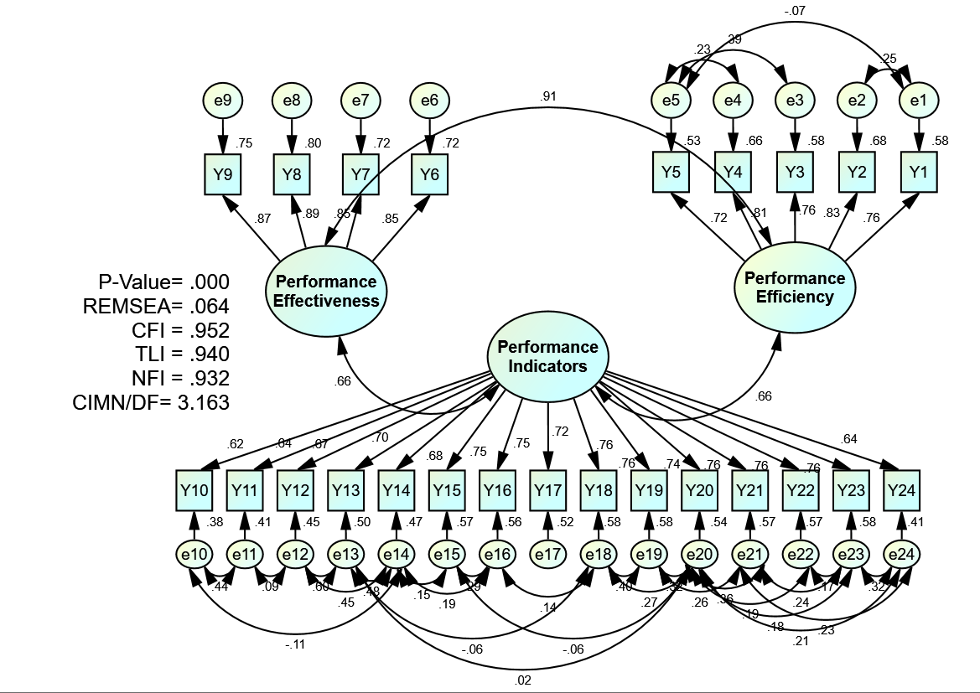
Supplementary Figure. S2. 2: Confirmatory Factor Analysis (CFA) Diagram for Nursing Performance Model. This diagram illustrates the three-factor structure of nursing performance with standardized factor loadings. Fit indices: RMSEA = 0.064, CFI = 0.952, TLI = 0.940, NFI = 0.932, CMIN/DF = 3.163, P-Value < 0.001.

Supplementary Table S2.3: CFA Model Fit Indices and Factor Loadings for Nursing Performance
Parameter | Value/Range | Description/Notes
Model | Three-factor | Performance Efficiency, Performance Effectiveness, Performance Indicators
Number of Items | 24 | Total items across all nursing performance dimensions
CFI | 0.952 | ≥0.90 acceptable, ≥0.95 ideal
TLI | 0.940 | ≥0.90 acceptable, ≥0.95 ideal
NFI | 0.932 | ≥0.90 acceptable
RMSEA | 0.064 | ≤0.06 good fit, ≤0.08 acceptable
CMIN/DF | 3.163 | ≤3 good fit, ≤5 acceptable; χ² and df values unavailable
P-Value | 0.000 | Statistically significant, typical in large samples
Factor Loadings |  | All loadings >0.4, confirming construct validity
- Performance Efficiency | 0.53–0.88 | 5 items (Y1–Y5)
- Performance Effectiveness | 0.72–0.80 | 4 items (Y6–Y9)
- Performance Indicators | 0.41–0.88 | 15 items (Y10–Y24)
Note: This table summarizes the CFA results for the three-factor nursing performance model, validating the 24-item structure. Fit indices indicate an acceptable-to-good model fit, and all factor loadings exceed the threshold of 0.4, confirming construct validity.
Abbreviations: CFA = Confirmatory Factor Analysis; RMSEA = Root Mean Square Error of Approximation; CFI = Comparative Fit Index; TLI = Tucker-Lewis Index; NFI = Normed Fit Index; CMIN/DF = Chi-Square/Degrees of Freedom; χ² = Chi-Square; df = Degrees of Freedom.

