In Situ NMR and Kinetics Reveal Origins of Regioselectivity Differences for Epichlorohydrin Ring-Opening in Lewis and Brønsted Acid Zeolites

David S. Potts,¹ Huston Locht,^{1,2} Sungmin Kim,³ Johannes Lercher,^{3,4} Jian Zhi Hu,^{3,5*}
David W. Flaherty^{1,2*}

¹Department of Chemical and Biomolecular Engineering
University of Illinois Urbana-Champaign, Urbana, Illinois 61801 (USA)

²School of Chemical and Biomolecular Engineering
Georgia Institute of Technology, Atlanta, Georgia 30332 (USA)

³Institute for Integrated Catalysis
Pacific Northwest National Laboratory, Richland, Washington 99352 (USA)

⁴Department of Chemistry and Catalysis Research Center, TU München, Lichtenbergstrasse 4, 85748 Garching, Germany

⁵The Gene & Linda Voiland School of Chemical Engineering and Bioengineering, Washington State University, Pullman, WA 99164, United States

Corresponding author e-mails: jianzhi.hu@pnnl.gov, dflaherty3@gatech.edu

S1. Inductive Effects in Epoxide Ring-Opening
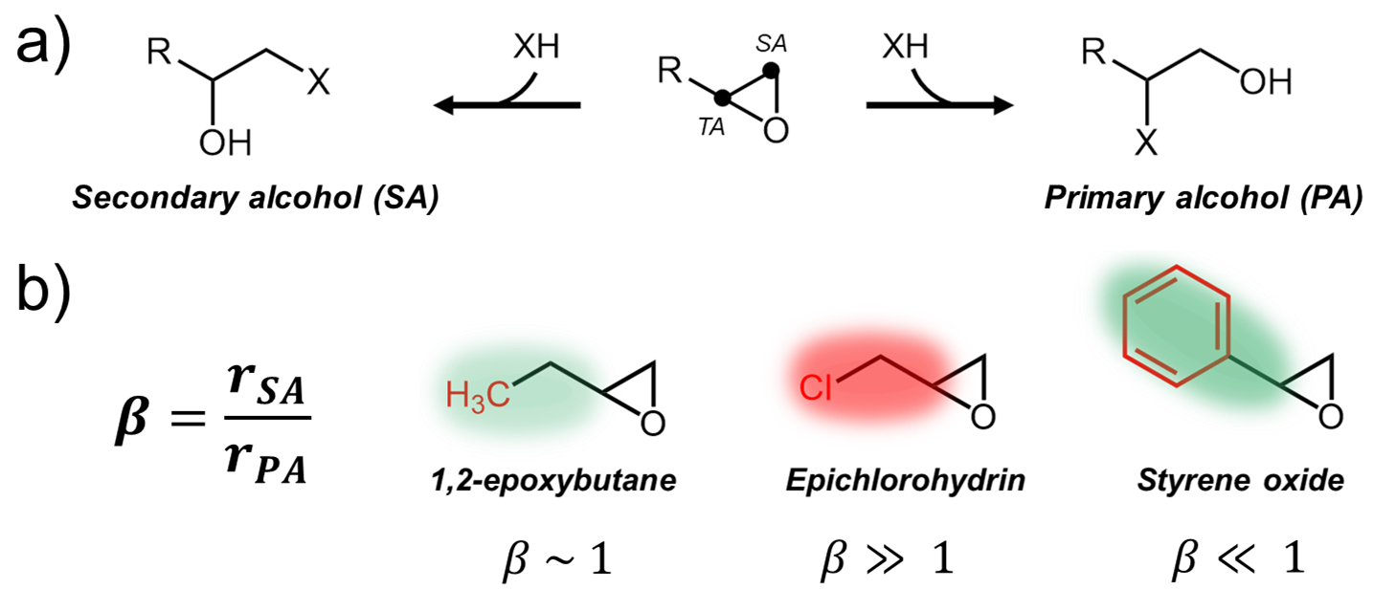
Scheme S1. a) Stoichiometric reaction for epoxide ring-opening with a nucleophile (XH), where either a secondary or primary alcohol product may form. b) Structures for 1,2-epoxybutane (a representative aliphatic epoxide with terminal methyl group), epichlorohydrin, and styrene oxide which illustrate an electron withdrawing effect (red shading) and electron donating effect (green shading), where a more intense shading indicates a stronger effect. These inductive effects significantly influence ratios of rates to form each isomer as quantified by values of β.

Note that the terminal ether (TE) formed during epoxide ring-opening with alcohols is a secondary alcohol, while the terminal alcohol (TA) product is a primary alcohol.
S2. Catalyst Characterization
Catalyst | M wt%ª | Si:Mª | Si:Alª | Band Gap (eV)^{b} | $Φ_{IR}$^{c} | Active Metal (%)^{d}
Al-BEA | 0.59 | 75 | 75 | -- | 1.56 | 97 ± 4
Sn-BEA | 1.35 | 143 | 3950 | 5.2 | 1.51 | 93 ± 6
Table S1. Characterization of the Chemical, Physical, and Electronic Properties of M-BEA.  ªMeasured with ICP-OES. ^{b}Extracted from leading edge of Tauc plot from DRUV-vis. ^{c}Calculated from infrared transmission spectra  of dehydrated M-BEA samples. ^{d}Measured from in situ 1,2-diphenylethylenediamine site titrations. |  |  |  |  |  |  |  |  |  |  |  |  | 104 ± 7
 |  |  |  |  |  |  |  |  |  |  |  |  | 96 ± 2
c
Table S1 summarizes the key material properties of the M-BEA materials, the calculation methods of which are described in the characterization subsections below.

S2.1 Diffuse Reflectance UV-Vis Spectra to Examine Dispersity of Active Sites

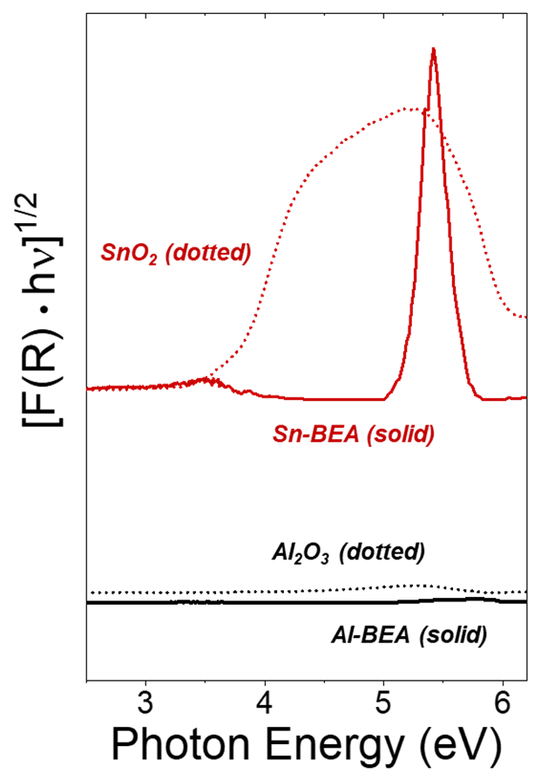

Figure S1. Tauc plots obtained with a UV-Vis spectrophotometer at ambient conditions for M-BEA (solid lines; Al ($-$), Zr ($-$)) and the respective metal oxides (dotted lines; γ-Al₂O₃ (--), SnO₂ (--)). UV-Vis spectra were obtained from 200 to 800 nm. Tauc plots were normalized to the most intense features and are vertically offset for clarity.

The band gaps for each M-BEA and the respective metal oxides were obtained by extrapolating the linear absorbance region of the Tauc plot in Figure S1 to the baseline. The intersection of the baseline and linear region equals the band gap photon energy. Al-BEA and γ-Al₂O₃ show negligible features within the region of photon energies examined, consistent with reported band gaps greater than 7 eV for γ-Al₂O₃.¹⁻² Table S2 reveals that the band gaps for Sn-BEA is greater than the band gaps for the metal oxides, providing evidence that the metal atoms are well dispersed in the *BEA framework.
The photon energy E in electron volts (eV) was obtained from the wavelength as follows:

$$E=\frac{3*{10}^{8}\frac{m}{s}}{λ \left(nm\right)*\frac{1 m}{{10}^{9} nm}}*h*\left(6.242*{10}^{18}\frac{eV}{J}\right)$$

where $λ$is the wavelength of the photon in nanometers, and h equals the Planck constant. The ordinate from Figure S1 was obtained from the ordinate of the raw spectra, the percent reflectance (% R). The Kubelka-Munk function (F(R)) was calculated from % R:

$$F\left(R\right)=\frac{{\left(1-\frac{\%R}{100}\right)}^{2}}{2*\left(\frac{\%R}{100}\right)}$$
F(R) was then multiplied by the photon energy, and taking the square root of the resulting quantity yielded the ordinate for Figure S1.

Catalyst | M-BEA  Band Gap (eV) | Metal Oxide Band Gap (eV)
Al-BEA | -- | --
Sn-BEA | 5.2 | 3.9

Table S2. Calculated band gaps for M-BEA and metal oxide materials. The band gaps for Al-BEA and Al₂O₃ likely exceed the regime of wavelengths possible to measure on the UV-Vis spectrophotometer.

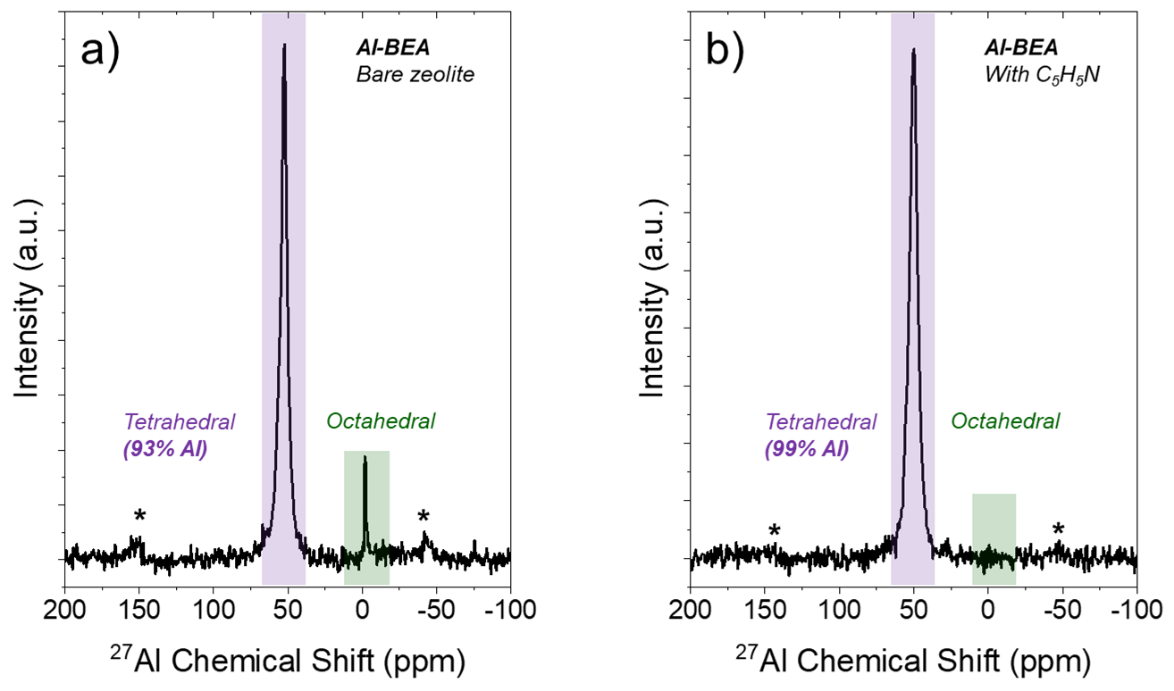
S2.2 ²⁷Al NMR Spectra to Elucidate Al Coordination in Al-BEA
Figure S2. ²⁷Al NMR spectra for a) bare Al-BEA and b) Al-BEA impregnated with C₅H₅N (298 K). The peaks representing tetrahedrally and octahedrally coordinated Al species are highlighted in purple and green, respectively. The calculated percentage of tetrahedral Al is shown in bold. Asterisks represent spinning side-band features.

Figure S2 presents the ²⁷Al NMR spectra for Al-BEA in the presence and absence of liquid pyridine (C₅H₅N). The percentage of tetrahedral Al shown in the figure was calculated from the ratio of the tetrahedral to octahedral peak area features. Notably, the bare zeolite shows a greater percentage of octahedral Al than the materials impregnated with C₅H₅N. Liquid or vapor water (H₂O) binds to tetrahedral Al atoms and gives rise to octahedral ²⁷Al NMR features, which reflects the additional coordination of two H₂O molecules.³⁻⁵ H₂O adsorbed from the atmosphere likely contributes to the larger quantity of octahedral Al observed in the bare zeolite. Previous works found that loading hydrated Brønsted acid zeolites with ammonia (NH₃) converts octahedral Al species back to tetrahedral Al sites,⁵⁻⁷ making the adsorption of a strong Brønsted base a reliable strategy to report octahedral Al content without interference from H₂O
Motivated by the role of NH₃ shown in previous studies, we impregnated the Al-BEA materials with liquid C₅H₅N to revert hydrated Al species to tetrahedral Al atoms. Figure S2 shows that the C₅H₅N-incorporated Al-BEA material shows lower quantities of octahedral Al (1%) than the bare materials (7%). The value for the C₅H₅N-incorporated Al-BEA aligns closely with the value of 3% obtained from active site titrations (Section S6, vide infra). Overall, the spectra in Figure S2 support that Al-BEA contains minor quantities of octahedral Al that do not convolute the kinetics reported in the main text.

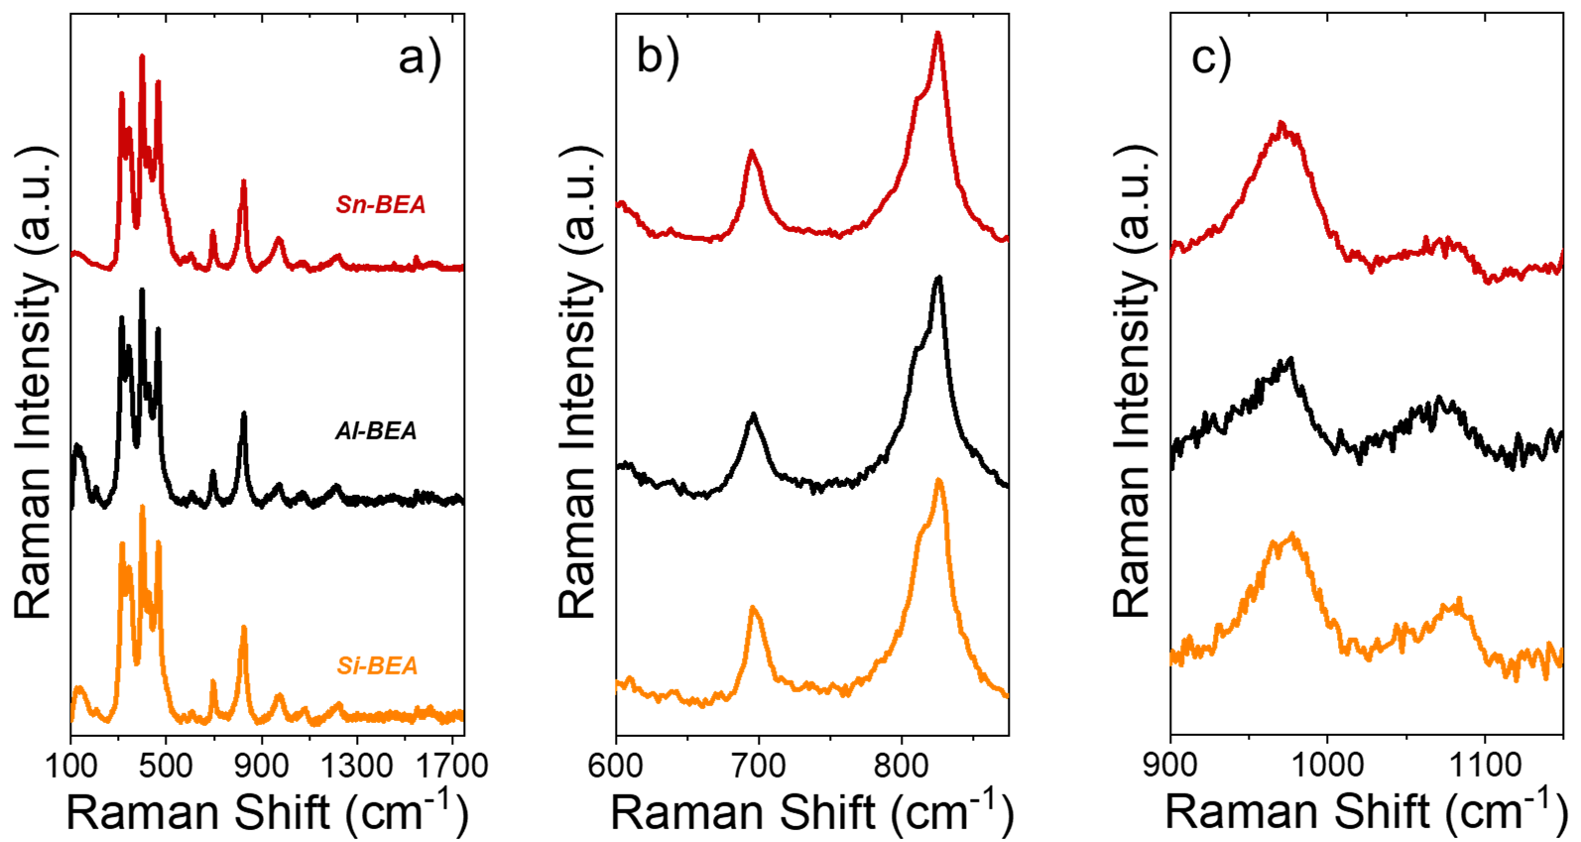
S2.3 Ex situ Raman Spectra to Determine Metal Coordination in M-BEA

Figure S3. Ex situ Raman spectra of M-BEA (Sn (red), Al (black), Si (orange)) at (a) the full range of Raman shifts examined, (b) magnified view of the range of 600-875 cm⁻¹, and (c) magnified view of the 900-1150 cm⁻¹ region. The spectra were taken at ambient conditions with a Raman spectrometer (Renishaw, InVia) equipped with a 532 nm laser that delivered a power density of ~2 mW μm⁻². The spectra are an average of 10 scans with an exposure time of 20 s. Spectra are normalized by the maximum feature at ~400 cm⁻¹ and are vertically offset for clarity.

Figure S3a reveals that each M-BEA and Si-BEA possess similar Raman spectra. The intense peaks between 250 and 550 cm⁻¹ represent features of the *BEA framework: the peaks at 315 and 345 cm⁻¹ represent six-membered rings, the peaks at 400 and 425 cm⁻¹ represent five-membered rings, and the peak at 465 cm⁻¹ represents four-membered rings characteristic of the *BEA framework.⁸⁻⁹ The peak at ~695 cm⁻¹ has previously been reported on spectra of *BEA zeolites and may originate from the *BEA framework.¹⁰⁻¹¹ The peak at ~820 cm⁻¹ represents a symmetric skeletal mode of microporous silicates.¹²⁻¹³

Both M-BEA show a feature at 144 cm⁻¹. The feature is also present in Si-BEA, suggesting the feature results from a mode inherent to the *BEA framework. Alternatively, the feature may be an artifact of the Raman filter used to suppress signal from Rayleigh scattering. Figure S3b zooms into a region in which Al₂O₃ (640, 751 cm⁻¹)¹⁴⁻¹⁶ and SnO₂ (632, 773 cm⁻¹)¹⁷⁻¹⁹ have been reported to show Raman features. Both M-BEA show nearly identical spectra in this region, with no notable features where the respective metal oxides contain features. This supports that both M-BEA do not contain oligomeric metal oxide structures.

Figure S3c shows that each M-BEA possesses features at ~960 and ~1080 cm⁻¹. The feature at ~960 cm⁻¹ has been attributed to silanol defects.²⁰⁻²² The peak at ~1080 cm⁻¹ plausibly originates from the *BEA framework. Ti-O-Si features have been commonly reported in the literature at ~960 and ~1125 cm⁻¹, respectively.²³⁻²⁶ However, similar features have not been well reported for Al- or Sn-containing zeolites. Therefore, the presence of each metal in the framework cannot be confirmed with Raman spectra but is indirectly supported by the absence of metal oxide features.

The Raman spectra in Figure S3 suggest that the Al and Sn atoms within M-BEA predominately reside at tetrahedral framework positions within the *BEA zeolite framework.
S2.4 X-Ray Diffraction to Confirm Crystallinity of M-BEA

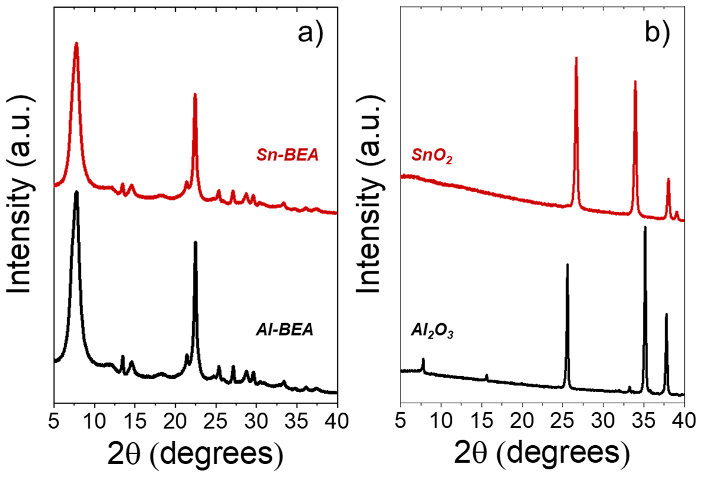

Figure S4. Powder X-ray diffractograms obtained with Cu Kα radiation (0.15418 nm) under ambient conditions for a) M-BEA (Al (black), Sn (red)) and b) the corresponding bulk metal oxides (γ-Al₂O₃ (black), SnO₂ (red)). Spectra are vertically offset for clarity.

The crystallographic features for each M-BEA are representative of the *BEA framework.²⁷ As displayed in Figure S4a, each M-BEA material shows weak features around 25.5, 27, 29, and 33 degrees. The broad feature at ~22.5 degrees suggests a small crystallite size²⁸ and the presence of internal (SiOH)_{x} defects formed by the dealumination of the parent Al-BEA material (Si:Al = 20).

Figure S4b reveals that several of these peak locations coincide with strong features in the diffractograms of at least one of the metal oxides. However, the presence of weak features at these positions in all M-BEA suggests that the features are characteristic of the *BEA framework, rather than originating from the presence of metal oxide. Overall, the XRD patterns in Figure S4 support that each M-BEA possesses the crystalline *BEA framework, with minimal to no detectable metal oxide crystallites present.

S2.5 Infrared Spectra to Measure Silanol Density of M-BEA
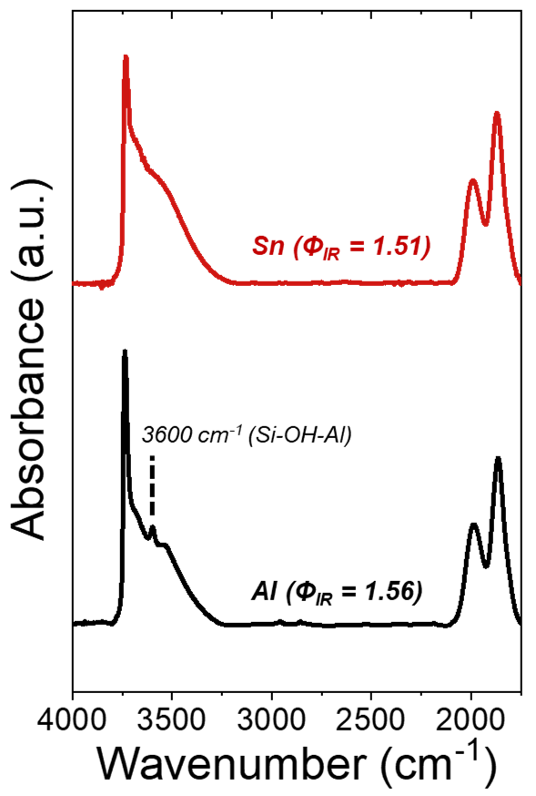

Figure S5. Infrared spectra of dehydrated samples of M-BEA (Sn (red), Al (black)). The samples were dehydrated under flowing Ar (101 kPa He, 50 cm³ min⁻¹) at 573 K prior to measurement. Spectra are vertically offset for clarity.

The greater v(O-H) areas (3300-3750 cm⁻¹) for each M-BEA-OH compared to M-BEA-F, with respect to the v(Si-O-Si) area (1800-2100 cm⁻¹), shows that the M-BEA-OH materials possess a greater density of (SiOH)_{x} groups than the M-BEA-F materials. The Φ_{IR} values in Table S1 were calculated by peak fitting on Origin 2021 (OriginLab Corporation). The peak areas for v(O-H) and v(Si-O-Si) were calculated with Gaussian fits (example shown in Figure S6).

As shown in Equation 8 in the main text, the equation to calculate Φ_{IR} is:

$Φ_{IR}=\frac{A_{ν\left(O-H\right)}}{A_{ν\left(Si-O-Si\right)}}$ (S1)

The red, purple, and orange peaks represent networked SiOH features which are summed to determine A_{v(O-H)}. The green and brown peaks in the Si-O-Si region were summed together to get $A_{ν\left(Si-O-Si\right)}$. The blue peak in v(O-H) represents isolated SiOH features, so these peak areas were excluded from the Φ_{IR} calculations.

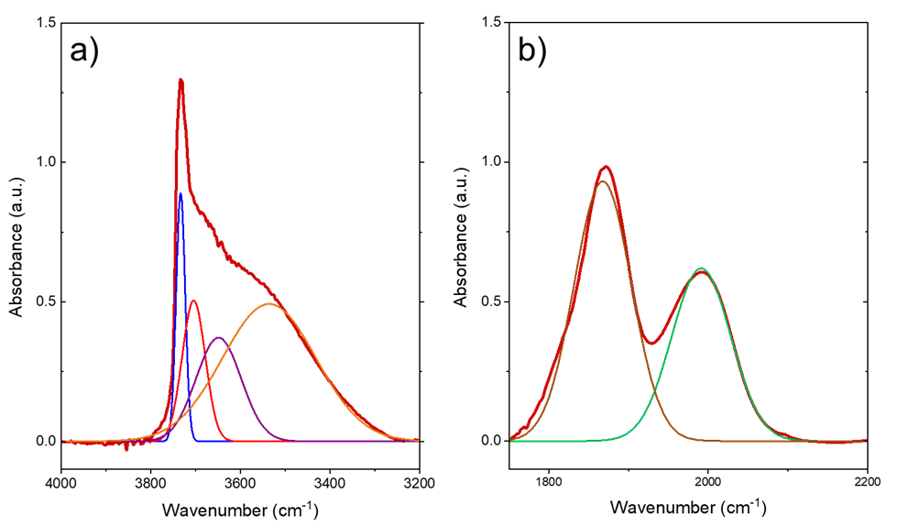
Figure S6. Fitted peaks for the (a) networked (red, purple, orange) and isolated (blue) Si-OH region and (b) Si-O-Si overtones at 1865 (brown) and 2000 cm⁻¹ (green) for Sn-BEA.

S2.6 Calculation of (SiOH)_{x} (unit cell)⁻¹ for M-BEA

The density of (SiOH)_{x} per unit cell was estimated based on the initial quantity of Al present in the commercial zeolite (Si:Al = 20). A *BEA unit cell contains 64 T atoms (i.e., Si, Al, or Sn), so the initial quantity of Al per unit cell equals 3.047:

$$Si+Al=64$$

$$20Al+Al=64$$

$$Al=3.047 per unit cell$$

Assuming all Al atoms are removed in the thorough dealumination treatment for Sn-BEA, the dealumination produces 3.047 (SiOH)_{x} (unit cell)⁻¹. The metal weight loading allows for the calculation of the Si:M ratio for each M-BEA:

$$Si+M=64$$

$$\left(Si:M\right)M+M=64$$

This can be used to calculate the number of metal atoms per unit cell incorporated into the formed (SiOH)_{x}. The final (SiOH)_{x} (unit cell)⁻¹ for Sn-BEA is equal to the initial amount of Al (assumed that all Al is removed) subtracted by the added Sn. In contrast, the (SiOH)_{x} (unit cell)⁻¹ for the Brønsted acid equals the initial quantity of Al subtracted by the amount of Al removed:

$${\left(SiOH\right)}_{x, Sn-BEA}=3.047 -added Sn$$

$${\left(SiOH\right)}_{x, Sn-BEA}=3.047 -removed Al$$

Table S3 reports metal loadings per unit cell from ICP and calculated (SiOH)_{x} per unit cell. The calculated values predict a wider range of zeolite hydrophilicity than the Φ_{IR} calculations in Section S2.5. However, rates depend weakly on metal loading (Section S4, vide infra), and therefore (SiOH)_{x} (unit cell)⁻¹, within the range of loadings examined for M-BEA.

Catalyst | M (unit cell)⁻¹ | (SiOH)_{x} (unit cell)⁻¹
Al-BEA-OH | 0.86 | 2.17
Zr-BEA-OH | 0.47 | 2.57

Table S3. Metal loadings and (SiOH)_{x} per unit cell, determined from metal loadings from ICP and estimated Al removed by dealumination treatments.
S2.7 CD₃CN and C₅H₅N Infrared Adsorption Spectra to Examine Acid Site Character

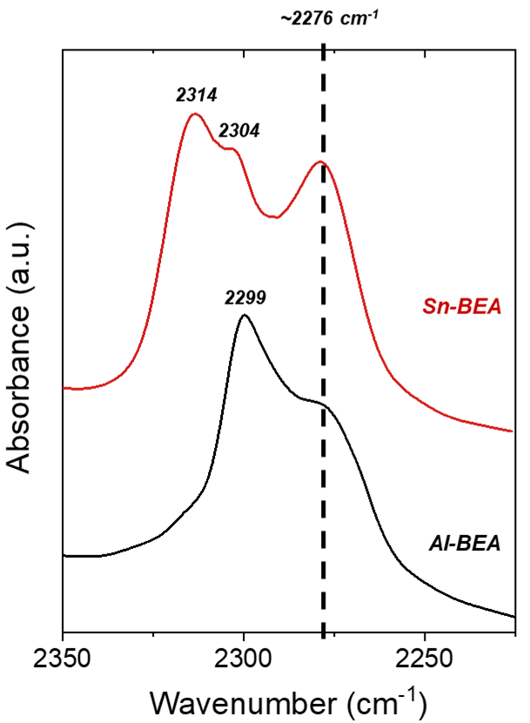

Figure S7. Infrared spectra of deuterated acetonitrile (CD₃CN) bound to M-BEA (Sn (red), Al (black)) materials (0.05 kPa CD₃CN, 101 kPa Ar, 303 K). All spectra are normalized to the area of the Si-O-Si region of the zeolite from 1750-2100 cm⁻¹. Spectra are vertically offset for clarity.

The feature at ~2299 cm⁻¹ for Al-BEA is consistent with previous assignments for CD₃CN bound to Brønsted acidic Al sites.²⁹⁻³⁰ Al-BEA shows a shoulder at ~2276 cm⁻¹ that has been reported to result from CD₃CN coordinated to (SiOH)_{x} nests within *BEA.^{29, 31} Extraframework Lewis acidic Al species have been reported to show a feature at ~2325 cm⁻¹,²⁹⁻³⁰ where no feature is observed in Al-BEA. The spectra suggests that the Al atoms in Al-BEA predominantly exist as tetrahedrally incorporated Brønsted acid sites.

Sn-BEA also shows a feature at ~2276 cm⁻¹ that likely originates from CD₃CN bound to Si-OH groups. Sn-BEA also displays features at ~2304 and ~2314 cm⁻¹, which align with previous proposals for closed and open tetrahedral Sn sites within zeolites, respectively.³²⁻³⁴ While the presence of these two features demonstrates a mix of Sn site structures under an inert gaseous environment, the ratio of open and closed sites may change in the presence of solvent. Several past studies argue that closed Lewis acid sites may open in the presence of protic molecules such as H₂O³⁵⁻³⁷ and alcohols,³⁸⁻³⁹ meaning that Sn sites can open in situ in the presence of CH₃OH and convolute the ex-situ site distribution.

Collectively, the spectra of adsorbed CD₃CN in Figure S7 demonstrate the presence of Lewis and Brønsted acid sites within the M-BEA materials.

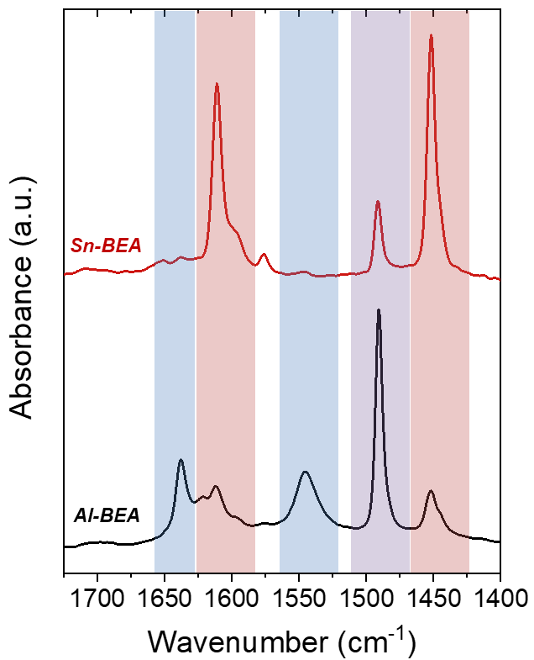

Figure S8. Infrared spectra of pyridine (C₅H₅N) bound to Lewis and Brønsted acid sites over M-BEA (Sn (red), Al (black)) materials (0.9 kPa C₅H₅N, 101 kPa Ar, 393 K). All spectra are normalized to the area of the Si-O-Si region of the zeolite from 1750-2100 cm⁻¹. The highlighted regions on the plot represent regions for C₅H₅N absorbance features coordinated to only Brønsted acid sites (blue), only Lewis acid sites (red), and either Lewis or Brønsted acid sites (purple). Spectra are vertically offset for clarity.

Figure S8 reveals that Al-BEA and Sn-BEA both possess features at ~1490 cm⁻¹, corresponding to C₅H₅N bound to Lewis or Brønsted acid sites.⁴⁰⁻⁴¹ Each catalyst also possesses features at ~1450 cm⁻¹ and 1580-1625 cm⁻¹, which have been attributed to C₅H₅N bound to Lewis acid sites.^{40, 42-47} The presence of these features in Al-BEA may signal the presence of some fraction of extraframework Lewis acidic Al species, in contrast with the absence of Lewis acid Al features on the CD₃CN spectra. Al-BEA also shows features at ~1550 and ~1640 cm⁻¹, which solely originate from protonated C₅H₅N at Brønsted acid sites.⁴⁰⁻⁴⁴ Sn-BEA contains very minor features in these regions, which may suggest that a minor fraction of Sn sites possess Brønsted acid character. Sn-BEA and Al-BEA show small features at ~1575 cm⁻¹, which has been attributed to physisorbed C₅H₅N.^{40, 44, 48}

Sn-BEA contains a sharp feature at ~1611 cm⁻¹, which has previously been assigned to C₅H₅N coordinated to Lewis acidic Sn sites.^{34, 49-50} Sn-BEA also shows a shoulder at ~1595 cm⁻¹, consistent with previous assignments for C₅H₅N hydrogen-bonded to -OH groups.^{41, 43-44, 46} These features may arise from C₅H₅N coordinated to the -OH group from Sn-OH (open sites), the adjacent Si-OH, or (SiOH)_{x} nests.

Overall, the spectra of adsorbed C₅H₅N in Figure S8 provide insight into the distribution of active sites within M-BEA.

S3. Calculation and Estimation of Epoxide and Product Sensitivity Factors
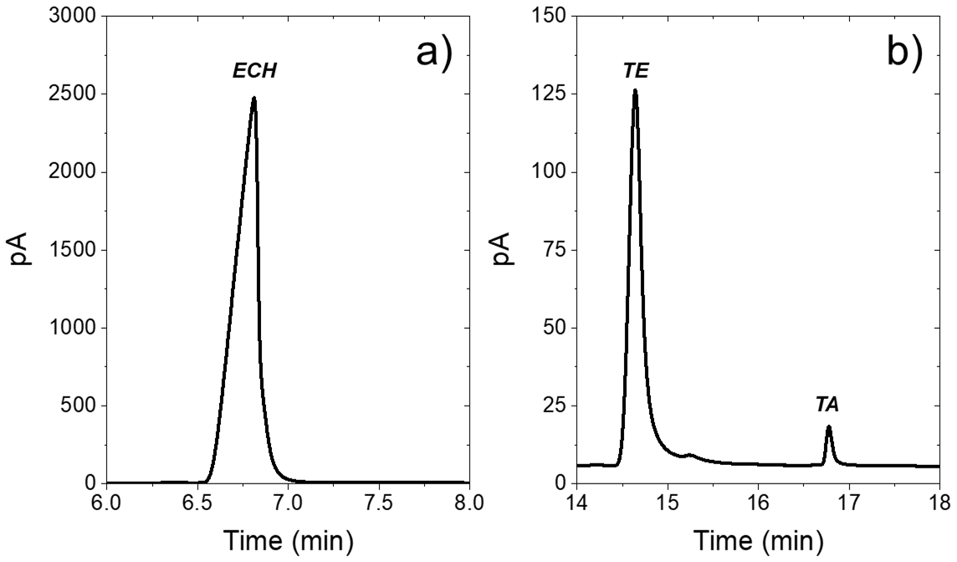

Figure S9. Raw GC chromatograms zoomed in to show peaks corresponding to (a) C₃H₅ClO, and (b) the terminal ether and terminal alcohol formed by the reaction of C₃H₅ClO with CH₃OH over Sn-BEA for 0.5 h (0.2 M C₃H₅ClO, 24.7 CH₃OH, 308 K).

Figure S9 demonstrates the high signal-to-noise ratio of C₃H₅ClO and the TE and TA product peaks from the GC chromatograms, as well as the peak separation between the ring-opening products. GC chromatograms were collected as a function of concentrations, which were used to determine the sensitivity factors of the epoxide and TE product using as-purchased chemicals (see Section 4.3 of the main text for sources and purities). Table S4 reports the sensitivity factors for these species, which equal the slope of the calibration curve fit lines for the GC peak area as a function of species concentration. A commercial sample for the TA product was not available for purchase, so we assumed that TA and TE have identical sensitivity factors. Our previous work showed that the sensitivity factors for the TA and TE products from C₄H₈O differ by less than 5%, so we expect the products from C₃H₅ClO will show very similar values as well.⁵¹

Compound | Sensitivity Factor (peak area M⁻¹)
C₃H₅ClO | 85210
TE | 63060

Table S4. Sensitivity factors determined from calibration curves.

During reactions, the concentration of the products was calculated with the integrated peak areas and measured sensitivity factors:

$\left[product\right]=\frac{GC Peak Area}{Sensitivity Factor}$ (S2)
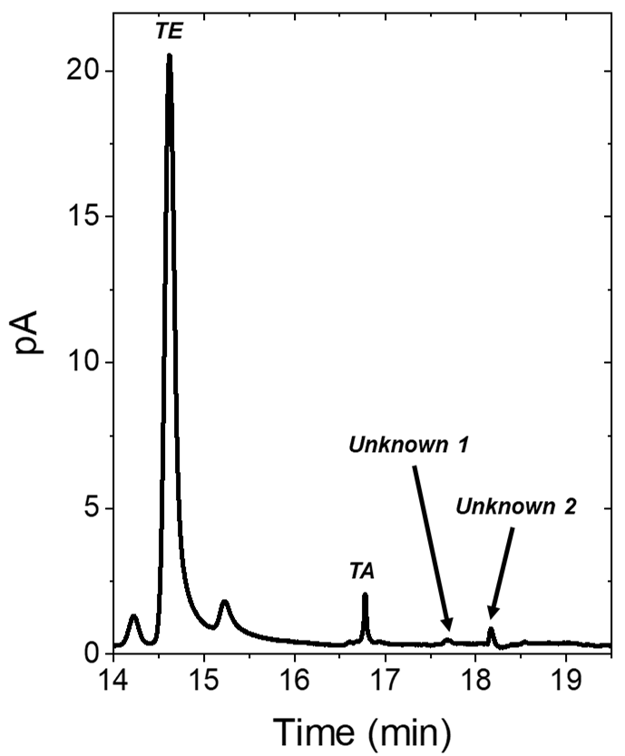

Figure S10. Raw GC chromatograms zoomed in to show peaks corresponding to the terminal ether product, terminal alcohol product, and unknown peaks that appear during the reaction of C₃H₅ClO with CH₃OH over Sn-BEA for 0.5 h (0.2 M C₃H₅ClO, 1 M CH₃OH, 308 K).

Figure S10 shows a GC chromatogram from the reaction of C₃H₅ClO with CH₃OH, where unknown peaks appear at 17.7 and 18.2 minutes. The unknown peaks account for < 5% of all products formed. While the unknown species have not been identified, the peaks may originate from secondary oligomers formed by the reaction of the ring-opening products reacting with epichlorohydrin.

S4. Madon-Boudart Criterion Test to Identify Active Centers for Ring-Opening

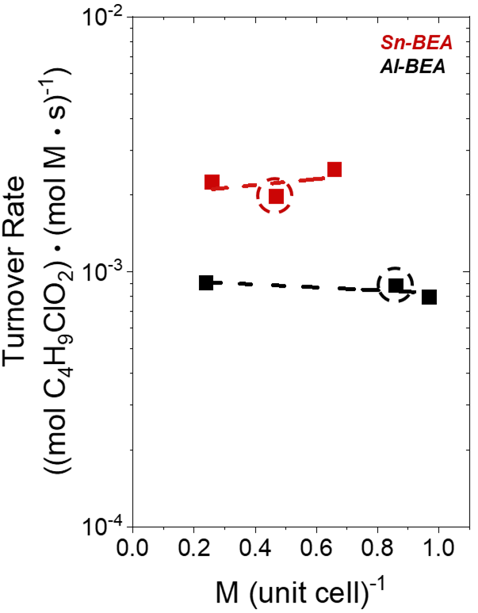

Figure S11. Total product formation rates from C₃H₅ClO ring-opening with CH₃OH (0.07 M C₃H₅ClO, 0.4 M CH₃OH, CH₃CN solvent, 308 K) as a function of active metal loading over Al- (black) and Sn-BEA (red). The circled points signify the catalyst used for this study.

Figure S11 presents turnover rates as a function of metal loading for each M-BEA. Rates depend negligibly on metal loading within the range of loadings examined for all materials, ruling out contributions from intrapore mass transfer to turnover rate measurements.
S5. XRD Analysis of Spent Catalyst and Hot Filtrations to Examine Catalyst Stability
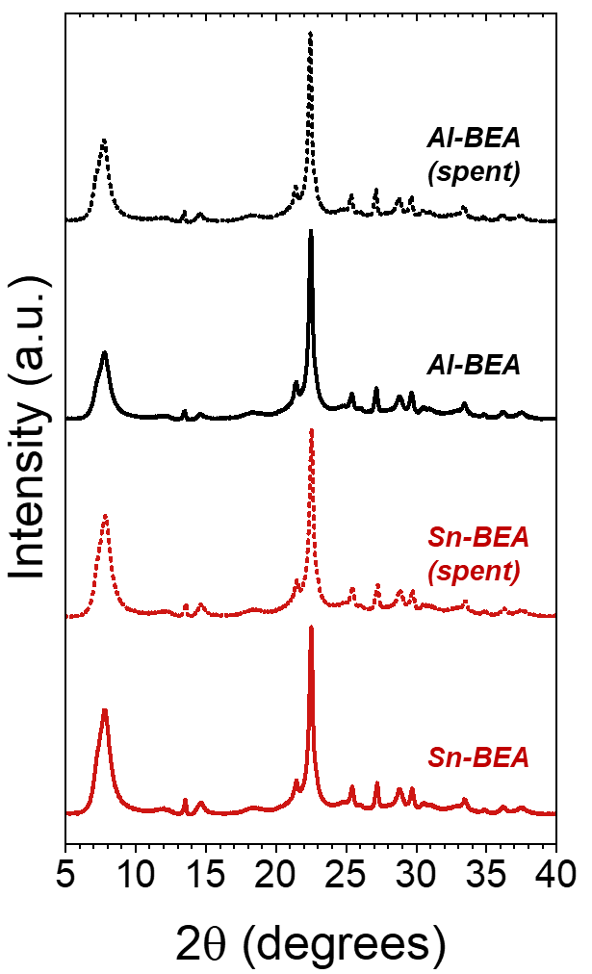

Figure S12. Powder X-ray diffractograms obtained before (solid lines) and after (hollow lines) the C₃H₅ClO ring-opening reaction with CH₃OH (0.07 M C₃H₅ClO, 1 M CH₃OH, CH₃CN solvent, 308 K) over Al- (black) and Sn-BEA (red). The reaction was carried out for 24 hours, then the catalyst was recovered and dried by vacuum filtration. Spectra were collected with Cu Kα radiation (0.15418 nm) under ambient conditions, and are vertically offset for clarity.

Figure S12 presents X-ray diffraction patterns for M-BEA before and after the reaction of C₃H₅ClO with CH₃OH over 24 hours. The fresh and spent Al-BEA and Sn-BEA materials show nearly identical peak locations and intensities, supporting that contacting these catalysts with the reaction mixture does not cause structural changes or catalyst deactivation.
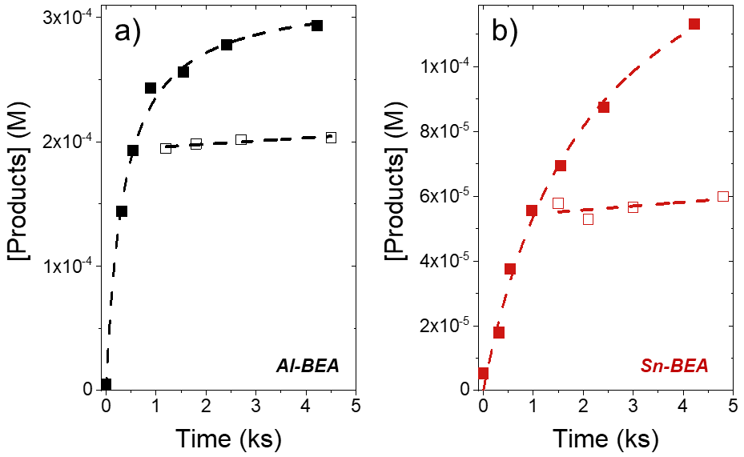
Figure S13. Measured total product concentrations (sum of [1M2B] and [2M1B]) as functions of time during hot filtration tests for 1,2-epoxybutane (C₄H₈O) ring-opening (0.005 M C₄H₈O, 6 M CH₃OH, CH₃CN solvent, 308 K) over (a) Al-BEA (black) and (b) Sn-BEA (red). The hollow points represent epoxide concentrations from aliquots that were separated from the catalyst after ~10-15 min, while solid points indicate concentrations from aliquots that were kept in contact with the catalyst throughout the reaction.

Figure S13 displays the results of hot filtration tests for Al-BEA and Sn-BEA during the ring-opening of 1,2-epoxybutane (C₄H₈O) with CH₃OH, taken from our previous work.⁵¹ After separating the solution from the catalyst, the concentration of the ring-opening products stops increasing with time (hollow points). This result provides evidence that metal atoms do not leach from the *BEA framework, and the active sites remain within the framework during catalysis. While these experiments utilize C₄H₈O instead of C₃H₅ClO, we argue that the experiments support that the active sites in Al-BEA and Sn-BEA will also remain coordinated to the zeolite framework during C₃H₅ClO ring-opening with CH₃OH.

S6. Counting Active Sites with 1,2-Diphenyl-1,2-Ethylenediamine Titrations
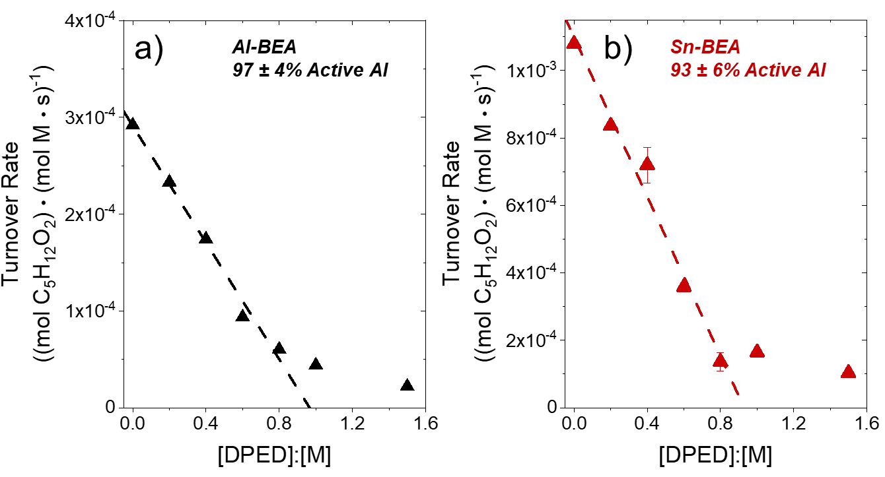
Figure S14. Total product formation rates from C₄H₈O ring-opening with CH₃OH (0.005 M C₄H₈O, 0.4 M CH₃OH, CH₃CN solvent, 308 K) as a function of 1,2-diphenyl-1,2-ethylenediamine (DPED) to active metal ratio over (a) Al-BEA (black) and (b) Sn-BEA (red). The data for Al-BEA was reported in a previous manuscript.⁵²

1,2-diphenyl-1,2-ethylenediamine (DPED) is a titrant that could poison active sites in both Lewis and Brønsted acidic M-BEA, which was utilized to count active sites during C₄H₈O ring-opening. A line was fit to the linear portion of the plots in Figure S14 and extrapolated to the x-axis to estimate the number of active sites present in the M-BEA materials. All materials show greater than 90% active metal atoms, providing evidence that all (or nearly all) metal atoms are tetrahedrally bound to the *BEA framework and catalyze ring-opening. We anticipate that the M-BEA materials would show a similarly high quantity of active metal atoms during C₃H₅ClO ring-opening.

S7. Derivation of Rate Expression for C₃H₅ClO Ring-Opening with CH₃OH over M-BEA
Catalyst | [CH₃OH]:[C₃H₅ClO] < 15 |  | [CH₃OH]:[C₃H₅ClO] > 30
Catalyst | TE | TA | TE | TA
Al-BEA | [CH₃OH]^{1.05}  [C₃H₅ClO]^{0.14} | [CH₃OH]^{0.58}  [C₃H₅ClO]^{0.19} | [CH₃OH]^{0.29}  [C₃H₅ClO]^{0.77} | [CH₃OH]^{0.24}  [C₃H₅ClO]^{0.83}
Sn-BEA | [CH₃OH]^{0.99}  [C₃H₅ClO]^{0.16} | [CH₃OH]^{0.45}  [C₃H₅ClO]^{0.22} | [CH₃OH]^{0.19}  [C₃H₅ClO]^{0.83} | [CH₃OH]^{0.10}  [C₃H₅ClO]^{0.80}
Table S5. Formation Rate Orders of TE and TA for C₃H₅ClO ring-opening from Figure 1 in main text.
The formation rates of TE and TA derived from C₃H₅ClO show clear differences in their dependence on the concentration of the nucleophile (i.e., [CH₃OH]), which contrasts with prior studies of epoxide ring-opening on solid catalysts. The apparent power-law dependencies for TE and TA formation differ significantly (by 0.5 – 0.6) at [CH₃OH]:[C₃H₅ClO] < 15.

S7. Derivation of Rate Expression for C₃H₅ClO Ring-Opening with CH₃OH over M-BEA
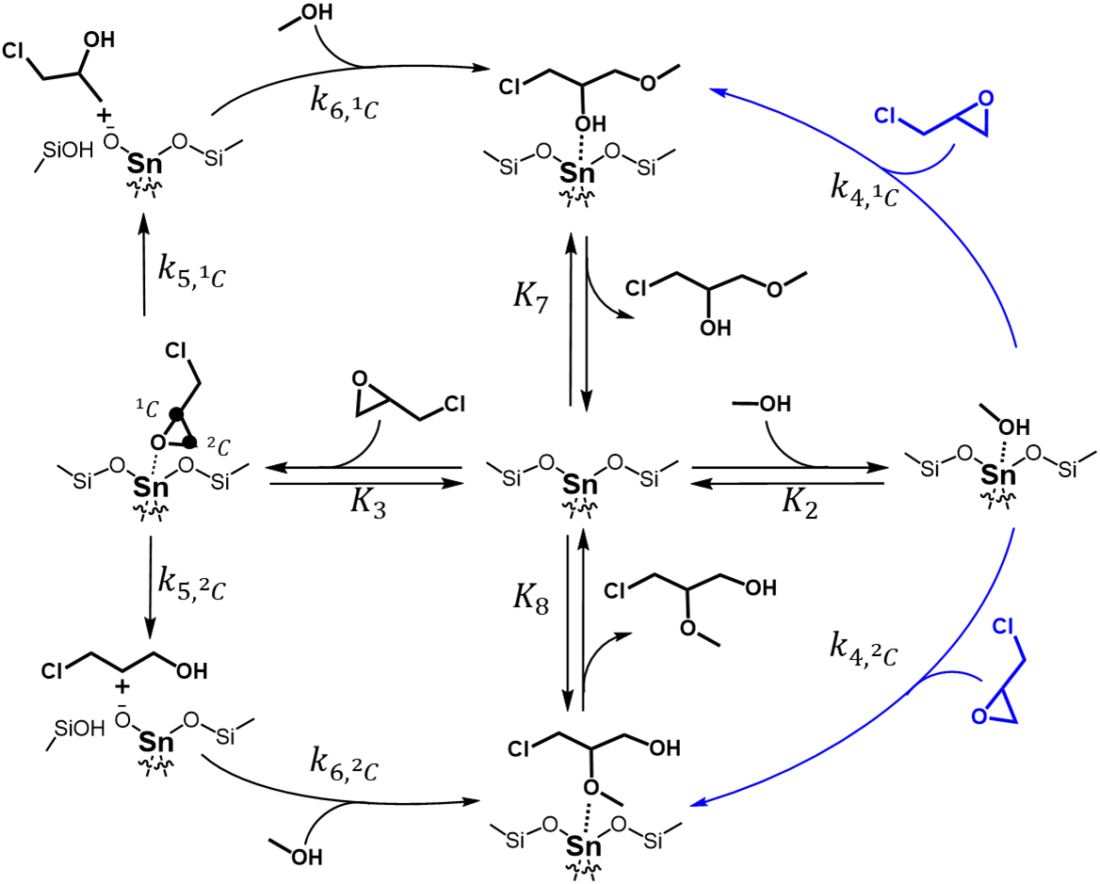
Scheme S2. Plausible product-forming steps for ring-opening of C₃H₅ClO with CH₃OH over Sn-BEA. Reaction may proceed through a concerted S_{N}2 pathway with an activated CH₃OH intermediate (blue) or a stepwise S_{N}1 pathway in which C₃H₅ClO ring-opens to form carbocations, followed by adsorption and activation of CH₃OH (black). For brevity, we do not show the reversible adsorption of CH₃CN molecules (step 1) in this cycle.

Scheme S2 and Scheme 1 in the main text depict the proposed steps for the ring-opening of C₃H₅ClO with CH₃OH over Sn-BEA and Al-BEA, respectively. The catalytic cycle begins with the adsorption of CH₃CN (step 1, not shown), C₃H₅ClO (step 2), or CH₃OH (step 3). The products may form through adsorbed CH₃OH in a kinetically relevant S_{N}2 reaction step (4). Alternatively, an S_{N}1 pathway may occur, where adsorbed C₃H₅ClO irreversibly ring-opens to form a primary or secondary carbocation (step 5). The products then form when CH₃OH attacks the adsorbed carbocations (step 6). The products desorb in reversible steps (7 and 8) to complete the cycle. The total rates of product formation from C₃H₅ClO ring-opening rates can be modeled with:

$r_{RO}= r_{4}+r_{6}=k_{4}\left[C_{3}H_{5}ClO\right]\left[CH_{3}OH^{*}\right]+(k_{6,{}_{ }^{1}C }\left[{C_{1+}}^{*}\right]+k_{6,{}_{ }^{2}C }\left[{C_{2+}}^{*}\right])\left[CH_{3}OH\right]$ (S3)

where $\left[{C_{1+}}^{*}\right]$ and $\left[{C_{2+}}^{*}\right]$ represent the numbers of primary and secondary ring-opened carbocations formed from steps with the rate constants $k_{5,{}_{ }^{1}C }$ and $k_{5,{}_{ }^{2}C}$, respectively. The term $k_{4}$ represents the sum of the rate constants to form the products in step 4 ($k_{4}=k_{4,{}_{ }^{1}C }+k_{4,{}_{ }^{2}C}$). We apply the pseudo-state hypothesis to the respective bound intermediates, which gives:

$r_{RO}=\frac{k_{2}k_{4}\left[C_{3}H_{5}ClO\right]\left[CH_{3}OH\right][*]}{k_{-2} +{ k}_{4}\left[C_{3}H_{5}ClO\right]} + \frac{k_{3}k_{5,{}_{ }^{1}C }\left[C_{3}H_{5}ClO\right][*]}{k_{-3} + k_{5 }}+ \frac{k_{3}k_{5,{}_{ }^{2}C }\left[C_{3}H_{5}ClO\right][*]}{k_{-3} + k_{5 }}$ (S4)
The $r_{6}$ term expands to two terms to account for the formation of the terminal ether and terminal alcohol products. The total number of active sites in each M-BEA ([L]) can be written as:

$\left[L\right]=\left[*\right]+\left[CH_{3}CN^{*}\right]+\left[CH_{3}OH^{*}\right]+\left[C_{3}H_{5}{ClO}^{*}\right]+\left[{C_{1+}}^{*}\right]+\left[{C_{2+}}^{*}\right]+\left[{TE}^{*}\right]+\left[{TA}^{*}\right]$ (S5)

Where $\left[*\right]$ represents the number of unoccupied active sites and the other terms represent the number of adsorbed solvent, reactant, and product molecules. Substituting in terms for the solvent, product, and reactant concentrations, rate constants, and equilibrium constants yields:

$\frac{\left[L\right]}{\left[*\right]}=1+K_{1}\left[CH_{3}CN\right]+\frac{k_{2}\left[CH_{3}OH\right]}{k_{-2}+k_{4}\left[C_{3}H_{5}ClO\right]}+\frac{k_{3}\left[C_{3}H_{5}ClO\right]}{k_{-3}+k_{5}}+\frac{k_{3}k_{5,{}_{ }^{1}C }\left[C_{3}H_{5}ClO\right]}{k_{6,{}_{ }^{1}C }\left[CH_{3}OH\right]\left(k_{-3} + k_{5}\right)}+\frac{k_{3}k_{5,{}_{ }^{2}C }\left[C_{3}H_{5}ClO\right]}{k_{6,{}_{ }^{2}C }\left[CH_{3}OH\right]\left(k_{-3} + k_{5}\right)}+\frac{\frac{k_{3}k_{5,{}_{ }^{1}C }k_{6,{}_{ }^{1}C }\left[C_{3}H_{5}ClO\right]}{k_{6,{}_{ }^{1}C }\left[CH_{3}OH\right]\left(k_{-3} + k_{5}\right)}+\frac{k_{2}k_{4,{}_{ }^{1}C }\left[CH_{3}OH\right]}{k_{-2}+k_{4,{}_{ }^{1}C }\left[C_{3}H_{5}ClO\right]}+k_{-8}\left[TE\right]}{k_{7}}+\frac{\frac{k_{3}k_{5,{}_{ }^{2}C }k_{6,{}_{ }^{2}C }\left[C_{3}H_{5}ClO\right]}{k_{6,{}_{ }^{2}C }\left[CH_{3}OH\right]\left(k_{-3} + k_{5}\right)}+\frac{k_{2}k_{4,{}_{ }^{2}C }\left[CH_{3}OH\right]}{k_{-2}+k_{4,{}_{ }^{2}C }\left[C_{3}H_{5}ClO\right]}+k_{-8}\left[TA\right]}{k_{8}}$ (S6)

$r_{RO}=\frac{\frac{k_{2}k_{4}\left[C_{3}H_{5}ClO\right]\left[CH_{3}OH\right]}{k_{-2} +{ k}_{4}\left[C_{3}H_{5}ClO\right]} + \frac{k_{3}k_{5,{}_{ }^{1}C }\left[C_{3}H_{5}ClO\right]}{k_{-3} + k_{5 }}+ \frac{k_{3}k_{5,{}_{ }^{2}C }\left[C_{3}H_{5}ClO\right]}{k_{-3} + k_{5 }}}{\frac{\left[L\right]}{\left[*\right]}}$ (S7)

The total rate of product formation depends linearly on [CH₃OH] and weakly on [C₃H₅ClO] at ratios of [CH₃OH] to [C₃H₅ClO] less than 15 over each M-BEA, implicating active sites saturated with a C₃H₅ClO-derived species. In this case, we assume that the [C₃H₅ClO*], [C₁₊*], and [C₂₊*] terms dominate in the denominator of Equation S7, allowing other terms to be canceled out:

$r_{RO}=\frac{\frac{k_{2}k_{4}\left[C_{3}H_{5}ClO\right]\left[CH_{3}OH\right]}{k_{-2} +{ k}_{4}\left[C_{3}H_{5}ClO\right]} + \frac{k_{3}k_{5,{}_{ }^{1}C }\left[C_{3}H_{5}ClO\right]}{k_{-3} + k_{5 }} + \frac{k_{3}k_{5,{}_{ }^{2}C }\left[C_{3}H_{5}ClO\right]}{k_{-3} + k_{5 }} }{\frac{k_{3}\left[C_{3}H_{5}ClO\right]}{k_{-3}+k_{5}} + \frac{k_{3}k_{5,{}_{ }^{1}C }\left[C_{3}H_{5}ClO\right]}{k_{6,{}_{ }^{1}C }\left[CH_{3}OH\right](k_{-3} + k_{5})} + \frac{k_{3}k_{5,{}_{ }^{2}C }\left[C_{3}H_{5}ClO\right]}{k_{6,{}_{ }^{2}C }\left[CH_{3}OH\right](k_{-3} + k_{5})}}$ (S8)

The second and third terms in the numerator dominate when ratios of [CH₃OH] to [C₃H₅ClO] are sufficiently low and the value of $k_{3}k_{5}$ far exceeds $k_{2}k_{4}$ (i.e., when adsorption and reaction of C₃H₅ClO overtakes the reaction through protonated CH₃OH). Independent measurements of the adsorption enthalpies of these reactants obtained by ITC support this assumption: adsorption enthalpies for C₃H₅ClO to M-BEA (-120 to -150 kJ mol⁻¹) are significantly more exothermic than those for CH₃OH (~ 0 kJ mol⁻¹) in CH₃CN (Section S10). These thermodynamic measurements suggest that C₃H₅ClO adsorbs more readily than CH₃OH (i.e., $k_{3}$ >> $k_{2}$). These insights collapse Equation S8 to the following form after combining and pulling out common terms:

$r_{RO}=\frac{\frac{k_{3}\left[C_{3}H_{5}ClO\right]}{k_{-3} + k_{5 }}\left(k_{5,{}_{ }^{1}C } + k_{5,{}_{ }^{2}C}\right) }{\frac{k_{3}\left[C_{3}H_{5}ClO\right]}{k_{-3} + k_{5 }}\left(1 + \frac{k_{5,{}_{ }^{1}C }}{k_{6,{}_{ }^{1}C }\left[CH_{3}OH\right]} + \frac{k_{5,{}_{ }^{2}C }}{k_{6,{}_{ }^{2}C }\left[CH_{3}OH\right]}\right)}$ (S9)

From there, the expression can be simplified to a rate equation that agrees with experimental observations (Figure 1) and describes rates for S_{N}1 pathways that proceed through protonated C₃H₅ClO as:

$r_{RO,S_{N}1}=\frac{\left(k_{5,{}_{ }^{1}C } + k_{5,{}_{ }^{2}C}\right)k_{6,{}_{ }^{1}C }∙k_{6,{}_{ }^{2}C}\left[CH_{3}OH\right] }{\left(k_{5,{}_{ }^{1}C}{∙k}_{6,{}_{ }^{2}C}\right) +\left( k_{5,{}_{ }^{2}C}∙k_{6,{}_{ }^{1}C}\right) +\left( k_{6,{}_{ }^{1}C }∙k_{6,{}_{ }^{2}C}\left[CH_{3}OH\right]\right)}$ (S10)

Notably, the form of Equation S10 implies that the number of ring-opened carbocation species derived from C₃H₅ClO exceeds the number of C₃H₅ClO* that retain the oxirane ring, which agrees with in situ NMR spectra (vide infra). Table S5 shows that TE formation rates increase linearly and TA formation rates increase sub-linearly with [CH₃OH], which implies that the rate constant to form a ring-opened primary carbocation intermediate (e.g., $k_{5,{}_{ }^{1}C }$) exceeds that to remove that intermediate from the active site (i.e., $k_{6,{}_{ }^{1}C }$). In contrast, $k_{5,{}_{ }^{2}C }$ and $k_{6,{}_{ }^{2}C }$ possess similar magnitudes to provide a sublinear dependence on [CH₃OH] for TA formation.

When CH₃OH-derived species saturate active sites, Equation S7 simplifies to:

$r_{RO}=\frac{\frac{k_{2}k_{4}\left[C_{3}H_{5}ClO\right]\left[CH_{3}OH\right]}{k_{-2} +{ k}_{4}\left[C_{3}H_{5}ClO\right]} + \frac{k_{3}k_{5,{}_{ }^{1}C }\left[C_{3}H_{5}ClO\right]}{k_{-3} + k_{5 }} + \frac{k_{3}k_{5,{}_{ }^{2}C }\left[C_{3}H_{5}ClO\right]}{k_{-3} + k_{5 }}}{\frac{k_{2}\left[CH_{3}OH\right]}{k_{-2} +{ k}_{4}\left[C_{3}H_{5}ClO\right]}}$ (S11)

Equation S11 reproduces the observations for rates and describes S_{N}2 pathways ($r_{4}$) when the first term in the numerator dominates, which occurs when catalysis proceeds at sufficiently high ratios of [CH₃OH] to [C₃H₅ClO] (>30). These conditions simplify Equation S11 to the form:

$r_{RO,S_{N}2}=k_{4}{\left[C_{3}H_{5}ClO\right]}^{ }$ (S12)

which predicts both TA and TE products form at rates proportional to [C₃H₅ClO] and independent of [CH₃OH]. The form of Equation S12 deviates slightly from the measured dependence of rate on [C₃H₅ClO] and [CH₃OH] (Figure 1 and Table S5). These differences indicate that the number of CH₃OH* species do not achieve much greater values than C₃H₅ClO*-derived intermediates even at the greatest concentration ratios examined, which agrees with expectations based on the more exothermic adsorption of C₃H₅ClO relative to CH₃OH (vide supra).

TE and TA formation show very similar rate orders with respect to [CH₃OH] at [CH₃OH]:[C₃H₅ClO] >30. As such, the significant preference towards the TE product at the highest [CH₃OH] in Figure 7 (β > 18) must occur because $k_{4,{}_{ }^{1}C }$ >> $k_{4,{}_{ }^{2}C}$. The S_{N}2 pathway therefore dominantly forms the TE product due to differences in the rate constants for product formation.

Equations S10 and S12 describe the two kinetic regimes observed for TA and TE formation in Figure 1 of the main text.

Equation S3 can be utilized to define the regioselectivity through the rate ratio of terminal ether to terminal alcohol formation (β):

$β=\frac{r_{TE}}{r_{TA}}=\frac{k_{4,{}_{ }^{1}C }\left[C_{3}H_{5}ClO\right]\left[CH_{3}OH^{*}\right] + k_{6,{}_{ }^{1}C }\left[{C_{1+}}^{*}\right]\left[CH_{3}OH\right]}{k_{4,{}_{ }^{2}C }\left[C_{3}H_{5}ClO\right]\left[CH_{3}OH^{*}\right] + k_{6,{}_{ }^{2}C }\left[{C_{2+}}^{*}\right]\left[CH_{3}OH\right]}$ (S13)

As described in Section 3.4 of the main text, the NMR spectra suggest that $k_{4,{}_{ }^{2}C }$ shows the lowest value of all rate constants in Equation S13, allowing the expression to simplify to:

$β=\frac{r_{TE}}{r_{TA}}=\frac{k_{4,{}_{ }^{1}C }\left[C_{3}H_{5}ClO\right]\left[CH_{3}OH^{*}\right] + k_{6,{}_{ }^{1}C }\left[{C_{1+}}^{*}\right]\left[CH_{3}OH\right]}{k_{6,{}_{ }^{2}C }\left[{C_{2+}}^{*}\right]\left[CH_{3}OH\right]}$ (S14)

Substituting in terms for $\left[CH_{3}OH^{*}\right]$, $\left[{C_{1+}}^{*}\right]$, and $\left[{C_{2+}}^{*}\right]$ then simplifying the expression yields:

$β=\frac{r_{TE}}{r_{TA}}=\frac{\frac{k_{2}k_{4,{}_{ }^{1}C }\left[C_{3}H_{5}ClO\right]\left[CH_{3}OH\right]}{k_{-2} +{ k}_{4}\left[C_{3}H_{5}ClO\right]} + \frac{k_{3}k_{5,{}_{ }^{1}C }\left[C_{3}H_{5}ClO\right]}{k_{-3} + k_{5 }}}{\frac{k_{3}k_{5,{}_{ }^{2}C }\left[C_{3}H_{5}ClO\right]}{k_{-3} + k_{5 }}}$ (S15)

Finally, combining terms yields a simplified expression for β:

$β=\frac{r_{TE}}{r_{TA}}=\frac{k_{2}k_{4,{}_{ }^{1}C }\left[CH_{3}OH\right]\left(k_{-3} + k_{5 }\right)}{k_{3}k_{5,{}_{ }^{2}C }\left(k_{-2} +{ k}_{4}\left[C_{3}H_{5}ClO\right]\right)} +\frac{k_{5,{}_{ }^{1}C }}{k_{5,{}_{ }^{2}C }}$ (S16)

Equation S16 predicts a linear dependence of β on $\left[CH_{3}OH\right]$ and a negative, sublinear dependence on $\left[C_{3}H_{5}ClO\right]$. As discussed in Section 2.4, this equation captures the linear dependence of β on $\left[CH_{3}OH\right]$ shown in Figure 7a of the main text. The weak dependence of $β$ on $\left[C_{3}H_{5}ClO\right]$ (Figure 7b) suggests that CH₃OH desorption proceeds much more rapidly than the S_{N}2 reaction step that forms the ring-opened products with adsorbed CH₃OH (i.e., $k_{-2}$ >> $k_{4}\left[C_{3}H_{5}ClO\right]$). Under this assumption, Equation S16 simplifies to a form that clearly demonstrates the linear dependence of β on $\left[CH_{3}OH\right]$ and negligible dependence on $\left[C_{3}H_{5}ClO\right]$ shown in Figure 7 of the main text:

$β=\frac{r_{TE}}{r_{TA}}=\frac{K_{2}k_{4,{}_{ }^{1}C }\left[CH_{3}OH\right]\left(k_{-3} + k_{5 }\right)}{k_{3}k_{5,{}_{ }^{2}C }} +\frac{k_{5,{}_{ }^{1}C }}{k_{5,{}_{ }^{2}C }}$ (S17)

S8. Excess Energies to Probe Liquid-Phase C₃H₅ClO and CH₃OH Stability

 | C₃H₅ClO |  |  | CH₃OH
Solvent | γ | $H^{ε}$ (kJ mol⁻¹) | $G^{ε}$ (kJ mol⁻¹) | γ | $H^{ε}$ (kJ mol⁻¹) | $G^{ε}$ (kJ mol⁻¹)
CH₃CN | 0.82 | -0.54 | -0.53 | 2.64 | 2.39 | 2.53
6 M CH₃OH (in CH₃CN) | 0.83 | -0.93 | -0.50 | 1.77 | 2.43 | 1.48
12 M CH₃OH (in CH₃CN) | 0.92 | -0.81 | -0.21 | 1.29 | 0.9 | 0.66
CH₃OH | 1.63 | -0.73 | 1.27 | 1 | 0 | 0
Table S6. Activity coefficients (γ), excess enthalpies ($H^{ε}$), and excess free energies ($G^{ε}$) calculated at 308 K in mixtures of CH₃CN and CH₃OH. Activity coefficients were obtained with the UNIFAC method on ChemCAD.

Table S6 presents excess energies and activity coefficients for C₃H₅ClO and CH₃OH in mixtures of CH₃OH and CH₃CN. The equations used to compute the excess energies from the activity coefficients are:

$G_{j}^{ε}=RT*\ln\left(γ_{j}\right)$ (S18)

$H_{j}^{ε}=-RT^{2}*\frac{d\ln\left(γ_{j}\right)}{dT}$ (S19)

where j represents C₃H₅ClO or CH₃OH, R is the ideal gas constant, and T equals temperature. The differential term was obtained from activity coefficients between 303-323 K. The natural log of the activity coefficients was plotted against the temperature, and the slope of this line equaled the differential term.

γ values vary by factors of less than 2 and 3 for C₃H₅ClO and CH₃OH, respectively, across the range of solvent compositions examined for ring-opening. Furthermore, both $H^{ε}$ and $G^{ε}$ values span a range of less than 3 kJ mol⁻¹. The weak dependences of these values on the fractions of CH₃OH and CH₃CN support that the stability of reactive species and adsorbates in the liquid phase does not drive changes in ring-opening rates, activation enthalpies for ring-opening, and enthalpies of adsorption for C₃H₅ClO.

S9. Activation Enthalpy and Entropy Measurements
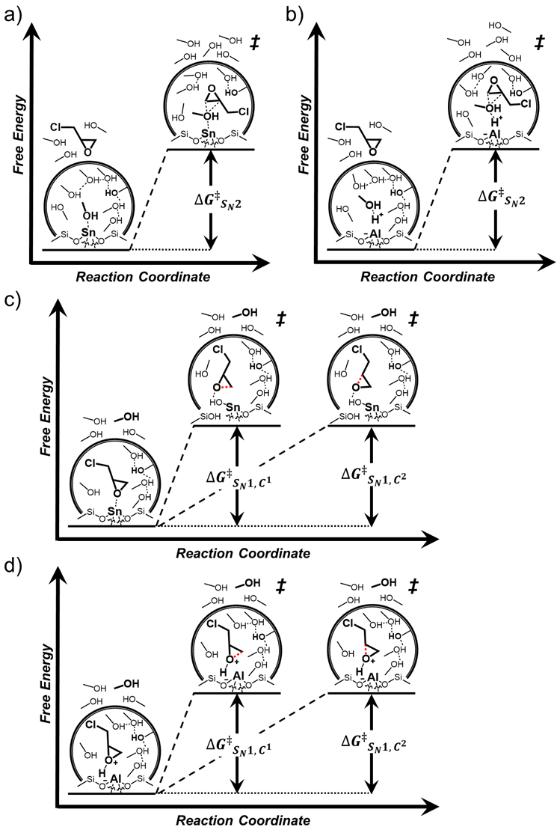

Scheme S3. Proposed reaction coordinate diagram for C₃H₅ClO ring-opening with CH₃OH through an a) S_{N}2 pathway over Sn-BEA, b) S_{N}2 pathway over Al-BEA, c) S_{N}1 pathway over Sn-BEA, d) S_{N}1 pathway over Al-BEA. Note: we acknowledge that the reaction of CH₃OH and the carbocations in c) and d) may also carry kinetic relevance.
Figure S15 presents activation barrier measurements for the formation of the terminal ether (TE) and terminal alcohol (TA) products from C₃H₅ClO ring-opening with CH₃OH. The formation of TA shows more positive ${∆H}^{‡}$ (by > 17 kJ mol⁻¹) and ${∆S}^{‡}$ (by > 40 J mol⁻¹ K⁻¹) values than TE at 0.07 M CH₃OH. The significant differences for ${∆H}^{‡}$ and ${∆S}^{‡}$ suggests that distinct reaction pathways may govern product formation in this regime. S_{N}1 pathways feature unimolecular transition states, which should lead to more positive ${∆S}^{‡}$ values than S_{N}2 pathways that react through bimolecular transition states (see Scheme S3 for proposed reaction pathways).⁵³ An S_{N}1 reaction pathway may dominate for TA formation at low [CH₃OH] values while TE may form from a combination of S_{N}1 and S_{N}2 reactions. Interestingly, the difference between ${∆H}^{‡}$ and ${∆S}^{‡}$ for the product is less significant over Al-BEA than Sn-BEA in this low [CH₃OH] regime, which may suggest that TE formation shows more S_{N}1 character to provide more positive ${∆H}^{‡}$ and ${∆S}^{‡}$.
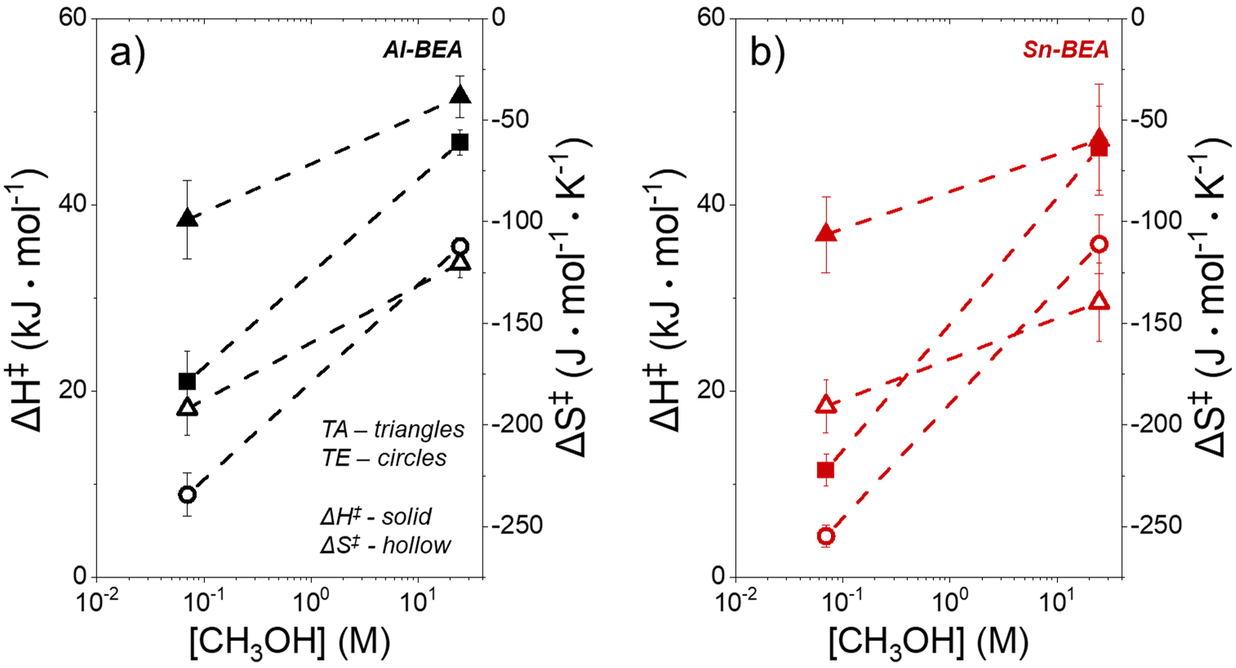 Figure S15. Activation enthalpy and entropy to form the terminal ether (circles) and terminal alcohol (triangles) products from C₃H₅ClO ring-opening (0.07 M C₃H₅ClO, 308 K) over a) Al-BEA (black) and b) Sn-BEA (red).

In the absence of CH₃CN co-solvent (24.7 M CH₃OH), the products shift to very similar ${∆H}^{‡}$ values (< 5 kJ mol⁻¹). This similarity may suggest that both products shift towards similar dominant reaction pathways, which we expect would be an S_{N}2 pathway through CH₃OH-derived adsorbed species. Here, more positive ${∆S}^{‡}$ values may drive the dominant formation of TE through lesser steric hindrance during the S_{N}2 pathway.

While we argue that the differences in activation parameters between the products provide evidence for the shift in reaction pathways with [CH₃OH] evidenced by the NMR spectra discussed in Section 2.3, we cannot rule out that solvation effects may also play a role. We have previously argued that the disruption of hydrogen-bonded CH₃OH molecules drives increases in ${∆H}^{‡}$ and ${∆S}^{‡}$ with [CH₃OH] for C₄H₈O ring-opening over M-BEA materials. Interactions with surrounding solvent molecules may also play a role in C₃H₅ClO ring-opening and may affect the TE and TA formation transition states differently.

S10. Isothermal Titration Calorimetry Thermograms and Heats of Adsorption
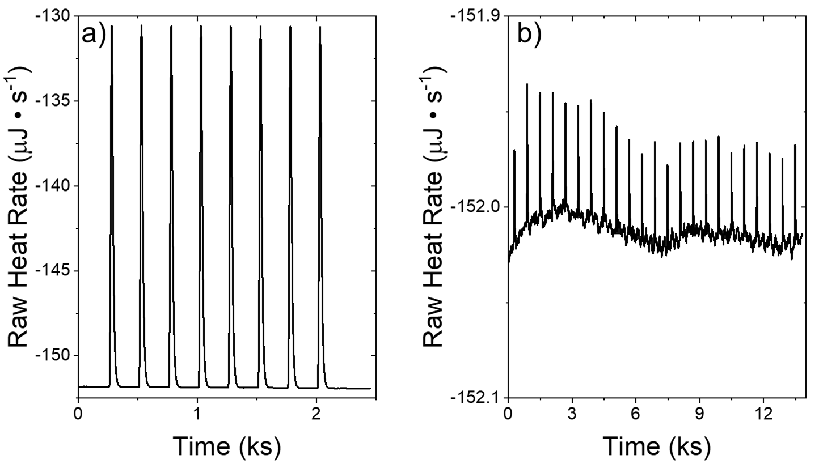

Figure S16. a) ITC thermogram from the electrical calibration of the NanoITC. b) ITC thermogram from the water-water adsorption to check the cleanliness of the ITC cell.

The plots in Figure S16 were obtained during the calibration and cleaning procedures for isothermal titration calorimetry (ITC), as discussed in Section 4.4 of the main text. Figure S16a shows the heat released from the sequential pulses during the electrical calibration. The instrument gave a calibration factor, for which values greater than 0.98 were assumed to be satisfactory. Figure S16b shows the heat released during the water-water injection, during which each 1 μL injection led to a peak with an area between -3 and +3 μJ.

Figure S17 shows an acid-base titration of NaHCO₃ into HNO₃, which was used as a standard to verify the results obtained from the NanoITC. The adsorption enthalpy calculated from Figure S17b was -8.1 ± 1.2 kJ mol⁻¹, which agrees well with the reported enthalpy of -9.1 kJ mol⁻¹.⁵⁴⁻⁵⁵
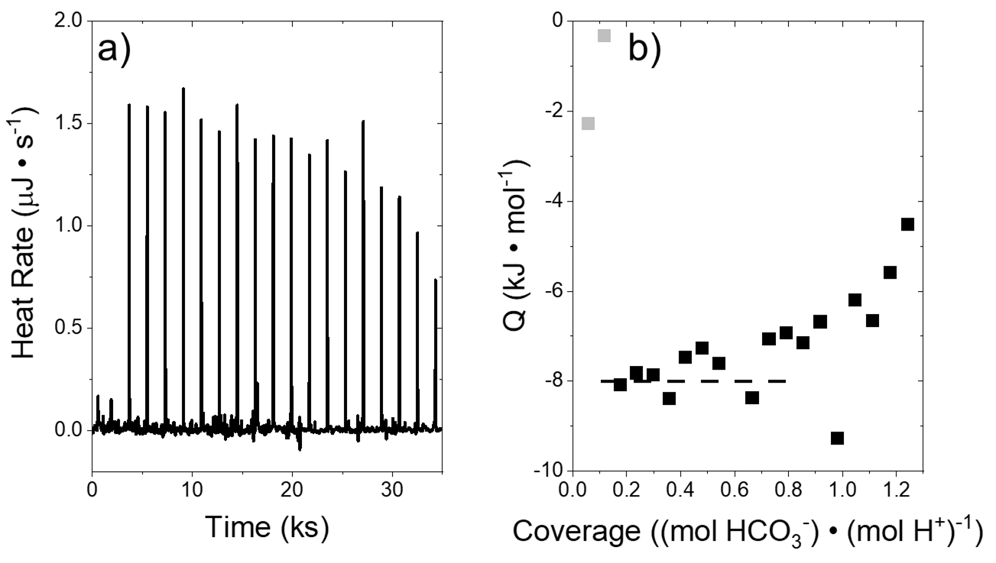

Figure S17. a) ITC thermogram from the acid-base titration of HNO₃ (0.0005 M in 0.1 M NaCl) with NaHCO₃ (0.0052 M in 0.1 M NaCl), b) the corresponding heats released as a function of bicarbonate ion coverage.
The ITC thermogram and heat release plots for all ITC experiments used to calculate the adsorption enthalpies of C₃H₅ClO and CH₃OH into M-BEA are shown below. The CH₃OH adsorption experiments were performed at higher titrant concentrations (and thus higher coverages) because CH₃OH adsorbs weakly and higher concentrations are needed to observe sufficiently large peaks in the thermogram. Early injections often show lower heat released than expected due to the evaporation of liquid from the syringe needle. Although less common, some of the experiments below show outlier points at later injections, which may result from an inconsistent volume or epoxide concentration in those injections.

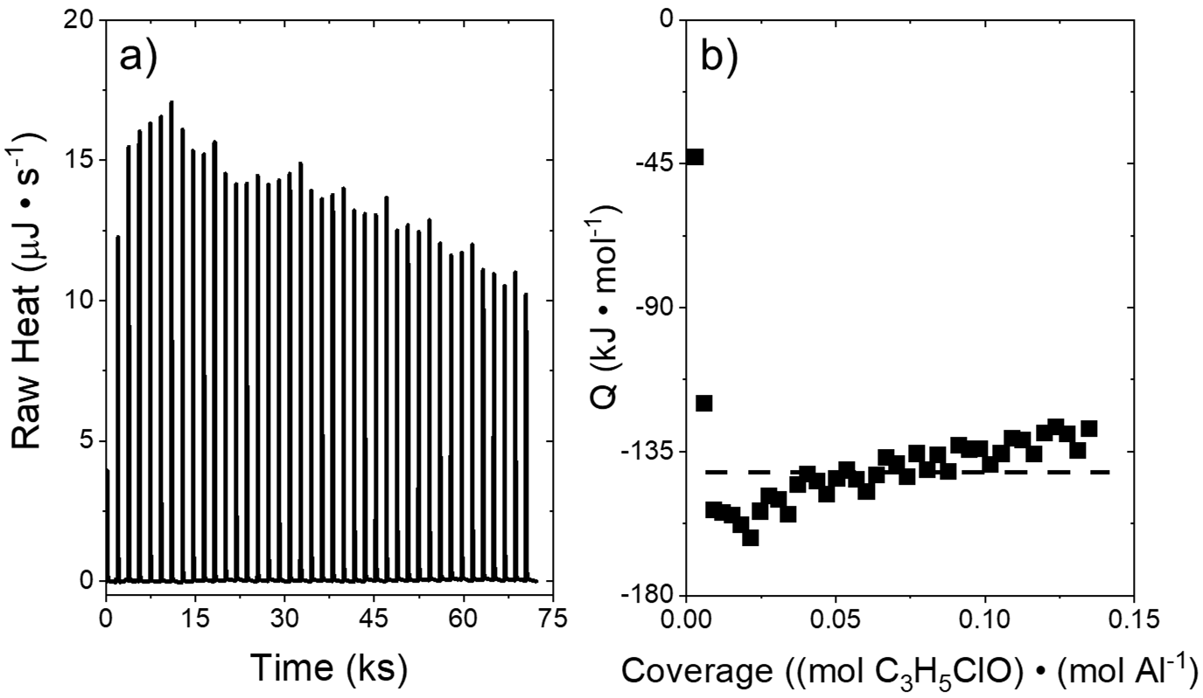

Figure S18. a) ITC thermogram from the titration of Al-BEA with C₃H₅ClO (0.005 M C₃H₅ClO in CH₃CN, 308 K, 1 μL per injection), b) the corresponding heats released as a function of titrant injected.

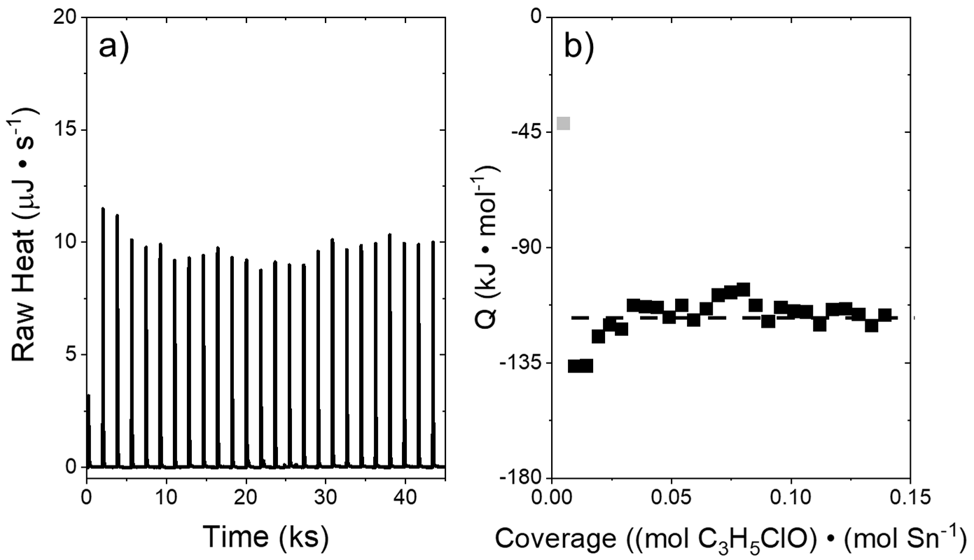

Figure S19. a) ITC thermogram from the titration of Sn-BEA with C₃H₅ClO (0.005 M C₃H₅ClO in CH₃CN, 308 K, 1 μL per injection), b) the corresponding heats released as a function of titrant injected.
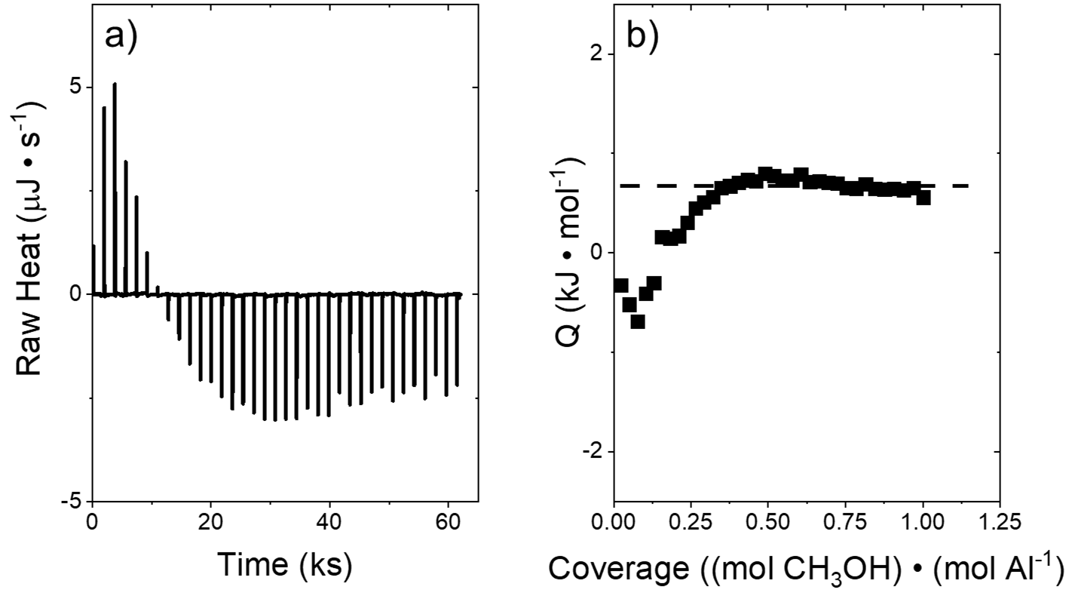

Figure S20. a) ITC thermogram from the titration of Al-BEA with CH₃OH (0.1 M CH₃OH in CH₃CN, 308 K, 1 μL per injection), b) the corresponding heats released as a function of titrant injected.

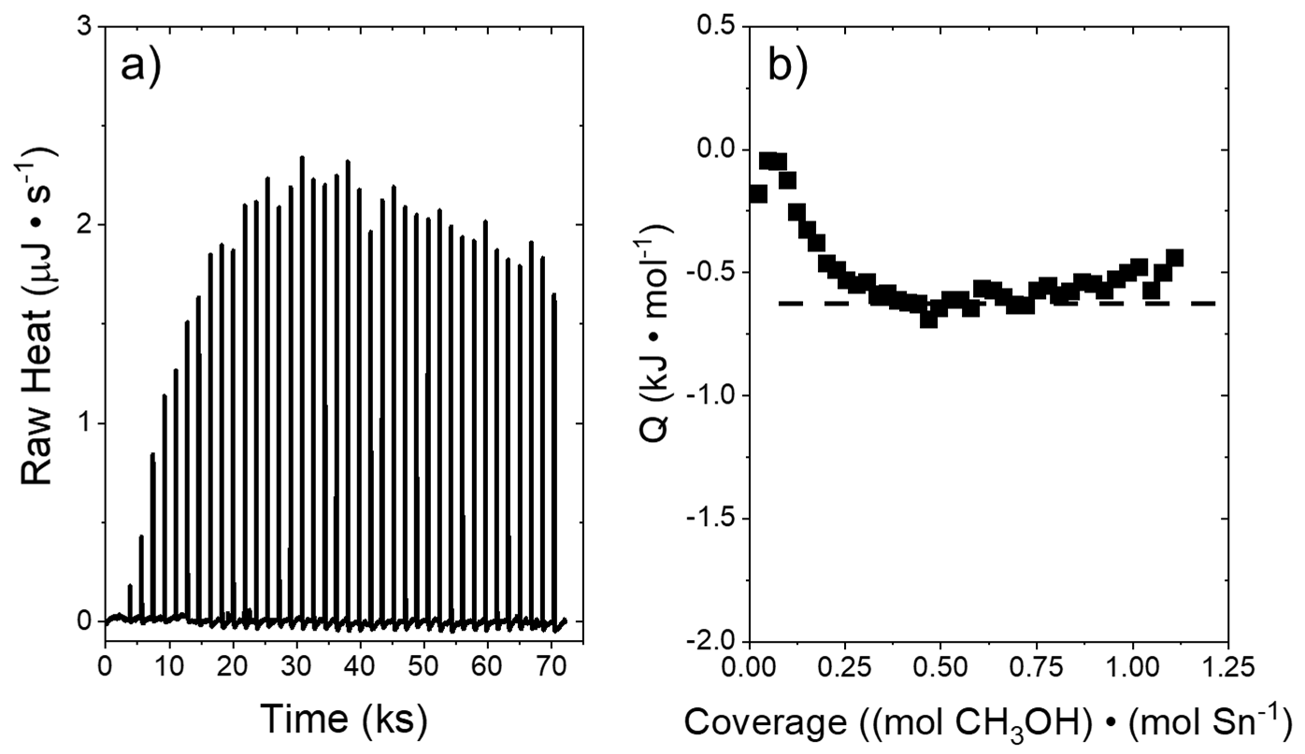

Figure S21. a) ITC thermogram from the titration of Sn-BEA with CH₃OH (0.1 M CH₃OH in CH₃CN, 308 K, 1 μL per injection), b) the corresponding heats released as a function of titrant injected.

Catalyst | ${∆H}_{ads,CH_{3}OH}$ (kJ mol⁻¹) | ${∆H}_{ads,C_{3}H_{5}ClO}$ (kJ mol⁻¹)
Al-BEA | 1.0 ± 0.4 | -141.7 ± 8.9
Sn-BEA | -0.6 ± 0.2 | -116.9 ± 7.0

Table S7. Adsorption enthalpies for CH₃OH and C₃H₅ClO calculated from ITC thermograms in Figures S18 to S21.

The adsorption enthalpies in Table S7 were calculated by fitting a line through the injections where the heat released was approximately constant. C₃H₅ClO shows significantly more exothermic adsorption enthalpies than CH₃OH over both Al-BEA and Sn-BEA, which may explain why adsorbed C₃H₅ClO dominates on active sites even in excess of CH₃OH ([CH₃OH]:[C₃H₅ClO] < 15, see Figure 1).

CH₃OH shows more exothermic adsorption to Sn-BEA than Al-BEA. This suggests that Sn sites activate CH₃OH more strongly than the Brønsted acid sites in Al-BEA, which may contribute to the greater reaction rates observed over Sn-BEA.

In contrast, C₃H₅ClO adsorbs more exothermically to Al-BEA than Sn-BEA. Figure S23 (vide infra) suggests that Al-BEA forms ring-opened carbocations from C₃H₅ClO more readily than Sn-BEA. The formation of these carbocations likely contributes to the more exothermic adsorption of C₃H₅ClO over Al-BEA.

S11. Supplemental ¹³C NMR Plots and Analysis

S11.1. ¹³C NMR Shifts and Discussion of Peak Convolution
Molecule | ChemDraw-Predicted ¹³C Shifts (ppm) | DFT-Predicted ¹³C Shifts (ppm) | Experimental ¹³C Shifts (ppm)
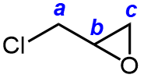  Epichlorohydrin | a = 45.4  b = 51.4  c = 46.9 | COSMO (in Methanol)  a = 51.77  b = 51.85  c = 47.56 | 1 M ¹³C ECH in Acetonitrile  a = 47.67  b = 52.44  c = 47.67
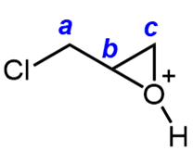  Protonated Epichlorohydrin | N/A  (unable to predict) | COSMO (in Methanol)  a = 43.0  b = 82.9  c = 74.6 | N/A
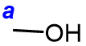  Methanol | a = 49.7 | COSMO (in Methanol)  a = 49.6 | 1 M ¹³CH₃OH in Acetonitrile  a = 49.6
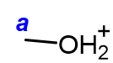  Protonated Methanol | a = 72.1 | COSMO (in Methanol)  a = 68.3 | N/A
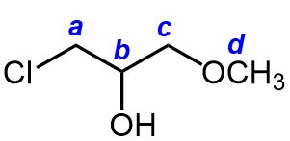  Terminal ether | a = 46.2  b = 70.6 ± 3.7  c = 76.2 ± 2.5  d = 59.0 ± 1.7 | COSMO (in Methanol)  a = 54.5  b = 77.9  c = 75.9  d = 55.8 | 3.1 M C₄H₉ClO₂ in CD₃CN  a = 46.5  b = 69.8  c = 73.6  d = 58.5
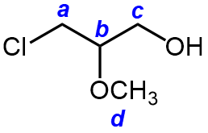  Terminal alcohol | a = 44.9 ± 4.8  b = 85.3 ± 3.7  c = 66.9 ± 3.1  d = 58.4 ± 2.6 | COSMO (in Methanol)  a = 52.3  b = 85.7  c = 68.5  d = 59.1 | N/A  (no standard available)
Table S8. Predicted ¹³C NMR peak shifts for reactants, primary products, and intermediates from the ring-opening of C₃H₅ClO with CH₃OH. These peak shifts were predicted by averaging values and errors obtained from ACD/Labs (v2024) and ChemDraw (version 23.0.1), which were further cross-referenced with reported shifts available in the literature.

Binding Structure | DFT-Predicted ¹³C Shifts (ppm)
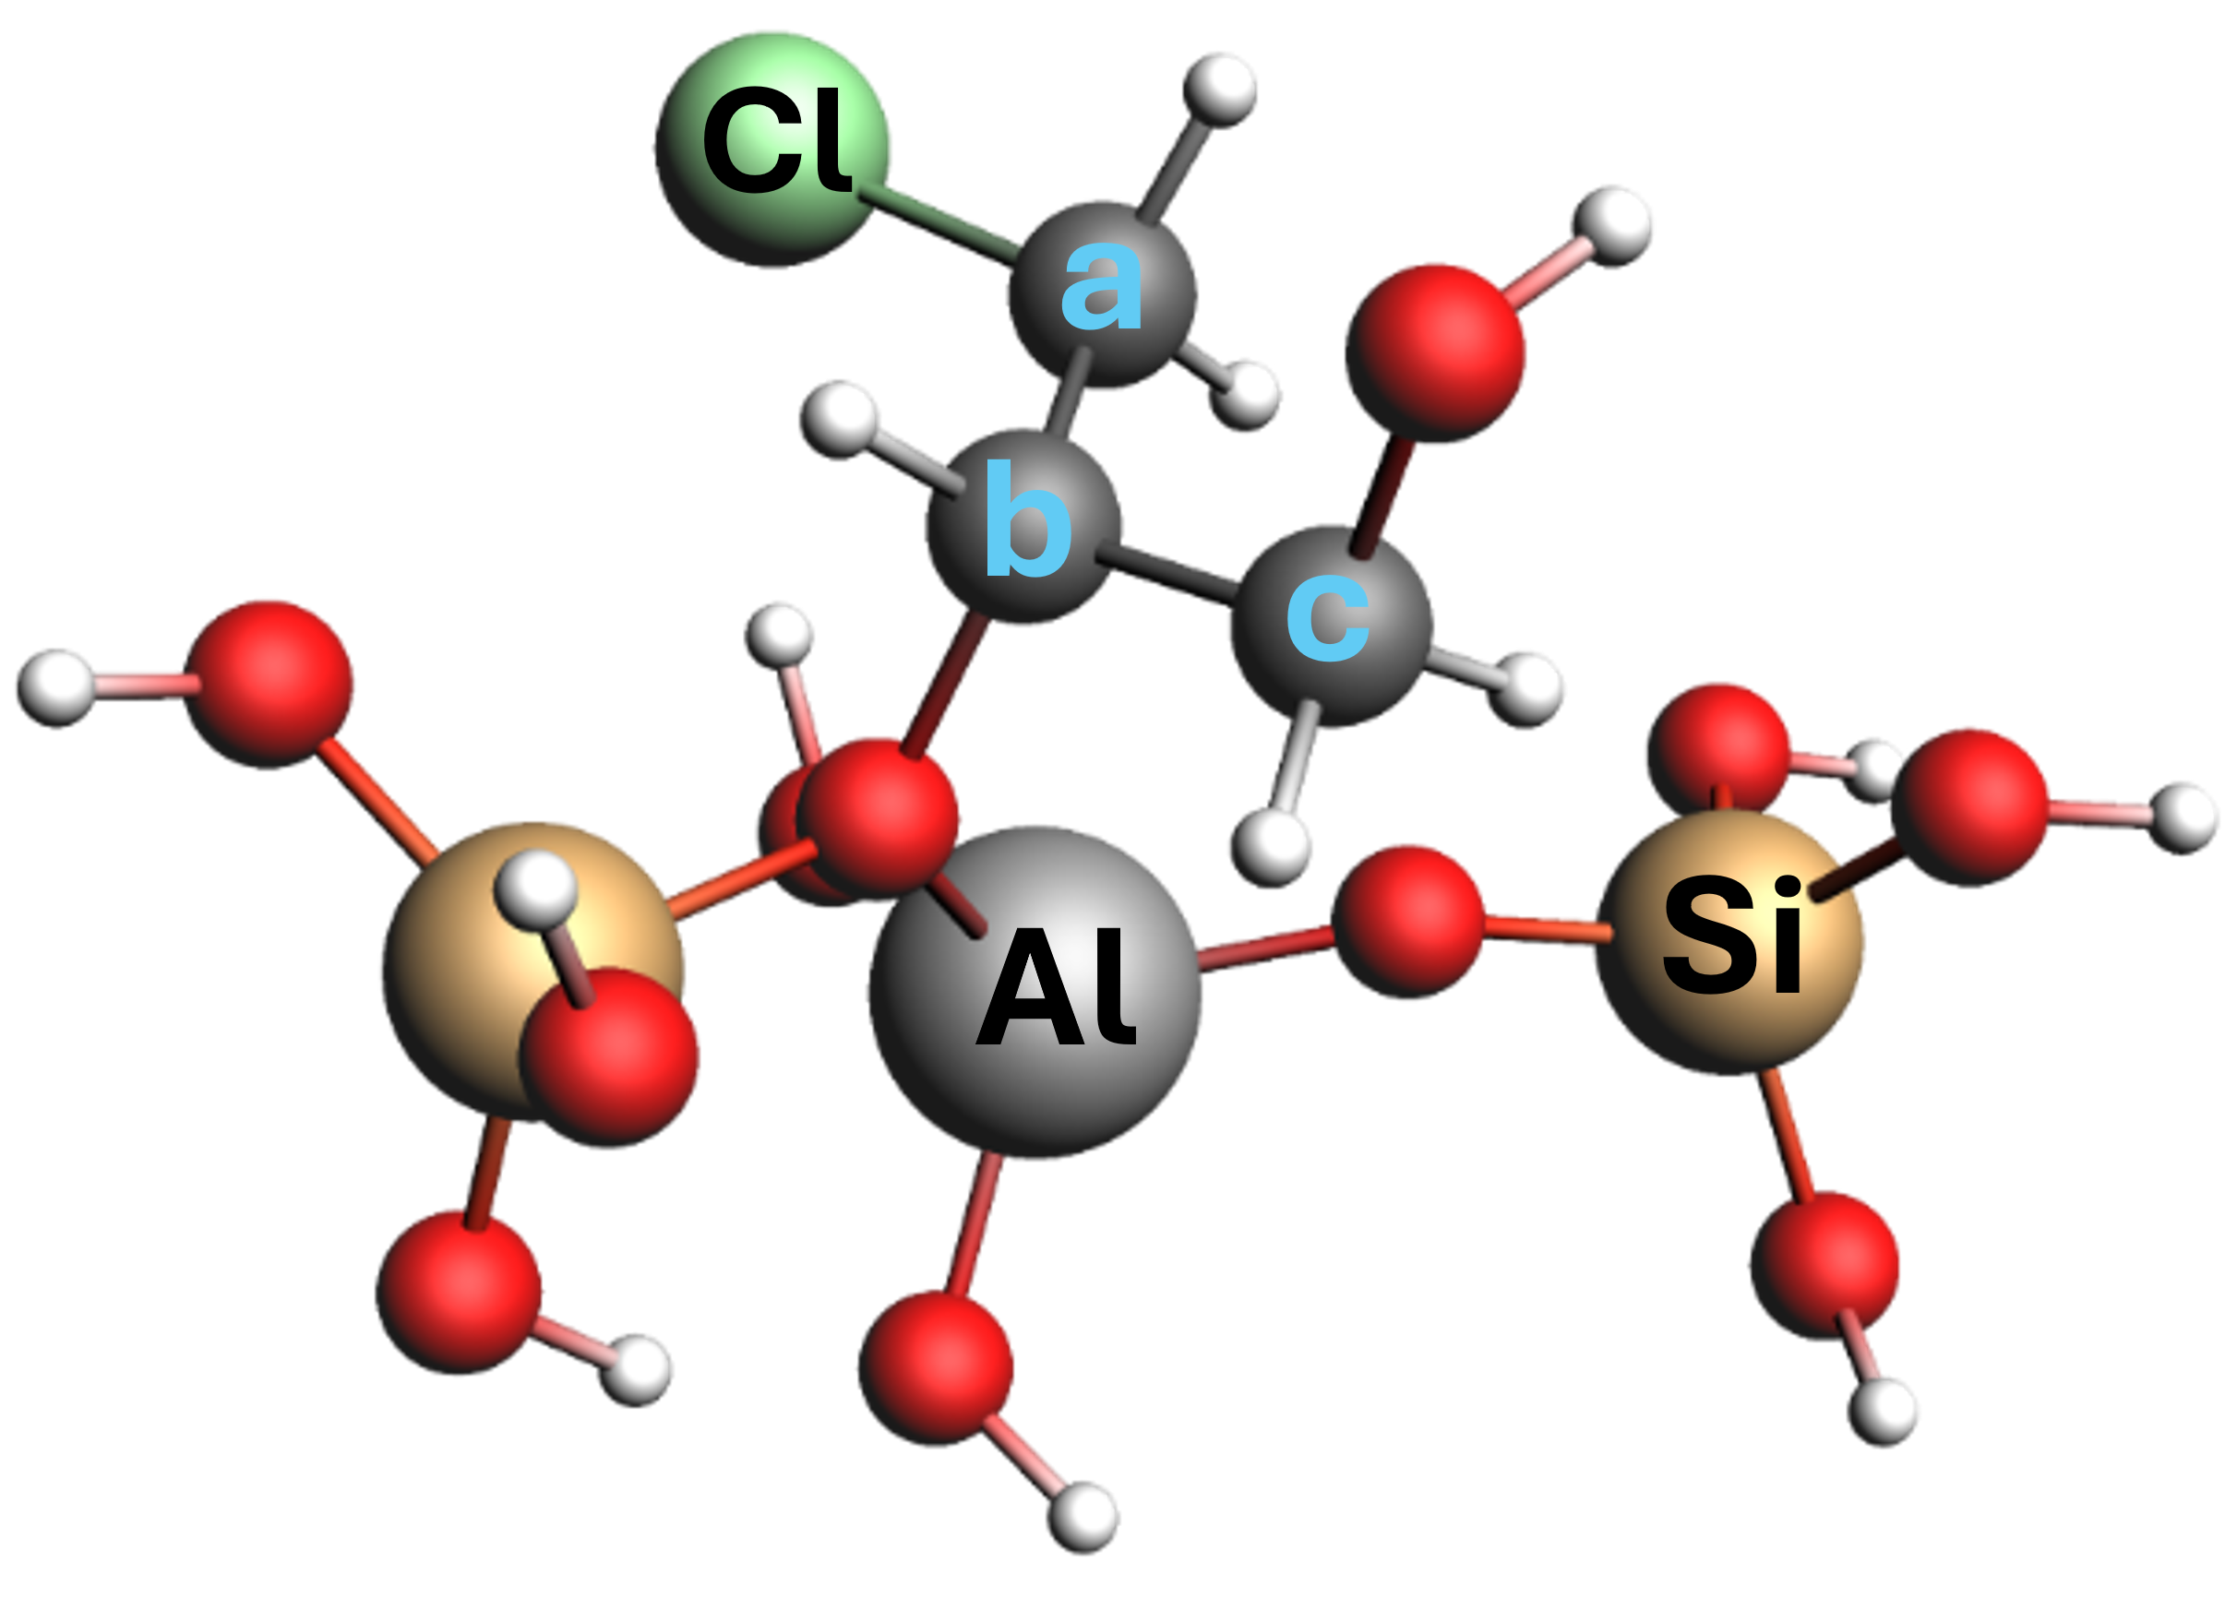  Secondary carbocation (derived from C₃H₅ClO)  (bound to Al-BEA) | COSMO (in Methanol)  a = 49.6  b = 89.0  c= 63.0
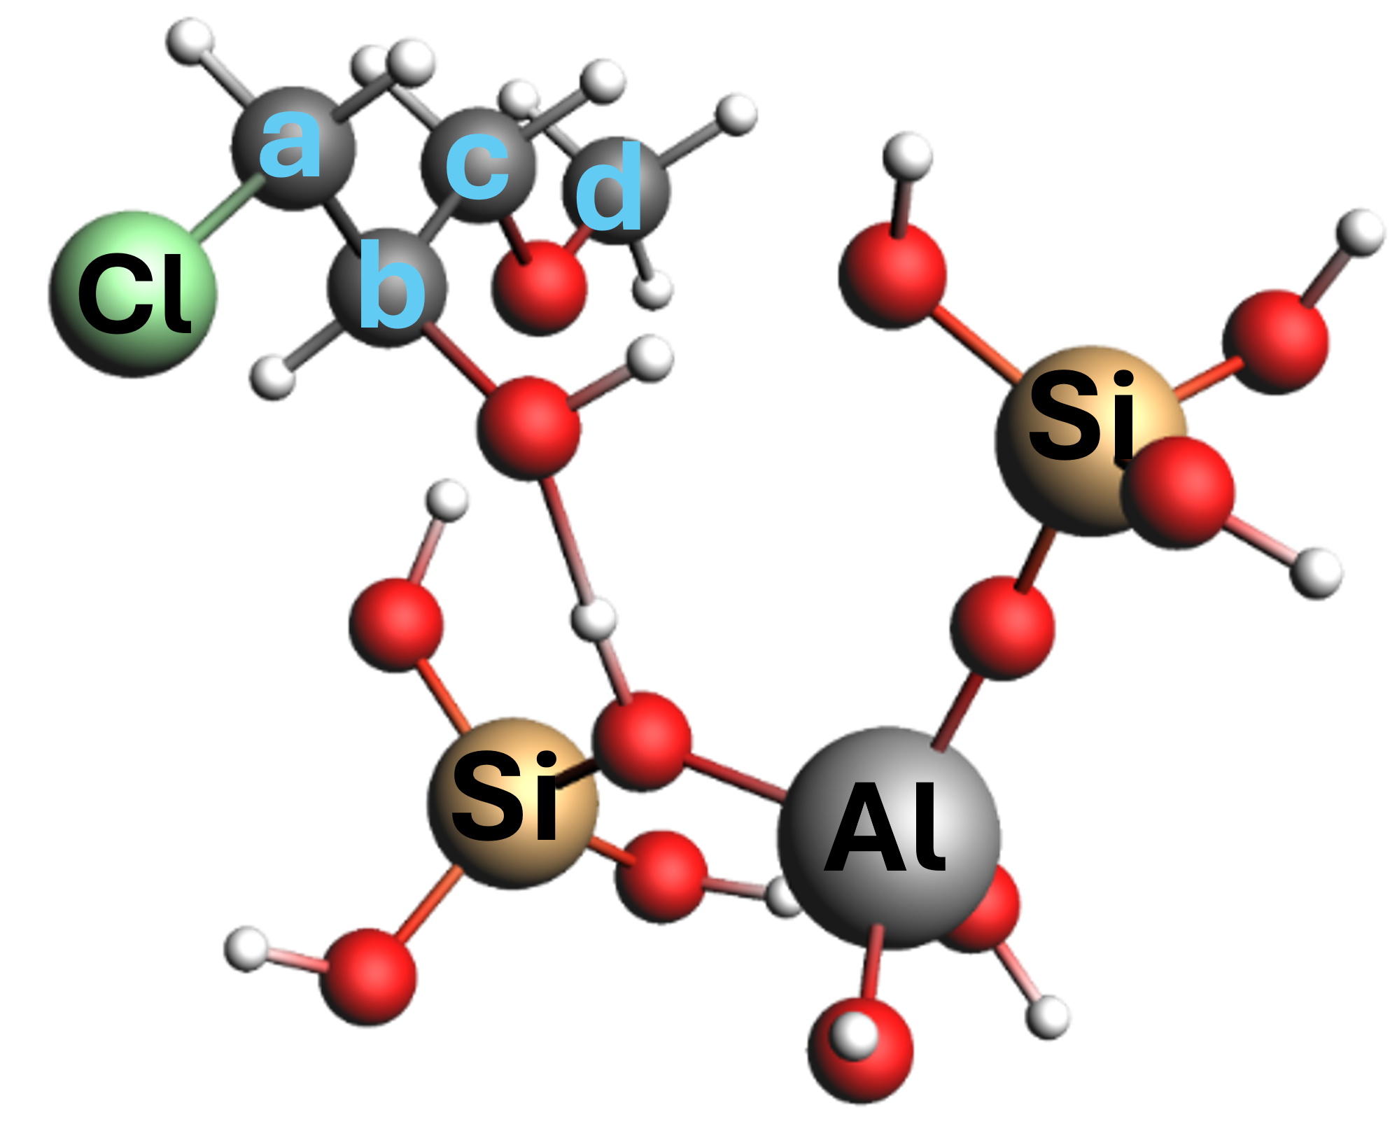  Terminal ether bound at Brønsted acid site in Al-BEA | COSMO(Methanol)  a=51.5  b=77.2  c=73.6  d=55.8
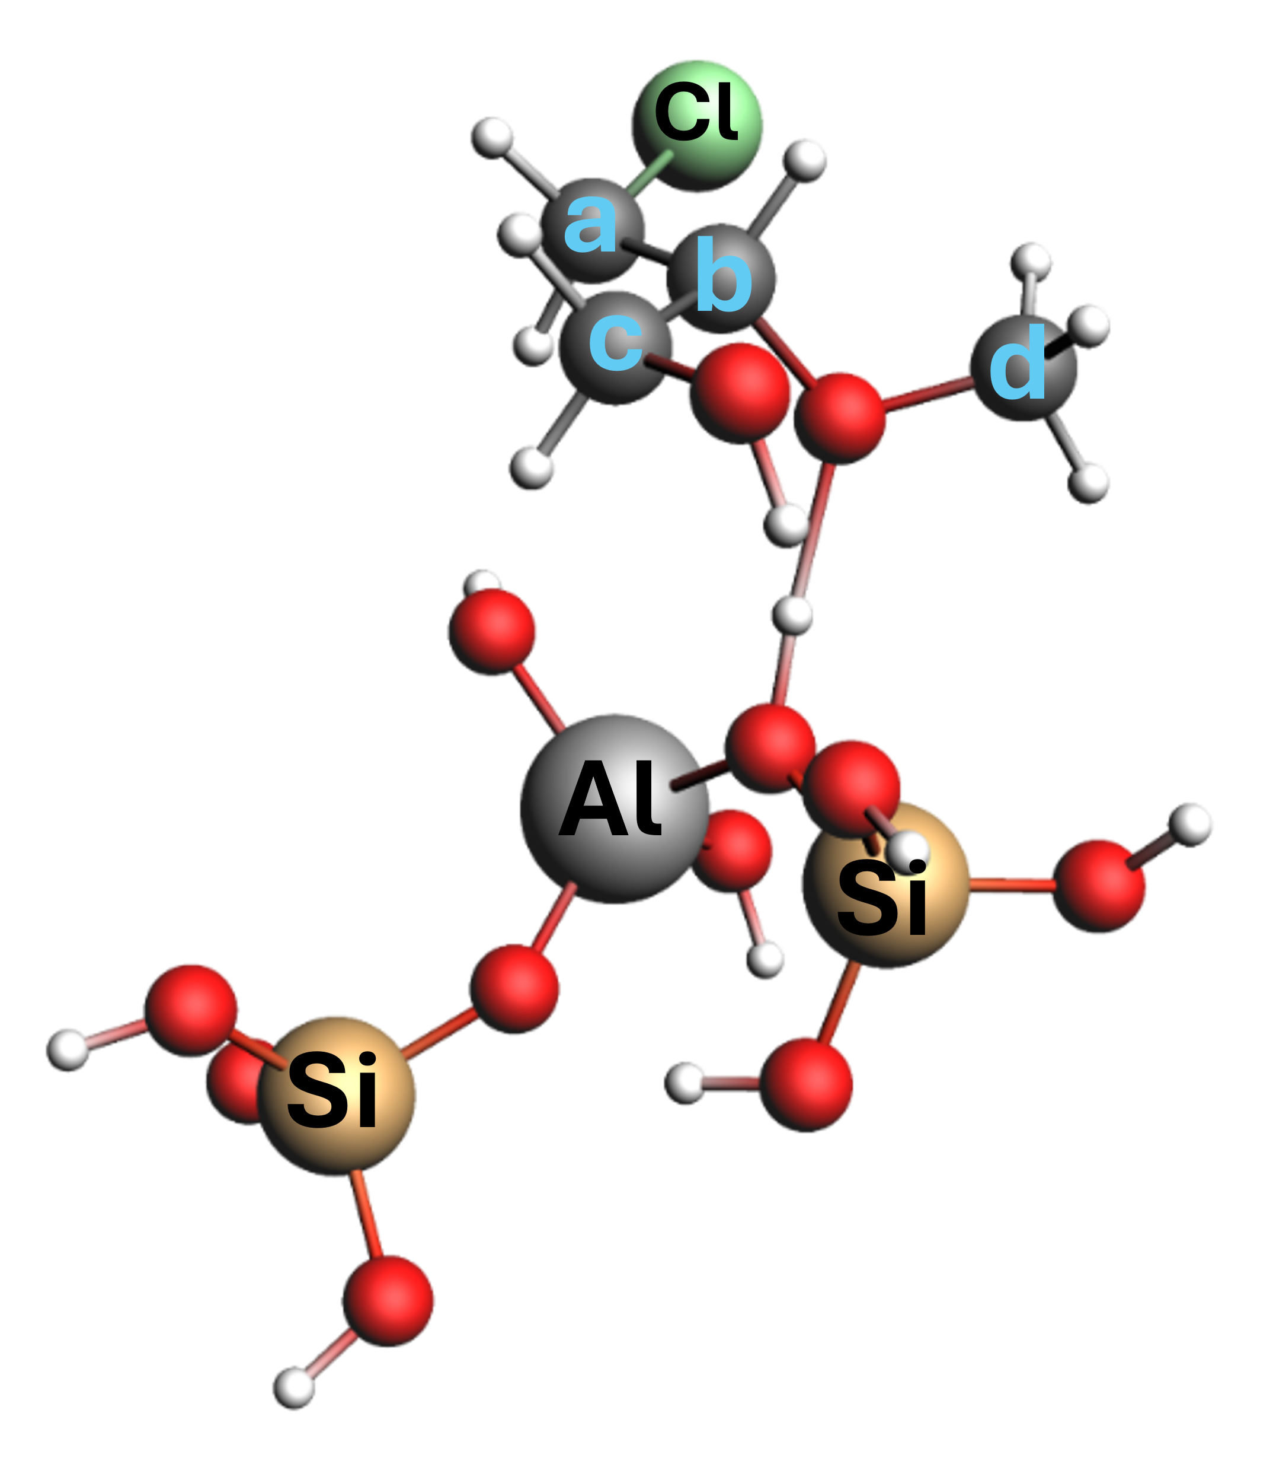  Terminal alcohol bound at Brønsted acid site in Al-BEA | COSMO(Methanol)  a=50.9  b=91.6  c=61.8  d=59.8
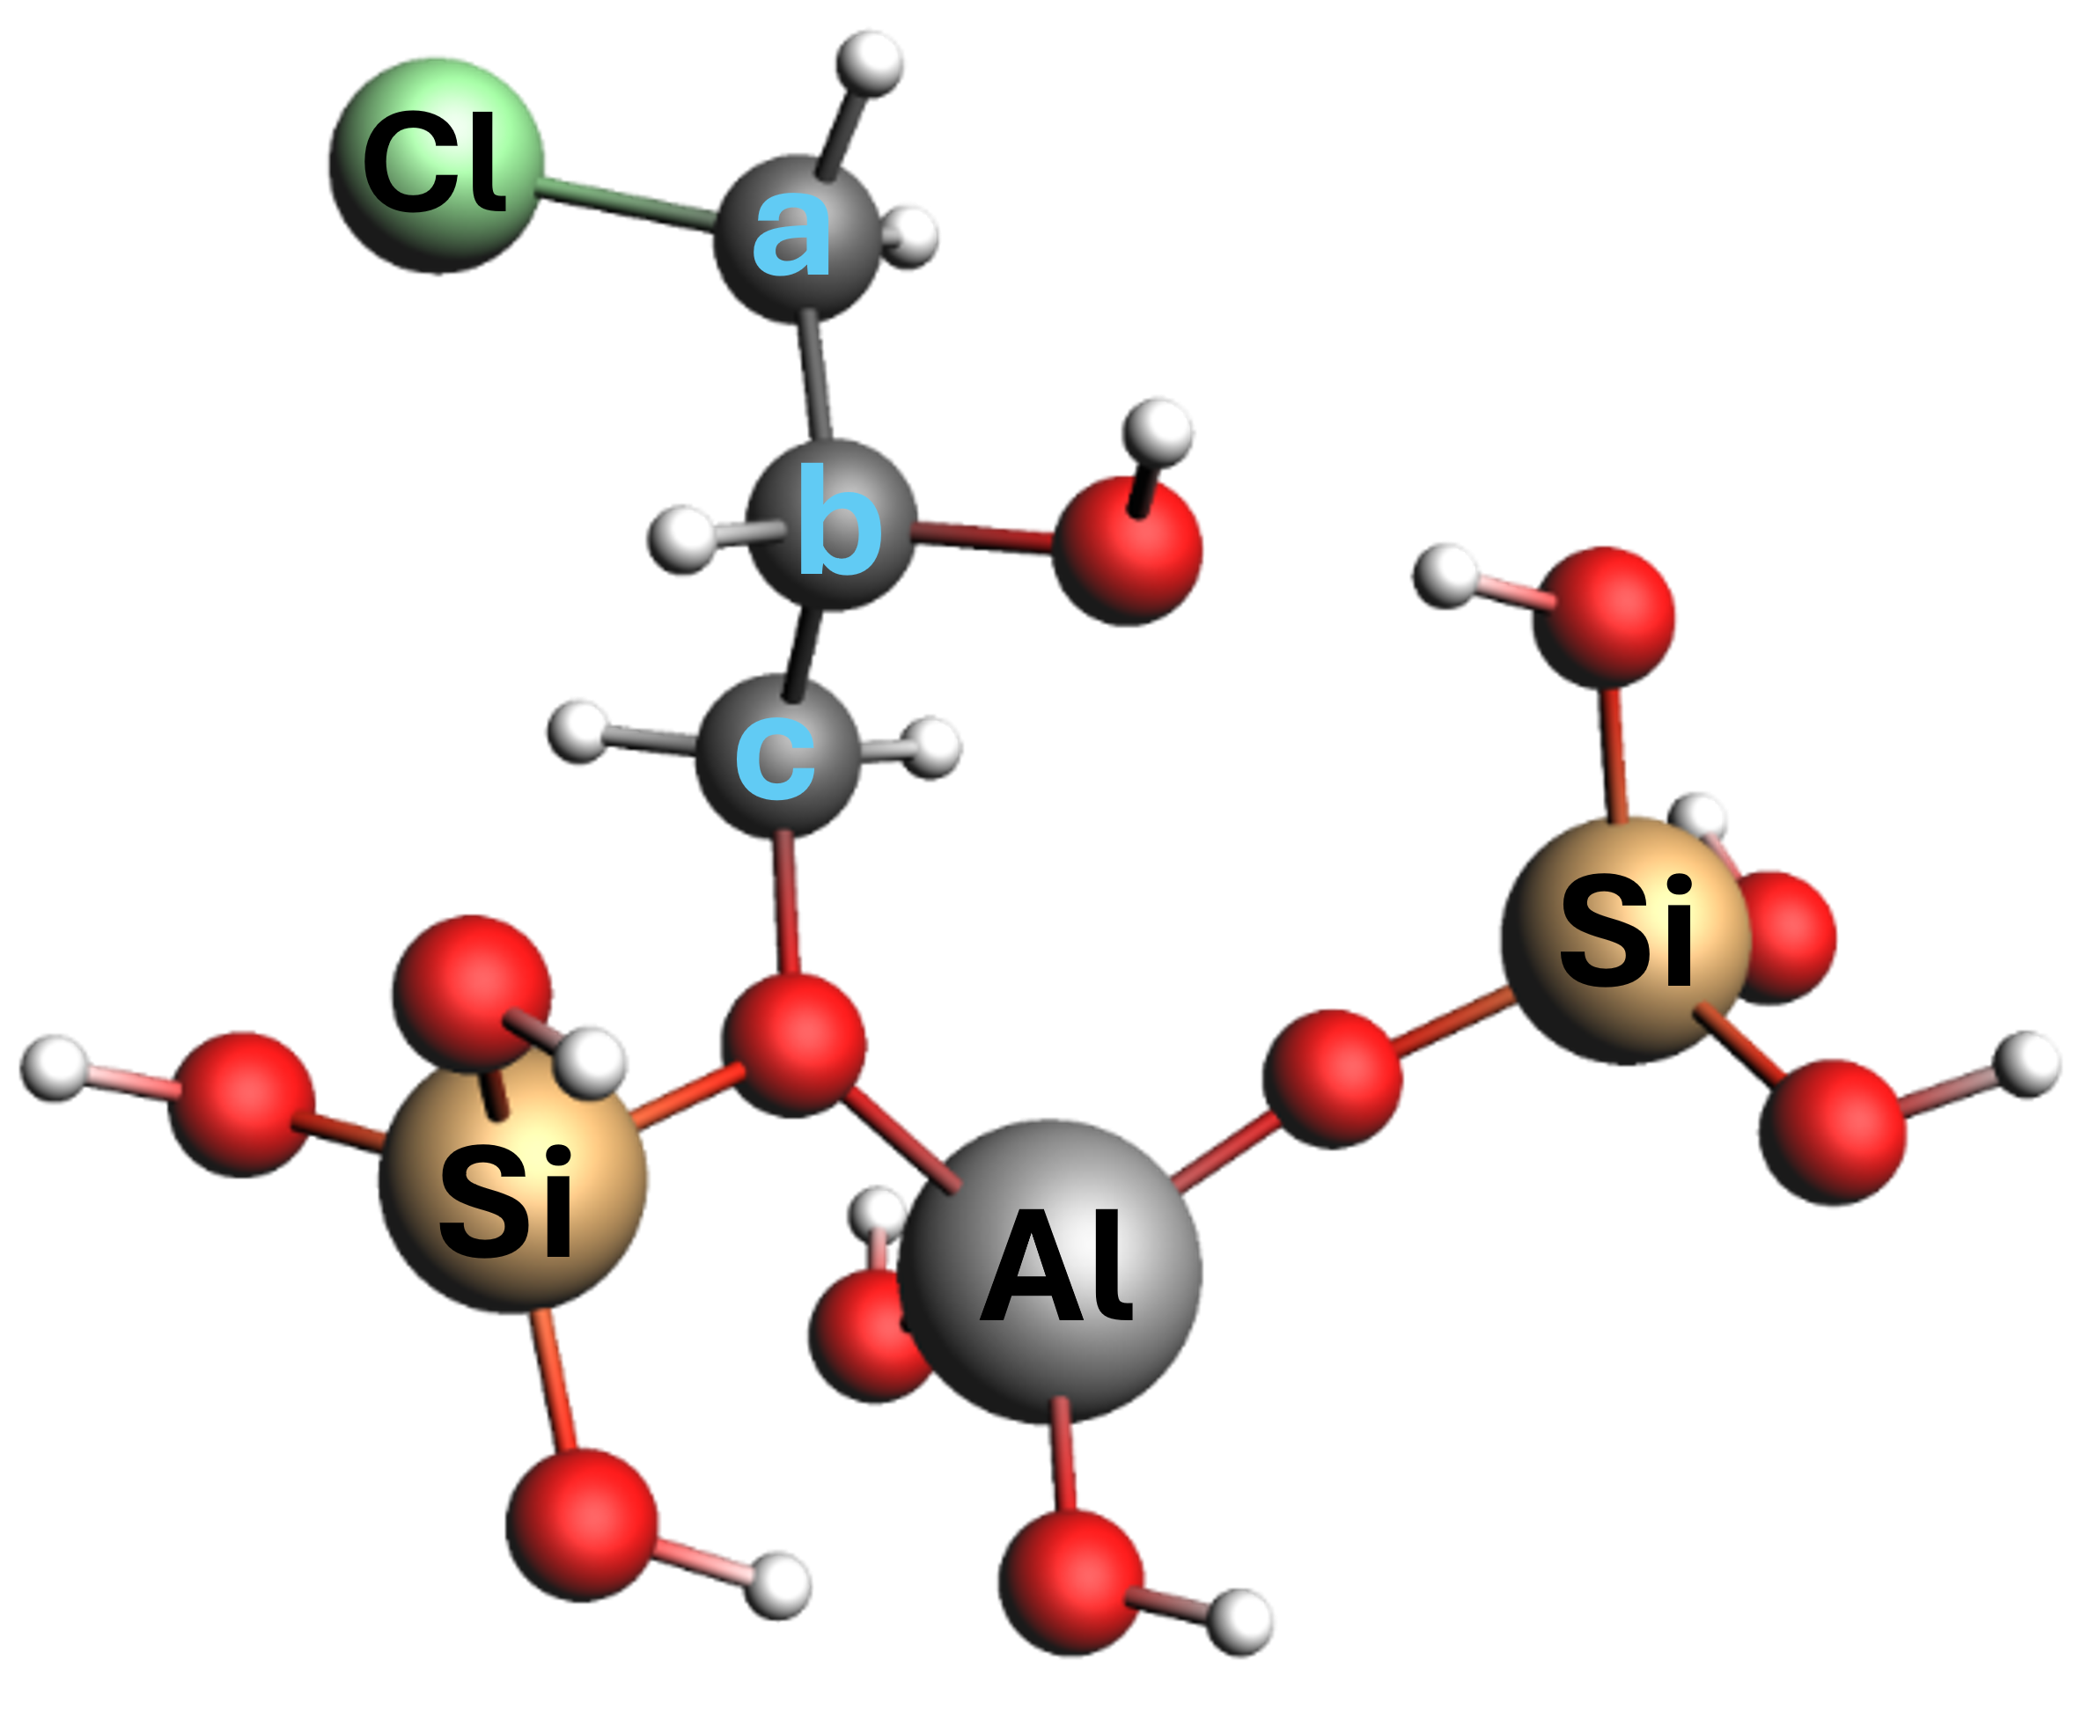  Primary carbocation (derived from C₃H₅ClO)  (bound to Brønsted acid site in Al-BEA) | COSMO(Methanol)  a=47.0  b=74.6  c=71.1
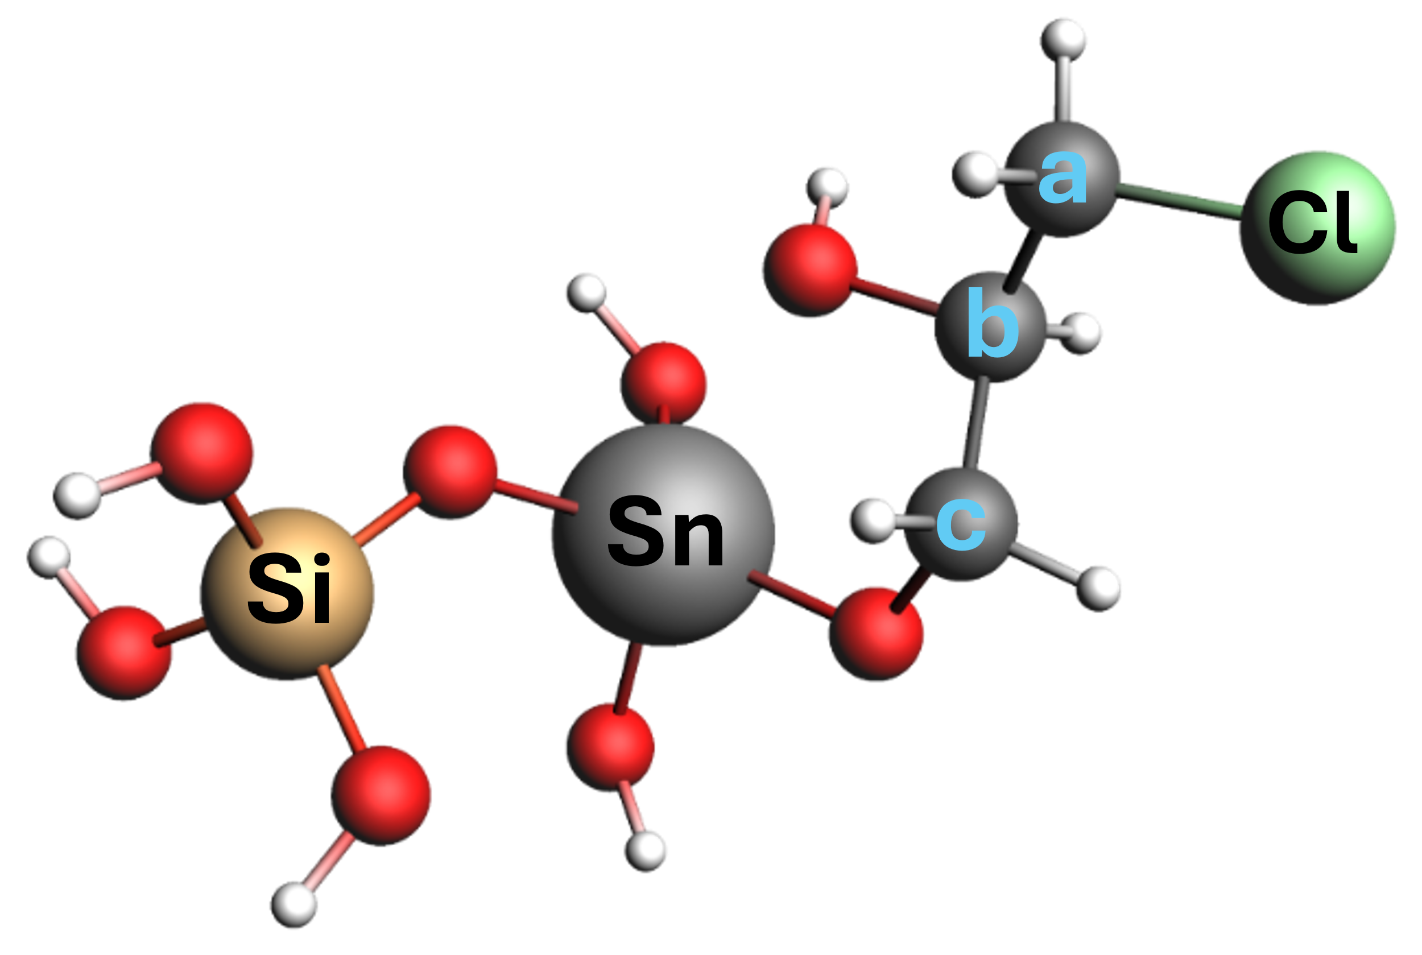  Primary carbocation bound to Sn-BEA | COSMO (Methanol)  a=49.3  b=72.5  c=67.3
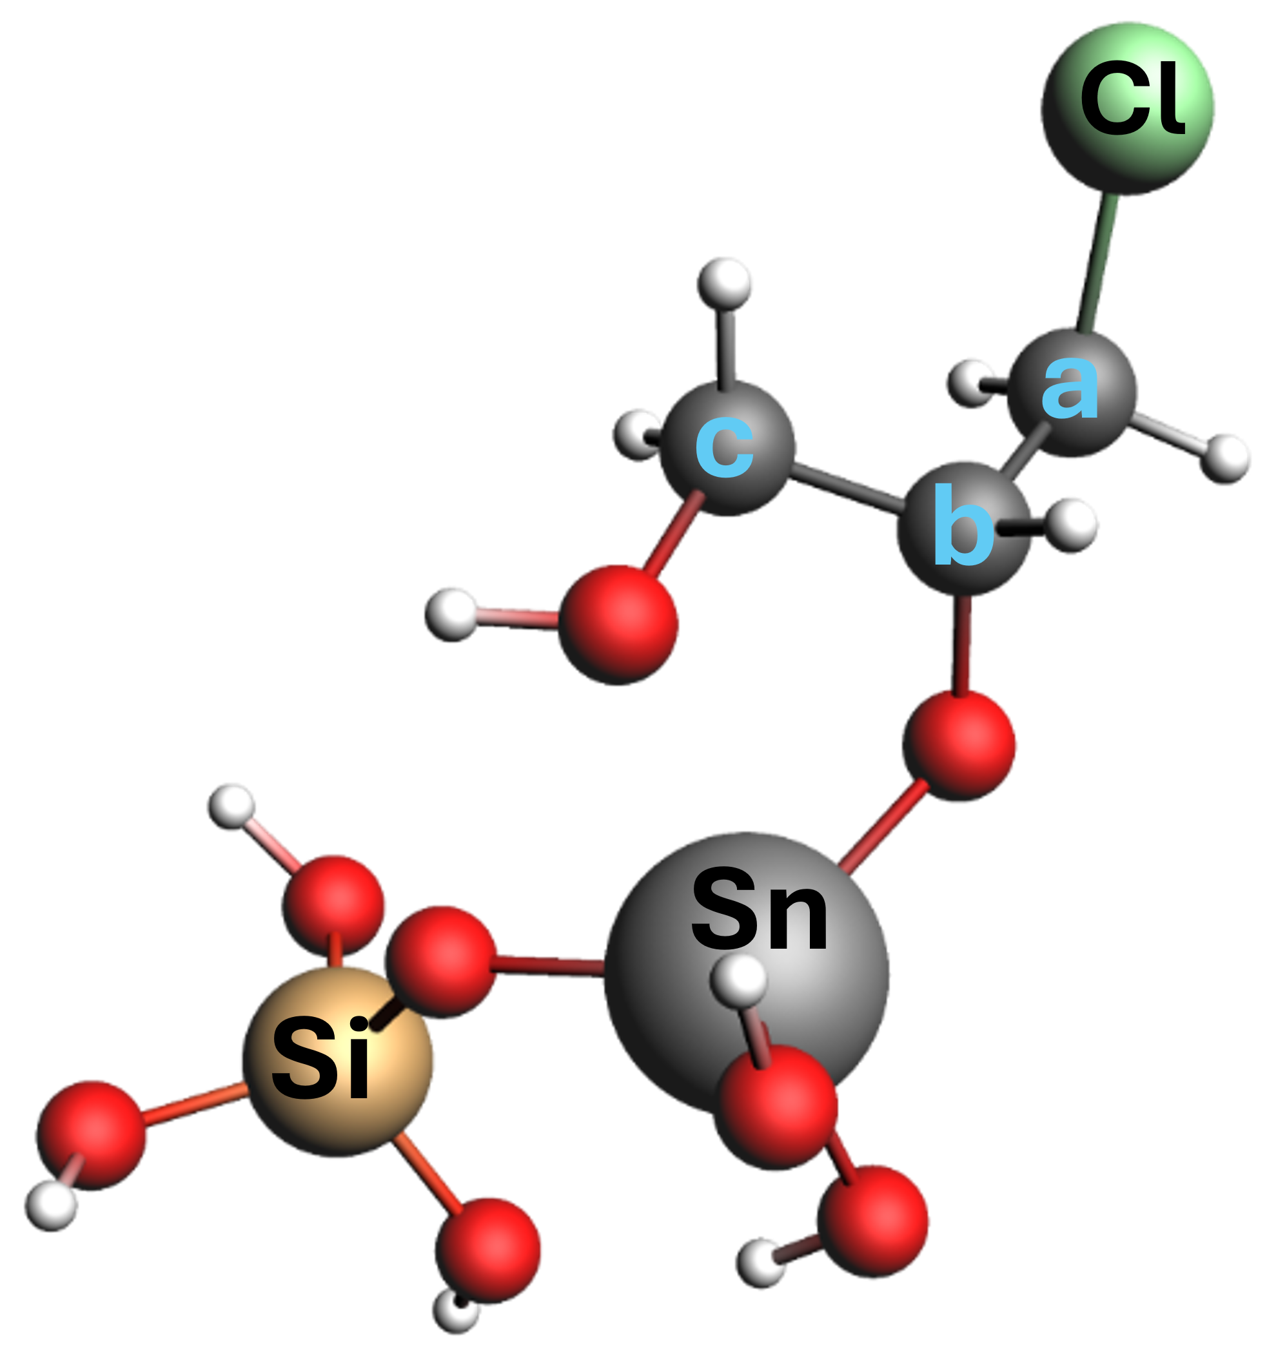  Secondary carbocation bound to Sn-BEA | COSMO (Methanol)  a=47.5  b=76.2  c=64.7
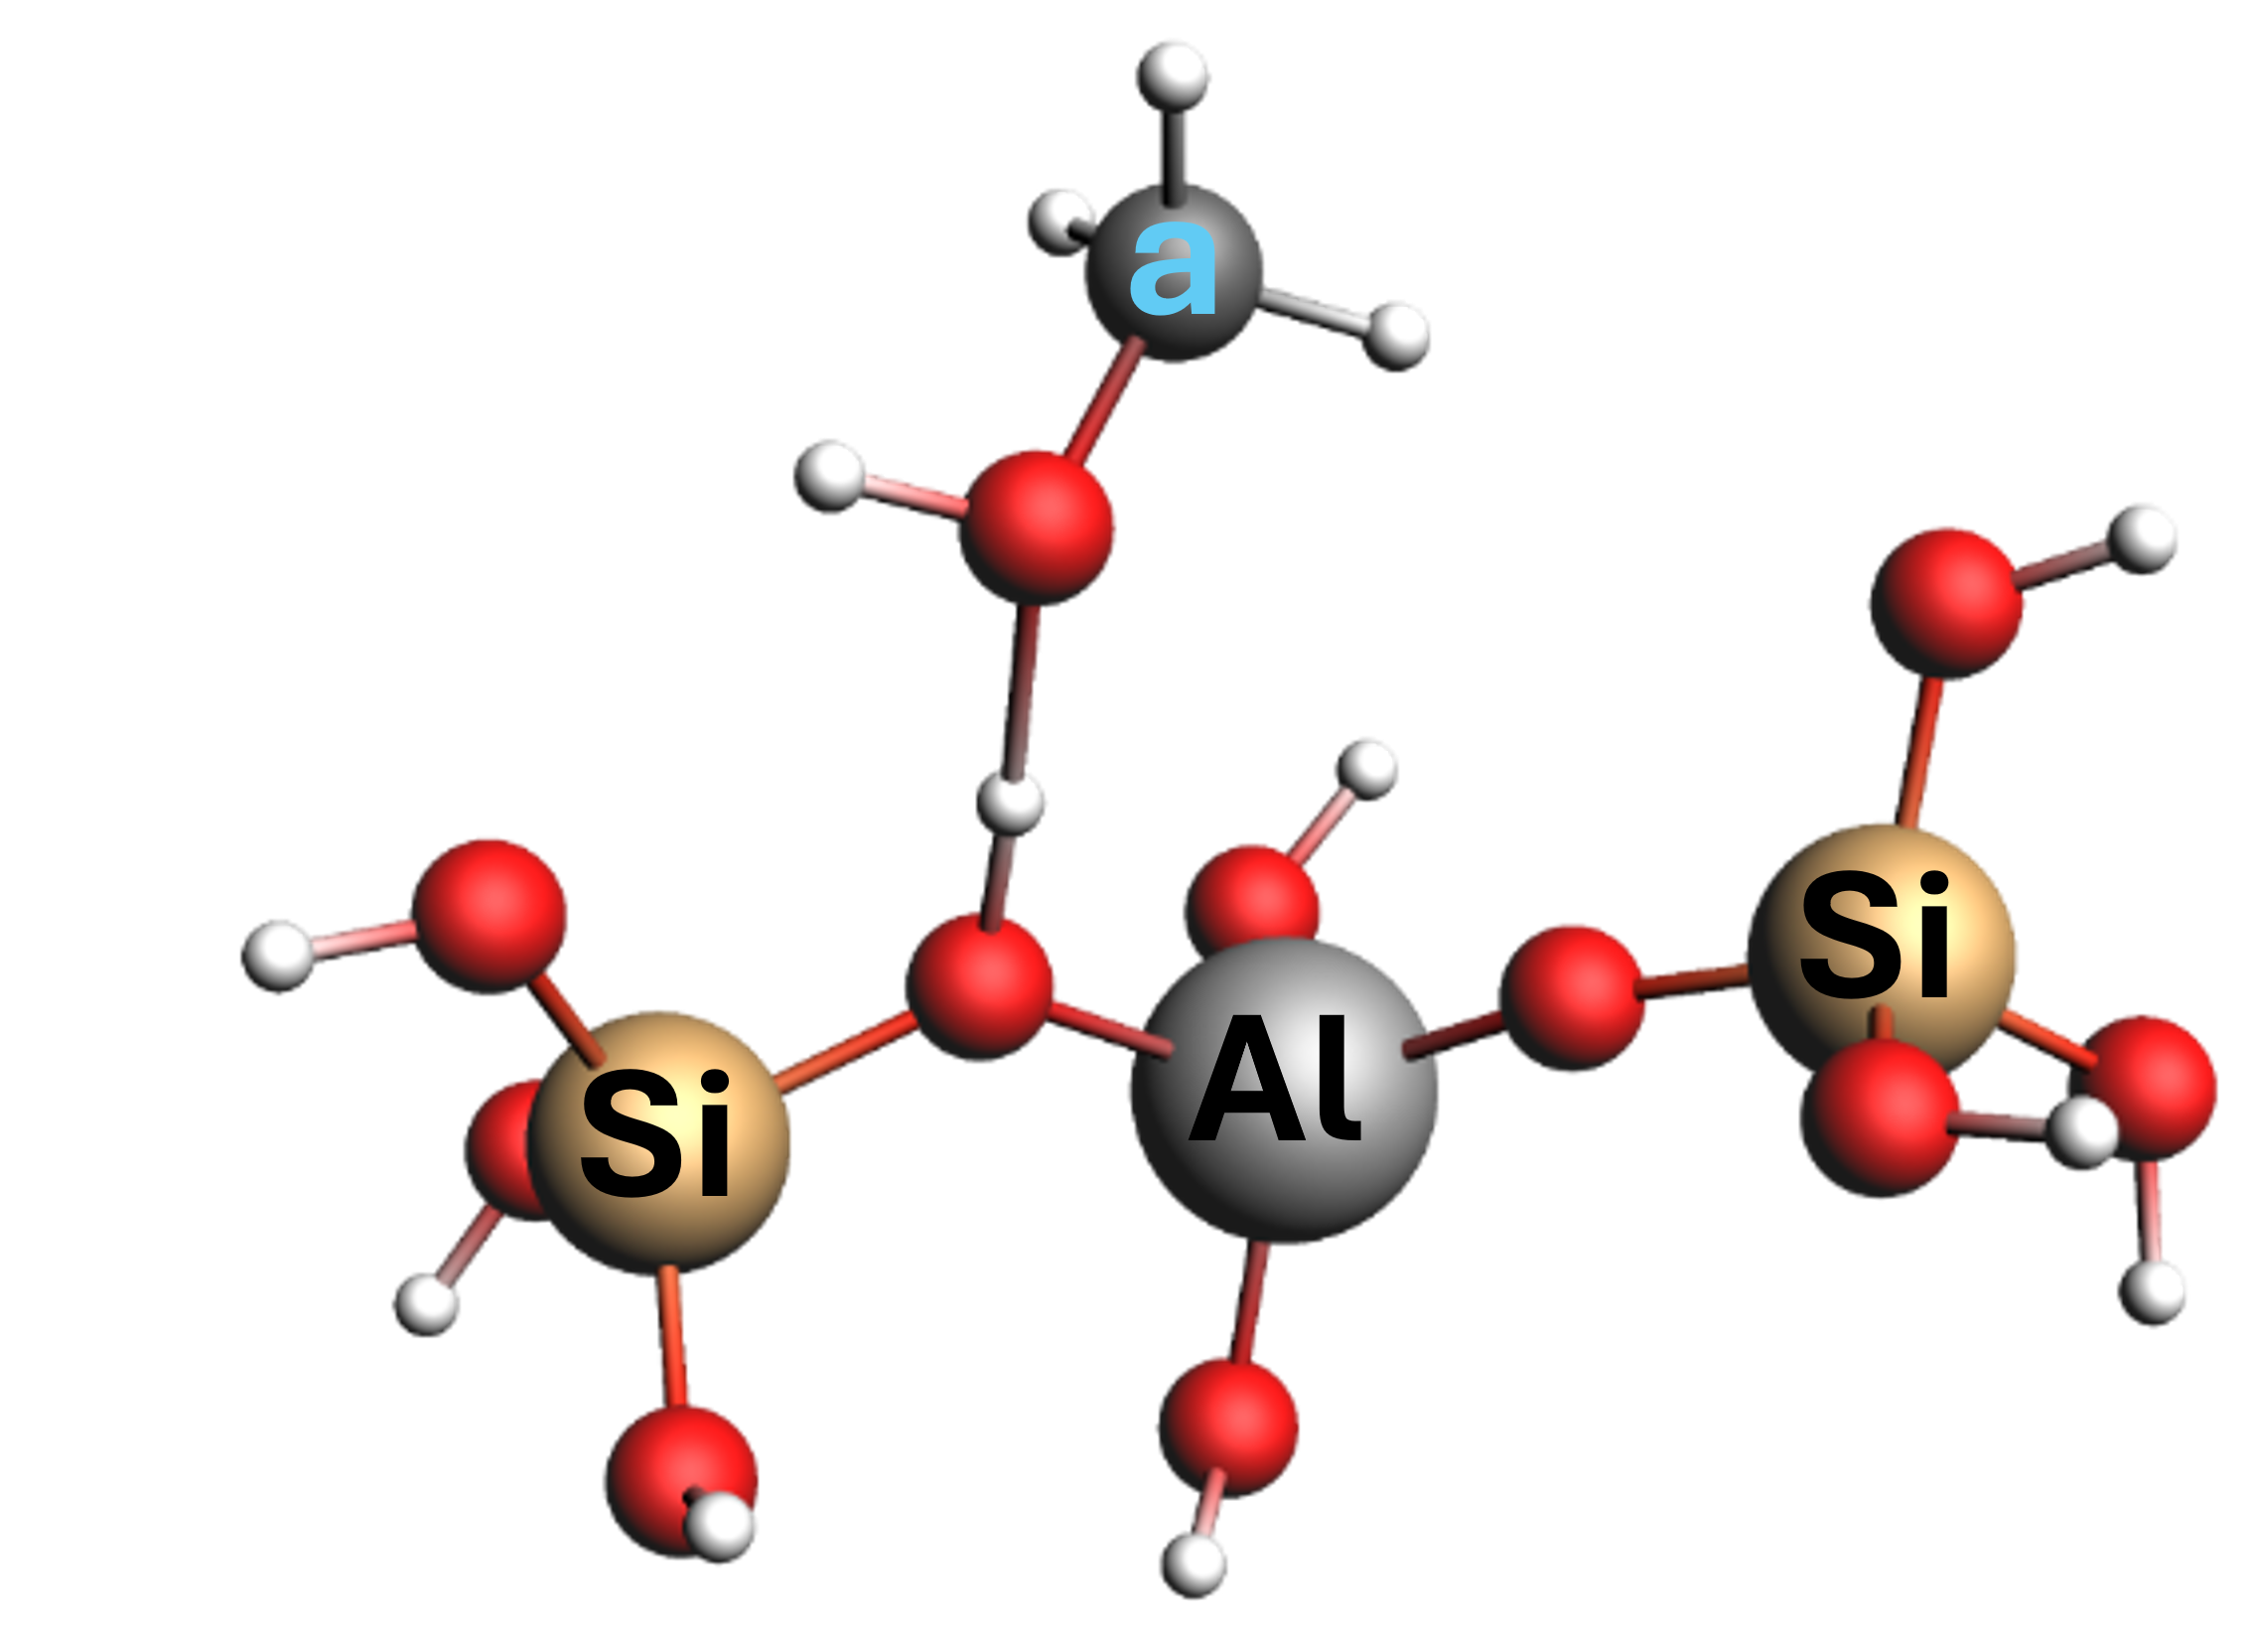  Methanol bound at Brønsted acid site in Al-BEA | COSMO(Methanol)  a=49.6  O (methanol)-H (BAS) bond length = 1.519 Å  H-O (BAS) bond length = 1.047 Å
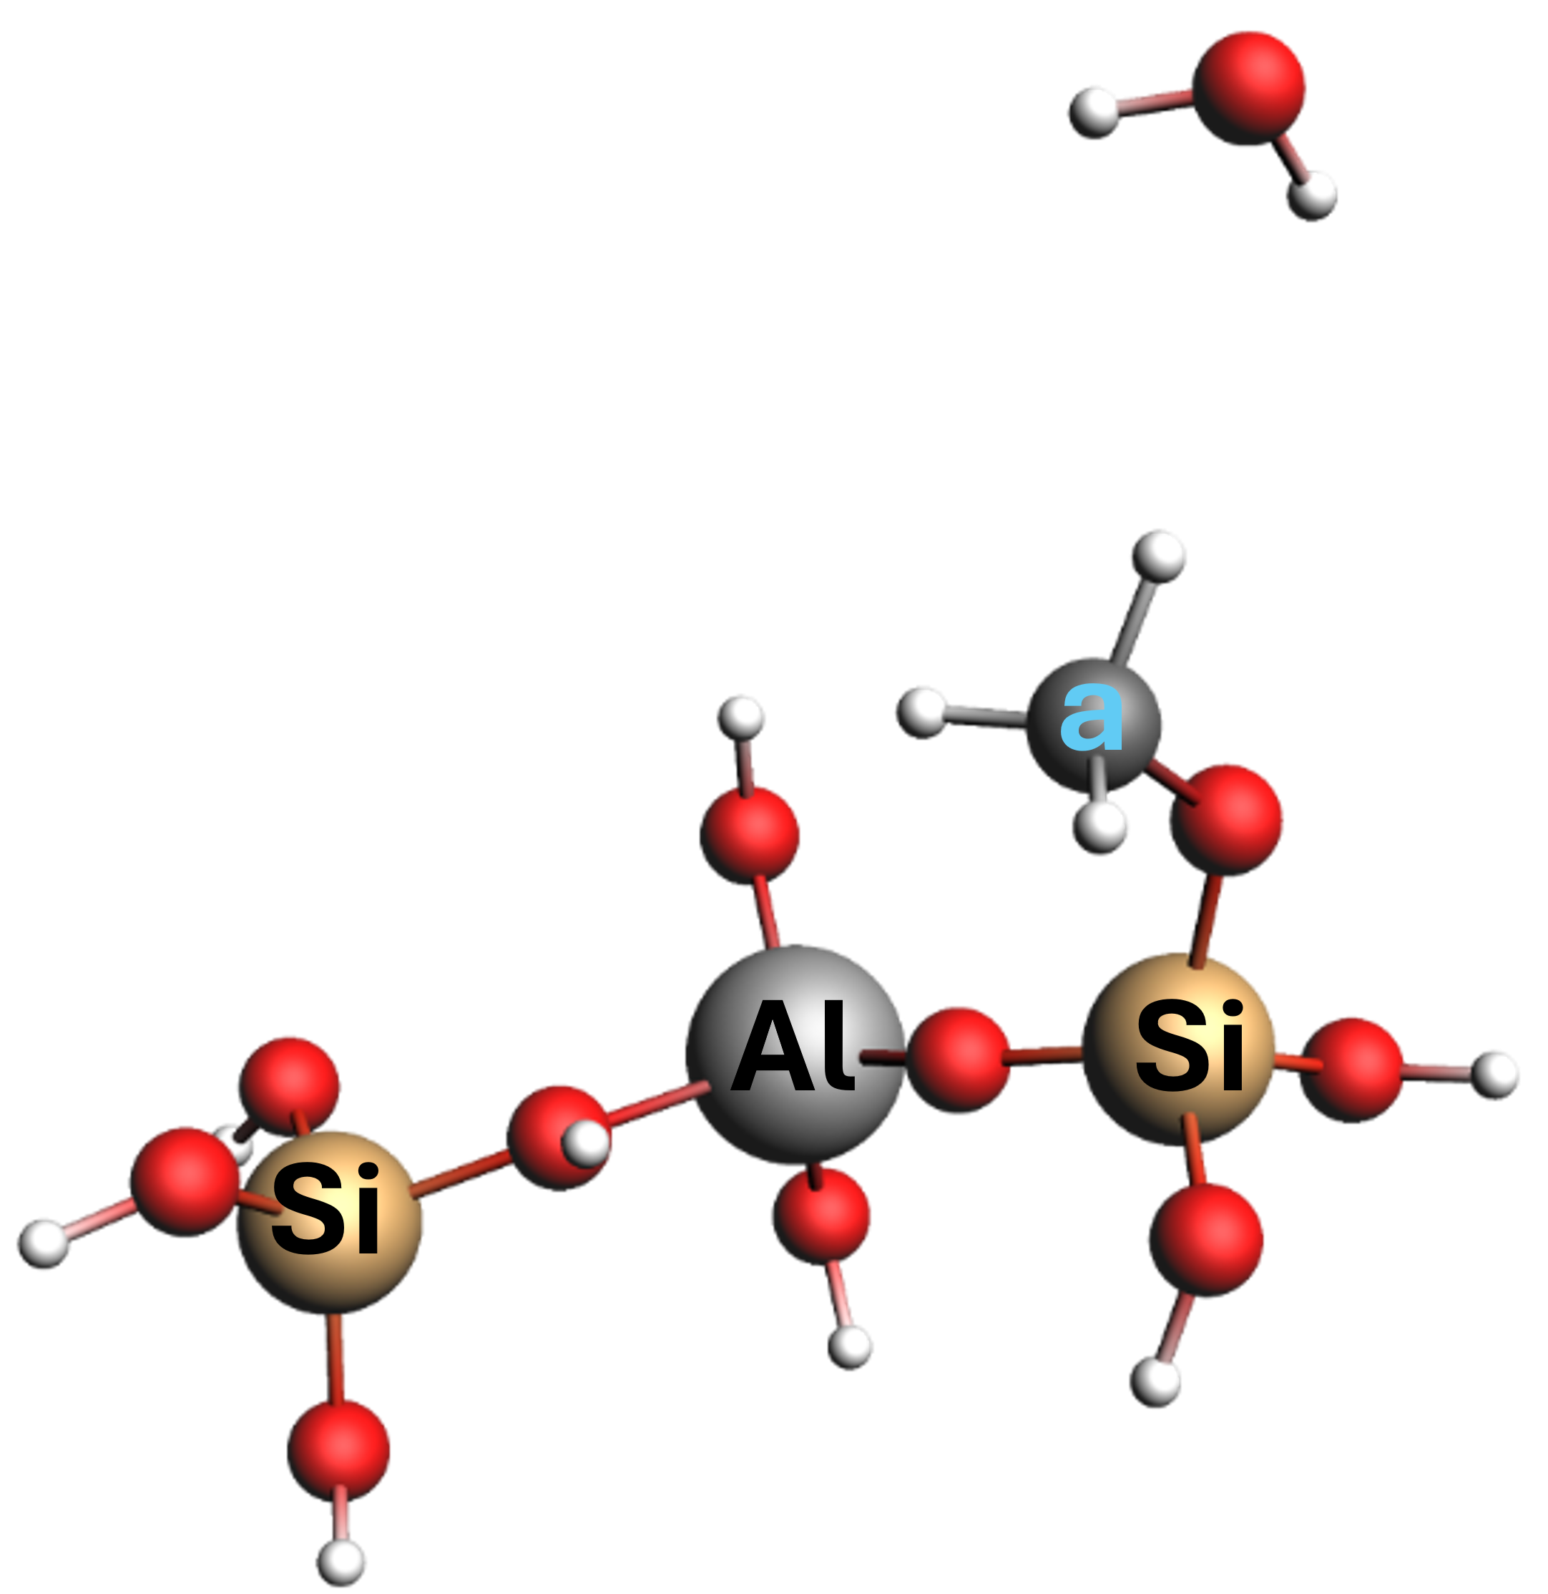  Methoxy bound at Si adjacent to Brønsted acid site in Al-BEA (with eliminated H₂O from CH₃OH) | COSMO(Methanol)  a=48.5
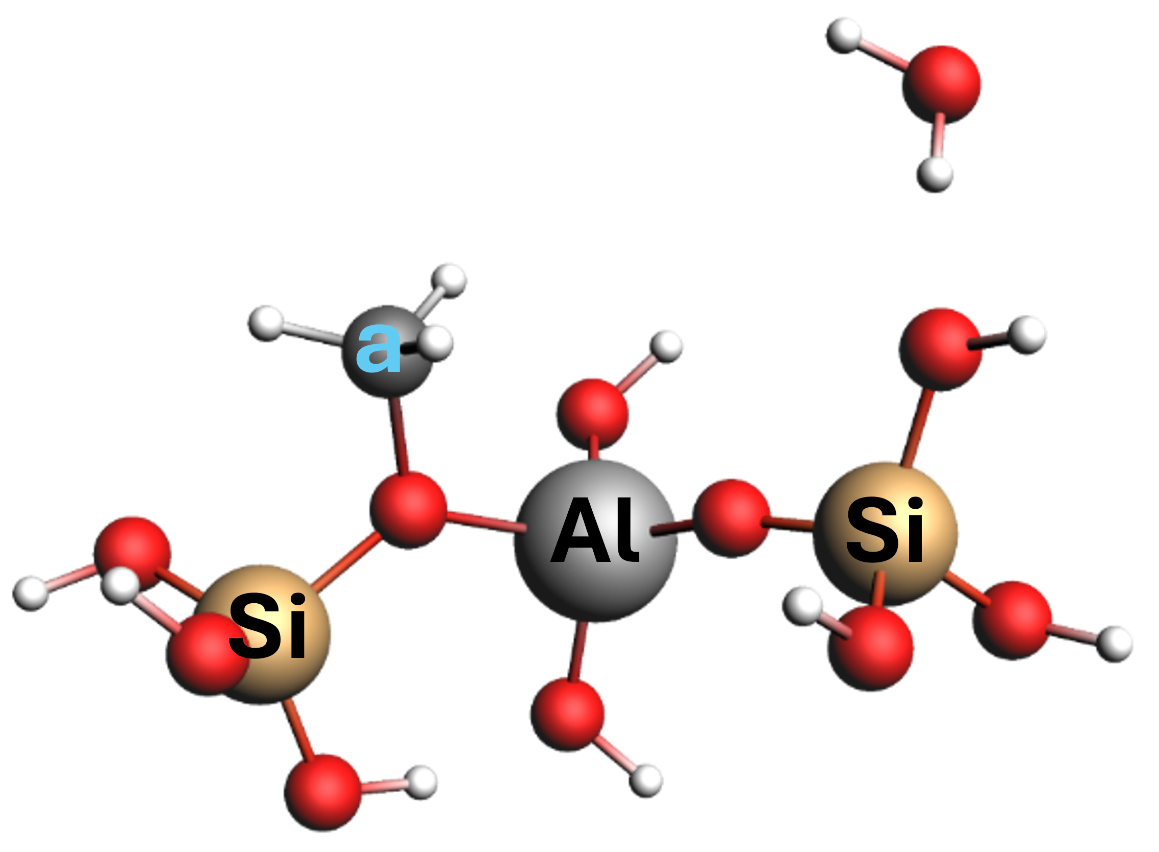  Methoxy bound at Brønsted acid site in Al-BEA  (with eliminated H₂O molecule from CH₃OH) | COSMO (Methanol)  a=54.6
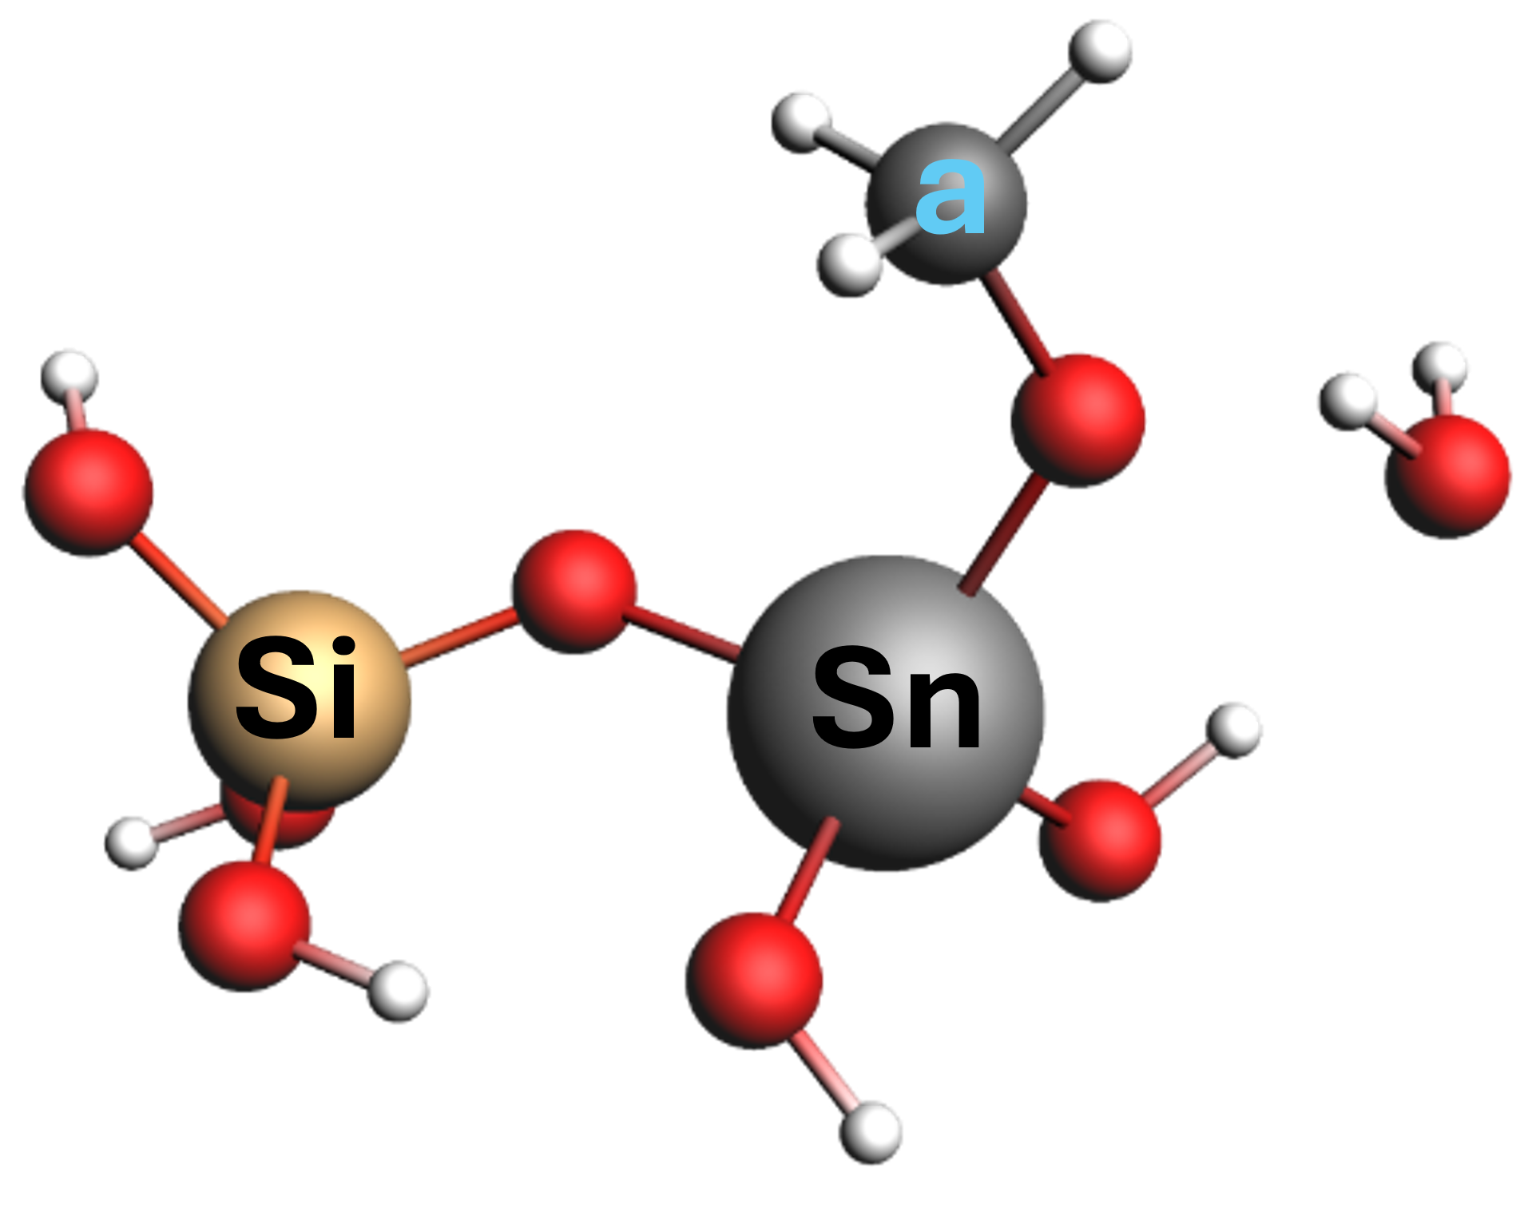  Methoxy bound to Sn site in Sn-BEA  (with eliminated H₂O from CH₃OH) | COSMO(methanol)  a=55.2
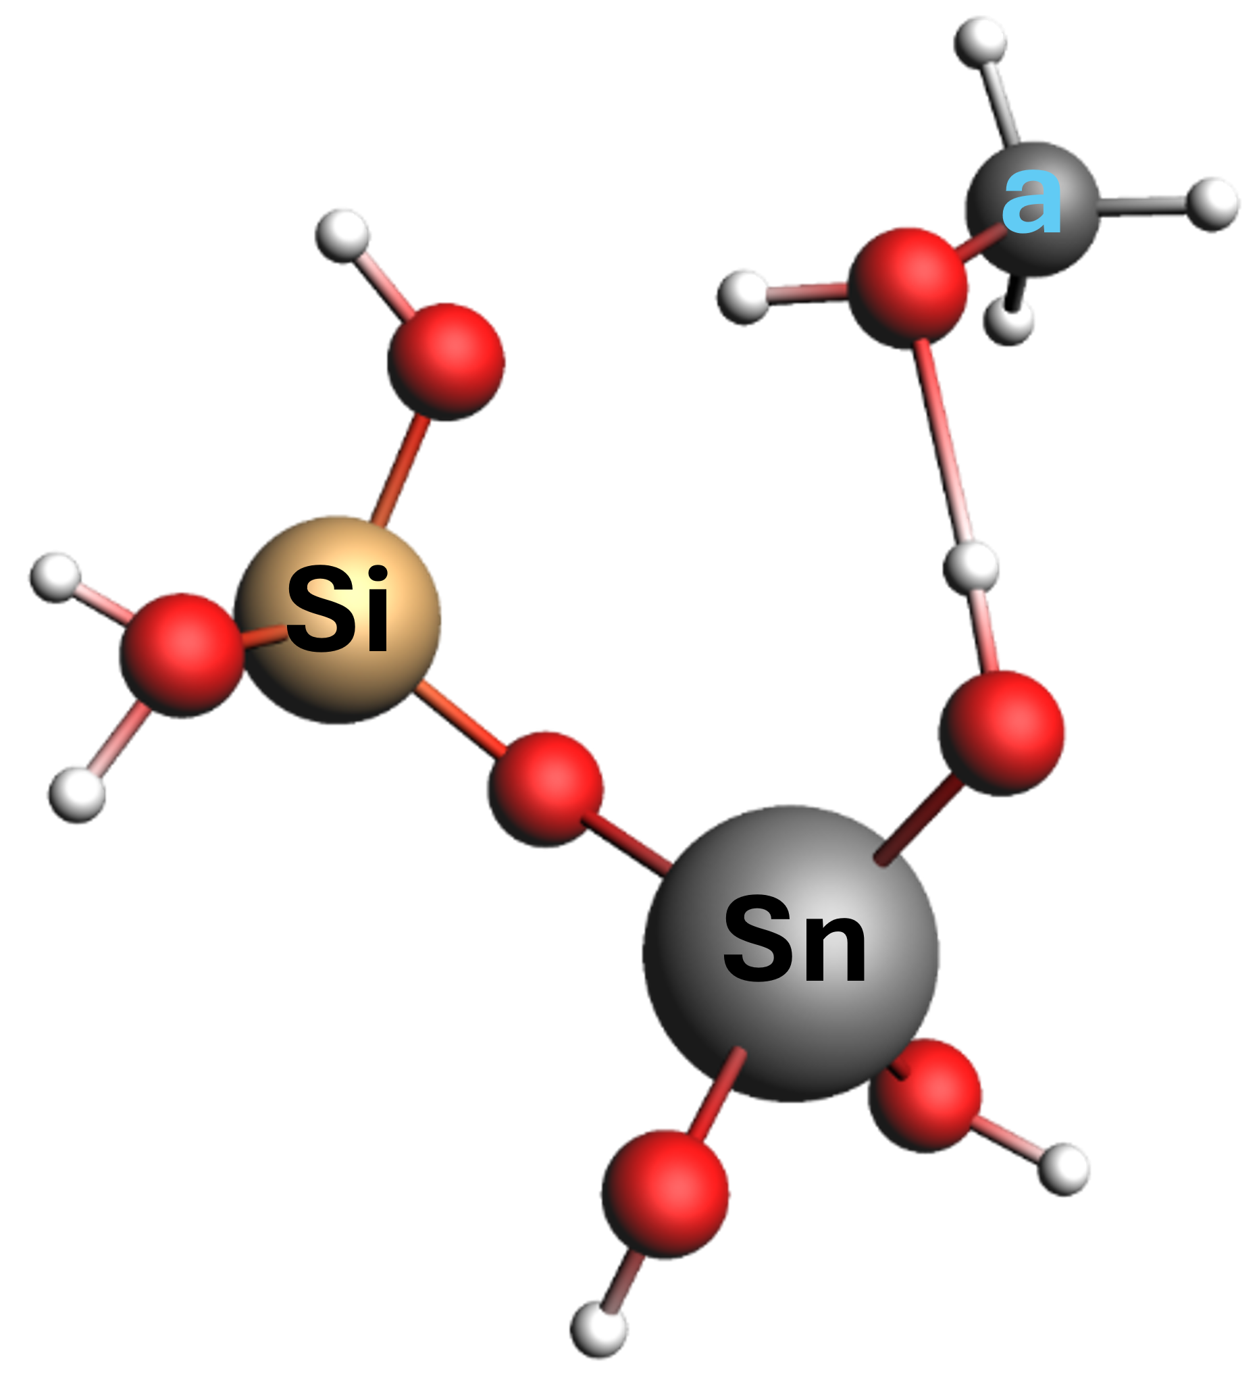  Methanol bound to -H at open site (Sn-OH) in Sn-BEA | COSMO(methanol)  a=47.9
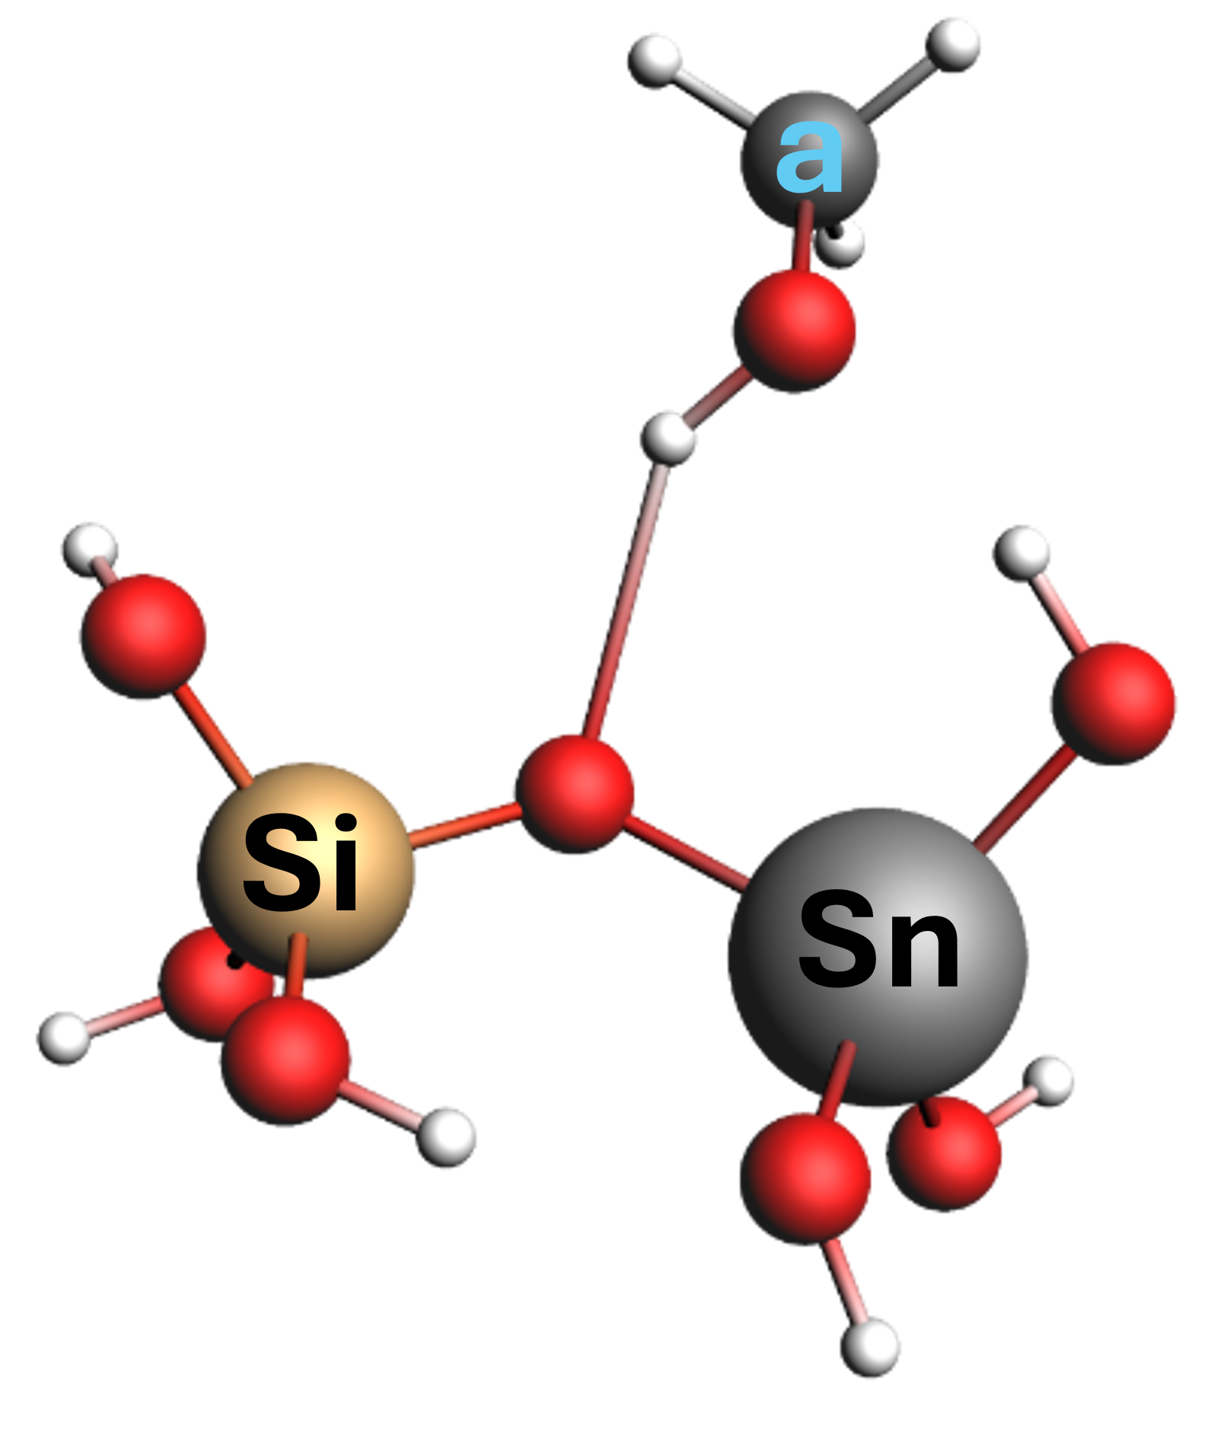  Methanol bound to O in Sn-O-Si near open site (Sn-OH) in Sn-BEA | COSMO(methanol)  a=49.0
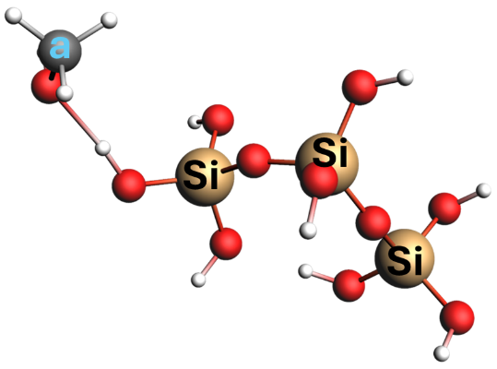  Methanol bound at Si-OH | COSMO(methanol)  a=49.7  H (methanol)-O (Si-O-Si) bond length = 4.478 Å  Methanol unlikely to bind to this site  O (methanol)-H (Si-O-H) bond length = 1.714 Å  Methanol likely binds to this site
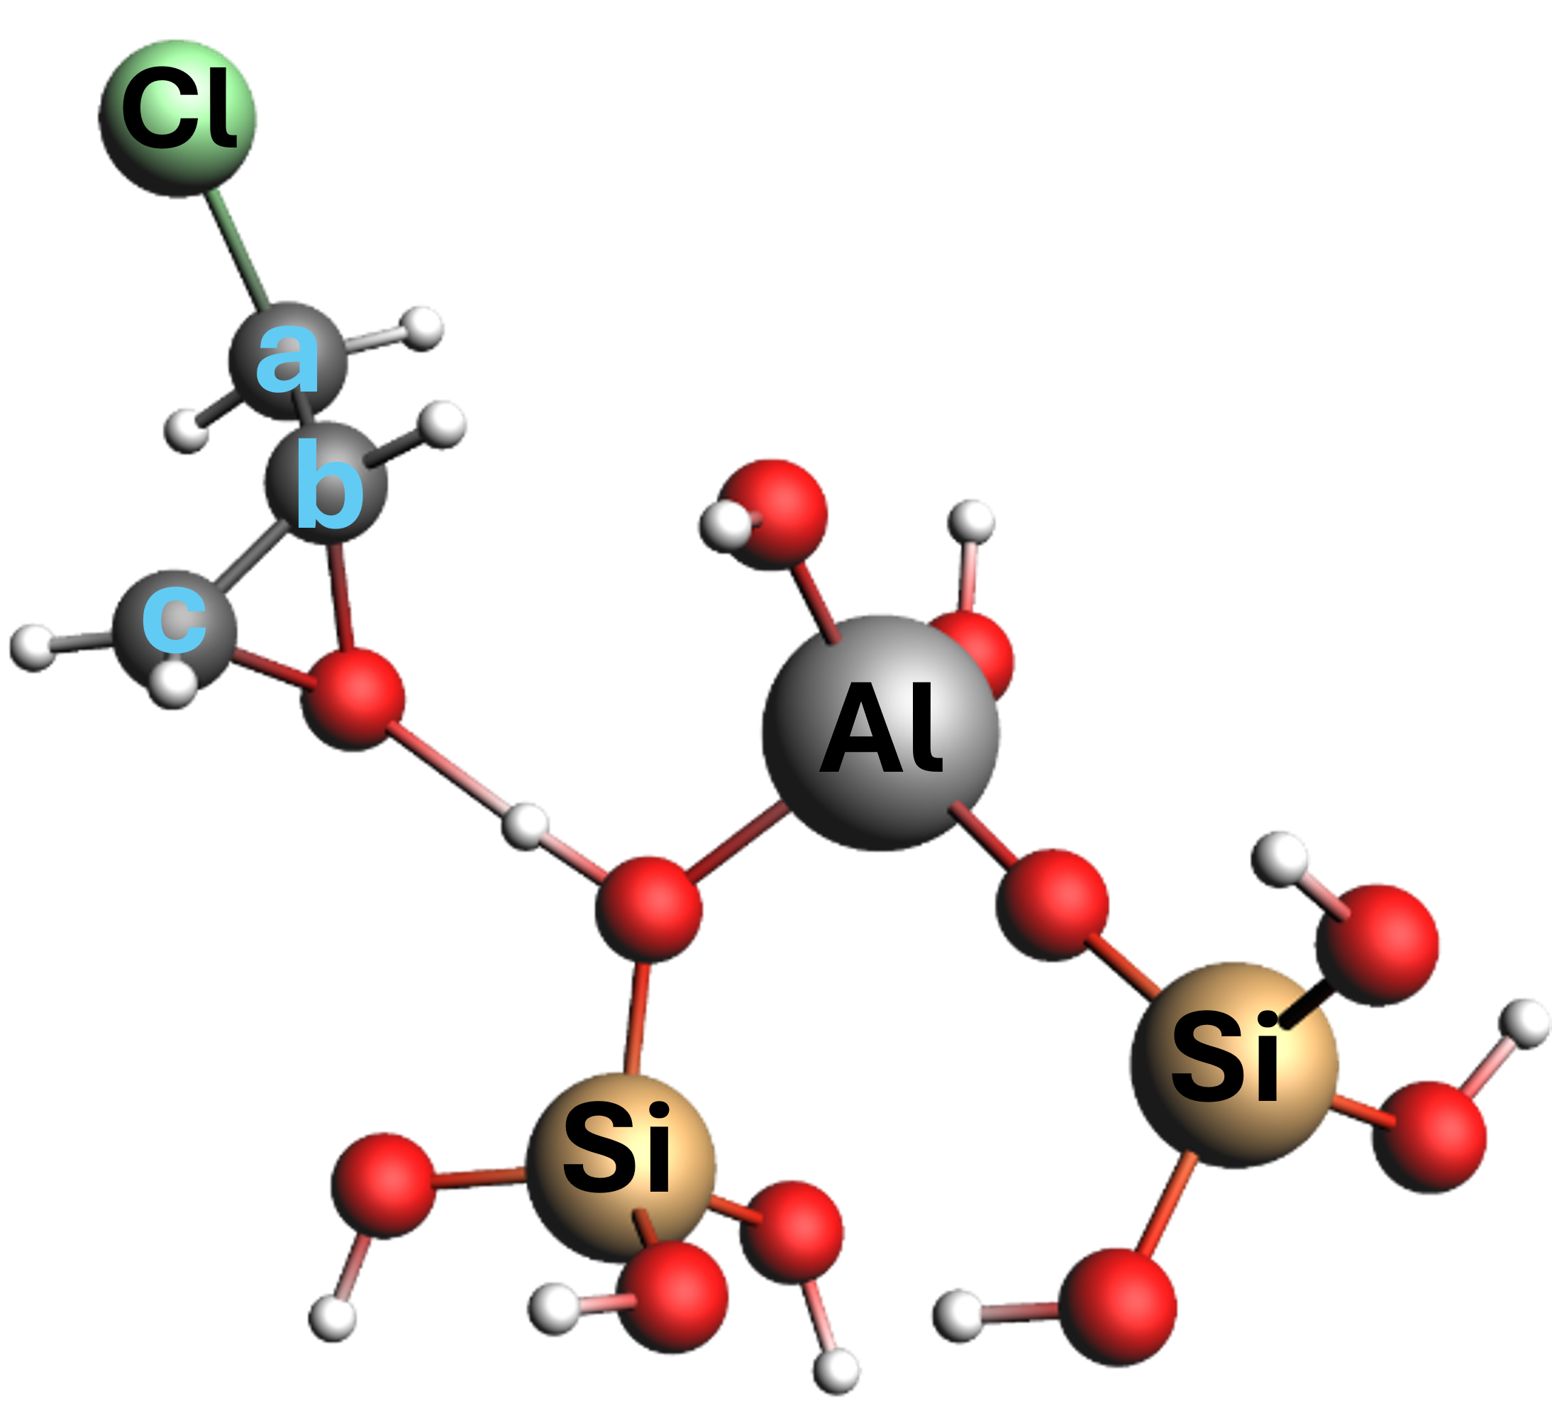  Epichlorohydrin bound at Brønsted acid site in Al-BEA | COSMO(methanol)  a=49.5  b=55.7  c=51.1  BA-H to O of ECH bond length =1.567 Å  BA-H to O of BAS bond length =1.033 Å
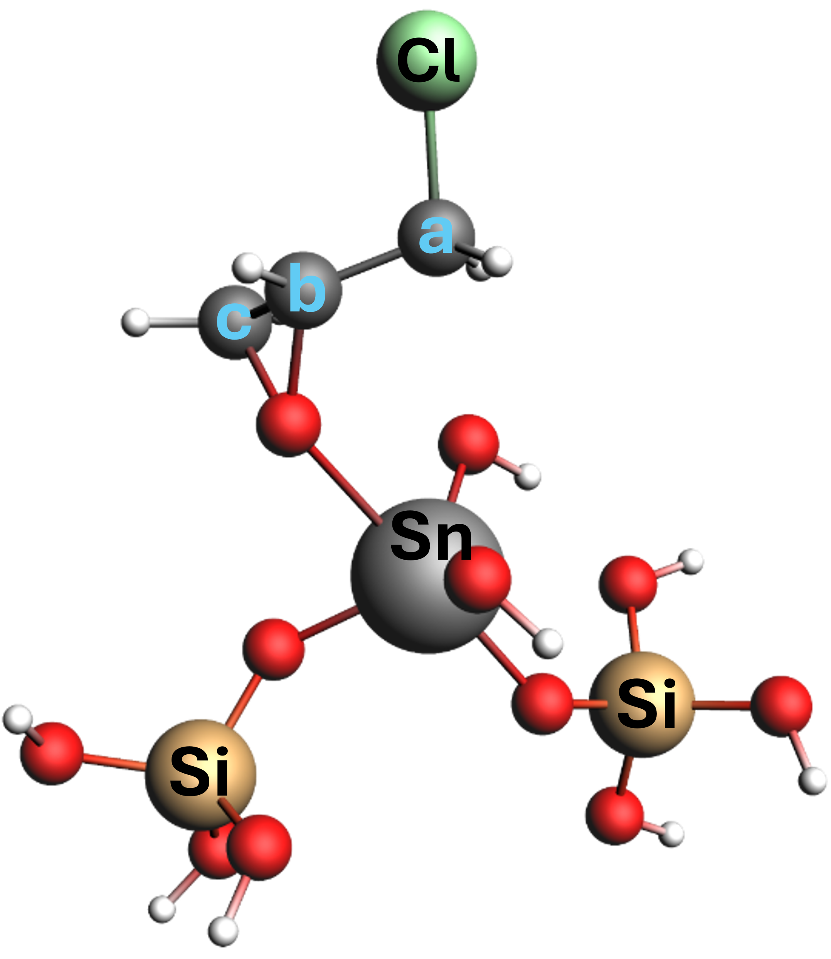  Epichlorohydrin bound at Sn site in Sn-BEA | COSMO(methanol)  a=48.5  b=58.9  c=53.5  O (ECH)-Sn bond length = 2.398 Å
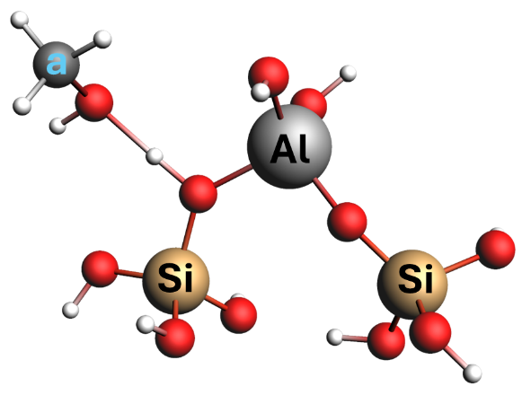  Protonated CH₃OH at Brønsted acid site, Al-BEA | COSMO(methanol)  a=50.2  O (methanol)-H (BAS) bond length = 1.492 Å  H-O (BAS) bond length = 1.055 Å  *Note that the predicted structure for protonated CH₃OH has a nearly identical structure to un-protonated CH₃OH bound to Brønsted acid sites, but with a slightly shorter bond between CH₃OH and the proton and a 0.6 ppm ¹³C shift downfield.
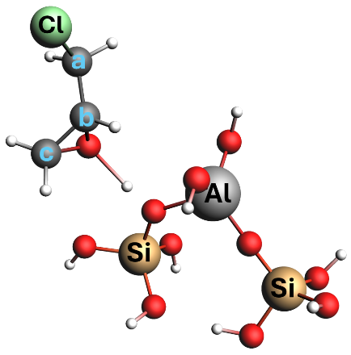  Protonated ECH at Brønsted acid site, Al-BEA | COSMO(methanol)  a=49.1  b=55.5  c=51.0  O (ECH)-H (BAS) bond length = 1.567 Å  H-O (BAS) bond length = 1.034 Å  *Note that the predicted structure for protonated ECH has nearly identical bond lengths and predicted peak shifts to un-protonated ECH bound to Brønsted acid sites.
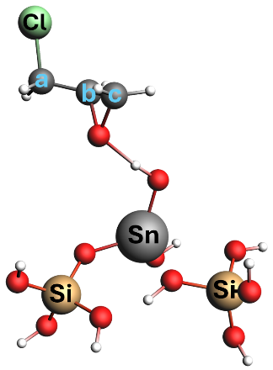  Protonated ECH at Sn-OH site, Sn-BEA | COSMO(methanol)  a=50.4  b=54.0  c=50.2  O (ECH)-H (Sn-OH) bond length = 1.697 Å  H-O (Sn-OH) bond length = 1.007 Å  *Note that the predicted structure for protonated ECH at Sn-OH has a significantly shorter bond length (1.697 Å) than for un-protonated ECH bound to Sn atoms (2.398 Å).
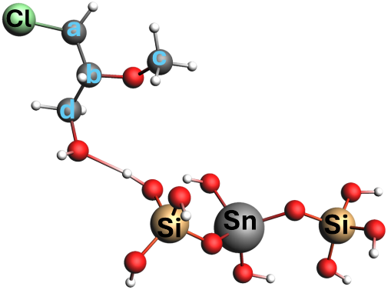  Terminal alcohol bound at Sn site, Sn-BEA | COSMO(methanol)  a=44.6  b=87.2  c=55.5  d=65.6  O (TA, -OCH₃)-Sn bond length = 6.202 Å  TA unlikely to bind to this site  O (TA, -OH)-H(Si-O-H) bond length = 1.732 Å  TA likely binds to this site
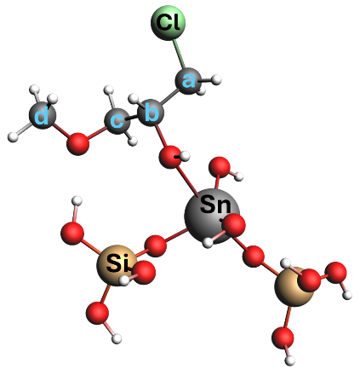  Terminal ether bound at Sn site, Sn-BEA | COSMO(methanol)  a=47.3  b=76.5  c=71.6  d=54.2  O (TE)-Sn bond length = 2.481 Å
Table S9. Predicted ¹³C NMR peak shifts for reactants, primary products, and intermediates from the ring-opening of C₃H₅ClO with CH₃OH, when adsorbed to Al-BEA and Sn-BEA acid sites. These peak shifts were predicted by the Amsterdam Density Functional package (ADF 2024).
The DFT calculations over Sn-BEA consider relativistic effects, while the calculations over Al-BEA do not. The heaviness of Sn atoms (118.71 amu) requires the consideration of relativistic effects for the DFT calculations to run properly.⁵⁶ However, Al atoms (26.98 amu) do not suffer from such limitations, as the DFT software predicts approximately identical peak shifts with and without relativistic effects included. We therefore ran the DFT calculations of Al-BEA without relativistic effects for simplicity.
Molecule | NO COSMO Shift (ppm) | COSMO in Acetonitrile Shift (ppm) | COSMO in Methanol Shift (ppm)
Epichlorohydrin | a = 50.26  b = 50.62  c = 45.20 | a = 51.76  b = 51.84  c = 47.54 | a = 51.77  b = 51.85  c = 47.56
Protonated Epichlorohydrin | -- | a = 43.0  b = 82.8  c = 74.6  b-O bond: 1.591 Å  c-O bond: 1.545 Å  O-H bond: 0.986 Å | a = 43.0  b = 82.9  c = 74.6  b-O bond: 1.591 Å  c-O bond: 1.545 Å  O-H bond: 0.986 Å
Methanol | -- | a = 49.56 | a = 49.6
Terminal ether | -- | a = 54.5  b = 77.9  c = 75.9  d = 55.8 | a = 54.5  b = 77.9  c = 75.9  d = 55.8
Terminal alcohol | -- | a = 52.3  b = 85.7  c = 68.5  d = 59.1 | a = 52.3  b = 85.7  c = 68.5  d = 59.1
Primary carbocation (bound to Brønsted acid site, Al-BEA) | -- | a=46.8  b=75.1  c=71.2 | a=47.0  b=74.6  c=71.1
CH₃OH bound at BAS in Al-BEA | -- | a = 49.5  Bond lengths:  - BA-O-H (O-H) = 1.049 Å  - BA-H to O (-OH, CH₃OH) = 1.513 Å | a = 49.6  Bond lengths:  - BA-O-H (O-H) = 1.047 Å  - BA-H to O (-OH, CH₃OH) = 1.519 Å
Table S10. Comparisons between DFT-predicted peak shifts and bond lengths without the COSMO model (i.e., gas-phase) and with the COSMO model in a solvent continuum of acetonitrile or methanol.
Comparison of the predicted and calculated peak shifts for the liquid phase (Table S8) and surface-bound species (Table S9) to the experimentally observed peak shifts yields some interesting observations and points of discussion. First, the DFT predictions appear to frequently predict a shift further downfield for the (a) carbon attached to the chlorine within C₃H₅ClO, intermediate carbocations, and the ring-opened products. The experimentally obtained spectra for C₃H₅ClO and terminal ether standards confirm this over-prediction, as the DFT predicts shifts for (a) that are ~4 and ~8 ppm greater than those demonstrated by experiment for the respective molecules. While we cannot confirm the same for other products or intermediates (no standards available), we expect a similar over-prediction downfield from the DFT-calculated shifts.

A significant overlap of peaks occurs in the 45-55 ppm range in spectra collected during C₃H₅ClO ring-opening with CH₃OH, as shown in Figure 4 and sections below (vide infra). This region contains peaks originating from liquid-phase and adsorbed CH₃OH-derived species, the (a) carbon on liquid-phase C₃H₅ClO, intermediate carbocations, and the ring-opened products, and the (c) carbon on liquid-phase C₃H₅ClO. Therefore, we utilized the peak areas of carbon atoms that are not convoluted to track peak growth and measure the concentrations of the products and reactants in the NMR rotor. We utilized the secondary epoxide carbon (b) for C₃H₅ClO and secondary carbon (b) in both the terminal ether and terminal alcohol. We acknowledge that the formation of the TE product convolutes the primary carbocation features in the range of 69-73 ppm, which likely increases the error of peak area deconvolution for these species. We assume that all carbons show equal peak areas, supported by comparisons of the peak areas of the epoxide carbons in the absence of the reaction.

Comparison of the DFT-computed peak shifts for the (b) and (c) carbons in the secondary carbocation bound to Al-BEA (b = 89.0 ppm, c = 63.0 ppm), terminal alcohol bound to Al-BEA (b = 91.6 ppm, c = 61.8 ppm), and liquid-phase terminal alcohol (b = 85.7 ppm, c = 68.5 ppm) provide insight into intermediate and product formation in Figure 4a. The broad nature of the evolving peak between 80-90 ppm suggests that all three of the (b) carbons from these species contribute and convolute peak assignments. However, the peaks at ~63 and ~67 ppm match well with the (c) carbon predictions for the secondary carbocation and liquid-phase terminal alcohol, which appear much more intensely than a very minor peak at ~62 ppm that matches the bound terminal alcohol prediction. Considering these intensities and the growth patterns of the peaks, where the ~63 ppm peak first evolves and is followed by the ~67 ppm peak, the product formation pathway becomes clear. The secondary carbocations first form on the surface, then the terminal alcohol product desorbs quickly once formed (explaining the very low intensity of bound terminal alcohol features). Cross-referencing the (c) carbon predictions for Sn-BEA bound species with Figure 4b yields a similar observation of rapid desorption of the terminal alcohol following secondary carbocation formation and reaction with CH₃OH. Figure S32 (vide infra) presents an analogous experiment to Figure 4, except Figure S32 shows faster and greater accumulation of intermediate and product peaks because the reaction was initiated by adding all species to the NMR rotor simultaneously. The evolution of the peaks at ~62, ~63, and ~67 ppm in Figure S32 illustrates the full cycle of terminal alcohol formation (further discussion provided below).

DFT predicts that coordination of the terminal alcohol product to a framework Sn atom in Sn-BEA is highly unfavorable (bond length = 6.202 Å) (Table S9). The terminal alcohol instead prefers to bind to an adjacent Si-OH group (bond length = 1.732 Å). In contrast, the terminal ether product binds more favorably to framework Sn (bond length = 2.481 Å). The difference between the binding configurations of the products may align with the significantly greater selectivity to the terminal ether during C₃H₃ClO ring-opening over Sn-BEA (Figure 7). While the peak areas in Figure 2 predict a primary to secondary carbocation ratio of 2.4 over Sn-BEA, the unfavorable binding of the terminal alcohol to Sn sites may contribute to the preference of Sn-BEA to form the terminal ether through either S_{N}1 or S_{N}2 reaction pathways.
The DFT-computed shifts for the (b) and (c) carbons unfortunately overlap more significantly for the primary carbocation bound to Al-BEA (b = 74.6 ppm, c = 71.1 ppm), terminal alcohol bound to Al-BEA (b = 77.2 ppm, c = 73.6 ppm), and liquid-phase terminal alcohol (b = 77.9 ppm, c = 75.9 ppm), with a similar issue for Sn-BEA as well. The narrow distribution of peak shifts aligns with the convoluted features observed from 69-76 ppm in Figure 4a (as discussed above), which precludes the precise observation of product formation and desorption possible for the terminal alcohol product. Nevertheless, the qualitative observation of evolving peak features in this region still demonstrates the formation of primary carbocations and the subsequent formation of terminal ether species.

Lastly, the predicted DFT binding structures for the secondary carbocation and terminal alcohol species suggest that these species will bind to the surface in a flatter configuration than other bound species, including CH₃OH, C₃H₅ClO, the primary carbocation, and terminal ether. The positively charged secondary carbon should coordinate with the proton in the secondary carbocation species, while the terminal alcohol product should bind through the -OCH₃ group that attaches to the same secondary carbon. This observation likely explains why the peaks originating from the secondary carbon in the terminal alcohol and secondary carbocation appear much more broadly than any other peaks in the NMR spectra, which makes these peaks difficult to observe and deconvolute. The flat binding configuration of these species on the zeolite surface likely leads to less freedom of motion for the secondary carbon compared to the other carbon atoms in the same molecules, which may cause the secondary carbon peaks to appear more broadly and difficult to observe.

S11.2. ¹³C NMR Spectra for Liquid-Phase C₃H₅ClO and CH₃OH
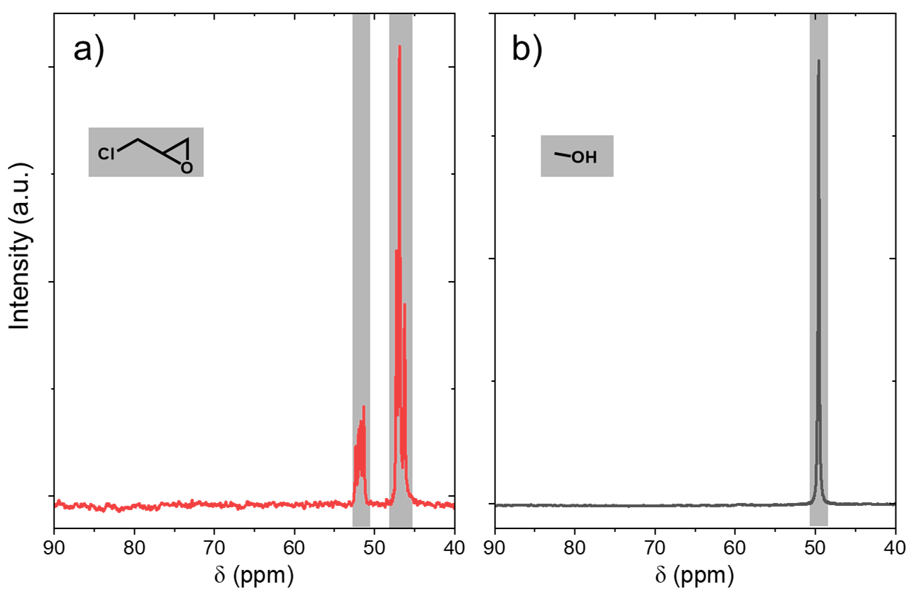
Figure S22. ¹³C NMR single-pulse spectra of a) C₃H₅ClO and b) CH₃OH without catalyst present (0.2 M ¹³C₃H₅ClO or ¹³CH₃OH, CH₃CN, 298 K). Spectra are an average of 268 scans (C₃H₅ClO) and 68 scans (CH₃OH).

Figure S22 displays single-pulse spectra for C₃H₅ClO and CH₃OH diluted in CH₃CN and without catalyst present. These spectra show the characteristic ¹³C peak shifts for the carbons within C₃H₅ClO and CH₃OH, highlighted in red and black, respectively. As discussed in Section S11.1, the DFT-calculated peak shifts closely predict all peak locations except for the carbon directly bound to -Cl in C₃H₅ClO.

S11.3. ¹³C NMR Spectra and Analysis for C₃H₅ClO Adsorption and Carbocation Formation
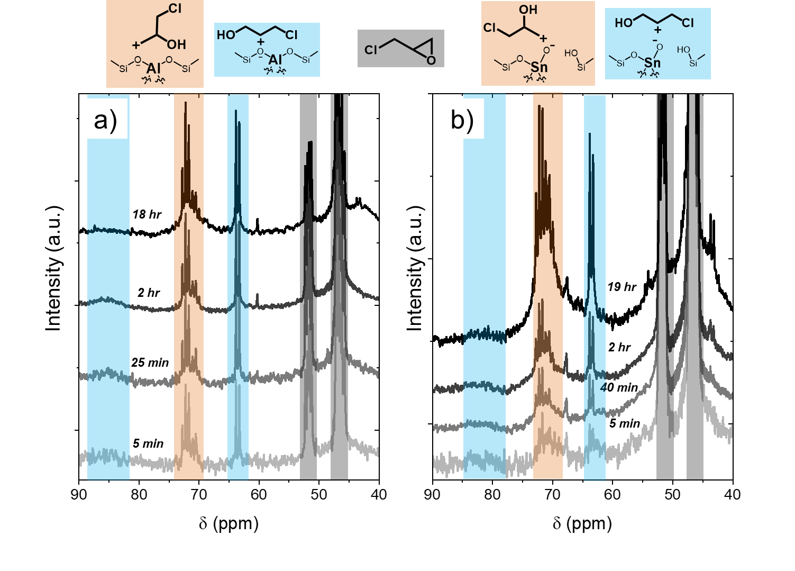
Figure S23. ¹³C NMR single-pulse spectra collected as a function of time during adsorption of C₃H₅ClO to a) Al-BEA and b) Sn-BEA (0.2 M ¹³C₃H₅ClO, CH₃CN, 298 K). Spectra are an average of scans, ranging from 24 scans (5 min time points) to 256 scans (last time points).
Figure S23 shows the single-pulse spectra for C₃H₅ClO adsorption as a function of time. The peak assignments match well with the computationally predicted and experimentally calculated peak shifts shown in Section S11.1. The peak areas of the ring-opened carbocation species increase relative to C₃H₅ClO over time, supporting that more C₃H₅ClO opens to form carbocations over time. The carbocation peaks accumulate less rapidly over Sn-BEA than Sn-BEA. The open sites (Sn-OH) within Sn-BEA likely have a weaker Brønsted acidity than the Brønsted acid sites within Al-BEA, which likely leads to a slower activation of C₃H₅ClO and a lower quantity of ring-opened carbocations over Sn-BEA. Furthermore, the peak areas of the carbocation features do not decrease over a long period (> 18 hr). The stability of these features supports that the C₃H₅ClO irreversibly ring-opens to form stable carbocations on the Al-BEA and Sn-BEA surface.
Notably, the ratio of primary to secondary ring-opened carbocations over Sn-BEA during the ring-opening reaction within the NMR rotor shown in Figures 5 and 6 (1.2 – 2.5) of the main text generally falls below the ratio observed in the absence of the reaction (2.4, Figure 2 of main text). In contrast, the ratio during the reaction over Al-BEA (1.3 – 2.3) typically exceeds the ratio without the reaction occurring (1.4, Figure 2). Nevertheless, the different trends in the carbocation ratios between Sn-BEA and Al-BEA in the presence and absence of the ring-opening reaction likely signal that the reactivity of these carbocations differs between the two catalysts. The primary carbocation may show a greater reactivity over Sn-BEA, which reduces the quantity of these species and lowers the carbocation ratio on the surface, while the primary carbocations may have lesser reactivity over Al-BEA and lead to a greater carbocation ratio on the surface. Despite the difference in carbocation ratios between Figure 2 and Figures 5 and 6, the greater prevalence of the primary relative to secondary ring-opened carbocation holds in all cases. The preference towards forming the primary carbocation, originating from differences in $k_{5,{}_{ }^{1}C }$ and $k_{5,{}_{ }^{2}C}$, likely primarily governs $β$ differences at low [CH₃OH]:[C₃H₅ClO] ratios in Figure 7.
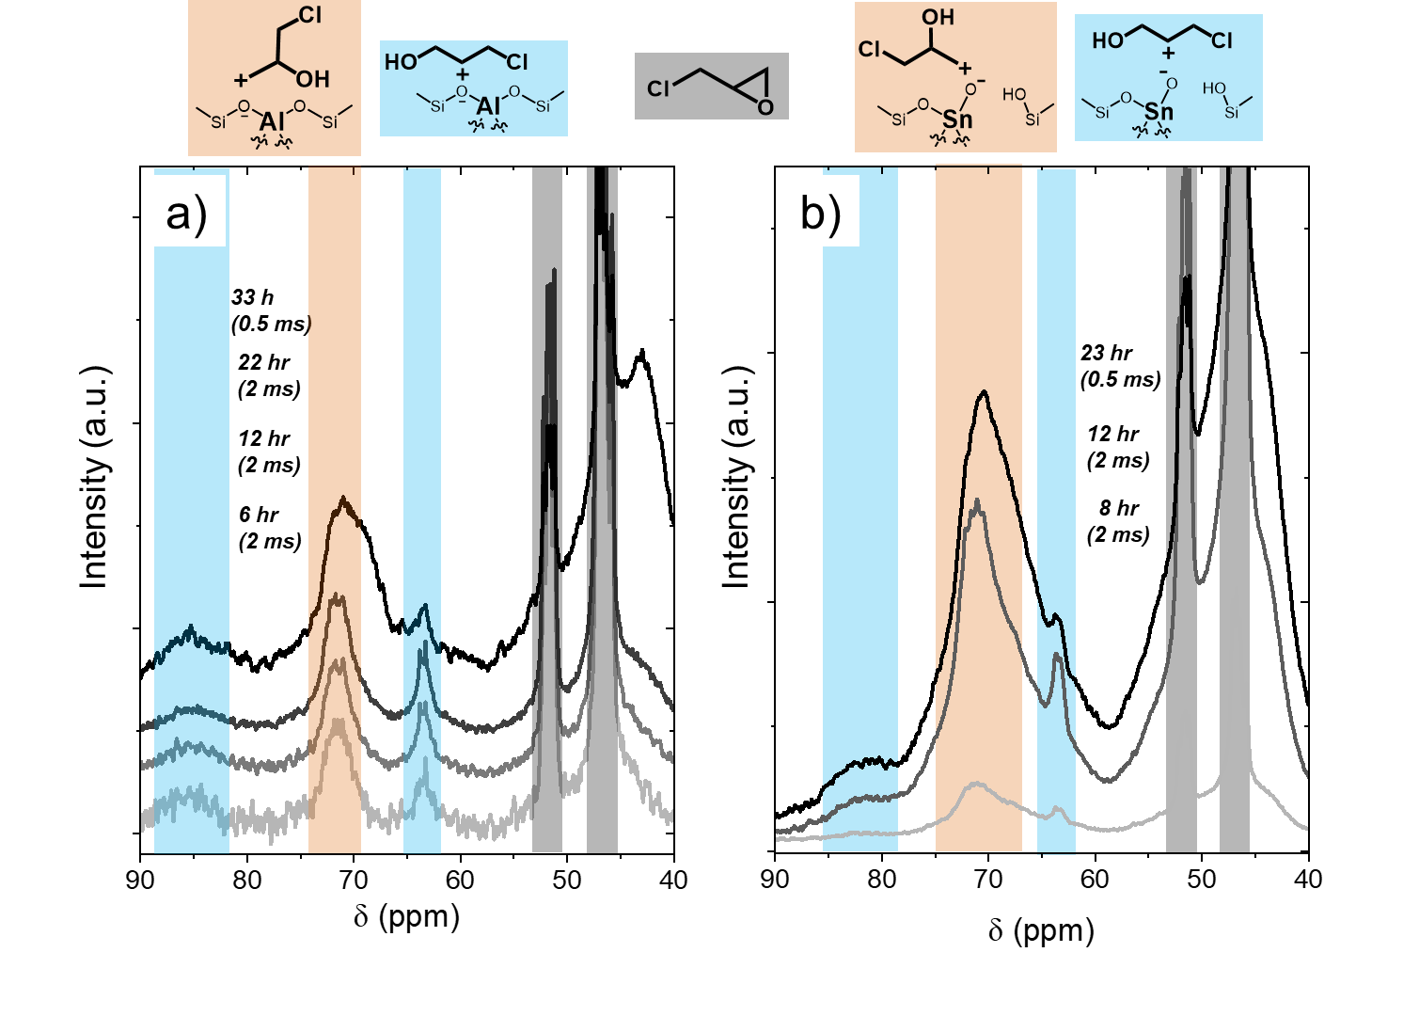
Figure S24. ¹³C NMR cross-polarization spectra collected as a function of time during adsorption of C₃H₅ClO to a) Al-BEA and b) Sn-BEA (0.2 M ¹³C₃H₅ClO, CH₃CN, 298 K). Contact times are shown in parentheses. Spectra are an average of scans, ranging from 756 to 10,000 scans.

Figure S24 reveals the cross-polarization spectra for C₃H₅ClO adsorption over time. Features corresponding to the ring-opened carbocations and intact C₃H₅ClO both appear in the spectra, aligning with tabulated values from Section S11.1. The broad nature of the carbocation features supports that these species are bound to the surface. The sharp nature of the C₃H₅ClO in Al-BEA suggests that these features originate from liquid-phase C₃H₅ClO that resides near the surface but is not bound to the surface. In contrast, the broader nature of the C₃H₅ClO features over Sn-BEA supports that a fraction of surface C₃H₅ClO exists as an intact molecule rather than ring-opened carbocations.
Of note, the intensity of the ring-opened carbocation peaks increases relative to intact C₃H₅ClO when the contact time is decreased from 2 ms to 0.5 ms. This supports that the ring-opened carbocations bind more strongly to the surface than C₃H₅ClO.

S11.4. ¹³C NMR Spectra and Analysis for CH₃OH Adsorption
Figure S25 displays the single-pulse spectra for CH₃OH adsorption as a function of time. The peak for physisorbed CH₃OH at Si-O-Si features (green) appears from very early times in both catalysts. in which the ring-opening reaction was initiated by adding CH₃OH (0.2 M CH₃OH). The chemisorbed (yellow) and protonated (purple) CH₃OH species appear slowly over time in Al-BEA, demonstrating the formation of activated CH₃OH intermediates at the Brønsted acid sites. Interestingly, chemisorbed CH₃OH appears from much lower times within Sn-BEA, suggesting that Sn-BEA may activate more strongly and more rapidly over Sn-BEA than Al-BEA.
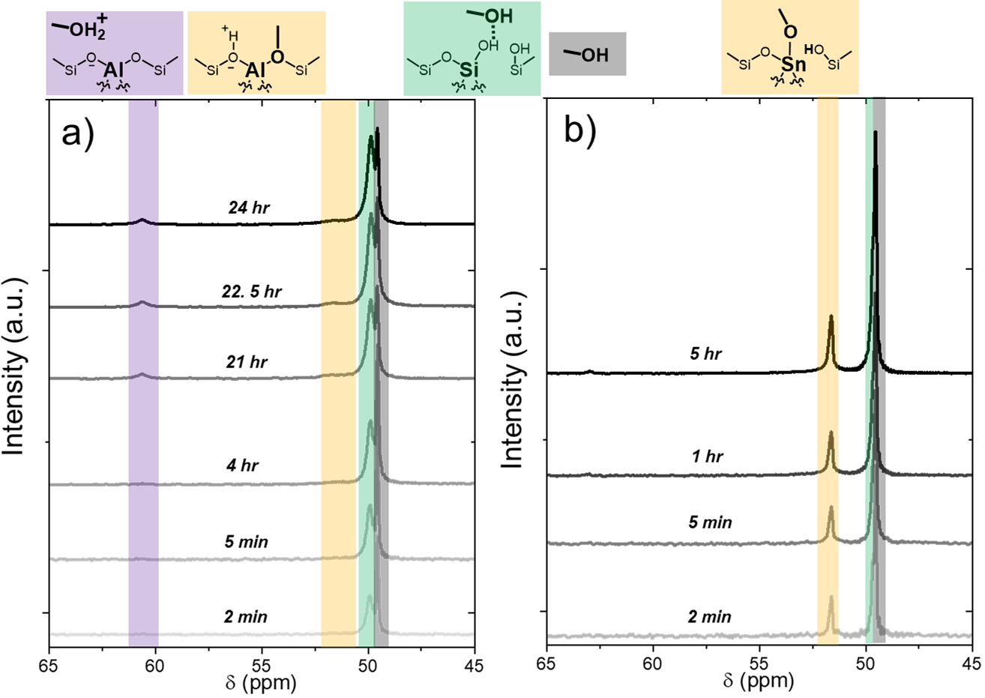
Figure S25. ¹³C NMR single-pulse spectra of ¹³CH₃OH on a) Al-BEA and b) Sn-BEA (0.2 M ¹³CH₃OH, CH₃CN, 298 K) collected as a function of time after initial contact between the liquid solution and the zeolite. Spectra are an average of scans, ranging from 16 scans (2 min time points) to 2000 scans (last time points).

Figure S26 displays the cross-polarization spectra for CH₃OH adsorption as a function of time. These spectra show the key adsorption peaks also observed in the single-pulse spectra in Figure S25: physisorbed CH₃OH at Si-O-Si features (green), chemisorbed CH₃OH (yellow), and protonated CH₃OH (purple) species. Figure S26 provides further support that CH₃OH adsorbs to the *BEA framework and activates at both Brønsted and Lewis acid sites.
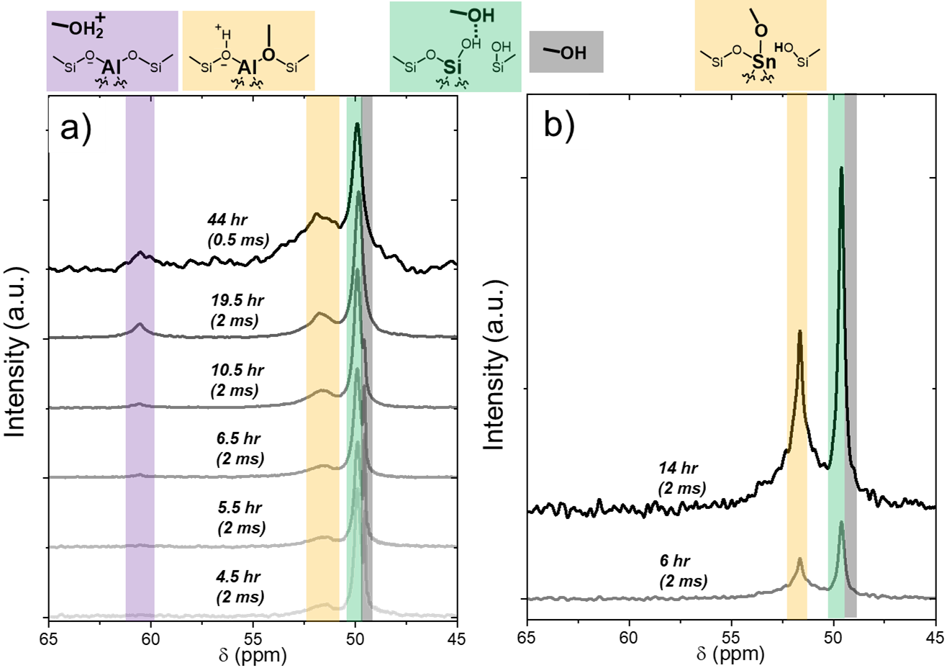
Figure S26. ¹³C NMR cross-polarization spectra of ¹³CH₃OH on a) Al-BEA and b) Sn-BEA (0.2 M ¹³CH₃OH, CH₃CN, 298 K) collected as a function of time after initial contact between the liquid solution and the zeolite. Contact times are shown in parentheses. Spectra are an average of scans, ranging from 734 to 8,000 scans.

S11.5. Supplemental ¹³C NMR Spectra from C₃H₅ClO Ring-Opening with CH₃OH
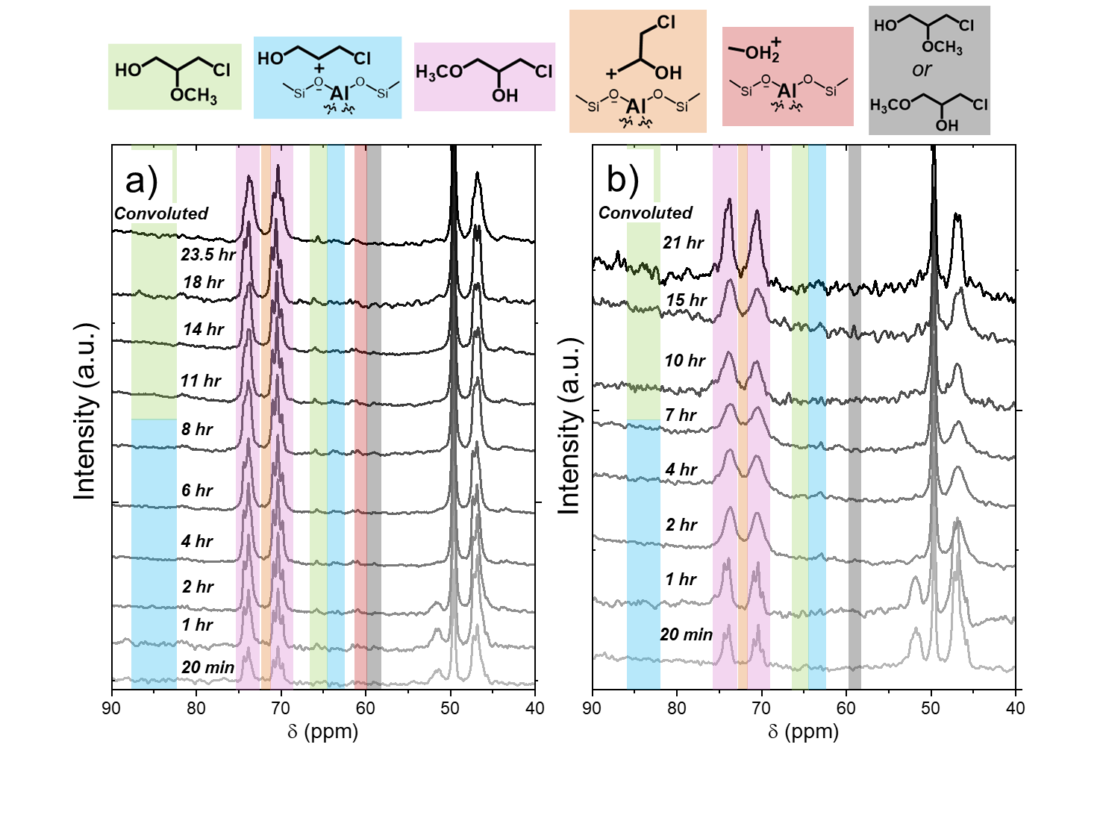
Figure S27. ¹³C NMR single-pulse spectra during ring-opening of C₃H₅ClO with CH₃OH over a) Al-BEA and b) Sn-BEA, where reaction was initiated by adding all components to the rotor at once (0.2 M ¹³C₃H₅ClO, 6 M CH₃OH, CH₃CN, 298 K). Spectra are an average of scans, ranging from 64 scans (20 min time points) to 2,000 scans (last time points). Note: these spectra were collected with unlabeled CH₃OH, so CH₃OH-derived features appear much less intensely.

Figure S27 presents the single-pulse NMR spectra collected during the ring-opening reaction of C₃H₅ClO at 6 M CH₃OH. The concentration-time profiles derived from these spectra are presented in Figure 6 of the main text. Compared to 0.2 M CH3OH, the carbocation species derived from are more difficult to observe. These features at low intensities over time in Al-BEA (Figure S27a), while the carbocation species do not appear in noticeable quantities over Sn-BEA (Figure S27b). The negligible accumulation of these ring-opened carbocations over both Al-BEA and Sn-BEA in Figure S27 gives evidence that the materials may catalyze ring-opening through similar reaction pathways in CH₃OH-rich conditions.

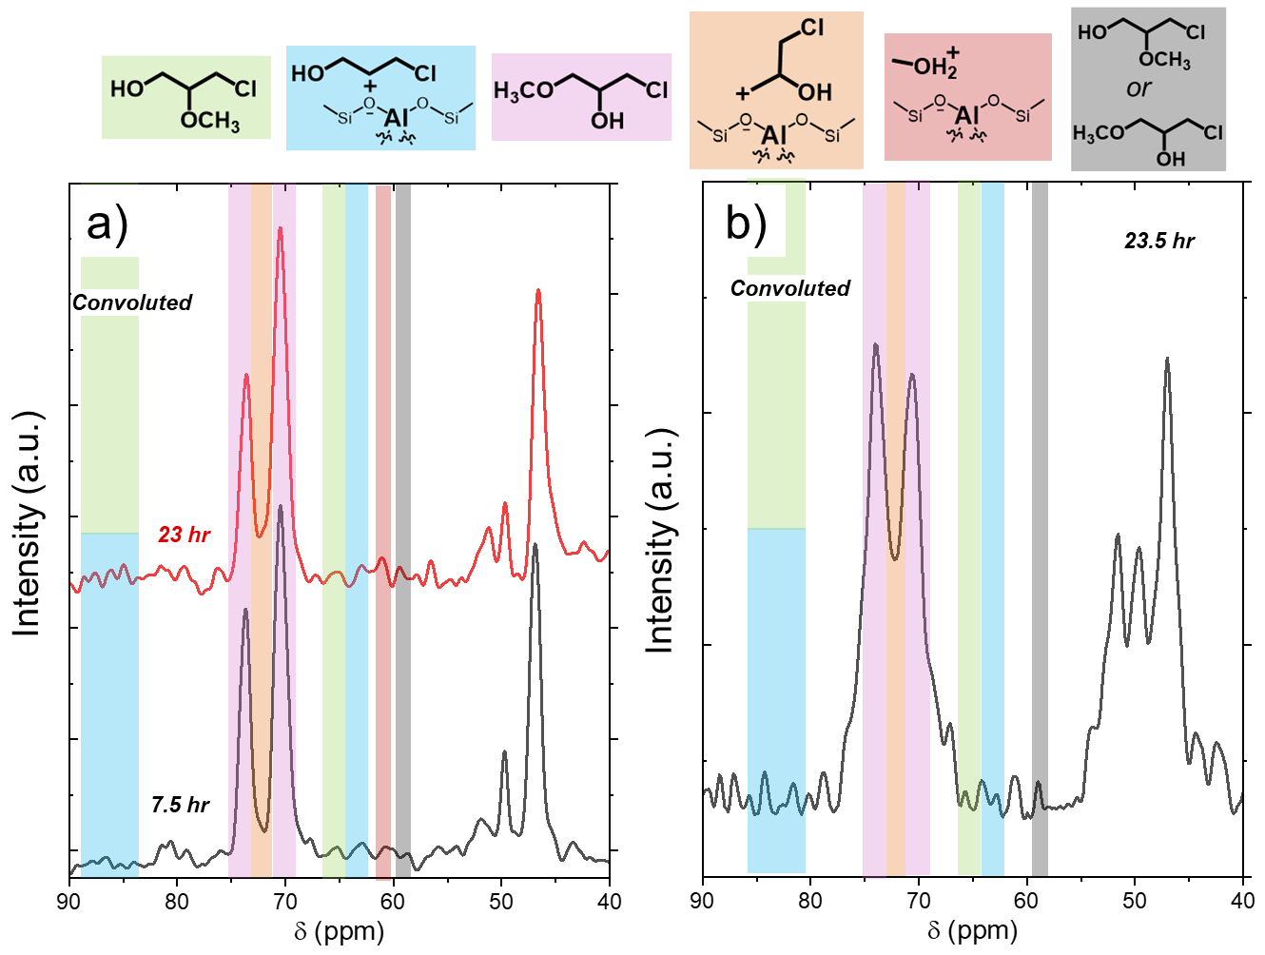
Figure S28. ¹³C NMR cross-polarization spectra during ring-opening of C₃H₅ClO with CH₃OH over a) Al-BEA and b) Sn-BEA, where the reaction was initiated by adding all components to the rotor at once (0.2 M ¹³C₃H₅ClO, 6 M CH₃OH, CH₃CN, 298 K). Contact time was 1 ms for all spectra shown here. Spectra are an average of scans, ranging from 300 to 1500 scans. Note: these spectra were collected with unlabeled CH₃OH, so CH₃OH-derived features appear much less intensely.

Figure S28 presents the cross-polarization spectra for the same experiment discussed in Figure S27 (6 M CH₃OH). The ring-opened carbocation species are not visible on the surface from these spectra, further supporting that C₃H₅ClO ring-opening proceeds through similar S_{N}2 reaction pathways in CH₃OH-rich conditions, which do not require the formation of the ring-opened carbocations as intermediates.
Figure S29 displays the cross-polarization spectra for the experiments shown with the single-pulse spectra in Figure 4 of the main text, where the reaction was initiated by adding C₃H₅ClO (0.2 M CH₃OH). The spectra show a greater quantity of the ring-opened carbocations on the surface of Al-BEA than Sn-BEA, aligning with the interpretation from the single-pulse spectra. The difference in carbocation concentration supports that Al-BEA and Sn-BEA may catalyze ring-opening through different mechanisms in CH₃CN-rich conditions.
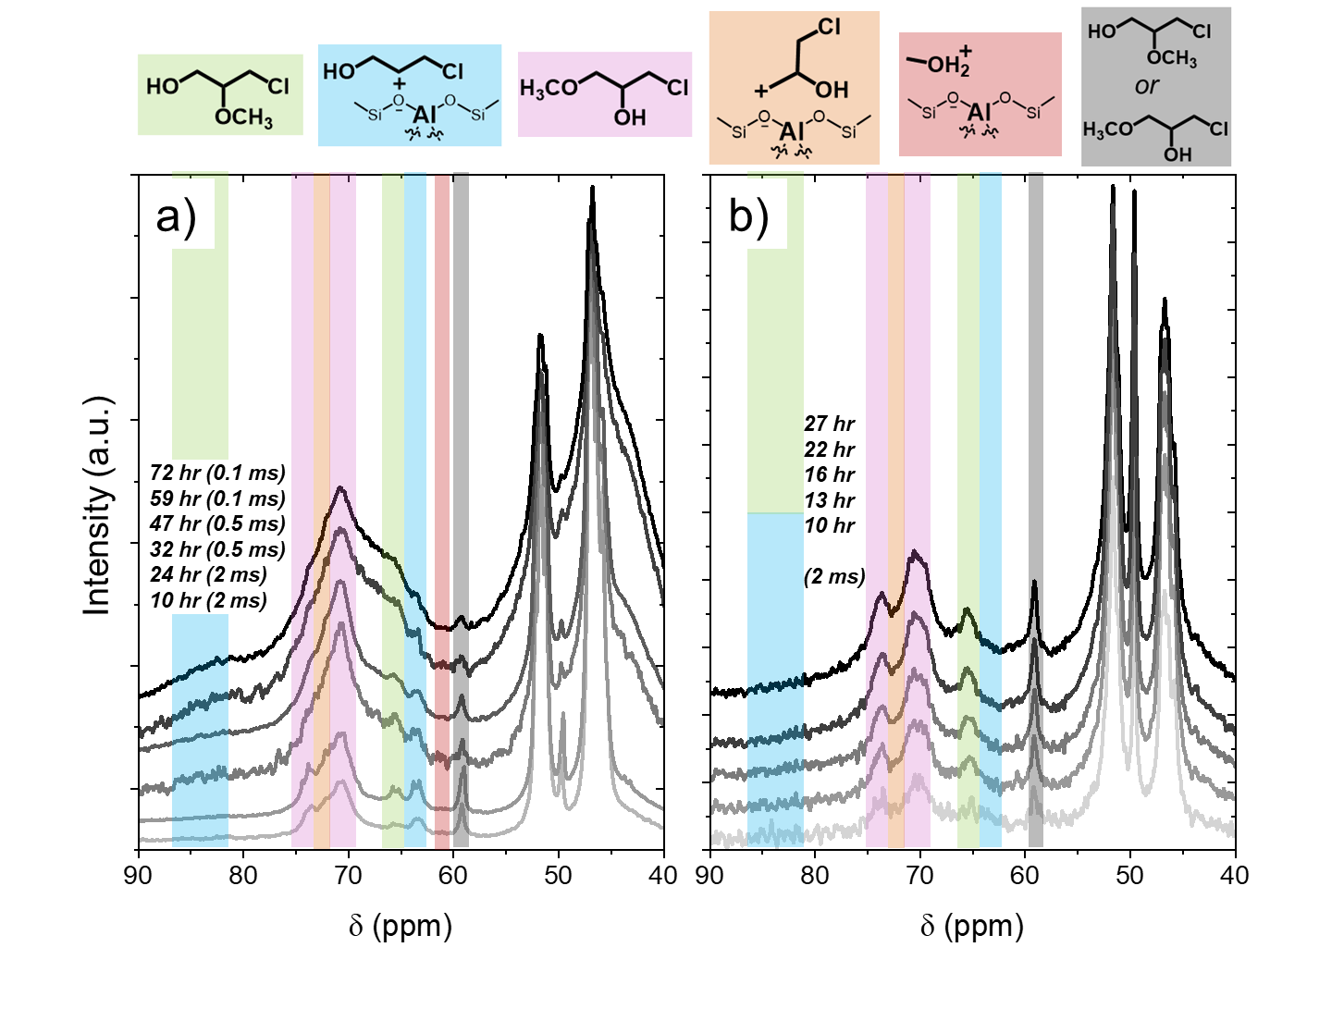
Figure S29. ¹³C NMR cross-polarization spectra during ring-opening of C₃H₅ClO with CH₃OH over a) Al-BEA and b) Sn-BEA, where reaction was initiated by adding ¹³C₃H₅ClO to the NMR rotor after pre-mixing all other components (0.2 M ¹³C₃H₅ClO, 0.2 M ¹³CH₃OH, CH₃CN, 298 K). Contact times are shown in parentheses; the contact time was 2 ms for all spectra in Sn-BEA. Spectra are an average of scans, ranging from 468 to 13,200 scans.

Interestingly, the difference in contact times in Figure S29a leads to differences in the ratio of adsorbed species on Al-BEA. The peak area ratio of CH₃OH-derived adsorbates (intact CH₃OH, protonated CH₃OH) to C₃H₅ClO-derived species (intact C₃H₅ClO, ring-opened carbocations, products) decreases as the contact time decreases. A lower contact time leads to greater intensities for more strongly-bound species, suggesting that C₃H₅ClO-derived adsorbates coordinate more strongly to the Al-BEA surface than CH₃OH-derived species. This interpretation aligns with the much more exothermic adsorption enthalpy for C₃H₅ClO than CH₃OH shown in Table S7 (vide supra).
Figure S30 presents single-pulse spectra where the ring-opening reaction was initiated by adding CH₃OH (0.2 M CH₃OH). Interestingly, initiating the reaction with CH₃OH slows the reaction down significantly compared to initiating with C₃H₅ClO. The ring-opened carbocations form before the reaction was initiated with CH₃OH, but only a small fraction converts to products over ~24 hr.
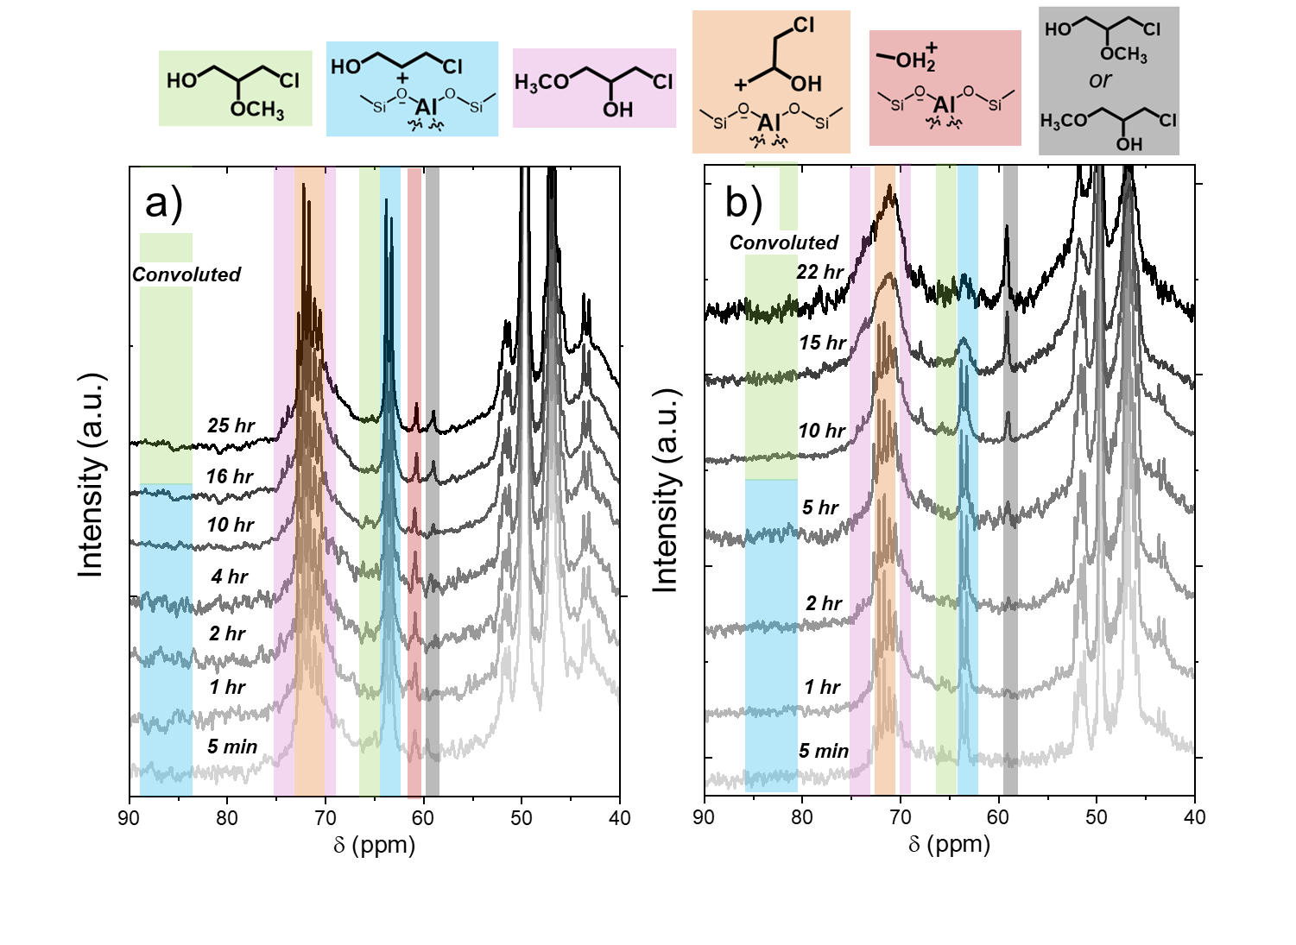
Figure S30. ¹³C NMR single-pulse spectra during ring-opening of C₃H₅ClO with CH₃OH over a) Al-BEA and b) Sn-BEA, where reaction was initiated by adding ¹³C₃H₃OH to the NMR rotor after pre-mixing all other components (0.2 M ¹³C₃H₅ClO, 0.2 M ¹³CH₃OH, CH₃CN, 298 K). Spectra are an average of scans, ranging from 32 scans (5 min time points) to 15,768 scans (last time points).

These spectra may suggest that CH₃OH still needs to activate in some capacity to facilitate the ring-opening reaction, even through an S_{N}1 pathway with ring-opened carbocations. C₃H₅ClO coordinates much more strongly with the active sites than CH₃OH, so the pre-treatment of the catalyst with C₃H₅ClO may prevent CH₃OH from easily accessing the active sites.
While the exact reason for the suppression of rates when initiating with CH₃OH currently evades understanding, Figure S30 still provides strong evidence that the ring-opened carbocations convert to the terminal ether and alcohol products through an S_{N}1 pathway.

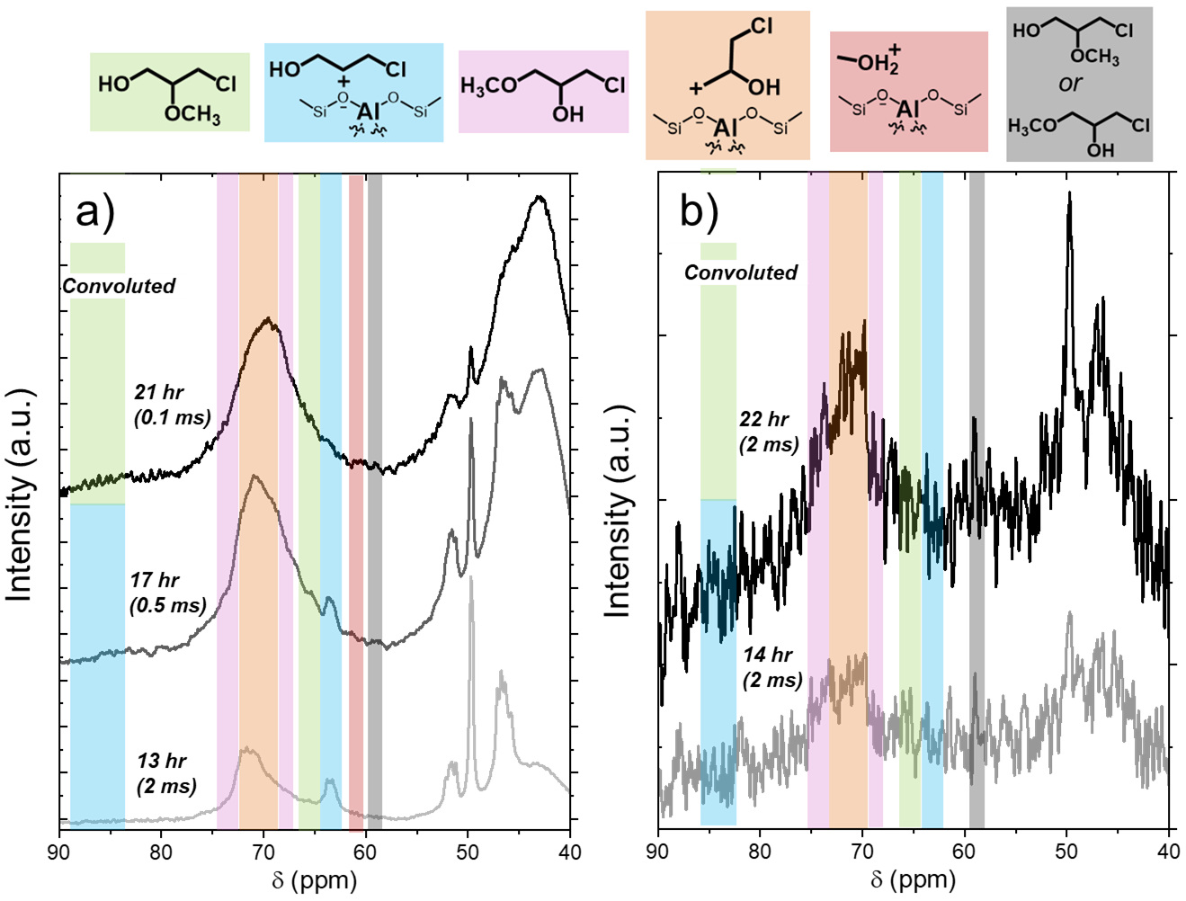
Figure S31. ¹³C NMR cross-polarization spectra during ring-opening of C₃H₅ClO with CH₃OH over a) Al-BEA and b) Sn-BEA, where reaction was initiated by adding ¹³C₃H₃OH to the NMR rotor after pre-mixing all other components (0.2 M ¹³C₃H₅ClO, 0.2 M ¹³CH₃OH, CH₃CN, 298 K). Contact times are shown in parentheses. Spectra are an average of scans, ranging from 754 to 4,096 scans.

Figure S31 presents the cross-polarization spectra from the same experiment in Figure S31, in which the ring-opening reaction was initiated by adding CH₃OH (0.2 M CH₃OH). As with Figure S29a, decreasing the contact time leads to a decrease in the relative intensity of CH₃OH-derived species over Al-BEA in Figure S31a, suggesting that C₃H₅ClO-derived species coordinate more strongly to the surface.

Figure S32 presents single-pulse spectra where the ring-opening reaction was initiated by adding all the components to the rotor at the start of the reaction (0.2 M CH₃OH). This experiment was carried out at an identical CH₃OH concentration to the experiments where the reaction was initiated by adding C₃H₅ClO (Figure 4 of main text) or CH₃OH (Figure S30).
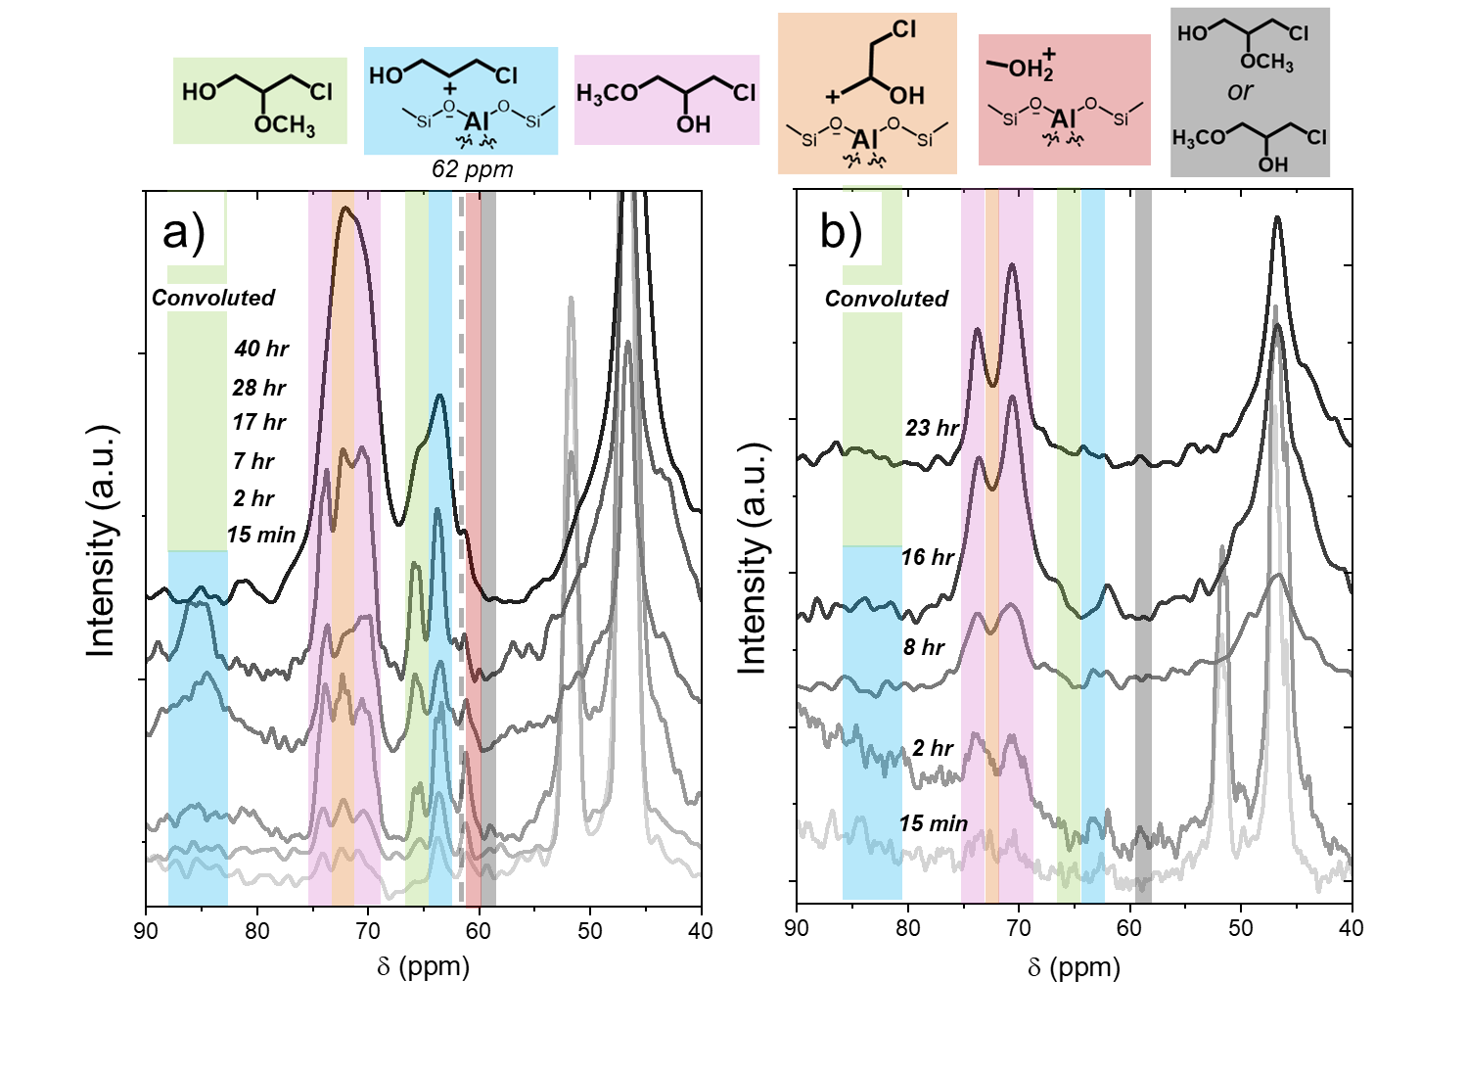
Figure S32. ¹³C NMR single-pulse spectra during ring-opening of C₃H₅ClO with CH₃OH over a) Al-BEA and b) Sn-BEA, where reaction was initiated by adding all components to the rotor at once (0.2 M ¹³C₃H₅ClO, 0.2 M CH₃OH, CH₃CN, 298 K). Spectra are an average of scans, ranging from 32 scans (15 min time points) to 3024 scans (last time points). Note: spectra were collected with unlabeled CH₃OH, so CH₃OH-derived features appear much less intensely.

We chose to present the data where C₃H₅ClO initiates the reaction in Figure 4 in the main text because initiating with C₃H₅ClO slows down the reaction to enable easier tracking of the reactant, product, and intermediate peaks. In particular, the method of initiating with C₃H₅ClO demonstrates the transformation of the ring-opened carbocation intermediates to ring-opened products, as discussed above in Section S11.1. Interestingly, Figure S32 shows an intense peak at ~62 ppm over both Al- and Sn-BEA that is only observed with very weak intensity in Figure 4, which initially increases and then decreases in intensity over time. This peak in Figure S32 does not originate from a CH₃OH-derived intermediate as observed at ~60.5 ppm in Figure 4 within the region highlighted red because Figure S32 was collected with unlabeled CH₃OH, as even liquid-phase CH₃OH appears hardly visible on Figure S32. Instead, the peak at ~62 ppm likely originates from the terminal alcohol bound to the zeolite surface, as predicted with the DFT peak shifts in Table S9. Therefore, the faster reaction rate in Figure S32 coincides with the easier observation of the full process of terminal alcohol formation (first discussed in Section S11.1). The secondary carbocation (~63 ppm) and bound terminal alcohol (~62 ppm) appear in the initial scans, with a greater intensity for the secondary carbocation that suggests the carbocation initially forms and then converts to the terminal alcohol. The liquid-phase terminal alcohol (~67 ppm) then appears and increases in intensity in the later scans, with a subsequent decrease of intensity for the bound terminal alcohol peak that shows desorption of the formed product over time. The secondary carbocation peak maintains the strongest intensity of the three peaks throughout the reaction, demonstrating consistent coverage of the active sites with this intermediate. Despite the differences in intensity of the product and reactant features, the ring-opening product peaks evolve in a very similar distribution for Figures 4 and S32. This suggests that the method of initiating the reaction does not affect the intrinsic behavior or regioselectivity of the reaction, but instead allows for control of the reaction rate and monitoring of specific intermediate and product peaks.

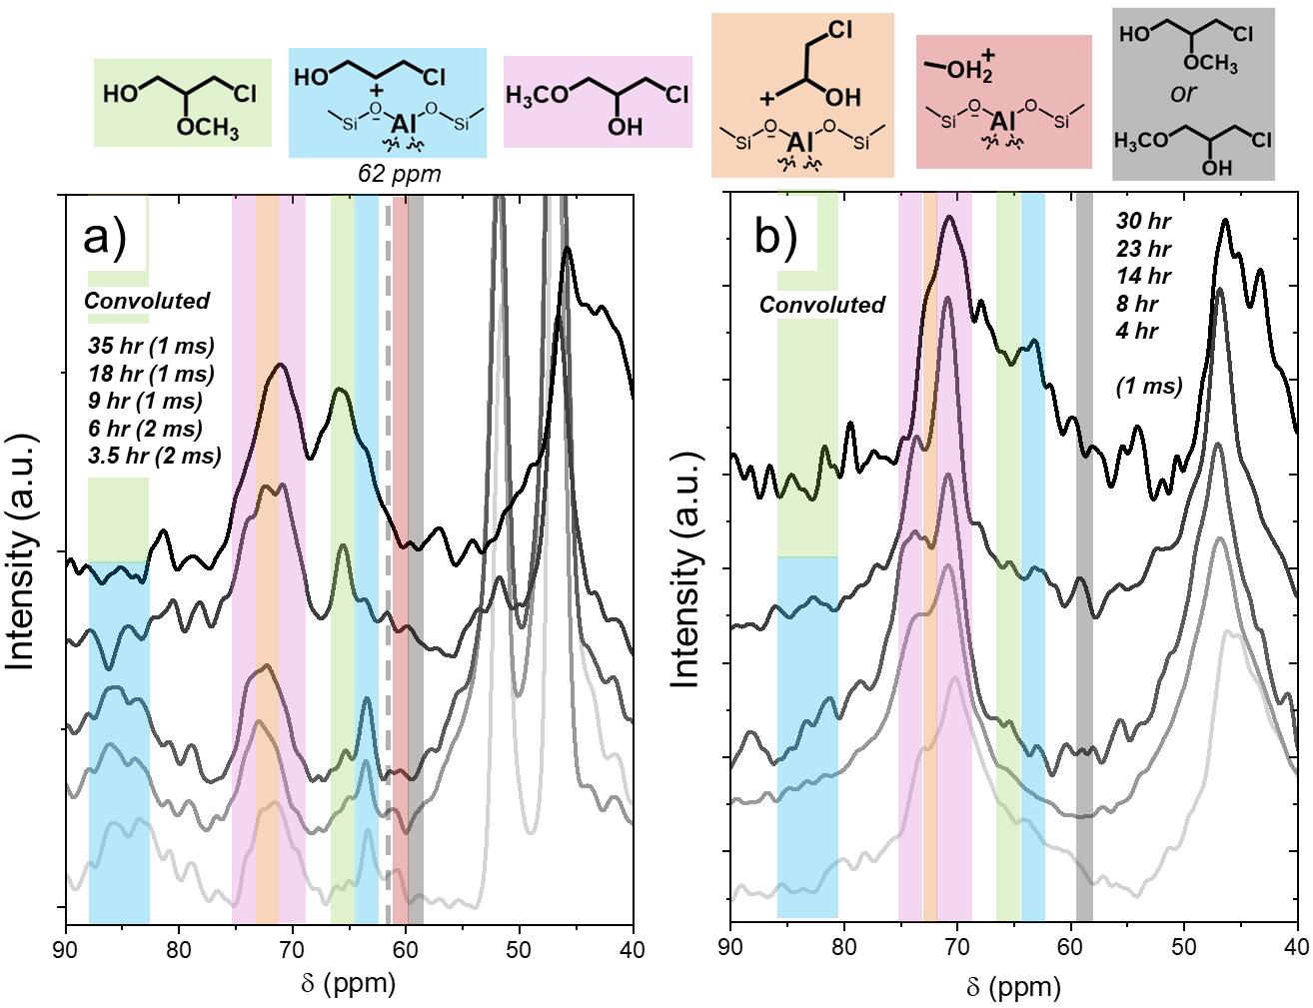
Figure S33. ¹³C NMR cross-polarization spectra during ring-opening of C₃H₅ClO with CH₃OH over a) Al-BEA and b) Sn-BEA, where reaction was initiated by adding all components to the rotor at once (0.2 M ¹³C₃H₅ClO, 0.2 M CH₃OH, CH₃CN, 298 K). Contact times are shown in parentheses; the contact time was 1 ms for all spectra in Sn-BEA. Spectra are an average of scans, ranging from 2564 to 10,094 scans. Note: these spectra were collected with unlabeled CH₃OH, so CH₃OH-derived features appear much less intensely.

Figure S33 shows the cross-polarization spectra that correspond to the single-pulse spectra in Figure S32, in which all components were added to the rotor to initiate the reaction (0.2 M CH₃OH). These spectra demonstrate the growth of the carbocation intermediate and ring-opened product species on the surface, as most clearly demonstrated for terminal alcohol over Al-BEA in Figure 33a. The growth patterns of the secondary carbocation (~63 ppm), bound terminal alcohol (~62 ppm), and liquid-phase terminal alcohol (~67 ppm) align with those described in Figure S32 and show the sequence of carbocation formation, product formation, and product desorption. The appearance of the peak at ~67 ppm that we attribute to the liquid-phase terminal alcohol is unexpected in the cross-polarization spectra but resembles the observation of liquid-phase C₃H₃ClO features from Figure 2 of the main text. We attribute this to desorbed terminal alcohol product species that remain near the zeolite surface. Figure S33 shows very similar peak growth trends to those shown in Figure S29, where the reaction was initiated by adding C₃H₅ClO.
S11.6. Kinetic Comparisons from Batch Reactions and Operando ¹³C NMR

Al-BEA | Batch Kinetics |  | Operando ¹³C NMR
[CH₃OH] | Product Formation Rate  (mol C₄H₉ClO₂) • (mol M • s)⁻¹) | $$β= \frac{r_{TE}}{r_{TA}}$$ | Product Formation Rate  (mol C₄H₉ClO₂) • (mol M • s)⁻¹) | $$β= \frac{r_{TE}}{r_{TA}}$$
0.2 M | 5.31 x 10⁻⁴ | 6.9 | 2.42 x 10⁻⁵ | 5.4
6 M | 5.63 x 10⁻³ | 15.3 | 4.58 x 10⁻⁴ | 11.6
Table S11. Comparisons of calculated total product formation rates and β values obtained from batch kinetics and operando ¹³C NMR measurements for C₃H₅ClO ring-opening over Al-BEA (0.2 M C₃H₅ClO, CH₃CN, 298 K).

Sn-BEA | Batch Kinetics |  | Operando ¹³C NMR
[CH₃OH] | Product Formation Rate  (mol C₄H₉ClO₂) • (mol M • s)⁻¹) | $$β= \frac{r_{TE}}{r_{TA}}$$ | Product Formation Rate  (mol C₄H₉ClO₂) • (mol M • s)⁻¹) | $$β= \frac{r_{TE}}{r_{TA}}$$
0.2 M | 1.42 x 10⁻³ | 12.1 | 5.96 x 10⁻⁵ | 9.0
6 M | 6.38 x 10⁻³ | 28.5 | 5.18 x 10⁻⁴ | 22.7
Table S12. Comparisons of calculated total product formation rates and β values obtained from batch kinetics and operando ¹³C NMR measurements for C₃H₅ClO ring-opening over Sn-BEA (0.2 M C₃H₅ClO, CH₃CN, 298 K).

The concentration-time profiles for the NMR spectra from Figures 5 and 6 were used to measure product formation turnover rates and regioselectivities (β) for the ring-opening reaction in the NMR rotor. The concentrations were used to calculate turnover numbers for each time point in the NMR experiment, and a polynomial was fit to the plots of turnover number as a function of time. This procedure matches the method used to calculate turnover rates from the batch reactions (see Section 4.3).
Tables S11 and S12 show that the reaction rates are 10-25 times lower in the NMR than in the glass batch reactors used for the data in Figure 1. The lower rates are likely due to differences in the agitation mechanism between the systems; a stir bar directly agitates the mixture in the batch reactors, while the NMR rotor indirectly agitates the mixture by spinning. The significant differences in spin rate between the two experiments (700 rpm for batch reactions, ~4400 Hz (or ~250,000 rpm) for the NMR rotor)) and the different catalyst to volume ratio (typically ~1 g mL⁻¹ for batch reactions, ~250 for NMR experiments) may also contribute to the observed differences in rates.
Despite the rate differences, the NMR experiments and batch reactions show very similar β values at each [CH₃OH] for both catalysts. Interestingly, the NMR experiments do consistently show slightly lower β values than the batch reactions. We believe this may originate from the NMR experiments being run to higher conversions, which may affect the reaction environment or concentration of surface-bound species in a way that promotes the terminal alcohol product over the terminal ether.
While the differences in spin rate, catalyst-to-volume ratio, and reaction conversion prevent exact comparisons between the NMR experiments and batch reactions, the qualitative regioselectivity agreement between these experiments supports that the NMR experiments capture the intrinsic behavior of the C₃H₅ClO ring-opening reaction.
S11.7. Comparison of Regioselectivity Trends for C₃H₅ClO and C₄H₈O Ring-Opening

The combination of kinetic and spectroscopic data presented in the main text provides evidence that changes in the reaction mechanism drive significant differences in reaction regioselectivity for C₃H₅ClO ring-opening. Interestingly, β values over Al-BEA and Sn-BEA materials depend much less strongly on [CH₃OH] for the ring-opening of 1,2-epoxybutane (C₄H₈O, 0.7 – 1.6)⁵¹ than for C₃H₅ClO (1 – 40) over *BEA zeolites. Our previous work on 1,2-epoxybutane argued that decreases in β with increasing [CH₃OH] originated from CH₃OH molecules stabilizing the transition state for TA formation through hydrogen bonding.⁵¹ The differences between C₄H₈O and C₃H₅ClO suggest that mechanistic differences play a much less significant role in regioselectivity changes for C₄H₈O ring-opening. The S_{N}1 reaction pathway may dominate during C₄H₈O ring-opening, leading to only minor changes in β with [CH₃OH] primarily driven by hydrogen-bonding effects through changes in ${∆G}^{‡,ε}$. The apparent dominance of the S_{N}2 pathway and more significant differences in β for C₃H₅ClO than C₄H₈O may originate from several possibilities (Scheme S4). First, the S_{N}1 reaction pathway likely proceeds less favorably for C₃H₅ClO than C₄H₈O. The electron-withdrawing terminal Cl atom in C₃H₅ClO destabilizes positive charge, while the electron-donating terminal methyl (-CH₃) group in C₄H₈O stabilizes positive charge. Therefore, the ring-opened carbocations likely form more easily from C₄H₈O, making the S_{N}1 reaction more favorable for C₄H₈O through larger values of $k_{5,{}_{ }^{1}C }$ and $k_{5,{}_{ }^{2}C}$. Second, electron-withdrawing groups like Cl increase the rates of S_{N}2 reactions by withdrawing electron density from the site of nucleophilic attack,⁵⁷⁻⁵⁸ which would increase values of $k_{4,{}_{ }^{1}C }$ and $k_{4,{}_{ }^{2}C}$ for C₃H₅ClO compared to C₄H₈O ring-opening. Furthermore, the presence of the Cl atom may promote TE formation through the S_{N}2 reaction more significantly than the expected effect from steric hindrance. Cl may stabilize CH₃OH through halogen bonding, drawing CH₃OH from the proximal secondary epoxide carbon atom and further hindering the formation of TA. To summarize, the different regioselectivity trends between C₃H₅ClO and C₄H₈O suggest that functional groups on epoxides lead to mechanistic differences that significantly influence product distribution from ring-opening.
S11.8. Uncertainties and Limitations of ¹³C NMR Experiments
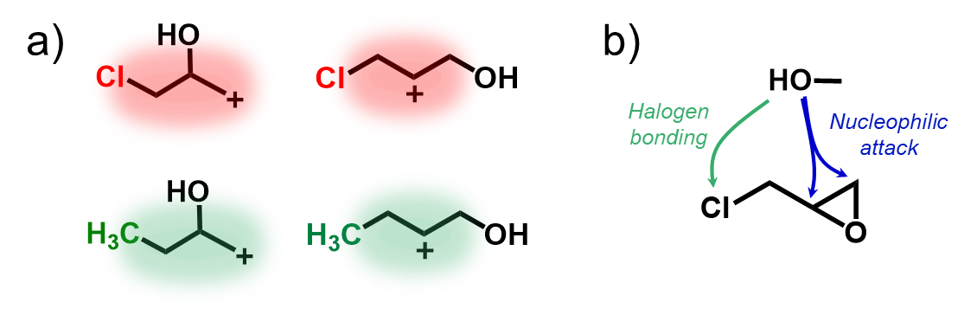
Scheme S4. Visual depictions for a) inductive effect of functional groups from C₃H₅ClO and C₄H₈O on ring-opened carbocations and b) possible binding sites of CH₃OH on C₃H₅ClO.

While the NMR spectra described in this contribution provide valuable insight into the reaction pathway for C₃H₅ClO ring-opening, several uncertainties remain. First, the NMR experiments provide evidence for the S_{N}1 pathway through the formation of the ring-opened carbocations but do not show direct evidence for S_{N}2 reaction pathways occurring. However, the differences in β with [CH₃OH] strongly suggest that multiple reaction pathways can occur, as we do not expect differences in [CH₃OH] would affect the ratio of primary to secondary ring-opened carbocations by orders of magnitude. Second, the identity of the adsorbed intermediates for an S_{N}2 reaction pathway remains unclear. We propose an S_{N}1 reaction through a C₃H₅ClO-derived intermediate and S_{N}2 pathway with a CH₃OH-derived intermediate based on the observed reaction orders (Table S5) and previous mechanistic proposals for C₃H₅ClO ring-opening over *BEA zeolites with CH₃OH⁵⁹ and allyl alcohol.⁶⁰ However, we cannot rule out that ring-opening through a C₃H₅ClO-derived intermediate may also proceed by an S_{N}2 reaction. Despite the unclear nature of a possible S_{N}2 reaction pathway, steric effects should drive the strong preference toward the TE product. Lastly, the differences in reactivity between the primary and secondary carbocations and how the reactivity of these species changes with [CH₃OH] have not been established. These differences would provide valuable insight into how changing [CH₃OH] affects the regioselectivity for the S_{N}1 pathway and the competition between S_{N}1 and S_{N}2 reactions, but the NMR spectra cannot provide this information.

References

1. Filatova, E. O.; Konashuk, A. S., Interpretation of the changing the band gap of Al2O3 depending on its crystalline form: connection with different local symmetries. The Journal of Physical Chemistry C 2015, 119 (35), 20755-20761.
2. Mo, S. D.; Xu, Y. N.; Ching, W. Y., Electronic and Structural Properties of Bulk γ‐Al2O3. Journal of the American Ceramic Society 1997, 80 (5), 1193-1197.
3. Zhao, Z.; Xu, S.; Hu, M. Y.; Bao, X.; Peden, C. H.; Hu, J., Investigation of aluminum site changes of dehydrated zeolite H-beta during a rehydration process by high-field solid-state NMR. The Journal of Physical Chemistry C 2015, 119 (3), 1410-1417.
4. van Bokhoven, J. A.; Van der Eerden, A.; Koningsberger, D., Flexible aluminium coordination of zeolites as function of temperature and water content, an in-situ method to determine aluminium coordinations. In Studies in surface science and catalysis, Elsevier: 2002; Vol. 142, pp 1885-1890.
5. Wouters, B.; Chen, T.-H.; Grobet, P., Reversible tetrahedral− octahedral framework aluminum transformation in zeolite Y. Journal of the American Chemical Society 1998, 120 (44), 11419-11425.
6. Jiao, J.; Wang, W.; Sulikowski, B.; Weitkamp, J.; Hunger, M., 29Si and 27Al MAS NMR characterization of non-hydrated zeolites Y upon adsorption of ammonia. Microporous and mesoporous materials 2006, 90 (1-3), 246-250.
7. Ravi, M.; Sushkevich, V. L.; van Bokhoven, J. A., On the location of Lewis acidic aluminum in zeolite mordenite and the role of framework-associated aluminum in mediating the switch between Brønsted and Lewis acidity. Chemical Science 2021, 12 (11), 4094-4103.
8. Mihailova, B.; Valtchev, V.; Mintova, S.; Faust, A. C.; Petkov, N.; Bein, T., Interlayer stacking disorder in zeolite beta family: a Raman spectroscopic study. Physical Chemistry Chemical Physics 2005, 7 (14), 2756.
9. Tosheva, L.; Mihailova, B.; Valtchev, V.; Sterte, J., Zeolite beta spheres. Microporous and Mesoporous Materials 2001, 48 (1-3), 31-37.
10. Majano, G.; Mintova, S.; Ovsitser, O.; Mihailova, B.; Bein, T., Zeolite Beta nanosized assemblies. Microporous and Mesoporous Materials 2005, 80 (1-3), 227-235.
11. Inagaki, S.; Nakatsuyama, K.; Saka, Y.; Kikuchi, E.; Kohara, S.; Matsukata, M., Elucidation of Medium-Range Structure in a Dry Gel-Forming *BEA-Type Zeolite. The Journal of Physical Chemistry C 2007, 111 (28), 10285-10293.
12. Yu, Y.; Xiong, G.; Li, C.; Xiao, F.-S., Characterization of aluminosilicate zeolites by UV Raman spectroscopy. Microporous and Mesoporous Materials 2001, 46 (1), 23-34.
13. Knops-Gerrits, P.-P.; De Vos, D. E.; Feijen, E. J.; Jacobs, P. A., Raman spectroscopy on zeolites. Microporous Materials 1997, 8 (1-2), 3-17.
14. Aminzadeh, A., Excitation frequency dependence and fluorescence in the Raman spectra of Al2O3. Applied spectroscopy 1997, 51 (6), 817-819.
15. Porto, S.; Krishnan, R., Raman effect of corundum. The Journal of Chemical Physics 1967, 47 (3), 1009-1012.
16. Aminzadeh, A.; Sarikhani-Fard, H., Raman spectroscopic study of Ni/Al2O3 catalyst. Spectrochimica Acta Part A: Molecular and Biomolecular Spectroscopy 1999, 55 (7-8), 1421-1425.
17. Zuo, J.; Xu, C.; Liu, X.; Wang, C.; Wang, C.; Hu, Y.; Qian, Y., Study of the Raman spectrum of nanometer SnO2. Journal of applied physics 1994, 75 (3), 1835-1836.
18. Scott, J., Raman spectrum of SnO2. The Journal of Chemical Physics 1970, 53 (2), 852-853.
19. Leonardy, A.; Hung, W.-Z.; Tsai, D.-S.; Chou, C.-C.; Huang, Y.-S., Structural features of SnO2 nanowires and raman spectroscopy analysis. Crystal Growth and Design 2009, 9 (9), 3958-3963.
20. Scarano, D.; Zecchina, A.; Bordiga, S.; Geobaldo, F.; Spoto, G.; Petrini, G.; Leofanti, G.; Padovan, M.; Tozzola, G., Fourier-transform infrared and Raman spectra of pure and Al-, B-, Ti- and Fe-substituted silicalites: stretching-mode region. Journal of the Chemical Society, Faraday Transactions 1993, 89 (22), 4123.
21. Blasco, T.; Camblor, M. A.; Corma, A.; Esteve, P.; Guil, J. M.; Martinez, A.; Perdigon-Melon, J. A.; Valencia, S., Direct synthesis and characterization of hydrophobic aluminum-free Ti-beta zeolite. Journal of Physical Chemistry B 1998, 102, 75-88.
22. Mihailova, B.; Valtchev, V.; Mintova, S.; Faust, A.-C.; Petkov, N.; Bein, T., Interlayer stacking disorder in zeolite beta family: a Raman spectroscopic study. Physical chemistry chemical physics 2005, 7 (14), 2756-2763.
23. Ricchiardi, G.; Damin, A.; Bordiga, S.; Lamberti, C.; Spanò, G.; Rivetti, F.; Zecchina, A., Vibrational Structure of Titanium Silicate Catalysts. A Spectroscopic and Theoretical Study. Journal of the American Chemical Society 2001, 123 (46), 11409-11419.
24. Bordiga, S.; Damin, A.; Bonino, F.; Ricchiardi, G.; Zecchina, A.; Tagliapietra, R.; Lamberti, C., Resonance Raman effects in TS-1: the structure of Ti(iv) species and reactivity towards H2O, NH3 and H2O2: an in situ studyPresented at the International Congress on Operando Spectroscopy, Lunteren, The Netherlands, March 2-6, 2003. Physical Chemistry Chemical Physics 2003, 5 (20), 4390.
25. Signorile, M.; Crocellà, V.; Damin, A.; Rossi, B.; Lamberti, C.; Bonino, F.; Bordiga, S., Effect of Ti Speciation on Catalytic Performance of TS-1 in the Hydrogen Peroxide to Propylene Oxide Reaction. The Journal of Physical Chemistry C 2018, 122 (16), 9021-9034.
26. Li, C.; Xiong, G.; Liu, J.; Ying, P.; Xin, Q.; Feng, Z., Identifying Framework Titanium in TS-1 Zeolite by UV Resonance Raman Spectroscopy. The Journal of Physical Chemistry B 2001, 105 (15), 2993-2997.
27. Newsam, J. M.; Treacy, M. M. J.; Koetsier, W. T.; Gruyter, C. B. D., Structural characterization of zeolite beta. Proceedings of the Royal Society of London. A. Mathematical and Physical Sciences 1988, 420 (1859), 375-405.
28. Vega-Vila, J. C.; Harris, J. W.; Gounder, R., Controlled insertion of tin atoms into zeolite framework vacancies and consequences for glucose isomerization catalysis. Journal of Catalysis 2016, 344, 108-120.
29. Penzien, J.; Abraham, A.; van Bokhoven, J. A.; Jentys, A.; Müller, T. E.; Sievers, C.; Lercher, J. A., Generation and characterization of well-defined Zn2+ Lewis acid sites in ion exchanged zeolite BEA. The Journal of Physical Chemistry B 2004, 108 (13), 4116-4126.
30. Pelmenschikov, A.; Van Santen, R.; Janchen, J.; Meijer, E., Acetonitrile-d3 as a probe of Lewis and Broensted acidity of zeolites. The Journal of Physical Chemistry 1993, 97 (42), 11071-11074.
31. Wichterlová, B.; Tvarůžková, Z.; Sobalık, Z.; Sarv, P., Determination and properties of acid sites in H-ferrierite: A comparison of ferrierite and MFI structures. Microporous and mesoporous materials 1998, 24 (4-6), 223-233.
32. Boronat, M.; Concepción, P.; Corma, A.; Renz, M.; Valencia, S., Determination of the catalytically active oxidation Lewis acid sites in Sn-beta zeolites, and their optimisation by the combination of theoretical and experimental studies. Journal of Catalysis 2005, 234 (1), 111-118.
33. Bermejo-Deval, R.; Orazov, M.; Gounder, R.; Hwang, S.-J.; Davis, M. E., Active Sites in Sn-Beta for Glucose Isomerization to Fructose and Epimerization to Mannose. ACS Catalysis 2014, 4 (7), 2288-2297.
34. Harris, J. W.; Cordon, M. J.; Di Iorio, J. R.; Vega-Vila, J. C.; Ribeiro, F. H.; Gounder, R., Titration and quantification of open and closed Lewis acid sites in Sn-Beta zeolites that catalyze glucose isomerization. Journal of Catalysis 2016, 335, 141-154.
35. Courtney, T. D.; Chang, C.-C.; Gorte, R. J.; Lobo, R. F.; Fan, W.; Nikolakis, V., Effect of water treatment on Sn-BEA zeolite: Origin of 960 cm− 1 FTIR peak. Microporous and Mesoporous Materials 2015, 210, 69-76.
36. Sushkevich, V. L.; Kots, P. A.; Kolyagin, Y. G.; Yakimov, A. V.; Marikutsa, A. V.; Ivanova, I. I., Origin of water-induced Brønsted acid sites in Sn-BEA zeolites. The Journal of Physical Chemistry C 2019, 123 (9), 5540-5548.
37. Montejo-Valencia, B. D.; Salcedo-Pérez, J. L.; Curet-Arana, M. C., DFT study of closed and open sites of BEA, FAU, MFI, and BEC zeolites substituted with tin and titanium. The Journal of Physical Chemistry C 2016, 120 (4), 2176-2186.
38. Bukowski, B. C.; Bates, J. S.; Gounder, R.; Greeley, J., First principles, microkinetic, and experimental analysis of Lewis acid site speciation during ethanol dehydration on Sn-Beta zeolites. Journal of Catalysis 2018, 365, 261-276.
39. Bukowski, B. C.; Greeley, J., Scaling relationships for molecular adsorption and dissociation in Lewis acid zeolites. The Journal of Physical Chemistry C 2016, 120 (12), 6714-6722.
40. Ward, J. W., A spectroscopic study of the surface of zeolite Y: the adsorption of pyridine. Journal of Colloid and Interface Science 1968, 28 (2), 269-278.
41. Lefrancois, M.; Malbois, G., The nature of the acidic sites on mordenite: Characterization of adsorbed pyridine and water by infrared study. Journal of Catalysis 1971, 20 (3), 350-358.
42. Cannings, F. R., Acidic sites on mordenite: an infrared study of adsorbed pyridine. The Journal of Physical Chemistry 1968, 72 (13), 4691-4693.
43. Kataoka, T.; Dumesic, J., Acidity of unsupported and silica-supported vanadia, molybdena, and titania as studied by pyridine adsorption. Journal of Catalysis 1988, 112 (1), 66-79.
44. Parry, E., An infrared study of pyridine adsorbed on acidic solids. Characterization of surface acidity. Journal of Catalysis 1963, 2 (5), 371-379.
45. Barzetti, T.; Selli, E.; Moscotti, D.; Forni, L., Pyridine and ammonia as probes for FTIR analysis of solid acid catalysts. Journal of the Chemical Society, Faraday Transactions 1996, 92 (8), 1401-1407.
46. Sushkevich, V. L.; Ivanova, I. I.; Yakimov, A. V., Revisiting acidity of SnBEA catalysts by combined application of FTIR spectroscopy of different probe molecules. The Journal of Physical Chemistry C 2017, 121 (21), 11437-11447.
47. Palomino, G. T.; Pascual, J. J. C.; Delgado, M. R.; Parra, J. B.; Areán, C. O., FT-IR studies on the acidity of gallium-substituted mesoporous MCM-41 silica. Materials chemistry and physics 2004, 85 (1), 145-150.
48. Murphy, B. M.; Letterio, M. P.; Xu, B., Selectivity Control in the Catalytic Dehydration of Methyl Lactate: The Effect of Pyridine. ACS Catalysis 2016, 6 (8), 5117-5131.
49. van der Graaff, W. N.; Li, G.; Mezari, B.; Pidko, E. A.; Hensen, E. J., Synthesis of Sn‐Beta with Exclusive and High Framework Sn Content. ChemCatChem 2015, 7 (7), 1152-1160.
50. Yuan, E.; Dai, W.; Wu, G.; Guan, N.; Hunger, M.; Li, L., Facile synthesis of Sn-containing MFI zeolites as versatile solid acid catalysts. Microporous and Mesoporous Materials 2018, 270, 265-273.
51. Potts, D. S.; Komar, J. K.; Locht, H.; Flaherty, D. W., Understanding Rates and Regioselectivities for Epoxide Methanolysis within Zeolites: Mechanism and Roles of Covalent and Non-covalent Interactions. ACS Catalysis 2023, 13, 14928-14944.
52. Potts, D. S.; Komar, J. K.; Jacobson, M. A.; Locht, H.; Flaherty, D. W., Consequences of Pore Polarity and Solvent Structure on Epoxide Ring-Opening in Lewis and Brønsted Acid Zeolites. JACS Au 2024, 4 (9), 3501-3518.
53. Anslyn, E. V.; Dougherty, D. A., Modern Physical Organic Chemistry. University Science: 2005; pp 374-377.
54. Goldberg, R. N.; Kishore, N.; Lennen, R. M., Thermodynamic Quantities for the Ionization Reactions of Buffers. Journal of Physical and Chemical Reference Data 2002, 31 (2), 231-370.
55. Berg, R. L.; Vanderzee, C. E., Enthalpies of dilution of sodium carbonate and sodium hydrogen carbonate solutions, and the standard enthalpies of ionization of aqueous carbonic acid, at 298.15 K. The Journal of Chemical Thermodynamics 1978, 10 (11), 1049-1075.
56. Das, A.; Das, U.; Das, A. K., Relativistic effects on the chemical bonding properties of the heavier elements and their compounds. Coordination Chemistry Reviews 2023, 479, 215000.
57. Tyagi, A.; Yadav, N.; Khan, J.; Mondal, S.; Hazra, C. K., Brønsted Acid‐Catalysed Epoxide Ring‐Opening Using Amine Nucleophiles: A Facile Access to β‐Amino Alcohols. Chemistry–An Asian Journal 2022, 17 (14), e202200379.
58. Ashenhurst, J. The SN2 Mechanism. https://www.masterorganicchemistry.com/2012/07/04/the-sn2-mechanism/ (accessed June 3rd, 2024).
59. Deshpande, N.; Parulkar, A.; Joshi, R.; Diep, B.; Kulkarni, A.; Brunelli, N. A., Epoxide ring opening with alcohols using heterogeneous Lewis acid catalysts: Regioselectivity and mechanism. Journal of Catalysis 2019, 370, 46-54.
60. Selvin, R.; Roselin, S. L.; Kumar, P. K.; Arul, S., Nanocrystalline Zeolite Beta: An Efficient Catalyst for The Regioselective Alcoholysis of Epichlorohydrin. Science of Advanced Materials 2010, 2 (2), 190-194.

