Supplementary materials

Supplementary Figures

Supplementary Figure 1: Boxplot distribution comparing unnormalised and normalised metabolite data
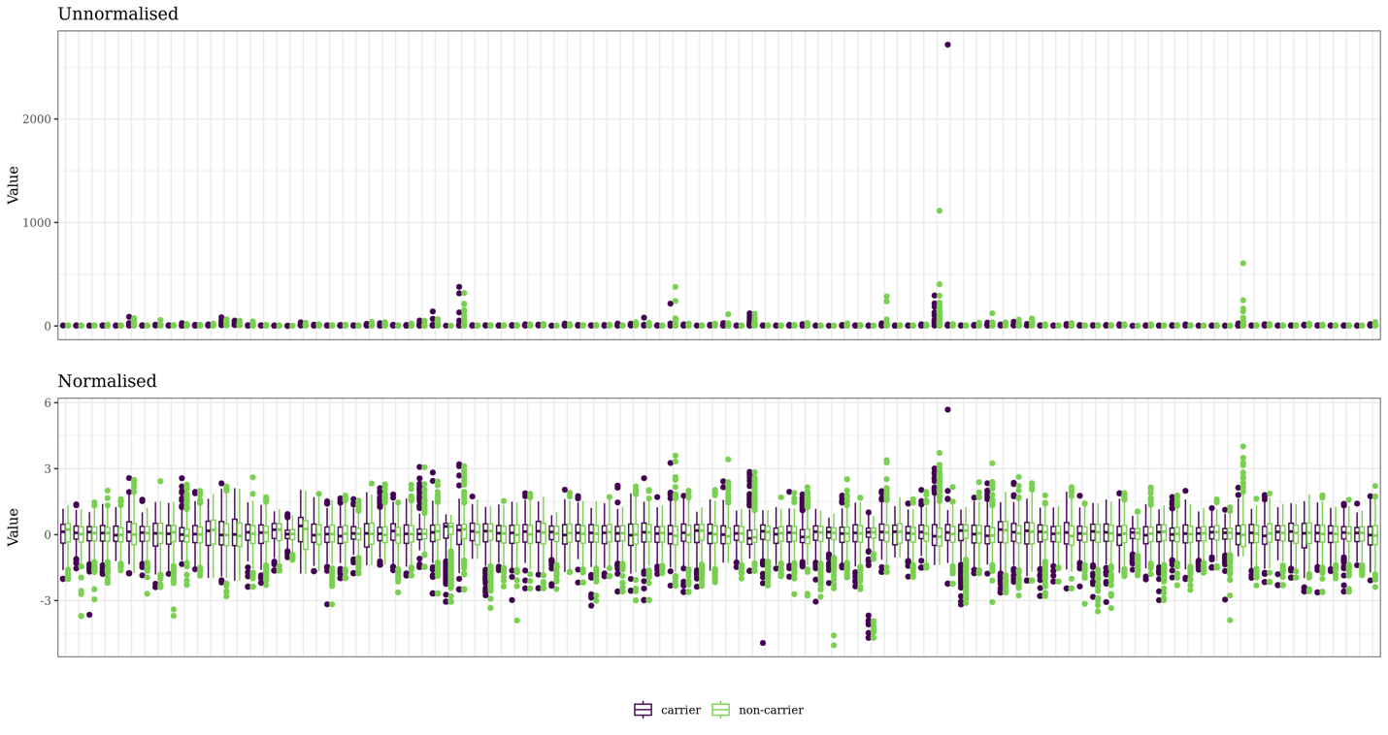

*Note that this figure only displays a random subset of 100 metabolites from the full dataset for visualisation purposes.

Supplementary Figure 2: Density distribution comparing unnormalised and normalised metabolite data
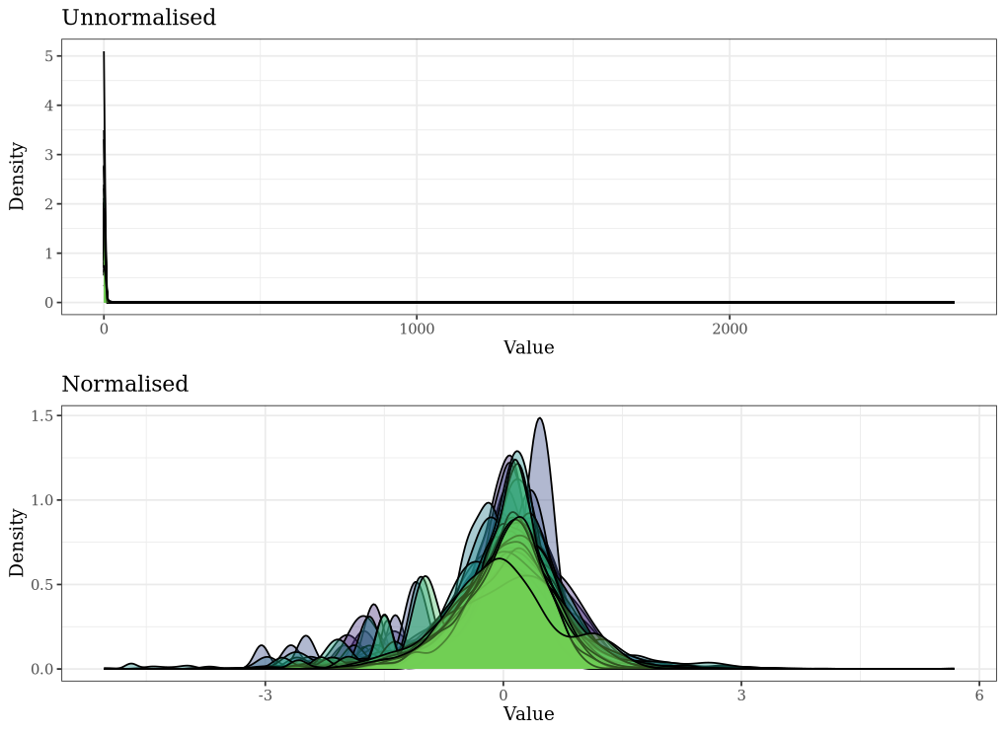

*Note that this figure only displays a random subset of 100 metabolites from the full dataset for visualisation purposes.

Supplementary Figure 3: Flow diagram of participants in the metabolomics analysis

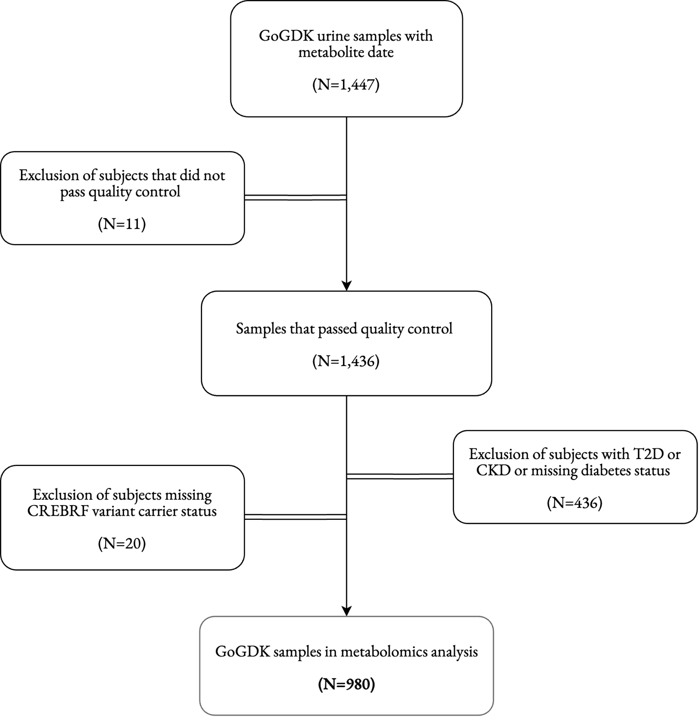

Abbreviations: GoGDK, Genetics of Gout, Diabetes, and Kidney disease; T2D, type 2 diabetes; CKD, chronic kidney disease; CREBRF, CREB3 regulatory factor.
Supplementary Tables

Supplementary Table 1: Full results from pathway analysis in the male group

Pathway | Total | Expected | Hits | Raw p | -log10(p) | FDR | Impact
Ascorbate and aldarate metabolism | 9 | 0.12 | 2 | 5.76e-03 | 2.24 | 2.86e-01 | 0.00
Caffeine metabolism | 10 | 0.13 | 2 | 7.15e-03 | 2.15 | 2.86e-01 | 0.31
Butanoate metabolism | 15 | 0.20 | 2 | 1.60e-02 | 1.80 | 3.63e-01 | 0.03
Histidine metabolism | 16 | 0.21 | 2 | 1.82e-02 | 1.74 | 3.63e-01 | 0.17
Neomycin, kanamycin and gentamicin biosynthesis | 2 | 0.03 | 1 | 2.65e-02 | 1.58 | 4.07e-01 | 0.00
beta-Alanine metabolism | 21 | 0.28 | 2 | 3.05e-02 | 1.52 | 4.07e-01 | 0.00
Alanine, aspartate and glutamate metabolism | 28 | 0.37 | 2 | 5.20e-02 | 1.28 | 5.94e-01 | 0.09
Glycine, serine and threonine metabolism | 33 | 0.44 | 2 | 6.98e-02 | 1.16 | 6.98e-01 | 0.10
Arginine and proline metabolism | 36 | 0.48 | 2 | 8.13e-02 | 1.09 | 7.23e-01 | 0.07
Pyrimidine metabolism | 39 | 0.52 | 2 | 9.34e-02 | 1.03 | 7.42e-01 | 0.09
Taurine and hypotaurine metabolism | 8 | 0.11 | 1 | 1.02e-01 | 9.91e-01 | 7.42e-01 | 0.17
Nicotinate and nicotinamide metabolism | 15 | 0.20 | 1 | 1.83e-01 | 7.37e-01 | 1.00 | 0.00
Glycerolipid metabolism | 16 | 0.21 | 1 | 1.94e-01 | 7.12e-01 | 1.00 | 0.09
Starch and sucrose metabolism | 18 | 0.24 | 1 | 2.16e-01 | 6.66e-01 | 1.00 | 0.14
Pentose and glucuronate interconversions | 19 | 0.25 | 1 | 2.26e-01 | 6.45e-01 | 1.00 | 0.11
Pantothenate and CoA biosynthesis | 20 | 0.27 | 1 | 2.37e-01 | 6.26e-01 | 1.00 | 0.00
Citrate cycle (TCA cycle) | 20 | 0.27 | 1 | 2.37e-01 | 6.26e-01 | 1.00 | 0.03
Purine metabolism | 70 | 0.93 | 2 | 2.39e-01 | 6.22e-01 | 1.00 | 0.01
Propanoate metabolism | 22 | 0.29 | 1 | 2.57e-01 | 5.90e-01 | 1.00 | 0.00
Pentose phosphate pathway | 23 | 0.31 | 1 | 2.67e-01 | 5.73e-01 | 1.00 | 0.00
Glutathione metabolism | 28 | 0.37 | 1 | 3.16e-01 | 5.01e-01 | 1.00 | 0.01
Inositol phosphate metabolism | 30 | 0.40 | 1 | 3.34e-01 | 4.76e-01 | 1.00 | 0.00
Sphingolipid metabolism | 32 | 0.43 | 1 | 3.52e-01 | 4.53e-01 | 1.00 | 0.01
Glyoxylate and dicarboxylate metabolism | 32 | 0.43 | 1 | 3.52e-01 | 4.53e-01 | 1.00 | 0.08
Cysteine and methionine metabolism | 33 | 0.44 | 1 | 3.61e-01 | 4.43e-01 | 1.00 | 0.02
Glycerophospholipid metabolism | 36 | 0.48 | 1 | 3.87e-01 | 4.13e-01 | 1.00 | 0.02
Steroid hormone biosynthesis | 87 | 1.16 | 1 | 6.99e-01 | 1.55e-01 | 1.00 | 0.00
P-values are derived from pathway enrichment analysis and pathway impact values are from pathway topology analysis.
P-values that are statistically significant are shown in bold (p < 0.05).
Abbreviation: FDR, false discovery rate.

