Supplementary material for “Development of the ecological activity index as a site selection criterion for ocean alkalinity enhancement” – Marx et al.

Table S1: Information on data sources and usage
Category | Metrics | Timeframe | Data source | Data used
Trophic level 1 | Chl a | 2002-2024 | AQUA-MODIS  Level 4 ²⁴ | Whole dataset
Trophic level 2 + 3 | Zooplankton  C. finmarchicus  Fish larvae  Commercial fish larvae | 1977-1988, 1992-2021 | NOAA-NMFS MARMAP/EcoMon ¹³ | Whole dataset
Trophic level 4 | North Atlantic Right whale  Kemp’s Ridley sea turtle  Roseate tern | 1998-2020 | MDAT ²⁵ | Only data used where monthly data was available
Overlapping ocean use | Benthic fishing activity  Pelagic fishing activity | 2016-2020 | NOAA-NMFS Fishing Footprints ²⁶ | Whole dataset

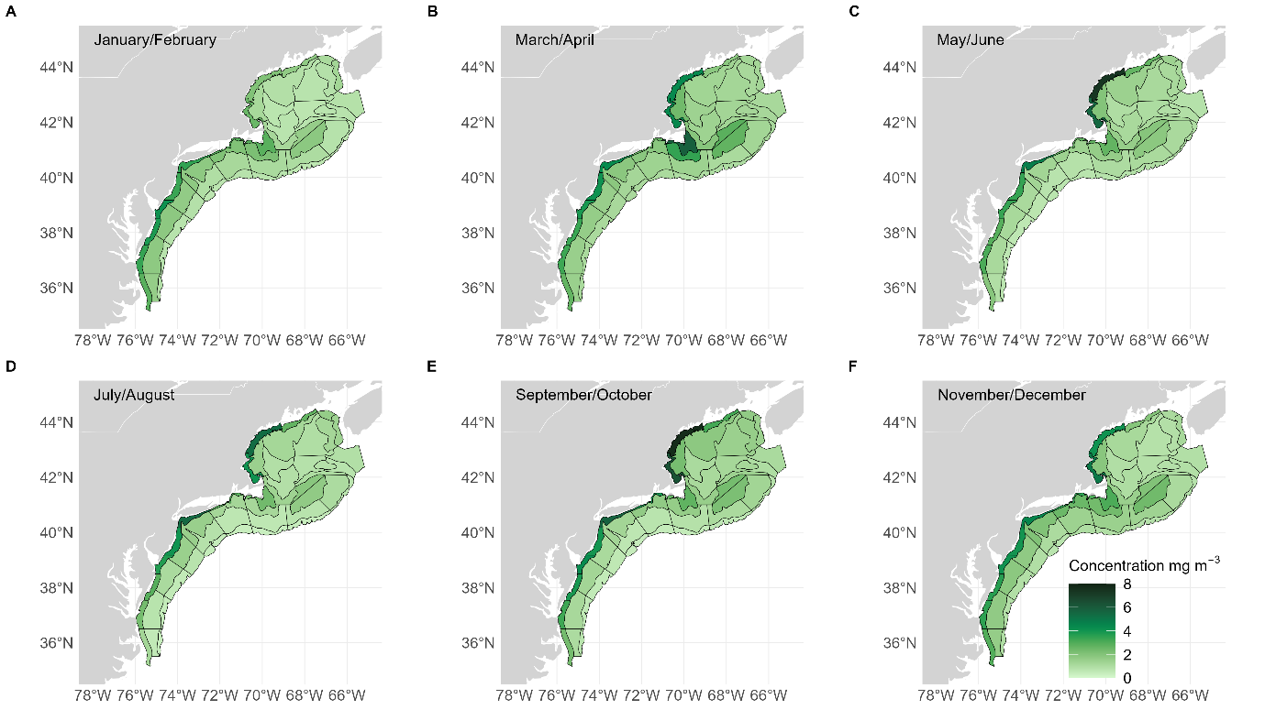
Figure S1: Mean Chlorophyll a concentration (mg m⁻³) within each stratum for each bimonthly timepoint. A January/February, B March/April, C May/June, D July/August, E September/October and F November/December.

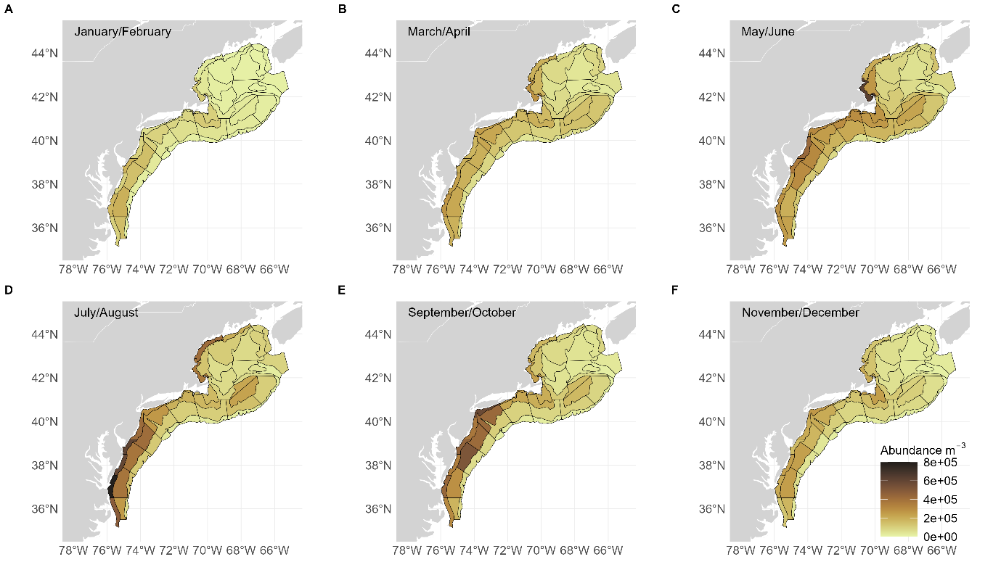
Figure S2: Mean zooplankton abundance (100 m⁻³) within each stratum for each bimonthly timepoint. A January/February, B March/April, C May/June, D July/August, E September/October and F November/December.

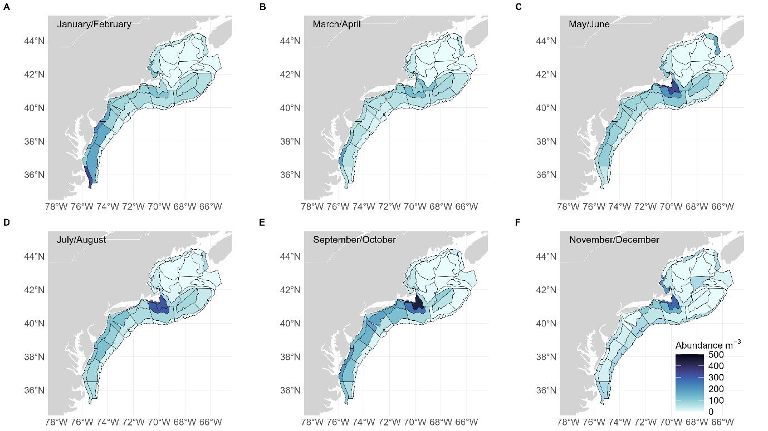
Figure S3: Mean fish larval abundance (100 m⁻³) within each stratum for each bimonthly timepoint. A January/February, B March/April, C May/June, D July/August, E September/October and F November/December.

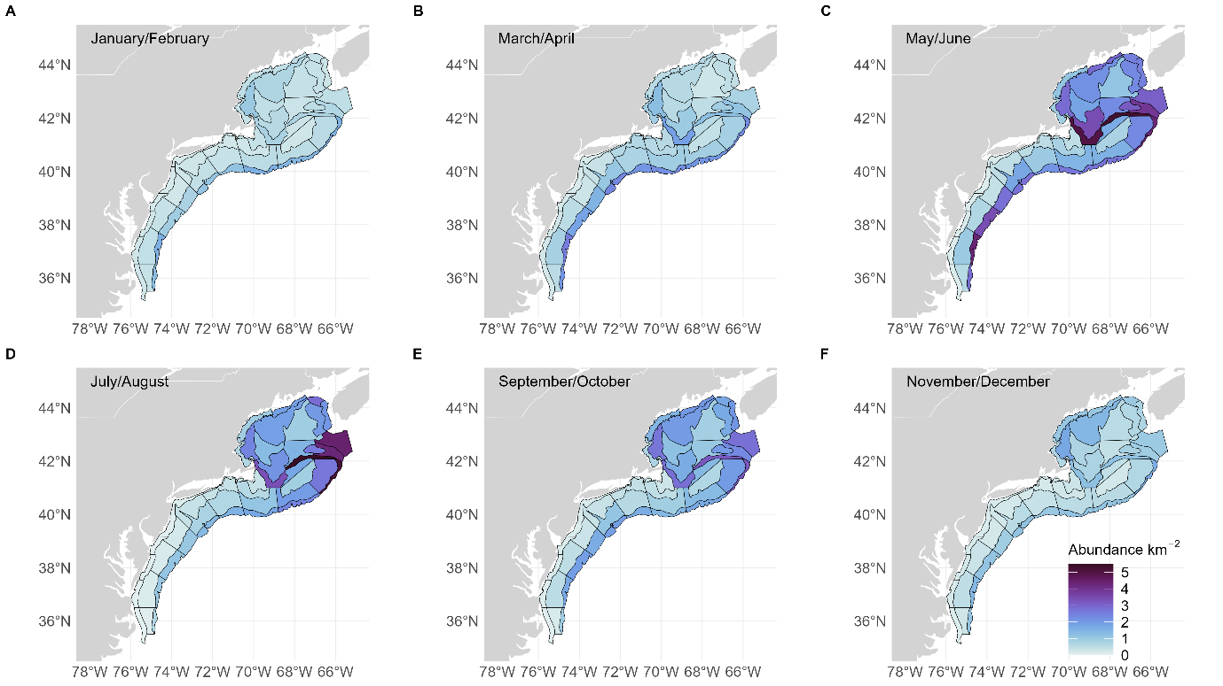
Figure S4: Mean cumulative abundance (100 km⁻²) of endangered whale species within each stratum for each bimonthly timepoint. A January/February, B March/April, C May/June, D July/August, E September/October and F November/December. 5 whale species shown: Balaenoptera physalus (Fin whale), Megaptera novaeangliae (Humpback whale), Eubalaena glacialis (North Atlantic right whale), Balaenoptera borealis (Sei whale) and Physeter macrocephalus (Sperm whale).

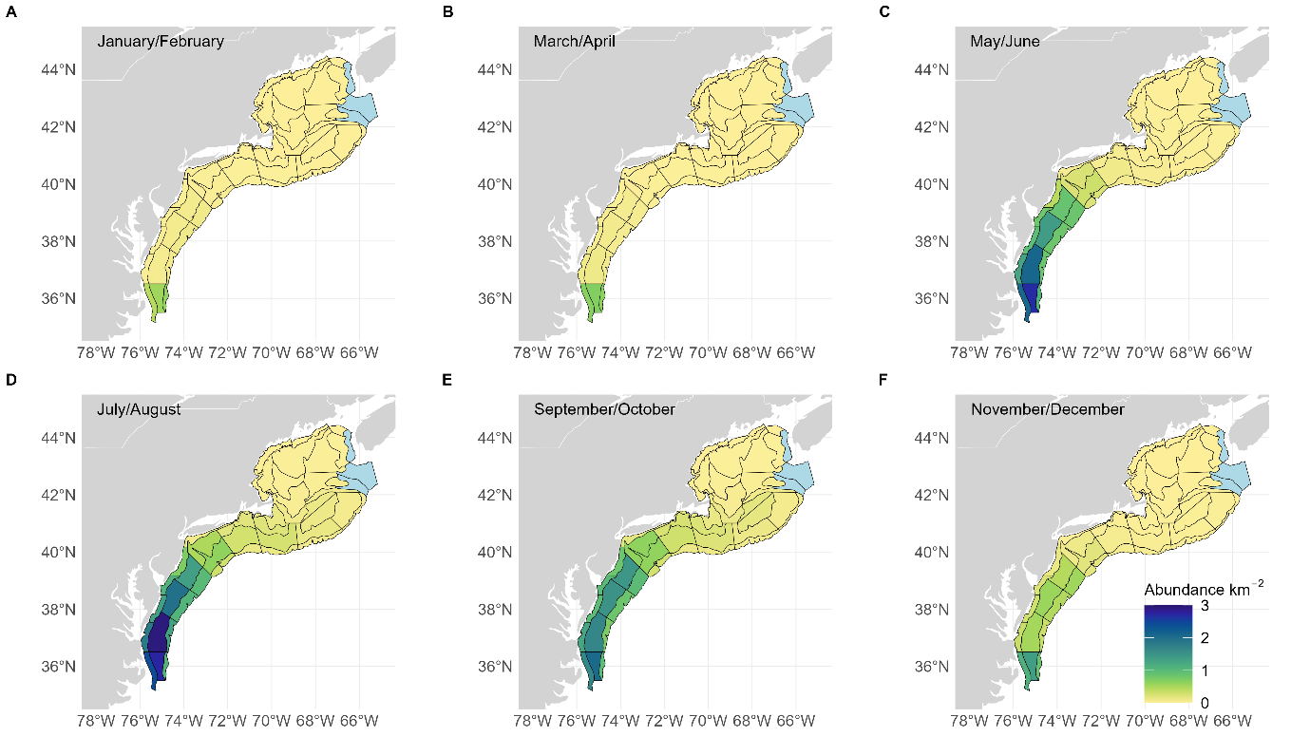
Figure S5: Mean cumulative abundance (100 km⁻²) of endangered sea turtle species within each stratum for each bimonthly timepoint. A January/February, B March/April, C May/June, D July/August, E September/October and F November/December. Strata colored in lightblue miss abundance data. 4 turtle species shown: Chelonia mydas (Green sea turtle), Lepidochelys kempii (Kemp’s Ridley sea turtle), Dermochelys coriacea (Leatherback sea turtle) and Caretta caretta (Loggerhead sea turlte).

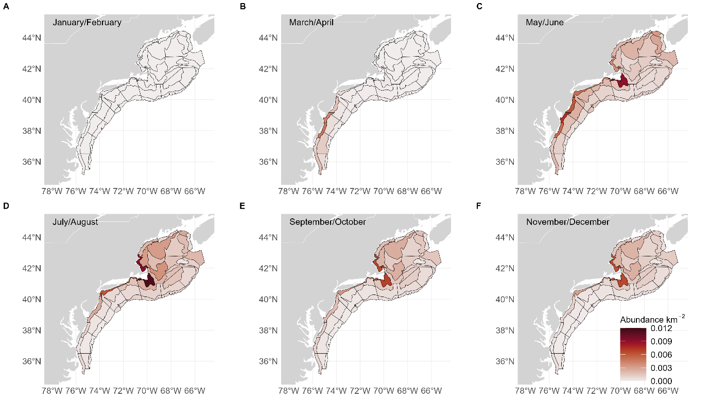
Figure S6: Mean abundance (100 km⁻²) of endangered seabird Sterna dougallii (Roseate Tern) within each stratum for each bimonthly timepoint. A January/February, B March/April, C May/June, D July/August, E September/October and F November/December.

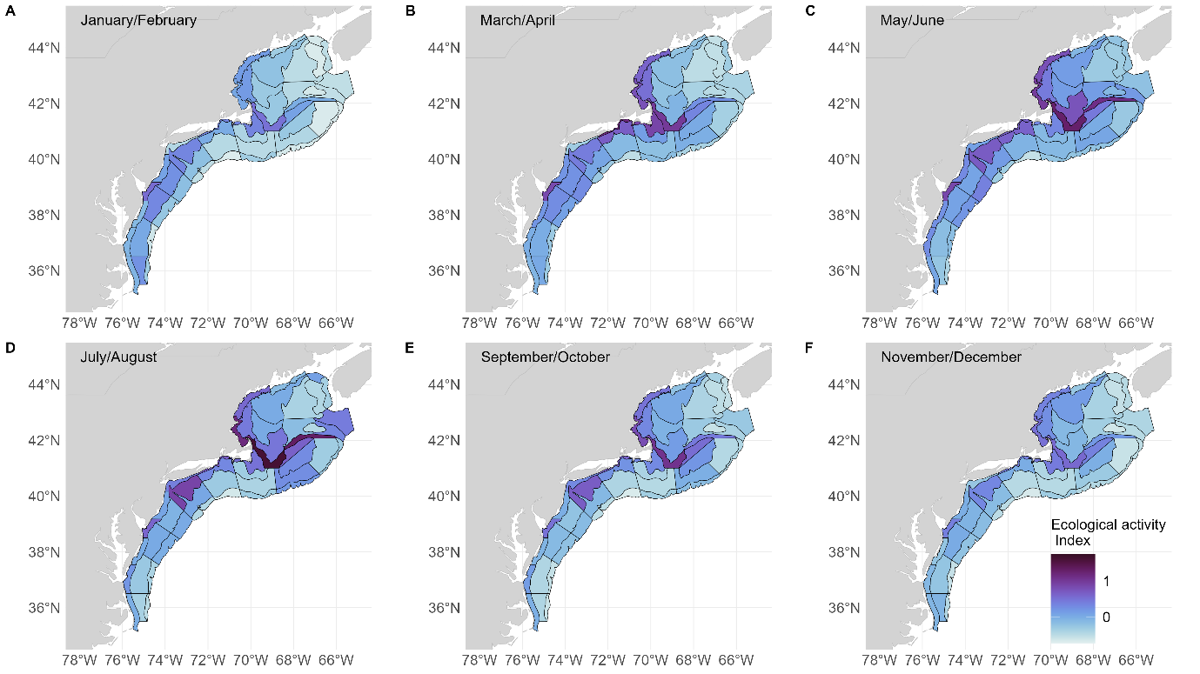
Figure S7: Weighted ecological activity index within each stratum for each bimonthly timepoint. A January/February, B March/April, C May/June, D July/August, E September/October and F November/December.

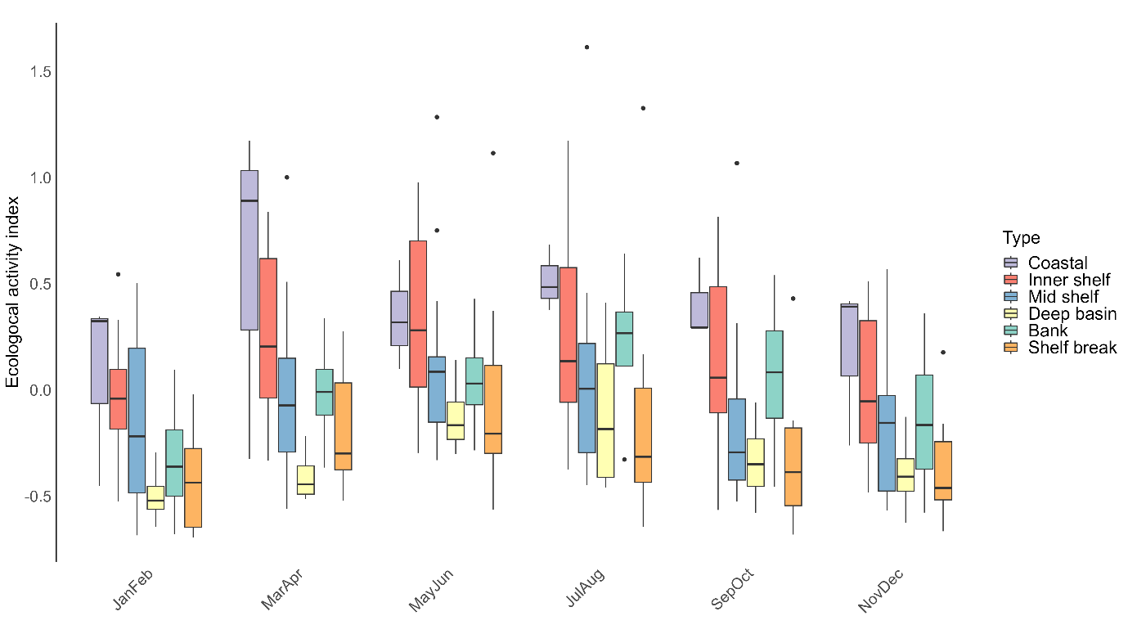
Figure S8: Weighted ecological activity index within each geospatial type for each bimonthly timepoint. Coastal (purple), Inner shelf (red), Mid shelf (blue), Deep basin (yellow), Bank (green) and Shelf break (orange).

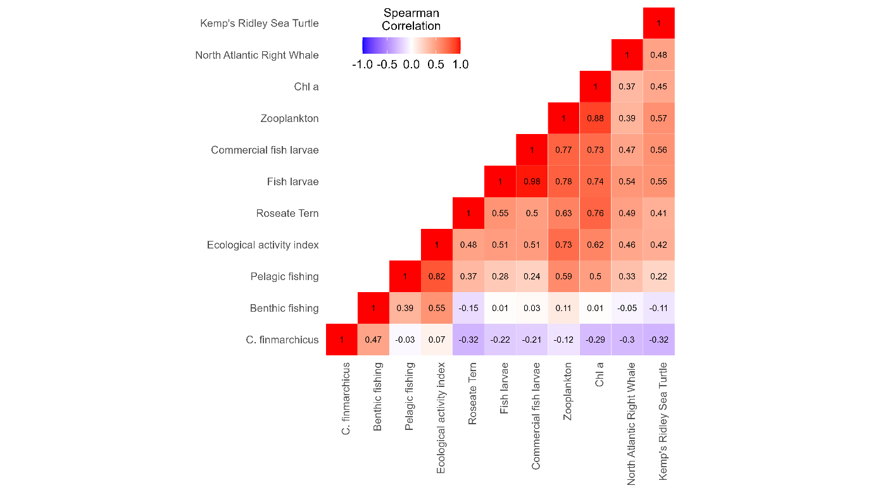
Figure S9: Spearman rank correlation of metrics implemented in the ecological activity index to identify intercorrelated metrics. High intercorrelation requires applying of a weighting scheme for the EAI to balance the correlation between metrics.

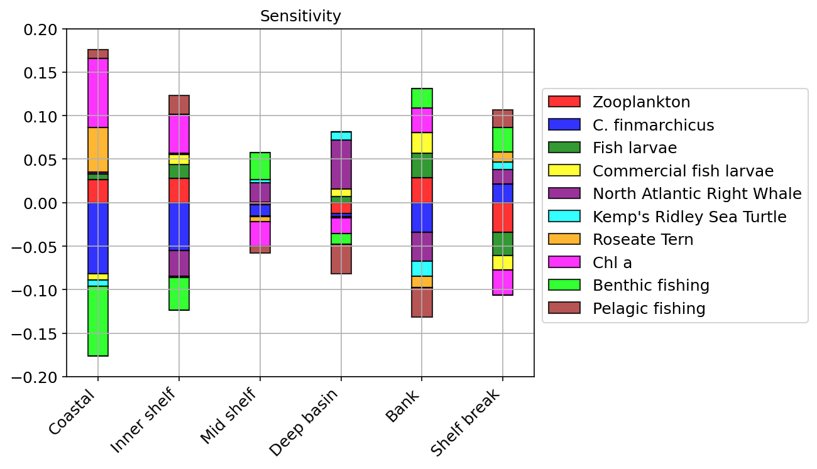
Figure S10: Sensitivity analysis for each geospatial type, depicting the change in the EAI if a given metric is weighted more heavily than others. The EAI was recalculated multiple times with weight increments of 0.1 times smaller to 5 times larger, while the total weight proportion remained at 100 %. Sensitivity was determined by fitting a linear model as the slope between weight values and resulting EAI. Note that in a given geospatial type, different metrics can be dominant in terms of abundance or concentration, thus the sensitivity of the EAI can vary across geospatial types.

