Table S1 Significant marker-trait associations (MTAs) identified for Septoria nodorum blotch (SNB) resistance
Trait | Marker | Chr | Position | P-value | Prem-P | PVE (%) | Trait | Marker | Chr | Position | P-value | Prem-P | PVE (%)
SNB_Exp1 | AX-158525572 | 5B | 546970656 | 5.67E-07 | 0.009 | 16.34 | SNB_Exp2 | AX-158525572 | 5B | 546970656 | 3.54E-05 | 0.218 | 12.76
SNB_Exp1 | IACX9261 | 5B | 546704069 | 1.07E-06 | 0.016 | 16.79 | SNB_Exp2 | AX-95023272 | 3A | 13405077 | 3.78E-05 | 0.084 | 10.12
SNB_Exp1 | AX-158525569 | 5B | 546672582 | 1.68E-06 | 0.02 | 15.34 | SNB_Exp2 | AX-95183368 | 3D | 6976581 | 3.78E-05 | 0.084 | 10.12
SNB_Exp1 | AX-111509567 | 5B | 546826552 | 1.68E-06 | 0.02 | 15.34 | SNB_Exp2 | IACX9261 | 5B | 546704069 | 3.89E-05 | 0.249 | 13.25
SNB_Exp1 | tplb0027f13_1493 | 5B | 546827810 | 1.68E-06 | 0.02 | 15.34 | SNB_Exp2 | AX-158525569 | 5B | 546672582 | 6.67E-05 | 0.33 | 12.11
SNB_Exp1 | Tdurum_contig25513_123 | 5A | 565753529 | 7.73E-06 | 0.047 | 15.84 | SNB_Exp2 | AX-111509567 | 5B | 546826552 | 6.67E-05 | 0.33 | 12.11
SNB_Exp1 | AX-108829232 | 5B | 546704556 | 4.51E-05 | 0.294 | 12.70 | SNB_Exp2 | tplb0027f13_1493 | 5B | 546827810 | 6.67E-05 | 0.33 | 12.11
SNB_Exp1 | Ex_c5594_2818 | 5B | 520885091 | 5.17E-05 | 0.168 | 9.33 | SNB_Exp2 | Ex_c5594_2818 | 5B | 520885091 | 1.55E-04 | 0.215 | 8.98
SNB_Exp1 | AX-94604036 | 1A | 12098848 | 1.12E-04 | 0.309 | 11.79 | SNB_Exp2 | BobWhite_c20558_374 | 7A | 6537043 | 2.19E-04 | 0.276 | 10.34
SNB_Exp1 | RAC875_c346_1226 | 7A | 10901950 | 1.43E-04 | 0.382 | 10.44 | SNB_Exp2 | GENE-0689_776 | 2A | 346205932 | 3.75E-04 | 0.534 | 8.00
SNB_Exp1 | BS00109912_51 | 7A | 653925 | 1.48E-04 | 0.515 | 8.26 | SNB_Exp2 | Tdurum_contig25513_123 | 5A | 565753529 | 3.87E-04 | 0.625 | 11.57
SNB_Exp1 | IAAV2718 | 2A | 681106708 | 1.59E-04 | 0.512 | 8.20 | SNB_Exp2 | GENE-0689_791 | 2A | 346205874 | 4.15E-04 | 0.57 | 7.81
SNB_Exp1 | AX-158567465 | 7A | 10861525 | 1.91E-04 | 0.479 | 9.98 | SNB_Exp2 | AX-94619024 | 3A | 1720575 | 4.30E-04 | 0.315 | 7.73
SNB_Exp1 | AX-158543921 | 7A | 28042678 | 2.40E-04 | 0.568 | 9.52 | SNB_Exp2 | AX-95225294 | 3A | 1904239 | 4.30E-04 | 0.315 | 7.73
SNB_Exp1 | Kukri_rep_c107630_127 | 2A | 686857812 | 3.89E-04 | 0.787 | 7.33 | SNB_Exp2 | AX-158577592 | 3A | 7435171 | 4.30E-04 | 0.315 | 7.73
SNB_Exp1 | AX-111612726 | 7A | 679960882 | 5.16E-04 | 0.808 | 8.73 | SNB_Exp2 | RFL_Contig2531_987 | 7A | 10193624 | 4.92E-04 | 0.702 | 9.19
SNB_Exp1 | wsnp_Ex_rep_c66465_64708628 | 2A | 686860574 | 6.45E-04 | 0.891 | 6.94 | SNB_Exp2 | BS00102646_51 | 3B | 6558708 | 5.43E-04 | 0.537 | 9.26
SNB_Exp1 | Tdurum_contig51645_738 | 7A | 68190769 | 6.53E-04 | 0.953 | 9.16 | SNB_Exp2 | Excalibur_c2827_227 | 4A | 726446439 | 5.82E-04 | 0.623 | 9.02
SNB_Exp1 | wsnp_Ra_c20970_30293078 | 5B | 577305676 | 6.99E-04 | 0.91 | 6.66 | SNB_Exp2 | wsnp_CAP7_c254_138937 | 4A | 712856544 | 6.12E-04 | 0.71 | 7.51
SNB_Exp1 | AX-95120952 | 2A | 720464227 | 7.10E-04 | 0.882 | 8.53 | SNB_Exp2 | Tdurum_contig41127_265 | 7A | 21263677 | 7.54E-04 | 0.796 | 7.17
SNB_Exp1 | AX-95247676 | 3A | 477986381 | 7.17E-04 | 0.938 | 6.60 | SNB_Exp2 | AX-111101357 | 3A | 8165580 | 7.61E-04 | 0.515 | 7.02
SNB_Exp1 | Ra_c70829_369 | 7A | 679840276 | 7.53E-04 | 0.895 | 8.36 | SNB_Exp2 | AX-158610208 | 2B | 744317347 | 7.86E-04 | 1 | 7.35
SNB_Exp1 | Excalibur_c15844_1470 | 6A | 447833875 | 7.67E-04 | 0.955 | 8.70 | SNB_Exp2 | wsnp_Ex_c2615_4862266 | 5B | 475586705 | 8.45E-04 | 0.616 | 6.92
SNB_Exp1 | AX-95002570 | 4A | 742553340 | 9.59E-04 | 0.978 | 8.53 | SNB_Exp2 | JD_c63005_896 | 6A | 546553020 | 8.50E-04 | 0.789 | 7.14
SNB_Exp1 | RAC875_c41169_68 | 7A | 10194063 | 9.84E-04 | 0.925 | 8.18 | SNB_Exp2 | BS00067878_51 | 2B | 784621059 | 8.67E-04 | 0.883 | 11.25
 |  |  |  |  |  |  | SNB_Exp2 | IAAV3545 | 4A | 726121700 | 9.76E-04 | 0.873 | 8.49
 |  |  |  |  |  |  | SNB_Exp2 | BS00105741_51 | 3B | 9092604 | 1.00E-03 | 0.704 | 6.76%

Table S2 Significant marker-trait associations (MTAs) identified for tan spot (TS) resistance
Trait | Marker | Chr | Position | P-value | Prem-P | PVE (%) | Trait | Marker | Chr | Position | P-value | Prem-P | PVE (%)
TS_Exp1 | AX-94782932 | 2D | 21061255 | 3.56E-05 | 0.108 | 12.81 | TS_Exp2 | Excalibur_c81824_411 | 7B | 739931859 | 1.51E-05 | 0.027 | 11.90
TS_Exp1 | GENE-3572_70 | 5D | 1613079 | 1.40E-04 | 0.146 | 11.19 | TS_Exp2 | RAC875_c8137_128 | 7B | 745585191 | 3.52E-05 | 0.052 | 10.99
TS_Exp1 | RFL_Contig3370_343 | 5A | 1201017 | 2.16E-04 | 0.315 | 10.85 | TS_Exp2 | RAC875_c34939_963 | 7B | 741576525 | 6.66E-05 | 0.06 | 12.31
TS_Exp1 | Excalibur_c19658_82 | 3A | 7951544 | 6.61E-04 | 0.294 | 7.77 | TS_Exp2 | AX-94748974 | 7B | 741244695 | 7.19E-05 | 0.074 | 12.31
TS_Exp1 | AX-158585290 | 5A | 695964 | 6.95E-04 | 0.295 | 9.38 | TS_Exp2 | Kukri_rep_c106477_365 | 7D | 630527152 | 1.07E-04 | 0.093 | 11.79
TS_Exp1 | RAC875_c7060_67 | 3A | 8686740 | 7.93E-04 | 0.191 | 7.20 | TS_Exp2 | AX-94393446 | 7B | 741572238 | 1.48E-04 | 0.165 | 11.31
TS_Exp1 | AX-94400545 | 4A | 584124176 | 8.61E-04 | 1 | 9.45 | TS_Exp2 | RAC875_c14064_308 | 7B | 740040340 | 1.60E-04 | 0.119 | 11.28
TS_Exp1 | AX-89650364 | 3A | 8213038 | 8.70E-04 | 0.205 | 7.15 | TS_Exp2 | AX-94393074 | 5B | 660201664 | 2.44E-04 | 0.193 | 8.89
TS_Exp1 | Excalibur_c81824_411 | 7B | 739931859 | 9.00E-04 | 0.479 | 7.07 | TS_Exp2 | AX-94467581 | 7B | 730909895 | 2.60E-04 | 0.276 | 10.58
TS_Exp1 | RAC875_c8137_128 | 7B | 745585191 | 9.71E-04 | 0.432 | 7.05 | TS_Exp2 | RAC875_rep_c108382_824 | 7B | 750083883 | 2.63E-04 | 0.197 | 8.65
 |  |  |  |  |  |  | TS_Exp2 | TG0119 | 7B | 740039652 | 3.58E-04 | 0.265 | 10.23
 |  |  |  |  |  |  | TS_Exp2 | RAC875_c31791_559 | 7B | 704671177 | 3.71E-04 | 0.271 | 8.34
 |  |  |  |  |  |  | TS_Exp2 | tplb0045c05_547 | 7A | 736434818 | 3.92E-04 | 0.285 | 10.19
 |  |  |  |  |  |  | TS_Exp2 | IAAV4542 | 7D | 633606239 | 4.52E-04 | 0.297 | 10.01
 |  |  |  |  |  |  | TS_Exp2 | tplb0060b03_432 | 7A | 732054727 | 4.68E-04 | 0.419 | 8.26
 |  |  |  |  |  |  | TS_Exp2 | AX-110016919 | 5B | 591062057 | 5.02E-04 | 0.283 | 7.94
 |  |  |  |  |  |  | TS_Exp2 | AX-108727865 | 5B | 591142467 | 5.09E-04 | 0.294 | 7.86
 |  |  |  |  |  |  | TS_Exp2 | wsnp_Ku_c18023_27232712 | 5A | 672408062 | 6.93E-04 | 0.487 | 7.62
 |  |  |  |  |  |  | TS_Exp2 | AX-158577598 | 3A | 19103443 | 6.98E-04 | 0.715 | 9.55
 |  |  |  |  |  |  | TS_Exp2 | RAC875_c50928_292 | 7A | 730710502 | 8.90E-04 | 0.473 | 7.23
 |  |  |  |  |  |  | TS_Exp2 | RAC875_c34939_467 | 7B | 741576974 | 8.94E-04 | 0.502 | 9.20
 |  |  |  |  |  |  | TS_Exp2 | BobWhite_c43557_103 | 7B | 741577128 | 9.31E-04 | 0.51 | 9.07
 |  |  |  |  |  |  | TS_Exp2 | wsnp_Ex_c47152_52446529 | 5B | 476636789 | 9.47E-04 | 0.591 | 7.19
 |  |  |  |  |  |  | TS_Exp2 | BobWhite_c22827_193 | 6B | 631740475 | 9.57E-04 | 0.443 | 9.04

Table S3 Grouping significant markers into quantitative trait loci (QTL)
QTL | Marker | Position | P-value |  | PVE (%)
Qsnb.cim.2AL | GENE-0689_776 | 346205932 |  | 3.75E-04 |  | 8.00
Qsnb.cim.2AL | GENE-0689_791 | 346205874 |  | 4.15E-04 |  | 7.81
Qsnb.cim.7AS | RAC875_c41169_68 | 10194063 |  | 9.84E-04 |  | 8.18
Qsnb.cim.7AS | AX-158567465 | 10861525 |  | 1.91E-04 |  | 9.98
Qsnb.cim.7AS | RAC875_c346_1226 | 10901950 |  | 1.43E-04 |  | 10.44
Qts.cim.3AS | AX-94461370 | 7437020 |  | 1.03E-03 |  | 6.90
Qts.cim.3AS | Excalibur_c19658_82 | 7951544 |  | 6.61E-04 |  | 7.77
Qts.cim.3AS | AX-89650364 | 8213038 |  | 8.70E-04 |  | 7.15
Qts.cim.3AS | tplb0053a24_2232 | 8593551 |  | 1.06E-03 |  | 6.80
Qts.cim.3AS | RAC875_c7060_67 | 8686740 |  | 7.93E-04 |  | 7.20
Qts.cim.3AS | AX-158577668 | 8907636 |  | 9.96E-04 |  | 6.97
Qts.cim.3AS | AX-94969670 | 9852648 |  | 1.04E-03 |  | 6.91
Qts.cim.5AS | RAC875_c15745_124 | 13858 |  | 1.21E-03 |  | 8.74
Qts.cim.5AS | tplb0035p20_710 | 335502 |  | 2.75E-03 |  | 7.91
Qts.cim.5AS | AX-158585290 | 695964 |  | 6.95E-04 |  | 9.38
Qts.cim.5AS | RFL_Contig3370_343 | 1201017 |  | 2.16E-04 |  | 10.85
Qts.cim.7AL | RAC875_c50928_292 | 730710502 |  | 8.90E-04 |  | 7.23
Qts.cim.7AL | tplb0060b03_432 | 732054727 |  | 4.68E-04 |  | 8.26
Qts.cim.7AL | tplb0045c05_547 | 736434818 |  | 3.92E-04 |  | 10.19
Qts.cim.7DL | Kukri_rep_c106477_365 | 630527152 |  | 1.07E-04 |  | 11.79
Qts.cim.7DL | AX-94861939 | 633516328 |  | 4.17E-03 |  | 5.54
Qts.cim.7DL | IAAV4542 | 633606239 |  | 4.52E-04 |  | 10.01
Qts.cim.7DL | RFL_Contig3607_648 | 634095988 |  | 2.73E-03 |  | 7.74
Qts.cim.7DL | RAC875_c8752_705 | 634693319 |  | 3.02E-03 |  | 7.68

Table S4 Summary of the candidate genes in the identified QTL regions.
QTL | Candidate Gene | Position | Protein
Qsnb.cim.2AL | TraesCS2A02G244200 | 348089209 - 348093743 | threonine protein kinase
Qsnb.cim.2AL | TraesCS2A02G243900 | 345461885 - 345462175 | RNase H type-1 domain-containing protein
Qsnb.cim.7AS | TraesCS7A02G020300 | 8263242 - 8266242 | TSL-kinase interacting protein 1
Qsnb.cim.7AS | TraesCS7A02G021058 | 8590273 - 8592383 | NB-ARC domain-containing protein
Qsnb.cim.7AS | TraesCS7A02G021100 | 8634427 - 8637728 | NB-ARC domain-containing protein
Qsnb.cim.7AS | TraesCS7A02G021700 | 8774656 - 8781215 | NB-ARC domain-containing protein
Qsnb.cim.7AS | TraesCS7A02G022700 | 8931899 - 8938966 | NB-ARC domain-containing protein
Qsnb.cim.7AS | TraesCS7A02G022800 | 8996265 - 9007449 | NB-ARC domain-containing protein
Qsnb.cim.7AS | TraesCS7A02G022900 | 9007919 - 9011947 | NB-ARC domain-containing protein
Qsnb.cim.7AS | TraesCS7A02G023400 | 9327923 - 9335785 | NB-ARC domain-containing protein
Qsnb.cim.7AS | TraesCS7A02G026400 | 10619635 - 10626123 | NB-ARC domain-containing protein
Qsnb.cim.7AS | TraesCS7A02G026900 | 10849564 - 10856201 | NB-ARC domain-containing protein
Qsnb.cim.7AS | TraesCS7A02G027000 | 10855484 - 10862014 | NB-ARC domain-containing protein
Qsnb.cim.7AS | TraesCS7A02G027700 | 11084872 - 11088792 | NB-ARC domain-containing protein
Qsnb.cim.7AS | TraesCS7A02G027800 | 11091491 - 11101081 | NB-ARC domain-containing protein
Qsnb.cim.7AS | TraesCS7A02G028400 | 11432768 - 11435195 | non-specific serine/threonine protein kinase
Qts.cim.3AS | TraesCS3A02G006900 | 7384784 - 7389062 | Protein kinase domain-containing protein
Qts.cim.3AS | TraesCS3A02G007400 | 7497308 - 7500211 | Rx N-terminal domain-containing protein
Qts.cim.3AS | TraesCS3A02G008000 | 7918329 - 7929294 | NB-ARC domain-containing protein
Qts.cim.3AS | TraesCS3A02G008200 | 8032629 - 8040119 | NB-ARC domain-containing protein
Qts.cim.3AS | TraesCS3A02G009200 | 8323975 - 8330044 | NB-ARC domain-containing protein
Qts.cim.3AS | TraesCS3A02G013900 | 9888295 - 9889938 | Disease resistance N-terminal domain-containing protein
Qts.cim.3AS | TraesCS3A02G014200 | 9950897 - 9951898 | Disease resistance N-terminal domain-containing protein
Qts.cim.3AS | TraesCS3A02G014500 | 9988218 - 9998164 | NB-ARC domain-containing protein
Qts.cim.3AS | TraesCS3A02G016100 | 10496916 - 10497287 | Serine-threonine/tyrosine-protein kinase catalytic domain-containing protein
Qts.cim.3AS | TraesCS3A02G016700 | 10827255 - 10830719 | Protein kinase domain-containing protein
Qts.cim.3AS | TraesCS3A02G017100 | 10951424 - 10955803 | Protein kinase domain-containing protein
Qts.cim.5AS | TraesCS5A02G000100 | 10126 - 18461 | non-specific serine/threonine protein kinase (EC 2.7.11.1)
Qts.cim.5AS | TraesCS5A02G000600 | 638578 - 644527 | non-specific serine/threonine protein kinase (EC 2.7.11.1)
Qts.cim.5AS | TraesCS5A02G001600 | 1228104 - 1231038 | Nucleolar protein 58/56 N-terminal domain-containing protein
Qts.cim.7AL | TraesCS7A02G557700 | 730430495 - 730434493 | Rx N-terminal domain-containing protein
Qts.cim.7AL | TraesCS7A02G558800 | 730895628 - 730895912 | Disease resistance N-terminal domain-containing protein
Qts.cim.7AL | TraesCS7A02G560600 | 732156038 - 732158443 | Leucine-rich repeat-containing N-terminal plant-type domain-containing protein
Qts.cim.7AL | TraesCS7A02G561100 | 732468316 - 732471001 | NB-ARC domain-containing protein
Qts.cim.7AL | TraesCS7A02G561200 | 732505046 - 732507142 | NB-ARC domain-containing protein
Qts.cim.7AL | TraesCS7A02G562400 | 733212782 - 733220563 | Disease resistance protein RPM1
Qts.cim.7AL | TraesCS7A02G562500 | 733274066 - 733278209 | NB-ARC domain-containing protein
Qts.cim.7AL | TraesCS7A02G562800 | 733340248 - 733351040 | NB-ARC domain-containing protein
Qts.cim.7AL | TraesCS7A02G562800 | 733340248 - 733351040 | NB-ARC domain-containing protein
Qts.cim.7AL | TraesCS7A02G566900 | 735960638 - 735961249 | Disease resistance N-terminal domain-containing protein
Qts.cim.7AL | TraesCS7A02G567300 | 736013442 - 736014002 | Disease resistance N-terminal domain-containing protein
Qts.cim.7AL | TraesCS7A02G568700 | 736424403 - 736429938 | NB-ARC domain-containing protein
Qts.cim.7BL | TraesCS7B02G453100 | 714457237 - 714458299 | Powdery mildew resistance protein
Qts.cim.7BL | TraesCS7B02G460200 | 717872581 - 717873560 | Disease resistance N-terminal domain-containing protein
Qts.cim.7BL | TraesCS7B02G460500 | 717982600 - 717983579 | Disease resistance N-terminal domain-containing protein
Qts.cim.7BL | TraesCS7B02G474800 | 730907564 - 730911541 | NB-ARC domain-containing protein
Qts.cim.7BL | TraesCS7B02G482300 | 740038137 - 740041421 | AAA+ ATPase domain-containing protein
Qts.cim.7BL | TraesCS7B02G491500 | 744239271 - 744241917 | Disease resistance N-terminal domain-containing protein
Qts.cim.7BL | TraesCS7B02G491600 | 744247685 - 744253606 | Disease resistance RPP13-like protein 1
Qts.cim.7BL | TraesCS7B02G492900 | 744648123 - 744652682 | Disease resistance N-terminal domain-containing protein
Qts.cim.7BL | TraesCS7B02G495100 | 746321496 - 746324997 | Disease resistance N-terminal domain-containing protein
Qts.cim.7BL | TraesCS7B02G497100 | 747736319 - 747773318 | Disease resistance protein RPM1
Qts.cim.7DL | TraesCS7D02G537100 | 628673951 - 628679274 | NB-ARC domain-containing protein
Qts.cim.7DL | TraesCS7D02G540000 | 630272767 - 630273493 | Disease resistance N-terminal domain-containing protein
Qts.cim.7DL | TraesCS7D02G541300 | 630720396 - 630721329 | Stress-response A/B barrel domain-containing protein
Qts.cim.7DL | TraesCS7D02G542200 | 631424255 - 631428465 | NB-ARC domain-containing protein
Qts.cim.7DL | TraesCS7D02G542600 | 631684915 - 631686729 | Leucine-rich repeat-containing N-terminal plant-type domain-containing protein
Qts.cim.7DL | TraesCS7D02G545900 | 632857507 - 632860030 | Protein kinase domain-containing protein
Qts.cim.7DL | TraesCS7D02G547100 | 633487530 - 633496633 | NB-ARC domain-containing protein
Qts.cim.7DL | TraesCS7D02G548100 | 633669501 - 633673714 | NB-ARC domain-containing protein
Qts.cim.7DL | TraesCS7D02G549000 | 634087243 - 634089949 | Leucine-rich repeat-containing N-terminal plant-type domain-containing protein
Qts.cim.7DL | TraesCS7D02G549200 | 634108690 - 634110840 | NB-ARC domain-containing protein

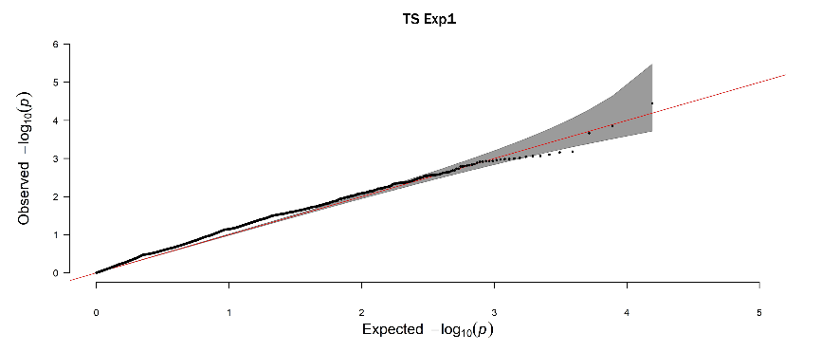
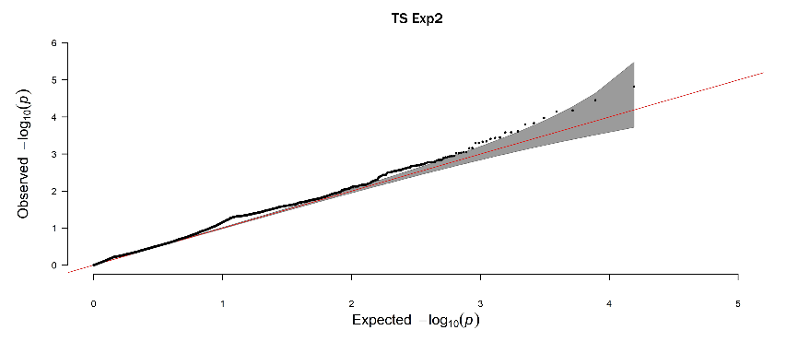
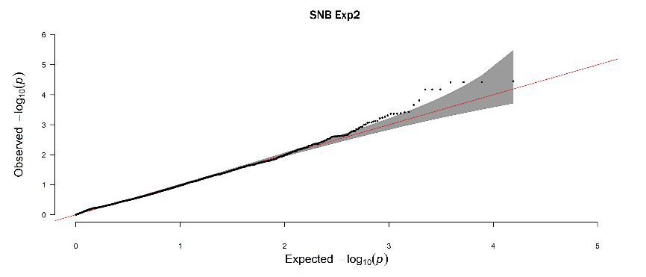
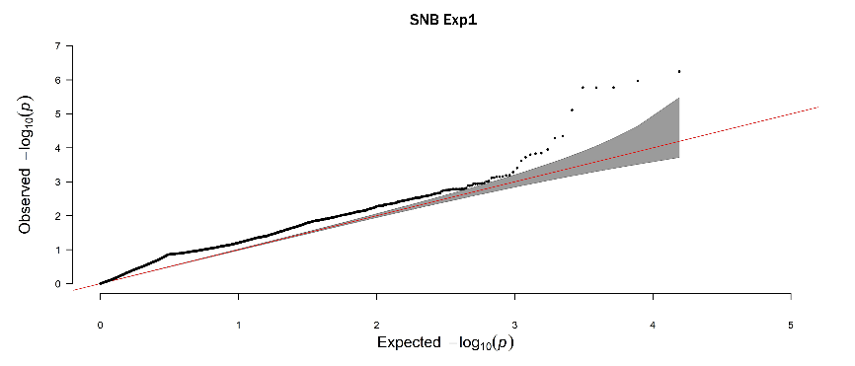
Figure S1 Q–Q plots for Septoria nodorum blotch (SNB) and tan spot (TS) resistance across two experiments.

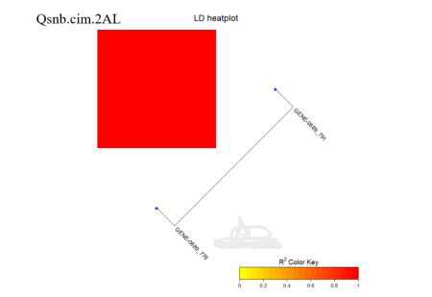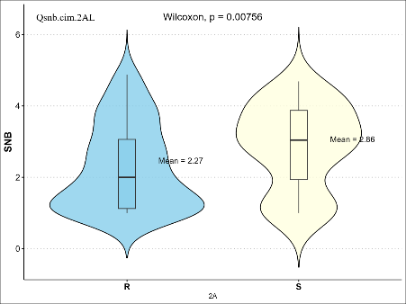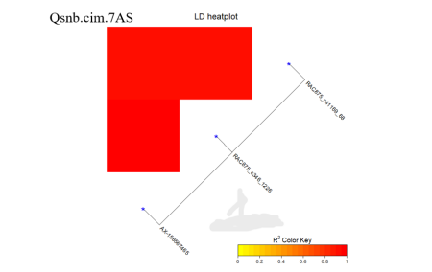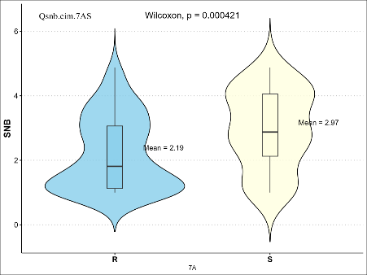
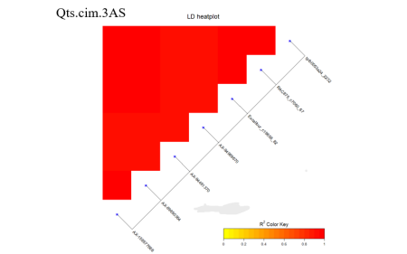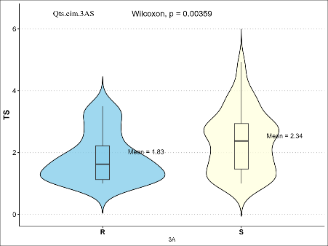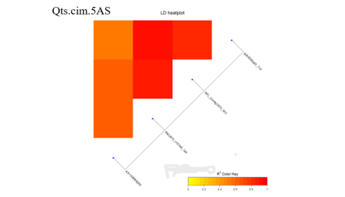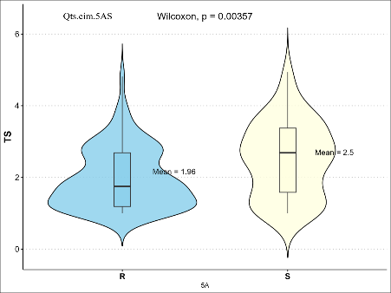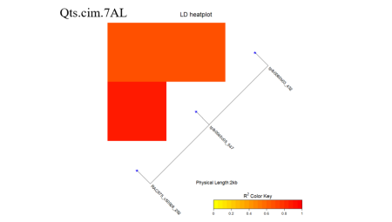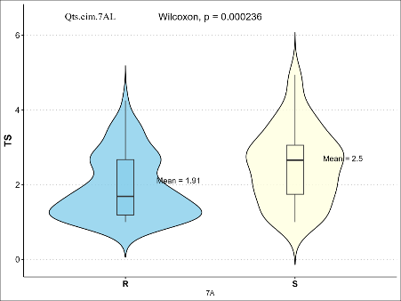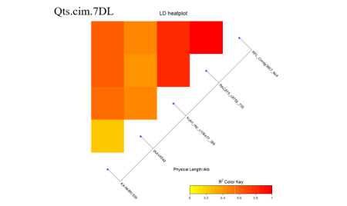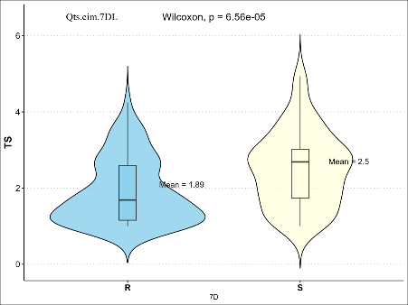
Figure S2 Linkage Disequilibrium (LD) Heatmaps and Phenotypic Effects of quantitative trait loci (QTL) associated with Septoria nodorum blotch (SNB) and tan spot (TS) Resistance

